SEISMIC DESIGN OF A WIDENED AND RECONSTRUCTED T-BEAM GIRDER BRIDGE

DOI 10.37153/2686-7974-2019-16-123-132

Sunlin Cao, Yan Xu, Jiangtao Yu, Leying Jia

ABSTRACT

The bridge was a continuous double-deck bridge, due to the continuously increased traffic pressure, the upper deck needs to be widened from the original two lanes to six lanes, and the lower deck is changed to non-motor vehicle lanes and sidewalks. The bridge is widened by splicing new T beams on both sides of the old bridges. The newly built superstructure and substructure both connect the corresponding parts of the old bridge. However, the load capacity of the old and new piers is different because the reinforcement ratio of the old pier is less than that of the new piers, and the old bridge was designed 40 years ago, hence the seismic performance needs to be checked by doing this. This paper presents the seismic responses of the widened and reconstructed of the bridge, and come up with the reasonable seismic design measures for the bridge to make it safe and operate normally under strong earthquakes according China criterion.

Keywords: double-deck bridge; widening and reconstruction; seismic design; seismic performance

1. INTRODUCTION

There is a combined highway and railway bridge, which was completed and open to traffic in June 1976. The upper deck is a two-lane highway and the lower is a single-track railway. This bridge has no longer taken the responsibility for railway operation after a new railway bridge was built next to it in 2012. Therefore, it is proposed to widen the bridge in situ in order to improve the operational capacity of the bridge, which saves a lot of money and time compared to constructing a new bridge. The upper deck is changed to a six-lane highway and the lower deck is changed to a non-motorized lane. The approach bridge has 22 spans, and the highway and railway are combined from P0# to P03# and separated since P04#. This part’s mass of superstructure is so large that the substructure is subjected to complex forces under earthquakes. Therefore, this paper mainly studies seismic performance of the combined parts. General layout of the approach bridge is shown in Figure 1.

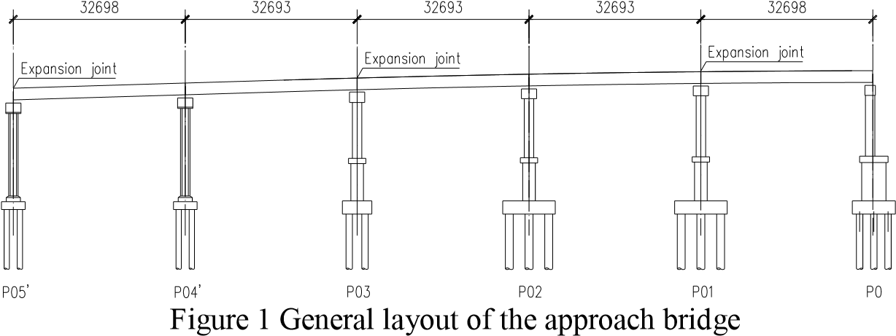

In order to ensure coordination of landscape and uniformity of force distribution, the upper deck is widened with the same T-beam as the original structure, and the old substructure is reserved with new foundations, piers and capping beams built on both sides. Typical cross-section and layout of the foundation after widening are shown in Figure 2 below, where the shaded part stands for the old structure.

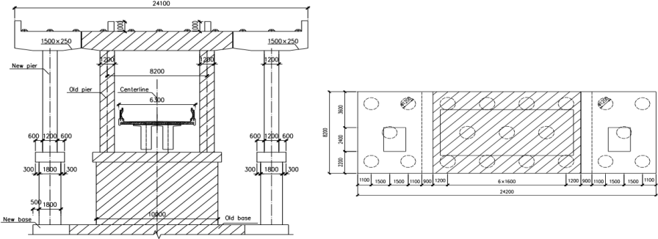

Figure 2. Typical cross section of the approach bridge and layout of pile foundation

He Zai-xing¹ (2008) and Wang Hao² (2013) have shown that with increase of the stiffness of the new beams and the wet joints, the lateral distribution coefficient of the old beam can be effectively reduced. Zhao Hongyan³ (2014) has found that the lateral distribution coefficient of each beam became smaller after widening for bridges with new and old bridges’ superstructure connected and substructure separated. Liu Xiao-yan⁴ (2016) has found that the stiffness of longitudinal beams has greater influence on the capacity of bridges than crossbeams, and proposed some principles about stiffness ratio between longitudinal beams and crossbeams. Ma Chun-sheng⁵ (2003) suggested that the separation of old and new structures should be adopted for the widening of Huzhou Bridge considering factors such as uneven settlement and differences in new and old concrete shrinkage and creep. Wang Yang⁶ (2017) has simplified uneven foundation settlement between old and new bridges into two forms, which are linear settlement and uniform settlement. Also, he put forward the allowable settlement difference for simply supported and continuous beam bridges. In addition, it is Wang Xue-jun⁷ (2006), Qiu Yan-hong⁸ (2011),Li Mao-qi and Zhang Guang-xuan⁹ (2015), and many other scholars have studied the stress characteristics of new and old structures under the effects of uneven shrinkage and creep between new and old concrete, uneven settlement of foundation and other static loads on the widening bridges.
Xu Xiu-li¹⁰ (2014) has studied and established the relationship between the seismic importance coefficient (C_{i}) and the subsequent service life according to the same probability of fortification required by the current regulations. Quan Zhi-yu and Wu Xiao-wei¹¹ (2010) and Shi Shao-li¹³ (2015) have done the comparative analysis of the seismic response of a widening bridge with capping beams connected or unconnected respectively and found that piers with capping beams connected are safer than those with capping beams unconnected. Also, there are others who have done some research about effects of soil types on the widening projects.
In summary, many scholars have focused on static characteristics of different widening methods and corresponding applicable conditions. In addition, other scholars have carried out some research on dynamic performance of the widening bridges, such as the seismic fortification criterion of the widened bridges with different subsequent service life and whether the capping beams should be connected and so on. This paper mainly studies seismic performance of the approaching bridge. The new and old structures all meet the seismic targets with isolation scheme adopted.

2. SEISMIC FORTIFICATION CRITERION

According to the Guidelines for Seismic Design of Highway Bridges¹⁴ (JTG/T B02-01-2008), the bridge project is in the “7 degree zone”, and the basic acceleration peak is 0.1g, with Class IV site and characteristic period of 0.75s. Two-stage seismic fortification (E1 and E2) is required. According to the criterion, the earthquake action E1 corresponds to 50-year return period, and E2 is about 2000 years. Under the earthquake action E1, the whole bridge is required to maintain elastic (piles and piers’ bending moment demand should be less than the initial yield bending moment). Under the earthquake action E2, it requires piers and piles to stay normal with simple reparation after the earthquake (piles and piers’ bending moment requirements should be less than the equivalent yield bending moment).

0
1
2
3
4
5
6
7
8
9
10
0.00
0.05
0.10
0.15
0.20
0.25
0.30
0.35
0.40
0.45
Acceleration (g)
Period (s)

E1-0.1g

E2-0.1g

Figure 3. Acceleration response spectrum

The acceleration response spectrum generated according to the above criterion is as shown in the above Figure 3. The acceleration time-history waves are synthesized according to the acceleration response spectrum, and the maximum value of the three sets of time-history calculation results is taken for seismic check. The acceleration time history waves corresponding to the earthquake action E1 and E2 are shown in Figure 4 below.

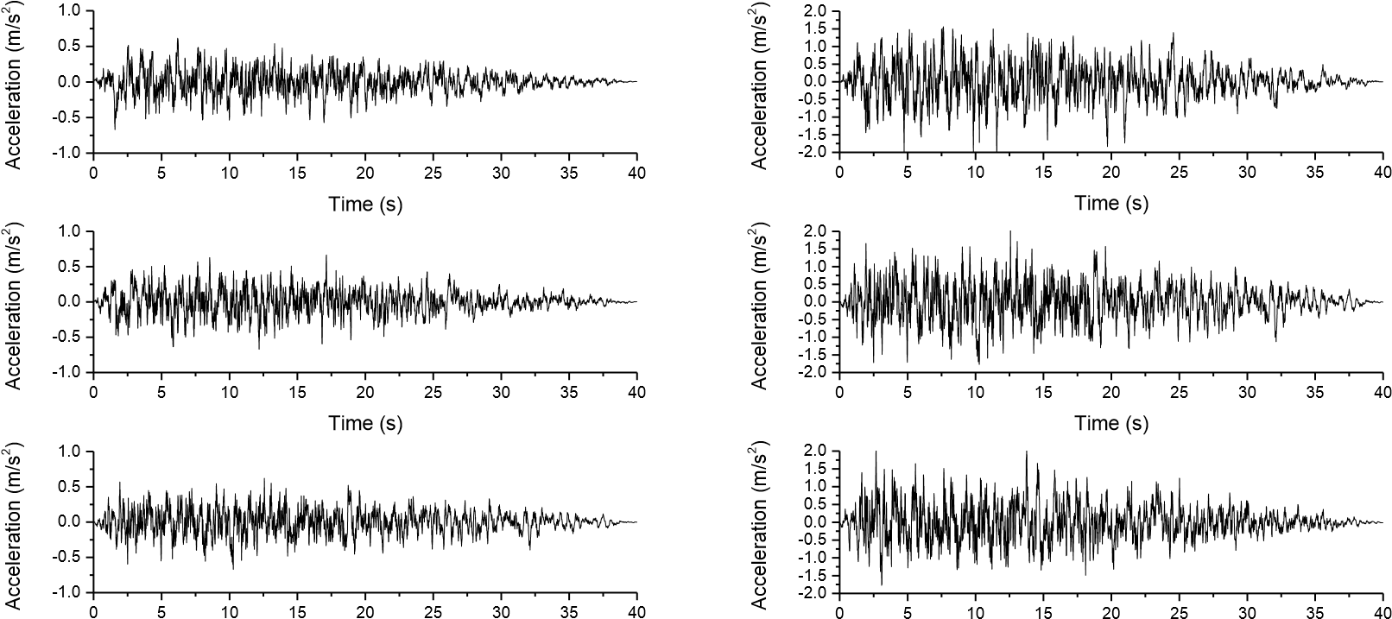
Time (s) Time (s)
E1 E2

Figure 4. Acceleration time history waves

3. SEISMIC CHECK OF THE APPROACH BRIDGE

SAP2000 is used to establish the model of the approach bridge and dynamic performance of the structure is analyzed. Girders and piers are simulated with elastic beam elements. The second-stage dead load is loaded on the main beam in the form of uniform mass to ensure reliability of model’s dynamic performance. Plate rubber bearings are used on both the upper and lower approach bridge, which are simulated by linear connecting elements, and the stiffness of the bearings are shown in the following Table 1. Pile foundations’ stiffness are simulated by adding six directions of springs at the bottom of bearing platforms. And the most unfavorable internal force of the single pile is the reversed with the reactions for piles’ seismic check. The FEM of the approach bridge is shown in Figure 5.

Table 1. Stiffness of the bearings

Bearings | Vertical (kN/m) | Transverse(kN/m)
Teflon slide bearing | 90800 | 0
Upper bridge | 896600 | 3370
Lower bridge | 1286500 | 3760

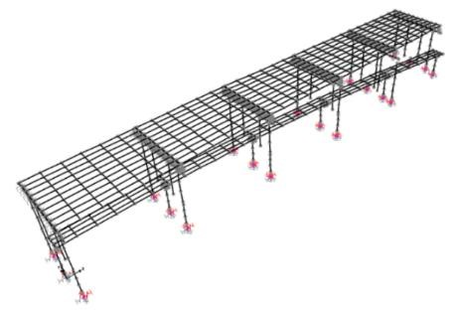

Figure 5. Schematic diagram of FEM

Modal analysis of the structure is carried out before seismic cases. The first ten modes and periods of the structure are shown in the following Table 2. The first-order longitudinal and transverse mode of vibration of the approach bridge are obtained as shown in the following Figure 6.

Table 2. The first 10th period of the approach bridge

Number | Period  (s) | Circular frequency (rad)
1 | 4.015 | 1.565
2 | 1.701 | 3.694
3 | 1.552 | 4.048
4 | 1.270 | 4.947
5 | 1.232 | 5.100
6 | 1.221 | 5.146
7 | 1.211 | 5.188
8 | 1.205 | 5.214
9 | 1.203 | 5.223
10 | 1.201 | 5.232

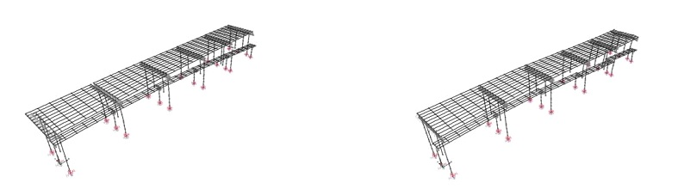
Longitudinal, T=1.701s Transverse, T=1.27s

Figure 6. Longitudinal and transverse first-order modal patterns
According to the modal analysis, the first-order longitudinal and transverse mode of vibration are the secondorder and fourth-order modes respectively, with periods of 1.701 s and 1.27 s, and the corresponding mass participation coefficients are 0.42 and 0.30. Therefore, it is preliminarily estimated that the transverse structural response of the seismic load cases is greater than that of the longitudinal.
Rayleigh damping is adopted in the dynamic time history analysis, and the damping ratio is 0.05. The abovementioned acceleration time history waves are used for ground motion input. The direct integration is used to perform nonlinear time-history analysis. Seismic check objects are dominated by piers and piles because the superstructure stays elastic under earthquakes. Considering that the flexural capacity of the compression members increases with the increase of pressure, we adopt the most unfavorable load combination. In other words, the axial force used to calculate the flexural capacity equals axial force under the dead load condition minus that under seismic conditions, while bending moment demand equals bending moment under dead load plus that under seismic conditions.
The initial yield bending moment M_{y} is used as the flexural capacity under earthquake action E1, while the equivalent yield bending moment M_{cr} is used under earthquake action E2. The schematic diagram of the initial yield bending moment M_{y} and the equivalent yield bending moment M_{cr} are shown in the figure 7 below.

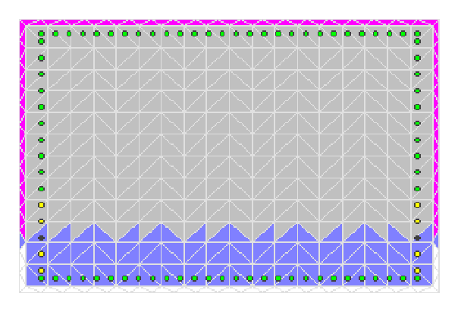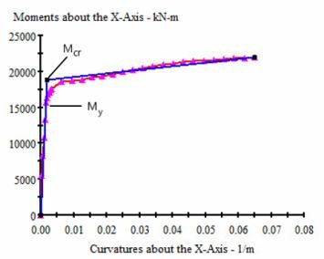

Figure 7. Schematic diagram of the initial yield moment and the equivalent yield moment

As we can see, the left figure stands for the deformation of the section under bending moment and right figure is the Moment-Curvature curve about specific local coordinate axis. Initial yield moment is the moment where of the first reinforcement is yielded, and the equivalent yield moment is the yield moment after the M-Φ curve is equivalent to bilinear curve.

3.1 Earthquake action E1

(1) Results of piers
According to the calculated axial force of the piers, the bending capacity is calculated with XTRACT, and the capacity-to-demand ratio (moment capacity/moment demand, C/D) of the piers in the longitudinal and transverse input of the earthquake action E1 are calculated, and the result is shown below Figure 8. In the figure, “1#L” indicates the left side pier of the P1#, and “R” indicates the right side. Because of the structural forms, when time history waves are input longitudinally, the bottom sections’ bending moment of new and old piers are checked. While top sections’ bending moment of old piers need to be checked additionally except the bottom sections when waves are input transversely.

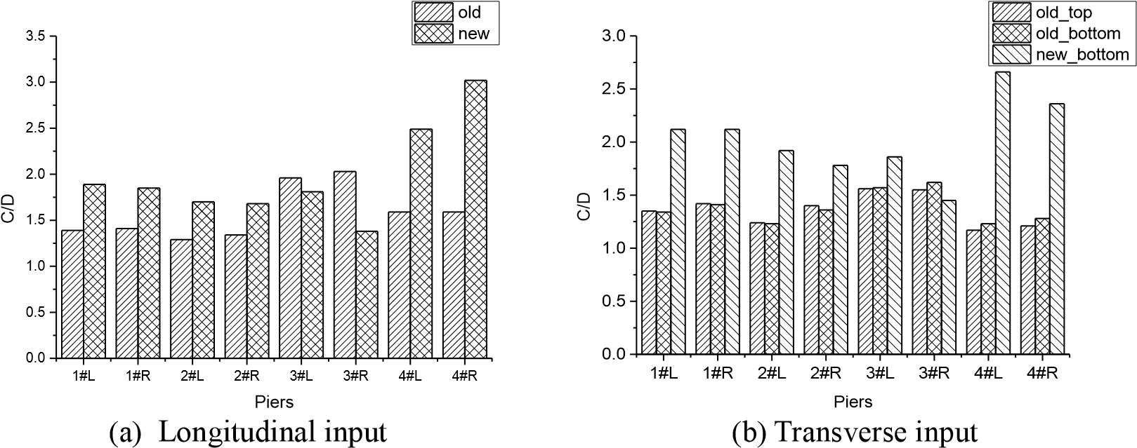

Figure 8. Capacity-demand ratio of piers under earthquake action E1

According to the results of nonlinear time history analysis, new piers at other locations bear more seismic force than that of old piers. After the upper approach bridge is widened, the number of T-beams is extended from 5 to 11, as shown in Figure 2. Therefore, each old pier bears about 2.5 T-beams’ inertia force, while each new pier bears about 3 T-beams’ inertia force. In addition, new piers are much higher than the old because newly built structure has no lower deck compared with old piers because it is the project of widening and reconstruction of a combined highway and railway bridge. To avoid the break of new piers, this project use larger piers’ sections from P0# to P3# to increase the flexural capacity of the bottom section of new piers. And the separation of the highways and railways leads to asymmetry structure, which is the reason for piers’ uneven distribution of inertia force.
From the above Figure 8, under the earthquake action E1, newly built piers and the old piers are all elastic.
However, it can be seen that the safety coefficient of the old piers is not large, and the C/D values are all almost less than 1.5, based on which we can predict that piers may not meet the regulatory requirements under earthquake action E2. While the C/D of the newly built piers are generally higher than the old. In short, safety coefficient of the newly built piers is large.

(2) Results of piles
After the nonlinear time history analysis, reactions of the structure are obtained, which are the exact loads responding pile foundations need to bear. According to the arrangement information of the pile foundations, we can get the most unfavorable internal force of the single pile. After that, the C/D values of piles under the earthquake action E1 is obtained in a similar way to the piers’ check. The calculation results are shown in the Figure 9 below. In the figure, “new_L” means the new piles on the original foundations’ left side, and “R” means the right side.

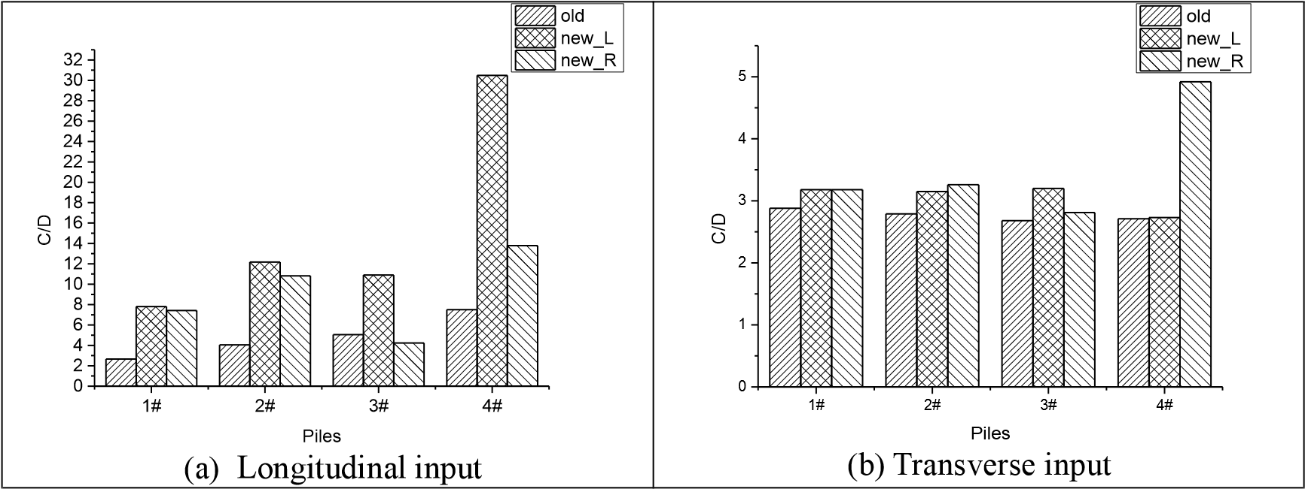

Figure 9. Capacity-demand ratio of piles under earthquake action E1

It can be seen from the above figure that under the earthquake action E1, the piles are all elastic, and almost all C/D values of the new and old piles are larger than 2, which means the piles are much safer than piers checked above.

3.2 Earthquake action E2

Similarly, when acceleration time history waves corresponding to earthquake action E2 are input, the flexural demand of piers and bearing platforms are obtained, and the C/D values of the piers and piles are calculated and shown in the Figure 10 and 11 below.

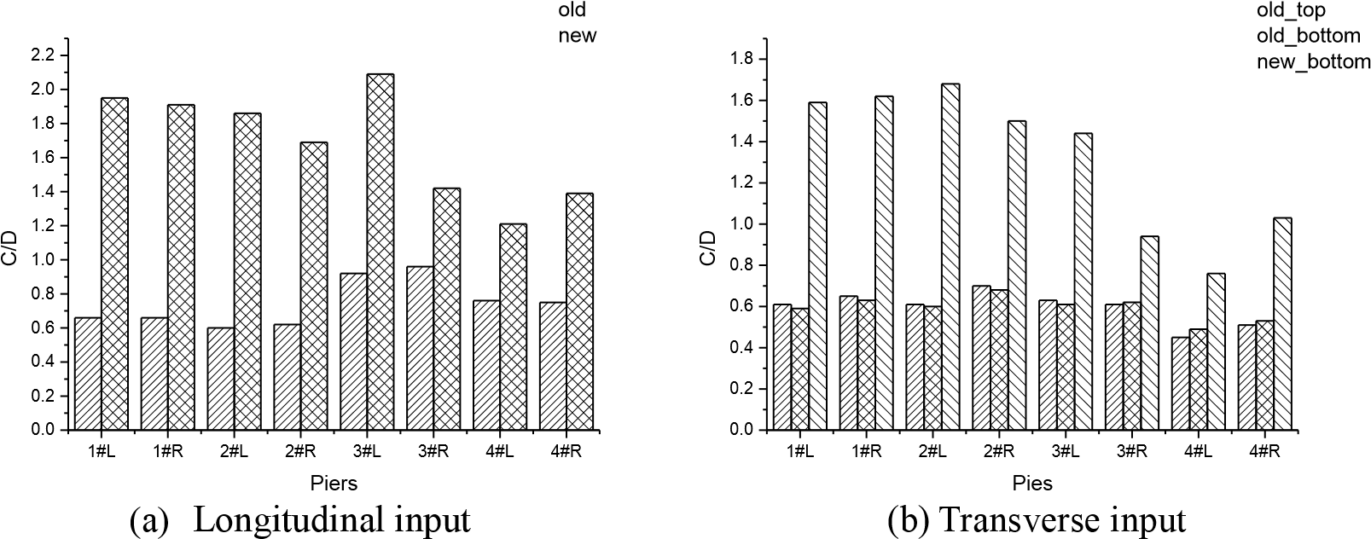

Figure10.Capacity-demand ratio of piers under earthquake action E2

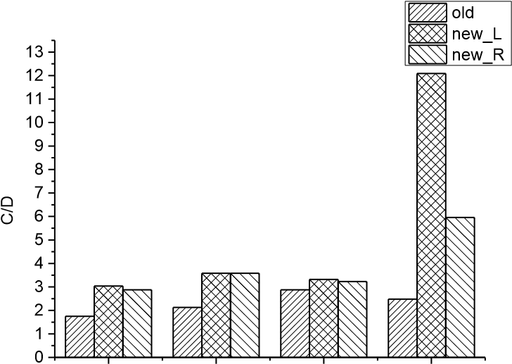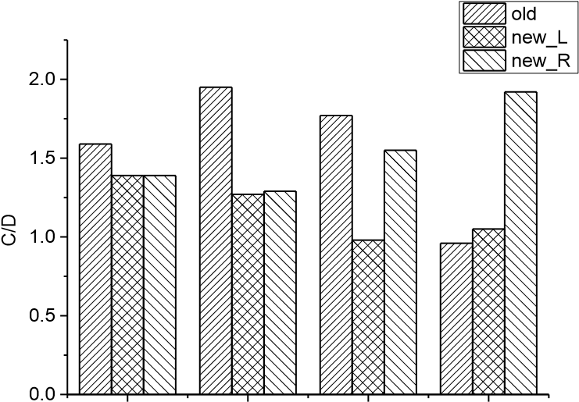
1# 2# 3# 4# 1# 2# 3# 4#
Piles Piles
(a) Longitudinal input (b) Transverse input

Figure 11. Capacity-demand ratio of piles under earthquake action E2

It can be seen from the above figure that the C/D values of all old piers are less than 1.0 no matter the time history waves are input longitudinally or transversely, that is, all old piers cannot meet the specification requirements under the earthquake action E2; while C/D values of most new piers still larger than 1 except two piers located in 3# and 4# with the earthquake waves input transversely. In addition to the individual piles, the piles meet the requirements of the specification both under longitudinal and transverse input earthquake action.
In summary, when the upper and lower approach bridges still use ordinary plate rubber bearings to support the superstructure, after the bridge is widened and reconstructed, the whole structure is elastic state under the earthquake action E1. While the structure (mainly old piers) cannot meet regulatory requirements under the earthquake action E2. Therefore, certain measures must be taken to improve the seismic performance of the structure.
This reconstruction is a widening project, and the original bridge has been in service for over 40 years. Given this, material properties of reinforcement and concrete are all worse than today’s product. Construction quality is worse either, not to mention that related design specifications may have certain problems because of limitations of times. In summary, these factors lead to weak ductility of old piers, which is not suitable for ductile seismic design. Moreover, the approach bridge has more than 20 spans, and the height of the piers varies from 2 to 25 m, resulting in uneven distribution of structural stiffness. To avoid excessive seismic loads on piers with larger stiffness, it is advisable to adopt seismic isolation design. Last but not least, considering the reparability after the earthquake, the approach bridge is more suitable for seismic isolation design.

3.3 Seismic isolation design

It is suggested to use high-performance plate rubber bearings for seismic isolation design. This type of isolation plate rubber bearings takes advantage of the characteristics of high-damping composite rubber which is reinforced by flexible high-strength steel mesh. As a result, the bearing can stably deform more stably to make the superstructure slide more easily, which will increase the superstructure’s lateral displacement and reduce the seismic effect on the structure. In addition, the bearings can effectively restrict the beam from moving too far to prevent the falling beam disaster with post-flexion stiffness. The relevant parameters of the bearings are shown in Table 3 below. The resilience curve of the isolation bearing is shown in Figure 12. After the bearing reaches yield force Q_{y}, the horizontal stiffness of the bearing decreases from K₁ to K₂, which leads to less inertia force transferred from the superstructure to substructure. Also, the isolation bearings can consume more energy input by earthquake to protect the structure.

Table 3. Parameters of the high performance plate rubber bearing

Bearings | Vertical capacity  (kN) | Vertical stiffness  (kN/m) | Yield force  (kN) | Initial stiffness  (kN/m) | Stiffness after yield  (kN/m)
HPR 400×400×102 | 1444 | 896600 | 86 | 3370 | 940

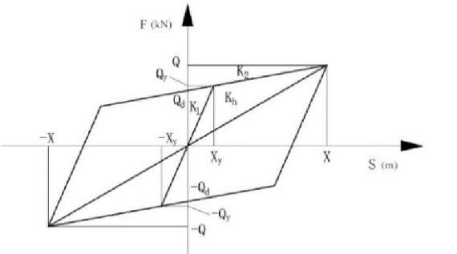

Figure 12. Resilience curve of the high performance plate rubber bearing

After the isolation bearings are used, the nonlinear time history analysis is performed again to obtain the updated seismic response of the structure. Under the earthquake action E2, the C/D values of piers and piles are calculated and shown in the figure below with longitudinal and transverse input.

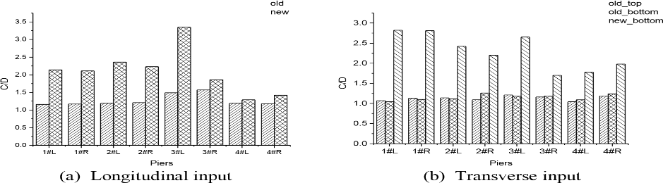

Figure 13. Capacity-demand ratio of piers under earthquake action E2

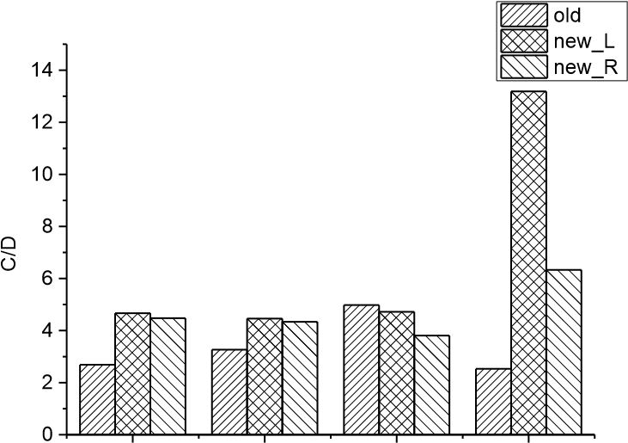
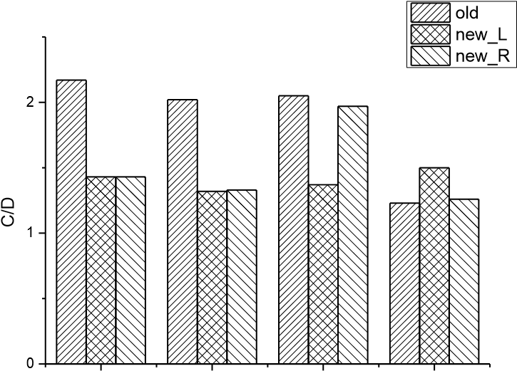
1# 2# 3# 4# 1# 2# 3# 4#
Piles Piles
(a) Longitudinal input (b) Transverse input

Figure 14. Capacity-demand ratio of piles under earthquake action E2

After the high-performance plate rubber bearings are used to connect the superstructure and substructure, the internal force of the structure are greatly reduced under the earthquake action E2, and all sections of piers and piles meet the seismic code from the above figure. However, C/D values of some old piers are barely larger than 1.0, so it is suggested to take some seismic strengthening measures to ensure safety of the old structure.
In the other hand, the decrease of horizontal stiffness will increase the relative displacement between girders and piers inevitably. In order to prevent the beams falling from piers, the deformation of bearings (equal to the relative displacement between beams and piers) is also checked according the relevant codes of bearings. Demand of the bearings after the earthquake action E2 are compared with the allowance, and the results are shown in the following Table 4.

Table 4. Displacement demand of bearings under earthquake action E2

 | Longitudinal input | Transverse input
Bearings | Shear Displacement Allowance  force (kN) (m) (m) | Shear force Displacement  (kN) (m) | Allowance (m)
HPR 400×400×102 | 158 0.098 0.153 | 152 0.094 | 0.153

It can be seen from the above table that the displacement demand of the high-performance plate rubber bearing is up to 0.098m, and the displacement capacity of the bearing is 0.153m. Therefore, the bearing meets the specification requirements, and beams will not fall from the piers.
In summary, under the earthquake action E2, the high-performance plate rubber bearings’ horizontal stiffness decreases after yielding, which prolongs the structural period and reduces the seismic response. Both new and old substructure of the approach bridge meet the seismic performance objectives after isolation design schemes are adopted.

4. CONCLUSIONS

After the approach bridge is widened and rebuilt, several conclusions can be drawn after the research on seismic performance of the widening structure:
Under the earthquake action E1, the substructure of the bridge is checked, mainly including piers and piles, and all members meet regulatory requirements. Among which, the C/D values of old pier are relatively small, the C/D values of new piers are relatively large, which are generally larger tan 2.0, which means no problem for piles when earthquake happens.
Under the earthquake action E2, old piers and some piles do not meet regulatory requirements, with other important factors, isolation design scheme is finally adopted. High-performance plate rubber bearings are used for seismic isolation design. Internal force of old piers and piles are greatly reduced and all meet the requirements of the corresponding code after the bearings yield. There is no risk of falling beams because the deformation of bearings all less than the allowable values either.

5. ACKNOWLEDGMENTS

The design team of Shanghai Municipal Engineering Design and Research Institute on this widening and reconstruction project is greatly appreicaited as well as postgraduate student ZhengWang from Tongji University who helped collecting information for this paper.

6. REFERENCES

He Zai-xing, Wu Ya-juan, Yang Xue-cheng.(2008) The effect of new beams on the old bridge during bridge widening. OURNALOFSHANDONG JIAOTONG UNIVERSITY, 16(4):38-41.
Wang Hao, Zhu Ruo-xi, Zhang Zhao-hong. (2013) Analysis of the Influence of Connection Stiffness on the Lateral Distribution of Widened Bridge. HIGHWAY, (7):143-146.
Zhao Hong-yan. (2014) Research on Design Method of Widening and Strengthening of Old Bridge. Transportation Science & Technology, (1):36-38.
Liu Xiao-yan, Chen Wei, Cao Yu-ci. (2016) Research on reasonable stiffness design of bridge widening and reinforcement structure. JOURNAL OF CHANGSHA UNIVERSITY, 30(2):31-35.
Ma Chun-sheng, Song Shen-you. (2003) New and Old Structure Connection Design of Main Bridge of Huzhou Bridge of Guangfo Expressway. HIGHWAY, (s1):63-66.
Wang Yang, WANG Wei, WU Xiaoguang. (2017) Analysis of allowable settlement difference of widening T-beam bridge . Journal of Railway Science and Engineering, (07):141-148.
Wang Xue-jun. (2006) Analysis of Influence of Foundation Subsidence upon Enlarged Superstructure of Bridges. China Harbour Engineering, (6):11-13.
Qiu Yan-hong. (2011) Using the MIDAS beam lattice model to study the old bridge widening-new and old bridge splicing problem. GUANGDONG ARCHITECTURE CIVIL ENGINEERING, (7):59-62.
Li Maoqi, Zhang Guang-yin. (2015) Study on the influence of concrete creep on the mechanical behavior of bridges in bridge widening. CHINA CONCRETE, (1):84-87.
Xu Xiu-li, Xu Qing-qing, Li Xue-hong. (2014) Study of seismic fortification criteria for expanded highway bridges[J]. Bridge Construction, 44(4):91-95.
Quan Zhi-yu, Wu Xiao-wei,Zhao Gao-jie. (2010) Study on the seismic performance of highway bridge after widening. SHANXI ARCHITECTURE, 36(19):293-294.
Shi Shao-li, Xu Xiu-li, Li Xue-hong. (2015) Earthquake Responses Analysis of the Concrete Continuous Beam Bridge with Expansion and Reconstruction. Earthquake Resistant Engineering and Retrofitting, 37(2):40-45.
Guidelines for Seismic Design of Highway Bridges, JTG/T B02-01-2008, China construction industry press, Beijing, China (in Chinese).

Master Student, Department of Bridge Engineering, Tongji University, Shanghai, China, caosunlin18@tongji.edu.cn
Associate Professor, Department of Bridge Engineering, Tongji University, Shanghai, China, yanxu@tongji.edu.cn
Professor, College of Civil Engineering, Tongji University, Shanghai, China, yujiangtao@tongji.edu.cn
Lab Technician, Department of Bridge Engineering, Tongji University, Shanghai, China, jialeying@tongji.edu.cn

