**Experimental Model for Double Concave Sliding Bearings**

**DOI 10.37153/2686-7974-2019-16-39-48**

Arsen ADZHEMYAN[1], Gianmario BENZONI[2], Giuseppe LOMIENTO[3]

**ABSTRACT**

This study deals with the modeling of sliding friction seismic isolation devices. Recent large-scale experimental tests confirmed the need for accurate models to account for the friction performance in the ranges of loads, velocity and displacement expected during a seismic excitation. An existing experimental model previously validated for single concave isolators is here extended to double concave sliding isolators. Full-scale mono-directional tests on a set of double concave friction bearings in are used to validate and calibrate the model. The friction model includes three independent functions to account for the effects of applied vertical load, velocity, and cycling effects associated to heating. The applicability of the model to the double concave isolators is discussed, in comparison with earlier results of single concave isolators.

*Keywords: Seismic isolation; Concave bearings; Single double pendulum; Friction pendulum; Sliding isolation*

**1. INTRODUCTION**

In recent decades, there has been an increase in the use of base isolators for seismic protection of critical structures throughout the world (Kelly 1994; Warn and Ryan 2012; Buckle 2000). Applications include Stravos Niarchos Foundation Cultural Center in Athens, the Louvre Museum in Abu Dhabi, Los Angeles City Hall, and a number of bridges with Japan and China leading in the number of seismically isolated structures. Succeeding the original model of a two-story frame structure (Zayas et al. 1987), a variety of experimental and numerical studies have been conducted to evaluate the performance of sliding isolators with a single sliding surface, or single concave isolators (Zayas et al. 1990; Chang et al. 1990; Mokha et al. 1991a; Tsopelas et al. 1996; Dolce et al. 2005; Matsagar and Jangid 2008). Later studies primarily focused on analyzing and improving the originally proposed simplified models (Bondonet and Filiatrault 1997; Almazán et al. 1998; Deb and Paul 2000; Almazan and De La Llera 2002; Mosqueda et al. 2004; Chang and Spencer 2010). Studies that analyzed sliders lined with fluoropolymers such as the PTFE also reported dependency of friction on contact pressure and sliding velocity (Constantinou et al. 1990; Chang et al. 1990). Benzoni et at. (2011) presented comparable dependency of friction coefficient on variations of the vertical loads and peak velocity when using single concave isolators with hydrocarbon high-strength polymer sliding surfaces. A model described by Lomiento et al. (2013) based on a large set of experimental data was able to evaluate the influence of several main effects on the coefficient of friction (*µ*). The model includes four main effects:

* “Breakaway effect”, i.e. the sudden increase of *µ* at the beginning of each motion and at each direction reversal;
* “Load effect”, i.e. the reduction of *µ* for increasing contact pressure;
* “Cycling effect”, i.e. the continued reduction of *µ* with the fast repetition of cycles due to the increasing temperature of the sliding interface produced by frictional heating;
* “Velocity effect”, i.e. the gradual increase of *µ* with the increasing sliding velocity.

Sliding isolators with two concave sliding surfaces, or double concave isolators, were later introduced and investigated by several authors (Fenz and Constantinou 2006; Tsai et al. 2008; Morgan and Mahin 2010; Lu, Wang, and Hsu 2006). When compared to single concave isolators, the double concave isolators provide larger displacement capacity for the same in-plane dimensions. The theoretical lateral force-displacement loop of a double concave isolator is equivalent to the one of a single concave sliding system with same coefficient of friction and an effective radius of curvature equal to the sum of the effective radii of the top and bottom sliding surfaces. However, it is important to note that the geometric and kinematic differences between the single and double sliding bearings significantly affect the variability of the coefficient of friction, mostly due to the velocity and cycling effects. As a consequence, a double concave isolator has a difference friction performance with respect to a theoretically equivalent single concave isolator, with the main differences arising from the following:

1) the sliding motion in a double concave isolator occurs simultaneously on two surfaces, so the sliding velocity at the contact interfaces is lower than the one in a single concave bearing (theoretically, for a same level of displacement and velocity of the isolators and assuming the exact same sliding velocity on both sliding surfaces, the sliding velocity of a double concave isolator is half the sliding velocity of its equivalent single concave isolator);

2) the sliding motion at each sliding surface of the double concave isolator generates less heat than the one of a single concave isolator going through the same lateral deformations. This is due to the velocity of the slider being lower and the travel path being shorter in comparison with an equivalent single concave device with same effective mechanical properties;

3) the average temperature rise of the sliding surfaces of a double concave isolator is higher than the temperature rise in a single concave isolator going through the same lateral deformations. This is because the heat is distributed on a smaller sliding surface, which could be as small as half in radius with respect to the single concave isolator in order to have the same displacement capacity.

The model presented in (Lomiento et al. 2013) shows that the coefficient of friction decreases due to the temperature rise of the sliding surfaces. This is accounted for by considering the cumulative heat flux, uniformly distributed over the sliding surface. The uniformly distributed heat flux for two theoretically equivalent single and double concave isolator is schematically shown in Figure 1. If the two isolators undergo the same deformations, the double concave isolator has a different uniformly distributed heat flux due to a different sliding velocity, travel path, and surface area that can cause different degradation rate of the coefficient of friction.

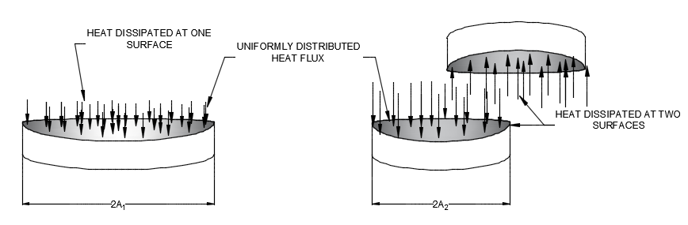

Figure 1. Heat flux comparison between single and double concave sliding systems

**2. OBJECTIVE**

The purpose of this paper is to investigate the validity of a friction model originally proposed for single concave isolators to double concave isolators. Experimental data from large-scale test on double concave isolators are first used to verify the applicability of the model. A unified model capturing the frictional performance of both single and double concave isolators is then proposed, based on the comparison between experimental evidence for such devices. The model can be used to capture the difference in performance of theoretically equivalent devices, by applying appropriate corrective factors to account for the effects of the different kinematics on the coefficient of friction.

**3. DATA PROCESSING AND OBSERVED BEHAVIOR**

Experimental data from past mono-directional tests of a series of single concave isolators was available. Seven double concave isolators utilizing same sliding material as the previously analyzed single bearings were tested with various levels of displacement, isolator velocity and vertical load using the procedures of ASCE 7 (2010). Each double concave isolator test included two prototype isolators, to ensure consistent performance, and 10-12 identical test runs were performed on each prototype. Both single and double concave isolators utilized same sliding material, Table 1 presents a test summary of a single bearing with typical values of lateral displacement, frequency, isolator velocity, vertical load, and the number of cycles. The geometry of the tested devices is summarized in Table 2.

The raw data was provided by the experimental equipment. External sensors recorded the values of time, displacement, velocity, vertical and lateral forces in binary format. The data for each test was then stored on a computer hard drive.

Table 1. Summary of prototype tests

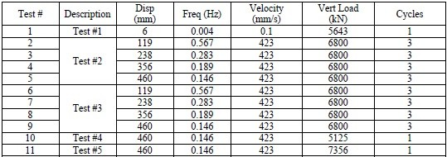

Table 2. Geometry of tested isolators



whereR is an effective radius of curvature of the sliding surface, a is the in-plane radius of the slider, and A is an in-plane radius of the sliding surface.

The users were allowed to determine the data storage location, output frequency, and starting delay. After extracting the raw output data from the setup equipment, the data was corrected to account for the shake table forces during the tests. As a general procedure adopted by the SRMD laboratory, the main objective of the data reduction process is to remove, from measured forces the components that are not directly applied to the test specimen; specifically, the inertial and machine friction forces. This procedure required a theoretical and experimental phase of machine characterization and shakedown, mainly oriented to the assessment of the frictional and inertial characteristics of the system. Recorded forces are corrected based on the idealized horizontal equilibrium equation of the system:

Force readouts = Shear across specimen + Inertial forces + Machine friction + Error (1)

where the Error term considers all the uncertainties related to the readout and correction process.

Sample experimental displacement, velocity, vertical force, and lateral force data are presented in Figures 2(a), 2(b), 2(c), 2(d). It can be seen that for the same levels of longitudinal velocity, displacement and vertical load, the longitudinal force acting on the slider decreases with time, which indicates degradation of frictional properties. In addition, values of lateral (longitudinal) force were plotted against time and displacement (Figure 2(e), 2(f)). The reduction of area inside the force-displacement (hysteresis) loops correlates to the reduction of Energy Dissipated per Cycle (EDC), i.e. the amount of energy the system is able to dissipate per one cycle of motion. After processing the recorded data, it was possible to determine the experimental values of friction coefficient µ and plot them against time (Figures 3a, 3b) and displacement (Figure 3c). The values of friction coefficient were computed by normalizing longitudinal force to vertical loading and subtracting a ratio of longitudinal displacement and the radius of curvature of the sliding surface:

µ = Flat/W – Dlat/R (2)

where Flat is lateral force, W is vertical load, Dlat is lateral displacement, and R is the effective radius of curvature of the isolator. This allowed to visually verify the behavior of the double concave isolators. The coefficient of friction drops by about 50% its original value at the beginning of the test, due to the temperature rise associated to the cycling effect.

**4. experimental model**

The experimental model of the coefficient of friction accounts for the vertical load, velocity, and cycling effects. The model expresses the coefficient of friction *µ* as a product of three independent functions, each one associated with one of the described effects:

µ(P,c,v) = fw(P) · fc(c) · fv(v) (3)

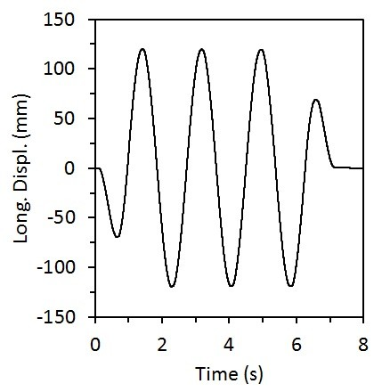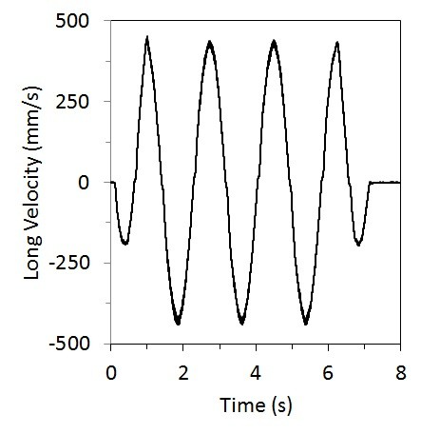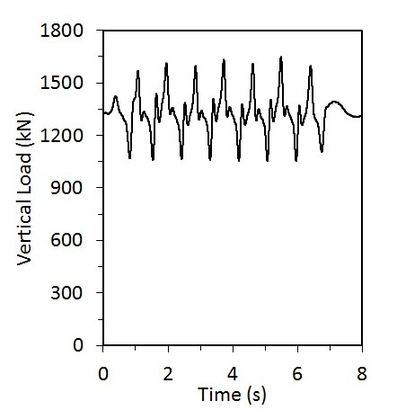

(a) (b) (c)

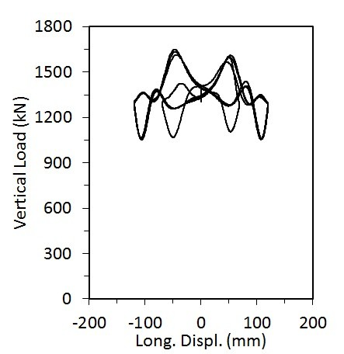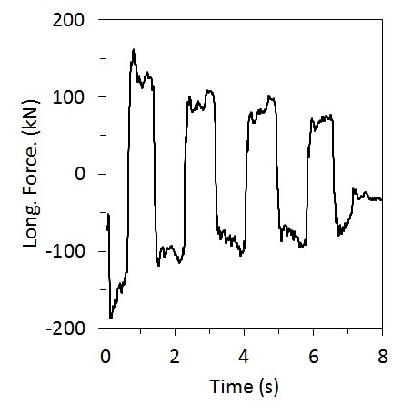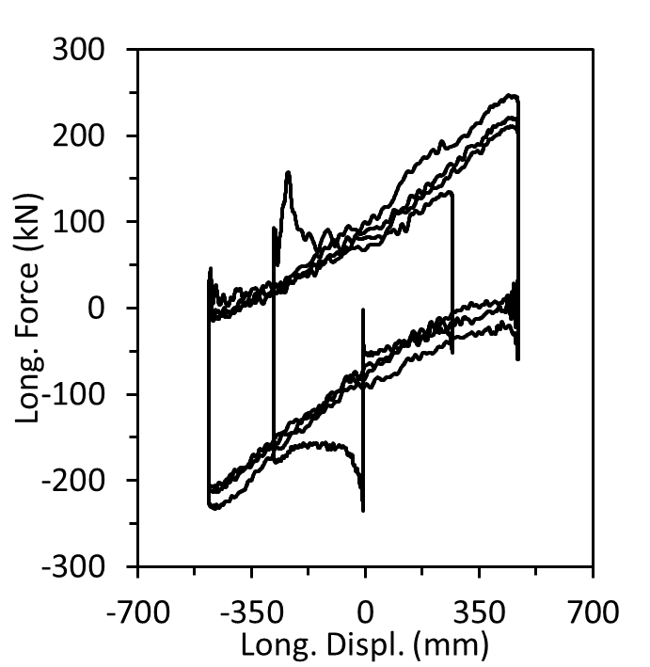

(d) (e) (f)

Figure 2. Typical test data

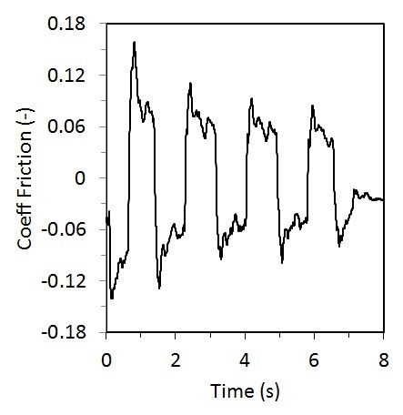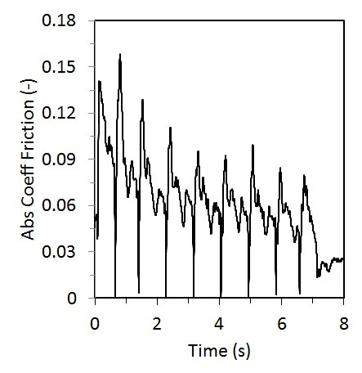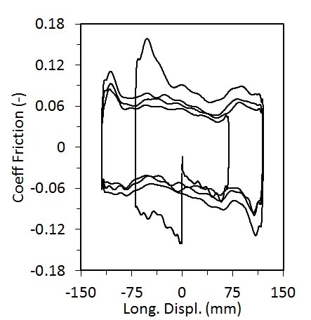

(a) (b) (c)

Figure 3. Typical plots obtained during the analysis

where fwis a function representing load effect,fw represents the cycling effect, and fv captures the velocity effect, respectively. The model was originally calibrated and verified against experimental data on single concave isolators.

This study is based on several assumptions first proposed by Lomiento et al. (2013) during the calibration of a single concave sliding system’s model:

1) The functions of vertical load effect fw(P), velocity effect fv(v), and cycling effect fc(c) were derived for single concave isolators and were never verified for a double concave isolator.

2) All of the aforementioned effects, namely fw(P), fv(v), fc(c) are independent from each other. While the assumption cannot be experimentally verified to be correct at this stage, models based on it have shown agreement with experimental results.

3) The cycling variable assumes that the heat is associated to the velocity of the device, and is distributed on a single surface. This is a simplified approach, as more complex systems, such as double concave isolators, have heat distribution on multiple surfaces.

In the following, the model is applied to double concave isolators, to verify its applicability on such devices based on experimental evidence.

***4.1 Vertical Load Effect***

Experiments have indicated the degradation of frictional properties of an isolator with the increase of the applied vertical load. When the vertical load W is increased, the coefficient of friction µ decreases; however, the friction force

f = µW (4)

increases due to the fact that the increase in W has a greater effect than the decrease in µ. This overall increase in the friction force f corresponds to a greater amount of energy dissipated by the isolator per one cycle of motion (EDC). The increase in EDC can be represented as the increase in the area inside the hysteresis diagram with the increase in vertical load W (Figure 4). To account for the variations in friction coefficient µ, an exponential function characterizing vertical load effect (fw)

(5)

where µs0 represents the theoretical slow-motion coefficient of friction under no vertical load, P is the applied vertical pressure, and Prefis a pressure reference value, was proposed. The exponential format of the load effect function was selected based on the experimental evidence from the single friction isolator (Lomiento et al. 2013). After performing the analysis, the coefficients µs0andPrefwere determined to be 0.06 and 2 MPa, respectively.

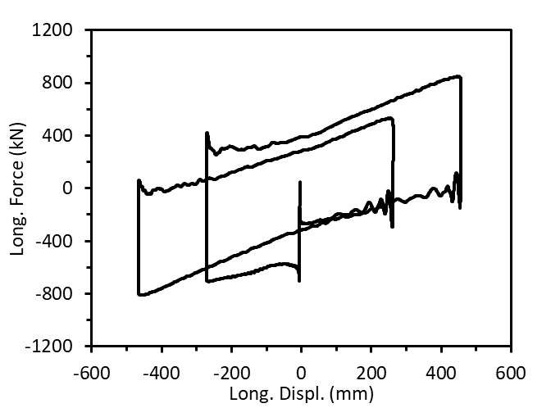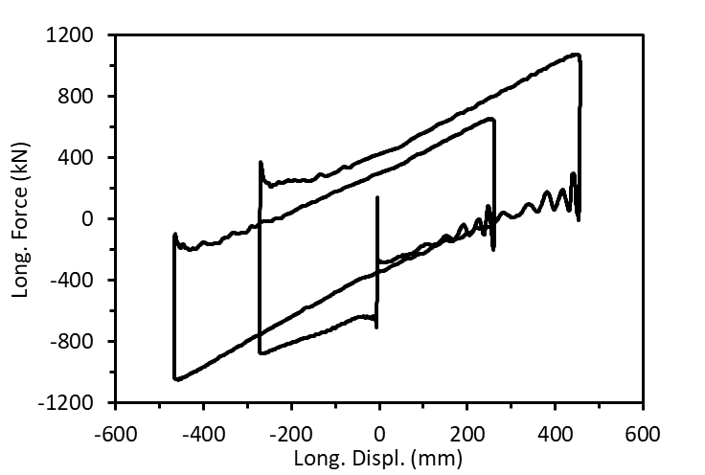

(a) W = 5125 kN (b) W = 7356 kN

Figure 4. Hysteresis plots for bearing 16 isolator under different vertical loads

***4.2 Velocity Effect***

The increase of the friction coefficient *µ* with increasing velocity is well-known and discussed extensively in literature (Constantinou et al. 1990; Mokha et al. 1991; Bondonet and Filiatrault 1997; Dolce et al. 2005). These experimental studies, however, rarely extend to high velocity levels and, more importantly, can be further expanded to include double concave isolators. Lomiento et al. (2013) presented a model that included the relationship between the friction coefficient *µ* and sliding velocity for single concave sliding isolators. Dolce et al. (2005) reported on variations of friction coefficient with sliding velocity for cases with different pressure and ambient temperature. The study indicated that the coefficient of friction increased rapidly with velocity up to a velocity value of 150 mm/s, and then approached a constant value. This behavior was consistent regardless of ambient air temperature and bearing pressure on the slider. Similar dependency was observed during the testing of double concave sliding isolators. The sudden increase of friction coefficient at the regions of zero velocity is due to breakaway effect occurring at each reversal of motion.

In order to describe the relationship between the friction coefficient *µ* and device velocity, a function

$f_{v}\left(v\right)=γ+\left(1-γ\right)e^{-\left|v\right|/v_{ref}}$ (6)

where *v* is the isolator velocity, vrefis a reference velocity that characterizes the variation rate, and γ ≥ 1 is the ratio between the fast-motion and the slow-motion coefficient of friction, was used. This function was previously used to describe the behavior of single sliding isolators and proved a satisfactory agreement with the experimental data (Lomiento et al. 2013). To accurately predict the behavior of the double concave isolators, constant coefficients γ and vref had to be determined. The analysis indicated values of γ and vref to be 1.8 and 25 mm/s, respectively.

***4.3 Cycling Effect***

Degradation of frictional material properties due to heating effects is well-known and has been extensively investigated. Previously proposed models mainly focused on the effects of ambient temperature on the behavior of sliding friction isolators. A study by Mokha et al. (1991) reported a decrease in kinetic coefficient of friction for PTFE-steel devices, but have not further investigated the phenomenon. According to thermodynamic principles, the degradation of frictional characteristics occurs due to reduction in hardness of the thin surface layer due to frictional heating (Lomiento et al. 2013). Chang et al. (1990) proposed a model for PTFE sliding isolators that included temperature variations at the sliding interface. Lomiento et al. (2013) explained the mechanism and distribution of heat over the sliding surface and developed a model for a single FPS. The cycling effect function was based on a single concave isolator and was presented in the following format:

$f_{c}\left(c\right)=e^{{-\left(c/c_{ref}\right)}^{β}}$ (7)

where

$c\left(t\right)=\frac{2}{aπ^{2}A^{2}}\int_{t_{0}}^{t}{Wv^{2}dt}$ (8)

cref represents the degradation rate of the friction coefficient with the cycling variable (smaller cref means faster degradation), the exponent β controls the shape of the function, a is the radius of the slider projection over the horizontal plane, A - radius of the projection of the sliding surface over the horizontal plane, W - vertical load, v - instant sliding velocity, and t0 and t represent the beginning and end of the time interval under consideration. The function c(t) represents the temperature effects over the sliding surface and implies the hypothesis of uniform distribution of the heat flux on the sliding surfaces (Lomiento et al. 2013). This assumption disregards the existence of higher heat fluxes in the areas interested by more frequent sliding activity.

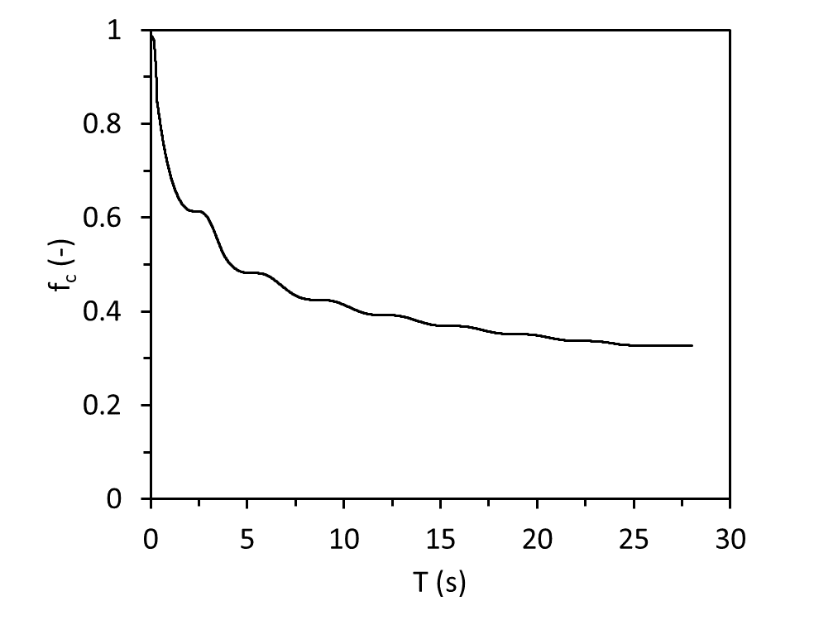 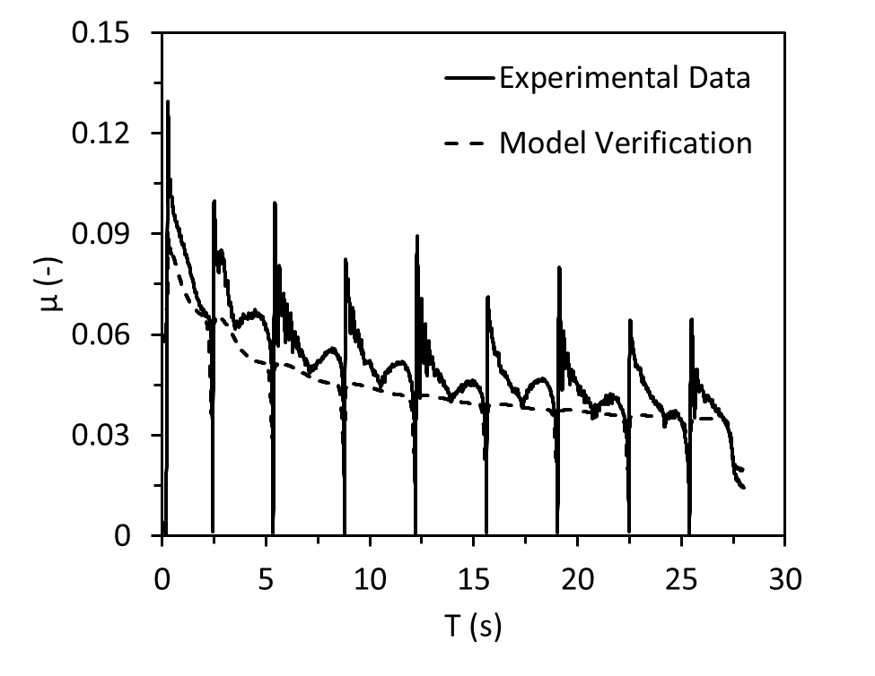

(a) Degradation of *fc* during a single test run (b) Regression analysis to capture deterioration

of frictional properties

Figure 5. Bearing 16 run 9 test plots

To obtain constant coefficients cref and β presented in the Equation 7 a regression analysis was performed. Figure 5 represents decrease in fc during the duration of a single test run to a value less than 35% of the initial. To calibrate the cycling effect the data for all bearings were combined into one model and parameters of cref and β were modified to obtain the lowest norm of error value as well as a satisfactory agreement between the experimental data and the proposed model. The obtained results indicated the coefficient of degradation rate cref being a value significantly lower than expected in comparison to the results obtained from single concave sliding system tests discussed in Lomiento et al. (2013) (1.9 kN/mms for single bearings and 8 kN/mms for double). The β parameter was set to be 0.21 comparing to 0.5 value used for a single isolator system.

**5. RESULTS AND DISCUSSION**

The obtained results indicate that the proposed model is capable of capturing the behavior of the double concave sliding isolators influenced by vertical load, velocity and cycling effects for mono-directional tests. The sudden increase of friction at each reversal of the direction of motion (i.e. breakaway effect) is well-depicted on Figures 2(f), 3(b), 4, and 5(b). Capturing this phenomenon remained outside of the scope of this study due to bidirectional nature of seismic excitations and the absence of motion reversals.

The significance of this study is the ability of the model to closely simulate the experimental force-displacement plots (Figure 6(a)) - an important parameter in determining energy dissipation characteristics of a system under cyclic loading. The proposed model results in *R*2 values of approximately 0.7 when validated on double concave isolators. The accuracy is improved when only large displacement tests are considered.

Comparison of the behavior of single and double concave isolators indicated that influence of vertical load effect is similar between the two systems, and constant coefficients µs,0, Pref, γ for a single sliding concave isolator model presented by Lomiento et al. (2013) are comparable to those discovered by this study (Table 3). However, a significant difference was noted during the comparison of velocity and cycling effects between two systems. Both coefficients cref and β, responsible for the rate of degradation of frictional properties of the material and the shape of the function’s curve respectively, are different between the single and double concave systems. For instance, typical value of cref for a single concave isolator is 2-7 kN/mms, while values for a double concave isolator range between 5 and 20 kN/mms. A possible explanation is the different heat distribution in the double concave friction isolator with respect to the one in a single concave isolator (Figure 1). Lower cref in single concave isolator corresponds to a faster degradation rate of frictional properties. This can be caused by the distribution of heat over the two sliding surfaces, top and bottom, instead of just one surface, resulting in a lower temperature rise and slower degradation of the frictional property at the sliding surfaces. The presence of the slider between the two surfaces also affects the heat distribution as some heat can be dissipated through the slider itself.

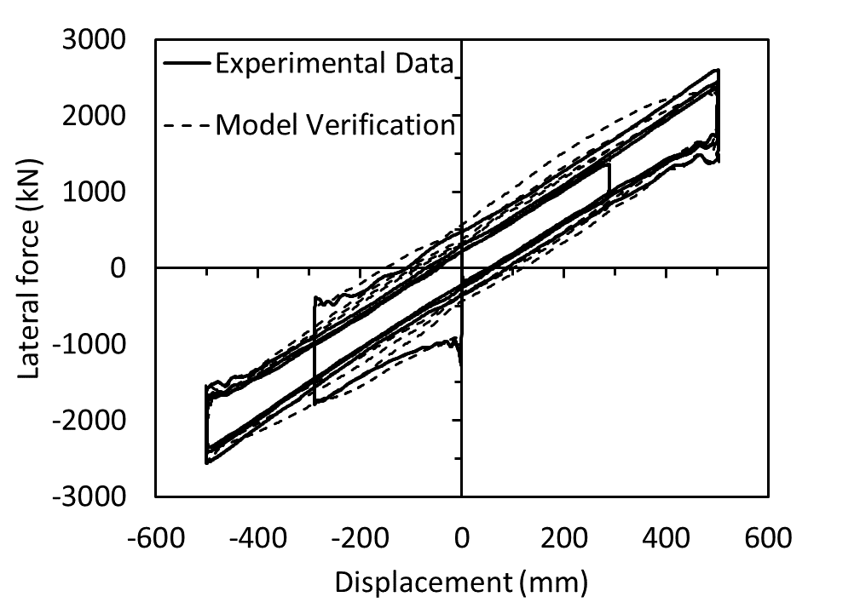 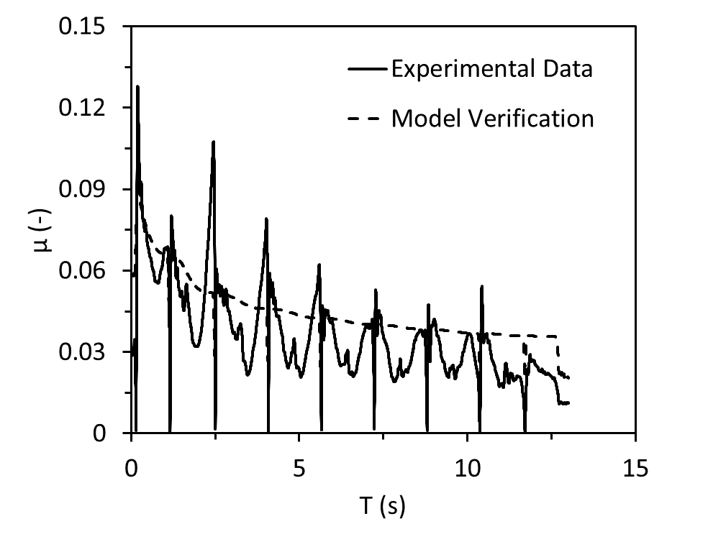

(a) Force-displacement loop (b) Degradation of friction coefficient

Figure 6. Model verification plots

Another behavioral aspect that is unique to double concave isolators and was not present in a single concave isolator is a drop in the magnitude of the friction coefficient *µ* when the slider passes over the center of the sliding surface. This phenomenon is a result of the isolator’s design: to account for rotation of the slider during the motion, and to keep the top and bottom surfaces of the device parallel, the slider has an adjustment mechanism - a sliding joint that allows a certain degree of rotation of the top slider’s surface relatively to its bottom surface.

The combined model presented in this paper includes all three frictional, making it difficult to estimate the contribution of each single effect separately. An ultimate test for the model is whether it can estimate the response of an isolator that was not included in the original calibration. Figures 6(a) and 6(b) presents model verification plots of the large-displacement tests for such case.

Furthermore, the difference between large (>350mm) and small (<350mm) displacement tests for double concave isolators was investigated. Comparison to a combined model revealed that constant values for a combined model fall between the values for large- and small-displacement tests as expected. The values of µs,0, Pref, and γ remained constant for both levels of displacement, while Vref, cref, and β for the combined model fell between the results of the large- and small-displacement tests (Table 3).

Table 3. Comparison of results for large- and small-displacement tests



**6. Conclusions**

An experimental model addressing the degradation of frictional properties in single concave isolators developed by Lomiento et al. (2013) was extended to double concave isolators. According to the model, the friction coefficient µ is represented as the product of three functions representing the vertical load effect fW, velocity effect fv, and cycling effect fc addressing the dependency of the friction coefficient on the applied vertical load, sliding velocity and temperature rise due to the repetition of cycles, respectively. Due to the different kinematics of single and double concave sliding bearings, adjustments to the model had to be done in order to account for different sliding conditions on the surfaces and heating effects.

Full-scale mono-directional tests were performed on seven double sliding bearings in accordance with ASCE 7 (2010) testing protocols in order to detect variations on the coefficient of friction. Breakaway was observed during the tests, however, remained outside of the scope of this study. Experimental results evidenced a degradation of frictional properties up to 50% of the original value during a single test. The degradation is less than the one observed on single concave isolators with similar sliding materials. This can be attributed to (i) a different heat distribution, since the heat flux in double devices affects two sliding surfaces rather than only one, and (ii) a difference in sliding velocity and travel path of the slider, as this is inversely proportional to the number of contact surfaces, given the deformation of the isolator. Experimental data also revealed a drop in the coefficient friction when the slider of the double concave isolator passes through the resting position. This drop is generally not observed in single concave isolators.

Each of the three independent functions of the model, namely vertical load effect, velocity effect, and cycling effect was calibrated using the test data. Modifications to the original model include: (i) modification of meaning of velocity (i.e. focusing on sliding velocity of the slider instead of device velocity), and (ii) considering different heat distribution between the single and double bearings. Comparison between large and small displacement tests for double concave isolators revealed that the values responsible for the degradation of frictional properties due to increase in vertical pressure, namely the theoretical slow-motion coefficient of friction µs,0 and the reference pressure Pref, are unaffected by the displacement level. Lower cref value represents faster degradation of friction for the small displacement tests, as the slider stays closer to the center of the sliding surface preventing heat dissipation. the ratio between the fast-motion and the slow-motion coefficient of friction, γ, also was unaffected by variations in displacement and remained at 1.8. The value of the reference velocity Vref is significantly lower for small displacement tests (10 vs 28 mm/s) indicating the greater decrease in friction for displacements under 350 mm.

**7. References**

Almazan, Jose L., and Juan C. De La Llera. 2002. “Analytical Model of Structures with Frictional Pendulum Isolators.” *Earthquake Engineering and Structural Dynamics* 31 (2): 305–32.

Almazán, José L., Juan C. De La Llera, and José A. Inaudi. 1998. “Modelling Aspects of Structures Isolated with the Frictional Pendulum System.” *Earthquake Engineering and Structural Dynamics* 27 (8): 845–67.

ASCE. 2010. *Minimum Design Loads for Buildings and Other Structures*. *ASCE/SEI 7-10*.

Becker, Tracy C., and Stephen A. Mahin. 2012. “Experimental and Analytical Study of the Bi-Directional Behavior of the Triple Friction Pendulum Isolator.” *Earthquake Engineering and Structural Dynamics* 41 (3): 355–73.

Benzoni, Gianmario, Giuseppe Lomiento, and Noemi Bonessio. 2011. “Testing Protocols for Seismic Isolation Systems.” In *Italian National Association of Earthquake Engineering*.

Bondonet, Gaël, and André Filiatrault. 1997. “Frictional Response of PTFE Sliding Bearings at High Frequencies.” *Journal of Bridge Engineering* 2 (4): 139–48.

Buckle, Ian G. 2000. “Passive Control of Structures for Seismic Loads.” In *Bulletin of the New Zealand Society for Earthquake Engineering*, 33:209–21.

Chang, Chia Ming, and Billie F. Spencer. 2010. “Active Base Isolation of Buildings Subjected to Seismic Excitations.” *Earthquake Engineering and Structural Dynamics* 39 (13): 1493–1512.

Chang, K C, J S Hwang, and G C Lee. 1990. “Analytical Model for Sliding Behavior of Teflon-Stainless Steel Interfaces.” *Journal of Engineering Mechanics* 116 (12): 2749–63.

Constantinou, Michalakis, Anoop Mokha, Andrei Reinhorn, Michalakis Constantinou, and Andrei Reinhorn. 1990. “Teflon Bearings in Base Isolation II: Modeling.” *Journal of Structural Engineering* 116 (2): 455–74.

Deb, Sajal K, and Dilip K Paul. 2000. “Seismic Response of Buildings Isolated by Sliding-Elastomer Bearing Subjected to Bi-Directional Motion.” In *12th World Conference on Earthquake Engineering*.

Dolce, M., D. Cardone, and F. Croatto. 2005. “Frictional Behavior of Steel-PTFE Interfaces for Seismic Isolation.” *Bulletin of Earthquake Engineering* 3 (1): 75–99.

Fenz, Daniel M., and Michael C. Constantinou. 2006. “Behaviour of the Double Concave Friction Pendulum Bearing.” *Earthquake Engineering and Structural Dynamics* 35 (11): 1403–24.

Kelly, James M. 1994. “Implementation of Base Isolation in the United States.” In *Earthquake Engineering, 10th World Conference*, 6507–17.

Lomiento, Noemi Bonessio, and Gianmario Benzoni. 2013. “Friction Model for Sliding Bearings under Seismic Excitation.” *Journal of Earthquake Engineering* 17 (8): 1162–91.

Lomiento, G, N Bonessio, and G Benzoni. 2012. “Effects of Loading Characteristics on the Performance of Sliding Isolation Devices.” In .

Lu, Lyan-ywan, Jain Wang, and Chao-chun Hsu. 2006. “Sliding Isolation Using Variable Frequency Bearings for Near - Fault Ground Motions,” no. 164: 1–10.

Matsagar, Vasant A, and R S Jangid. 2008. “Base Isolation for Seismic Retrofitting of Structures.” *Practice Periodical on Structural Design and Construction* 13 (4): 175–85.

Mokha, Anoop, M. C. Constantinou, A. M. Reinhorn, and Victor A. Zayas. 1991a. “Experimental Study of Friction-Pendulum Isolation System.” *Journal of Structural Engineering*.

Morgan, Troy A., and Stephen A. Mahin. 2010. “Achieving Reliable Seismic Performance Enhancement Using Multi-Stage Friction Pendulum Isolators.” *Earthquake Engineering and Structural Dynamics* 39 (13): 1443–61.

Mosqueda, Gilberto, Andrew S. Whittaker, and Gregory L. Fenves. 2004. “Characterization and Modeling of Friction Pendulum Bearings Subjected to Multiple Components of Excitation.” *Journal of Structural Engineering* 130 (3): 433–42.

Tsai, C. S., Po Ching Lu, Wen Shin Chen, Tsu Cheng Chiang, Chen Tsung Yang, and Yung Chang Lin. 2008. “Finite Element Formulation and Shaking Table Tests of Direction-Optimized-Friction-Pendulum System.” *Engineering Structures* 30 (9): 2321–29.

Tsopelas, P., M. C. Constantinou, S. Okamoto, S. Fujii, and D. Ozaki. 1996. “Experimental Study of Bridge Seismic Sliding Isolation Systems.” *Engineering Structures* 18 (4): 301–10.

Warn, Gordon P., and Keri L. Ryan. 2012. “A Review of Seismic Isolation for Buildings: Historical Development and Research Needs.” *Buildings* 2 (4): 300–325. https://doi.org/10.3390/buildings2030300.

Zayas, Victor A., Stanley A. Low, and Stephen A. Mahin. 1987. “The FPS Earthquake Resisting System Experimental Report.” *Technical Report UCB/EERC-87/01*. Berkeley, Calif. : Earthquake Engineering Research Center ;

Zayas, Victor A., Stanley S. Low, and Stephen A. Mahin. 1990. “A Simple Pendulum Technique for Achieving Seismic Isolation.” *Earthquake Spectra* 6 (2): 317–33.

1. Project engineer, Gannett Fleming, 601 S. Figueroa, #3800, Los Angeles, CA, USA 90017, aadzhemyan@gfnet.com
2. Research Scientist, Structural Engineering, University of California, San Diego, USA, [benzoni@ucsd.edu](mailto:benzoni@ucsd.edu)
3. Asst. Professor, Civil Engineering, California State Polytechnic University, Pomona, USA, [glomiento@cpp.edu](mailto:glomiento@cpp.edu)