OPTIMUM PROPERTIES OF SEISMIC ISOLATION SYSTEMS

IN HIGHWAY BRIDGES TO MINIMIZE ISOLATOR DISPLACEMENTS OR SUBSTRUCTURE FORCES

DOI 10.37153/2686-7974-2019-16-218-227

Murat DİCLELİ, Memduh KARALAR

ABSTRACT

In this study, closed form equations as functions of the isolator, bridge and ground motion properties are formulated to calculate the optimum characteristic strength, Qd and post-elastic stiffness, kd, of the isolator to minimize the maximum isolator displacement (MID) and force (MIF) for seismic isolated bridges (SIBs). For this purpose, first, sensitivity analyses are conducted to identify the bridge, isolator and ground motion parameters that affect the optimum values of Qd and kd. Next, for the identified parameters, nonlinear time history analyses of typical SIBs are conducted to determine the optimum values of Qd and kd for a wide range of values of the parameters. Next, nonlinear regression analyses of the available data are conducted to obtain closed form equations for the optimum values of Qd and kd to minimize the MID and MIF. The equations are then simplified for various site soil conditions. It is observed that the optimum Qd and kd are highly dependent on the site soil condition. However, the effect of the bridge substructure stiffness on the optimum Qd and kd and the effect of the structural or supplemental damping on the optimum kd are found to be negligible. Furthermore, the optimum Qd is found to be a linear function of the peak ground acceleration.

Keywords: seismic isolation, bridge, optimization, site soil

1. INTRODUCTION

The force-displacement hysteresis of most commercially available isolators is generally idealized as bilinear for design purposes. A typical bilinear force-displacement hysteresis of an isolator and a typical isolated bridge substructure are shown in Figs. 1(a) and (b). In the figures, Q_{d} is the characteristic strength, k_{u} is the elastic stiffness, k_{d} is the post-elastic stiffness, F_{y} and u_{y} are respectively the yield force and displacement and F_{i} and u_{i} are respectively the maximum (or design) force and displacement of the isolator. The characteristic strength, Q_{d} and the post-elastic stiffness, k_{d}, are the main isolator parameters that affect the behavior of a SIB for a given ground motion with specific frequency characteristics and intensity (Dicleli & Buddaram 2006). Thus, the optimal selection of these isolator parameters based on minimizing the MID and MIF will result in an economical design of the SIB. Several research studies have been conducted to identify the optimal characteristic properties of isolators or yielding systems for the seismic design of structures (Veletsos et al. 1965, Park & Otsuka 1999, Iemura et al. 2007). However, none of these research studies provide simple yet effective equations to calculate the optimal isolator properties. Therefore, it is clear that closed form equations as functions of the properties of the bridge, isolator and frequency characteristics and intensity of actual ground motions are still needed to obtain the optimum values of the isolator characteristic parameters, Q_{d} and k_{d} based on minimizing the MID and MIF. Such equations may be used by the bridge engineering community to select proper values of Q_{d} and k_{d} for the economical seismic design of SIBs.

U

F
i

U
i

Q
d

k
d

1

k
u

F
y

U
y

F

Superstructure

Isolator

Substructure

(a) (b)

Figure 1. (a) Idealized hysteresis loop of a typical isolator, (b) Typical seismic-isolated bridge substructure.

2. RESEARCH OBJECTIVE AND METHODOLOGY

The main objective of this research study is to formulate closed form equations as functions of the isolator, bridge and ground motion properties to calculate the optimum characteristic strength, Q_{d} and post-elastic stiffness, k_{d}, of the isolator to minimize the MID and MIF. Using the developed equations it will be possible to select the proper isolator properties that will result in an economical SIB design. To achieve the above stated objective, first, sensitivity analyses are conducted to investigate the effects of several bridge, isolator and ground motion parameters on the optimum values of Q_{d} and k_{d}. From these sensitivity analyses, the parameters that affect the optimum values of Q_{d} and k_{d} are identified. Next, for each one of the identified parameters, nonlinear time history (NLTH) analyses of simplified structural models representative of typical SIBs are conducted to determine the optimum values of Q_{d} and k_{d} for an assumed range of values of the parameter under consideration. Furthermore, for each assigned value of the parameter under consideration, the NLTH analyses are repeated until the optimum values of Q_{d} and k_{d} are correctly identified. Next, the available data is plotted as a function of some dimensionless parameters proposed by Makris& Black (2004a, 2004b). Nonlinear regression analyses of the plotted data are then conducted to obtain closed form equations for the optimum values of Q_{d} and k_{d}, to minimize the MID and MIF. The obtained closed form equations are then verified using a suite of ground motions different than that used for the development of the same equations.

3. GROUND MOTIONS AND PARAMETERS CONSIDERED

Two sets of ground motions are used. The first set involves a suite of 15 earthquakes with A_{p}/V_{p} ratios ranging between 5.50 s⁻¹ and 21.5 s⁻¹ presented in Table 1 (No.: 1-15). These ground motions are used for the formulation of the optimum values of Q_{d} and k_{d}. The second set involves a suite of five earth-quakes with A_{p}/V_{p} ratios ranging between 4.70 s⁻¹ and 23.6 s⁻¹ presented also in Table 1 (No.: 16-20). These ground motions are used for the verification of the equations developed to calculate the optimum values of Q_{d} and k_{d}.
Several parameters are considered for the sensitivity analyses to study the effect of the bridge, isolator and ground motion properties on the optimum values of Q_{d} and k_{d}. The parameters that affect the optimum values of Q_{d} and k_{d} are then used in the optimization procedure. The parameters that are used in the sensitivity analyses are categorized into three groups as those representing the bridge, isolator and ground motion properties. The bridge properties are represented by the superstructure mass, m, substructure stiffness, k_{s} and structural or supple-mental damping, ζ. The superstructure mass tributary to a typical isolator is taken as a constant equal to 204 tons (2000 kN weight). The substructure stiffness is varied between 200 kN/cm (very flexible) and 6400 kN/cm (very stiff). This stiffness range corresponds to 10 to 320 times the 20 kN/cm post elastic stiffness of the isolator used in the analyses while studying the effect of the substructure stiffness on the optimum values of Q_{d} and k_{d}. The structural and/or supplemental damping is varied between 0% and 8% of critical. The isolator properties are represented by the characteristic strength, Q_{d} and post-elastic stiffness, k_{d}. The isolator’s elastic stiffness is not considered as a parameter in this study since its effect on the performance of SIBs has been found to be negligible earlier by Dicleli and Buddaram (2006).

Table 1. Important features of the earthquake records used in the analyses.

No | Earthquake | Station/Component | Ap/Vp
1 | San Fernando, 1971 | 8244 Orion Blvd. / 180º | 5.5
2 | Imperial Valley, 1940 | El Centro / 180º | 5.8
3 | Loma Prieta, 1989 | Oakland Outer Wharf / 0º | 6.1
4 | Loma Prieta, 1989 | Oakland Outer Wharf / 270º | 7.2
5 | Northridge, 1994 | Arleta and Nordhoff Fire Station / 90º | 8.4
6 | Kern County, 1952 | Taft Lincoln Tunnel / 69º | 9.7
7 | Imperial Valley, 1940 | El Centro / 270º | 10.6
8 | Santa Barbara, 1978 | 283 Santa Barbara Courthouse / 222º | 12.2
9 | Coalinga, 1983 | 36227 Parkfield - Cholame 5W / 270º | 13.4
10 | Northridge, 1994 | Santa Monica City Hall Grounds / 0º | 14.6
11 | Whitter Narrows, 1987 | 24401 San Marino, SW Academy / 360º | 15.6
12 | Whitter Narrows, 1987 | 90079 Downey Birchdale / 90º | 17.4
13 | San Fernando, 1971 | Pacoima Dam. / 196º | 18.4
14 | Northridge, 1994 | Santa Monica City Hall Grounds / 90º | 20.7
15 | Parkfield, 1966 | Cholame, Shandon / 40º | 21.5
16 | Borrego Mount., 1968 | Hollywood Storage Lot / 180º | 4.7
17 | Kobe, 1995 | FUK / 0º | 7.7
18 | Friuli, Italy, 1976 | Conegliano / 0º | 13.6
19 | NW California, 1941 | Ferndale City Hall / 45º | 16.7
20 | Morgan Hill, 1984 | San Francisco Int. Airport, / 90º | 23.6

4. DIMENSIONLESS PARAMETERS USED IN THE DEVELOPMENT OF THE EQUATIONS

Using formal dimensional analysis, Makris & Black (2004a, 2004b) proposed four dimensionless terms to describe the response of a structural system with bilinear force-deformation relationship in relation to the characteristics of a pulse type excitation with a period, Tp. Two of the proposed terms; Π₂=Q_{d}/mA_{p}, and Π₄= T_{d}/T_{p}, are used in this study to represent the analyses results where T_{d} is the period of the bridge based on the post-elastic stiffness, k_{d}, of the isolator and all the other variables are as described before. Since seismic ground motions with various frequency characteristics are considered in the presented study, the term, T_{p}, is replaced by the dominant period of the ground motion given as T_{g}= 2π/(A_{p}/V_{p}) (Kramer 1996). The term, Π₂=Q_{d}/mA_{p} represents the ratio of the characteristic strength of the isolator to the seismic inertial force of a rigid bridge superstructure. Using this term eliminates the number of independent variables used in the analyses.

5. OPTIMIZATION PROCEDURE

The calculation of the optimum values of Q_{d} and k_{d} to minimize the MIF and MID consists of three sets of analyses. The first two sets of analyses are performed to obtain the optimum values of Q_{d} to minimize the MIF and MID respectively. The third set of analyses is performed to obtain the optimum values of k_{d} to minimize the MID.
To calculate the optimum values of Q_{d} to minimize the MIF for the range of parameters and ground motions considered in this study, first, the MIF is determined for a wide range of presumed Q_{d} values. Next, the bisection search method (Chapra & Canale 2002) is used between the data points before and after the apparent minimum value of MIF within the MIF-Q_{d} plot, to determine the actual minimum MIF and the corresponding optimal value of Q_{d}. This required repeating the NLTH analyses of the simplified bridge model until convergency is reached for the optimum values of Q_{d}. This procedure is repeated for the range of parameters and ground motions considered in this study to obtain a wide range of data giving the optimal Q_{d} values. Similar procedures are also used to obtain the optimum values of Q_{d} and k_{d} corresponding to minimum MID.

6. EFFECT OF VARIOUS PARAMETERS ON OPTIMUM Q_{D}

In this section, sensitivity analyses are conducted to identify the parameters that affect the optimum value of Q_{d}, based on minimizing the MIF and MID. For this purpose, iterative NLTH analyses of simplified structural models of SIBs are conducted. In the analyses, a single bridge substructure and an isolator supporting a tributary bridge superstructure is considered as shown in Figure 1(b). The superstructure is assumed to have infinite in-plane rigidity as normally done in the design of most SIBs. The bridge, isolator and ground motion parameters used in the analyses are; m=204 ton (W=2000 kN), ζ=0, k_{u}=200 kN/cm, k_{d}=20 kN/cm, k_{s}/k_{d}=160, A_{p}=0.6g and A_{p}/V_{p}=5.8, 12.2 and 21.5 s⁻¹ (i.e. the analyses are repeated for three ground motions). In the sensitivity analyses, while the parameter under consideration is varied, the rest of the parameters are assigned the values reported above. The sensitivity analyses results for each parameter are given below.

6.1 Effect of Peak Ground Acceleration

In this section, the effect of the peak ground acceleration, A_{p} on the optimum value of Q_{d} is investigated by varying the peak ground acceleration between 0.1g and 1.0g while keeping the other parameters constant. The sensitivity analyses results are presented in Figs. 2(a) and (b) for three ground motions with A_{p}/V_{p} =5.8, 12.2 and 21.5 s⁻¹ in the form of optimum Q_{d} versus A_{p} plots based on minimizing the MIF and MID respectively. As observed from the figures, the optimum value of Q_{d} is linearly proportional to A_{p}. Knowing this, the optimum value of Q_{d} is normalized with respect to mA_{p} as suggested by Makris & Black (2004a) and re-plotted in Figs. 2(c) and (d). As observed from the figures, the Q_{d}/mA_{p} ratio is independent of the peak ground acceleration, A_{p}. Thus, for the remainder of the study, the peak ground acceleration is not considered as an independent parameter in the development of the closed form equations to calculate the optimum values of Q_{d} based on minimizing MIF and MID. Instead the Q_{d}/mA_{p} ratio is used in the optimization procedure. The dimensionless term, Q_{d}/mA_{p}, is also used in the presentation of the analyses results for the remainder of the study.

6.2 Effect of A_{p}/V_{p} Ratio of Ground Motion Effect

T in this section, the effect of the A_{p}/V_{p} ratio of the ground motion on the optimum value of Q_{d} is investigated. The sensitivity analyses results presented in Figs. 2(a), (b), (c) and (d) reveal that, the optimum value of Q_{d}/mA_{p} ratio or Q_{d} is highly dependent on the A_{p}/V_{p} ratio of the ground motion. That is, for each A_{p}/V_{p} ratio, a different relationship between Q_{d} and A_{p} is obtained. In general, the sensitivity analyses results revealed that the optimum value of Q_{d} increases as the A_{p}/V_{p} ratio of the ground motion decreases (Figs. 2(a) and (b)). Thus, the A_{p}/V_{p} ratio of the ground motion must be included as a parameter in the development of closed form equations to calculate the optimum values of Q_{d} based on minimizing the MIF and MID.

6.3 Effect of Post-Elastic Stiffness of the Isolator

In this section, the effect of the post-elastic stiffness, k_{d}, of the isolator on the optimum value of Q_{d} is investigated. For this purpose, NLTH analyses of simplified structural models of SIBs with isolators having kd ranging between 1.25 and 40 kN/cm are conducted for three ground motions with A_{p}/V_{p}= 5.8, 12.2 and 21.5 s⁻¹ scaled to A_{p} = 0.6g to determine the optimum values of Q_{d} based on minimizing the MIF and MID. The analyses results are presented in Figs. 3(a) and (b). As observed from the figures, the optimum Q_{d}/mA_{p} ratio varies as a function of k_{d}. Thus, k_{d} must be included as a parameter in the development of closed form equations to calculate the optimum values of Q_{d} based on minimizing the MIF and MID.

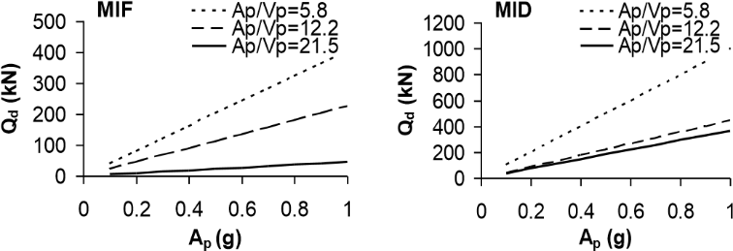
(a) (b)
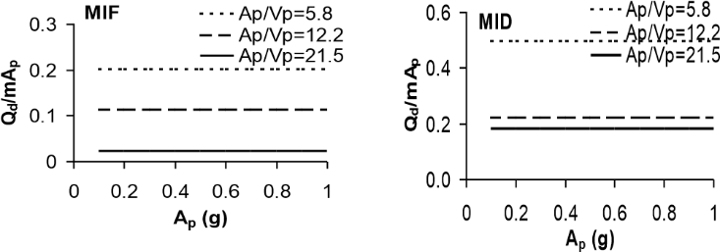
(c) (d)

Figure 2. Effect of various parameters on optimum Q_{d} (a) A_{p} for MIF (b) A_{p} for MID, (c) A_{p} for MIF using Q_{d}/mA_{p} ratio, (d) A_{p} for MID using Q_{d}/mA_{p} ratio.

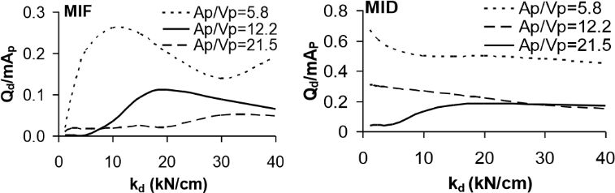
(a) (b)

Figure 3. Effect of various parameters on optimum Q_{d} (a) k_{d} for MIF, (b) k_{d} for MID.

6.4 Effect of Structural/Supplemental Damping

In this section, the effect of structural/supplemental damping on the optimum value of Q_{d} is investigated. For this purpose, NLTH analyses of simplified structural models of SIBs with structural/supplemental damping ratios ranging between 0% and 7% are conducted for three ground motions with A_{p}/V_{p}= 5.8, 12.2 and 21.5 s¹ scaled to A_{p} = 0.6g to determine the optimum values of Q_{d} based on minimizing the MIF and MID. The analyses results are presented in Figs. 4(a) and (b). As observed from the figures, the optimum Q_{d}/mA_{p} ratio varies as a function of the damping ratio. Thus, damping ratio must be included as a parameter in the development of closed form equations to calculate the optimum values of Q_{d} based on minimizing the MIF and MID.

6.5 Effect of Substructure Stiffness

In this section, the effect of the substructure stiffness on the optimum value of Q_{d} is investigated by changing, in the structural model, the ratio, k_{s}/k_{d}, of the lateral stiffness of the substructure to the post-elastic stiffness of the isolator between 10 (very flexible) and 320 (very stiff). The analyses results are presented in Figure 4(c) and (d). As observed from the figures, the optimum Q_{d}/mA_{p} ratio or Q_{d} does not vary as a function of k_{s}/k_{d} (i.e. the curves remain nearly flat for the range of k_{s}/k_{d} ratios considered) except for the cases where the substructure is very flexible (k_{s}/k_{d} < 40).

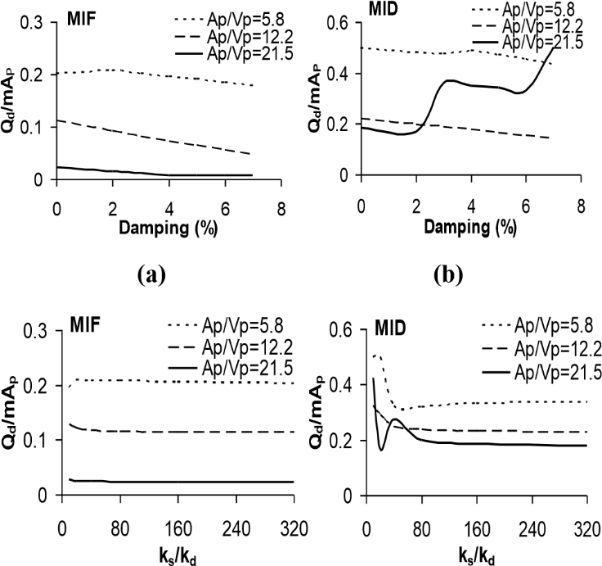
(
c
)

(
d
)

Figure 4. Effect of various parameters on optimum Q_{d} (a) Damping for MIF, (b) Damping for MID (c) Substructure stiffness for MIF, (d) Substructure stiffness for MID.

7. EFFECT OF VARIOUS PARAMETERS ON OPTIMUM K_{D}

In this section, the effect of various parameters on the optimum value of k_{d}, based on minimizing the MID, is investigated via sensitivity analyses. The bridge, isolator and ground motion parameters used in the analyses are; m=204 ton (W=2000 kN), ζ=0, k_{u}=200 kN/cm, Q_{d}=100 kN, k_{s}=3200 kN/cm, A_{p}=0.6g and A_{p}/V_{p}=5.8, 12.2 and 21.5 s-1 (i.e. the analyses are repeated for three ground motions). In the sensitivity analyses, while the parameter under consideration is varied, the rest of the parameters are assigned the values reported above. The sensitivity analyses results for each parameter are given below.

7.1 Effect of Peak Ground Acceleration and Characteristic Strength

As discussed earlier, the dimensionless term, Q_{d}/mA_{p} represents the ratio of the characteristic strength of the isolator to the seismic inertial force of a rigid bridge superstructure and eliminates the need for considering the peak ground acceleration and the characteristic strength of the isolator independently. Thus, the Q_{d}/mA_{p} ratio is used in the sensitivity analyses to study the combined effects of A_{p} and Q_{d} on the optimum value of k_{d}. The analyses results are presented in Figs 5(a) and for three ground motions with A_{p}/V_{p} =5.8, 12.2 and 21.5 s-1 in the form of optimum kd versus Q_{d}/mA_{p} plots based on minimizing the MID. As observed from the figure, the optimum value of kd varies as a function of the Q_{d}/mA_{p} ratio. Thus, the Q_{d}/mA_{p} ratio must be included as a parameter in the development of the closed form equation to calculate the optimum values of k_{d} based on minimizing the MID.

7.2 Effect of A_{p}/V_{p} Ratio of Ground Motion

In this section, the effect of the A_{p}/V_{p} ratio of the ground motion on the optimum value of k_{d} is investigated by varying the A_{p}/V_{p} ratio between 5.5 and 21.5 s⁻¹ while keeping the other parameters constant. The sensitivity analyses results are presented in Figure 5(b) in the form of an optimum k_{d} versus A_{p}/V_{p} ratio plot based on minimizing the MID. As observed from the figure, the optimum value of k_{d} is highly dependent on the A_{p}/V_{p} ratio of the ground motion. In fact, the optimum value of k_{d} increases as the A_{p}/V_{p} ratio of the ground motion decreases. Thus, the A_{p}/V_{p} ratio of the ground motion must be included as a parameter in the development of closed form equations to calculate the optimum values of k_{d} based on minimizing the MID.

0
50
100
150
200
0.05
0.1
0.15
0.2
Q
d
/mA
p
k
d
(kN/cm)
Ap/Vp=5.8
Ap/Vp=12.2
Ap/Vp=21.5

0
100
200
5.5
9.5
13.5
17.5
21.5
A
p
/V
p
k
d
(kN/cm)
(a) (b)

Figure 5. Effect of various parameters on optimum kd based on minimizing the MID (a) Qd/mAp ratio (b) Ap/Vp ratio.

7.3 Effect of Structural/Supplemental Damping

In this section, the effect of structural/supplemental damping on the optimum value of k_{d} is investigated. For this purpose, NLTH analyses of simplified structural models of SIBs with structural/supplemental damping ratios ranging between 0% and 8% are conducted for three ground motions with A_{p}/V_{p} =5.8, 12.2 and 21.5 s¹ scaled to A_{p} = 0.6g to determine the optimum values of k_{d} based on minimizing the MID. The analyses results are presented in Figure 6(a). As observed from the figures, the optimum value of k_{d} does not vary significantly as a function of the damping ratio. Thus, damping ratio need not be included as a parameter in the development of closed form equations to calculate the optimum values of k_{d} based on minimizing the MID.

7.4 Effect of Substructure Stiffness

In this section, the effect of the substructure stiffness on the optimum value of k_{d} is investigated by changing, in the structural model, the lateral stiffness, k_{s}, of the substructure between 200 kN/cm (very flexible) and 6400 kN/cm (very stiff). The analyses results are presented in Figure 6(b). As observed from the figure, the optimum value of k_{d} does not vary as a function of k_{s} (i.e. the curves remain nearly flat) except for the cases where the substructure is very flexible.

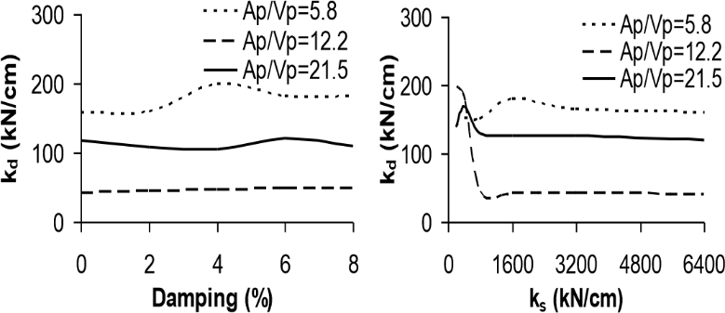
(a) (b)

Figure 6. Effect of various parameters on optimum k_{d} based on minimizing the MID (a) Damping, (b) Substructure stiffness.

8. FORMULATION OF THE OPTIMUM CHARACTERISTIC STRENGTH

In view of the sensitivity analyses results, the optimum values of Q_{d} based on minimizing the MIF and MID are calculated for a wide range of values of the parameters that are found to affect the optimum value Q_{d}. The analyses results for the optimum values of Q_{d} based on minimizing the MIF and MID are presented respectively in Figure 7(a) and (b) in the form of Q_{d}/mA_{p} versus T_{d}/T_{g} plots. These graphs and similar plots of Q_{d}/mA_{p} versus damping are used in the formulation of the optimum Q_{d} based on minimizing the MIF and
MID via regression analyses. Thus, the optimum Q_{d-F} is obtained as;

$Q_{d-F}=\frac{47mA_{p}}{50{\left(\frac{T_{d}}{T_{g}}\right)}^{0.7}e^{2.5}}$ (1)

Note that the post elastic period of the SIB, T_{d} and the dominant period of the ground motion, T_{g}, in Eq. (1) are expressed as;

$T_{d}=2\text{π}\sqrt{\frac{m}{k_{d}}}$ (2)

$T_{g}=\frac{2\text{π}}{{A_{p}}/{V_{p}}}$ (3)

Substituting Eqns. (2) and (3) into Eqn. (1) and rearranging, the optimum Q_{d-F} based on minimizing the MIF is obtained as;

$Q_{d-F}=\frac{47mA_{p}}{50{\left(\frac{m}{k_{d}}\right)}^{0.35}{\left(\frac{A_{p}}{V_{p}}\right)}^{0.7}e^{2.5}}$ (4)

The optimum characteristic strength Q_{d-D} based on minimizing the MID is also obtained as;

$Q_{d-F}=\frac{3A_{p}k_{d}}{4{\left(\frac{A_{p}}{V_{p}}\right)}^{2}e^{28}}$ (5)

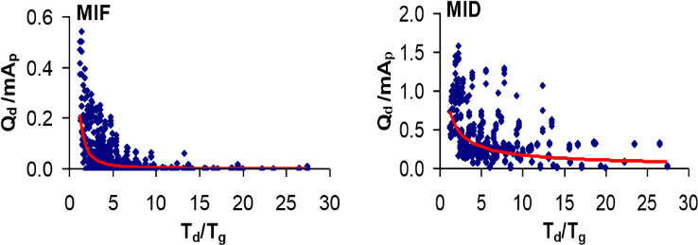
(
a
)

(
b
)

Figure 7. (a) Variation of the optimum Q_{d}/mA_{p} ratio as a function of T_{d}/T_{g} ratio based on minimizing the MIF, (b) Variation of the optimum Q_{d}/mA_{p} ratio as a function of T_{d}/T_{g} ratio based on minimizing the MID.

9. FORMULATION OF THE OPTIMUM POST-ELASTIC STIFFNESS

In light of the sensitivity analyses results, the optimum values of k_{d} based on minimizing the MID are calculated for the assumed range of values of the parameters that are found to influence the optimum value of k_{d}. The analyses results for the optimum values of k_{d} based on minimizing the MID are presented in Figure 8(a) in the form of k_{d} versus Q_{d}/mA_{p} plot. This graph and the plot in Figure 8(b) are used in the formulation of the optimum k_{d} based on minimizing the MID. The following equation that may be used to calculate the optimum values of k_{d} to achieve the smallest possible MID is obtained via regression analyses;

$k_{d}={\left(\frac{mA_{p}}{Q_{d}}\right)}^{0.34}\left[0.264{\left(\frac{A_{p}}{V_{p}}\right)}^{2}-7.45\left(\frac{A_{p}}{V_{p}}\right)+72.4\right]$ (6)

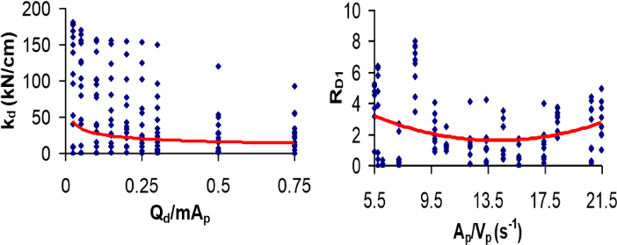
(a) (b)

Figure 8. (a) Variation of the optimum k_{d} as a function of Q_{d}/mA_{p} ratio based on minimizing the MID, (b) Ratio of the optimum kd based on minimizing the MID as a function of the A_{p}/V_{p} ratio.

10. VERIFICATION OF THE DEVELOPED EQUATIONS

The developed equations are verified using a suite of five ground motions different than those used for their development (Record # 16-20 in Table 1). The comparison of the optimum Q_{d} and k_{d} values obtained from the developed equations (Eqns. (4), (5) and (6)) with those obtained from iterative NLTH analyses are presented as a function of the A_{p}/V_{p} ratio of the ground motions in Figure 9 for various isolator properties and structural/supplemental damping ratios. As observed from the plots of Figure 9, although some differences between the analytical and NLTH analyses results are noted at specific A_{p/}V_{p} points, in general, the overall variation of the developed equations as a function of the A_{p}/V_{p} ratio of the ground motions agrees well with the analysis results.

MID, ζ=0, k = 20 kN/cm
0
200
400
600
800
Q
d-F
kN)
(
Analysis
Eqn. (7)
MIF, ζ=0, k
d
=
20 kN/cm
0
400
800
1200
Q
d-D
(
)
kN
Analysis
Eqn. (8)
d
4 8 12 16 20 24 4 8 12 16 20 24
Ap/Vp (s-1) Ap/Vp (s-1)
(a) (b)

Q
d
/W=0.05
0
50
100
150
200
4
8
12
16
20
24
A
p
/V
p
(
s
-1
)
k
d
(
kN/cm
)
Analysis
Eqn. (11)
(c)

Figure 9. Comparison of the optimum isolator characteristic parameters (Q_{d-F}, Q_{d-D}, k_{d}) obtained from the developed equations with those obtained from NLTH analyses (a) Eqn. (4), (b) Eqn. (5), (c) Eqn. (6)

11. CONCLUSIONS

In this study, closed form equations as functions of the isolator, bridge and ground motion properties are formulated to calculate the optimum characteristic strength, Q_{d} and post-elastic stiffness, k_{d}, of the isolator to minimize the MID and MIF for SIBs. It is found that, the effect of the bridge substructure stiffness on the optimum Q_{d} and k_{d} and the effect of the structural/supplemental damping on the optimum k_{d} are negligible. The optimum Q_{d} and k_{d} are found to be highly dependent on the frequency characteristics of the ground motion and the peak ground acceleration.

12. REFERENCES

Chapra, S. C. and Raymond, C. 2002. Numerical methods for engineers: with software and programming applications. McGraw Hill, New York, NY.
Constantinou M. C. and Tadjbakhsh I. G. 1984. Optimum design of a base isolation system with frictional elements. Earthquake Engineering & Structural Dynamics, 12(2):203-214
Dicleli, M.and Buddaram S. 2006. Effect of isolator and ground motion characteristics on the performance of seismicisolated bridges. Earthquake Eng. and Structural Dyn., 35(2), 233-250.
Iemura H., Taghikhany, T., Jain S. K. 2007. Optimum design of resilient sliding isolation system for seismic protection of equipments. Bulletin of Earthquake Engineering, 5:85–103.
Makris, N. and C. J. Black, 2004a. Dimensional analysis of rigid-plastic and elastoplastic structures under pulse type excitations. Journal of Engineering Mechanics, ASCE, 130(9): 1006-1018.
Makris, N. and C. J. Black, 2004b. Dimensional analysis of bilinear oscillators under pulse-type excitations. Journal of Engineering Mechanics, ASCE, 130(9):1019-1031.
Naeim, F. and Kelly, J. M., 1999. Design of Seismic Isolated Structures; From Theory to Practice. Wiley , Chichester, U.K.
Park, J-G. and Otsuka, H., 1999. Optimal yield level of bilinear seismic isolation devices. Earthquake Engineering and Structural Dynamics, 28(9): 941-955.
Veletsos, A. S., Newmark, N. M., Chelepati, C. V., 1965. Deformation spectra for elastic and elastoplastic systems subjected to ground shock and earthquake motions. Proc. of the 3rd World Conf. on Earthquake Engineering, New Zealand, 2: 663-682.

Professor, Middle East Technical University, Ankara, TURKEY, mdicleli@metu.edu.tr
Assistant Professor, Zonguldak Bülent Ecevit University, Zonguldak, TURKEY, memduhkaralar@beun.edu.tr

