**A NEW VERTICAL BASE ISOLATION SYSTEM**

**DOI 10.37153/2686-7974-2019-16-165-175**

Gian Paolo CIMELLARO[1], Marco DOMANESCHI[2], Gordon WARN[3]

**ABSTRACT**

A 3-D base isolation system to control both the horizontal and vertical vibrations is presented in this paper. The system is adopting a negative stiﬀness device (NSD) that can be considered as an adaptive passive protection system, which can apparently change the stiﬀness of the structure. This work is analyzing through numerical simulations the mitigation performance of the NSD against strong earthquakes in the vertical direction. The base isolation arrangement consists of elastomeric bearings acting both in the horizontal and vertical direction and NSDs acting only in the vertical direction. So, a 3-D base isolation is achieved, where it is assumed that the NSDs aﬀect the vertical stiﬀness of the system only. Numerical analyses show that the presence of NSDs reduces the vertical acceleration in the structure. Nevertheless, accordingly with the passive control theory, the relative displacements increase. Therefore, it seems advisable a supplemental damping to mitigate this eﬀect. Thanks to the presence of rubber isolators, it is possible to employ their inherent damping without introducing speciﬁc dampers in the vertical direction.

*Keywords: base isolation; negative stiffness; passive system; 3-D base isolation; vertical base isolation*

**1. INTRODUCTION**

Typically, while a conventional seismic isolation system reduces the horizontal component of an earthquake, the vertical component is entirely transmitted in the structure. Therefore, the interest toward three-dimensional (3-D) isolation systems is increasing. In literature can be found some examples of application of 3-D base isolations systems that consists in modifying the design parameters of laminated rubber bearings (Aiken 1989; Kelly 1988; Okamura et al. 2011).

The GERB system (Kelly 1990) has been introduced in 1990 and consists of helical steel springs that are flexible horizontally and vertically. The spring is essentially undamped so it needs to be used in conjunction with supplemental dampers. The system has been applied in two buildings in California. Limitations can be identified in the coupling between the horizontal and the vertical motion due to geometric nonlinearities.

Suhara (Suhara 2003) developed a 3-D seismic isolation device that uses a laminated rubber bearing for the horizontal direction and a rolling seal type air spring in the vertical direction.

The protection of structures through constant load spring devices against near-field earthquakes, characterized by a vertical component of the same intensity as the horizontal ones, is investigated in (Asai 2008).

Hybrid control solutions have been also studied for developing a 3-D vibration isolation system assembling mechanical and electromagnetic units (Hoque 2011).

A recent MCEER report compares different alternatives to seismically isolate electrical transformers. In particular, the performance of non-isolated, horizontally isolated and 3-D isolated solutions are analyzed considering triple friction pendulum (FP) devices in horizontal direction and viscous dampers in the vertical one (Kitayama 2016).

This paper considers as an alternative idea to insert a negative stiffness device (NSD) in the vertical direction only, within a conventional base isolation system.

The concept of negative stiffness has been first introduced in the pioneering publication of Molyneaux (Molyneaux 1957; Molyneaux 1957) in several proposals for vibration isolation systems. Later an effective passive negative-stiffness isolator that uses mechanical concept only in low-frequency vibration isolation has been proposed by Platus (Platus 2007). The isolation of the vertical-motion is provided by a stiff spring that supports a weight load, combined with a negative-stiffness mechanism. The limitation with this device is that it requires preload forces of the order of the supported weight. Therefore, it is usually employed for special equipment of lightweight real applications.

So far, the application of NSDs has been limited to vibration isolation of small, highly sensitive equipment and of seats in automobiles (Lee et al. 2007), because large forces (typically the same order of the weight of the building) are required to develop negative stiffness.

Some examples of applications of a pseudo-negative stiffness system for civil engineering structures have been also developed. “Negative” hysteresis loops are firstly achieved using a hydraulic device that is fully active or semi-active (Iemura and Pradono 2003). Then, Iemura et al. (Iemura et al. 2006) proposed a variable damper with a combination of friction loops with pseudo negative stiffness (“negative” hysteresis loops), to reduce the acceleration of the structure along with displacements. In (H Iemura 2008) a structure is placed on top of convex pendulum bearings, exactly the opposite with respect to friction pendulum bearings which use a concave surface. So the negative stiffness is generated from the structure’s vertical loads applied on the convex surface, while the elastomeric bearings are placed in parallel to provide positive stiffness. However, the reliance of variable damper on the external power and feedback signal to generate the negative hysteresis loops limits its applications. A negative stiffness is regarded as one of the promising control strategies in view of absolute response reduction except that such a control requires, in general, active or semi-active devices (Soong and Cimellaro 2009).

The concept of NSD presents some similarities with the retrofit system based on weakening and damping (WeD) the structure (Cimellaro et al. 2009; Reinhorn et al. 2009; Viti et al. 2006), however even though weakening and damping of structures is capable of reducing both the accelerations and the interstory drifts, it generates damage and permanent deformations.

Nagarajaiah et al. (Nagarajaiah et al. 2010) have proposed the concept of “apparent weakening” where the NSD is employed to simulate the yielding of the global system (weakening) without changing the real stiffness of the structure. Therefore, it allows to move the system away from the resonance condition. Practically, a pseudo yielding is created that is below the real yielding of the structure. The NSD is designed not to transfer forces to the structure until the displacement is greater than the gap displacement (displacement when occurs the pseudo-yielding). Nevertheless, the proposed concept at this stage results impractical for large structures.

In order to attain the negative stiffness more economically, a new structural control device that realizes a negative stiffness in a passive manner has been firstly proposed by Sarlis et al. (Sarlis et al. 2013) and tested on a shaking table at the University at Buffalo (Pasala et al. 2013; Pasala et al. 2014).

However, to the authors’ knowledge, limited studies for the application in civil engineering of the concept of NSD to reduce the vertical accelerations in base isolated buildings can be found in literature, trying to reach what can be called three-dimensional base isolation. E.g. a theoretical study for 3-D base isolation using a negative stiffness mechanism is investigated for possible applications (Mochida 2015). More negative stiffness and quasi-zero stiffness designs also exist (P. Alabuzhev 1989).

This paper presents an innovative 3-D base isolation system that adopts a NSD for vibration mitigation in the vertical direction, combined with elastomeric devices acting in the horizontal plane. The main assumption is that the NSD is self-contained and therefore when installed it affects only the vertical stiffness of the system while leaving the horizontal stiffness equal to the stiffness of the isolators.

**2. characteristics of negative stiffness devices**

The NSD (S Nagarajaiah 2010) can be classified as a passive seismic protection system but it belongs to a more sophisticated typology, the adaptive one. It means that it can change its characteristics when it deforms.

The negative stiffness is generated through a pre-compressed spring at the center between two chevron braces, designed to contain the high compressive force of the spring. When the NSD deforms, the spring rotates and extends giving a force that assists the structure.

The NSD is designed to transfer almost zero forces to the structure until the displacement is greater than the gap displacement (displacement at which occurs the pseudo yield). To generate such behavior a so called Gap Spring Assembly (GSA) is implemented. It consists in a couple of mechanical springs, generating bilinear elastic positive stiffness. When the displacement is smaller than the gap, the GSA is able to cancel out the negative stiffness. On the contrary, when the displacement overcome the gap threshold, the stiffness of the GSA is close to zero, hence the negative stiffness of the device is transferred to the structure.

Details on NSD can be found in Sarlis et al.(Sarlis et al. 2013), where the force-displacement law for the NSD without GSA, the GSA and the combination of them is presented.

*F2*

***Ka***

***KS***

***KNSD***

*F*

*y2*

*F3*

*y3*

*∆*

*F1*

*y1*

*F*

*F’3*

*y’3*

*∆*

*F1*

*y1*

*damping*

*F*

*NSD*

*spring*

*∆*

(a)

(b)

(c)

Figure 1. Schematic Force-Displacement behavior of the NSD implemented in the structure.  
(a) Force components, (b) structure + NSD, (c) effect of damper in parallel with the structure + NSD

Figure 1a depicts the force-displacement laws for the main structure (linear elastic), a linear passive damper and the NSD with GSA. Figure 1b shows the bilinear behavior coming from the structure in parallel with NSD and GSA without damper. The structure + NSD assembly stiffness reduces to Ka=Ks-KNSD beyond the displacement y1. If F2 and y2 are the maximum force and displacement for the linear system, F3 and y3 are the same variable, but related to the assembly. The maximum displacement y3 results increased with respect to the linear stiffness y2 (y3> y2). So, the introduction of a damper in parallel with the NSD and the spring allows an improved response in terms of displacement y’3 (Figure 1c).

In this work, for the sake of simplicity, the NSD function is adopted with a bilinear model in the vertical direction only. In the horizontal plane, uncoupled isolation function coming from rubber bearings is implemented. As the rubber isolators have already an intrinsic damping capacity, this latter can be useful for limiting the relative vertical displacements.

***2.1 Description of the model adopted***

The effectiveness of the NSD for the mitigation of the vertical vibrations has been assessed using a standard structure. It consists in a 2-D frame, one story and one bay with general dimensions and characteristics. The case study is not related to a specific application, but it serves as a useful benchmark for assessing the effectiveness of the NSD in the vertical direction. It consists in two columns and a rigid horizontal beam. The span measures 9.15 m and the height is 3.96 m. The mass distributed on the beam is 160000 kg. The frame has a total horizontal stiffness of 77000 kN/m, so the corresponding period of vibration is *TH* = 0,28 s. The total vertical stiffness of the frame is *5.7×106* kN/m, hence the vertical period is *TV* = 0,033 s. The damping ratio for this structure is assumed ξ=5% and it has been included in the equation of motion using the Rayleigh damping matrix.

The performance of three structural arrangements are compared: (i) a fixed base structure, (ii) a rubber bearings horizontally isolated structure and (iii) a rubber bearings horizontally isolated structure with decoupled NSD in the vertical direction. The fixed base structure (i) and the isolated superstructure (ii and iii) correspond to the frame and the parameters described at the beginning of this section. However, the three studied typologies are described in detail in what follows:

*1) Fixed base structure:*

The horizontal beam is assumed rigid, the columns deformable and fixed at the base, therefore the frame has three degrees of freedom: the horizontal displacement, the vertical displacement and the rotation angle in the vertical plane (the displacements are referred to the centroid of the beam). The stiffness matrix results:

 (1)

where *T*, *N*, *M* are the internal forces in the columns: respectively shear force, axial force, bending moment. *E* is the Young modulus, *h* the total length, *A* and *I* the cross section area and inertia, *L* the distance between the columns (Figure 2a). The term *K11* is 77000kN/m, while *K22* is 5.7×106 kN/m.

The governing dynamic equations are presented in Equation (2), where the damping matrix is omitted. The mass matrix is diagonal and the term corresponding to the rotation degree of freedom is the moment of inertia of the beam. The right side of the equation reports the forces coming from the ground motion. Obviously, the rotational part is negligible.

 (2)

With reference to Equation (2), *m* is the mass, *x*, *y*, *θ* the Lagrangian coordinates, ,  the ground motion acceleration components in the horizontal and the vertical direction respectively. Over-dot represents the derivative with respect to time. It is evident how the vertical motion is uncoupled from the other two.

*2) Isolated structure (without the NSD device):*

For this configuration, another floor at the base isolation level is added and two rubber isolators support it. The floor is assumed rigid and has the same mass *m* of the floor over the deformable columns. The new degrees of freedoms are the horizontal and vertical displacements of the mass centroid (*x1*, *y*1) at the isolation level. The rotation at this level is not considered: in other words, the rocking motion is disregarded at the isolation level. At the end, five degrees of freedom are considered in the structure.

Each isolator has a fixed damping ratio of 15% and their behavior is assumed linear elastic. This value is typical for high damping rubber bearings, or lead rubber bearings, at larger cycles of hysteresis (Abe et al. 2004; Perotti et al. 2013), where the benefits coming from the base isolation system, in terms of dissipation and system decoupling from the ground motion, are more evident. Equation (3) summarizes the stiffness matrix of the base isolated structure:

 (3)

where *KSH* and *KSV* are respectively the total horizontal and vertical stiffness of the isolators. If a 2DOF system is assumed for the base isolated structures in the horizontal direction (*x1, x2*), the damping matrix is determined by the corresponding damping coefficients at the superstructure level *c2* and at the isolator level *c1*. In particular *c2* is determined assuming that the superstructure is a SDOF system with a damping ratio *ξ*=0.05, while *c1* is determined assuming that the base isolated structure is a SDOF system with a damping ratio *ξ*=0.15.

The equations of motion are finally presented in the following:

 (4)

Thus, the vertical problem remains uncoupled from the others.

*3) Structure isolated with the NSD:*

The structure is the same as the isolated case, but the NSD is introduced at the base. The vertical isolation related to NSD is arranged to be uncoupled from the horizontal one (rubber bearings) and the NSD is linked to the structure at the base centroid of mass. Thus, it acts in the vertical direction only and provides no force in the horizontal direction. Hence, in the horizontal direction the rubber bearings ensure the base isolation, while the total vertical Force-Displacement law at the isolator level is the sum of both the NSD and the isolators contributions as they act in parallel. It is nonlinear elastic and the parameters that characterize the behavior are the following:

* The stiffness of the first branch, equal to the total vertical isolators stiffness *KNSD*.
* The stiffness of the second branch, equal to 10% of *KNSD*.
* The gap-displacement *δ* when the NSD is engaged.

When the absolute value of the displacement is smaller than *δ*, the GSA provides a force opposite to the NSD, so that the structure behaves as if the NSD is not present. In this parametric study, five different gap-displacements are considered: 1-2-3-4-5 mm. The dynamic equations are the same as the isolated case, except for the second equation. The new one is detailed below:

 (5)

As an extension of the previous structural configuration, the damping ratio of the superstructure is assumed *5%*, while it is assumed equal to *15%* for the rubber bearings, while NSD provides no damping.

Equations (4) and (5) of the NSD base isolated structural model outline how the vertical response results uncoupled from the others. Such quantitative aspect evidences the independent nature of the 3-D isolation system, where the vertical isolation function is self-contained from the others components. Figure 2c summarizes the force-displacement characteristics in the vertical direction for the three structural configurations herein considered. All the numerical simulations have been performed using the software MATLAB (Matlab 2015).

***2.2 Ground motion selection***

The principles herein adopted for the ground motion selection is to find earthquake records with high vertical component of ground motion, for example, by observing the PGA of the vertical component and by visual inspection of the displacement time history identifying the records with pulses. This condition is usually common in near field earthquakes where pulses are usually present both in the horizontal and vertical direction. The database adopted for the selection of ground motions is the PEER database. The software OPENSIGNAL (Cimellaro 2013; Cimellaro and Marasco 2015; Marasco and Cimellaro 2017) has been used for the ground motion selection. Bi-dimensional analyses have been performed considering both the vertical and the maximum horizontal component. The mean response spectra of the selected set in term of displacements and accelerations in the vertical direction are shown in Figures 2 where the period of the analyzed structure in the vertical direction is also shown.

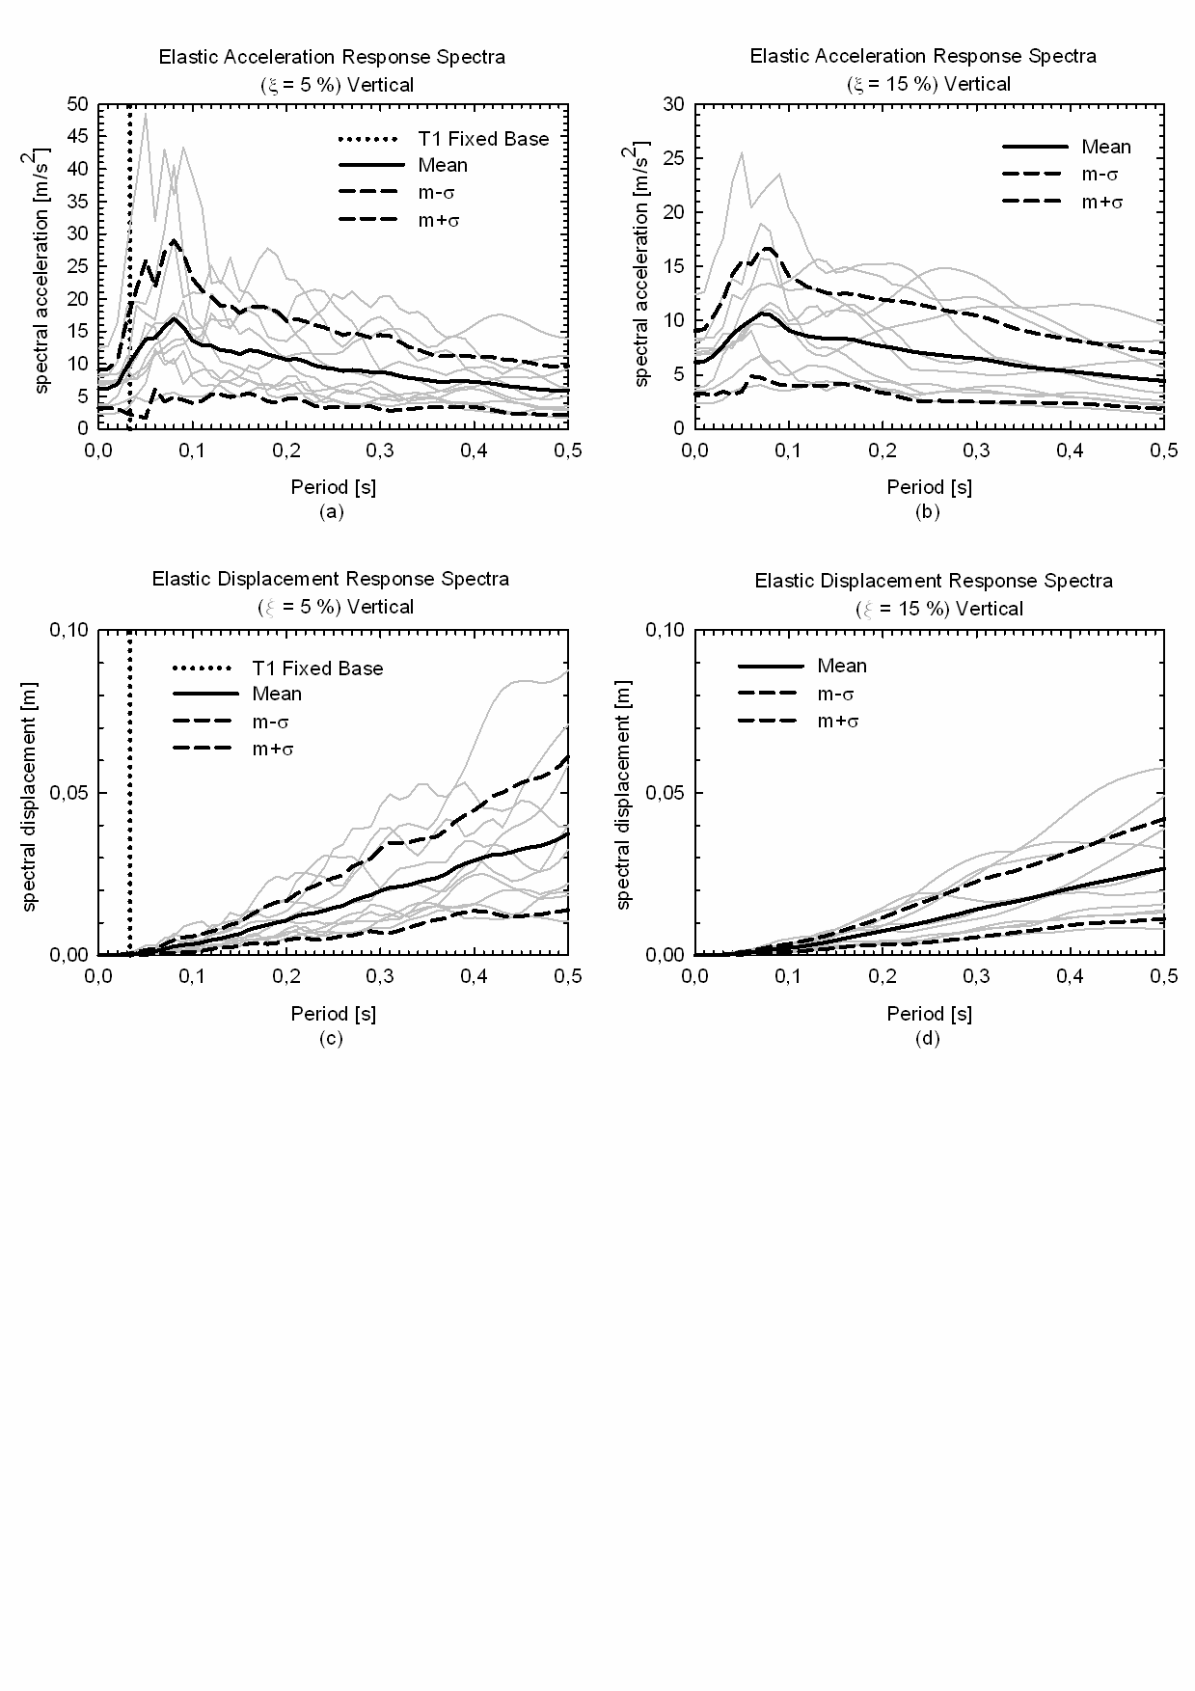

Figure 2. Vertical acceleration response spectrum for (a) *ξ*=5%; (b) *ξ*=15%;  
Displacement response spectrum for (c) *ξ*=5%; (d) *ξ*=15%.

***2.3 Design of the isolation system and devices***

Assessing the characteristics of the isolation system with the possible benefits coming from the NSD employment, the fixed base frame, the isolated structure and the isolated structure with NSD are considered. Focusing on the rubber bearings devices, assuming a starting range of horizontal stiffness for the isolators, the goal is to find the stiffness  at which the NSD is more efficient in mitigating the vertical acceleration of the superstructure. To get a reasonable range, the first assumption is to consider a stiffness range that correspond to a horizontal period of vibration between 1 s and 4 s. Then, for identifying the total vertical stiffness of the isolators, the assumption is to have a ratio between the vertical and the horizontal reactions equal to 1000. For each record, and for each stiffness, all the 5 values of gap-displacement δ are assumed.

The second part of the analysis concerns the design of the isolators. After the selection of the optimal vertical stiffness, the purpose is to design an isolation system that is able to withstand the displacements and the stresses induced by the seismic loading. Four geometrical and mechanical parameters characterize a rubber isolator. For each parameter, a range of possible values is selected and all the possible combinations are considered.

* the shear modulus of the elastomer G (0.4 – 0.8 – 1.4 MPa)
* the diameter D (from 0.3 m to 2.5 m)
* the number of rubber layers n (from 3 to 60)
* the thickness of each layer t (from 3 mm to 50 mm)

The next section is devoted to present results of the numerical simulations in terms of response mitigation by comparing the three different structural configurations herein considered.

**3. NUMERICAL RESULTS**

As described in the previous paragraph, first simulations are focusing on the research of the optimal vertical stiffness of the isolator at which the NSD is more effective in term of reduction of vertical acceleration component in the structure with respect to the isolated case. Obviously, the limitation of the displacements at the isolator level must be guaranteed. It happens that the number of records that engages the NSD with the gap-displacement δ greater than 1 mm is negligible. However, with the value δ=1mm the results are satisfactory in terms of vertical acceleration mitigation. Therefore, for the aim of this preliminary study, all the analysis presented in the following are referred to this value. Figure 3a shows the maximum vertical acceleration corresponding to each vertical stiffness for the earthquake Cape Mendocino. In Figure 3b the mean values and the standard deviations of all the ground motions considered are presented. In this study, all the records used for the analyses generate large vertical displacements in the isolators. To withstand those displacements, it is necessary to improve the bearings deformability by managing the number and the thickness of the rubber layers.

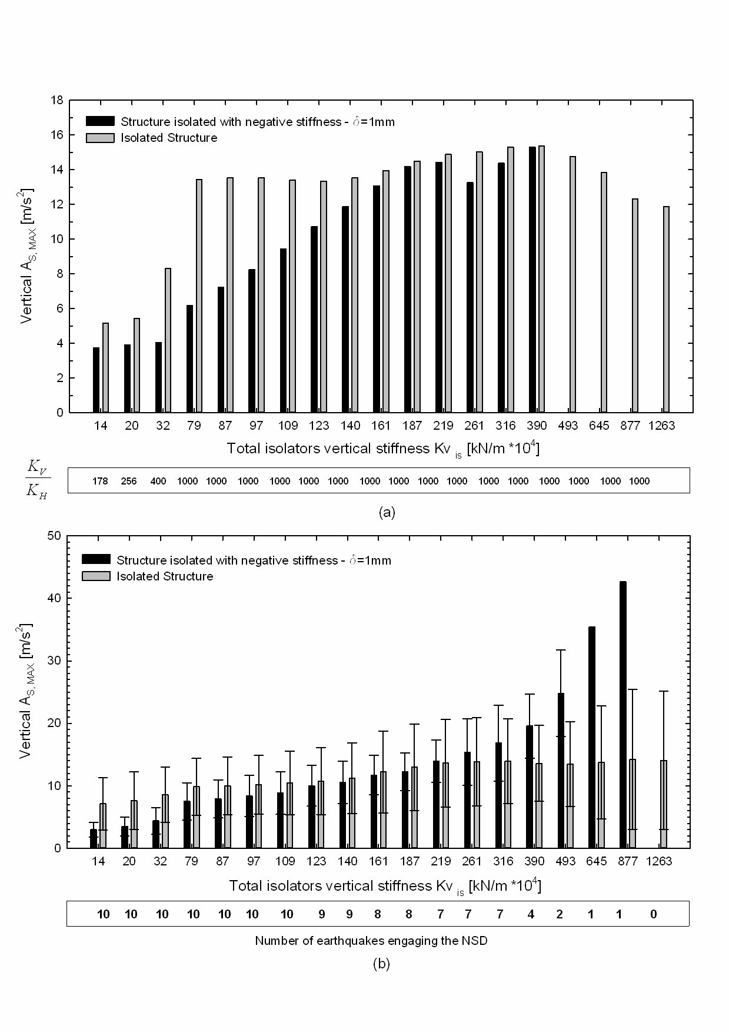

Figure 3. Comparison of vertical accelerations for traditional base isolation vs. NSD for different vertical stiffnesses. Cape Mendocino (a), mean values of all earthquake records (b)

All the limitations have been satisfied except the (i) buckling condition in the Gazli quake and the (ii) the cavitation acceptable tensile limit that is exceeded under the Northridge record. About the first condition, the vertical load is smaller than the buckling load, but it is greater than its half (4.34 MPa). This means that the stiffness of the isolators is influenced and a nonlinear model in the analysis should be used. About the second issue, even if the theoretical cavitation limit is overcome for a small time period at the peak structural response, the design of the isolation system for a real application should be re-evaluated. However, these questions are not within the aim of this work that represents a preliminary stage of the design, so the unsatisfactory responses related to these quakes have been disregarded.

It is worth mentioning, about tensile forces in base isolation systems, the studies by Roussis (e.g. (Roussis 2009)) on special connections between the devices and the structure. Such solutions that remove the possibility of the vertical load on the isolator becoming tensile are also allowed by the standard (STANDARDIZATION 2009). However, the implementation of any uplift prevention mechanism would modify the behavior of the isolation system and should then be included in the model of analysis. Figure 4 shows that the results in terms of vertical drifts in the superstructure are satisfactory. There are cases in which the reduction is significant, while in other cases there is no significant reduction.

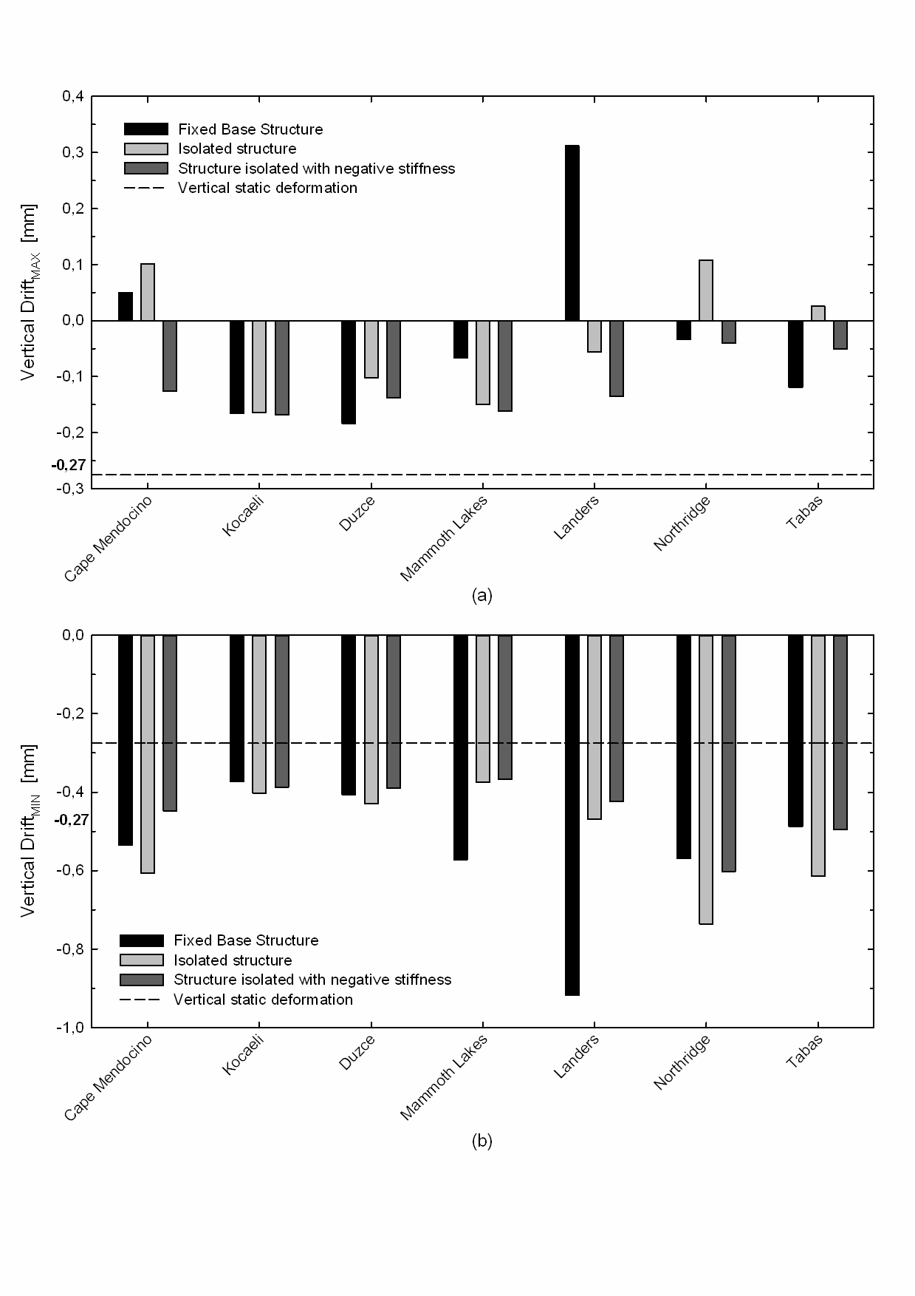

Figure 4. Comparison of vertical drift of the proposed design retrofit strategy vs. the traditional base isolated structure for different earthquake events. Max vertical drift (a), min vertical drift (b)

**4. CONCLUDING REMARKS**

The paper deals with the insertion of negative stiffness devices in parallel with rubber bearings in a base isolated building to control the vertical response. The structure is isolated horizontally with a system of elastomeric bearings and vertically with the NSD in parallel with the isolators. Both the horizontal and the vertical stiffness elements are implemented independently and a 3-D base isolation with uncoupled reaction components is achieved.

A standard SDOF steel portal frame have been considered in the analysis to test the effectiveness of the proposed configuration with respect to traditional fixed base and isolated ones. A set of earthquake records typical of the near-fault regions with the characteristic of pulse shape has been selected to perform the nonlinear dynamic analyses.

The numerical analyses show that by implementing negative stiffness devices in the vertical direction, the vertical accelerations are smaller than in a structure simply isolated. However, consistently with the base isolation theory, there are increments of displacements at the isolator level. Thus, the NSD, if properly designed, is able to reduce the vertical seismic forces with respect to the traditional base isolated systems, without considerably increasing the absolute and relative displacements. The NSD is also able to reduce the input energy transferred to the superstructure with respect to the base-isolated structure.

**5. Acknowledgments**

The research leading to these results has received funding from the European Research Council under the Grant Agreement n° ERC_IDEAL RESCUE_637842 of the project IDEAL RESCUE-Integrated Design and Control of Sustainable Communities during Emergencies.

**6. References**

AA Sarlis, D. P., MC Constantinou, AM Reinhorn, S Nagarajaiah, D Taylor "Negative stiffness device for seismic protection of structures - an analytical and experimental study." Proc., 3rd ECCOMAS Thematic Conference on Computational Methods in Structural Dynamics and Earthquake Engineering - COMPDYN 2011.

AASHTO (2010). "Guide specifications for seismic isolation design, 3rd Edition." A. A. o. S. H. a. T. Officials-AASHTO, ed.Washington, DC.

Abe, M., Yoshida, J., and Fujino, Y. (2004). "Multiaxial behaviors of laminated rubber bearings and their modeling. I: Experimental study." J Struct Eng-Asce, 130(8), 1119-1132.

Asai, T., Yoshida, N., Masui, T. and Araki, Y. (2008). "Vertical Seismic Isolation Device Using Constant Load Supporting Mechanisms." Journal of Structural and Construction Engineering AIJ(73), 8.

Attary, N., Symans, M., Nagarajaiah, S., Reinhorn, A. M., Constantinou, M. C., Sarlis, A. A., Pasala, D. T. R., and Taylor, D. (2015). "Performance Evaluation of Negative Stiffness Devices for Seismic Response Control of Bridge Structures via Experimental Shake Table Tests." Journal of Earthquake Engineering, 19(2), 249-276.

Cimellaro, G. P. (2013). "Correlation in spectral accelerations for earthquakes in Europe." Earthquake Engineering & Structural Dynamics, 42(4), 623-633.

Cimellaro, G. P., Lavan, O., and Reinhorn, A. M. (2009). "Design of Passive systems for controlled inelastic structures." Earthquake Engineering & Structural Dynamics, 38(6), 783-804.

Cimellaro, G. P., and Marasco, S. (2015). "A computer-based environment for processing and selection of seismic ground motion records: OPENSIGNAL." Frontiers in Built Environment, 1:17.

Ghaffarzadeh, H., and Nazeri, A. (2015). "The effect of the vertical excitation on horizontal response of structures." Earthq Struct, 9(3), 625-637.

H Iemura, O. K., A Toyooka, I Shimoda "Development of the friction-based passive negative stiffness damper and its verification tests using shaking table." Proc., The 14th World Conf. on Earthquake Engineering (14WCEE).

Harvey, P. S. (2016). "Vertical Accelerations in Rolling Isolation Systems: Experiments and Simulations." J Eng Mech, 142(3).

Hoque, M. E., Mizuno, T., Ishino, Y. and Takasaki, M. (2011). "A three-axis vibration isolation system using modified zero-power controller with parallel mechanism technique." Mechatronics, 21(6), 8.

ID Aiken, J. K., FF Tajirian (1989). "Mechanics of Low Shape Factor Elastomeric Seismic Isolation Bearings." University of California, Berkeley, CA.

Iemura, H., Igarashi, A., Pradono, M. H., and Kalantari, A. (2006). "Negative stiffness friction damping for seismically isolated structures." Structural Control & Health Monitoring, 13(2-3), 775-791.

Iemura, H., and Pradono, M. H. (2003). "Application of pseudo negative stiffness control to the benchmark cable-stayed bridges." Journal of structural control, 10(3-4), 187-203.

Inoue, K., Fushimi, M., Moro, S., Morishita, M., Kitamura, S. and Fujita, T. (2004). "Development of Three-Dimensional Seismic Isolation System for Next Generation Nuclear Power Plant." 13th World Conference on Earthquake EngineeringVancouver, B.C., Canada.

JM Kelly, E. Q. (1990). "Testing and Evaluation of CEGB Isolation System." University of California, Berkeley, CA.

Kelly, J. M. (1988). "Base Isolation in Japan." University of California, Berkeley, CA.

Kelly, J. M., and Van Engelen, N. C. (2016). "Fiber-Reinforced Elastomeric Bearings for Vibration Isolation." J Vib Acoust, 138(1).

Kitayama, S., Constantinou, M.C. and Lee, D. (2016). "". (2016). "Procedures and Results of Assessment of Seismic Performance of Seismically Isolated Electrical Transformers with Due Consideration for Vertical Isolation and Vertical Ground Motion Effects." MCEER-16-0010 Report, 180.

Lee, C. M., Goverdovskiy, V., and Temnikov, A. (2007). "Design of springs with ‘negative’ stiffness to improve vehicle driver vibration isolation." Journal of Sound and Vibration, 302(4-5), 865-874.

Li, X. Y., Xue, S. D., and Cai, Y. C. (2013). "Three-dimensional seismic isolation bearing and its application in long span hangars." Earthq Eng Eng Vib, 12(1), 55-65.

Marasco, S., and Cimellaro, G. P. (2017). "A new energetic-based ground motion selection and modification method limiting the dynamic response dispersion and preserving the median demand." Bulletin of Earthquake Engineering, DOI: 10.1007/s10518-017-0232-5, 1-21.

Matlab. 2015. The MathWorks, Inc. The Language of Technical Computing

Mochida, Y., Kida, N. and Ilanko, S. (2015). "Base Isolator of Vertical Seismic Vibration Using a Negative Stiffness Mechanism." Vibration Engineering and Technology of Machinery, 7.

Molyneaux, W. (1957). "Supports for vibration isolation."

Molyneaux, W. G. (1957). "Supports for vibration isolation." A.R.C. - C.P. No.322, Aeronautical Research Council.

Morishita, M., Inoue, K. and Fujita, T. (2004). "Development Of Three-Dimensional Seismic Isolation Systems For Fast Reactor Application." Journal of Japan Association for Earthquake Engineering, 4(3), 6.

Nagarajaiah, S., Pasala, D. T. R., Reinhorn, A., Constantinou, M., Sirilis, A. A., and Taylor, D. (2013). "Adaptive Negative Stiffness: A New Structural Modification Approach for Seismic Protection." Adv Mater Res-Switz, 639-640, 54-66.

Nagarajaiah, S., Reinhorn, A. M., Constantinou, M. C., D., T., Pasala, D. T. R., and Sarlis, A. A. "True adaptive negative stiffness: A new structural modification approach for seismic protection." Proc., Proc. 5th World Conf. on Structural Control and Monitoring.

NEHRP (1994). "Recommended provisions for seismic regulations for new buildings." FEMA 222A.

NIST (2011). "Selecting and Scaling Earthquake Ground Motions for Performing Response-History Analyses." NIST GCR 11-917-15, N. I. o. S. a. T. N. u. t. N. E. H. R. P. (NEHRP), ed.

Okamura, S., Kamishima, Y., Negishi, K., Sakamoto, Y., Kitamura, S., and Kotake, S. (2011). "Seismic Isolation Design for JSFR." J Nucl Sci Technol, 48(4), 688-692.

P. Alabuzhev, A. G., L. Kim, G. Migirenko, V. Chon, P. Stepanov (1989). Vibration Protecting and Measuring Systems with Quasi-Zero Stiffness, Hemisphere Publishing Corporation, New York

Pasala, D. T. R., Sarlis, A. A., Nagarajaiah, S., Reinhorn, A. M., Constantinou, M. C., and Taylor, D. (2013). "Adaptive Negative Stiffness: New Structural Modification Approach for Seismic Protection." J Struct Eng, 139(7), 1112-1123.

Pasala, D. T. R., Sarlis, A. A., Reinhorn, A. M., Nagarajaiah, S., Constantinou, M. C., and Taylor, D. (2014). "Simulated Bilinear-Elastic Behavior in a SDOF Elastic Structure Using Negative Stiffness Device: Experimental and Analytical Study." Journal of Structural Engineering, 140(2).

Pasala, D. T. R., Sarlis, A. A., Reinhorn, A. M., Nagarajaiah, S., Constantinou, M. C., and Taylor, D. (2015). "Apparent Weakening in SDOF Yielding Structures Using a Negative Stiffness Device: Experimental and Analytical Study." J Struct Eng, 141(4).

Perotti, F., Domaneschi, M., and De Grandis, S. (2013). "The numerical computation of seismic fragility of base-isolated Nuclear Power Plants buildings." Nucl Eng Des, 262, 189-200.

Platus, D. (1991). "Negative-stiffness-mechanism vibration isolation system." Proceedings of the SPIE, vibration control in microelectronics, optics, and metrology, 1619, 11.

Platus, D. L. a. F., D.K. (2007). "Negative-stiffness vibration isolation improves reliability of nanoinstrumentation." Laser Focus World, 43(10), 3.

Reinhorn, A. M., Lavan, O., and Cimellaro, G. P. (2009). "Design of controlled elastic and inelastic structures." Earthq Eng Eng Vib, accepted for publication October 13, 2009.

Roussis, P. C. (2009). "Panayiotis C. Roussis." Journal of Structural Engineering ASCE, 135(12), 10.

S Nagarajaiah, A. R., MC Constantinou, DTR Pasala, AA Sarlis " True adaptive negative stiffness: A new structural modification approach for seismic protection." Proc., 5th World Conf. on Structural Control and Monitoring.

Sarlis, A. A., Pasala, D. T. R., Constantinou, M. C., Reinhorn, A. M., Nagarajaiah, S., and Taylor, D. P. (2013). "Negative Stiffness Device for Seismic Protection of Structures." J Struct Eng, 139(7), 1124-1133.

Sarlis, A. A., Pasala, D. T. R., Constantinou, M. C., Reinhorn, A. M., Nagarajaiah, S., and Taylor, D. P. (2016). "Negative Stiffness Device for Seismic Protection of Structures: Shake Table Testing of a Seismically Isolated Structure." J Struct Eng, 142(5).

Shakib, H., and Fuladgar, A. (2003). "Effect of vertical component of earthquake on the response of pure-friction base-isolated asymmetric buildings." Eng Struct, 25(14), 1841-1850.

Soong, T. T., and Cimellaro, G. P. (2009). "Future directions on structural control." journal of Structural control and Health Monitoring 16(1), 7-16.

STANDARDIZATION, E. C. F. (2009). "EUROPEAN STANDARD - EN 15129 - Anti-seismic devices." Isolators.

Suhara, J. "Research on 3D base isolation system applied to new power reactor 3D seismic isolation device with rolling seal type air spring: part 1 - Paper #K09e4, ." Proc., SMiRT 17.

UBC (1997). "The Uniform Building Code."

Viti, S., Cimellaro, G. P., and Reinhorn, A. M. (2006). "Retrofit of a hospital through strength reduction and enhanced damping " Smart Structures and Systems, An international Journal, 2(4), 339-355.

1. Associate Professor, Politecnico di Torino, Turin, Italy, [gianpaolo.cimellaro@polito.it](mailto:gianpaolo.cimellaro@polito.it)
2. Assistant Professor, Dept. DISEG, Politecnico di Torino, Turin, Italy, [gianpaolo.cimellaro@polito.it](mailto:gianpaolo.cimellaro@polito.it)
3. Associate Professor, Penn State University, University Park, PA 16802-1408, USA, [gpw1@psu.edu](mailto:gpw1@psu.edu)