PAPER TITLE (leave two blank lines before, times new roman 14pt bold, upper case, max. two lines, centered)

Firstname LASTNAME1, Firstname LASTNAME2, Firstname LASTNAME3

ABSTRACT

This template illustrates the format that must be used in the preparation of full papers for the 16th World Conference on Seismic Isolation, Energy Dissipation and Active Vibration Control of Structures. Papers are to be submitted in English based on the original abstract submitted. All presenting authors must be registered as full conference delegates to submit a final manuscript. All manuscripts must be prepared electronically and submitted in accordance with the following instructions using the online submission feature provided on the conference web site http://www.16wcsi.org/?q=node/22
Text and headings should be in Times New Roman 11-point type (except this abstract text in 10-pt) with one line space between paragraphs and headings. Included in this template are examples of headings, equation format, references, and other typographical features likely to be encountered in technical papers. The abstract should be approximately 200 words or less. It should provide a good overview of the paper including an informative summary of the most important results. Note that the abstract is the most widely read portion of a manuscript. Maximum paper length is 12 pages including figures, tables, endnotes, and references.

Keywords: Keyword1; Keyword2; Keywords should use Times New Roman 10 pt. font, Italic; separated by semicolon; Maximum 5

1. INTRODUCTION

The proceedings of the conference will be compiled directly from the documents received from authors. Therefore, to enhance the overall visual quality of the proceedings, each author should make every effort to comply with the guidelines outlined here. The purpose of this template is to aid in clarifying those guidelines and provide a uniform appearance of the papers. Specifically, the ‘styles’ panel in Microsoft Word should be consulted in order to apply the correct formatting directly for the titles, section headings, and body text.

1.1 Publication Quality and Uniformity

This template has been created to illustrate the correct format for the preparation of papers. To ensure publication quality and uniformity, the following guidelines are intended to assist authors in preparing their papers for the Conference. Failure of authors to adhere to these guidelines will result in papers being returned to authors prior to the technical peer review and may compromise the eventual publication of their paper. All the full papers should describe original research and should not be published elsewhere.

1.2 Required Registration

All presenting authors must register as a full conference delegate (or student if applicable) to submit a final paper. This must be done through the conference web site at http://www.16wcsi.org. The online paper submission feature will prompt you to register as a delegate if you have not done so before uploading your paper.

Online Submission

All final papers must be submitted electronically by April 1, 2019, using the online submission feature on the conference web site – emailed submissions will not be accepted. The corresponding authors of accepted abstracts can access the paper submission feature by logging in using their User Name and Password registered during the abstract submission process.
Please ensure that your document meets the formatting guidelines before submitting. The required files per submitted contribution should include the MS Word DOC or DOCX as well as the PDF file of the paper. The maximum file size allowed is 15 megabytes (this limit refers to the sum of all files uploaded at one time. You may also upload file by file if your single files are big.)

2. paper preparation guidelines

2.1 Length

The normal length of a complete paper including title, abstracts, text, figures, photographs, tables, acknowledgments and references is twelve (12) pages. The final abstract length should not normally exceed 200 words.

2.2 Page Size, Margins, Conference Logo and Page numbers

The supplied MS Word template has been formatted per this document. If you are not using MS Word, please select “A4” paper size and portrait orientation. Please set your page for the following margin dimensions: top - 25 mm, bottom - 25 mm, left - 20 mm, right - 20 mm, and gutter position left. The header and footer settings should both be set at 12 mm and 10mm from the edge. The 16WCSI conference logo has been placed at the top of the first page (only). It is sized 18 mm high x 107.5 mm wide and is positioned centered. Do not insert page numbers or headers or footers. These will be added when the proceedings are assembled.

2.3Title/Author(s)- Affiliations

The full paper title should be typed at the top of the first page in 14 point bold using upper case, and center justified. Leave two (2) line space below the title. The authors' institutional affiliations and addresses are to be given in single-line form at the bottom of the first page. Example illustrates format.

2.4 Heading 1 Example

The styles for three levels of headings are specified. Heading 1 is shown at the beginning of this section.
Headings should be preceded and followed by a one-line space. Do not indent the first line of a paragraph. Use the decimal system for numbering of headings with no more than three levels.

2.5 Heading 2 Example

Text goes here.

2.5.1 Heading 3 Example

Text goes here

3. Special Features

Among the special features likely to be encountered in a technical paper are equations, figures, tables, and references. This section will show how to deal with these features.

3.1 Equations

Equations should be aligned with the left margin, and should have a reference number in parentheses flush with the right margin. Equations should be preceded and followed by a one-line space. For example,

[M]{Ü} + [K]{U} = {f(t)} (1)

where [M], [K], {Ü}, and {U} are variables in the equation and should be described in the text. Awkward line spacing caused by in-line equations should be avoided. Equations should be referred to in the text as Equation 1, or as Equations 2, 3, and 4.

3.2 Figures and Tables

Leave one blank line between the text and the figure (or table caption), and one blank line between the figure caption (or table) and the text.

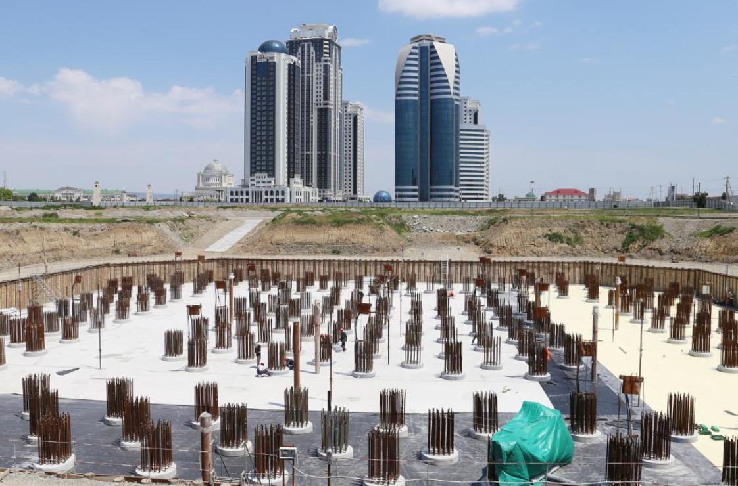

Figure 1. A figure in the text; first letter capitalized, and centrally aligned

Figures and tables should be included in the body of the paper (not at the end). Tables and figures should be placed immediately below (or at the first appropriate location) the text where reference is made to them. Each figure should be sequentially numbered and referred to by the respective number in the text, as in Figure 3, or as in Figures 3, 4, and 5. Similarly, tables should be referred to as Table 3, or Tables 3, 4, and 5. All figures and tables must be referred to and described in the text. Figure captions should be placed below the figure and table captions above the table. Drawings may be in color since papers will only be published in electronic format. Lettering should be approximately the same size as the text with a minimum of 2 mm. Lines should preferably be 0.2 mm thick. Fonts in the figures must be embedded. Under no circumstance is it acceptable to change the orientation of any page to “Landscape” to accommodate an illustration or exhibit – these pages will not output properly when the proceedings or an individual paper is printed.

Table 1. Captions of tables; first letter capitalized, period at end, and centrally aligned.

Heading | Heading (Times New Roman 11pt Bold)
Line heading | 222 | 222 (Times New Roman 11pt)
Line heading | 111 | 111

4. References Within Text

References should appear together in the References section in alphabetical order. All references must be cited in the text such as Eizenberg and Smirnov (2002) (Eizenberg et al. 2009). References should be in 10-pt Times New Roman style.

5. Conclusions

Each paper is expected to concisely state the conclusions of the work. The Conclusions section should discuss the significance and applicability of the work, and not merely restate the abstract. Great care should be exercised to make explicit the limitations or conditions under which the results can be applied.

6. Acknowledgments

The acknowledgments provide an opportunity to express appreciation to those who contributed significantly to the preparation of the paper. They may be written in a free style, and must be brief.

7. References

Zvezdov A.I., Smirnova L.N., Vedyakov I.I., Bubis A.A. (2017) Earthquake engineering of the Russian Federation as a priority direction of activity of JSC Research Center of Constructions. Earthquake engineering. Constructions safety, (6): 11-26.
Smirnova L.N., Bubis A.A. Introduction of systems of seismic isolation in practice of construction production in Russia Proceedings of the 16-th European Conference on Earthquake Engineering, 18-21 June 2018, Thessaloniki, Greece.
Pavlenko O.V. (2017) Possible Mechanisms for Generation of Anomalously High PGA During the 2011 Tohoku Earthquake, Pure and Applied Geophysics 174 (8): 2909-2924.
Aleshin A..S. (2015) The paradigm of the seismic zonation continuality. World Journal of Engineering and Technology, ISSN: 2331-4222. (3): 338-343.

Appendix

Appendices only should be used to provide information that would otherwise disrupt the principle focus and format of the paper or to provide supplemental information to be read by a small portion of the readership. Appendices should be placed after the References section.

8. CLEARANCES

All authors are responsible for obtaining written permission to profile the project or subject matter in their papers from any and all clients, owners or others who commissioned the work.
16WCSI assumes that you have obtained the proper permission(s) and require all corresponding authors to indicate their awareness of these requirements by indicating such in the online submission process when uploading your paper(s). 16WCSI assumes no liability for failure by the author(s) to gain proper permission.

9. COPYRIGHTED MATERIAL

If a figure, table or photograph has been published previously, authors must obtain written approval from the original publisher for it to be reprinted in the conference proceedings. The source of previously published material should be included in the caption of the table, figure or photograph.

10. PAPER SUBMISSION

All manuscripts must be submitted electronically, preferably in MS Word format or as a file that can be opened using MS Word, as well as PDF file. Submitted manuscripts must not be password protected. Authors of accepted abstracts can access the paper submission feature by logging in using their User Name and Password registered during the abstract submission process.
Submission of initial version of manuscripts must be completed by February 1, 2019 to be considered. Submission of final version – April 1, 2019.
The online submission process will prompt corresponding authors to register for the conference as a full delegate (or student, if applicable). The paper submission process cannot be completed without the registration process. For complete details on the manuscript/presentation guidelines, please visit the conference website at http://www.16wcsi.org

Position (Times New Roman 10), Affiliation, City, Country, email@address1
Title_Author2, Department, Affiliation, City, Country, email@address2
Title_Author3, Department, Affiliation, City, Country, email@address3

