**Study of RC coupled shear wall with replaceable components**

**DOI 10.37153/2686-7974-2019-16-355-363**

Huanjun JIANG [1], and Shurong LI [2]

**ABSTRACT**

During past earthquakes the coupling beams and the bottom of wall piers in reinforce concrete (RC) coupled shear walls easily suffered severe damage which is repaired hardly or costly. A new type of coupled shear wall with replaceable coupling beams and replaceable corner components at the bottom of wall piers is put forward. During the strong earthquake the damage is expected to mainly concentrate on the replaceable components in the wall. The function of the structural wall can be quickly restored by replacing the replaceable parts after the earthquake. The design method for the new wall is proposed. Two RC coupled shear walls, one new wall and one conventional wall, were designed. The responses and the damage process of two shear walls were analyzed and compared by numerical simulation. The results show that the lateral stiffness and load carrying capacity of the new shear wall are similar to that of the conventional shear wall. In the new wall the replaceable coupling beams yields at first, then the replaceable corner components yield. The damage concentrates on the replaceable components, and slight damage occurs in other parts. Compared with the conventional shear wall, the seismic performance of the new shear wall is improved significantly.

*Keywords: RC coupled shear wall; replaceable coupling beams; replaceable corner components; design method; pushover analysis*

**1. INTRODUCTION**

The reinforced concrete (RC) coupled shear wall is one of the predominant structural components used widely in tall buildings to resist lateral loads induced by earthquakes. However, the past earthquake experience indicated that coupling beams and the bottom corners of RC coupled shear walls easily suffer severe damage. RC coupling beams are prone to non-ductile failure. And the damage at corners of the walls includes crushing and spalling of concrete and buckling or fracture of longitudinal reinforcement. These kinds of damage are very difficult to be repaired, and the associated cost and repair time can be significant.

Recently, many researchers have put forwards different kinds of replaceable coupling beams. Fortney et al. (2007) first proposed the concept of replaceable coupling beams consisting of non-replaceable part and replaceable part. The replaceable part located in the middle of the coupling beams acts as a “weak link” where the inelastic deformation concentrates. Chung et al. (2009) developed a friction damper which is applied in the middle of coupling beams. The viscoelastic coupling damper, which consists of layers of viscoelastic material sandwiched between layers of steel plates, was developed by Montgomery et al. (2013, 2015). The hybrid energy-dissipation coupling beam consisting of high damping rubbers and a pair of U-shaped steel damper was introduced in lieu of coupling beams in RC coupled wall (Oh et al. 2012).

To reduce the damage at the bottom of the wall, such as crushing of concrete, buckling or fracture of longitudinal reinforcement, a new type of shear wall with replaceable components installed at the two bottom corners of the structural wall was first proposed by Lu et al. (2012). A new combined rubber bearing was adopted as the replaceable component designed to resist both compression and tension force. Jiang and Liu (2014, 2017) developed a new replaceable energy-dissipation component at the two bottom corners of the wall. The replaceable corner component (RCC) is comprised of the buckling-restrained mild steel core and the steel tube filled with the concrete. When the replaceable component is subjected to the tension, the inner mild steel core is stretched alone, and the concrete surrounding the steel core does not come into play. When it is compressed, the steel core is subjected to compression together with the concrete.

Considering that the coupling beam and the bottom corners in the shear wall are vulnerable to severe damage during strong earthquakes, in this study, a new type of RC coupled shear wall with replaceable coupling beams and replaceable components installed at the bottom corners of shear wall is put forward. Then, the design method for the new wall is proposed. Finally, two RC coupled shear walls, one new wall and one conventional wall, are designed. The responses and the damage process of two shear walls are analyzed and compared by numerical simulation.

**2. New RC coupled shear wall with replaceable components**

The new coupled shear wall with replaceable components (Figure 1) has multiple defense lines. Under strong earthquakes, the combined dampers installed in the middle of coupling beam yield first, then the replaceable corner components begin to dissipate energy, and the other parts of the coupled shear wall remain elastic. Therefore, the function of the structural wall can be quickly restored by replacing the replaceable dampers and replaceable corner components after earthquakes.



Figure 1. Coupled shear wall with replaceable components

***2.1 Description of combined damper***

Figure 2 shows the schematic diagram of the replaceable coupling beam, which comprises of the middle replaceable damper and non-replaceable end parts. The two parts are connected by bolts so that it can be replaced readily after the earthquake. The combined damper, which is the combination of one central metallic damper and two edge VE dampers, is installed in the middle of replaceable coupling beam. As shown in Figure 3, the metallic damper is an I-shaped steel beam with multiple mild steel plate webs placed in parallel, which are welded together by complete joint penetration groove welds. The VE damper consists of multiple layers of VE materials bonded between multiple layers steel plates. Under winds or minor earthquakes, the VE damper dissipates energy, and the metallic damper remains elastic and works with non-replaceable parts. Under moderate earthquakes or rare earthquakes, the metallic damper yields and dissipates a large portion of energy, and the non-replaceable parts remain elastic. If the dampers are damaged, after the earthquake they can be replaced easily.



Figure 2. Schematic drawing of replaceable coupling beam

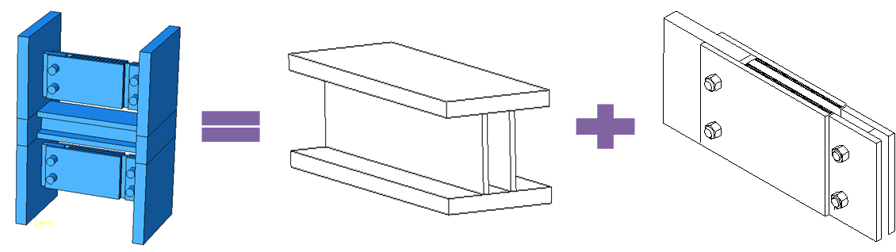

Figure 3. Schematic drawing of the combined damper

***2.2 Description of RCC***

As shown in Figure 4, the replaceable corner component mainly consists of buckling-restrained mild steel core and the concrete filled steel tube. The bonding between the steel core and the concrete is prevented by a layer of plastic film coated to the surface of the steel core. Under the tension, the inner mild steel core will be stretched alone, and the concrete surrounding the steel core does not come into play. When the replaceable corner component is compressed, the inner mild steel core and concrete are subjected to the compression together, and the steel tube provides the confinement to the concrete.

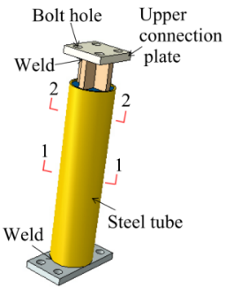 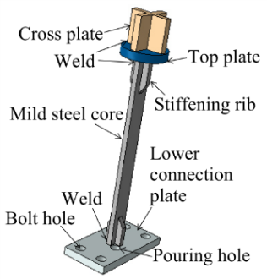 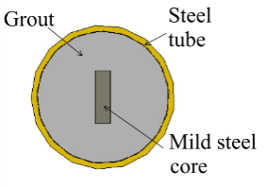 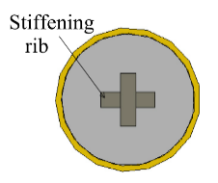

(a) Appearance (b) Internal construction (c) Section 1-1 (d) Section 2-2

Figure 4. Constitution of replaceable corner component

**3. Design method FOR new resilient coupled shear wall**

***3.1 Replaceable Coupling Beams***

The length of the replaceable part (*Lr*) is related to the wall rotation and the extreme deformation of the combined damper (Li et al. 2017). To ensure that the damper does not be destroyed under rare earthquakes, the length of the replaceable part should meet the requirement expressed by the following equation:

 (1)

where *γ*r is the ultimate rotation of the damper; *L*wis the distance between two adjacent walls; and *θw* is the wall rotation.

In order to ensure that the new type of replaceable coupling beams provide enough constraint to the shear wall under winds and small earthquakes, the stiffness ratio of the replaceable coupling beam to that of the conventional beam should not be less than 0.5.

The dimensions of the metallic damper are determined by the equal-strength principle, which means that the strength of the metallic damper equals to that of the conventional coupling beam. The thickness of the VE material layer is determined by the principle that the shear strain of VE material is less than 200% under rare earthquakes. If the post-yield stiffness of the combined damper is too large, the deformation of the metallic damper will be reduced and accordingly dissipate less energy. Therefore, the stiffness of VE damper is chosen to be less than 10% of the stiffness of the metallic damper. After determining the stiffness of the VE damper, the shear surface area of the VE damper can be determined according to the following equation:

 (2)

where *A*v is the shear area of the VE material; *h* is the thickness; *G*’ is shear storage modulus; and *K*v is stiffness of the VE damper.

In order to ensure that the non-replaceable parts remain elastic under rare earthquakes, their flexural strength and shear strength should exceed the maximum bearing capacity of the combined damper. With this consideration, the hardening effect of the metallic damper should be considered. The overstrength factor of the metallic damper, defined as ratio between the maximum shear strength and the yield strength, indicates the enhancement of bearing capacity due to the hardening effect of the web steel, which can be taken as 2.5. The bearing capacity safety factor of the non-replaceable part is taken as 1.2.

***3.2 RCCs***

Based on the previous study (Jiang et al., 2014), the length of the replaceable zone can been determined by the following equation:

 (3)

where *h*r is the length of the replaceable zone; *ε*x is the compressive strain of the concrete, which can be adjusted according to the requirements of the performance objective; ξ is the factor of the depth of compressive zone of the cross-section; *h*0 is the effective cross-section height of shear wall section; *ε*c,max is the maximum compressive strain at the extreme compression edge; *θ*u is the maximum story drift angle; and *h*p is the length of the plastic hinge, determined by the following equation (Paulay et al. 1992):

 (4)

in which *H* is the total height of wall; *h*w is cross-section height of shear wall section. If the length of the replaceable zone calculated according to Equation 3 is smaller than the length of boundary element, it is taken as the length of boundary element.

The height of the replaceable zone is the sum of the height of yield steel core, the steel core reinforcement constraint section and the connector. Assuming that the deformation mainly concentrates on the yielding section of the replaceable component, the height of yield steel core can been determined by the following expression:

 (5)

where *h*y is the height of yield steel core; and *ε*y,max is the maximum tension strain of the mild steel, which can be adjusted according to the requirements of the performance objective. Related experimental studies have shown that steel core can maintain stable mechanical behavior when the strain of the steel core is less than 3%, so it is recommended to take 3% for *ε*y,max. The safety factor is taken as 1.5 (FEMA 2003).

The dimensions of the mild steel core and the diameter of the steel tube are determined by the equal-strength principle, which means that the strength of the replaceable corner component equals to that of the replaceable region. In order to complement the lateral stiffness and shear strength of the RC shear wall and prevent the non-replaceable zone from the damage, the strengthening steel plate is embedded at the bottom part of the shear wall. To avoid the damage to the upper part of the shear wall, the bearing capacity of the replaceable shear wall shall meet the requirements of the following equations:

 (6)

 (7)

where *M*t and *M*new are the bending capacity of upper and bottom shear wall, respectively; *V*t and *V*new are shear capacity of upper and bottom shear wall, respectively;and *H*t is the height of the top of the steel plate to the top of the shear wall.

**4. Case study**

***4.1 Description of Two Coupled Shear Walls***

The geometry and the reinforcement of the conventional RC coupled shear wall are determined in accordance with Chinese codes (MOHURD 2010). Figure 5 shows the dimensions and steel reinforcement of conventional three-story coupled shear wall with the story height of 1.5 m. The new coupled shear wall with replaceable components is determined according to the aforementioned method. The parameters of combined damper and RCC are listed in Table 1 and 2, respectively. The mild steel LY225 with the yield strength of 225MPa is adopted for the web of metallic damper and steel core of RCC. The thickness and the height of strengthening steel plate in shear wall is 4mm and 1700mm, respectively. The dimensions of I shaped steel beam embedded in the non-replaceable part of replaceable coupling beam is 80mm×14mm×80mm×10mm (flange length × flange thickness ×web height ×web thickness). The conventional RC coupled shear wall is named as CW, and the new coupled shear wall is named as NS.



(a) Front view

 

(b) Section 1-1 (c) Section 2-2

Figure 5. Dimensions and steel reinforcement of conventional coupled shear wall

Table 1. Dimensions of combined damper

|  |  |  |  |  |  |  |
| --- | --- | --- | --- | --- | --- | --- |
| **Length (mm)** | **Web thickness (mm)** | **Web height (mm)** | **Number of webs** | **Flange width (mm)** | **Flange thickness (mm)** | **Dimensions of VE damper (mm)** |
| 160 | 6 | 48 | 1 | 60 | 12 | 8×60×70 |

Table 2. Dimensions of RCC

|  |  |  |  |  |  |
| --- | --- | --- | --- | --- | --- |
| **Length of replaceable part (mm)** | **Height of replaceable part (mm)** | **External diameter of steel tube (mm)** | **Thickness of steel tube (mm)** | **Width of inner core (mm)** | **Thickness of inner core (mm)** |
| 250 | 685 | 85 | 6 | 40 | 16 |

***4.2 Finite Element Models***

The finite element models shown in Figure 6 are established with the aid of the commercial software ABAQUS. The three-dimensional eight-node linear brick and reduced integration with hourglass control solid element (C3D8R) are used for the concrete and steel plate. The reinforcing bars are simulated by truss element T3D2. The truss elements are embedded in the concrete, regardless of the slip between the steel bars and concrete. The equivalent stiffness and equivalent damping model, which is a spring and a viscous damper in parallel, is adopted to simulate the viscoelastic damper. For the replaceable corner components, the Mander model (Mander et al. 1988) is employed for the concrete to consider the effect of steel tube instead of establishing the element model of steel tube. The inner steel core and the concrete are coupled at the X and Z direction to simulate the concrete constraint effects on the inner steel core, while the DOF in Y direction (the tensile direction) is released to simulate the relative displacement between the inner steel core and the concrete filled steel tube. The bilinear stress-strain relationship considering the kinematic hardening effect is used for the steel and the reinforcing bars. The concrete is modeled using the damaged plasticity model, which can describe the nonlinear material behavior of concrete.

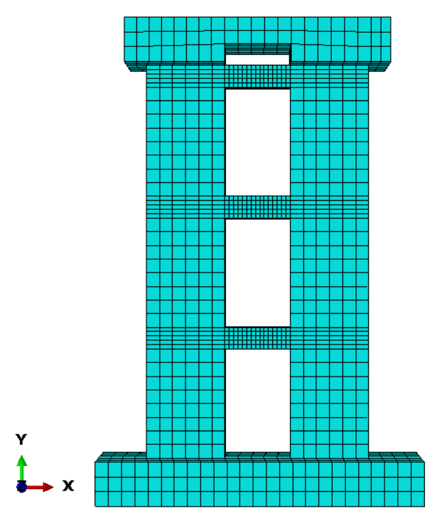 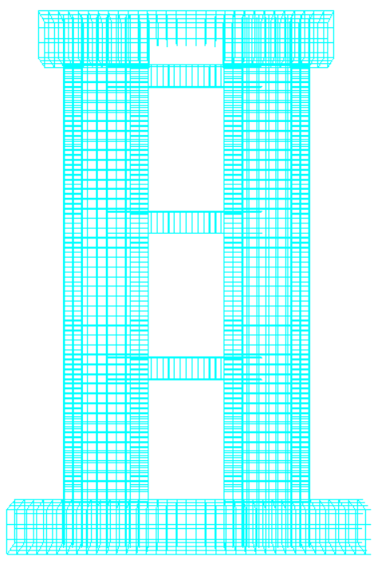 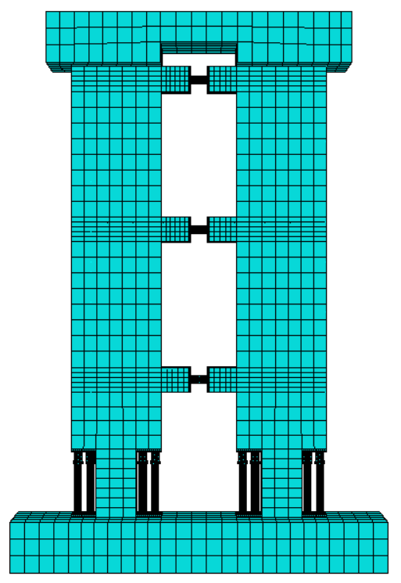 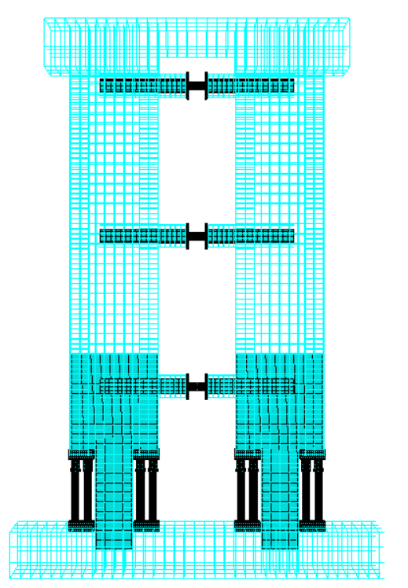

(a) CW (b) Steel rebars in CW (c) NW (d) Steel rebars in NW

Figure 6. Finite element model

***4.3 Analysis Results***

The pushover analyses for CW and NW are carried out. The axial force of 960 kN is applied at the top of the wall. The comparison of the lateral load-top displacement curves is shown in Figure 7. Compared with the conventional coupled shear wall, the lateral stiffness of NW is similar to that of CW while the strength of NW is higher than that CW.



Figure 7. Comparison of lateral load-top displacement curves

For the conventional shear wall, the longitudinal reinforcement in coupling beams first yields, then the longitudinal reinforcement in the boundary element yields. For the new coupled shear wall, the web of metallic damper yields first, then the mild steel core in the RCC yields. The non-replaceable part of coupling beams remain elastic. Figures 8 and 9 show the distribution of concrete plastic strain and steel bar plastic strain of the walls with the top drift ratio of 1%. Compared with CW, the concrete tension and compressive plastic strain of NW reduces by 7.8% and 58%, respectively. And the tension and compressive plastic strain of steel bar in NW reduces by 47% and 57%, respectively. The damage concentrates on the combined dampers and RCCs, and the remaining parts are protected well.

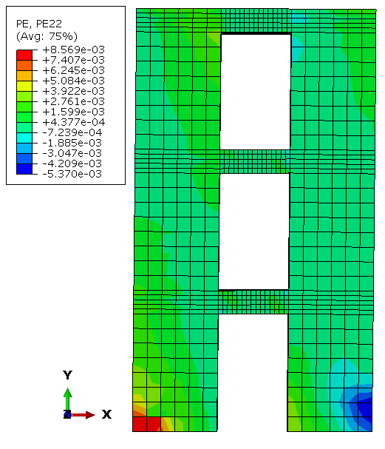 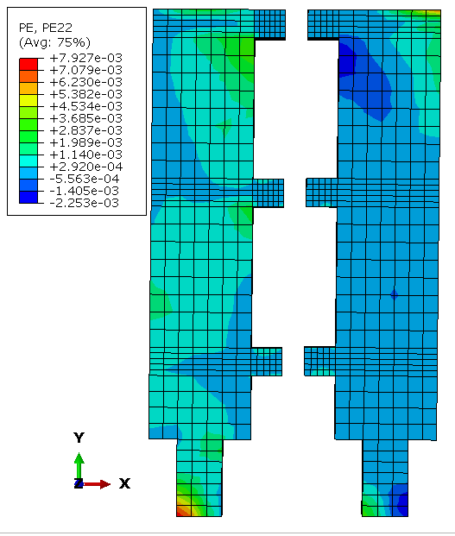

(a) CW (b) NW

Figure 8. Distribution of plastic strain of concrete

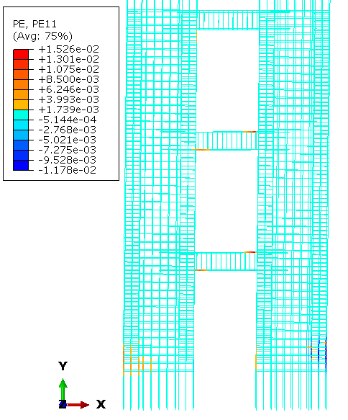 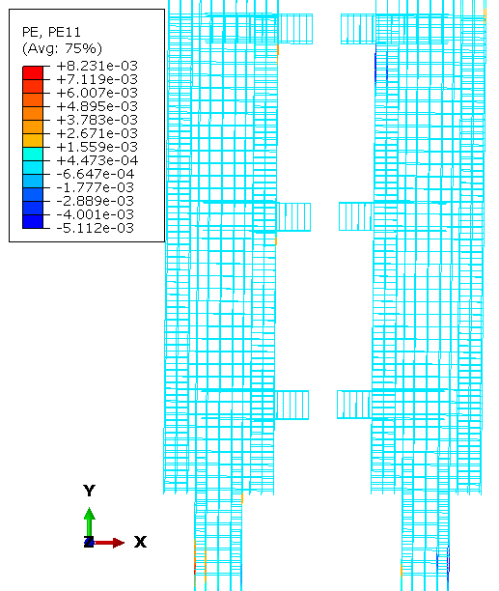

(a) CW (b) NW

Figure 9. Distribution of plastic strain of steel bar

**5. Conclusions**

A new type of RC coupled shear wall with replaceable coupling beams and replaceable components installed at the bottom corners of shear wall is developed in this study. The design method of this new coupled shear wall is introduced. To verify the mechanical properties, a case study is conducted. The finite element models of CW and NW are established with the aid of software ABAQUS. The results of pushover analysis show that in NW the damage concentrates on the combined damper and the RCC, while slight damage occurs in other parts. Compared with the conventional shear wall, the seismic performance of the new shear wall is improved significantly. The function of the structural wall can be quickly restored by replacing the replaceable parts after the earthquake. The experiment on the NW will be carried out to further verify the seismic performance of NW.

**6. Acknowledgments**

The authors gratefully acknowledge the support from the National Key Research and Development Program of China under Grant No. 2017YFC1500701.

**7. References**

Christopoulos C., Montgomery M. (2013) Viscoelastic coupling dampers (VCDs) for enhanced wind and seismic performance of high-rise buildings. *Earthquake Engineering & Structural Dynamics*, 42(15): 2217-2233.

Chung H. S., Moon B. W., Lee S. K., Park J. H., Min K. W. (2009) Seismic performance of friction dampers using flexure of RC shear wall system. *Structural Design of Tall and Special Buildings*, 18(7): 807-822.

Federal Emergency Management Agency. (2003) FEMA450, NEHRP Recommended provisions for seismic regulations for new buildings and other structures part 1: provisions. Washington DC: National institute of building sciences.

Fortney P. J., Shahrooz B. M., Rassati G. A. (2007) Large-scale testing of a replaceable "fuse" steel coupling beam. *Journal of Structural Engineering-ASCE*, 133(12): 1801-1807.

Jiang H., Liu Q (2014) Study of a new type of RC shear wall with replaceable corner components. *Proceedings of the 13th International Symposium on Structural Engineering*, 24 October 2014, Hefei, China.

Liu Q., Jiang H. (2017) Experimental study on a new type of earthquake resilient shear wall. *Earthquake Engineering & Structural Dynamics*, 46(14): 2479-2497.

Li S, Jiang H. (2018) Design and analysis of RC coupled shear wall with replaceable coupling beams. *Journal of Tongji University (natural science)*, 46(7): 1023-1032. (in Chinese)

Lu X., Mao Y., Chen Y. (2012) Test and analysis on shear walls with replaceable devices under cyclic loading for earthquake resilient structures. *Proceedings of the 9th CUEE and 4th ACEE Joint Conference*, 2012, Tokyo.

Mander J. B., Priestley M. J., Park R. (1988) Theoretical stress-strain model for confined concrete. *Journal of Structural Engineering*, 114(8): 1804-1826.

MOHURD (Ministry of Housing and Urban-Rural Development of the People's Republic of China). (2010) Code for seismic design of buildings (GB50011-2010). Beijing: China Architecture & Building Press. (in Chinese)

Montgomery M., Christopoulos C. (2015) Experimental validation of viscoelastic coupling dampers for enhanced dynamic performance of high-rise buildings. *Journal of Structural Engineering*, 141, 04014145.

Oh S. H., Choi K. Y., Kim H. J., Kang C. H. (2012) Experimental validation on dynamic response of RC shear wall systems coupled with hybrid energy dissipative devices. Proceedings of *15th WCEE*, 2012, Lisbon, Portugal.

Paulay T., Priestley M. N. (1992). Seismic design of reinforced concrete and masonry buildings. New York: John Wiley & Sons, Inc.

1. Professor, College of Civil Engineering, Tongji University, Shanghai, China, jhj73@tongji.edu.cn
2. PhD Candidate, College of Civil Engineering, Tongji University, Shanghai, China, lishurong1010@126.com