**mechanical behavior of sliding bearings  
for seismic isolation under cyclic loading**

**DOI 10.37153/2686-7974-2019-16-332-341**

Ken ISHII[1], Masaru KIKUCHI[2]

**ABSTRACT**

This research focuses on the thermal-mechanical coupled behavior of sliding bearings under a large number of cyclic loadings. First, loading tests of sliding bearings were conducted. Two scaled test specimens were used for the tests, and two displacement patterns, one unidirectional and one circular, were applied for both specimens. To obtain a high temperature in the sliding surface, imposed axial stress was set to 1.5 times that of the standard design pressure, and the loading frequency was set to 0.33 Hz. Then, a numerical model was proposed for sliding bearings after the friction coefficient from the test results was identified. The model is a combination of a mechanical model and a thermal conductivity analysis model. Using the newly developed model, simulation analysis of the loading tests was performed. The analysis result shows a good agreement with the test results and validates the accuracy of the numerical model. Finally, earthquake response analyses of seismically isolated structures supported by sliding bearings and elastomeric bearings were conducted. The results indicated that the heat generation in the sliding surface greatly affected the responses of the isolators. By considering the thermal-mechanical coupled behavior, the response deformation increased because the friction coefficient decreased.

*Keywords: Seismic isolation; Sliding bearings; Loading test; Friction coefficient; Hybrid analysis*

**1. INTRODUCTION**

Seismically isolated structures have a higher aseismic performance compared with that of conventional fixed-base structures. In designing seismic isolation systems, it is most important to make the fundamental period of structures longer than the predominant period of ground motions caused by earthquakes. Therefore, seismically isolated buildings can be classified as long-period structures (Kelly 1997). The acceleration response and structural damage in a superstructure are efficiently reduced by structural period elongation. Horizontally flexible support devices, called seismic isolators, are used to lengthen the period of structures. Sliding bearings are one of the most common seismic isolators in Japan. Sliding bearings consist of a plane sliding plate, a sliding material, and multilayered rubber and steel plates. The mechanical characteristics of this device enable low fundamental frequencies even for lightweight structures. It can also be applied beneath the foundation of columns supporting a low vertical load. Moreover, even hysteretic damping is available due to the sliding behavior with friction (Higashino 2006). Because of these advantages, the number of seismically isolated buildings with sliding bearings being built are increasing (AIJ 2016).

On the other hand, mega-earthquakes from subductions around Japan are a great concern in this research area. Such earthquakes are predicted to cause strong, long-period components in earthquake waves and to last several minutes. These are referred to as long-period, long-duration ground motions. Long-period components might resonate with a long-period structure to cause excessive deformation of isolators, and long-duration motions might cause isolators to deform over dozens of cycles. We have to consider these severe inputs to guarantee the safety of seismically isolated structures. Previous research has predicted that a very large subduction earthquake in the Nankai and Tokai regions of Japan will produce similar strong long-duration ground motions (MLIT 2016). A large number of cyclic deformations might cause the performance of the sliding bearings to deteriorate due to an increase in the contact surface temperature (Hibino 2012). This phenomenon has been identified as thermal-mechanical coupled behavior. Since 2017, the Japanese Ministry of Land, Infrastructure, Transport and Tourism (MLIT) has obliged structural engineers to consider the impact long-period, long-duration ground motions have on isolation devices when designing seismically isolated buildings (MLIT 2016).

This research focuses on the thermal-mechanical coupled behavior of sliding bearings under a large number of cyclic loadings. First, the authors conducted loading tests of sliding bearings. The aim of these tests is to obtain the temperature dependency of the friction coefficient in a high temperature range. Two scaled test specimens were used for the tests, and two displacement patterns, one unidirectional and one circular, were applied for both specimens. To obtain a high temperature in the sliding surface, imposed axial stress was set to 1.5 times that of the standard design pressure, and the loading frequency was set to 0.33 Hz. Next, the authors proposed a numerical model for sliding bearings after identifying the friction coefficient from the test results. The model, which is a combination of a mechanical model and a thermal conductivity analysis model, is an extension of a previously developed coupled analysis model (Kikuchi 2018A, Kikuchi 2018B). Using the newly developed model, simulation analysis of the loading tests was performed. Finally, earthquake response analyses of seismically isolated structures supported by sliding bearings and elastomeric bearings were conducted to examine the influence of cyclic deformations to the response of the building structures.

**2. bearing tests**

***2.1 Concept of Sliding Bearing***

Figure 1 shows a sliding bearing with a rubber pad. It consists of a multilayered natural rubber pad, sliding material, sliding plate, and base plate (Oiles 2019). The sliding material is polytetrafluoroethylene (PTFE). The materials of the sliding plate and base plate are stainless steel (SUS) and steel, respectively. There are two stages of deformation depending on the level of ground motions. Only the multi-layered natural rubber pad deforms when the shear force in the bearing is within the friction limit force in the case of a low-level earthquake (Figure 1 (a)). When the shear force reaches the friction limit force in the case of a high-level earthquake, the bearing starts sliding on the base plate (Figure 1 (b)). The shape of a typical hysteresis loop in the device is bilinear (Figure 1 (c)). The elastic stiffness is determined from the dimensions (thickness and cross-section area) and shear modulus of the rubber pad, and the second stiffness is theoretically zero.

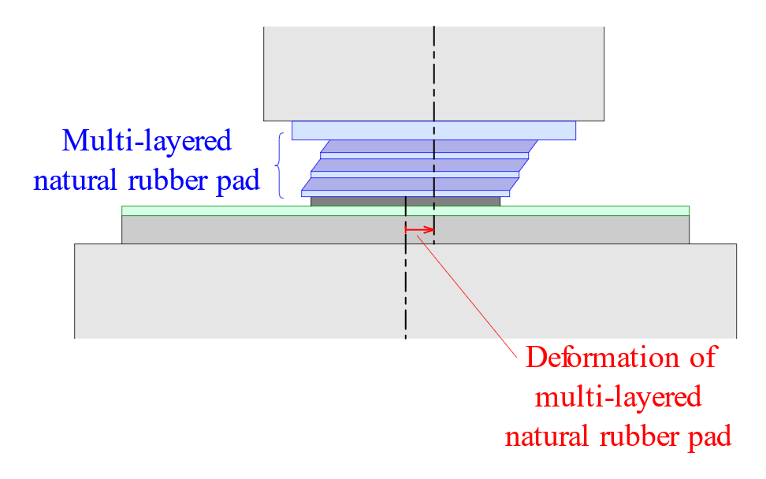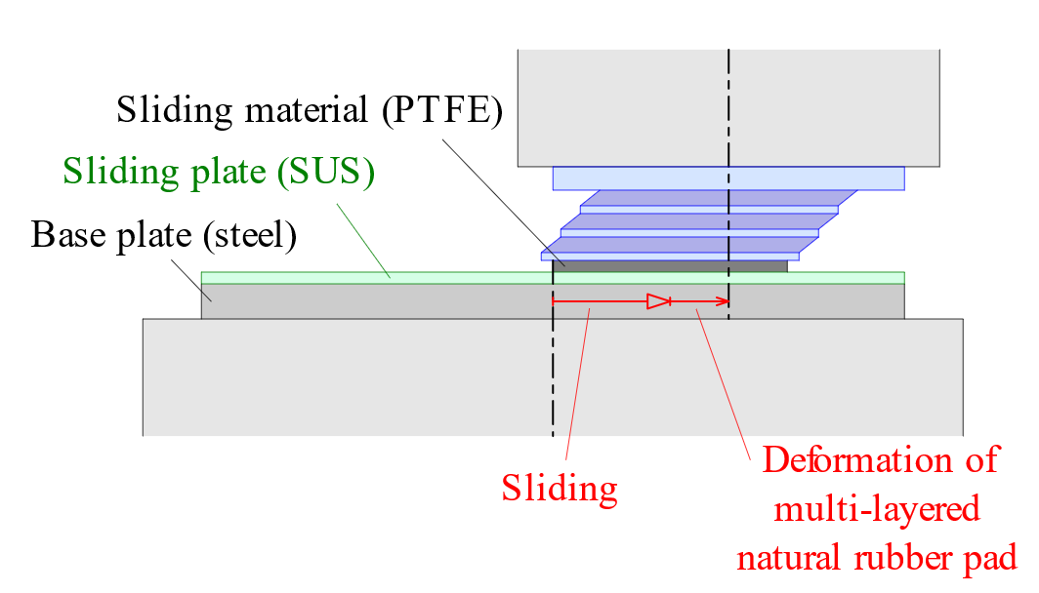

|  |
| --- |
| (c) Typical hysteresis loop  (b) High-level earthquake  (a) Low-level earthquake |

Figure 1. Concept of sliding bearing with rubber-pad

***2.2 Specimen***

Two scaled sliding bearings and a base plate were used in the tests. Both bearings have the same size and are hereafter called Specimen A and B. They were manufactured by Oiles Corporation, Japan. The design of the bearings tested is shown in Figure 2. The diameter of the rubber pad and sliding material were 120 and 100 mm, respectively. The multi-layered rubber pad consisted of six layers of 1.0-mm thick natural rubber sheets and 1.6-mm thick steel shims. The shear modulus of the natural rubber was 0.784 MPa.

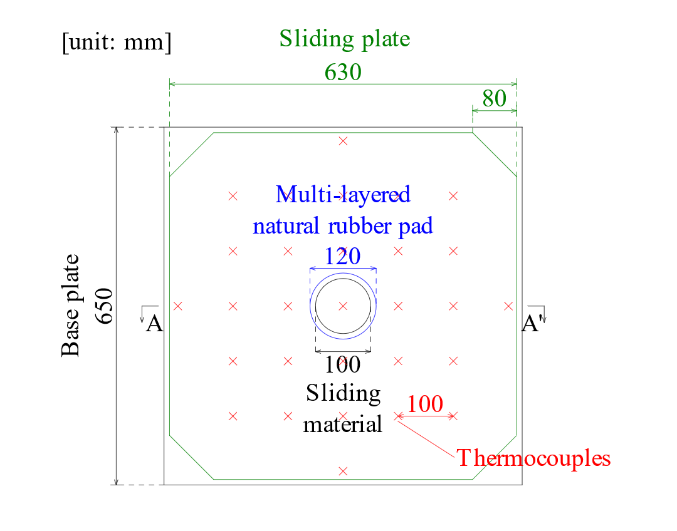

|  |
| --- |
| (a) Plan  (b) Section (A-A’) |

Figure 2. Design of sliding bearing for test

***2.3 Test Program***

Tests of the sliding bearings were conducted to investigate their mechanical characteristics under different horizontal displacement patterns. The aim of the tests was to obtain the temperature dependency of the friction coefficient in a high temperature range. Two types of displacement patterns shown in Figure 3 were examined. The test parameters are summarized in Table 1. To obtain a high temperature in the sliding surface, imposed axial stress was set to 1.5 times that of the standard design pressure. The loading frequency was set to 0.33 Hz, and the number of cycles was 250 for every test case. The temperature was observed with thermocouples attached to the back side of the sliding plate.

|  |
| --- |
|  |

Figure 3. Displacement patterns

Table 1. Test parameters

|  |  |
| --- | --- |
| Displacement pattern | 1-direction, Circle |
| Peak longitudinal displacement [mm] | 100 |
| Axial load [kN] | 203 |
| Loading frequency [Hz] | 0.33 |
| Number of cycles | 250 |

***2.4 Test Results***

The hysteresis loops in the longitudinal direction for the two types of displacement patterns are shown in Figure 4. The shape of the hysteresis loops varied depending on the displacement pattern. Degradation of shear force during cyclic loading was commonly observed. In every test, the friction coefficient decreased to about 50% of the initial value. The temperature rose to around 170 and 130°C in the case of 1-direction and circle loading, respectively. The thermal-mechanical coupled behavior should be considered for evaluating the performance of sliding bearings.



|  |
| --- |
| (d) Specimen B, circle, 51—250 cycles  (c) Specimen A, 1-dir, 51—250 cycles  (b) Specimen B, circle, 1—50 cycles  (a) Specimen A, 1-dir, 1—50 cycles |

Figure 4. Force-deformation relationship (longitudinal direction)

Figure 5 (a) shows the relationship between the temperature measured on the back side of the sliding plate and the friction coefficient, **. The tendency that the friction coefficient decreases with the rise in temperature can be clearly seen. The manufacturer has specified Equation 1 as an evaluation formula of the friction coefficient of this device (Oiles 2009);

$μ_{0}=(0.305-0.103exp⁡[-0.019v])⋅σ^{-0.29}$ (1)

where *v* [mm/s] is the relative velocity between the sliding material and plate, and ** [MPa] is the vertical pressure in the sliding material. This formula is expressed only in terms of the velocity and the vertical pressure in the bearing. Note that it does not involve the influence of temperature on the friction coefficient as it is quantified by the following process. First, the friction coefficient, **, was normalized by **0. Then, the temperature on the back side of the plate (measurement point) was modified to the value on the surface of the plate. The temperature difference between the surface and the back side of the sliding plate were assumed to be 15 and 10°C for the 1-direction and circle loading, respectively. The authors will use Equation 2 for the simulation analysis so that the influence of temperature can be taken into account;

$μ=μ_{0}⋅(0.5\exp\left[-0.02\left(T-45\right)\right]+0.45)$ (2)

where *T* [°C] is the temperature of the sliding plate in contact with the center of the sliding material. Equation 2 is plotted together with the experimental results in Figure (b).

|  |
| --- |
| (b) Normalized friction coefficient  (a) Friction coefficient vs. temperature |

Figure 5. Friction coefficient obtained from tests

**3. numerical analysis**

***3.1 Analysis Flow***

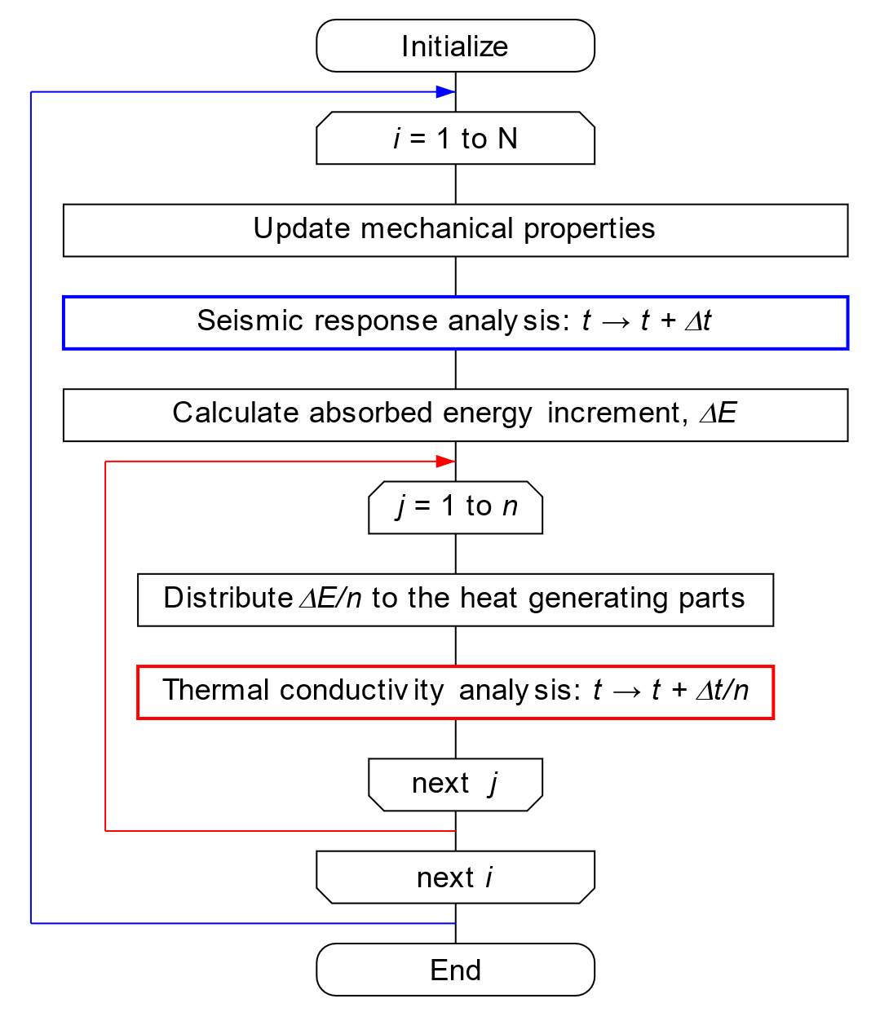

|  |
| --- |
|  |

Figure 6. Flowchart of thermal-mechanical coupled analysis

The numerical analysis model consists of a thermal conductivity and seismic response analysis. The model was implemented in the program OpenSees (McKenna 2019). Both analyses are performed interactively by updating their parameters incrementally at each time step. Figure 6 shows a flowchart of the thermal-mechanical coupled analysis. This model was constructed by refining an existing model that the authors had previously developed for elastomeric seismic isolation bearings (Kikuchi 2018A). First, the mechanical properties of the sliding bearings are updated at a certain time step through the use of Equation 2 in which the temperature of the sliding plate was obtained in the previous analysis step. Equation 2 was quantified from the multi-cycle loading test results, and contains the mechanical properties of the sliding bearing under high temperature. Then, the seismic response analysis is conducted using the updated parameters. The hysteresis model shown in Figure 1 (c) is applied for the sliding bearing in the seismic response analysis. Accordingly, an energy increment absorbed by the sliding bearing, *E*, is calculated at the end of the time increment. Next, *E* is distributed to the surface of the sliding plate where the sliding material contacts, then thermal conductivity analysis is conducted. Note that the contact area of the sliding material to the surface of the sliding plate is updated in accordance with the movement and deformation of the rubber pad at each analysis step. Eventually, the temperature of the sliding plate for the next analysis step is obtained. These procedures are repeated until the end of the analysis steps.

A finite volume method was used for the thermal conductivity analysis (Kikuchi 2018B). Figure 7 shows the three-dimensional analysis model for the sliding bearing used in the test. The cell thickness of the sliding plate (SUS) and the base plate (steel) were 2 and 5 mm, respectively. Each cell of both plates measured 20 × 20 mm in the horizontal direction. The material constants used for the analysis are summarized in Table 2. The Newmark beta method was used for the seismic response analysis (Newmark 1954). It has been widely used in the numerical evaluation of the nonlinear dynamic response of structures as a method of numerical time integration. The constant average acceleration method (** =1/4) was used as an option of the Newmark beta method in this paper.

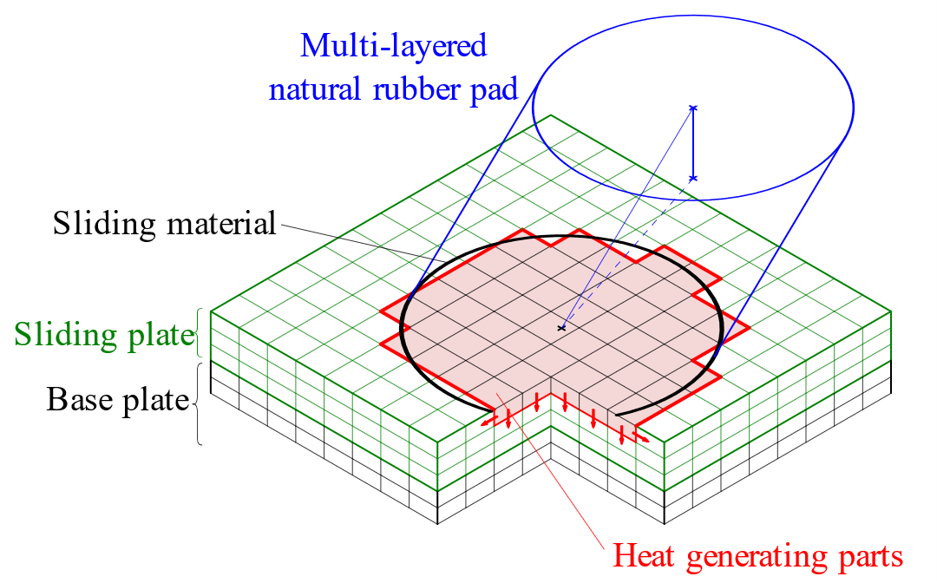

|  |
| --- |
|  |

Figure 7. Thermal conductivity analysis model for sliding bearing

Table 2. Material constants for thermal conductivity analysis

|  |  |  |  |
| --- | --- | --- | --- |
| **Material** | **Thermal conductivity**  **[W/(m∙K)]** | **Density**  **[g/cm3]** | **Specific heat capacity**  **[J/(g∙K)]** |
| SUS | 16.0 | 7.93 | 0.500 |
| Steel | 59.0 | 7.86 | 0.473 |

***3.2 Simulation Analysis***

Simulation analysis was conducted for the cyclic loading tests described in the previous section. Time step intervals were 0.01 and 0.002 second for the seismic response and the thermal conductivity analysis, respectively. Thus, five steps of the thermal conductivity analysis were carried out in one step of the seismic response analysis. Distributed energy to the sliding plate was 95% of the hysteretic energy absorbed by the sliding bearing, in consideration of the heat dissipation to the rubber bearing. The loading sequence was exactly the same as that for the tests.

The analysis results are shown in Figure 8. Comparing these results with those shown in Figure 4, the analysis model can accurately predict the deterioration of the hysteresis loops due to cyclic loading in every displacement pattern. These results verified that the analysis model captured the thermal-mechanical coupled behavior of the sliding bearing well.



(b) Circle, 1—50 cycles

(a) 1-dir, 1—50 cycles

|  |
| --- |
| (d) Circle, 51—250 cycles  (c) 1-dir, 51—250 cycles |

Figure 8. Force-deformation relationship obtained from analysis (longitudinal direction)

**4. seismic response analysis**

***4.1 Structure Model***

A 15-storey reinforced concrete building model was used for the seismic response analysis. Details of the model are shown in Figures 9. It was characterized as a typical seismically isolated condominium commonly designed in Japan (AIJ 2016). The structure consisted of 6 × 1 bays in the plan, with each bay measuring 6.5 × 12.0 m. One isolation bearing was placed underneath each column for a total of 14 seismic isolation bearings. Those bearings consisted of ten natural rubber bearings and four sliding bearings; both bearing types were 1100 mm in rubber diameter. The yield base shear coefficient was 0.037. The structure was modeled as a 16-node multiple degree of freedom (MDOF) system. The analysis dealt with only the X-direction of the building. The total mass of the superstructure was 11,443 tons. The superstructure was assumed to be elastic. The fundamental period was 1.23 seconds when the base of the superstructure was fixed. Stiffness proportional damping was applied only to the superstructure. A damping ratio of 3% was defined for the fundamental period of the fixed-base structure.

|  |
| --- |
|  |

Figure 9. Structure model

***4.2 Ground Motions***

Two types of ground motions shown in Figures 10 were used in the seismic response analysis. One is the El Centro N‒S component observed during the Imperial Valley earthquake of May 18, 1940 in California, USA. This record has been widely used in the seismic design of buildings for a long time. The duration time is 40 seconds. The other is one of the ground motions provided by MLIT in Japan (MLIT 2016). It had been developed for the purpose of reviewing the design of long-period structures such as tall buildings or seismically isolated buildings against huge subduction earthquakes. The location of this developed ground motion, OS1, is Osaka city. The duration time is much longer than that of the El Centro N‒S component (over 600 seconds).



|  |
| --- |
| (b) OS1  (a) El Centro |

Figure 10. Ground motions

***4.2 Analysis Results***

Four cases of seismic response analysis were conducted to evaluate the influence of the thermal-mechanical coupled behavior in the sliding bearings on seismic response values in the building structure. The analysis cases are summarized in Table 3.

Table 3. Analysis cases

|  |  |  |
| --- | --- | --- |
| **Case** | **Ground motion** | **Thermal-mechanical coupled behavior in the sliding bearings** |
| 1 | El Centro | Not considered |
| 2 | El Centro | Considered |
| 3 | OS1 | Not considered |
| 4 | OS1 | Considered |

Figures 11 and 12 show the seismic response analysis results that compare the peak response accelerations and displacements in the structure and hysteresis loops of the isolation level for the El Centro and OS1 input, respectively. The response values obtained in Cases 1 and 2 for the El Centro input are similar (Figure 11). The influence of thermal-mechanical coupled behavior in the sliding bearings does not appear so much under such a short-duration earthquake ground motion. The temperature in the sliding bearings increased only by 40 °C in Case 2. However, the response values obtained in Cases 3 and 4 for the OS1 input are quite different (Figure 12). The peak response accelerations are almost similar, although the peak response displacements in Case 4 are approximately twice as large as those in Case 3. The deterioration of the performance of the sliding bearings appeared very strongly in Case 4, and the friction coefficient decreased to about 50% of the design value. The temperature in the sliding bearings increased by 200°C in Case 4. These results suggest that the thermal-mechanical coupled behavior of seismic isolation devices should be considered, especially for long-duration earthquake ground motions.

|  |
| --- |
| (b) Force-displacement relationship  of the isolation level  (a) Peak response values |

Figure 11. Seismic response analysis result for El Centro input

|  |
| --- |
| (b) Force-displacement relationship  of the isolation level  (a) Peak response values |

Figure 12. Seismic response analysis result for OS1 input

**5. Conclusion**

In this research, the authors focused on the thermal-mechanical coupled behavior of sliding bearings for seismic isolation under long-duration ground motions. Sliding bearings are a major type of seismic isolation device for building structures. They have been widely used because of their advantage in easily providing a low natural frequency to building structures. Sliding bearings absorb seismic input energy and convert it to heat energy. Therefore, a large number of cyclic deformations significantly increases the temperature of the friction contact surface in the device. The temperature rise results in the deterioration of damping performance.

Cyclic loading tests of a scaled sliding bearing were conducted. The aim of the tests was to obtain the temperature dependency of the friction coefficient in a high temperature range. To obtain a high temperature in the sliding surface, imposed axial stress was set to 1.5 times that of the standard design pressure, the loading frequency was set to 0.33 Hz, and the number of cycles was 250. The tests were performed with two types of displacement pattern. Degradation of the force during cyclic loading was commonly observed in every test. The friction coefficient decreased in accordance with the rising of the temperature of the sliding plate during the tests.

To consider such behavior, an analysis model was constructed by combing thermal conductivity and seismic response analysis procedures. The model was implemented in the program OpenSees. The temperature dependency of the friction coefficient was quantified from the multi-cycle loading test results, therefore it can explain the mechanical properties of the sliding bearing under high temperature. The heat dissipation to the rubber bearing and the base plate were considered together. The analysis result shows a good agreement with the cyclic loading test results, and validates the accuracy of the analysis model.

Seismic response analyses of an isolated building with sliding bearings were conducted using OpenSees. The results indicated that the heat generation in the sliding surface greatly affected the responses of the isolators. By considering the thermal-mechanical coupled behavior, the response deformation increased because the friction coefficient decreased. In the case of long-period long-duration earthquake input, the friction coefficient decreased to about 50% of the design value. The results of the earthquake response analyses indicated the necessity to consider the coupled behavior under long-period long-duration ground motions. The proposed model could be a useful numerical analysis tool for accurate seismic response analysis of seismically isolated structures equipped with sliding bearings.

**Acknowledgments**

This research was supported by the Taisei Foundation, Japan. The sliding bearing tests were conducted using the facilities of the Ashikaga Factory, Oiles Corporation, Japan. Dr. Frank McKenna of the University of California, Berkeley, assisted in the implementation of the numerical analysis model in the OpenSees program. The authors would like to express their gratitude for all of the financial support and assistance.

**References**

AIJ (Architectural Institute of Japan) (2016) Design Recommendations for Seismically Isolated Buildings. ISBN978-4-8189-5000-9.

Hibino H., Maseki R., Nii A., Minewaki S., Yamamoto M., Yoneda H., Takayama M., Kikuchi M., Iiba M. (2012) Safety Verification of Seismic Isolation System using Sliding Bearings against Long Period Earthquake Motions. *15th World Conference of Earthquake Engineering*, No. 1377, Lisbon, Portugal.

Higashino M., Okamoto S. (2006) Response Control and Seismic Isolation of Buildings. Taylor & Francis, UK.

Kelly J.M. (1997) Earthquake-Resistant Design with Rubber. 2nd edition, Springer, London.

Kikuchi M., Ishii K. (2018A) Thermal-mechanical Coupled Behavior of Elastomeric Isolation Bearings under Cyclic Loadings. *15th European Conference on Earthquake Engineering*, Thessaloniki, Greece.

Kikuchi M., Ishii K. (2018B) Thermal-mechanical coupled behavior of sliding bearings for seismic isolation. *1st International Conference on Numerical Modelling in Engineering*, Proceedings, CIV 04, Ghent, Belgium.

McKenna F., Fenves G., Scott M. (2019) Computer Program OpenSees, Open System for Earthquake Engineering Simulation. Pacific Earthquake Engineering Center, University of California, Berkeley, CA, USA, http://opensees. berkeley. edu/, last accessed 2019/1/25.

MLIT (Ministry of Land, Infrastructure, Transport and Tourism, Japan) (2016) Homepage, http://www.mlit.go.jp/re port/press/house05_hh_000620.html, last accessed 2019/1/25. (in Japanese)

Newmark N.M. (1954) A method of computation for structural dynamics. *Journal of Engineering Mechanics*, ASCE, 85(EM3), 67–94.

Oiles Corporation, Japan (2009) Technical Report. (in Japanese).

Oiles Corporation, Japan (2019) Homepage, http://www.oiles.co.jp/en/menshin/building/menshin/products/ssr/, last accessed 2019/1/25.

1. Assistant professor, Hokkaido University, Sapporo, Japan, ishii@eng.hokudai.ac.jp
2. Professor, Hokkaido University, Sapporo, Japan, mkiku@eng.hokudai.ac.jp