**THE DEVELOPMENT OF A SEISMIC ISOLATION DEVICE FOR HIGH VOLTAGE PORCELAIN INSULATORS**

**DOI 10.13753/2686-7974-2019-16-290-299**

Tansu GOKCE[1], Engin ORAKDOGEN[2], Ercan YUKSEL[3]

**ABSTRACT**

High voltage (HV) porcelain insulators are the vulnerable components of the electrical substations during strong earthquakes. It is rather hard to repair them in service. Dependently, it will be useful to reduce the internal forces on the insulators to increase their seismic safety. A new low-cost seismic isolation device that is mounted underneath of HV post-insulator is being proposed here to provide period elongation and supplementary damping. Seismic isolation device consists of four polyurethane springs that are positioned between two circular stainless-steel plates. The plates are connected each other by pre-stressed steel rod positioned at their center. Experimental studies were conducted on rigid and seismically isolated 550 kV porcelain post insulator. A set of historical earthquakes selected according to IEEE-693 were utilized in the dynamic tests. The developed seismic isolation device meets the requirements given by IEEE-693 for the seismic base isolators and it reduces the internal forces of high voltage porcelain post insulator severely compared with the rigid type connection.

Keywords: Earthquake safety; seismic isolation; low-cost isolation; post-insulator; polyurethane spring.

**1. INTRODUCTION**

Substations are the key facilities in lifeline systems and power networks. Older substation equipment were designed to relatively lover seismic standards or none at all. High voltage porcelain insulators are vulnerable components of the electrical substations during strong earthquakes. It is rather hard to repair them in service. Hence, it will be useful to reduce the internal forces on the insulators to increase their seismic safety. The replacement costs as well as indirect costs due to interruption of the power supply are somewhat significant. In 1994 Northridge-America, 1995 Kobe-Japan, 1999 İzmit-Turkey and 1999 Chi-Chi-Taiwan Earthquakes, the losses were hundreds of millions of dollars for each event. Damage of the electrical substation equipment in Loma Prieta and Northridge Earthquakes resulted to be $283,000,000 worth of losses (Filiatrault, and Matt, 2006).

Murota et al. (2006) performed tri-axial shaking table tests of the power transformers for two isolation systems. They were sliding bearings combined with rubber and the segmented high damping rubber bearings. The interaction between bushing connecting cables and the bushing in the base-isolated system were experimentally studied. They stated that the base isolation, when properly designed, is very effective for seismic protection of power transformers even in existence of the connection cables. Kong and Reinhorn (2009) performed shake table tests of the full scale disconnect switch with supporting structure. Two dissimilar base isolation systems, friction pendulum and wire rope systems that were located under the supporting structure were utilized to reduce seismic risk of the insulators. Alessandri et al. (2015a, 2015b) accomplished a contemporary study in Europe. They proposed a seismic isolation system made of wire ropes for HV circuit porcelain breakers. It was concluded that wire ropes reduced the maximum stress of porcelain about 75%. Therefore, seismic safety of the porcelain breakers was increased enormously. Takhirov et al. (2017) proposed a similar base isolation system, also. Based on the performed tests, it was concluded that the isolation device reduced the seismic demands by a factor of 2.5.

Lee and Constantinou (2018) proposed a combined horizontal-vertical seismic isolation system for HV power transformers. The system consists of triple friction pendulum isolators to provide horizontal seismic isolation. They were supported by coil steel springs, linear viscous dampers and the telescopic system. The tests demonstrated that the effectiveness was very high in reducing the horizontal accelerations in all cases and was limited in reducing the vertical accelerations.

Polyurethane has been utilized in various applications as a member of seismic isolation systems. Jeong et al. (2016) developed a damper by using the sliding friction of aramid brake lining. The restoring capability of the device is supplied by pre-compressed polyurethane springs. Falborski and Jankowski (2017) reported results of an investigation on the effectiveness of a prototype base isolation system made of polymeric bearings. It was used specially prepared polymeric material with improved damping properties. Dynamic behaviors of single-story and two-story models, both fixed-base and base-isolated, subjected to different ground motions, were studied.

Gokce et al., (2018) performed failure tests of 550 kV HV post insulators with different moment to shear force ratios. The tests were resulted with two distinct failure modes, namely breaking just over the cast iron cap and fragile breaking at mid-height of porcelain. Dependently, it will be beneficial to reduce the internal forces of the porcelain insulators to increase their seismic safety.

A new low-cost seismic isolation device that is mounted underneath of HV porcelain insulator has been developed to provide period elongation and supplementary damping. The preliminary test results of the device can be found elsewhere (Gokce et al. 2017). Depending on the preliminary test results some modification were applied on the device and the evaluation tests were performed on the shake table. The all tests were performed at Structural and Earthquake Engineering Laboratory (STEELab) of Istanbul Technical University. The numerical model of the seismically isolated HV post insulator was generated and utilized to reproduce the experimental results (Gokce et al. 2019).

In this paper, the results of the shake table tests performed for fixed base and isolated cases are presented. The results are compared with each other to evaluate the effectiveness of the seismic isolation device.

**2. description of base ısolatıon system and test specimen**

Porcelain insulators are supported generally on the steel truss systems with varying geometry and stiffness properties. The porcelain insulators and steel truss may be provided by independent suppliers. The supporting truss may not be accounted in the design stage of HV porcelain insulator system. The developed seismic isolation device is placed between the steel supporting truss and the porcelain insulator. It gives an opportunity to tune stiffness and damping properties of the whole system.

Seismic isolation device consists of four polyurethane springs that are positioned between two circular stainless-steel plates. The plates are connected each other by pre-stressed steel rod (M14 bolt, 12.9 quality) positioned at their center. The polyurethane springs are located in the cavities created on the steel plates. Depth of the cavities, which transfer shear forces between the upper and the lower steel plates, is selected as 7 mm depending on the preliminary calculations. The dimensions of seismic isolation device are given in Figure 1.

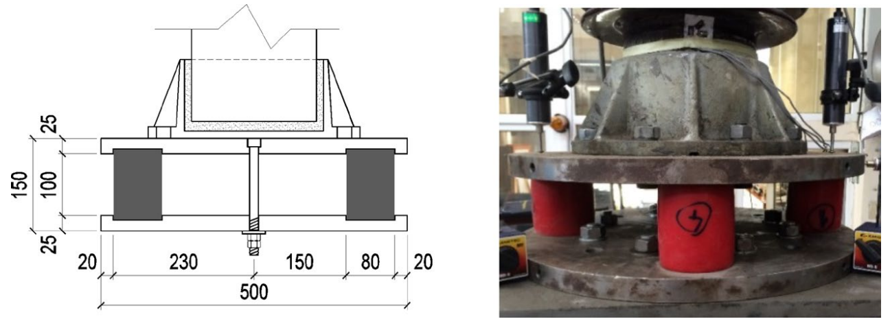

Figure 1. Typical sectional dimensions (in mm) and photograph of seismic isolation device

550 kV post-insulator was utilized in the experimental study with its steel caps. Base and top core diameters were 180 mm and 150 mm, respectively. Total height was 4000 mm, Figure 2. Self-weights of S1, S2 and S3 posts were 1.43 kN, 1.49 kN and 1.46 kN, respectively. Eight M16 (8.8 quality) bolts were utilized for connection of the bottom insulator cap.

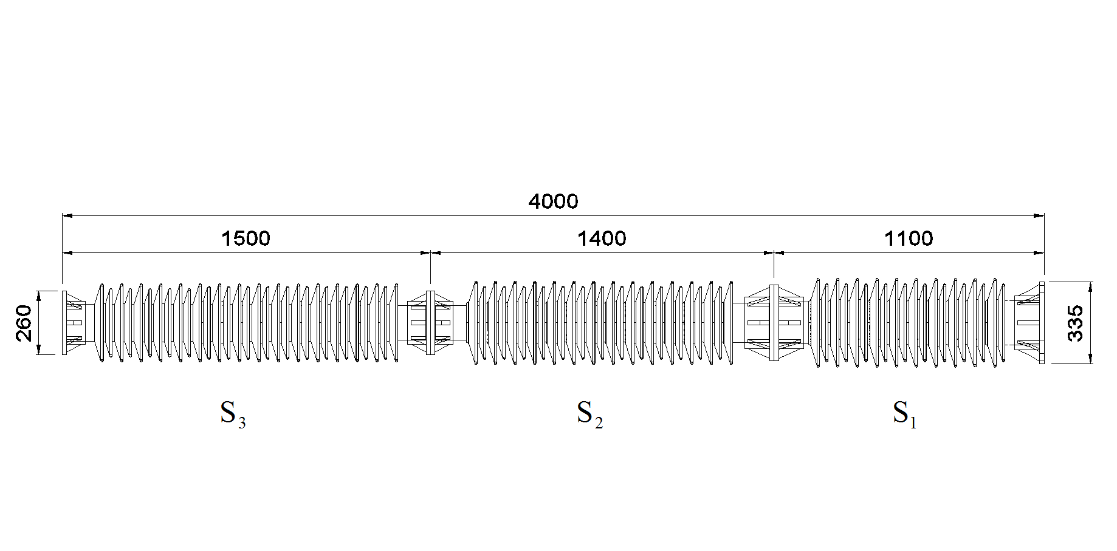

Figure 2. Dimensions of the tested porcelain post-insulator (in mm)

The supporting truss used in the experimental study has plan dimensions of 500×500 mm and height of 900 mm (Figure 3). All members of the truss are L50.50.5 section. The steel plate with 20 mm thickness was welded top of the truss.

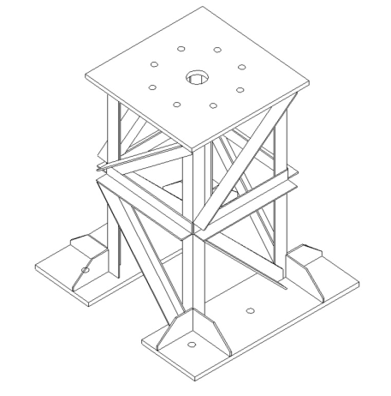

Figure 3. Steel support structure

**3. Experimental Studies**

***3.1 Free Vibration Tests***

Two test methods were applied to determine free vibration characteristics of the fixed base and isolated systems. They were impact hammer and pull-back tests that were performed for four different displacement intensities. Accelerometers were placed top and bottom sections of post-insulator, and top of supporting truss, Figure 4.

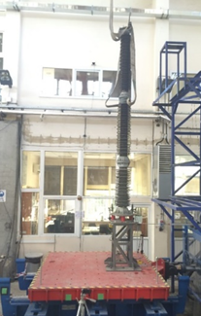

Figure 4. Post-insulator system on shake table

Typical recorded data for both of the support conditions is presented in Figure 5. Half power band-with and logarithmic decrement methods were utilized in the calculation of damping. Fundamental frequencies of the isolated and fixed base systems were obtained as 1.56 Hz and 5.57 Hz, respectively.

Figure 5. Typical free vibration response of the systems.

Although 2% damping ratio was obtained for the fixed base system, damping ratio was related with the applied displacement intensity for the isolated system. Stages of the damping tests for the isolated system is given in Table 1. The ratio varies in the range of 3-8%.

Table 1. Damping ratios obtained for the isolated case.

|  |  |  |  |  |  |
| --- | --- | --- | --- | --- | --- |
| **Method** | **Top Disp. (mm)** | **Max. Acc. (mm/s2)** | **Fund. Freq. (Hz)** | **Damping Ratio** | |
| **Logarithmic Decrement M.** | **Half-Power Bandwidth M.** |
| Hammer Test | 1.57 | 153 | 1.56 | 8.36% | 7.05% |
| Pullback-F | 25.12 | 1573 | 1.56 | 3.35% | 3.21% |
| Pullback-2F | 52.77 | 1380 | 1.56 | 4.87% | 3.94% |
| Pullback-3F | 88.14 | 4511 | 1.46 | 5.59% | 3.94% |
| Pullback-4F | 126.84 | 5040 | 1.46 | 6.00% | 3.90% |

***3.2 Strong Ground Motion Data***

Institute for Electrical and Electronics Engineers proposed acceleration spectra for seismic testing and qualification of substation equipment, IEEE-693 (2005). The acceleration spectra corresponding to 2% damped high-performance level were utilized as the target spectra in the study.

Five historical acceleration records were selected from FEMA-P695 (2009) database. The important features of the records are listed in Table 2.

Table 2. Selected ground motion data

|  |  |  |  |  |  |  |  |
| --- | --- | --- | --- | --- | --- | --- | --- |
| **Year** | **Earthquake** | **Station** | **Mw** | **PGA (mm/s2)** | **PGV (mm/s)** | **PGD (mm)** | **Scale Factor**  **(SF)** |
| 1976 | FRIULI | A-TMZ270 | 6.5 | 3088.3 | 308.0 | 50.9 | 1.84 |
| 1994 | NORTHR | LOS270 | 6.7 | 4728.4 | 449.1 | 125.4 | 1.35 |
| 1987 | SUPERST | B-POE360 | 6.5 | 2945.9 | 327.8 | 112.6 | 2.26 |
| 1989 | LOMAP | CAP090 | 6.9 | 4348.7 | 292.2 | 54.9 | 1.63 |
| 1989 | LOMAP | G03000 | 6.9 | 5444.8 | 356.8 | 82.6 | 1.65 |

The scaling procedure defined by Koliou et al. (2009) was applied to all acceleration data to fit their elastic spectra to the target one in the frequency range of 1.0-8.0 Hz. The scaling factors given in the last column of Table 2 are between in the range of 1.35-2.26. Mean spectrum of the records is presented together with the target spectrum in Figure 6. The frequencies of 5.57 Hz and 1.56 Hz that correspond to dominant frequencies of the systems are also revealed in the figure. It is obvious that the mean spectrum is higher than the target one for the tested specimens.

Fig. 6. IEEE-693 target spectrum vs. mean spectrum of the selected records

***3.3 Shake Table Tests***

550 kV post-insulator was positioned at center of the uni-axial shake table. Measuring system comprises four accelerometers, three long and three short-stroke displacement transducers, Figure 7.

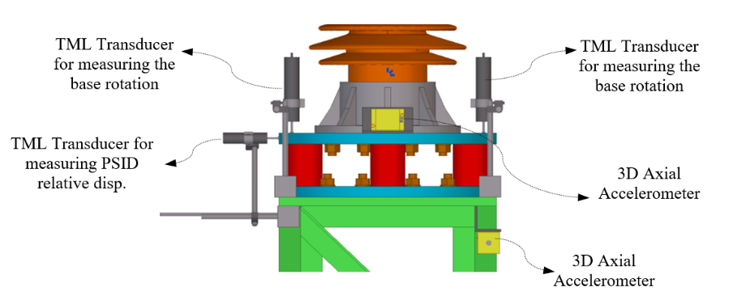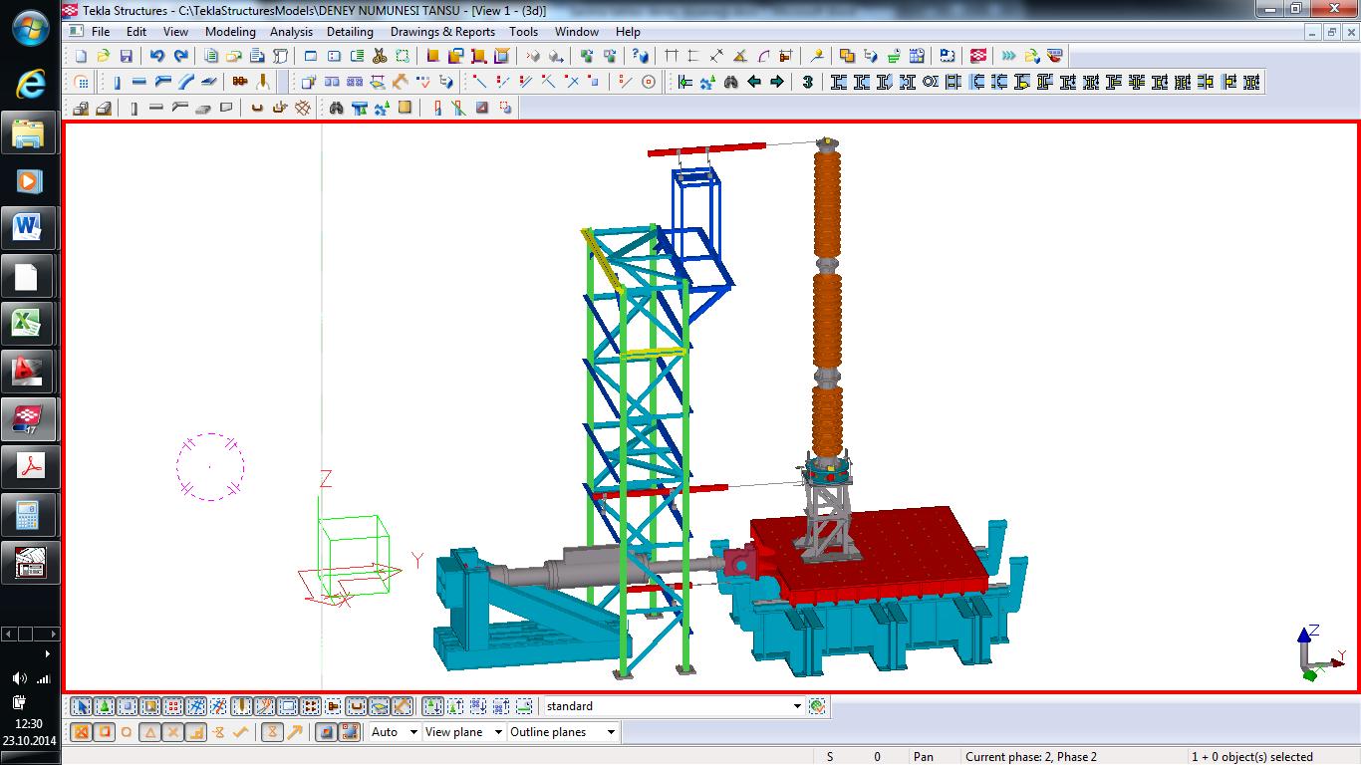

Figure 7. Shake table test setup and measuring system

The acceleration records listed in Table 2 were multiplied with the scale factors of 0.33, 0.66, 1.00 and (SF). White noise tests were performed between the successive runs. No damages were observed in the successive tests of fixed base and isolated specimens.

Relative top displacement and absolute top acceleration histories for A-TMZ270 and GO3000 earthquake records that corresponds to the least and the most effective cases for isolated system are presented in Figures 8 and 9. The effectiveness ratios calculated for the absolute accelerations are also given Figure 9.

|  |  |
| --- | --- |
|  |  |
| *max, fixed =12.83 mm*  *max, isolated =174.61 mm* | *max, fixed =32.40 mm*  *max, isolated =182.66 mm* |
| a. ATMZ-270 | b. GO-3000 |

Figure 8. The relative top displacement comparisons

|  |  |
| --- | --- |
|  |  |
| *amax, fixed = 11534 mm/s2*  *amax, isolated = 9306 mm/s2*  *effect ratio = 1 - (9306/11534) = 20%* | *amax, fixed = 25134 mm/s2*  *amax, isolated = 9668 mm/s2*  *effect ratio*= *1 - (9668/25134) = 62%* |
| a. ATMZ-270 | b. GO-3000 |

Figure 9. The top absolute acceleration comparisons

The measured maximum top accelerations are listed in Table 3 for the all selected earthquakes. Seismic isolation device is effective to decrease accelerations in ratios of 20%-62%.

Table 3. Comparison of the maximum top acceleration

|  |  |  |  |  |
| --- | --- | --- | --- | --- |
| **Earthquake** | **Station** | **Fixed Base (*mm/s2)*** | **Isolated (*mm/s2)*** | **Attenuation Ratio (%)** |
| FRIULI | A-TMZ270 | 11534 | 9306 | 20 |
| NORTHR | LOS270 | 17980 | 11187 | 38 |
| SUPERST | B-POE360 | 16429 | 9648 | 41 |
| LOMAP | CAP090 | 13341 | 10266 | 23 |
| LOMAP | G03000 | 25134 | 9668 | 62 |

The experimental shear and moment histories at the bottom section of post insulator were determined by using the recorded acceleration data, mass and height properties of the specimen. Equations 1 and 2 were utilized in the calculation of shear and moment values, (Koliou et al., 2009).

 (1)

 (2)

where and are mass, acceleration, damping and velocity profiles along height of the post insulator. *H* stands for total height of post-insulator.

The experimentally obtained shear force and base moment histories are illustrated in Figures 10 and 11 for ATMZ-270 and GO-3000 records. The effectiveness ratios are also demonstrated in the figures.

|  |  |
| --- | --- |
|  |  |
| *Vmax, fixed = 1.89 kN*  *Vmax, isolated = 1.59 kN*  effect ratio = *1 - (1.59/1.89) = 16%* | *Vmax, fixed = 6.42 kN*  *Vmax, isolated = 1.78 kN*  effect ratio = *1 - (1.78/6.42) = 72%* |
| a. ATMZ-270 | b. GO-3000 |

Figure 10. Shear force histories

|  |  |
| --- | --- |
|  |  |
| *Mmax, fixed = 5.78 kNm*  *Mmax, isolated = 3.81 kNm*  effect ratio *= 1 - (3.81/5.78) = 34%* | *Mmax, fixed = 15.43 kNm*  *Mmax, isolated = 3.33 kNm*  effect ratio *= 1 - (3.33/15.43) = 78%* |
| a. ATMZ-270 | b. GO-3000 |

Figure 11. Base moment histories

Ultimate moment capacity of post insulator was determined as from the performed quasi-static tests (Gokce, 2018). The capacity is above the obtained moments from the shake table tests. Dependently, no damage was observed in the tests. However, last versions of IEEE-693 (1985 & 2006) suggested the allowable bending moment for porcelain insulators as  and , respectively. The base moments given in Table 4 should be compared with . Moreover, the usage of lower damage threshold is suggested by Mohammadpour and Hosseini (2017) for the assessment of existing substation equipment that are relatively old and had poor engineering service.

Effectiveness ratios in terms of base moments are calculated in the last column of Table 4. The minimum and maximum effectiveness ratios are 28% and 78%, respectively.

Table 4. Comparisons of the maximum base moments

|  |  |  |  |  |
| --- | --- | --- | --- | --- |
| **Earthquake** | **Station** | **Fixed Base (kNm)** | **Isolated**  **(kNm)** | **Effectiveness**  **Ratio (%)** |
| **(1)** | **(2)** | **(3)** | **(4)** | **(4-3)/3** |
| FRIULI | A-TMZ270 | 5.78 | 3.81 | 34 |
| NORTHR | LOS270 | 8.09 | 4.50 | 46 |
| SUPERST | B-POE360 | 7.33 | 3.99 | 46 |
| LOMAP | CAP090 | 5.56 | 3.98 | 28 |
| LOMAP | G03000 | 15.43 | 3.33 | 78 |

**4. Conclusions**

Full scale dynamic tests of porcelain insulators on the support structure were performed for rigid and the isolated cases for a set of historical earthquakes. The general conclusions are as follows;

1. The predominant vibrational period of the HV porcelain insulator system is elongated to a target value as well as adding supplementary damping.
2. Equivalent damping ratios extracted from the distinct testing methods for the system with seismic isolation device was in the range of 3~8%, while it was 2% for fixed base system.
3. The recorded maximum top displacement of the isolated system was 183 mm. The larger top displacement matter may cause some modifications in the cable connections of the seismically isolated device.
4. Top acceleration of porcelain insulator is reduced significantly in the seismically isolated case.
5. The internal forces at the bottommost section that are crucial in the seismic design, reduced severely in the isolated case. Base moment of the isolated system reduced about 30 to 80% comparing with fixed base case.
6. The seismic isolation device returned to its original position after the completion of dynamic tests. No residual deformations and displacements were observed on the isolation device and the porcelain insulator.

The seismic isolation device meets the requirements given by IEEE-693 (2005) and it reduces the internal forces of HV porcelain insulator severely compared with the rigid type connection.

**5 Acknowledgments**

The first author was sponsored by Bideb 2211 Program of Scientific and Technological Research Council of Turkey (TUBITAK). The study was sponsored by the research funds of Istanbul Technical University (ITU BAP 39552). 550kV HV post-insulators were supplied by Güral Elektrik Company. The study was carried out in the Structural and Earthquake Engineering Laboratory (STEELab) of ITU. All supports are gratefully acknowledged.

**6. References**

Alessandri, S., Giannini, R., Paolacci, F. and Malena, M. (2015a) Seismic retrofitting of an HV circuit breaker using base isolation with wire rope. Part 1: Preliminary test and analyses, *Engineering Structures*, 98: 251-262.

Alessandri, S., Giannini, R., Paolacci, F. and Malena, M. (2015b) Seismic retrofitting of an HV circuit breaker using base isolation with wire rope. Part 2: Shaking table test validation, *Engineering Structures*, 98:263-274.

Buckle, I. Constantinou, M., Dicleli, M. and Ghasemi, H., (2006) Seismic isolation of highway bridges (Report No. MCEER-06-SP07), University at Buffalo, NY: MCEER.

Clemitson, I. R. (2015) Castable polyurethane elastomers. CRC Press, Boca Raton, USA.

FEMA P-695 (2009) Quantification of building seismic performance factors. Applied Technology Council for the Federal Emergency Management Agency, Washington, DC.

Filiatrault, A. and Matt, H. (2006) Seismic response of high voltage electrical transformer-bushing systems, *Journal of Structural Engineering*, 132-2: 287-295.

Falborski, T. and Jankowski, R. (2017) Experimental study on effectiveness of a prototype seismic isolation system made of polymeric bearings, *Applied Sciences* 7(8): 808.

Gokce, T., Yuksel, E., Orakdogen, E. (2017) Seismic protection of high voltage bushings by using polyurethane springs. *16th World Conference on Earthquake Engineering*, 9-13 January 2017, Santiago, Chile, Paper no: 2381.

Gokce, T., Orakdogen, E., Yuksel, E. (2018) Failure mode investigation for high voltage porcelain insulators, 16th European Conference on Earthquake Engineering, 18-21 June 2018 Thessaloniki, Greece, Paper no:11334.

Gokce, T., Orakdogen, E., Yuksel, E. (2019) Seismic performance enhancement of high-voltage post insulators by a polyurethane spring isolation device, *Bulletin of Earthquake Engineering*, 17 (3), 1739-1762.

IEEE Standard 693 (1985 & 2005) Recommended practice for seismic design of substations. Piscataway, NJ: IEEE Standard Department.

Koliou, M., Filiatrault, A., Reinhorn, A.M., (2009) Seismic protection of electrical transformer bushing systems by stiffening techniques (Report No. MCEER-12-002), University at Buffalo, NY: MCEER.

Jeong, K., Choi, E., Back, S. Y. and Kang, J. W. (2016) Smart damper using sliding friction of aramid brake lining and self-centring of rubber springs, *International Journal of Steel Structures*, 16(4): 1239-1250.

Kong, D. and Reinhorn, A. (2009) Seismic evaluation and protection of high voltage disconnect switches. *Lifeline Earthquake Engineering in a Multihazard Environment,* ASCE, 221-231.

Lee, D. and Constantinou, M.C. (2018) Combined horizontal–vertical seismic isolation system for high voltage–power transformers: development, testing and validation, *Bulletin of Earthquake Engineering*, 16 (9), 4273-4296.

Mohammadpour, S. and Hosseini, M. (2017), Experimental system identification of a 63kV substation post insulator and the development of its fragility curves by dynamic finite element analyses, *Earthquake Spectra*, 33-3: 1149–1.

Murota, N., Feng, M.Q. and Liu, G.Y. (2006) Earthquake simulator testing of base-isolated power transformers. *IEEE Transactions on Power Delivery,* 21-3:1291-1299.

Takhirov, S., Fujisaki, E., Kempner, L., Riley, M., Low, B. (2017) Full-scale component testing of seismic isolation devices and verification of their performance in full-scale system level tests on a shaking table. *7th International Conference on Advances in Experimental Structural Engineering*, 6-8 September 2017, Pavia, Italy.

1. Ph.D, Research Associate, Department of Civil Engineering, University of Bristol, UK, [tansu.gokce@bristol.ac.uk](mailto:tansu.gokce@bristol.ac.uk)
2. Prof. Dr., Faculty of Civil Engineering, Istanbul Technical University, Istanbul, Turkey, [orak@itu.edu.tr](mailto:orak@itu.edu.tr)
3. Prof. Dr., Faculty of Civil Engineering, Istanbul Technical University, Istanbul, Turkey, [yukselerc@itu.edu.tr](mailto:yukselerc@itu.edu.tr)