**AN analytical MODEL FOR LOW-SHEAR MODULUS HIGH-DAMPING RUBBER BEARINGS UNDER LARGE SHEAR DEFORMATION**

**DOI 10.37153/2686-7974-2019-16-438-448**

Masaru KIKUCHI[1], Ken ISHII[2], Hideaki KATO[3], Masahiro NAKAMURA[4]

**ABSTRACT**

This paper presents a new analytical model to accurately simulate the behavior of newly-developed low-shear modulus high-damping rubber bearings. The analytical model was constructed by combining two existing models previously proposed by the authors. One is a mechanical model to represent the coupled behavior of horizontal deformation and axial load on the shear properties of an elastomeric seismic isolation bearing. The model comprises a shear spring at mid-height and a series of axial springs at the top and bottom boundaries. The rigid columns are combined between the series of axial springs and the mid-height shear springs. The other model is a hysteresis model to represent the shear stress-strain relationship of the high-damping rubber bearings to be used for the shear spring in the mechanical model. The hysteresis model is based on empirical model parameters established by analyzing the bearings' test results. The validity of the proposed analytical model was demonstrated by analyzing the results of the bearing tests. Strong agreement between the analytical and experimental results was obtained. The proposed analytical model was shown to be capable of accurately expressing the effect of large shear deformation and axial load on the hysteresis loops for low-shear modulus high-damping rubber bearings.

*Keywords: Seismic isolation; Elastomeric seismic isolation bearing; Hysteresis model; Material nonlinearity; Geometrical nonlinearity*

**1. INTRODUCTION**

Low-shear modulus high-damping rubber bearings (HDRBs) for seismic isolation have been developed in Japan and offer many advantages. Their use in seismic isolation systems eliminates the need for other types of damping devices because their elastomers possess damping properties. The simplicity of this system is such that their use is expected to spread widely. Furthermore, their use gives a structure a lower fundamental frequency than that obtained from regular-shear modulus ones. In general, the lower the horizontal stiffness of the isolation device, the smaller the response acceleration in isolated buildings. Low-shear modulus HDRBs can be easily applied to even lightweight structures. Thus, these types of elastomeric bearings have great potential for applying seismic isolation technology to a wide range of building types.

Long-period ground motions caused by large subduction earthquakes have been of great concern in Japan, especially after the 2003 Tokachi-Oki earthquake (Mw 8.0) and the 2011 Tohoku earthquake (Mw 9.0). Extremely large deformation can be caused in bearings due to such long-period ground motions. Low-shear modulus HDRBs could suffer from deformations larger than that of regular shear modulus ones during severe earthquake ground motions. Thus, demand has been increasing for an analytical model to predict the behavior of low-shear modulus HDRBs under severe conditions for the design of seismically isolated buildings. The authors believe it a key issue in promoting the use of low-shear modulus HDRBs in the future.

**2. BEaring Tests**

Tests of a low-shear modulus HDRB were carried out with the objective of fully identifying its mechanical characteristics.

***2.1 Bearing Design***

The design of the tested bearing is summarized in Figure 1. The newly-developed compound is called X0.3R, the shear modulus of which is 0.3 MPa at 100% shear strain of rubber. The bearing consists of twenty-three rubber layers 2.0 mm thick and 225 mm in diameter (shape factor = 28.1) and twenty-two 1.0-mm thick steel shims.

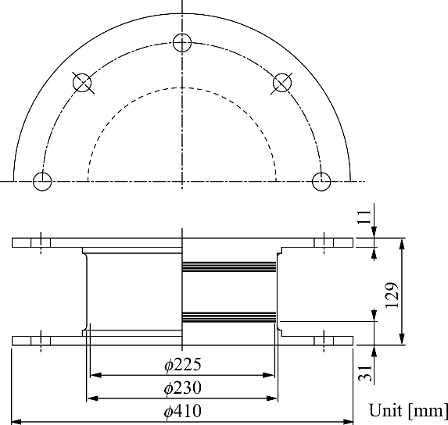

Rubber compound type: X0.3R

Diameter of rubber: 225 mm

Rubber sheet: 2.0-mm thickness x 23 layers

Steel shim: 1.0-mm thickness x 22 layers

Shape factor: 28.1

Aspect ratio: 4.89

Shear modulus*: 0.3 MPa

Equivalent damping ratio*: 0.17

* Standard temperature: 20°C,

Standard shear strain: 100%

Figure 1. Design of bearing tested

***2.2 Test Results***

The test was a sinusoidal horizontal displacement-controlled loading with three fully-reversed cycles. Shear strain amplitudes of 10, 20, 50, 100, 150, 200, 250, 300, and 400% were applied with three constant compressive stresses levels of * *=1 MPa, 5 MPa, and 10 MPa. Compressive stress of * * 5 MPa was the design standard value specified by the manufacture of this HDRB. The frequency of loading was 0.33 Hz for every test.

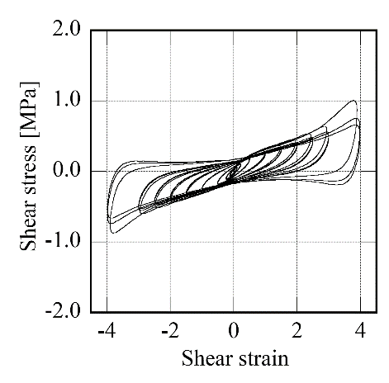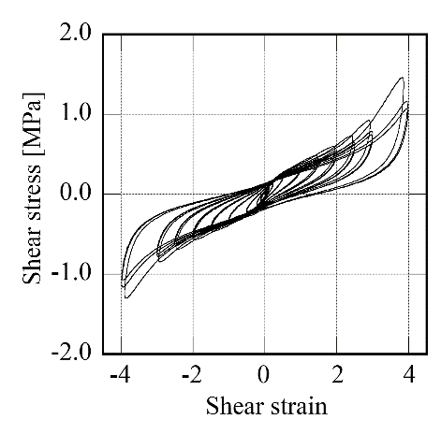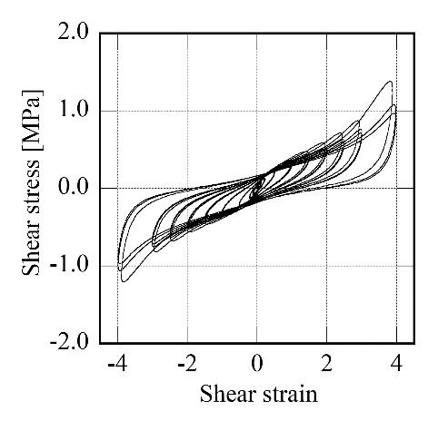

(a) * * 1 MPa (b) * * 5 MPa (c) * * 10 MPa

Figure 2. Shear stress-strain hysteresis loops obtained from tests

Shear stress-strain hysteresis loops of the HDRB under the three different compressive stresses are shown in Figure 2. Beyond a certain strain level, the HDRB exhibited common stiffening behavior in every compressive stress. Moreover, the dependency of compressive stress on the hysteresis loops were also exhibited. Two normal types of shear properties for HDRB, which are the equivalent shear modulus, *Geq*, and the equivalent damping ratio, *heq*, were evaluated from the test results as shown in Figure 3. The influence of compressive stress on the shear properties is clearly seen, especially in the large shear strain range. This shows that the coupled behavior under horizontal shear deformation (shear strain) and axial load (compressive stress) should be considered to predict the mechanical behavior of an HDRB under large shear deformation.

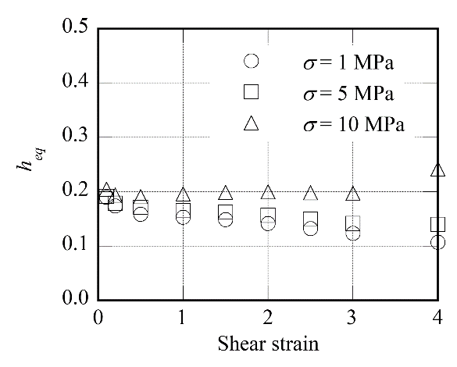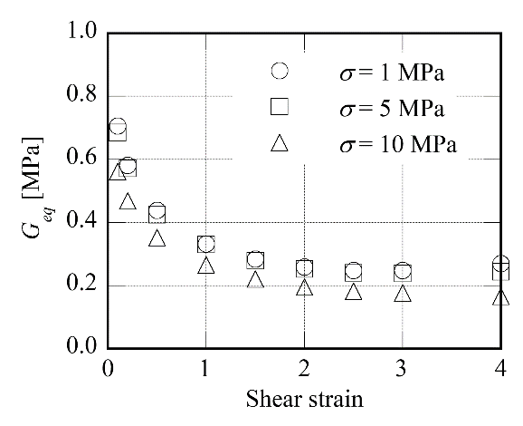

(a) Equivalent shear modulus, *Geq* (b) Equivalent damping ratio, *heq*

Figure 3. Shear properties

**3. ANALYTICAL MODEL**

An analytical model to predict the coupled behavior under horizontal deformation and axial load observed in the tests is described in this section. The model will be constructed by combining the mechanical model (Kikuchi et al. 2010 and 2012) and the shear hysteresis model (Kikuchi and Aiken 1997), both of which were previously developed for other types of elastomeric isolation bearings.

***3.1 Mechanical Model***

Figure 4 shows the mechanical model to incorporate the interaction between shear and axial forces. The model comprises a shear spring and an axial spring at the mid-height and two series of axial springs at the top and bottom boundaries. Each spring in the series of axial springs represents an individual strip of the bearing cross-sectional area. The rigid columns, which represent the height of the bearing, are combined between the series of axial springs and the mid-height shear and the axial springs. Each spring in the model is a uniaxial, nonlinear spring.

The definition of the forces and displacements on the model is shown in Figure 5. There are three displacement degrees of freedom, two transitions (horizontal and vertical) and one rotation, at the external nodes, *a* and *b*. The internal nodes, *m* and *n*, have two displacement degrees of freedom (vertical and rotational). The horizontal displacement of the internal node *m* is equal to that of the external node *a*. The same definition for nodes *a* and *m* is made for nodes *b* and *n*. By using incremental displacements of nodes *a* and *m*, and assuming that plane sections remain plane, the relationship between the incremental force vector, **f***am*, and the incremental displacement vector, **u***am*, on nodes *a* and *m* can be obtained as Equations 1–5.

 (1)

 (2)

 (3)

 (4)

 (5)

where *ikN* is the tangential stiffness of the *i*-th axial spring, and *il* is the distance from the centroid of the *i*-th strip to the cross-sectional area of the bearing.

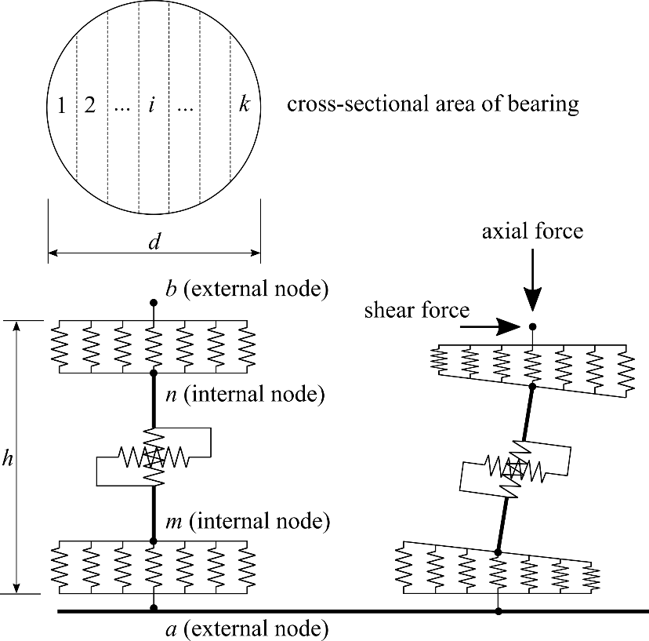

Figure 4. Mechanical model

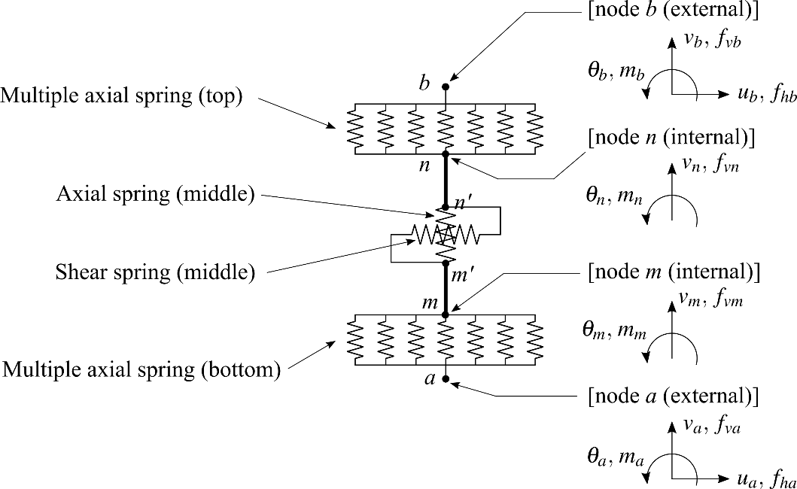

Figure 5. Force and displacement on mechanical model

The relationship between the incremental forces and displacements on nodes *b* and *n* can be obtained by replacing *a* with *b* and *m* with *n* in Equation 1 as follows:

 (6)

where **K***bn* is the stiffness matrix, **f***bn* is the incremental force vector, and **u***bn* is the incremental displacement vector of nodes *b* and *n*.

Considering the force-displacement relationship for the shear and axial springs at the mid-height of the model, the force-displacement relationship on nodes *n*’ and *m*’ in Figure 5, which exclude the rigid columns, is expressed as follows:

 (7)

where

 (8)

 (9)

 (10)

and *KS* and *KN* are the tangential stiffness of the mid-height shear and axial springs, respectively. *KR*is the stiffness of a rotational spring connected between nodes *m*’ and *n*’, which is not shown in Figures 4 and 5. The spring is a supplementary element, which provides rotational flexibility at the mid-height and gives the mechanical model the ability of handling various distributions of bending moment. The assumption that *KR* is infinity is made here.

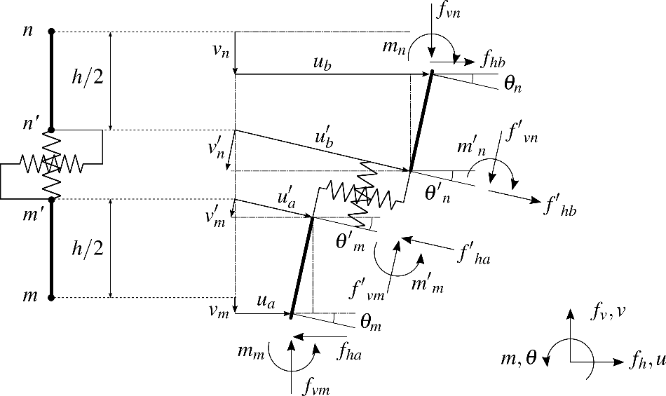

Figure 6. Geometrical relationships of deformations and forces on internal nodes

To convert the force-displacement relationship of nodes *m*’ and *n*’, expressed by Equation 7, to nodes *m* and *n*, which includes the rigid columns, a transformation matrix is used. Taking the geometrical relationships of the deformations, the force equilibrium condition, and the P- effect into account gives the transformation matrix, **T**. The geometrical relationships of the deformations and forces are shown in Figure 6. By using the matrix **T**, the transformation of the displacements and forces on nodes *m*’ and *n*’ into those on nodes *m* and *n* is expressed as follows:

 (11)

 (12)

where

 (13)

 (14)

 (15)

and *h* is the total height of the bearing.

Substituting Equations 7 and 11 into Equation 12, force-displacement relations on nodes *m* and *n* are obtained as

 (16)

 (17)

The overall stiffness matrix, **K***ab*, is obtained by arranging the elements of the partial stiffness matrices, **K***am*, **K***mn*, and **K***nb* into a 10×10 matrix. Finally, the relationship between the forces and displacements at the external and internal nodes in the mode is expressed as follows:

 (18)

where

 (19)

 (20)

 (21)

 (22)

and **f**ex and **u**ex are the incremental forces and displacements on the external nodes, *a* and *b*, and **f**in and **u**in are the incremental forces and displacements on the internal nodes, *m* and *n,* respectively.

***3.2 Hysteresis Model***

The shear hysteresis model previously developed by the authors is applied for the low-shear modulus HDRB. The model was originally developed for the initial compound of the 0.6 MPa shear modulus HDRB (Kikuchi and Aiken 1997). In this paper, the model will be expanded to the low-shear modulus HDRB tested above. The model defines a skeleton curve and hysteresis loops separately. The skeleton curve is expressed by Equation 23.

 (23)

where *F* is the shear force, *X* is the shear displacement, *Geq* is the elastomer shear modulus as a function of shear strain, ** is the shear strain of rubber, *A* is the bearing shear area, and *H* is the total thickness of the rubber sheet in the bearing.

The hysteresis loops are given by Equations 24–26. The force *F* is the combination of an elastic component *F*1 and a hysteretic component *F*2.

 (24)

 (25)

 (26)

where *Fm* is the peak force on the skeleton curve, *x* is the normalized displacement (*x* =*X/Xm*), and *Xm* is the peak displacement on the skeleton curve. In Equation 25, the parameter *n* specifies the stiffening, and the parameter *u* is the ratio of the force at zero displacement, *Fu*, to the peak force, *Fm* (*u*= *Fu /Fm*). In Equation 26, parameters *a* and *b* are calculated from Equations 27 and 28, which enforce the presumption that the analytical and experimental hysteresis loop areas are equal. The parameter *c* is a pre-selected constant that specifies the shape of the hysteresis loop.

 (27)

 (28)

where *heq* is the equivalent damping ratio. Equation 27 cannot be solved in closed form for parameter *a*, and thus must be solved numerically.

All of the parameters that control the shape of the hysteresis loop are updated using Equations 27 and 28 when the displacement on the skeleton curve exceeds the maximum displacement previously experienced. The above formulae are derived for application to steady-state hysteresis behavior. It is necessary to further develop a hysteresis rule for randomly varying displacement conditions of earthquake response analyses. The Masing rule is applied to fully define the bearing shear force under a randomly-varying displacement (Rosenblueth and Herrera 1964).

Table 1. Empirical formulae of shear hysteresis model.

**: shear strain of rubber]

|  |
| --- |
| *Geq* = 0.33433* *− [MPa](0.05 <* *≤ 2.0)  = 0.49000−0.21014* *+0.057652* *2−0.0046475* *3 [MPa] 2.0 <* *≤ 4.0) |
| *heq* = 0.18956−0.05284* *+0.0019156** 2−0.0028118** 3 0.05 <* *≤ 4.0) |
| *u*= 0.38928−0.15678* *+0.05432** 2−0.0077259** 3 0.05 <* *≤ 4.0) |
| *n* = 1.0 (const.)(0.05 <* *≤ 2.0)  = 1.86072−1.135* *+0.35232** 2 2.0 <* *≤ 4.0) |
| *a* : obtained from Equation 27, if * *≥ 1.5, 10.3411 (const.) |
| *b* : obtained from Equation 28, if * *≥ 1.5, 0.0 (const.) |
| *c* = 6.0 (const.) 0.05 <* *≤ 4.0) |

To apply the shear hysteresis model to the tested HDRB, empirical formulae as functions of shear strain were carefully identified from the third cycle of data for each shear strain level by using the least-square method. The formulae obtained are summarized in Table 1. Exponential and polynomial functions are used for the empirical formulae. The test data for 1 MPa of compressive stress was used, in which the effect of compressive stress on the shear properties was mostly eliminated. The effect of the axial load on the shear properties will be represented by the mechanical model considering the P-** effect described above.

The validity of the shear hysteresis model is examined through comparisons with experimental data and analytical results. The analyses were performed using the OpenSees program (PEER 2019). The hysteresis loops analytically obtained are compared with the experimental result of the third cycle under compressive stress of 1 MPa shown in Figure 2(a). The model expressed the experimental results with smooth curves. The proposed model can accurately predict the test hysteresis loops up to a 400% shear strain.

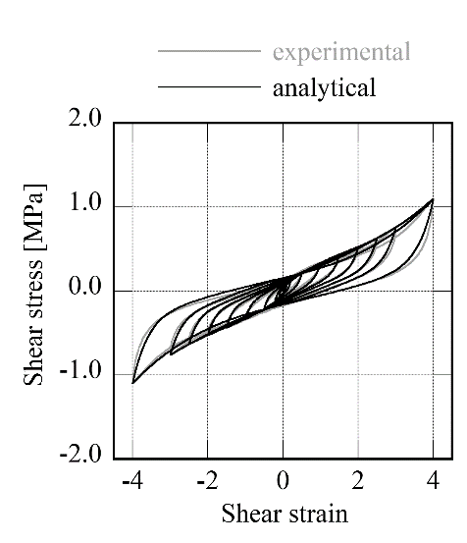

Figure 7. Analysis result using shear hysteresis model under compressive stress of 1 MPa

The stress-strain relationship for the series of axial springs at the top and bottom boundaries is shown in Figure 8. In general, a laminated rubber bearing exhibits high stiffness and yielding stress in the compression region and low stiffness and yielding stress in the tension region. The relationship between vertical strain and stress is antisymmetric. The behavior represented by the model shown in Figure 8 is generally accepted for the nonlinear vertical behavior of elastomeric isolation bearings.

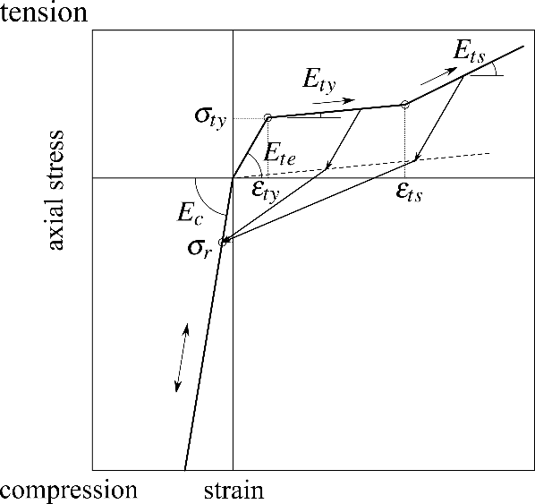

Figure 8. Hysteresis model for axial springs at the top and bottom boundaries

The apparent compression modulus assuming bulk compressibility, *Ec*, is obtained by Equation 29.

 (29)

where *E*0 is Young’s modulus of rubber, ** is the correction factor for the apparent compression modulus according to hardness, *S*1 is the shape factor, and *K* is the bulk modulus of rubber. The values of the parameters for the hysteresis model shown in Figure 8 are summarized in Table 2. Note that *Ec* was obtained by substituting *E*0 = 4.0 MPa, *K* = 1150 MPa, ** = 1.0 and *S*1 = 28.1 into Equation 29. (Bridgestone Corporation 2017)

Table 2. Value of the parameters for the hysteresis model shown in Figure 8.

|  |  |
| --- | --- |
| *Parameter* | Value |
| *Ec* | 9.73 x102 MPa |
| *Ete* | *Ec* /10 |
| *Ety* | *Ec* /100 |
| *Ets* | *Ec* /50 |
| *ty* | 1.0 MPa |
| *r* | 1.0 MPa |
| *ts* | 10 *ty* |

Moreover, the distribution of the compression modulus is also considered as shown in Figure 9. The weight function of Equation 30 is introduced to accommodate the distribution of the compression modulus, which is expressed as a function of the distance, *r*, from the centroid of the bearing cross section (Kelly 1997).

 (30)

where

 (31)

and *I*0 and *I*1 are the modified Bessel function of the first kind of order 0 and 1, respectively, *R* is the radius of the bearing cross section, *G* is the shear modulus of rubber, and *t* is the thickness of the rubber sheet.



Figure 9. Distribution of initial compression modulus

**4. simulation analyses**

The validity of the proposed model is examined through comparison with experimental data and analytical results. The analyses were performed using the OpenSees program (PEER 2019). The loading sequence used for the analyses was the same as that for the tests. The axial load was applied to the top of the model first, then the horizontal displacement histories for each peak shear strain level were applied. The analysis results are shown in Figure 10. The model accurately represented the influence of the magnitude of vertical compressive stress on the shape of those hysteresis loops.

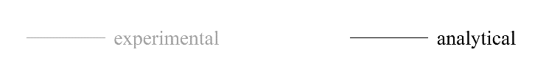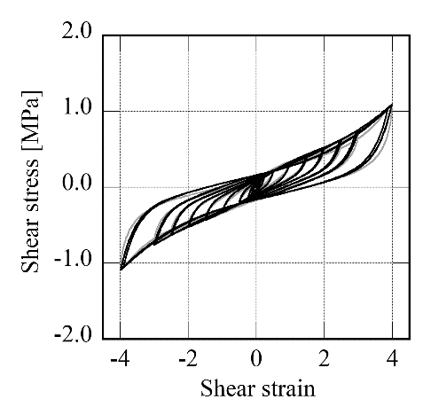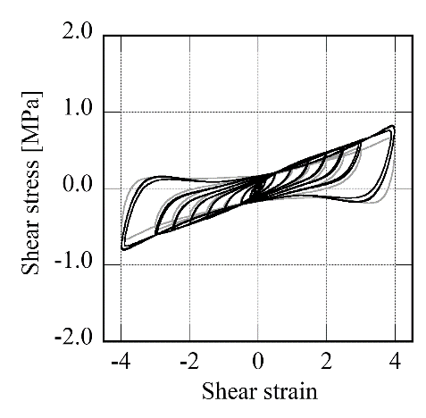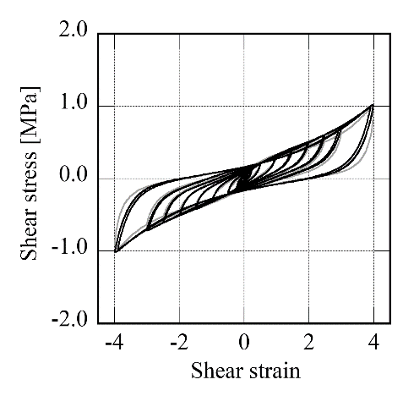

(a) * * 1 MPa (b) * * 5 MPa (c) * * 10 MPa

Figure 10. Analysis results using mechanical model

**5. Conclusions**

An analytical model for low-shear modulus high-damping rubber bearings has been developed. The model was constructed by combining two analytical models previously proposed by the authors: a mechanical model to represent geometrical nonlinearity and P- effect on the hysteresis loops, and a hysteresis model of the shear stress-strain relationship of the HDRBs. The bearing tests were conducted under three different compressive stresses to evaluate the mechanical characteristics of a newly developed low-shear modulus HDRB. The test results showed a dependency of compressive stress on the shear hysteresis loops, especially in the large shear strain range. The simulation analyses were conducted using the analytical model developed in this paper. The model accurately represented the magnitude influence of vertical compressive stress on the shape of the hysteresis loops. This shows that the model can become a useful numerical tool for designing seismically isolated buildings using low-shear modulus HDRBs.

**6. References**

Kikuchi, M., Nakamura T., Aiken, I. D. (2010) Three-dimensional analysis model for square seismic isolation bearings under large shear deformation and high axial loads. *Earthquake Engineering and Structural Dynamics,* (39): 1513-1531.

Kikuchi, M., Aiken, I. D., Kasalanati, A. Simulation analysis for the ultimate behavior of full-scale lead-rubber seismic isolation bearings. *Proceedings of the 15-th World Conference on Earthquake Engineering*, 24-28 September 2012, Lisbon, Portugal.

Kikuchi, M., Aiken, I. D. (1997) An analytical hysteresis model for elastomeric isolation bearings. *Earthquake Engineering and Structural Dynamics,* (26): 215-231.

Rosenblueth, E., Herrera, I. (1964) On a kind of hysteretic damping. *Journal of the Engineering Mechanics Division*, ASCE, 90(EM4): 37-48.

PEER (2019): <http://opensees.berkeley.edu/index.php>.

Bridgestone Corporation (2017) Seismic Isolation Product Line-up.

Kelly, J.M. (1997) *Earthquake-resistant Design with Rubber*. Springer: London, U.K.

1. Prof., Faculty of Eng., Hokkaido University, Sapporo, Japan, [mkiku@](mailto:mkiku@)eng.hokudai.ac.jp
2. Assistant prof. , Faculty of Eng., Hokkaido University, Sapporo, Japan, [ishii@ eng.hokudai.ac.jp](mailto:emailaddress@canterbury.ac.nz) 
3. Dept. of Infrastructure Development, Bridgestone Corp., Yokohama, Japan, [hideaki.kato@](mailto:hideaki.kato@)bridgestone.com
4. Dept. of Infrastructure Development, Bridgestone Corp., Yokohama, Japan, [masahiro.nakamura@](mailto:masahiro.nakamura@)bridgestone.com