THE NEW GENERATION EARTHQUAKE ISOLATION –
A BREAKTHROUGH IN PERFORMANCE

DOI 10.37153/2686-7974-2019-16-257-266

M. Bek, B. von Bernstorff, I. Emri, and B. V. Gusev, Y.L.Yin, K.C. Chang

Abstract

In this paper, we demonstrate performance of the new generation vibration isolation based on the patented Dissipative bulk and granular systems technology. This technology uses polymeric materials in granular form to enhance their dynamic properties by exposing them to “self-pressurization”, which shifts material energy absorptions maximum towards lower frequencies, to match the excitation frequency and/or rate of dynamic loading to which a mechanical system is exposed. In the case of TPU materials the stiffness and energy absorption capability of an isolation may be increased between 10 to 100 times.

Keywords: Vibration-isolation, Impact-isolation, Granular viscoelastic materials, Energy dissipation, Effect of pressure

1. INTRODUCTION

The role of vibrations and impact protection is to minimize kinetic energy transmission between the source and surrounding (receiver) [1, 2]. The effectiveness of an isolation is determined by parameters such as mass, stiffness and damping of an isolation [3]. Polymers are commonly used as isolations due to their good damping properties through viscose mechanisms, low specific density and good design and production flexibility [4]. However, their main drawback is low stiffness [5]. Comparing stiffness and damping of different polymeric materials, shows that the two properties are contradictory. Hence, polymers with high damping (energy absorption capability), typically elastomeric materials, have lower stiffness compared to polymers with lower damping, typically thermoplastic polymers [6, 7]. Due to their lower stiffness, polymers with higher damping are usually not used for vibration isolation. In addition, these materials exhibit maximal values of damping (energy absorption) at high frequencies, often at frequencies far away from working range of machines and devices. It becomes clear, that at present, we do not have available solutions allowing us to utilize the full damping potential that especially elastomeric materials offer. In order to overcome these drawbacks of polymeric materials (limited stiffness and maximal damping at high frequencies), we need to find an approach (i) how to increase isolation stiffness, and (ii) how to shift maximal values of material damping towards lower frequencies. We have solved the two issues with the patented Dissipative bulk and granular systems technology [8], which utilizes two scientific findings:
(a) We found that by exposing polymeric materials to selected hydrostatic pressure [9, 10], causes a shift of mechanical properties to lower frequencies. Hence, by selecting a proper (elastomeric) material with high damping properties and exposing it to a selected hydrostatic pressure, we can match the frequency range where material exhibits its maximal dissipation properties with the excitation or resonance frequency range of a vibrating structure. Using this principle, materials energy dissipation properties can be enhanced for several orders of magnitude. Unfortunately, pressures required for substantial change of damping properties may be quite high, i.e., from 50 - 100MPa, and even higher. Exposing bulk materials to such pressure levels in uniaxial compression will inevitably lead to appearance of cracks due to excessive accompanying shear stresses, and eventually to material failure. We have solved this problem with an inventive patented solution described below.
(b) We have realized that granular materials with a proper particles size-distribution may exhibit a flow-like behavior while maintaining all properties of a bulk material. To study the flowability of granular materials we have used the self-developed GFA apparatus (Granular Friction Analyzer) [11], which allows studying the ability of granular materials to flow in case when driving force is high (hydrostatic) pressure. Based on the studies of granular materials flowability we have concluded that polymeric granular materials with proper particles size-distribution may be used as a pressurizing media (similar as air in tires) to impose hydrostatic pressure on themselves (i.e., self-pressurization) and, as a result, change frequency dependence of their own damping properties. With a proper adjustment of the hydrostatic pressure, we can also adjust the stiffness of the damping element (again, similar as with air in tiers). Since energy dissipation of a damping element is proportional to the volume of used granular materials, whereas the stiffness in addition depends on geometry of a damping element, the two parameters (damping and stiffness) may be adjusted independently.

1.1 Granular damping elements (GDE)

Considering the two scientific fats, Granular damping elements (GDE), were developed. GDE consists of a container, made of woven basalt, carbon or glass fibers, which is filled and pressurized with polymeric granular materials with multi-modal particles size-distribution. Due to the flow-like behavior of granulated polymers, the generated pressure within the container will be hydrostatic and will act on polymeric particles themselves, and consequently modify frequency dependence of their energy absorption properties. Hence, with a proper pressurization we may shift the material energy absorption maximum to any desired frequency. A sketch of such Granular damping element (GDE) is shown Figure 1, whereas Figure 2 schematically presents its working principle.

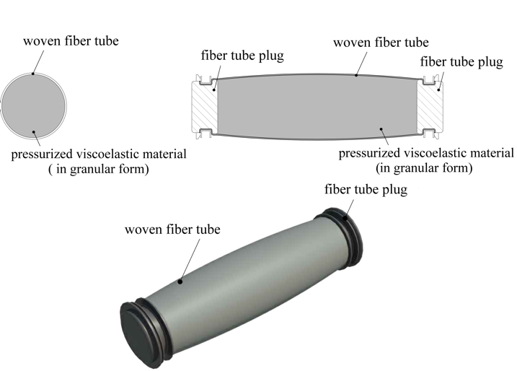

Figure 1. Schematic presentation of Granular damping element (GDE).

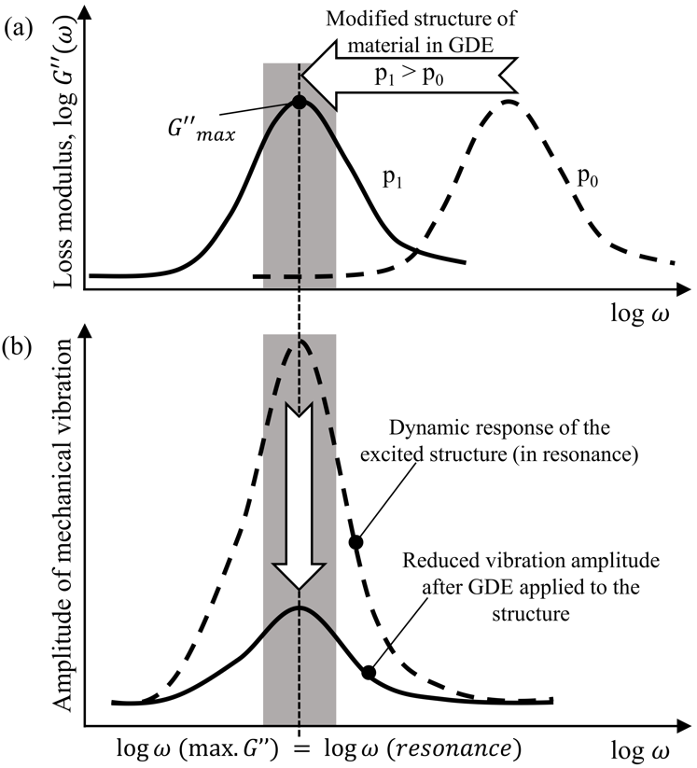

Figure 2 Working principle behind Granular damping elements.

Let us assume that a vibrating structure is equipped with a damping element made of a polymeric material of which its frequency dependent damping properties at environmental pressure p₀, expressed with the loss modulus $G''(ω)$, are shown in Figure 2(a) as a dashed line. In the frequency range where the structure is in resonance, indicated as a shadowed area, the damping properties of this material are low. Consequently, the structure vibration amplitudes in the resonance frequency range will be large, as shown with a dashed line in Figure 2(b). Now, if we take the very same material in a granular form with a proper particles-size distribution and self-pressurize it within a woven container, we obtain the new GDE damping element with the ultimate damping properties. This is achieved by selecting a proper hydrostatic pressure p₁ within the container that shifts the loss modulus maximum to the resonance frequency range of the structure, as shown in Figure 2(a) with a solid line. As a result, the vibration amplitudes of the structure will substantially diminish, as shown as a solid line in Figure 2(b).
To summarize, for vibration and/or impact control, where high damping is necessary, high values of loss modulus $G''(ω)$ are needed, since loss modulus is related to dissipated energy. To fully utilize the damping properties of a polymeric material, the frequency range of its loss modulus maximum ${G''}_{max}(ω)$should be matched with an excitation frequency or an impact rate imposed to a mechanical system. As mentioned before, this may be achieved by exposing elastomeric granular material to a properly selected hydrostatic pressure and adjust the frequency at which the material exhibits maximum energy dissipation, i.e., ${G''}_{max}(ω)$, such so to match the frequency of the vibrating structure. Described approach allows ultimate utilization of damping properties of all existing and/or newly developed polymeric materials of which its maximum damping frequency is located at higher frequencies than the resonance frequency range of an observed dynamic system.
To this end, the goal of this paper is to examine pressure and frequency dependence of three polyether-based thermoplastic polyurethane (TPU) materials that are potential candidates for building the new generation GDE damping elements.

2. EXPERIMENTAL

2.1 Experimental setup

All experiments were performed on a self-built apparatus, called CEM Measuring System, shortly CMS [9, 10]. CMS allows measurements of shear relaxation and bulk creep compliance properties of polymers in solid state, simultaneously subjected to temperatures ranging from -40°C to +120°C, and hydrostatic pressures ranging from atmospheric to 500MPa. The apparatus is shown schematically in Figure 3.

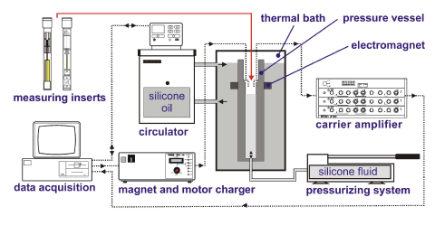
Figure 3. Schematic representation of CMS apparatus [9].

The pressure is generated by the pressurizing system using silicone oil. The pressure vessel is contained within the thermal bath, where another silicone oil circulates from the circulator, used for precise temperature control. The apparatus utilizes two separate measuring inserts, which can be inserted into the pressure vessel, the relaxometer and the dilatometer. Signals from the measuring inserts pass through the carrier amplifier prior to being collected in digital format by the data acquisition system. The magnet and motor charger supplies current to the electromagnet, which activates the measurement. The same charger also supplies current to the electric motor of the relaxometer, which pre-loads the spring that then applies the desired torsional deformation (angular displacement), to the specimen. Specimens can be simultaneously subjected to pressures of up to 500MPa with a precision of ±0.1MPa, and to temperatures ranging from -40°C to +120°C with a precision of ±0.01°C. Details on the experimental setup are given elsewhere [9, 10].

2.1 Sample preparation

We have investigated three polyether-based thermoplastic polyurethane (TPU) materials from the Elastollan® 11 series, i.e., (i) 1190A, (ii) 1175A, and (iii) 1195D, produced by BASF, that are already used in manufacturing of vibration insulation. Since Elastollan® is hygroscopic material, all materials were dried at 100°C for at least 3 hours in a commercial dryer (SP105-C, Kambič, Slovenia), to avoid bubbles formation during the extrusion process.
Due to measuring limitations of the CMS apparatus, we had to prepare samples with different diameters for measurements at different pressure-temperature boundary conditions. Samples were prepared with PolyLab HAAKE Rheomex PTW 16 extruder (Thermo Haake, Germany) equipped with two co-rotating 16mm screws. Thicker samples ($ϕ=\sim$6mm and $\sim$11mm) were prepared by extrusion into glass tubes that were coated from the inside with a silicon rubber (Tesacoma, silicone pastry board), to prevent the extruded melt from sticking to the glass. Coated glass tubes were pre-heated to 100°C before they were filled with materials, and then-after naturally cooled at room conditions. Thinner samples ($ϕ=\sim$2mm and $\sim$4.5mm) were prepared by continuous extrusion into a water bath. The speed of a subsequent conveyor belt together with the screw speed enabled us to alter diameters of thin samples. After extrusion, the thin samples were let to free hang under their own weight for about 12 hours at room conditions, to make them straight. Next, materials were cut with a razor blade to the specified length and the cut surfaces were finished with a sand paper (using very fine P220 and super fine P1200 sand paper).
To remove residual stresses in samples resulting from extrusion, cutting, and gluing, all samples were annealed prior measurements. The start of this procedure was raising the temperature in the commercial dryer (SP105-C, Kambič SP105-C, Slovenia) from room conditions to 90°C. The temperature was held constant for three hours, followed by slow cooling. Cooling was done in two stages, 1st stage was done inside the oven to room conditions, around 20°C, and in the second stage samples were removed from the oven and placed inside insulation box (to assure required rate of cooling) that was placed inside a freezer. Using this procedure temperature of -20°C was achieved. During the cooling, the average cooling rate was ~0.15°C/min.

2.2 Measuring procedure

All experiments were conducted on previously described CMS apparatus. For obtaining the shear relaxation properties, experiments were performed at two different sets of boundary conditions. The 1st Set of experiments was performed at isobaric conditions (at constant pressure) at p = 0.1MPa, at different constant temperatures between -20 to 60°C. The exact temperatures are provided within diagrams. The 2nd Set of experiments was performed at isothermal conditions (at constant temperature) at T = -20°C, at different constant pressures ranging between 0.1 and 300MPa. Figure 4 schematically shows boundary conditions of both sets of experiments, while the corresponding temperature and the pressure loading profiles for each of the three TPU's are presented in Figure 5.
In all experiments, each loading step consists of 3 hours stabilization time and 1000s (~ 15min) measuring time. All experiments started at conditions where material is closer to glassy state, i.e., at lowest temperature for the 1st Set and at highest pressure for the 2nd Set of experiments. In all cases at least three repetitions of measurements were performed, where for each repetition different sample was used. After averaging segments measured at the same boundary conditions, we have applied the Closed Form Shifting algorithm to create the shear relaxation, G(t) mastercurves. The latter were then interconverted into the frequency domain, to obtain the storage $G'(ω)$, and the loss $G''(ω)$, moduli for the three examined materials.

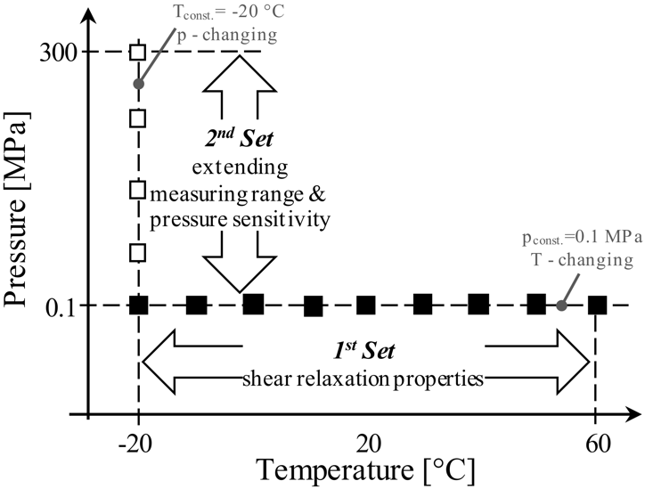

Figure 4. Boundary conditions for determining shear relaxation properties and pressure sensitivity of selected materials.

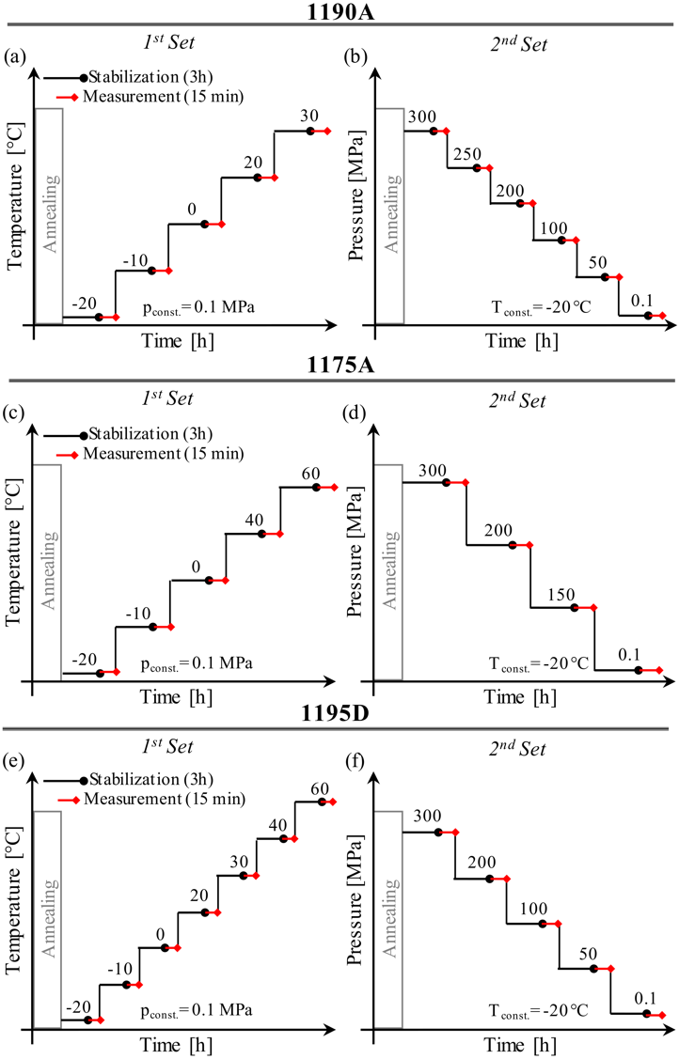

Figure 5. Temperature/pressure loading profiles for individual materials used in shear relaxation experiments.

2. RESULTS AND DISCUSSION

To model the effect of pressure, we have used the FMT model, proposed by Fillers, Moonan and Tschoegl [13-15]. The FMT model can be viewed as an extension of the WLF equation to account for the effect of pressure in addition to that of temperature. The shift factor as function of temperature and pressure is given in the form:

$\log{a_{T,p}=-\frac{C_{1}^{00}\left[T-T_{0}-θ(p)\right]}{C_{2}^{00}\left(p\right)+T-T_{0}-θ(p)}}$ (1)

where

$θ\left(p\right)=C_{3}^{0}\left(p\right)\ln\left(\frac{1+C_{4}^{0}\left(p\right)}{1+C_{4}^{0}\left(p_{0}\right)}\right)-C_{5}^{0}\left(p\right)\ln\left(\frac{1+C_{6}^{0}\left(p\right)}{1+C_{6}^{0}\left(p_{0}\right)}\right)$ (2)

and C's follow as

$C_{1}^{00}=B/{2.303f_{0}}$, (3)

$C_{2}^{00}={f_{0}}/{α_{f}(p)}$, (4)

$C_{3}^{0}(p)=1/{k_{e}α_{f}(p)}$, (5)

$C_{4}^{0}={k_{e}}/{K_{e}^{*}}$, (6)

$C_{5}^{0}(p)=1/{k_{ϕ}α_{f}(p)}$, (7)

$C_{6}^{0}={k_{ϕ}}/{K_{ϕ}^{*}}$ (8)

The 00 superscript indicates that the parameter is referred to the reference temperature T₀ (first place) and to the reference pressure p₀ (second place). A single 0 superscript refers to the reference temperature only. The * superscript refers to zero (in practice, atmospheric) pressure, while subscripts e and f stand for “entire-” and “free-” volume, respectively. Equation 1 is the Fillers-Moonan-Tschoegl (FMT) equation. $K_{e}^{*}$ and $k_{e}$ and thus $C_{4}^{0}$, can be determined from separate volume-pressure measurements through a fit to the equation

$\ln{\frac{V}{V_{0}}}{=-\frac{1}{k_{e}}\ln\left[\frac{K_{e}^{*}\left(T\right)+k_{e}p}{K_{e}^{*}\left(T\right)+k_{e}p_{0}}\right]}$, (9)

by a non-linear least-squares procedure. In Equations 1-9, $α_{f}$ denotes expansivity (i.e., the isobaric cubic thermal expansion coefficient) of the fractional free volume, f₀ = f(p₀) is fractional free volume at reference pressure, $K_{e}^{*}\left(T\right)= K_{e}(T)|_{p=0}$ is the bulk modulus at atmospheric pressure, and $k_{e}$ is a proportionality constant deemed independent of either pressure or temperature. FMT constants C₁ and C₂ were obtained through time-temperature-pressure superposition. Volumetric measurements were used to determine material parameters $K_{e}^{*}$ and $k_{e}$ (and thus C₄ using Equation 6) by fitting the Equation 9. For the calculation of the remaining constants C₃, C₅ and C₆, experimental shift factors obtained from measurements at constant temperature ($T=-20°C$) and varying pressures, were fitted to Equation 1 using Levenberg-Marquardt algorithm (MATLAB R2015a). Table 1 shows FMT parameters for all three materials.

Table 1. FMT parameters

Due to the space limitation, we do not show results on shear relaxation, G(t), mastercurves, which were interconverted into the frequency domain, to obtain the storage $G'(ω)$, and the loss $G''(ω)$, moduli for the three examined materials. Frequency domain material functions, the storage $G'(ω)$, and the loss $G''(ω)$, moduli, are shown in Figure 6, in double logarithmic and semi-logarithmic coordinate systems. Figures 6(a) and (c) show the storage modulus $G'(ω)$, whereas Figures 6(b) and (d) the loss moduli $G''(ω)$.
The storage modulus $G'(ω)$, which defines the vibro-isolation stiffness, increases with excitation frequency for about 100 times for 1190A and 1195D, and for about 10 times for 1175A. However, as seen from the semi-logarithmic diagrams, within the frequency range indicated as shaded area that is of interest for engineering applications, their stiffness is quite low. In the case of 1175A we may see that it behaves elastically, i.e., its storage modulus is almost constant, up to 10⁴Hz, whereas, within the same frequency range, the stiffness of other two materials exhibit quite strong frequency dependence. From double logarithmic diagram, we see that 1175A exhibits abrupt transition at 10⁴Hz, while for the other two materials this transition is much more gradual.
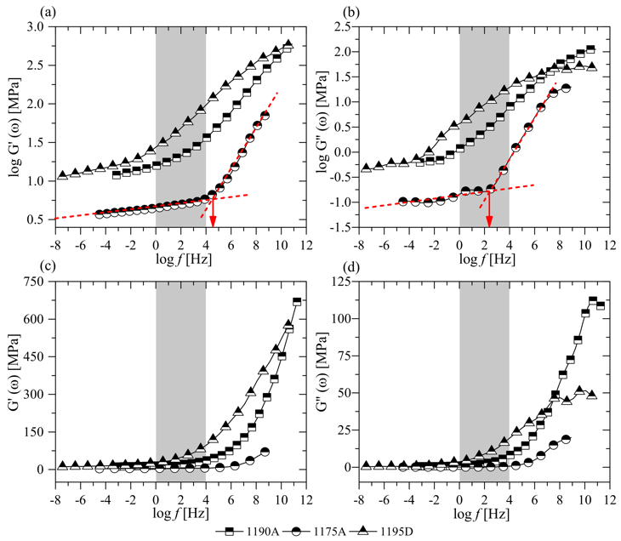

Figure 6. Shear storage modulus $G'(ω)$ in (a) double logarithmic and (b) semi-logarithmic coordinate systems; and shear loss modulus $G''(ω)$ in (c) double logarithmic and (d) semi-logarithmic coordinate systems. All figures are shown at T_{ref} = 20C and p_{ref} = 0.1MPa.

The loss modulus $G''(ω)$, also increases with excitation frequency for all three materials, again for about 100 times for 1190A and 1195D, and for about 10 times for 1175A. Since the loss modulus $G''(ω)$, defines the damping ability of a vibro-isolation, the higher values mean better damping. However, from the Figures 6(b) and (d) we may see that maximal measured values in all three cases are located at very high frequencies, between 10⁸-10¹² Hz. In addition to this, it may also be seen that in the frequency range that is of interest in most engineering applications, shown as shaded area, values of loss modulus $G''(ω)$, are relatively low, i.e., in the range between 0.1 to 25MPa, which is not bad in comparison to metals, however far away from real potentials of TPU materials.
Comparing the three TPUs shows that material 1175A has the lowest loss modulus $G''(ω)$, through the whole frequency range. As in the case of storage modulus $G'(ω)$, 1175A at about 10³ Hz abruptly enters the transition state where its energy absorption properties are strongly excitation frequency dependent, before that its dissipation properties are more or less constant, see Figure 6(b). This transition is for 1190A and 1195D much more gradual.

2.1 Analysis of GDE potentials

Combining the information on dynamic viscoelastic material functions presented in Figures 6 with materials hydrostatic pressure sensitivity, we may construct 3D diagrams showing interrelation between the storage, $G'(ω)$, and the loss, $G''(ω)$, moduli, excitation frequency, and hydrostatic pressure to which material is exposed. The results are shown in Figure 7 for the storage modulus $G'(ω)$, and in Figure 8 for the loss modulus $G''(ω)$.
The 3D diagrams provide a general inside how the two material functions depend on hydrostatic pressure and excitation frequency. The differences between the three materials are obvious, particularly when comparing their loss moduli.

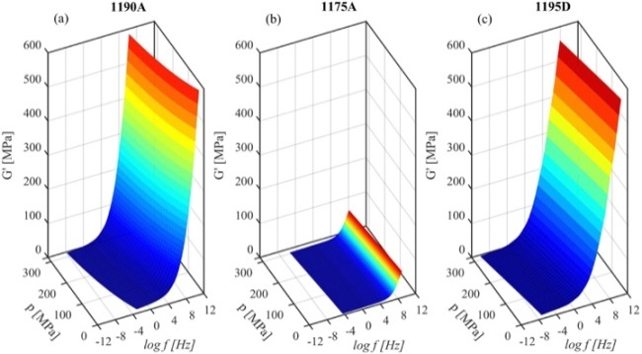

Figure 7. Frequency dependent shear storage modulus $G'(ω)$ in dependence of hydrostatic pressure for (a) 1190A, (b) 1175A and (c) 1195D at Tref = 20°C.

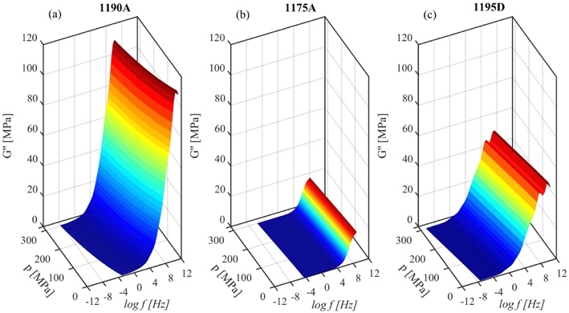

Figure 8. Frequency dependent shear loss modulus $G''(ω)$ in dependence of hydrostatic pressure for (a) 1190A, (b) 1175A and (c) 1195D at T_{ref} = 20C.

Comparing the three diagrams in Figures 7, we clearly see the huge difference between the three materials in the effect of pressure on improvement of isolation stiffness. Within the frequency range of interest TPU 1190A and TPU1195D are very sensitive, both, to pressure and to excitation frequency to which material (insulation) is exposed. In case of isolation energy absorption properties, displayed in Figure 8, we again observe strong difference between the three materials, however, the effect of pressure is in this case even stronger and different than in the case of isolation stiffness.
High energy absorption and an increase of isolation stiffness caused by excitation frequency makes TPU 1190A a very attractive material for the new generation DGE damping elements. The two characteristics work hand-in-hand, high energy absorption diminishes vibrations per se, in addition an increase of isolation stiffness will move away mechanical system resonance frequency causing additional reduction of vibrations.

3. SUMMARY AND CONCLUSIONS

The paper presents analysis of pressure dependence of three Elastollan® materials, i.e., 1190A, 1175A, and 1195D in frequency domain, that are used in manufacturing of vibration insulation. The aim of the investigation was to analyze how much one can enhance performance of an insulation by using these materials in breakthrough Granular damping elements (GDE), that are based on a patented Dissipative bulk and granular systems technology. DGE insulation uses polymeric materials in granular form to enhance their dynamic properties by exposing them to hydrostatic pressure, which shifts material energy absorptions maximum towards lower frequencies, to match the excitation frequency of dynamic loading to which a mechanical system is exposed.
From the obtained results, one may draw the following conclusions:
- The three polyether-based thermoplastic polyurethane (TPU) materials from the Elastollan® 11 series, i.e., 1190A, 1175A, and 1195D, with similar chemical structure, exhibit significantly different frequency-dependent properties.
- All three materials are quite sensitive to pressure, and 1190A proofs to be the most sensitive of the three materials. At 300MPa, properties of 1190A are shifted along the logarithmic frequency scale for around 5.5 decades, for 1195D and 1175A this shift is only about 3.5, and 1.5 decades, respectively. These shifts may be achieved by exposing materials to selected hydrostatic pressure.
- The storage modulus $G'(ω)$, which defines the vibro-isolation stiffness within the frequency range of interest, may be increased with pressure for about 100 times for 1190A and 1195D, and for about 10 times for 1175A.
- The loss modulus $G''(ω)$, which defines the vibro-insulation energy absorption capability within the frequency range of interest, may be increased with pressure for again about 100 times for 1190A and 1195D, and for about 10 times for 1175A.
In conclusion, among the three measured materials it was shown that material 1190A seems to be the most promising for the use in Granular damping elements. Besides having the largest values of loss modulus$G''(ω)$ it is also the most sensitive to pressure. Meaning, that even at relatively small applied hydrostatic pressures the increase of loss modulus $G''(ω)$ is higher compared to the other two materials.

4. Acknowledgement

The authors wish to thank Uroš Mavec and Ernest Tripodi for their contribution in performing shear relaxation measurements, and BASF for their generous donation of TPU materials. We also want to acknowledge the partial financial support of the Slovenian Research Founding Agency, under the contract P2-0264.

5. References

C. Hansen, Effects of low-frequency noise and vibration on people (Brentwood, UK, 2007).
M. J. Crocker, Handbook of noise and vibration control (John Wiley & Sons, 2007).
D. D. L. Chung, Journal of Materials Science 36, 5733 (2001)
E. I. Rivin, Passive vibration isolation (Asme press New York, 2003) p. 432.
R. Lakes, Viscoelastic Materials (Cambridge University Press, 2009).
D. I. G. Jones, Handbook of viscoelastic vibration damping (John Wiley & Sons, 2001).
R. S. Lakes, Journal of Composite Materials 36 (2002), 10.1106/002199802023538.
I. Emri and B. von Bernstorff, “Dissipative bulk and granular systems technology," (2016), patent EP2700839.
I. Emri and T. Prodan, Experimental mechanics 46, 429 (2006).
A. Kralj, T. Prodan, and I. Emri, Journal of Rheology 45, 929 (2001).
M. Bek, J. Gonzalez-Gutierrez, J. A. M. Lopez, D. Bregant, and I. Emri, Powder Technology 288, 255 (2016).
M. Bek, J. Betjes, B. von Bernstorff, and I. Emri, Viscoelasticity of the new generation TPU vibration isolation, Submitted to Physics of Fluids
W. G. Knauss, I. Emri, and H. Lu, Mechanics of Polymers: Viscoelasticity. In W. N. Sharpe (Ed.), Springer Handbook of Experimental Solid Mechanics (Springer Verlag, 2008) pp. 49-96
R. Fillers and N. Tschoegl, Transactions of the Society of Rheology 21, 51 (1977).
W. Moonan and N. Tschoegl, Macromolecules 16, 55 (1983)

Center for Experimental Mechanics, Faculty of Mechanical Engineering, University of Ljubljana, Slovenia
International Academy of Engineering, Russia
Center for Experimental Mechanics, Faculty of Mechanical Engineering, University of Ljubljana, Slovenia; International Academy of Engineering, Russia
International Academy of Engineering, Russia
International Academy of Engineering, Russia
International Academy of Engineering, Russia

