aLIBEYKöY AND KAGITHANE VIADUCTS: ADVANCED SEISMIC PROTECTION SOLUTIONS IN HIGH SEISMICITY REGION

DOI 10.37153/2686-7974-2019-16-660-671

Mauro SARTORI, Stefano BARONE, Claudio GALBIATI,
Burak TURKDONMEZ, Ivica ZIVANOVIC

ABSTRACT

High-seismicity regions require advanced earthquake protection systems. Turkey is one of the most seismically active regions in the world; its capital city, Istanbul, has an ever-increasing demand of public transportation between different parts of the city. The Alibeyköy and Kagithane viaducts are integral part of the new Istanbul metro line and represent an extraordinary worldwide example of base isolation and energy dissipation through the combination of different types of anti-seismic devices.
The seismic protection is obtained through spherical bearings able to support vertical loads up to 60.000 kN with maximum displacement capacity in longitudinal and transversal directions equal to ±350 mm. The bearings are equipped with CE marked anti-seismic devices with high hysteresis capacity and high strength sliding material with frictional properties to improve the overall dissipation capacity. The hysteretic dampers are made by “E” and “C” shaped steel elements. Some of these bearings are equipped with lock-up devices to allow service movements and to activate the hysteretic dampers during the seismic event. The paper describes in detail the need of multi-functional solution covering the full range of products available for seismic protection and all the tests performed to qualify the behavior of the devices.

Keywords: Base Isolation; Energy Dissipation; Viaducts; Anti-seismic Devices

1. INTRODUCTION

Turkey is one of the highest seismic regions in the world, being in the middle of the Anatolian fault. This strike-slip fault is about 1500 km long and crosses the country from east to west. Lots of destructive earthquakes up to Moment Magnitude M_{w} = 7.5 occurred in the last years on the fault-line like the ones occurred in Izmit (1999, M_{w} = 7.4) and Duzce (1999, M_{w} = 7.2). Istanbul, due to the ever-increasing demand for transport, requires a continuous improvement of its mobility system. In this context, the Alibeyköy and Kagithane viaducts, part of the new Istanbul metro line between Mecidiyeköy and Mahmutbey cities, are 18 km long and are protected against earthquakes through base isolation. Figure 1 shows the location of the viaducts.

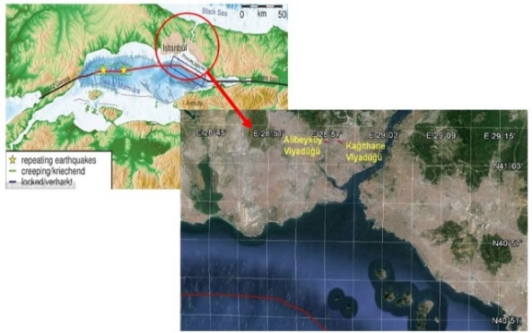

Figure 1. Geographic location of the viaducts

2. CHARACTERISTICS OF THE VIADUCTS AND SITE SEISMICITY

The viaducts, located close to the Alibeyköy and Kagithane stations, are very similar and composed by two post-tensioned box girder decks with three continuous spans at the center and two continuous spans from 50 to 73 m close to the abutments. The piers are short (about 6 m) and this makes the viaducts very sensible to the seismic excitation since their high stiffness allow the direct transfer of the ground acceleration to the deck, which mass is approximatively 23800 tones. Figure 2 and 3 show the frontal view of these infrastructures.

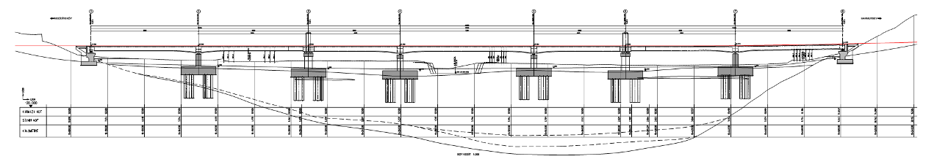

Figure 2. Alibeyköy viaduct section

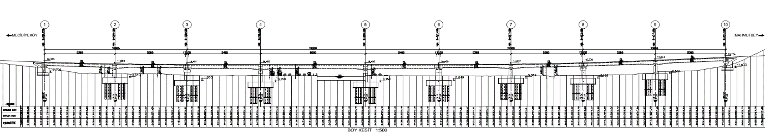

Figure 3. Kagithane viaduct section

The soil is characterized by a 30 m deep soft clay layer, set on a rock unit, as shown in the stratigraphy of Figure 4.

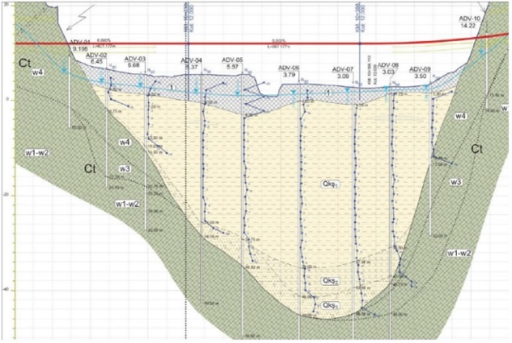

Figure 4. Stratigraphy of the soil crossed by the Alibeyköy viaduct

Soil characterization is fundamental to define the seismic input of the viaducts. The Peak Ground Acceleration (PGA) for a return period of 2475 years is 0.53g (g is the gravity acceleration, equals to 9.81 m/s²) and the relative design response spectrum has a maximum acceleration of 1.1g. Figure 5 shows the design acceleration response spectra for different return periods, according to the Turkish standard.

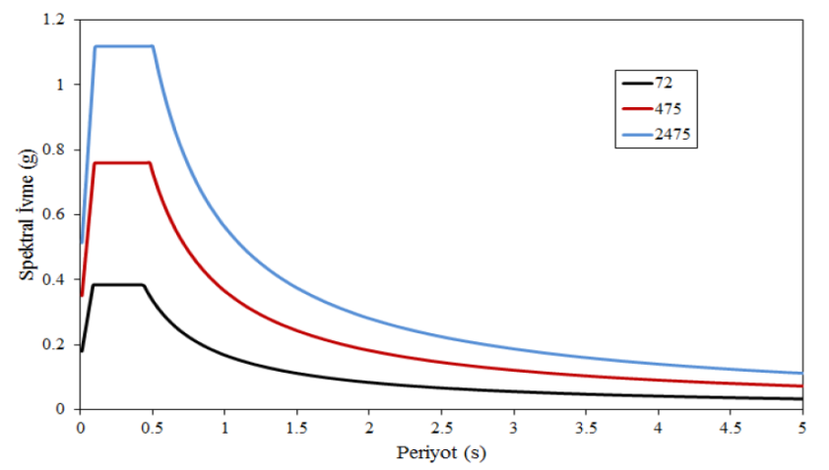

Figure 5. Design acceleration response spectra for different return periods

3. DESCRITPION OF THE SEISMIC PROTECTION SYSTEM

The high seismic demand together with limited acceptable displacements of the railway lines to limit damages brought to study a non-conventional solution to solve in a brilliant and efficient way the seismic protection of the viaducts. The study lead to a complex multi-functional solution where an isolation system with high stiffness and damping capacity was applied to reduce the seismic acceleration without increasing too much the natural period of the isolated structure. The solution thought by Yuksel Project consists in a system composed by different devices developed by the engineering team of Freyssinet, capable to provide an adequate restoring stiffness to re-center the viaducts after earthquakes. Figure 6 and 7 illustrates details of the isolation system while Table 1 lists all the devices used for the viaducts.

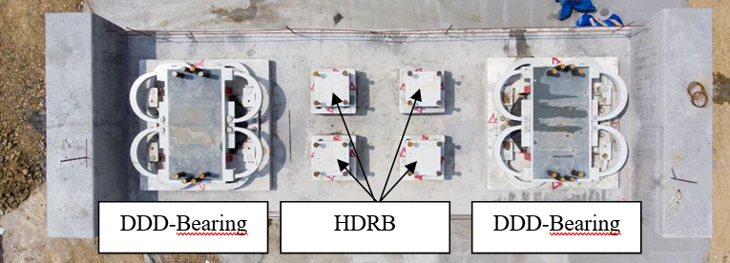

Figure 6. Isolation components of the piers

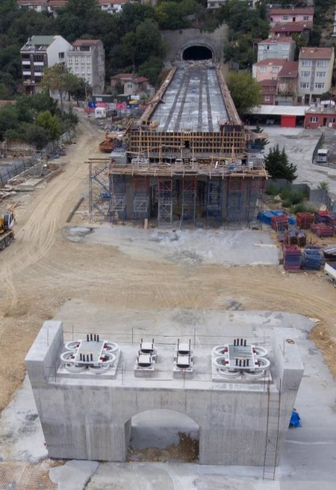 | 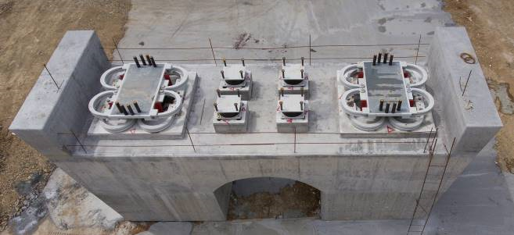
 | 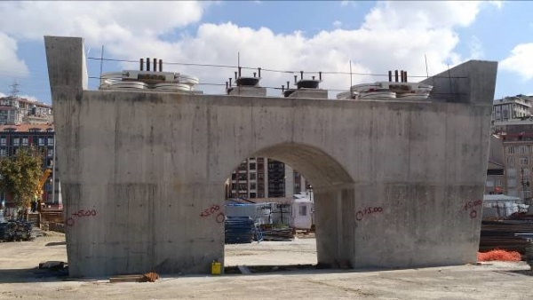

Figure 7. Views of Alibeyköy viaduct under construction

Table 1. List of devices involved in the project.

Viaduct | Piers | Type of device | Quantity
Alibeyköy | 1 – 3 – 6 - 8 | CSM-D 12900-1400/350/350  HDRB 0.8-10 700x209 | 12  12
 | 2 - 7 | CSM-D 35250-4075/350/350  HDRB 0.8-10 700x171 | 4  8
 | 4 - 5 | CSM-D 48750-5540/350/350  HDRB 0.8-10 700x171 | 4  8
Kagithane | 1 – 3G – 6I – 8G – 8I - 10 | CSM-D 12900-1400/350/350  HDRB 0.8-10 700x209 | 12  12
 | 2 – 7 – 9 | CSM-D 35250-4075/350/350  HDRB 0.8-10 700x171 | 6  12
 | 4 – 5 | CSM-D 60000-6440/350/350  HDRB 0.8-10 700x171 | 4  8
 | 3I – 3G | CSM-D 13975-2050/350/350  HDRB 0.8-10 700x171 | 4  6

The named DDD-bearings of Figure 8 are composed by a spherical bearing (two for each alignment) with a vertical capacity from 12900 kN up to 60000 kN and are equipped with a special sliding material called ISOSLIDE, able to provide high compressive strength capacity (up to 180 MPa) and low friction when lubricated (less than 1% of the applied vertical load). The low frictional properties allow to limit as much as possible the restoring moments in the spherical bearings when rotations due to live loads are applied. Each spherical bearing is equipped with two sliding plates, one for each horizontal direction, both on the top and on the bottom of it, allowing seismic displacements. These surfaces are made of a special sliding material, named ISOSLIDE+, capable to develop high dynamic friction and hence damping capacity. Indeed, these sliders play a primary role in the global energy dissipation mechanism, since they provide a dynamic friction coefficient of 5%, which represents about 46% of total energy dissipated by the DDD-Bearing.

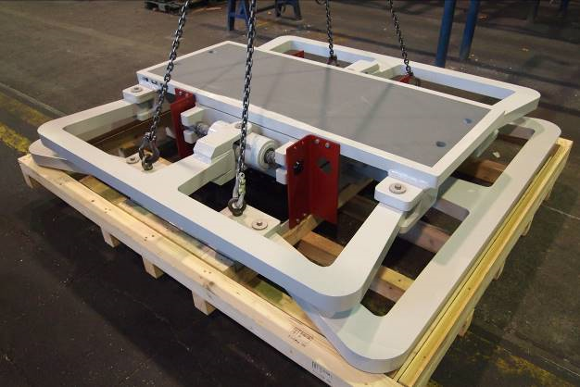 | 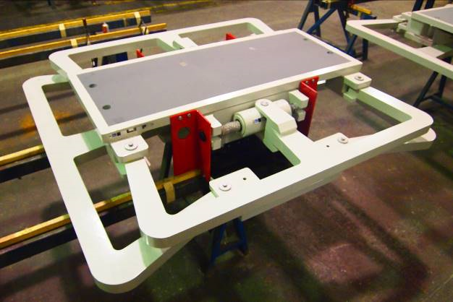

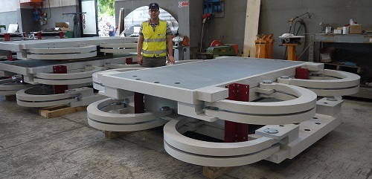

Figure 8. DDD bearings of the project

The sliding plates movements are restrained by C-shaped or E-shaped steel elements, which, thanks to their special geometry and high material ductility, can provide high energy dissipation through yielding; the behavior is hence dependent on the displacement/deformation demand. The shape (C or E) of these elements is optimized so that plasticization is almost uniformly distributed over the volume. By preventing localization and concentration of deformations, it is possible to extend the low-cycle fatigue life of such devices. Special arrangements neutralize the effects of geometry changes and improve the dissipative efficiency without suffering from geometric effects which, in case of large displacements, could cause hardening/softening and/or asymmetric hysteretic cycles. The Finite Element Model of Figure 9 demonstrates the uniform distribution of yielding stresses into the DDD elements when deformed. The numerical model has been used to define the shape of the elements and to confirm the plastic behavior.
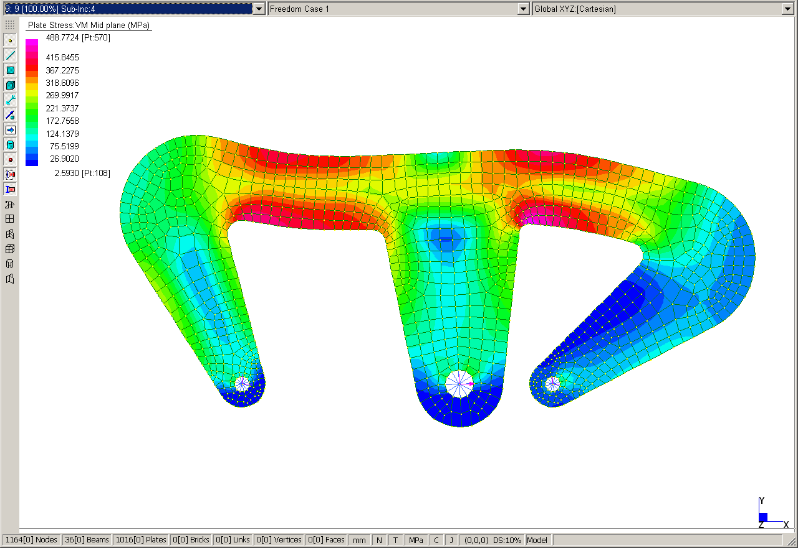
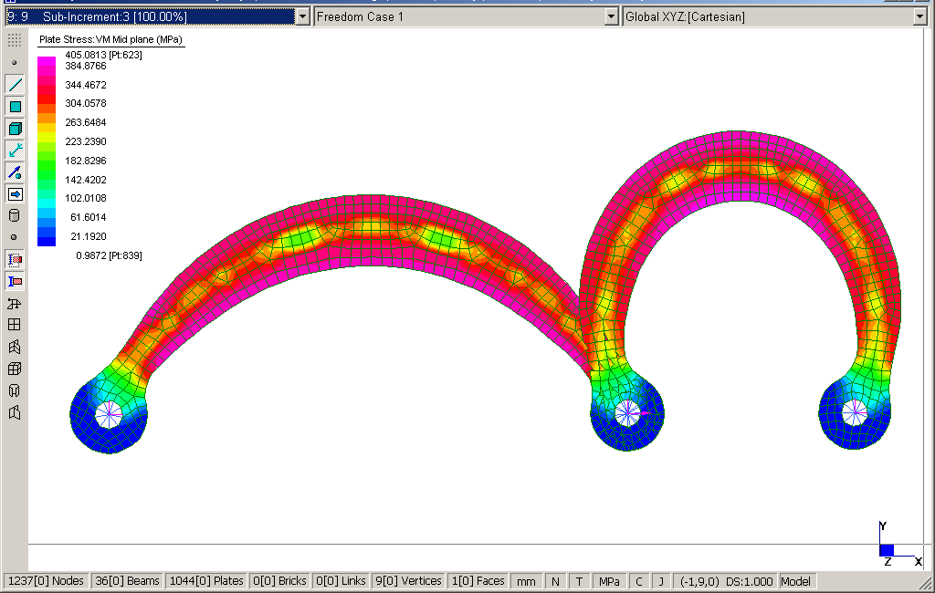

Figure 9. Finite element model of DDD elements: E-shaped (top) and C-shaped (bottom)

The overall non-linear force-displacement behavior of DDD elements can be idealized by a bilinear law. The first branch represents the elastic response prior to steel yielding, while the second one is the post-yielding behavior (see Figure 10).

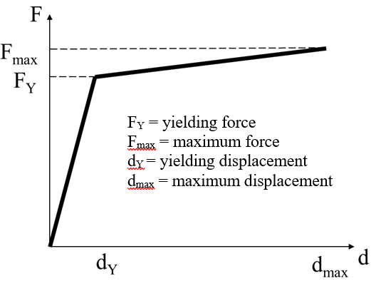

Figure 10. Idealized bilinear law of DDD elements

DDD-bearings installed on the abutments and on those piers where the deck is simply supported, are also equipped with Shock Transmission Units (STU). These devices allow to make the DDD-Bearing working differently during service and seismic conditions. STU is in fact a hydraulic device capable to allow slow movements in service condition (i.e. thermal displacements) and to lock fast movements like those induced by earthquakes or braking. The STU is installed in series between the sliding plate and the DDD elements, hence governing the DDD activation. Figure 11 illustrates the DDD-bearing configuration when the STU activates the DDD elements both in longitudinal and transversal direction (seismic condition), and when the DDD are not activated, allowing thermal movements of the bridge (service condition).

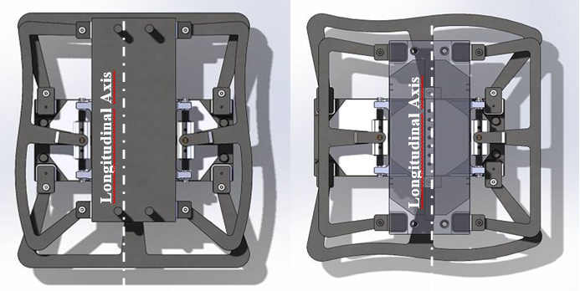
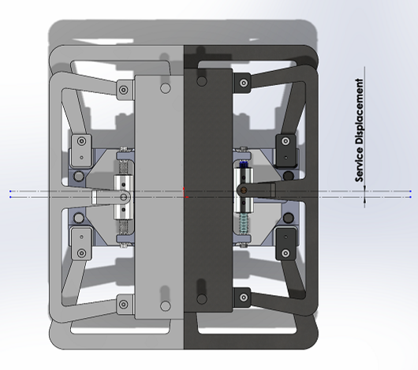

Figure 11. Longitudinal (top left) and transversal (top right) configuration in seismic condition and service configuration (bottom)

All the DDD-bearings are equipped with end stoppers to limit the maximum movement to ± 350 mm in both directions; these stoppers have been added as additional safety elements to avoid the falling of the deck for exceptional earthquakes that could lead to higher displacement demand than the design one. Table 2 summarizes main characteristics of the biggest DDD-Bearing. The device is shown in Figure 12.

Table 2. Characteristics of the biggest DDD-Bearing.

CSM-D 60000-6440/350/350
Vetical load at service limit state [kN] | 40000
Vertical load at ultimate limit state [kN] | 60000
Maximum horizontal load [kN] | 6440
Maximum rotations [rad] | ± 0.01
Longitudinal maximum displacement [mm] | ± 350
Transveral maximum displacement [mm] | ± 350
Plane dimensions [mm] | 3050 x 3050
Total height [mm] | 670

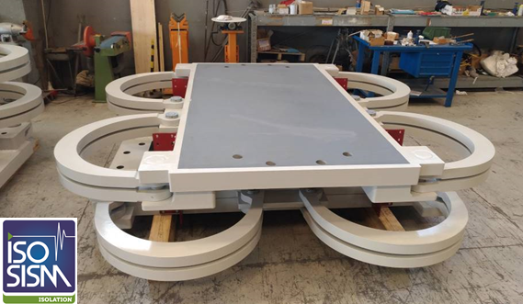

Figure 12. Biggest DDD-Bearing of the project

To increase the restoring stiffness of the isolation system, ISOSISM® High Damping Rubber Bearings (HDRB) have been added at each pier. They are composed by a series of dissipative elastomeric layers and steel plates vulcanized together (see Figure 13). These devices work in parallel to the DDD-Bearings and are equipped with flat jacks to provide a constant vertical pressure to ensure the damping capacity. All the elastomeric isolators have been manufactured by FPC Rubber, the owned rubber devices factory of Freyssinet.

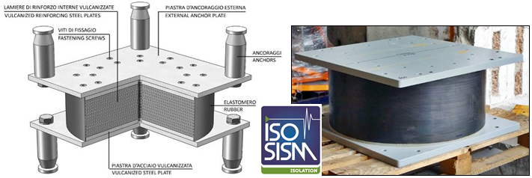

Figure 13. ISOSIM® High Damping Rubber Bearing

Figure 14 illustrates the global lateral force-displacement behavior of the isolation system, highlighting the contributions of the different components.

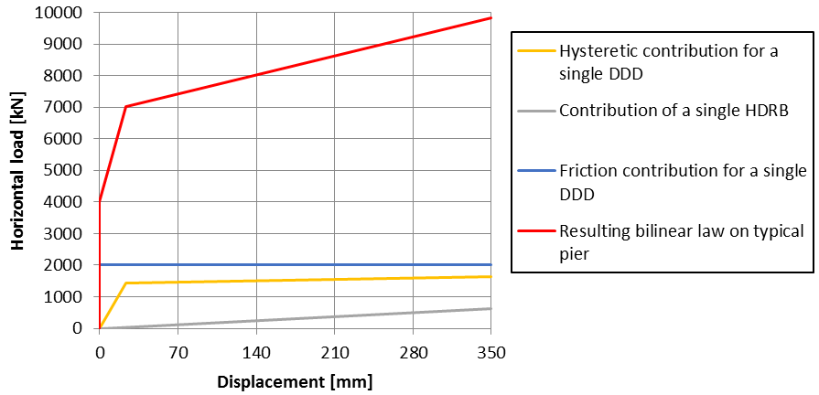

Figure 14. Force-displacement response of the isolation system

All the devices were designed, manufactured and tested by Freyssinet and supplied with CE marking.

4. DYNAMIC ANALYSIS

The dynamic analysis of the viaducts, performed by Yuksel Project with Larsa 4D software, allowed to determine the required characteristics of the different types of devices based on the geometry of the structures and the strong seismic input. The viaducts have been modelled using beam elements and a spectral analysis has been performed to determine the dynamic response; the seismic input was properly reduced to consider the additional damping provided by the anti-seismic devices. Figure 15 shows the seismic deformations of Alibeyköy viaduct numerical model.

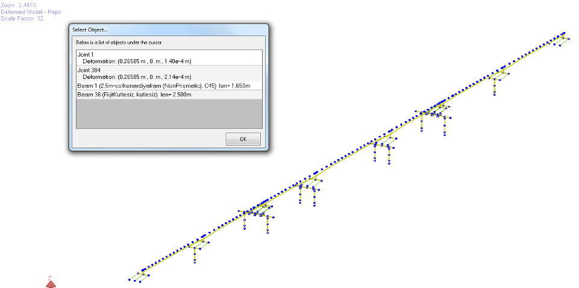
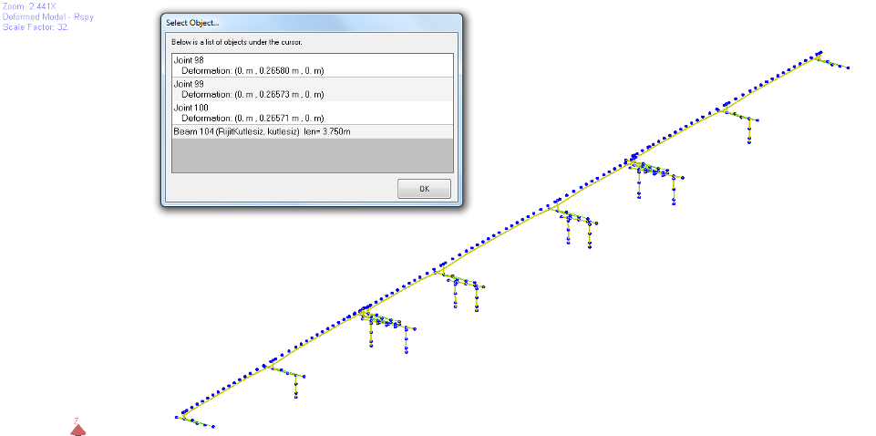

Figure 15. Seismic longitudinal (top) and transversal (bottom) displacements of Alibeyköy viaduct

5. TEST OF THE DEVICES

All the anti-seismic devices supplied by Freyssinet for the Alibeyköy and Kagithane viaducts have been tested both under Type Test protocol, to verify the compliance of the performances with the design values according to defined tolerances, and by Factory Production Control (FPC) test on a percentage of the mass production to check performance stability. The devices have been tested full-scale at ISOLAB (the Freyssinet testing facility based in Montebello della Battaglia, Pavia, Italy), thanks to the advanced dynamic equipment capable to apply the design loads and displacements under three dynamic cycles.
Table 3 and 4 report main parameters of HDRBs Type Tests and FPC tests; Figure 16 shows the testing of one device and its hysteretic response.

Table 3. HDRB Type Tests parameters.

Device type | HDRB 0.8-10 700x209
Number of tested devices | 2
Maximum vertical load [kN] | 2310
Design displacement for cyclic test [mm] | ± 314
Maximum displacement for lateral stability test [mm] | 402

Table 4. HDRB FPC tests parameters.

Device type | HDRB 0.8-10 700x209 | HDRB 0.8-10 700x171
Number of tested devices | 4 | 5
Maximum vertical load [kN] | 2310 | 2310
Design displacement for cyclic test [mm] | ± 314 | ± 257

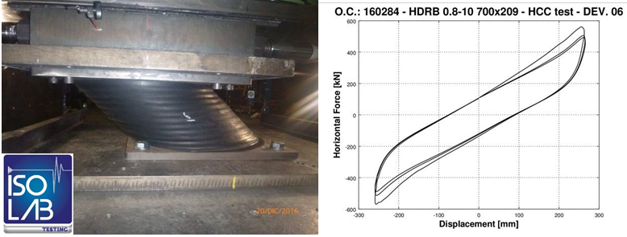

Figure 16. Testing of HDRB and associated hysteretic response

C-shaped and E-shaped steel elements have been tested separately with coupled configuration, applying the design load and displacement. Figure 17 shows testing configuration of these elements and their hysteretic response.
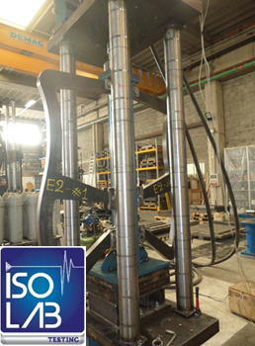 | 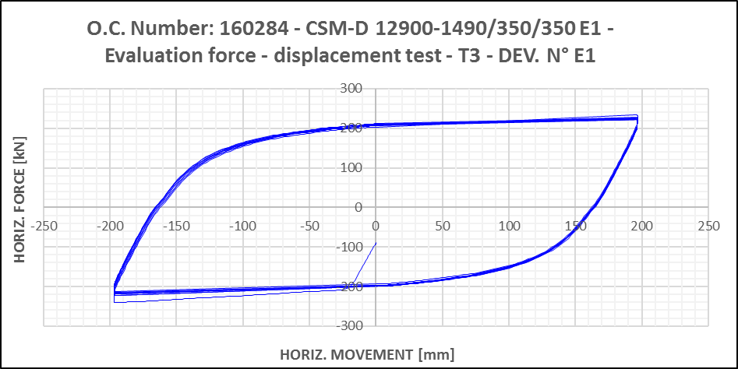

Figure 17. Testing of E-shaped steel elements (left) and associated hysteretic response (right)

Once the full DDD-bearings have been assembled, a test on a full-scale complete device has been performed to verify the overall behavior, thus checking that all the components worked well when assembled together, avoiding any interference between elements that could cause unexpected behavior or, worst, failing of the device. Figure 18 shows the device under the testing machine with its hysteretic response.

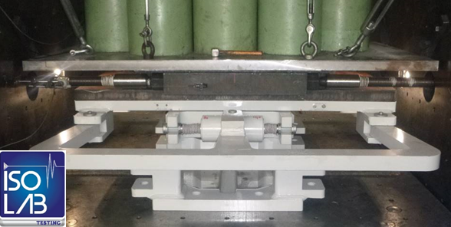 | 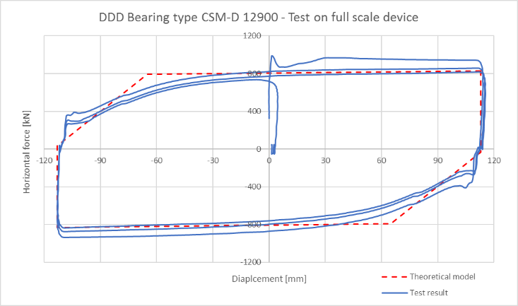

Figure 18. Testing of DDD-Bearing (left) and associated hysteretic response (right)

Finally, Table 5 reports main testing parameters of the full device.

Table 5. DDD-Bearing testing parameters.

Device type |  | E1 | E2 | E3 | E4 | C1 | C2
Type Tests | Number tested devices | 1 | 1 | 1 | 1 | 1 | 1
 | Maximum load [kN] | 222 | 272 | 420 | 472 | 209 | 170
 | Design displacement of cyclic test [mm] | ± 193 | ± 233 | ± 193 | ± 233 | ± 350 | ± 350
 | Maximum displacement [mm] | 319 | 385 | 319 | 385 | 385 | 385
FPC Tests | Number of tested devices | 2 | 2 | 1 | 1 | 4 | 4
 | Maximum load [kN] | 208 | 255 | 394 | 443 | 196 | 160
 | Design displacement of cyclic test [mm] | ± 193 | ± 233 | ± 193 | ± 233 | ± 233 | ± 233

6. Conclusions

The Alibeyköy and Kagithane viaducts, part of the new metro line of Istanbul between Mecidiyeköy and Mahmutbey, as all the rest of the infrastructures of this seismic region, are subjected to strong earthquakes. Railway structures are special infrastructures that can admit limited displacements to avoid damages to the rail line. Satisfying all the design requirements it has been a challenge, especially regarding the conception, design and delivery of the exceptional multi-functional isolation system.
The solution chosen by Yuksel Project and developed by Freyssinet engineering team consisted in a very complex system of devices with different behaviors working together in a unique special bearing called DDD-Bearing. Additional stiffness is provided by High Damping Rubber Bearings installed in parallel.
All the devices have been designed and manufactured and tested by Freyssinet; special attention was given to the DDD-Bearing, testing both the full-scale complete device and the different components, verifying the satisfaction of the global behavior. The efficiency of the isolation system was hence validated according to the designer requirements to protect the viaducts against earthquakes and allowing people mobility even after a seismic event.
This project highlights the know-how of the Freyssinet Group in the seismic protection field and its capacity to offer a global support: from the seismic assessment of the viaduct to the design of the isolation system; from the design to the production and testing of full-scale anti-seismic devices in dynamic conditions.

7. References

Özkaya, C, Yılmaz, M. T. (2017) Baret Temeller İçin Basen Etkisinin İncelenmesi: Alibeyköy Viyadüğü Çalışması, 3rd International Soil-Structure Interaction Symposium-Izmir, Turkey
Erdik, M. & Harmandar, E. (2015) Alibeyköy Viyadüğü Spektrum Uyumlu Ölceklenmis Deprem Yer Hareketi Kayitlari Belirlemesi, Istanbul, Turkey.

Technical Manager, Freyssinet Product Company Italia, Milan, Italy, mauro.sartori@freyssinet.com
R&D Engineer, Freyssinet Product Company Italia, Milan, Italy, stefano.barone@freyssinet.com
Technical Dept Manager, Freyssinet Product Company Italia, Milan, Italy, claudio.galbiati@freyssinet.com
Engineer, Freysaş, Istanbul, Turkey, burak.turkdonmez@freyssinet.com
Deputy Technical Director, Freyssinet, Rueil Malmaison, France, ivica.zivanovic@freyssinet.com

