INVESTIGATION OF POTENTIAL POUNDING OF BASE ISOLATED

BUILDINGS UNDER STRONG NEAR-FAULT EARTHQUAKE EXCITATIONS

DOI 10.37153/2686-7974-2019-16-547-557

Eftychia MAVRONICOLA, Panayiotis POLYCARPOU, Petros KOMODROMOS

ABSTRACT

By inserting flexibility at the isolation levels of relatively stiff buildings, their fundamental eigenperiods are shifted outside the dangerous for resonance range and the induced seismic loads are significantly decreased. However, a wide seismic gap must be provided around a seismically isolated building to accommodate the expected large relative displacements at the isolation level. Therefore, the proper estimation of the required clearance around a seismically isolated building is very crucial, as there is a possibility of structural pounding with the adjacent moat wall or a neighboring building during stronger than expected seismic excitations. This paper describes the research work that has been carried out, through both planar (2D) and spatial (3D) simulations and parametric studies, to better assess how potential structural pounding may affect the effectiveness of seismic isolation and specifically the importance of providing the necessary clearance around a base isolated building in order to avoid pounding. Specifically, the importance of performing spatial, than planar, simulations is underlined, in order to take into account torsional effects due to potential eccentricities and the influence of the incidence angle of the imposed seismic excitations to better assess the required width of the seismic gap to prevent structural pounding.

Keywords: structural pounding; seismic isolation; seismic gap; base isolation; incidence angle

1. INTRODUCTION

The fundamental eigenfrequencies of low- to medium-rise conventionally fixed-supported buildings unfortunately fall within the predominant frequencies range of typical earthquakes, resulting in unavoidable amplifications of ground accelerations and significant seismic loads that cause inelastic responses. Alternatively, we can use seismic isolation to introduce flexibility at the isolation level of relatively stiff buildings, shifting their fundamental eigenperiods outside the dangerous for resonance range, in order to reduce the induced seismic loads, and, consequently, decrease significantly both floor accelerations and interstory deflections, while large deformations are confined at the isolators, which are capable of accommodating large deformations. However, a wide seismic gap must be provided around a seismically isolated building to facilitate the expected large relative displacements at the isolation level. Since the width of the provided seismic gap is often finite, there is a possibility of pounding with the adjacent moat wall or an adjacent building during stronger than expected excitations. Although pounding between fixed-supported buildings has been extensively studied, very limited research work has been carried out for pounding of seismically isolated buildings, which exhibit quite different dynamic characteristics. Specifically, pounding of seismically isolated buildings occur mostly due to the large relative displacements at the isolation level, while in the case of conventionally fixed-supported buildings pounding occurs usually at the top of the lower of adjacent buildings due to the deformations of their superstructures. This research work investigates exactly that possibility, through both planar (2D) and spatial (3D) simulations and parametric studies, aiming to understand how structural pounding may affect the effectiveness of seismic isolation and properly assess the required clearance to avoid pounding incidences, taking into account the seismic incidence angle and potential eccentricities.

2. PLANAR (2D) NUMERICAL SIMULATIONS AND PARAMETRIC STUDIES

2.1 Modeling assumptions

Regarding the presented planar (2D) simulations, multi degree of freedom systems are used, assuming that the superstructures behave linearly as shear-beam buildings with the masses lumped at the floor levels, and the isolation system, which consists of lead-rubber bearings, is simulated using a bilinear inelastic model.
Structural impact is modeled using a penalty approach through a modified linear viscoelastic impact model, which consists of a viscous impact dashpot parallel to the linear impact spring. Contact springs and dashpots are automatically formed as soon as an impact is detected with the moat wall or with an adjacent building, kept as long as the colliding structures remain in contact and removed as soon as the colliding structures are detached from each other, in order to avoid the tensile impact forces that arise, between the colliding structures, at the end of the restitution branch.
The equations of motion are formed at time t, including the elastic and damping impact forces, which are nonzero only during impact, and numerically integrated, using the Central Difference Method, in order to compute the displacements at time (t+dt). Based on this approach, a 2D software has been specifically designed and developed in order to efficiently perform planar numerical simulations and parametric studies of base isolated buildings with impact capabilities.

2.2 Selected planar analyses and parametric studies

2.1.1 Structural and earthquake characteristics

A typical 4-story base isolated building, which may pound against the moat wall or/and adjacent buildings, is considered in the performed simulations. The story mass is 320 tons for all floors (including the isolation level) except the top floor, which equals 250 tons. The horizontal story stiffness is 600 MN/m, while the initial stiffness of the isolation system, which is assumed to exhibit bilinear inelastic behavior, is 200 MN/m and the post-yield stiffness is 25 MN/m. The characteristic strength of the isolation system equals 10 % of the total weight of the building.
Regarding impact, the modified linear viscoelastic impact model with impact stiffness of 2500 kN/mm, is used to take into account impact incidences, which are automatically detected and resolved by the software. The coefficient of restitution is assumed to be equal to 0.7 for all cases, while the mass of the surrounding moat wall is taken to be equal to 500 tons.
The 4-story base isolated building is considered in 6 different configurations regarding the adjacent structures. In the first case, the adjacent structure is only the surrounding moat wall, while in the remaining 5 cases two identical multistory fixed-supported buildings, with two, three, four, five and six stories in each case, respectively, are standing on both sides of the base isolated building.
In the indicative parametric study that is presented, a set of 5 strong earthquake excitations, all characterized by low frequency content, is used, with their characteristics presented in Table 1 and their acceleration response spectra provided in Figure 1.

Table 1. Characteristics of imposed earthquake excitations.

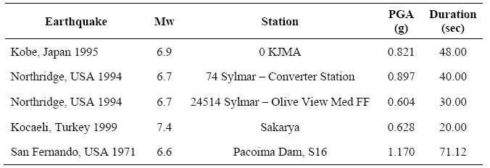

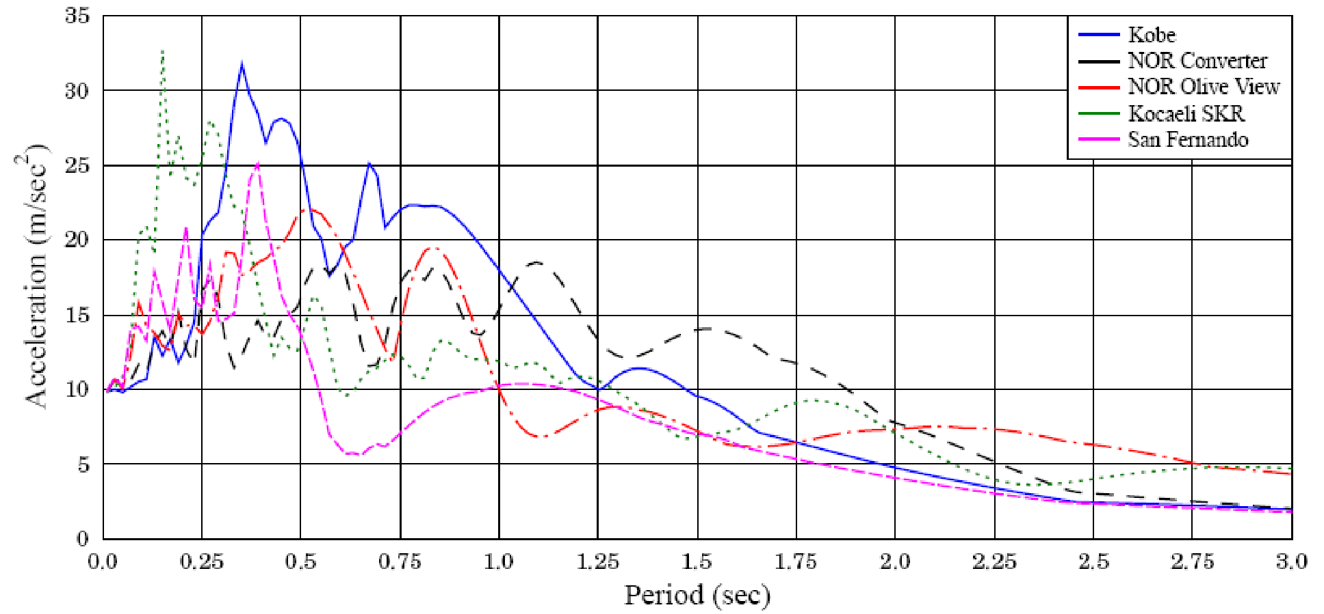

Figure 1. Acceleration response spectra of imposed earthquake excitations.

Table 2 provides the maximum unobstructed relative displacements of the base isolated building, both at its base and top, and the maximum unobstructed relative displacements at the tops of the adjacent fixed-supported buildings for each of the 5 earthquake excitations.

Table 2. Peak relative displacements [cm] of the seismically isolated building and the fixed-supported buildings.

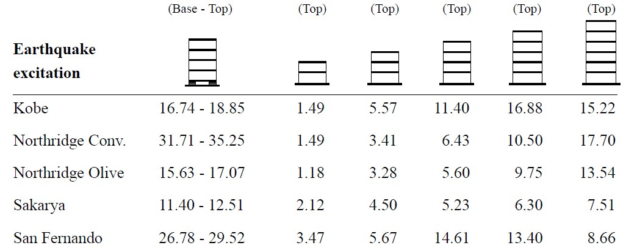

A set of parametric analyses is performed while the width of the gap between the seismically isolated building and the adjacent structures is varied, simultaneously on both sides of the building, considering the six aforementioned cases regarding the type of the adjacent structures. Table 3 provides the difference between the distance that is required according to the SRSS rule and the clearance that is actually required in order to avoid poundings, where the negative sign indicates insufficiency of the SRSS rule, which would lead to impact.

Table 3. Difference [mm] between the required distance according to SRSS and required clearance to avoid pounding.

Earthquake excitation | 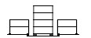 | 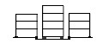 | 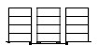 | 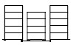 | 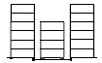
Kobe | -0.9 | -3.4 | -54.7 | -67.0 | -17.7
Northridge Conv. | 7.8 | 19.1 | -31.7 | -77.2 | -50.6
Northridge Olive | 6.1 | -6.2 | 24.6 | 16.6 | 2.9
Sakaya | 6.9 | -7.0 | -14.4 | 0.1 | 35.9
San Fernardo | 7.2 | 10.6 | 33.1 | 4.2 | -37.4

According to the conducted numerical simulations and parametric studies, as well as in several other relevant research works (Dimitrakopoulos et al. 2009, Jankowski and Mahmoud 2015, Komodromos 2008, Mahmoud and Jankowski 2010, Matsagar and Jangid 2003, Mavronicola et al. 2016, Polycarpou and Komodromos 2011), structural poundings, occurring either at the base of the seismically isolated building or at its upper floors, increase significantly the absolute floor accelerations and the interstory deflections, which may lead to substantial structural and non-structural damage as well as damage of the its contents.
The planar analyses revealed that even when a “sufficient” gap is provided, with which poundings with the surrounding moat wall at the base of the building would be avoided, this might not be sufficient to prevent collisions with neighboring buildings due to the deformations of the superstructures of the neighboring buildings during a very strong earthquake, especially when the fundamental eigenfrequency of the latter fall within the predominant frequencies of the imposed seismic excitation.

3. SPATIAL (3D) NUMERICAL SIMULATIONS AND PARAMETRIC STUDIES

While the majority of research studies on structural impacts approach the problem in 2Ds, there is a number of recent research works that extent the simulation in the more realistic 3D space (Pant and Wijeyewickrema 2012, Pant and Wijeyewickrema 2014, Polycarpou et al. 2014, Mavronicola et al. 2016) investigated the factors that influence the spatial dynamic responses of base isolated buildings during impact with the surrounding moat walls or/and adjacent structures.
With spatial (3D) analyses the effect of several important variables that may affect the overall peak seismic response, when structural pounding occurs, can be assessed, while the required width of the seismic gap can be more reliably evaluated. The possibility of impacting against moat walls or against surrounding structures, including adjacent conventionally fixed-supported buildings, is also examined.
More specifically, the peak response of a base isolated building is investigated while varying important parameters, such as the incidence angle of seismic excitations, the available seismic clearance and mass eccentricities, under the action of bidirectional horizontal excitations. A large number of numerical simulations and parametric studies is performed, using a specially developed software that implements an efficient approach to model spatial impacts with arbitrary locations of the contact points.

3.1 Limitations of 2D vs. 3D analysis

The planar analyses have several limitations, since some important factors, such as spatial movements, torsional effects and the directionality of the imposed excitation inherently cannot be considered in 2D analyses, which can consider only one seismic excitation.
Based on an efficient methodology for numerically simulating in three-dimensions adjacent buildings that may experience pounding during strong earthquakes (Polycarpou et al. 2014), the developed source code for planar analyses was extended to a 3D software, which can be used to effectively simulate spatial multi-degree-offreedom systems of 3 dynamic DOF at each floor level with impact capabilities.
While the contact forces in planar (2D) simulations are computed based only on the interpenetration depth, in 3D simulations the contact area and geometry are considered in the estimation of the contact force, which is much more realistic and accurate. Specifically, the impact modeling in 3D simulations is based on an overlapping region and a contact plane according to which normal and tangential impact forces can be assessed. The impact forces in the normal and tangential directions are computed with the equations shown in Figure 2, while the Coulomb law of friction restricts the magnitude of the tangential impact forces.
The simulated buildings are subjected to two orthogonal seismic components, of which the angle of incidence may vary in an automated parametric procedure through the developed software. The equations of motion of the simulated buildings are formulated at each time step taking into account the impact forces, whenever there is contact, and numerically integrated using the Newmark method. The utilized methodology is quite simple and efficient, taking into account the geometry at the vicinity of impact. The location of impact is not predetermined and multiple impacts can be simultaneously considered.
With this approach, the investigation of effects of certain factors that cannot be examined using planar (2D) simulations, such as the effect of the incidence angle, which might play an important effect on the peak seismic response (López et al 1997, Anagnostopoulos et al 2015), torsional effects due to eccentricities and the spatial effect of adjacent conventionally fixed-supported structures.

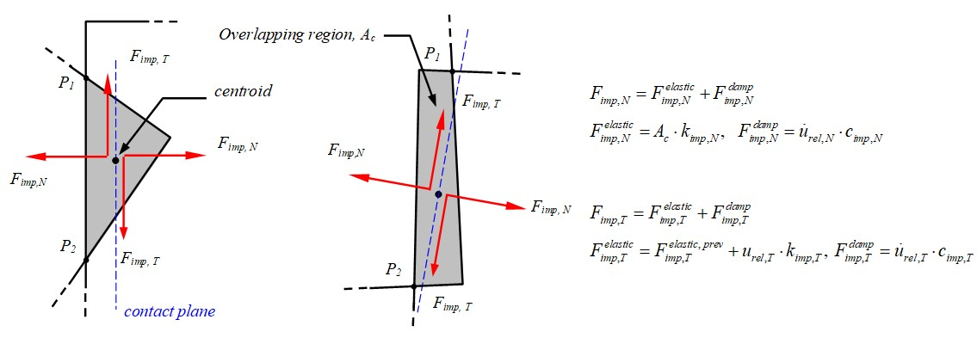

Figure 2. Contact resolution based on the contact plane and the overlapping region.

The developed software enables the spatial simulation of base-isolated buildings modeled as 3D MDOF systems with shear-type behavior, the slabs are modeled as rigid diaphragms and the masses are lumped at the floor levels with 3 DOF at each floor. Regarding base-isolated buildings, the nonlinear inelastic bidirectional coupled Bouc–Wen model is employed to more accurately simulate the seismic isolation system.

3.2 Modeling assumptions and structural characteristics

In the conducted analyses, a typical symmetric 3-story, 3x3 bays of 5.5m and height 3.2m, base-isolated building is considered (Figure 3). The cross sections of all column are 45cm x 45cm. The Young’s modulus is assumed to be equal to 30 GPa with a Poisson’s ratio of 0.2. A uniformly distributed mass is considered, which corresponds to a 250 tons lumped mass for the roof mass and a 340 tons lumped mass for each floor level, including the base of the building. For the determination of the Rayleigh damping matrix, the viscous damping ratios for the first and the last eigenfrequencies are set to 0.05 and 0.02, respectively.
Regarding the modeling of the seismic isolation system, a coupled plasticity model is employed to take into account the bidirectional lateral response of the seismic isolators (Nagarajaiah et al., 1991; Park et al., 1986; Wen, 1976). Specifically, for each bearing an isolation period based on the post-yield stiffness of 2.0 seconds, a yield displacement equal to 1.0 cm and a normalized characteristic strength equal to 0.10 are considered. In the performed simulations, a typical 3-story base isolated building is considered to be either standing alone, without a neighboring building, or adjacent to a 2, 3, or 4-story fixed-supported building, which are located on its one side, with the possibility of pounding occurring not only at its base with the moat wall but also at the upper floors of the buildings due to the deformation of their superstructures. The floor-slabs of the neighboring buildings are assumed to be located at the same levels, leading to potential slab-to-slap impacts.
The adjacent moat wall, which is assumed to be 100 cm thick and 100 cm high, is modeled as a single-mass system, with three dynamic DOF. The normal impact stiffness is k_{imp,N} =2.58×10⁷kN/m², while the corresponding tangential impact stiffness is k_{imp,T} =5.74×10⁶kN/m. The static and kinetic friction coefficients are taken as μ_{s} = 0.8 and μ_{k} =0.6, respectively.

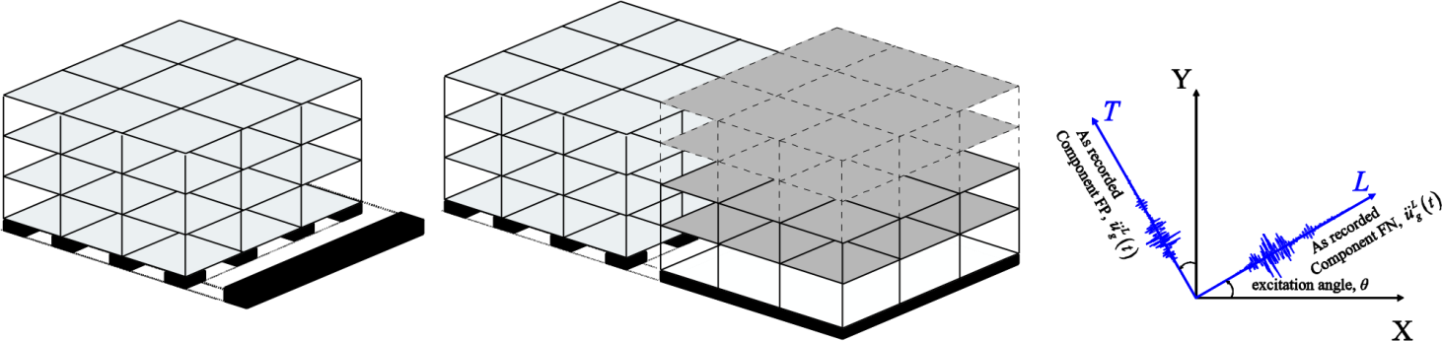

Figure 3. Contact resolution based on the contact plane and the overlapping region.

A set of 5 near-fault fault-normal (FN) and fault-parallel (FP) seismic recordings has been selected and used, while the major characteristics of the imposed earthquake excitations are summarized in Table 4.

Table 4. Major characteristics of the imposed earthquake excitations.

Earthquake | Mw | Station | Comp | PGA | PGV | PGD
 |  |  |  | (g) | (cm/s) | (cm)
Loma Prieta, USA 1998 | 6.9 | LGPC | FN | 0.94 | 97 | 62.5
 |  |  | FP | 0.54 | 72.1 | 30.5
Erzican, Turkey 1992 | 6.7 | Erzincan | FN | 0.49 | 95.4 | 32.1
 |  |  | FP | 0.42 | 45.3 | 16.5
Northridge-01, USA 1994 | 6.7 | Newhall -W Pico Canyon Rd. | FN | 0.43 | 87.7 | 55.1
 |  |  | FP | 0.28 | 74.7 | 21.8
Northridge-01, USA 1994 | 6.7 | Sylmar – Converter Sta | FN | 0.59 | 130.3 | 54
 |  |  | FP | 0.8 | 93.3 | 53.3
Denali, Alaska 1999 | 6.2 | TAPS Pump Station #10 | FN | 0.33 | 95.5 | 92.4
 |  |  | FP | 0.27 | 121.3 | 116.2

3.3 Selected results from spatial parametric studies

The following sections provide the maximum of the peak interstory drifts of the 4 corner columns of the base isolated building, under each of the five earthquake excitations (unscaled), as computed from spatial parametric studies, initially pounding solely against the surrounding moat wall and, subsequently, pounding with the moat wall or/and with adjacent conventionally fixed-supported buildings. The possibility of mass eccentricities of 10% is also investigated in order to assess its influence on the peak seismic response, as well as the width of the clearance that would be required around the base isolated building in order to avoid structural pounding.

3.3.1 Pounding against the surrounding moat wall

Figure 4 provides the peak interstory drift ratios (resultants) at each floor of the 3-story base-isolated building during collisions with the adjacent moat-wall, in terms of the angle of incidence considering a 20 cm wide seismic gap and investigating two cases: (a) without any eccentricities (top subplots), and (b) with 10% of the floor plan dimension at all floors of the base isolated building bidirectional eccentricities (bottom subplots).

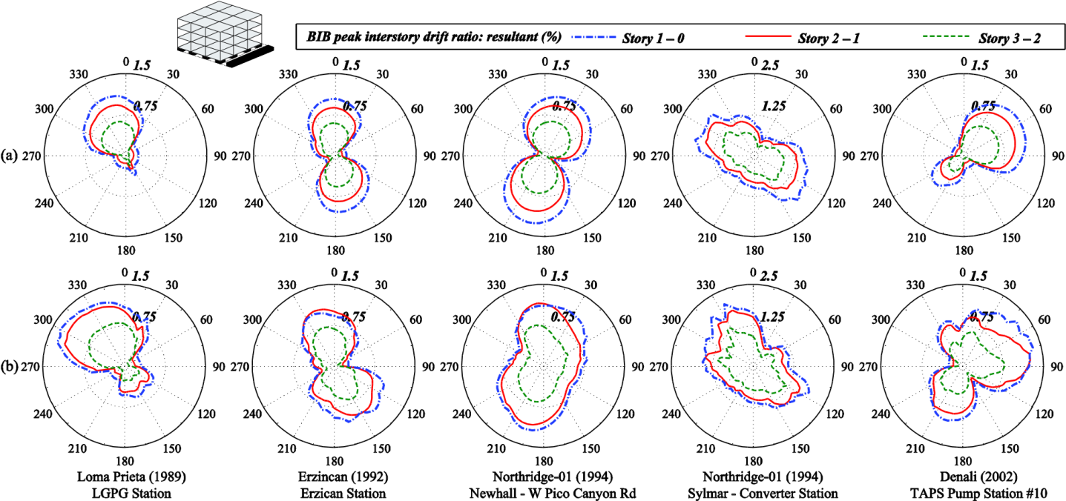

Figure 4. Peak interstory drifts (resultant) ratio at each floor of the base isolated building during collisions with the adjacent moat-wall, in terms of the angle of incidence considering a gap size of 20 cm: (a) no eccentricity case, and (b) bidirectional eccentricities of 10% of the floor plan dimension at all floors of the building.

These parametric analyses reveal that the angle along which the maximum seismic response is observed differs among the five pairs of earthquake excitations that are imposed to the building. Furthermore, aligning the seismic components along the major construction axes of the building does not always lead to the maximum responses over other angles of incidence. Moreover, when pounding may occur only at the base of the seismically isolated building (without any eccentricities) with the moat wall, the peak interstory drifts decrease while moving from the ground floor upwards. It should be noted, however, that in the case of a base isolated building with mass eccentricities, the floor that dominates the critical envelope might change.

3.3.2 Pounding with adjacent fixed-supported buildings

Figures 5, 6 and 7 provide the peak interstory drift ratios (resultant) at each floor of the 3-story base-isolated building among all corner columns during poundings with either the moat wall or/and the 2-, 3- and 4-story respectively, adjacent fixed-supported buildings, with the same characteristics as those of the superstructure of the base isolated building, in terms of the angle of incidence. A seismic gap of 20 cm is set, while two cases are investigated: (a) without any eccentricities, and (b) with bidirectional eccentricities of the superstructure of the base isolated building equal to 10% of the floor plan dimensions of the floors.

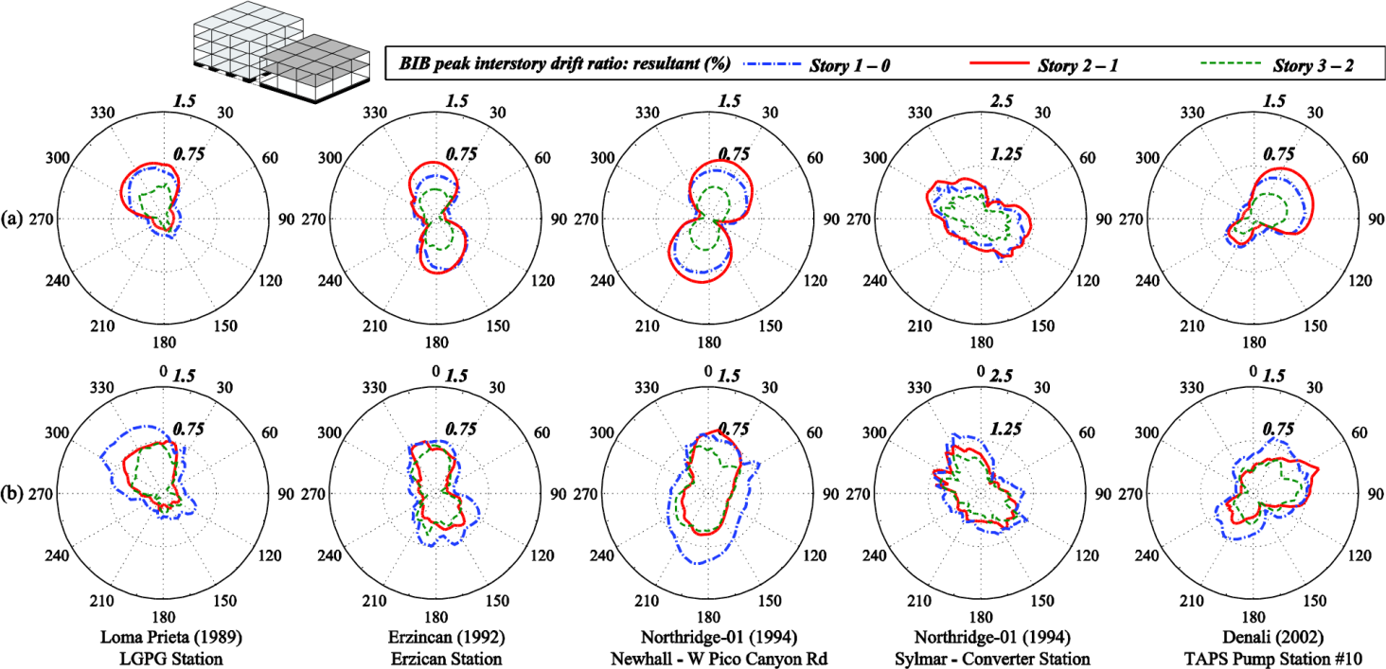

Figure 5. Peak ratio of the interstory drifts resultant at each floor of the base isolated building during collisions with the adjacent 2-story fixed-supported structure and the moat wall, in terms of the angle of incidence considering a gap size of 20 cm: (a) no eccentricity case, (b) 10% bidirectional eccentricities.

These plots confirm that the critical angle of incidence, along which the seismic excitations cause the maximum interstory drifts is neither the same for the five earthquakes that are imposed, nor necessarily along the major construction axes of the base isolated building. Thus, the common practice of applying the earthquake records along the major construction axes may lead to significant underestimation of the peak structural response in case of pounding. In general, the effect of the directionality of the imposed seismic excitations, in combination with the number of stories and, consequently, the fundamental eigenperiod of the adjacent structures, significantly influence the possibility of structural pounding and the severity of the peak structural response in case of impact. Most importantly, the seismic incidence angle influences significantly the width of the required seismic gap that should be provided as clearance to avoid pounding. Moreover, comparing the computed peak interstory drifts of Figure 4 with those of Figures 5, 6 and 7, the peak interstory drifts of the base isolated building that may pound only with the moat wall, are in general higher than the peak interstory drifts for the case of buildings in series. Furthermore, although the peak interstory drifts of the symmetric base isolated building next to the moat wall without neighboring buildings decrease when moving from the ground floor upwards, as shown in Figure 4, the peak interstory drifts of the base isolated building with adjacent buildings may occur at a higher floor, probably due to the activation of higher modes of deformation.

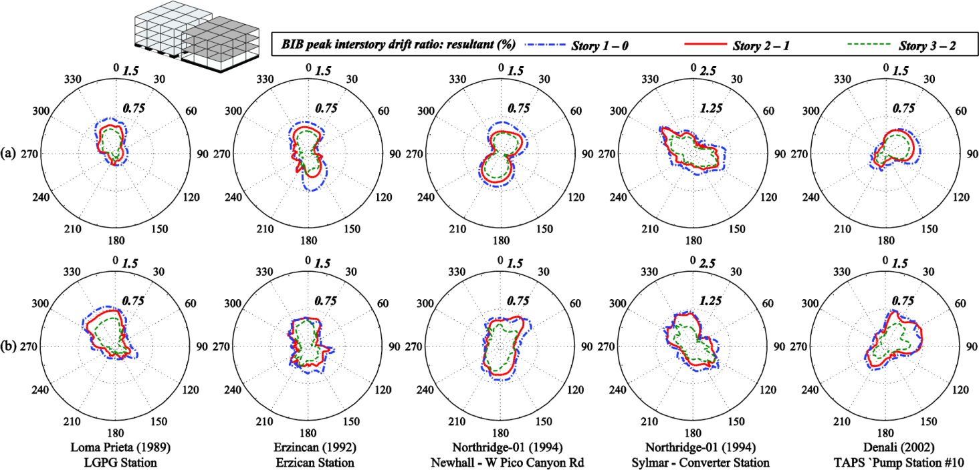

Figure 6. Peak ratio of the interstory drifts resultant at each floor of the base isolated building during collisions with the adjacent 3-story fixed-supported structure and the moat wall, in terms of the angle of incidence considering a gap size of 20 cm: (a) no eccentricity case, (b) 10% bidirectional eccentricities.
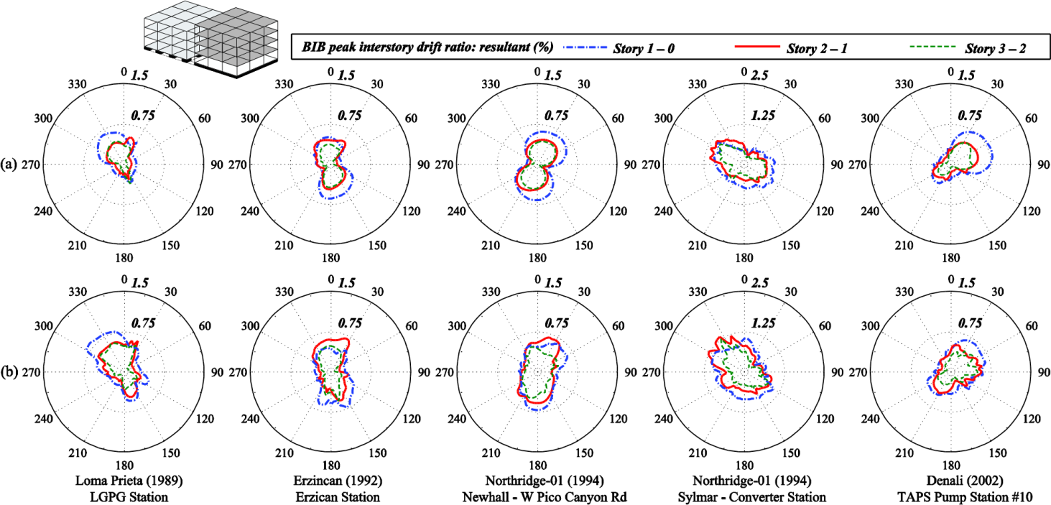

Figure 7. Peak ratio of the interstory drifts resultant at each floor of the base isolated building during collisions with the adjacent 4-story fixed-supported structure and the moat wall, in terms of the angle of incidence considering a gap size of 20 cm: (a) no eccentricity case, (b) 10% bidirectional eccentricities.

Subsequently, we consider the case of buildings in series, examining the peak interstory drifts of the base isolated building, which is adjacent to a 2-, 3- and 4-story conventionally fixed-supported building while the width of the available seismic gap varies between 15 and 45cm. Specifically, Figure 8 provides the envelope of peak interstory drifts of the base isolated building (BIB) among the corner columns in terms of the available seismic gap size for different arrangement of the adjacent fixed supported structures and moat wall, for 0° and 180° angle of seismic incidence. The provided graphs also indicate that seismic characteristics, such as the direction and frequency content, of the imposed ground motion significantly affect the peak interstory drift ratio. In general, the superstructure’ drift ratio increases rapidly when the separation distance between structures decreases and, then, in some cases, might slightly decrease with further reduction in the separation. It is evident that structural pounding should be avoided, by providing a sufficiently wide seismic gap around a seismically isolated building, as it increases substantially the peak seismic response of a base isolated building, amplifying the peak interstory drifts by about 3-4 times in the presented simulations. The conducted analyses indicated that the necessary width of the provided seismic gap depends on the characteristics of both the earthquake excitation and the structural characteristics. Furthermore, it depends on the incidence angle of the imposed earthquake excitations, which may further increase the required clearance. Furthermore, the extent at which the incidence angle influences the peak response depends on the structural systems (e.g. number of stories and/or moat wall) and the separation distance.

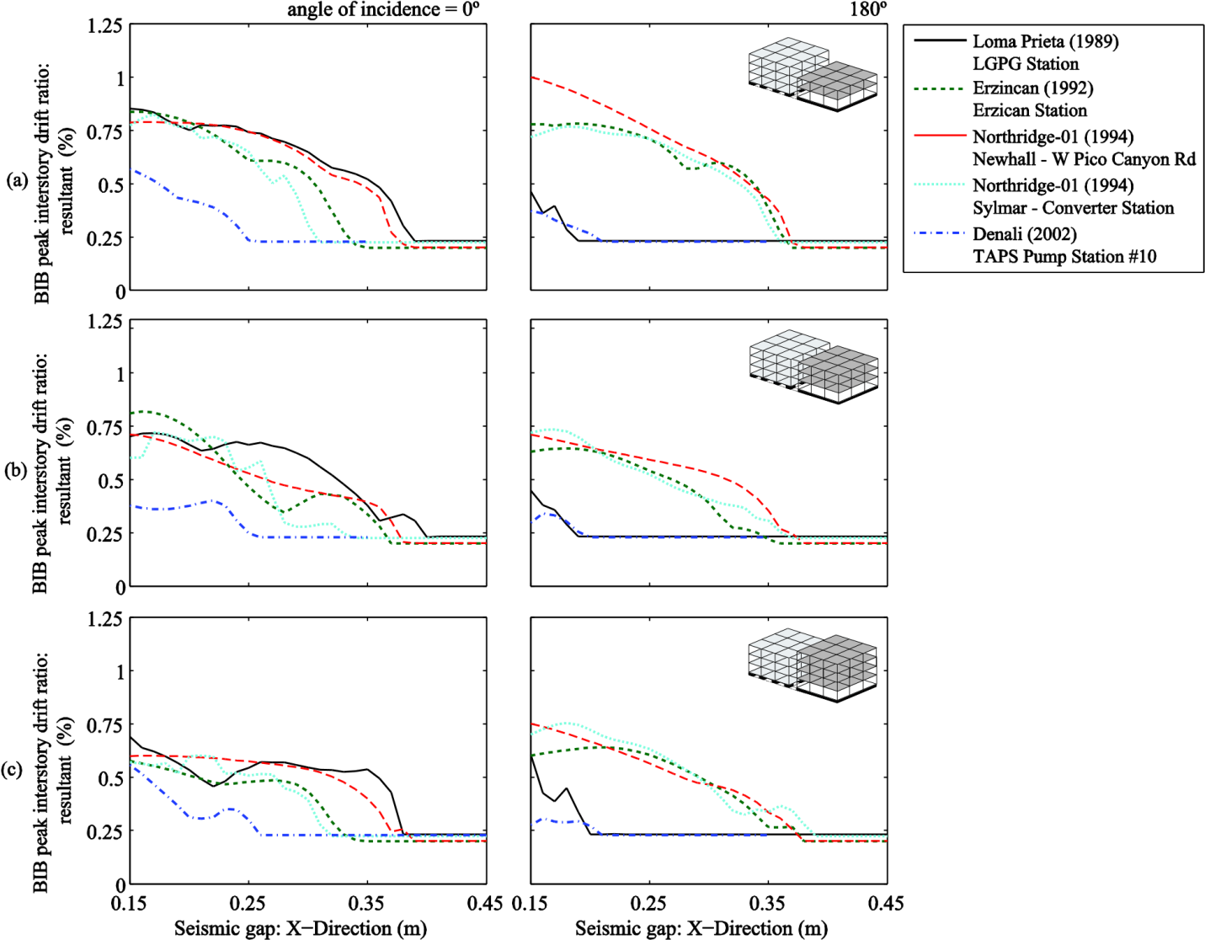

Figure 8. Envelope of peak interstory drifts of the base isolated building among the corner columns in terms of the available seismic gap size for different arrangement of the adjacent fixed supported structures and moat wall, for angle of incidence equal to 0° and 180°.

5. CONCLUSIONS

Selected planar (2D) analyses results of a typical base isolated building subjected to a set of strong earthquake excitations, revealed that the width of the clearance assessed in 2D with the SRSS rule might not be sufficient to avoid structural pounding, which might be detrimental to the building and its contents. The required clearance depends not only on the structural characteristics of the base isolated building but also on whether there are adjacent buildings and their structural characteristics, as well as the characteristics of the imposed excitations. However, spatial effects, such as torsional effects in case of eccentricities and the incidence angle of the imposed seismic excitations cannot be considered with planar analyses.
Spatial analyses revealed that the possibility of potential pounding increases and the detrimental effects of pounding become more severe for certain values of the excitation angle. Furthermore, while considering potential pounding of a base isolated building with adjacent structures, the characteristics and eccentricities of the adjacent structures may significantly influence its peak seismic response. Therefore, spatial (3D) simulations and parametric analyses should be performed for each particular case, in order to obtain a more reliable assessment of the required seismic gap that should be provided and the expected peak seismic response in case of potential pounding.
Moreover, the torsional vibration that a base isolated building experiences due to the potential mass eccentricities might further increase the required clearance to prevent structural pounding and, in case of unavoidable pounding, may intensify the detrimental effects of pounding on the seismic performance of the structure. Thus, this important parameter should not be omitted by simplifying the structure to a planar frame model and performing 2D analysis, since its effect on the response during pounding seems to be significant. In general, the process of determining the critical incidence angle is more complex while considering pounding to adjacent multistory buildings. Therefore, it should be noted that the results presented herein cannot be generalized. Since generalizations cannot be adopted, numerical simulations and parametric analyses should be performed for each particular case in order to identify the most critical seismic response and obtain a more reliable assessment of the expected peak seismic response and the required clearance to avoid pounding.

7. REFERENCES

Anagnostopoulos, S. A., Kyrkos, M. T., Papalymperi, A., and Plevri, E. (2015). Should accidental eccentricity be eliminated from Eurocode 8? Earthquakes Struct. Vol 8, No 2, pp. 463-484.
Dimitrakopoulos, E., Makris, N., and Kappos, A. J. (2009). Dimensional analysis of the earthquake-induced pounding between adjacent structures. Earthq. Eng. Struct. Dyn. 38, pp. 867–886.
Jankowski, R., and Mahmoud, S. (2015). Earthquake-Induced Structural Pounding. Cham: Springer Intern. Publishing.
Komodromos, P. (2008). Simulation of the earthquake-induced pounding of seismically isolated buildings. Earthq. Eng. Struct. Dyn. 86, pp. 618–626.
López, O. A., and Torres, R. (1997). The critical angle of seismic incidence and the maximum structural response. Earthq. Eng. Struct. Dyn. 26, pp. 881–894.
Mahmoud, S., and Jankowski, R. (2010). Pounding-involved response of isolated and non-isolated buildings under earthquake excitation. Earthquakes Struct. 1, pp. 231–252.
Matsagar, V. A., and Jangid, R. S. (2003). Seismic response of base-isolated structures during impact with adjacent structures. Eng. Struct. 25, pp. 1311–1323.
Mavronicola, E. A., Polycarpou, P. C., and Komodromos, P. (2016). Spatial seismic modeling of base-isolated buildings pounding against moat walls: effects of ground motion directionality and mass eccentricity. Earthq. Eng. Struct. Dyn. , Vol. 46, Issue 7, pp. 1161–1179.
Nagarajaiah, S., Reinhorn, A. M., and Constantinou, M. C. (1991). Nonlinear Dynamic Analysis of 3D Base Isolated Structures. J. Struct. Eng. 117, pp. 2035–2054.
Pant, D. R., and Wijeyewickrema, A. C. (2012). Structural performance of a base-isolated reinforced concrete building subjected to seismic pounding. Earthq. Eng. Struct. Dyn. 41, pp. 1709–1716.
Pant, D. R., and Wijeyewickrema, A. C. (2014). Performance of base-isolated reinforced concrete buildings under bidirectional seismic excitation considering pounding with retaining walls including friction effects. Earthq. Eng. Struct. Dyn. 43, pp. 1521–1541.
Park, Y. J., Wen, Y.-K., and Ang, A. (1986). Random vibration of hysteretic systems under bi-directional ground motions. Earthq. Eng. Struct. Dyn., Vol 14, pp. 543–557.
Polycarpou, P. C., and Komodromos, P. (2011). Numerical investigation of potential mitigation measures for poundings of seismically isolated buildings. Earthquakes and Structures, Vol. 2, No.1, pp. 1-24.
Polycarpou, P. C., Papaloizou, L., and Komodromos, P. (2014). An efficient methodology for simulating earthquakeinduced 3D pounding of buildings. Earthq. Eng. Struct. Dyn., Vol. 43, Issue 7, pp. 985-1003.
Wen, Y.-K. (1976). Method for random vibration of hysteretic systems. J. Eng. Mech. Div. 102, pp. 249–263.
Ye, K., Li, L., and Zhu, H. (2009). A modified Kelvin impact model for pounding simulation of base-isolated building with adjacent structures. Earthq. Eng. Eng. Vib. 8, pp. 433–446.

University of Cyprus, Nicosia, Cyprus
University of Nicosia, Nicosia, Cyprus
Associate Professor, Civil & Env. Engineering Dept, University of Cyprus, Nicosia, Cyprus, komodromos@ucy.ac.cy

