DEVELOPMENT AND APPLICATION OF A VARIABLE STIFFNESS

ISOLATION SYSTEM CONSIDERING GROUND MOTION CHARACTERISTIC

DOI 10.37153/2686-7974-2019-16-511-522

Zheng-Jia LIU, Tzu-Kang LIN, Lyan-Ywan LU, Yu-Chi Sung

ABSTRACT

In recent years, the research of isolation and mitigation system has become more and more important. In the traditional isolation and mitigation system, the control effect may be reduced because of unknown earthquake types. To have the best effect of response reduction, the systems have to be adaptive with the earthquake type. To achieve that, an upgraded algorithm, Feed-forward Predictive Earthquake Energy Analysis (FPEEA), is proposed by considering the energy of earthquake velocity to have the optimal response. The new algorithm quickly evaluates the velocity energy to have the optimal weighting of minimum energy weighting (MEW). With the optimal weighting of the potential energy and the kinetic energy, the PFEEA can reduce the structural responses efficiently. In order to demonstrate the performance of the proposed algorithm, a single-degree-of-freedom structure is used as a benchmark in both numerical simulation and experimental verification. With predicting the optimal weighting in advance, the type of earthquake can be defined before the main shock of earthquake comes. The results have shown that the dynamic response of the structure can be effectively alleviated. Comparing to the structural responses of the MEW method, the performance of the proposed algorithm is similar to MEW or even better. The shaking table test also demonstrates the feasibility of applying the proposed algorithm in practical application.

Keywords: Potential energy; Semi-active control; near-fault earthquake; Minimum energy weighting; velocity energy

1. INTRODUCTION

Large-scale earthquake events often result in considerable casualties and can also cause structures in the affected area to collapse. To prevent loss of life and property due to earthquakes, researchers have focused on dampening the structural responses. Structure control systems have been under development for several decades. Such systems can be mainly classified into three categories: passive, active, and semi-active control. Passive control systems have advantages such as low control energy and reliability and effectiveness of control. For instance, a triangular-plate added damping and stiffness device (TADAS) was developed by Tsai et al. (1993). Hybrid damper actuator bracing control was proposed by Zhang et al. (2006), in which bracing equipment is installed on the floor and linked to energy-absorbing dampers. Several studies (Tamura et al. 1995, Martinez Rueda 2002, De la Cruz et al. 2007) have revealed that structural reactions can be ameliorated by utilizing dampers on the structure.
An active control device used in combination with a control algorithm often produces results superior to those of a passive control system. The first phase of a comprehensive experimental study concerning the possible application of active control to structures under seismic excitations was presented by Chung et al. (1998). A dynamic fluid control device was proposed by Battista et al. (2008); use of the device involves placing multiple parallel tubes on the top of the structure and connecting a rotating device below to adjust the device direction. The response of the structure can be attenuated by arranging the tubes along the excitation direction.
For adaptive stiffness control, the potential of using a semi-active controllable stiffness device whose spring coefficient can be modulated in real-time for tonal disturbance rejection applications was examined by Anusonti-Inthra (2003). A short time Fourier transformation (STFT) control algorithm based on a semiactive independently variable stiness (SAIVS) device was proposed and numerically evaluated by Narasimhana and Nagarajaiah (2005). A new moving average non-linear tangential stiffness control algorithm for control of the SAIVS device was further developed and experimentally verified by Nagarajaiah and Sahasrabudhe (2006). A high-static low-dynamic stiffness (HSLDS) vibration isolator was proposed by Zhou and Liu (2010). The tunable semi-active control system was connected to mechanical springs and comprised an electromagnet and a magnetic generator, and the positive and negative stiffness can be controlled. An isolation layer with a magnetorheological elastomer (MRE) was developed, where the material stiffness can be changed via electrical current (Du et al. 2011). The experimental results revealed that the acceleration can be controlled effectively through a semi-active configuration.
A semi-active isolation mechanism called a leverage-type stiffness-controllable isolation system (LSCIS) was proposed by Lu et al. (2011). The stiffness of the isolation layer can be altered instantaneously by switching the pivot point of the lever arm, thereby achieving control of the structure. A control algorithm named the least input energy method (LIEM) was then proposed by Lu et al. (2012). A series of shaking table tests indicated that displacement and acceleration responses can be reliably ameliorated. Nevertheless, in these early studies of the LSCIS, excessive displacement of the isolation layer was sporadically observed under near-fault earthquakes, which may endanger the isolation system. To alleviate this problem, an algorithm that considers the minimum energy combination of the kinetic and potential energy is proposed here.

2. MINIMAL ENERGY WEIGHTING METHOD

For an adaptive stiffness control system, the controllable stiffness (𝑡), which can be tuned between 0 and the upper bound 𝑘_{𝑟,}, can be divided into an uncontrollable stiffness 𝑘_{𝑟0} and a variable stiffness ∆𝑘_{𝑟}(𝑡), expressed as:

(𝑡) = 𝑘_{𝑟0} + ∆(𝑡) (1)

The equation of motion can be rewritten using the state space method (Naeim and Kelly 1999) as:

𝐳̇(𝑡) = 𝐀𝐳(𝑡) + 𝐁𝐃_{𝑑}𝐳(𝑡)∆𝑘_{𝑟}(𝑡) + 𝐄𝑥̈_{𝑔}(𝑡) (2)

where z(t) represents the state vector; A represents the system matrix; B represents the support matrix, and E represents the excitation matrix. The system matrix can be expressed as:

(3)

The mass M, damping C, and stiffness K of the isolated structure are expressed as:

(4)

where 𝑚_{𝑠} and 𝑚_{𝑏} are the masses of the main structure and the isolation layer, and 𝑘_{𝑠} and 𝑐_{𝑠}are the stiffness and damping coefficient of the superstructure; 𝑥̈_{𝑔}(𝑡) denotes the earthquake acceleration; 𝑥_{𝑠}(𝑡) and 𝑥_{𝑏}(𝑡) represents the relative displacement of the main structure and the isolation layer, respectively.

The discreet state space equation can be further derived as:

$z\left[k+1\right]=A_{d}z\left[k\right]+B_{d}D_{d}z\left[k\right]k_{r}\left[k\right]+E_{d}{\ddot{x}}_{g}\left[k\right]$ (5)

$A_{d}=e^{At}$
$B_{d}=A^{-1}\left(A_{d}-I\right)B$ (6)
$E_{d}=A^{-1}\left(A_{d}-I\right)E$

where 𝐀_{d}, 𝐁_{d}, and 𝐄_{d} are the discrete forms of A, B, and E, and z[k + 1] is the state space response in time step (k + 1), which can be determined from the structural responses 𝐳[𝑘], 𝑥̈_{𝑔}[𝑘], and ∆𝑘_{𝑟}[𝑘]; 𝑥̈_{𝑔}[𝑘] is the ground acceleration.
As demonstrated in previous studies, the superstructure response can be ameliorated by the LIEM under most far-field earthquakes (Naeim and Kelly 1999). Nevertheless, extreme displacement may occur on the isolation layer under near-fault earthquakes. To resolve this, an algorithm called MEW is proposed. By applying the MEW algorithm, the overall structural energy, including the potential and kinetic energy, can be minimized under external vibration.

To derive the optimal ∆[𝑘] Equation (5) is rewritten as:

$z\left[k+1\right]=A_{d}z\left[k\right]+k_{r}\left[k\right]B_{1d}z\left[k\right]+E_{d}{\ddot{x}}_{g}\left[k\right]$ (7)

where

$B_{1d}=B_{d}D_{d}$ (8)

The kinetic energy can be stated as:

$E_{k}\left[k+1\right]=\frac{1}{2}(a_{1}\left[k\right])k_{r}{\left[k\right]}^{2}+a_{2}\left[k\right]k_{r}\left[k\right]+a_{3}\left[k\right]$ (9)

where

$a_{1}\left[k\right]=z{\left[k\right]}^{T}{B_{1d}}^{T}{D_{2}}^{T}MD_{2}B_{1d}z\left[k\right]$ (10)

$a_{2}\left[k\right]=z{\left[k\right]}^{T}{B_{1d}}^{T}{D_{2}}^{T}MD_{2}{(A}_{d}z\left[k\right]+E_{d}{\ddot{x}}_{g}\left[k\right])+DMD_{2}B_{1d}z\left[k\right]{\dot{x}}_{g}\left[k\right]$ (11)

$a_{3}\left[k\right]=\frac{1}{2}(z{\left[k\right]}^{T}{A_{d}}^{T}+{E_{d}}^{T}{\ddot{x}}_{g}\left[k\right]){D_{2}}^{T}MD_{2}{(A}_{d}z\left[k\right]+E_{d}{\ddot{x}}_{g}\left[k\right])+$
$+DMD_{2}{(A}_{d}z\left[k\right]+E_{d}{\ddot{x}}_{g}\left[k\right]){\dot{x}}_{g}\left[k\right]+\frac{1}{2} DMD^{T}({\dot{x}}_{g}{\left[k\right])}^{2}$ (12)

$D=\left[\begin{matrix}1 & 1\end{matrix}\right]$, (13)

The potential energy of the superstructure 𝐸_{𝑝,sup}[𝑘 + 1], and the potential energy of the isolation layer
𝐸_{𝑝,}[𝑘 + 1] are written as:

$E_{p,sup}\left[k+1\right]+E_{p,iso}\left[k+1\right]=\frac{1}{2} \left(k_{s}\right)×{\left(x_{s}\left[k+1\right]\right)}^{2}+\frac{1}{2}\left(K_{r}+K_{r0}\right)×{\left(x_{b}\left[k+1\right]\right)}^{2}=$
$=\frac{1}{2}\left(b_{1,sup}\left[k\right]+b_{1,iso}\left[k\right]\right)k_{r}{\left[k\right]}^{2}+\left(b_{2,sup}\left[k\right]+b_{2,iso}\left[k\right]\right)k_{r}\left[k\right]+\left(b_{3,sup}\left[k\right]+b_{3,iso}\left[k\right]\right)$ (14)

where

$b_{1,iso}\left[k\right]=0.5{\left(B_{1dL}z\left[k\right]\right)}^{2}$ (14)

$b_{2,iso}\left[k\right]=B_{1dL}z\left[k\right]{(A}_{dL}z\left[k\right]+E_{dL}{\ddot{x}}_{g}\left[k\right])K_{r0}$ (15)

$b_{3,iso}\left[k\right]=0.5{(A}_{dL}z\left[k\right])^{2}K_{r0}+0.5(E_{dL}{\ddot{x}}_{g}\left[k\right])K_{r0}+A_{dL}z\left[k\right]E_{dL}{\ddot{x}}_{g}\left[k\right]K_{r0}$ (16)

$b_{1,sup}\left[k\right]=0.5k_{s}\left({\left(B_{1dT}z\left[k\right]\right)}^{2}+{\left(B_{1dL}z\left[k\right]\right)}^{2}-2B_{1dT}z\left[k\right]B_{1dL}z\left[k\right]\right)$ (17)

$b_{2,sup}\left[k\right]=B_{1dL}z\left[k\right]K_{r}(2{(A}_{dL}z\left[k\right]+E_{dL}{\ddot{x}}_{g}\left[k\right])+{(A}_{dT}z\left[k\right]+E_{dT}z\left[k\right]))+$
$+ B_{1dT}z\left[k\right]K_{r}(2{(A}_{dT}z\left[k\right]+E_{dT}{\ddot{x}}_{g}\left[k\right])+{(A}_{dL}z\left[k\right]+E_{dL}z\left[k\right]))$ (18)

$b_{3,sup}\left[k\right]=0.5{(A}_{dL}z\left[k\right])^{2}k_{s}+0.5(E_{dL}{\ddot{x}}_{g}\left[k\right])k_{s}+A_{dL}z\left[k\right]E_{dL}{\ddot{x}}_{g}\left[k\right]k_{s}+$
$+ 0.5{(A}_{dT}z\left[k\right])^{2}k_{s}+0.5(E_{dT}{\ddot{x}}_{g}\left[k\right])k_{s}+A_{dT}z\left[k\right]E_{dT}{\ddot{x}}_{g}\left[k\right]k_{s}-$
${- 0.5A}_{dT}z\left[k\right]A_{dL}z\left[k\right]k_{s}-0.5E_{dT}{\ddot{x}}_{g}\left[k\right]E_{dL}{\ddot{x}}_{g}\left[k\right]k_{s}-$
${- 0.5A}_{dT}z\left[k\right]E_{dL}{\ddot{x}}_{g}\left[k\right]k_{s}-0.5A_{dL}z\left[k\right]E_{dT}{\ddot{x}}_{g}\left[k\right]k_{s}$ (19)

To determine the optimal stiffness increment, the energy performance index J[𝑘 + 1] is proposed as:

$J\left[k+1\right]=E_{k}\left[k+1\right]+\frac{R}{2}k_{r}{\left[k_{r}\right]}^{2}+QE_{p}×E_{p,sup}\left[k+1\right]+QE_{p}×E_{p,iso}\left[k+1\right]$ (20)

where R is the penalty weighting of the pivot point and 𝑄𝐸_{𝑝} is the weighting of the potential energy. In Equation (14), is simplified to accelerate the search process.

The optimal stiffness increment Δk_{r,opt}[k] can be expressed as:

$k_{r,opt}\left[k\right]=\frac{-(a_{2}+QE_{p}×b_{2,str}+QE_{p}×b_{2,iso})}{a_{1}+R+QE_{p}×b_{2,str}+QE_{p}×b_{2,iso}}$ (21)

In order to achieve adaptive stiffness control, the LSCIS is adopted in this study. The mechanism of the adaptive stiffness control system of the LSCIS is illustrated in Figures 1(a) and (b), and the mathematical model is depicted in Figure 1(c). The relationship between ∆k_{r}[𝑘] and 𝑥_{𝑝}[𝑘] for the LSCIS system can be expressed as:

$k_{r}\left[k\right]=\left[\frac{2Lx_{p}\left[k\right]}{\left(0.5L-x_{p}{\left[k\right]}^{2}\right)}\right]k_{r0}$ (22)

As shown in Equation (25), a controllable ∆k_{r}[𝑘] in the isolation layer is generated by properly shifting the leverage point 𝑥_{𝑝}[𝑘] between 0.0202L and -0.191L with leverage length L.

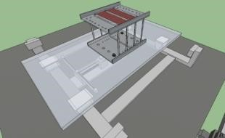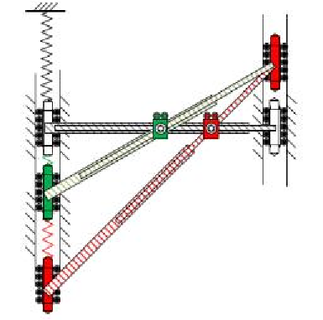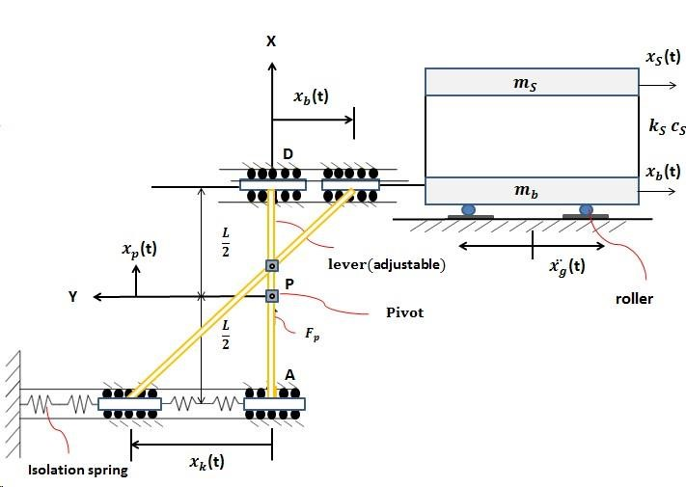

(
a
S
)
uperstructure isolated by LSCIS

b) Leverage mechanism
(

c) Physical model for LSCIS
(
-
isolated structure

Figure 1 The LSCIS system

Mass
block

S
uperstructure

I
solation layer

L
inked to
superstructure

pivot

spring

3. NUMERICAL EVALUATION OF PROPOSED ALGORITHM

3.1 Input earthquakes and numerical model

Three earthquake records with various dynamic characteristics shown in Figure 2 were applied in the numerical simulation:
- El Centro (S00E) earthquake; May 18, 1940; peak acceleration: 341.0 cm/s².
- Imperial Valley (El Centro Array 6) earthquake; Channel 1 230deg; October 15, 1979; peak acceleration: 428.1 cm/s².
- Chi-Chi earthquake, Taiwan; September 20, 1999; station: TCU068 – N; peak acceleration: 0.462 g.
An 18.66-kg superstructure and a 28.30-kg isolation base were used. The practical system parameters were first identified under white-noise excitation of 0.1-g peak ground acceleration (PGA); they are listed in Table 1.

Table 1. Identified parameters for the isolated system

System | Item | Value | System | Item | Value
 | Mass (ms) | 18.66kg |  | Mass (mb) | 28.30 kg
Superstructure | Damping ratio (ξ) | 0.02 | Isolation layer | Isolation period (Tr0) | 2.49 s
 | Stiffness (ks) | 2780 N/m |  | Damping Ratio (ξs) | 0.075
 | Natural frequency | 1.95 Hz |  | Stiffness (kr0) | 300 N/m

3.2 Control weighting optimization

Based on the identified model, the optimal control weightings were found by exciting the structure with the El Centro and Imperial Valley earthquake time histories, which are typical far-filed and near-fault earthquakes, respectively. The contour of the relative displacement and absolute acceleration under various R and QE_{p} values were generated and compared for the optimal arrangement. The R was set from 10⁻¹² to 10⁰ and QE_{p} was explored from 0 to 200.
The numerical structural response under the El Centro earthquake (PGA: 0.3 g), representing a characteristic far-field earthquake, is shown on the left side of Figure 2. As indicated, the absolute acceleration illustrated in Figure 2(a) is exaggerated dramatically with increases of R and QE_{p}. Moreover, the minimum relative displacement illustrated in Figure 2(c) can be reached through the settings 10⁻⁸ and 30 for R and QE_{p} , respectively. As both the absolute acceleration and relative displacement can be alleviated most among the searching contour, the optimum weightings of QE_{p} and R are determined as 30 and 10⁻⁸, respectively.
The numerical simulation under the Imperial Valley earthquake (PGA: 0.2 g), reflecting the classical nearfault characteristic, is illustrated on the right side of Figure 4. The relative displacement is amplified when QE_{p} approaches 0 and R is lower than 10⁻⁷. In comparison to the LIEM control (QE_{p} = 0、R = 10⁻⁸), the displacement response can be significantly suppressed when QE_{p} is set as 30. Thus, the minimum displacement is reached through the setting of QE_{p} = 180 and R= 10⁻⁸. For the acceleration response, the minimum acceleration of the superstructure is achieved with QE_{p} = 0 and R = 10⁻⁶. As relative displacement is the main concern under near-fault earthquake, and similar displacement can be achieved by the setting of QE_{p} = 180 and R = 10⁻⁸, the optimal weightings are set as QE_{p} = 180 and R = 10⁻⁸ for near-fault earthquakes.

Acceleration of roof (m/s )
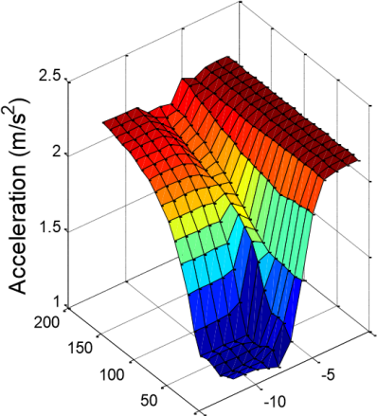0 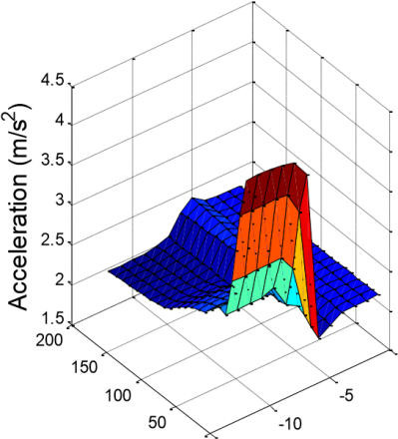0
Y axis : QEp 0 -15 X axis : 10n Y axis : QEp 0 -15 X axis : 10n

(a) Superstructure acceleration (El Centro PGA = 0.3 g) (b) Superstructure acceleration (Imperial Valley PGA = 0.3 g)
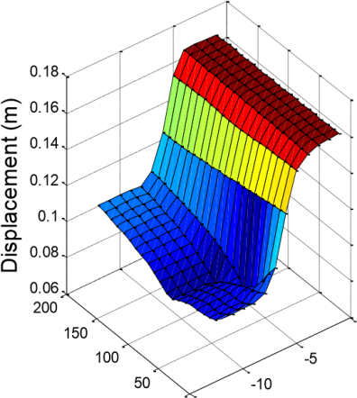0 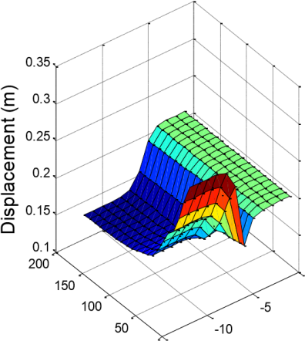0
Y axis : QEp 0 -15 X axis : 10n Y axis : QEp 0 -15 X axis : 10n

(c) Isolation layer displacement (El Centro PGA = 0.3 g) (d) Isolation layer displacement (Imperial Valley PGA = 0.3 g)

Figure 2. Control parameter optimization

Based on the results, R is determined as 10⁻⁸. Two types of MEW control algorithm with different QE_{p} values are proposed in accordance with various earthquake characteristics. The near-fault MEW control (QE_{p} = 180) is considered for near-fault earthquakes to reduce the extreme displacements; and the generic MEW control, where QE_{p} = 30, is proposed for common earthquakes. Although an optimal response reduction cannot be obtained using the generic MEW control under near-fault earthquakes, improvements in control efficiency are expected after the appropriate consideration of the potential energy. Depending on the seismic zone of the structure’s location, the optimal algorithm can be selected. For example, the generic MEW control can be deployed outside near-fault areas. The near-fault MEW control can be adopted when structures are located inside the near-fault zone.

3.3 Structural response under earthquake conditions

The structural responses of several algorithms, including passive, LIEM, generic MEW, and near-fault MEW control, under diverse earthquake excitations were evaluated. For the passive control case, the LSCIS pivot point was kept constant in the center, and thus the value of the isolation stiffness remained as the original stiffness K_{r0}, with no stiffness increment throughout the excitation. Although better acceleration performance can be achieved by extending the isolation period, excessive displacement of the isolation layer under nearfault earthquakes hinders the practicality of the long-period isolation system. In contrast, with the reduction in displacement, the acceleration is largely influenced by a relatively small isolation period. Since the isolation period is commonly suggested to be between 2 and 3 s (Naeim and Kelly 1999), the isolation period of the structure was set as 2.5 s. Moreover, the control parameters QE_{p} and R of the LIEM method were set as 0 and 10⁻⁸, respectively.
The superstructure acceleration under the El Centro earthquake with numerous earthquake intensities is illustrated in Figure 3(a). Among the four control modes, the generic MEW control has the most efficient performance for the far-field earthquake. Generic MEW control and the LIEM have similar responses for PGA values of 0.25, 0.45, and 0.5 g; satisfactory control effectiveness is achieved for PGA values of 0.3 and 0.4 g. Regarding the near-fault MEW control, greater responses are observed for PGA values of 0.15 and 0.2 g compared with those for the passive control; nevertheless, the acceleration responses at 0.25 and 0.5 g are smaller than those of the passive control algorithm. The displacements of the isolation layer under the El Centro earthquake with various magnitudes are illustrated in Figure 3(b). The generic and near-fault MEW control modes both display better control effects for all PGA values compared to those of the LIEM control algorithm. To conduct a detailed comparison, the structural responses under the El Centro earthquake (PGA: 0.3 g) are listed in Table 2. The maximum displacements of the isolation layer for the passive, LIEM, generic MEW, and near-fault MEW control are 0.164 (100%), 0.095 (57.9%), 0.090 (54.8%), and 0.098 (59.7%) m, respectively. The maximum superstructure accelerations for the four control modes are 2.176 (100%), 1.050 (48.2%), 1.083 (49.7%), and 2.040 (93.3%) m/s2, respectively. As both displacement and acceleration can be reduced, the advantage of considering the potential energy under far-field earthquakes is verified.
As the main objective of the present study is to control the excessive displacement of the isolation layer under near-fault earthquakes, the typical near-fault TCU-068NS earthquake was used for verification. Figures 3(e) and (f) present the absolute superstructure accelerations and relative isolation layer displacements for various PGA values, respectively. The near-fault control algorithm yields the smallest response for the various PGA values. For earthquakes exceeding 0.2 g, the displacement of the isolation layer can be significantly suppressed by the near-fault MEW control algorithm. The structural responses for a PGA value of 0.2 g are further detailed in Table 3. As shown in this table, the maximum accelerations of the superstructure for the passive, LIEM, generic MEW, and near-fault MEW control modes are 3.659 (100%), 3.815 (104.2%), 3.627(99.1%), and 2.512 (68.6%) m/s2, respectively, and the maximum displacements of the isolation layer for these four control modes are 0.317 (100%), 0.359 (113.2%), 0.341 (107.5%), and 0.159 (50.1%) m, respectively. These results demonstrate that both the superstructure acceleration and isolation layer displacement can be effectively controlled by the near-fault MEW control, and better performance can also be achieved by the generic MEW control compared to the LIEM. Moreover, promising results can still be achieved when the near-fault MEW control is applied under far-field earthquakes. Compared to the passive control, an estimated 30% reduction in acceleration can be provided by the semi-active control, and similar displacement control results can be expected for the other three methods (LIEM, far-field MEW, and near-fault MEW control).

Table 2. Simulated peak response under El Centro earthquake(PGA=0.3g)

Control system | Superstructure displacement (m) | Isolation layer displacement (m) | Superstructure acceleration (m/s²) | Isolation layer acceleration (m/s²)
Passive | 0.174 | 0.164 | 2.176 | 1.753
 | (1.00) | (1.00) | (1.00) | (1.00)
LIEM | 0.093 | 0.095 | 1.050 | 0.873
(R=10⁻⁸) | (0.534) | (0.579) | (0.482) | (0.498)
LIEM+Ep | 0.091 | 0.090 | 1.083 | 0.889
(QEp=30) | (0.523) | (0.548) | (0.497) | (0.507)
LIEM+Ep | 0.109 | 0.098 | 2.040 | 1.532
(QEp=180) | (0.626) | (0.597) | (0.933) | (0.873)
Note: numbers in parentheses represent ratio between passive and controlled responses.

Table 3. Simulated peak response under Chi-Chi TCU-068NS earthquake (PGA=0.2g)

Control system | Superstructure displacement (m) | Isolation layer displacement (m) | Superstructure acceleration (m/s²) | Isolation layer acceleration (m/s²)
Passive | 0.340 | 0.317 | 3.659 | 3.039
 | (1.00) | (1.00) | (1.00) | (1.00)
LIEM | 0.367 | 0.359 | 3.815 | 3.778
(R=10⁻⁸) | (1.079) | (1.132) | (1.042) | (1.243)
LIEM+Ep | 0.346 | 0.341 | 3.627 | 3.482
(QEp=30) | (1.017) | (1.075) | (0.991) | (1.145)
LIEM+Ep | 0.172 | 0.159 | 2.512 | 2.632
(QEp=180) | (0.505) | (0.501) | (0.686) | (0.866)
Note: numbers in parentheses represent ratio between passive and controlled responses.

Roof Acceleration Base Displacement
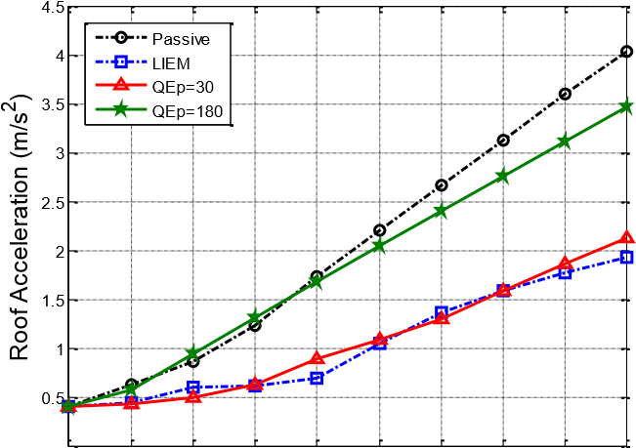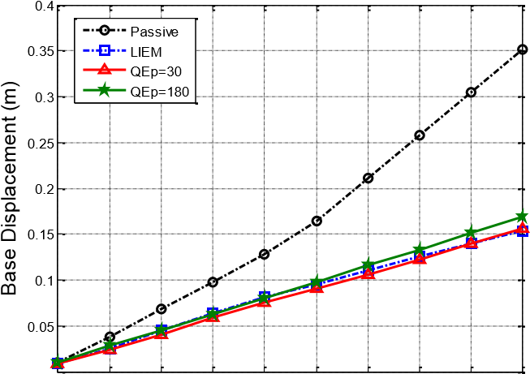
- ⁰
0.05 0.1 0.15 0.2 PGA (g)0.25 0.3 0.35 0.4 0.45 0.5 0.05 0.1 0.15 0.2 PGA (g)0.25 0.3 0.35 0.4 0.45 0.5
(a) Superstructure acceleration (El Centro) (b) Isolation layer displacement (El Centro)

Roof Acceleration Base Displacement
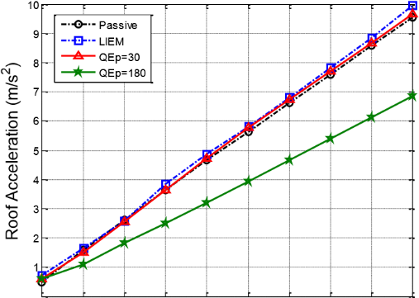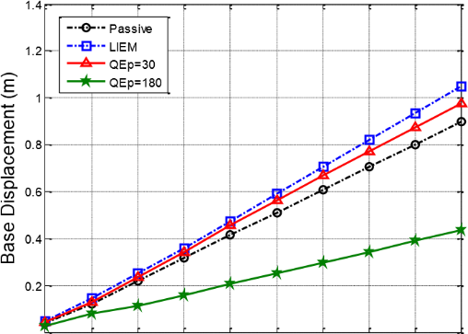
⁰ ⁰
0.05 0.1 0.15 0.2 PGA (g)0.25 0.3 0.35 0.4 0.45 0.5 0.05 0.1 0.15 0.2 PGA (g)0.25 0.3 0.35 0.4 0.45 0.5
(c) Superstructure acceleration (TCU-068NS) (d) Isolation layer displacement (TCU-068NS)

Figure 3. Numerical simulation of passive, LIEM, generic MEW (QEp=30), and near-fault MEW (QEp=180)

4. EXPERIMENTAL VERIFICATION

To demonstrate the feasibility of the proposed algorithms, a series of shaking table experiments was executed. As the maximum stroke of the shaking table is limited to 12 cm, only the El Centro and Imperial Valley earthquakes were utilized as the ground input during the experiments. The experimental setup, including the control system, the lever device, experimental specimen, and the LSCIS, is shown in Figure 4. As indicated, the pivot point can be shifted between point A and D for the optimal isolation stiffness. Linear variable differential transformers (LVDTs) (±300 and ±100 mm), a velocity meter (±100 kine), and an accelerometer (±2 G) were deployed to measure structural responses.

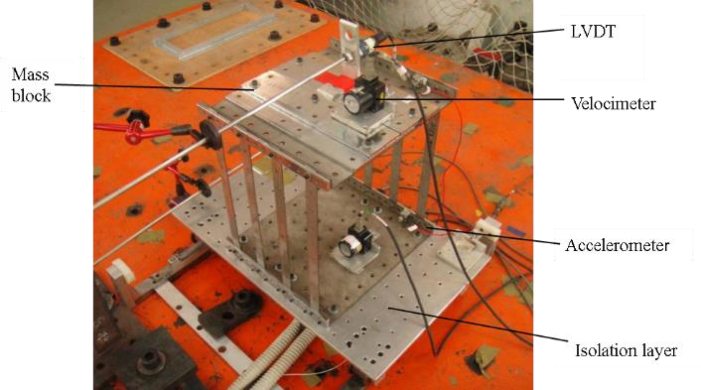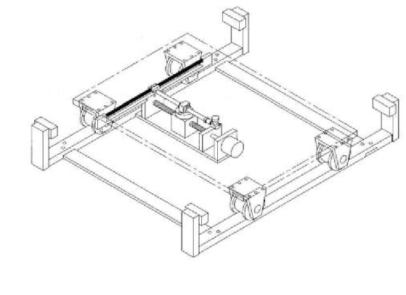

Isolation Platform

Guiding
Rail

Leverage bar

Pivot

P

Connection point A

Connection point D

Linkage

Spring

Servo mo
tor

Lead screw

A

P

D

(a) Experimental specimen (b) lever device

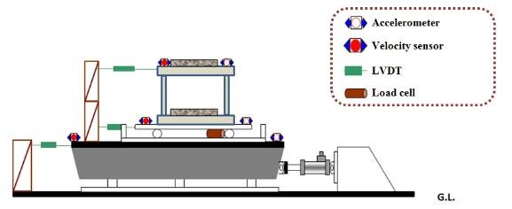
(c) instrumentation

Figure 4. Experimental set-up of the LSCIS

The structural responses under the El Centro (PGA: 0.3 g) and Imperial Valley (PGA: 0.2 g) earthquakes with various algorithms were first compared. The results of the passive, LIEM, generic MEW, and near-fault MEW control modes under the El Centro earthquake (PGA: 0.3 g) are shown in Table 4. The peak displacements of the isolation layer under the passive, LIEM, generic MEW, and near-fault MEW control were 0.101 (100%), 0.071 (70.2%), 0.070 (69.3%), and 0.073 (72.8%) m, respectively. Based on the experimental results, the displacement of the isolation layer was effectively dampened by the LIEM, generic MEW, and near-fault MEW control modes; the displacement of the isolation layer was suppressed most by the generic MEW control. Moreover, the structural accelerations were also compared. The peak superstructure accelerations for the passive, LIEM, generic MEW, and near-fault MEW control were 1.917 (100%), 1.295 (67.6%), 0.989 (51.6%), and 1.815 (94.7%) m/s2, respectively. Among the four methods, the superstructure acceleration was controlled best by the generic MEW control, with an estimated 10% advantage over the LIEM. The performance of the near-fault MEW control is close to that of the passive control system as the near-fault MEW control is mainly considered for near-fault ground excitation.
The displacements of the isolation layer for the various algorithms under the Imperial Valley earthquake (PGA: 0.2 g) are shown in Table 5. The peak displacements of the isolation layer for the passive, LIEM, generic MEW, and near-fault MEW algorithms were 0.119 (100%), 0.131 (109.5%), 0.102 (85.3%), and 0.085 (71.3%) m, respectively. The displacement for the generic MEW and near-fault MEW control modes are depicted in Figures 5(a) and (b), respectively. While the displacement of the isolation layer was significantly exaggerated under the passive and LIEM control, the maximum values for the generic MEW and near-fault MEW control modes can be effectively reduced. The near-fault MEW control exhibited optimal control under near-fault earthquakes, demonstrating a 39% enhancement over the LIEM. The peak superstructure accelerations for the passive, LIEM, generic MEW, and near-fault MEW control were 2.332 (100%), 2.161 (92.7%), 1.899 (81.4%), and 1.771 (75.9%) m/s2, respectively. The acceleration for the generic MEW control is depicted, and that for the near-fault MEW control is depicted in Figures 5(c) and (d). As illustrated in these figures, the acceleration responses for peak ground excitation, occurring at 10 s, for both the generic MEW and near-fault MEW control algorithms were less than those observed for the passive and LIEM control. The acceleration for the generic MEW control algorithm was reduced by at least 10% compared with that for the LIEM control. The near-fault MEW control yielded a maximum acceleration reduction that was 17% lower than that of the LIEM.
The displacement of the pivot and the hysteresis loops of the near-fault MEW control modes under the Imperial Valley earthquake (PGA: 0.2 g) are depicted in Figures 5(e) and (f), respectively. The pivot displacement of the generic MEW control was controlled similarly to that of LIEM control, resulting in comparable sizes of hysteresis loops. For the near-fault MEW control, the pivot displacement was controlled toward the positive direction to provide the required damping force against the large stroke caused by the near-fault earthquake. Thus, better energy dissipation was observed from the hysteresis loop. Moreover, the direction of hysteresis loops in both QEP and LIEM is further indicated by arrows in 8(f), where is clockwise in the first quadrant and counterclockwise in the fourth quadrant. The higher and lower tangents shown in the figures represent the upper and lower bounds of the isolation stiffness for the LSCIS system, which fits well with the original setting of the isolation system.

Table 4. Experimental peak response under El Centro earthquake (PGA=0.3g)

Control system | Superstructure displacement (m) | Isolation layer displacement (m) | Superstructure acceleration (m/s²) | Isolation layer acceleration (m/s²)
Passive | 0.104 | 0.101 | 1.917 | 1.585
 | (1.00) | (1.00) | (1.00) | (1.00)
LIEM | 0.069 | 0.071 | 1.295 | 0.805
(R=10⁻⁸) | (0.66) | (0.70) | (0.68) | (0.51)
LIEM+Ep | 0.069 | 0.070 | 0.989 | 1.000
(QEp=30) | (0.66) | (0.69) | (0.52) | (0.63)
LIEM+Ep | 0.080 | 0.073 | 1.815 | 1.435
(QEp=180) | (0.77) | (0.73) | (0.95) | (0.91)
Note: numbers in parentheses represent ratio between passive and controlled responses.

Table 5. Experimental peak response under Imperial Valley earthquake (PGA=0.2g)

Control system | Superstructure displacement (m) | Isolation layer displacement (m) | Superstructure acceleration (m/s²) | Isolation layer acceleration (m/s²)
Passive | 0.125 | 0.119 | 2.332 | 1.931
 | (1.00) | (1.00) | (1.00) | (1.00)
LIEM | 0.134 | 0.131 | 2.161 | 1.592
(R=10⁻⁸) | (1.07) | (1.10) | (0.93) | (0.82)
LIEM+Ep | 0.108 | 0.102 | 1.899 | 1.111
(QEp=30) | (0.86) | (0.85) | (0.81) | (0.58)
LIEM+Ep | 0.097 | 0.085 | 1.771 | 1.571
(QEp=180) | (0.78) | (0.71) | (0.76) | (0.81)
Note: numbers in parentheses represents ratio between passive and controlled responses.

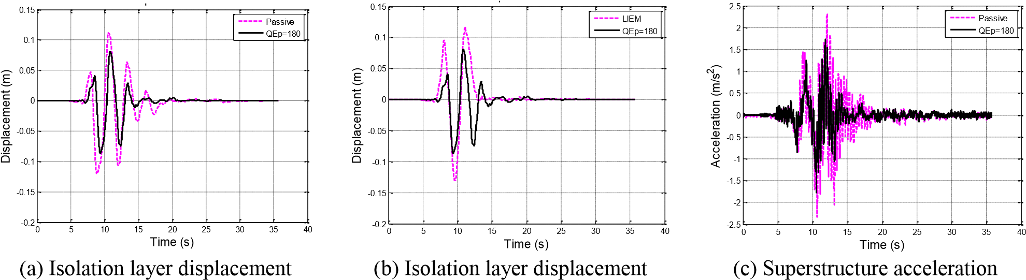
(passive and near-fault MEW) (LIEM and near-fault MEW) (passive and near-fault MEW)

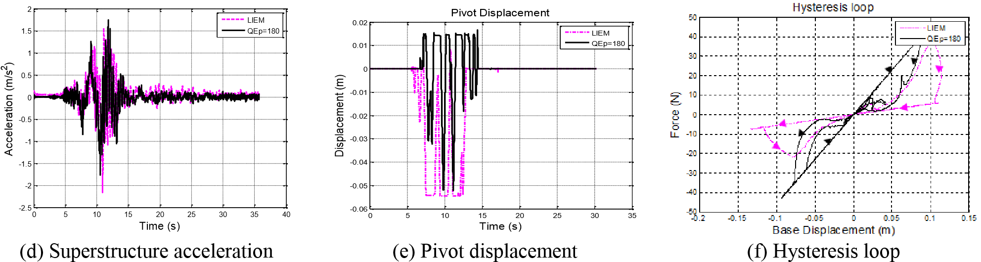
(passive and near-fault MEW)

Figure 5. Comparison of responses for passive, LIEM and near-fault MEW cases (Imperial Valley PGA=0.2g)

5. CONCLUDING REMARKS

To constrain the extreme displacement of isolation layers that occurs under near-fault earthquakes, the total structural energy was considered. By determining the optimum weightings between the kinetic and potential energy, two novel algorithms, namely the generic MEW and near-fault MEW control modes, were developed. Numerical simulation shows that the generic MEW control can provide structural responses similar to those of the LIEM control under regular far-field earthquakes. The superstructure acceleration and the isolation layer displacement can be successfully ameliorated. Although the structural response may be slightly exaggerated under near-fault earthquakes, it can still be dampened more than that of the LIEM control. For the near-fault MEW control, control efficiency close to that of LIEM control can be achieved for far-field earthquakes, and control performance better than that of the passive control algorithm can be achieved. In addition, the superstructure acceleration and the displacement of the isolation layer are efficiently suppressed by the near-fault MEW control under near-fault earthquakes.
The MEW algorithms were experimentally verified through shaking table tests. Both the generic MEW and near-fault MEW control modes yield satisfactory results under near-fault earthquakes. The displacement response of the isolation layer was ameliorated successfully by the generic and near-fault MEW control. Moreover, the acceleration can be suppressed more efficiently than those under the passive control and the LIEM. The performance of the proposed system was demonstrated.

6. REFERENCES

Anusonti-Inthra, F.G.P. (2003), “Adaptive Control of Semiactive Variable Stiffness Devices for Narrow-Band Disturbance Rejection”, Journal of Intelligent Material Systems And Structures, 14.
Battista, R.C., Carvalhob, E.M.L. and de Almeida Souza, R. (2008), “Hybrid fluid-dynamic control devices to attenuate slender structures oscillations”, Engineering Structures, 30(12), 3513–3522.
Chung, L.L., Reinhorn, A.M. and Soong, T.T. (1988), “Experiments on Active Control of Seismic Structures”, Journal of Engineering Mechanics, 114(2).
De la Cruz, S.T., López-Almansa, F., Oller, S. (2007), “Numerical simulation of the seismic behavior of building structures equipped with friction energy dissipators”, Comput Struct, 85(1–2), 30–42.
Du, H., Li, W. and Zhang, N. (2011) “Semi-active variable stiffness vibration control of vehicle seat suspension using an MR elastomer isolator”, Smart Materials and Structures, 20(10), 105003.
Lu, L.Y., Chu, S.Y., Yeh, S.W. and Chung, L.L. (2012) “Seismic test of least-input-energy control with ground velocity feedback for variable-stiffness isolation systems”, J. Sound and Vibration, 331(4), 767–784.
Lu, L.Y., Chu, S.Y., Yeh, S.W. and Peng, C.H. (2011), “Modeling and experimental verification of a variable-stiffness isolation system using leverage mechanism.” Journal of Vibration and Control, 17(12), 1869-1885.
Martinez Rueda, J.E., (2002), “On the evolution of energy dissipation devices for seismic design”, Earthq Spectra, 18(2), 309–346.
Naeim, F., and Kelly, J.M. (1999), Design of Seismic Isolated Structures, John Wiley & Sons, Inc., New York, USA.
Narasimhan S, Nagarajaiah S. (2005), A STFT semiactive controller for base isolated buildings with variable stiffness isolation systems. Engineering Structures, 27(4):514–523.
Nagarajaiah S, Sahasrabudhe S. (2006), Seismic response control of smart sliding isolated buildings using variable stiffness systems: an experimental and numerical study. Earthquake Engineering and Structural Dynamics, 35(2):177– 197.
Tamura, Y., Fujii, K., Ohtsuki, T., Wakahara, T., Kohsaka, R. (1995), “Effectiveness of tuned liquid dampers under wind excitation”, Engineering Structures, 17(9), 609–621.
Tsai, C., Chen, H.W., Hong, C.P., and Su, Y.F. (1993), “Design of Steel Triangular Plate Energy Absorbers for Seismic‐ Resistant Construction”, Earthquake Spectra, 9(3), 505-528.
Zhang, X.Z., Cheng, F.Y., Jiang, H.P. (2006), “Hybrid actuator–damper–bracing control (HDABC) system with intelligent strategy and soil–structure interaction”, Engineering Structures, 28(4), 2010–2022.
Zhou, N. and Liu, K. (2010), “A tunable high-static-low-dynamic stiffness vibration isolator.” Journal of Sound and Vibration, 329(9), 1254-1273.

Master student, Department of Civil Engineering, National Chiao Tung University, Hsinchu, R.O.C., thslf123@gmail.com
Professor, Department of Civil Engineering, National Chiao Tung University, Hsinchu, R.O.C., tklin@nctu.edu.tw
Professor, Department of Civil Engineering, National Cheng Kung University, Tainan, R.O.C., lylu@mail.ncku.edu.tw
Professor, Department of Civil Engineering, National Taipei University of Technology, Taipei, R.O.C., sungyc@ntut.edu.tw

