COMPARATIVE ANALYSIS OF THE EFFECT OF SEISMIC ISOLATION

BY MEANS OF STATIONS OF ENGINEERING SEISMOMETRIC SERVICE ON BUILDINGS

DOI 10.37153/2686-7974-2019-16-482-488

LAPIN V.A.

ABSTRACT

Studies on the effectiveness evaluation of seismic isolation systems of various types are performed in «KazRDICA» JSC at the permanently operating special test site. In 1989, stations of engineering seismometric service were installed on three constructed houses with the same supra-foundation part (9-storeyed large-panel houses of the series 158), but with different foundations: conventional strip foundations with a system of cross strips, seismically isolating kinematic foundations and supports with PTFE gaskets.
In the Republic of Kazakhstan, over 20 houses on kinematic foundations were built in Almaty.
During the earthquake on August 16, 2014, instrumental records of the indicated earthquake were obtained. These instrumental records formed a very convenient for studying sample out of 10 accelerograms – they were obtained on the analogue house and two buildings with seismically isolating foundations.
It has been established that the magnitudes of the acceleration at the level of the 9th floor in seismically isolated buildings are 47% less than the similar value in the building on a strip foundation. The maximum values ​​of the spectral acceleration for seismically isolating buildings at the level of the 9th floor are 1.2 times less than the same value for FT, and 2.4 times for KF.

Keyword: seismic isolation, accelerogram, seismic station

1. INTRODUCTION

The issues of application, calculation and design of buildings with various systems of seismically isolating structures are still important. The use of seismic isolation systems allows construction in the areas of higher seismicity without increasing the load-bearing capacity of building superstructures.

With the introduction of a new regulatory framework in construction in the Republic of Kazakhstan in 2015 on the basis of the Eurocodes, the use of seismic isolation obtains a full-fledged regulatory and technical document for its development.

Note that SP RK 2.03-30-2017 «Construction in seismic areas» adopted in connection with the introduction of new «Map of Seismic Zoning of the Republic of Kazakhstan» does not regulate the use of active seismic protection systems in earthquake engineering. The cancellation of this regulatory document from 2020 should be recognized as a rather positive phenomenon, allowing the use of new structural solutions for seismically isolated buildings.

A separate chapter of Eurocode 8 is intended for design of buildings using seismically isolating foundations of various types. It is Chapter 10 «Base Isolation» covering the design of seismically isolated structures, in which the seismic isolation system is meant to reduce seismic response of the building that resists horizontal seismic loads. This regulatory document intensifies efforts to use active seismic isolation systems.
In the Republic of Kazakhstan, several types of seismically isolating foundations are used - kinematic foundations Cherepinsky Yu.D., Lapin V.A. (1995), foundations with PTFE gaskets Zhunusov T.Zh., Shakhnovich Yu.G., Gorovits I.G., Korolev A.N. (2017), friction with spherical sliding surfaces Yerzhanov S.Y., Lapin V.A. (2015), as well as combined supports of the Italian company «FIP INDUSTRIALE» Yerzhanov S.Y., Lapin V.A. (2015).
The use of the platform robot SHOLCOR in the system of active seismic protection of the building should also be noted at the proposal level Sholanov K.S., Abzhaparov K.A. (2017).
In Khomyakov V.A., Zabakov A.A. (2017) various systems of seismic isolation were tested on models with the help of measuring equipment «ZETLAB». The tests did not show new results, but aroused the interest of young scholars - Master's degree students and postdoctoral students.

The questions of the behavioral research of buildings equipped with various seismic protection systems under conditions of real seismic effects remain topical.
KazNIISA JSC has a network of engineering seismometric stations on buildings - 10 stations in Almaty, 1 - in Taraz, 1 - in Kapshagay, whose instrumental data allow us to objectively evaluate the behavior of buildings of various design solutions under conditions of real seismic impact.

In KazNIISA JSC, such studies on the effectiveness evaluation of seismic isolation systems of various types are performed at the permanently operating special test site. In 1989, stations of engineering seismometric service (ESS) were installed on three constructed houses with the same supra-foundation part (9-storeyed large-panel houses of the series 158), but with different foundations: conventional strip foundations with a system of cross strips, seismically isolating kinematic foundations Cherepinsky Yu.D. (2003) and supports with PTFE gaskets.
The following problems were solved:
- Comparison of the effect of seismic isolation of two seismically isolating systems.
- Quantitative assessment of seismically isolating properties, taking into account local features of seismic impact. The region of the city of Almaty is subject to strong earthquakes with magnitudes M = 8. Such earthquakes occurred in 1887, 1889.1911.
- Study of the effects of seismic isolation system elements ageing on the change of seismically isolating properties of foundations.
Kinematic foundations as a means of seismic isolation of large-panel and frame & brick buildings have gained significant widespread in the Russian Federation (RF) and the Republic of Kazakhstan. With their use, over 300 buildings were built in the Russian Federation in the cities of Ir-kutsk, Novokuznetsk, Usolye-Sibirskoye, Shelekhov, Severo-Baikalsk, Tynda, Yuzhno-Sakhalinsk, Petropavlovsk-Kamchatsky, etc.
In the Republic of Kazakhstan, over 30 houses on kinematic foundations were built in Almaty and 1 in Shymkent.

The seismic isolation system in the form of a support with PTFE gaskets associated with the names of Zhunusov T.Zh., Shakhnovich Yu.G., Gorovits I.G., was developed and experimentally investigated by the institutes KazpromstroyNIIproekt and CNIIPromzdaniy (Central Scientific-Research Institute of Industrial Buildings). This system was originally proposed for reinforced concrete skeleton-type buildings. It is performed with inclined planes of contact surfaces using a PTFE film − 4.
A standardized building is a large-panel residential house of the series158, a single entranceway bay. Dimensions of the building: length − 17.4 m, width − 12.9 m, height – 31.5 m. The building has 9 floors 3 m in height each with an additional crawl space and crawl attic floor. On the building with KF, the kinematic foundations rest on a cross ribbon at the intersections of the walls. Laying depth is 3.8 m.
Each building was designed for areas of seismic activity of 9 points.
Soil conditions at the construction site – boulders and gravel, 2nd category by seismic properties. Groundwater table is 20 m.
Thus, all the houses were equipped with the stations of engineering seismometric service, which received the numbers No. 20, 21, 22, respectively. The building with KF is equipped with 5 measuring points (1, 4, 7, 9 floors and basement).
Instrumental records of earthquakes are unbiased information for evaluation of the quality of seismic isolation systems, taking into account the day-to-day operation and technical condition of houses.
Recording of accelerations is performed by analogue instruments OSP, displacements – VBP. Instrumental data are recorded on the photograph paper. It is clear that the digitization of instrumental records is done manually.

2. RESULTS

Yerzhanov S.Y., Lapin V.A., Daugavet V.P. (2017) provides the results of the analysis of instrumental records made during the earthquake of May 31, 2012 with an intensity of 4-5 points at the stations No. 21 and No. 22. However, no satisfactory records were obtained on the analogue building (station No. 20).
On August 16, 2014 at 03 o'clock 42 min. the network of seismic stations of the State Institution «Seismological Experimental and Methodological Expedition of the Committee of Science of the Ministry of Education and Science of the Republic of Kazakhstan» recorded an earthquake. The epicenter was located 41 km east of Almaty with coordinates of 43° 30′ N and 77° 40′ E, energy class K = 12.0, magnitude MPV-5.2, depth 5 km. The aftershocks were felt in Almaty 4-5 points on the MSK-64 scale.
At the seismic stations No. 20, 21, 22 located on 9-storeyed large-panel buildings of the series 158 with the foundations of three types, instrumental records of said earthquake were obtained. These instrumental records formed a very convenient for studying sample out of 10 accelerograms – they were obtained on the analogue house and two buildings with seismically isolating foundations. The sample is very informative, allowing us to assess the influence of structural solution of the foundations on the response of large-panel buildings of the series158. The analysis of seismically isolating properties of buildings using the classical spectral method was performed in Lapin V.A., Yerzhanov S.Y., Daugavet V.P. (2017). The maximum values ​​of the spectral ratio β for seismically isolated buildings at the level of the 9th floor is less than the similar value for the analogue building for FT by 11%, for KF by 63%.
Figure. 1 and Figure 2 show accelerograms registered in the building at KF in the basement and 9th floor levels. The magnitude of the peak acceleration values are the same.

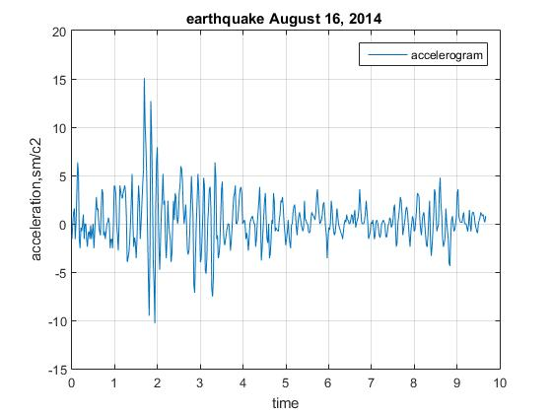

Figure 1. Accelerogram in base level (the building with KF)

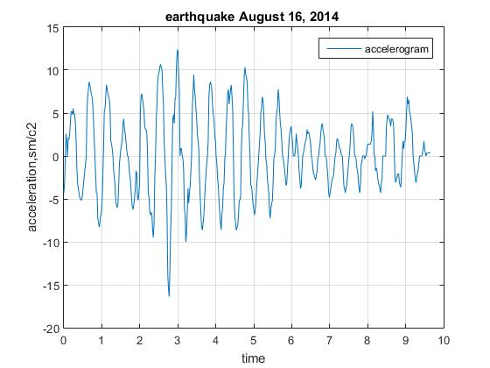

Figure 2. Accelerogram in floor level 9 (the building with KF)

Figure 3 and Figure 4 show accelerograms recorded in the building on FT in the basement and 9th floor levels. Interestingly, the peak acceleration values in Figure 2 and Figure 4 coincide.

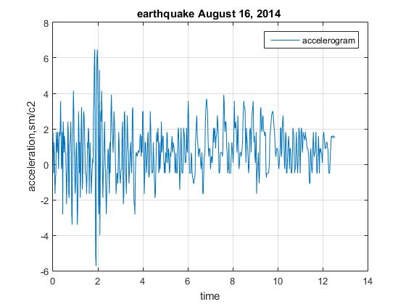

Figure 3. Accelerogram in floor level 1 (the building with FT)

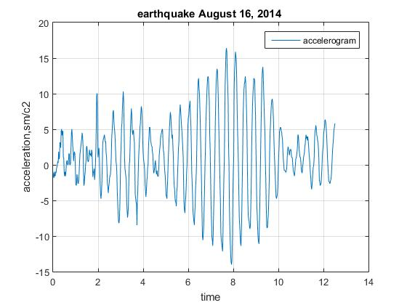

Figure 4. Accelerogram in floor level 9 (the building with FT)

Below, the analysis of seismically isolating properties is performed according to the values of spectral accelerations.
The methods of calculation of seismically isolated buildings presuppose spectral acceleration curves for soil conditions of various type Fardis M., Carvalho O., Elnashai A., Faccioli E., Pinto P., Plumier A. (2013) .
All accelerograms are recorded on the transverse axis of the building. In Eurocode 8, the values of spectral accelerations are used to determine seismic forces, therefore, for each of the recorded accelerograms with a value of vibration decrement of 0.314, we will determine the dimensional spectral accelerations instead of the classical spectral curves β. Tables 1-3 show the parameters of instrumental accelerograms on the analogue house and buildings with seismically isolating foundations of two types. The values of spectral accelerations of the 2nd peak are given in parentheses. The values of spectral accelerations were determined using the solvers of the computer mathematics system SCILAB or MATLAB.
Figures 5-7, respectively, show spectral accelerations curves (cm/s²) for floor-by-floor accelerograms for analogue house, building with PTFE gaskets (FT) and building on KF, correspondingly. A reduction in the values of spectral accelerations for buildings with seismically isolated foundations is visually observed.
It may be noted that the analogue building is distorted according to the classical single-mass scheme with a uniform acceleration build-up along the height of the building. The effective exposure time from the 4th to the 9th tier is almost the same.

Table 1. Maximum acceleration values and accelerogram parameters.
(Analogue building with strip foundations, Station No.20)

Instrumental record | Acceleration,  cm/s² | Effective duration,  s | Spectral acceleration, cm/s² | Peak period  of spectrum,  s
89-A-1-1х, foundation | 5.12 | 6.38 | 21.88 | 0.22
89-A-4-4х,  4th floor | 10.59 | 10.75 | 50.64(48.21) | 0.10(0.40)
89-A-7-7х,  7th floor | 16.01 | 10.45 | 126.63 | 0.39
89-A-9-9х,  9th floor | 24.07 | 10.45 | 190.34 | 0.39

Table 2. Maximum acceleration values and accelerogram parameters.
(Building with KF, Station No.21)

Instrumental record | Acceleration,  cm/s² | Effective duration,  s | Spectral acceleration, cm/s² | Peak period  of spectrum,  s
89-KF-1-1х foundation | 15,08 | 1,60 | 45,76 | 0,14
89-KF-4-4х  4th floor | 8,53 | 2,81 | 38,72 | 0,14
89-KF-7-7х  7th floor | 11,88 | 14,04 | 63,23 | 0,46
89-KF-9-9х  9th floor | 16,38 | 4,16 | 79,45 | 0,45

Table 3. Maximum acceleration values and accelerogram parameters.
(Building with FT, Station No.22)

Record | Acceleration,  cm/s² | Effective duration,  s | Spectral acceleration, cm/s² | Peak period  of spectrum,  s
89-FT-1-1х foundation | 6,48 | 8,57 | 22,95 | 0,14
89-FT-9-9х  9th floor | 16,41 | 7,81 | 117,34 | 0,41

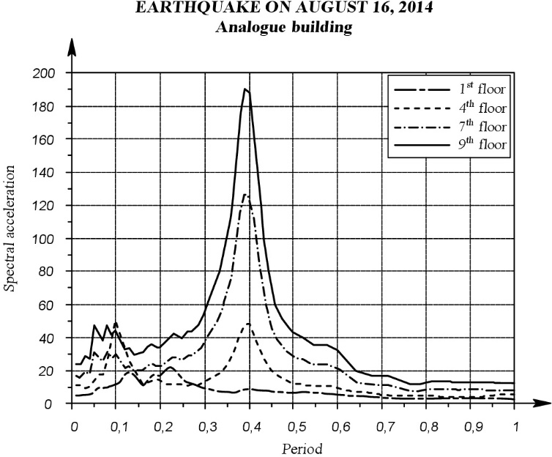

Figure 5. Spectral accelerations of floor-by-floor accelerograms for the analogue building

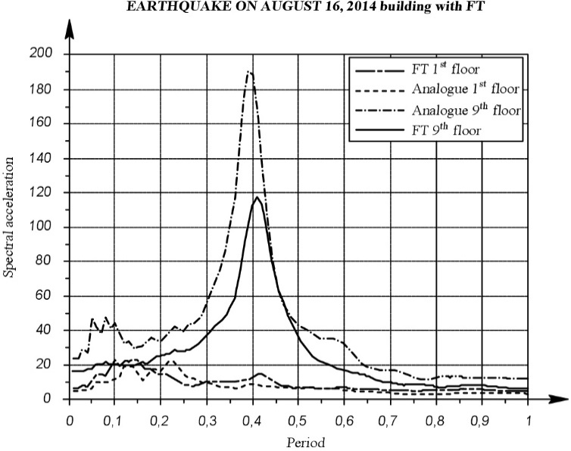

Figure 6. Spectral accelerations of floor-by-floor accelerograms for building with FT

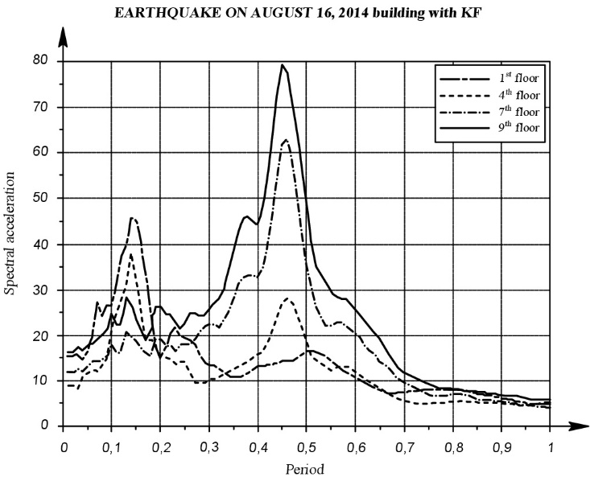

Figure 7. Spectral accelerations of floor-by-floor accelerograms for building with KF

3. Acknowledgments

- The building on the strip foundation operates on the classical model with a proportional increase in floor-by-floor accelerations towards the last floor.
- The magnitudes of the acceleration at the level of the 9th floor in seismically isolated buildings are 47% less than the similar value in the building on the strip foundation. However, the acceleration magnitudes at the level of the 9th floor on seismically isolating buildings are the same.
- The maximum values of the spectral acceleration for seismically isolated buildings at the level of the 9th floor are 1.62 times less than the same value for FT, and 2.4 times for KF for building on strip foundation.
- The effect of diminution of seismic forces in seismically isolated buildings after 30 years of operation takes place. Ageing of seismically isolating components is not observed.
- On the values of spectral accelerations, the effect of seismic isolation is more significant than on the values of the spectral curves β Lapin V.A., Yerzhanov S.Y., Daugavet V.P. (2017). The use of seismic isolation contributes to the enhancement of safety of seismically isolated buildings.
- The elements of seismic insulating structures, i.e. a fluoroplastic layer and a kinematic support reatin their properties. The durability of the elements of seismic isolation is at least 30 years.
- The test site of KazNIISA JSC in Almaty, consisting of 3 buildings of the same type with different foundation structures, is a unique test aids that allows us to evaluate the effects of seismic isolation under conditions of real seismic impacts. According to the current "Map of Seismic Zoning of the Republic of Kazakhstan", the median values of the predictable accelerations on the soil in Almaty are 0.38g at the occurrence frequency of earthquakes once every 475 years and 0.73g at the occurrence frequency of earthquakes once every 2475 years.

4. REFERENCES

Cherepinsky Yu.D., Lapin V.A. (1995) Fundamentals of Seismic Isolation in Construction. Irkutsk: ELITE Publishing House: 204.
Cherepinsky Yu.D. (2003) Seismic isolation of residential buildings. Almaty: KazGASA: 157.
Zhunusov T.Zh., Shakhnovich Yu.G., Gorovits I.G., Korolev A.N.(1984) Pilot studies of reinforced concrete skeleton frame with beamless floors. Express information. VNIIIS, 1984, Series 14, (7): 15-20.
Zhunusov T.Zh., Shakhnovich Yu.G., Gorovits I.G., Korolev A.N. (2017) Determination of the parameters of seismically isolating support structure with PTFE sliding pads. In the collected book: Studies of seismic stability of constructions and structures. Ed. 25(35): 90-99.
Yerzhanov S.Y., Lapin V.A. (2015) Systems of seismic isolation of buildings and structures in the Republic of Kazakhstan and the world’s developed countries. In the collected book: Studies of seismic stability of constructions and structures. Ed. 23(33): 164-192.
Sholanov K.S., Abzhaparov K.A. (2017) SHOLCOR robot as an active support for active earthquake protection system. In the collected papers of the International scientific and practical conference "New construction trends in the XXI century". Section "Earthquake Engineering and Engineering Seismology": 110-114.
Khomyakov V.A., Zabakov A.A. (2017) Issues of seismic isolation of buildings using foundations of different types. In the collected papers of the International Scientific and Practical Conference "New Construction Trends in the ХХI Century", Section "Earthquake Engineering and Engineering Seismology": 91-96.
Yerzhanov S.Y., Lapin V.A., Daugavet V.P. (2017) Dynamic study of seismically isolated house with the aid of the stations of engineering seismometric service. In the collected papers of the International scientific and practical conference "New construction trends in the XXI century", Almaty: 82-89.
Lapin V.A., Yerzhanov S.Y., Daugavet V.P. (2017) Dynamic study of seismically isolated buildings with the aid of the stations of engineering seismometric service. “Technology-related and natural risks. Structure safety”, (6): 33-34.
Fardis M., Carvalho O., Elnashai A., Faccioli E., Pinto P., Plumier A. (2013) Designer’s Guide to Eurocode 8: Design Provisions for Earthquake Resistant Structures: General Design Rules for Earthquake-Resistant Structures, Seismic Effects, Rules for Design of Buildings and Retaining Works. M.: MSUCE, 2013: 484.

Lapin V.A., Ph.D. in Engineering Science, «KazRDICA» JSC, Almaty , lapin_1956@list.ru

