DEVELOPING AND NATURAL SCALE TESTING OF THE 3D BCS BASE ISOLATION SYSTEM

DOI 10.37153/2686-7974-2019-16-460-472

Victor Kostarev, Dr. Peter Nawrotzki, Petr Vasil’ev, Maksim Vaindrakh

ABSTRACT

The most common seismic isolation systems as various modifications of LRB, Rubber Pads and PFB bearings are effective for protection against horizontal seismic excitation. At the same time these devices could lead to a significant amplification of an isolated structure’s seismic response in the vertical direction due to a coupling phenomenon of their horizontal and vertical components and certain stiffness in the vertical direction. These effects could provide an essential reduction of the total seismic isolation efficiency and in some cases remain in structure seismic response approximately at the same level or even higher than for a rigidly supported structure.
This paper presents results of optimization and efficiency analysis for the new developed 3D seismic isolation base control system BCS for a typical NPP Reactor Building (RB) with coil spring isolators and separately located 3D dampers.

1. INTRODUCTION

In general, the SIS efficiency depends on the combination of elastic properties of isolators and system damping. The tests of a 3D Floor Seismic Isolation System performed in Japan at the IHI 35-ton shaking table have confirmed an evident but unexpectedly positive influence of system damping [1]. Upgrading the Floor Isolation System damping from 3% to 14% by changing the features of 3D viscoelastic variable dampers had a double effect in 16% increase of the efficiency of SIS acceleration isolation and at the same time in decrease by 1.5 times of relative super- and substructures displacements. This has given rise to an idea of developing a 3D SIS with capacities that would satisfy rather controversial demands for good isolation efficiency along with limited umbilical displacements using the optimization procedure [2].
A conventional SIS design involves the use of existing or permanently appeared new isolation devices, which have fixed stiffness and damping parameters. Subsequent seismic analysis shows clearly defined positive and negative features of the SIS devices implemented. The vertical seismic excitation and other possible dynamic impacts on the structure are usually excluded from consideration and the SIS efficiency is shown in the horizontal direction only. One more concern in using the conventional SIS practice for 3D isolation appeared after relevant experiments have been carried out at the shaking table in Japan where a full-scale building was equipped with Lead Rubber Bearing (LRB) and Friction Pendulum Bearing (FPB) bearings and subjected to 3D seismic excitation. While in cases of 1D and 2D horizontal excitations both SI systems demonstrated relatively good behavior and isolation properties, the addition of vertical seismic impact has brought the building structure practically to a non-isolated state [3, 4].
A newly developed SIS approach suggests the initial definition of the Demand in a form of SIS Performance Target Criteria (PTC) by using the Goal Function (GF) and an optimization process. The target is to obtain the optimal 3D SIS in terms of sufficient 3D acceleration isolation including efficient vertical seismic isolation and appropriate 3D displacements for a specific seismic input and the current structure, which has separately defined the optimal elastic (natural frequencies) and damping SIS parameters. The limitation of relative displacements of the SIS super- and substructures is a very important goal, which enables to simplify the SIS design and avoid making special compensations for connecting the distribution systems of an isolated structure and mitigate as it named “umbilical” problem.
Achieving the PTC goal implies the use of an optimization process, which considers the actual characteristics of the structure and the site specific seismic spectra GMRS/UHRS as fixed input parameters. As a result of the optimization process with variable isolator stiffness and system damping, the optimal values of SIS horizontal and vertical stiffness (basic natural frequencies of the structure) have been obtained providing the structure with necessary 3D isolation efficiency including the vertical component and quite limited relative displacements.

2. SIS BENEFITS AND LIMITATIONS

In nuclear power, the following benefits of SIS application based on [5] have been determined:
- Increase in nuclear safety under seismic and other dynamic impacts.
- Essentially lower accelerations applied to structures, systems, components, equipment, distribution systems and piping.
- Decrease in weight, reinforcement and cost of structures and components.
- Possibility of using conventional or minimized seismic demand designs of structures and components.
- Essential decreasing of a foundation dynamic soil pressure.
- Possibility of aligning and maintaining the vertical position of an isolated structure and protecting it from possible soil subsidence during the whole life cycle.
- Simpler structural behavior resulting in a simpler and more defined structural analysis.
- Reduction of uncertainties in safety analysis. A structure has the only key system (SIS) responsible for seismic safety.
- Decrease in public pressure and doubts relating to seismic protection of NPPs.
- Reduction of the overall cost of NPPs located in high seismic regions with the peak ground acceleration (PGA) levels over 0.3g.
At the same time the application of SIS entails some difficulties in the design and requires considering a number of new circumstances:
- More complex design and cost of slotted foundation separated on sub structure and super structure.
- Extended relative seismic displacements of internal and external structures require extra flexibility of distribution systems (umbilical problem).
- Confirmation of a specific safety margin of this SIS as the key system in seismic protection of NPP structures.

3. GENERAL COST EVALUATIONS IN THE SIS APPLICATIONH

Application of the SIS in nuclear power promises great benefits in safety upgrading and even could be very cost effective by the following reasons. The average cost of a 1000-1200 MWt NPP of standard design for PGA of 0.1-0.2g could be assumed as $6.0 billion in 2018 year prices and it essentially and non-linearly increases with a site PGA [6, 7].
According to these evaluations the total cost of seismic engineering, the cost of seismically restrained equipment, components and piping and its maintenance plus the construction costs for an NPP with PGA 0.4g could be considered as at least 10% of the total NPP cost. For PGA 0.6g it would achieve 20% of the overall NPP cost. Just for information, a standard aseismic NPP design for high seismicity zones presumes installation of around 2000 seismic restraints, (snubbers, etc.) having maintenance cost times to its primary cost. Only this “seismic restraining” cost could be estimated around $ 100 mln for the life cycle of NPP built in a seismic region. Thus the total NPP seismic design and seismic construction costs could be estimated over $1 000 mln for sites with PGA>0.4g.
Our estimation has shown that SIS application would save at least 50% of the above sum, i.e.
about $500 mln for the NPP sites with PGA>0.4g considering some increase in the design and slotted foundation construction costs and the cost of SIS devices.
So in general the total benefit in the SIS applying could be evaluated at least as 7% of the total cost of NPP located in a high seismicity zone.

4. SIS OPTIMIZATION MODEL

It is obviously that there are no universally optimal characteristics (elastic properties, natural frequencies, ductility and damping) for all structures, buildings and sites. These values depend to a high degree upon the following three primary parameters:
- Inertia, dynamic properties, geometry and other features of an isolated superstructure;
- Peculiarities of the seismic input, site specific spectra, acceleration time-histories (TH), its frequency content and duration;
- The goal established in achieving the isolation parameters and relative super and substructures displacements, e.g. some Goal Function in isolation efficiency and umbilical displacements.
The results given below show the parameter optimization for this SIS of a PWR Reactor Building having approximately 80 meters in height and 20 meters in elevation of the Center of Gravity that corresponds to the most important location of the reactor supports. Due to a large amount of calculations the optimization process required using a simplified stick RB model, which included 18 degrees of freedom (DoF) plus 3 DoF for the “seismic” mass as shown in Figure 1. Isolation Units (100 conditional devices) were modeled with linear springs and viscous elements.
Artificial time-histories correspond to the UHRS 7% damping spectra of one of NPP sites, are scaled to 0.4g in the X, Y directions and in 2/3 ratio to the Z vertical component. The comparison of the target spectrum to the artificial time-histories spectra can also be found in Figure 1.

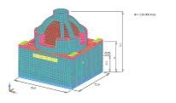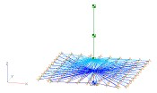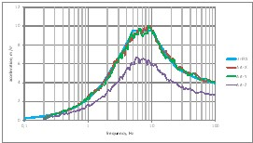

Figure 1. PWR Reactor Building, Stick Analysis Model and GRMS seismic input in the form of UHRS.

A combination of the following two parameters was adopted as the Goal Function: the peak acceleration at the reactor support level (A) and maximal displacement at isolation unit (D). The goal function was written as:

$GF={\left(\frac{A}{Aw}\right)}^{2}+{\left(\frac{D}{Dw}\right)}^{2}$ (1)

Aw and Dw in formula (1) are the weight coefficients. Aw and Dw represent undesirable values of the response superstructure acceleration and its relative displacement against substructure. In this research, the following weights were adopted: Aw = 0.4g (no isolation efficiency) and Dw = 100 mm as a limit for the self-compensation ability of connecting (umbilical) distribution systems.
Nominal frequencies as well as nominal damping for horizontal and vertical directions (4 parameters altogether) are used as optimization parameters. The nominal frequency is defined by the following formula:

$f_{N}=\frac{1}{2\text{π}}\sqrt{\frac{C}{M}}$ (2)

The nominal damping is defined by the following formula:

$d_{N}=\frac{B}{2\sqrt{C∙M}}$ (3)

Where: M is the mass of the building; C is the total stiffness of isolation units; B is the total viscous resistance of isolation units.
It is obvious that the real frequencies and damping of the system differ from the nominal parameters indicated, so they are conditional for the purposes of analysis and simplification of the optimization process.
Preliminary calculations performed included the optimization using the Hooke-Jeeves method and were carried out without any limitations set upon the parameter values. It turned out that damping growth occurred in both directions up to the critical damping value. It was subsequently decided to limit damping to 20% of the critical value in order to exclude overdamping and stiffening of the system. As a result, only two parameters remained arbitrary, i.e. the nominal frequencies in the horizontal and vertical directions. In such case, it became possible to construct the goal function surface shown in Figure 2. The nominal frequencies in the horizontal and vertical directions have the variation within the range from 0.15 Hz to 3 Hz with 0.15 Hz increments. The results for 20% damping are shown in Table 1.
The results of the SIS optimization analysis for a non-isolated structure and an isolated structure allow making some principal and important conclusions. A widespread opinion that SIS should compensate all or most of the earthquake soil motion is a delusion. To achieve good isolation parameters of SIS it is quite enough to compensate much less than a half of anticipated soil displacements.
For the heavy and high NPP RB structure considered and the specific seismic motion defined by UHRS, the seismic input with 0.4g PGA and the specific soil conditions used the optimal or close to optimal SIS should have:
- The first conditional natural frequency in the horizontal direction around 0.9 Hz;
- The first conditional natural frequency in the vertical direction around 3.0 Hz;
- System damping within the range from 20% to 40% of the critical value.

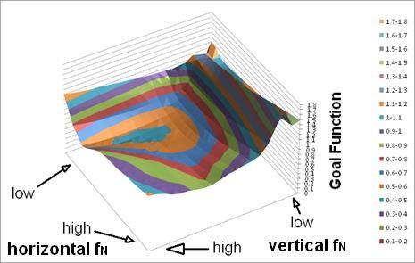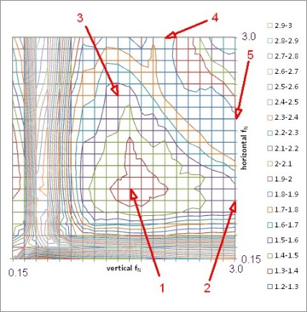

Figure 2. Goal Function Surface for 20% system damping.

Table 1: Tables should be centred and preceded by a numbered caption.

Nominal frequency, Hz | Displacement, mm | Acceleration, g |  | Goal function
Horizontal Vertical | X Y Z | X Y | Z
0.90 3.00 | 39 39 15 | 0.15 0.14 | 0.26 | 1.01

5. BASIC REQUIREMENTS FOR THE SIS AND OPTIMIZATION CHALLENGES

In the new IAEA Report on seismic isolation [5], it has been noted that the main and very strict requirements should be applied for the base isolation devices in nuclear power applications. These requirements could be updated using some conclusions of the current study. Among them the most principal are as follows:
- SIS should be passive with the ability to provide RB with required natural frequencies in the horizontal and vertical directions in order to achieve the target RB isolation efficiency in all DoF;
- High SIS damping ability in the horizontal and vertical directions with the range of system damping at least 20% of critical damping;
- Long-term stability in the mechanical and damping properties under all design conditions (temperature, moisture, radiation, damaging substances, fire, flood, wind, air plane crash, blast, accidental and malevolent explosions, etc.);
- Confidence on SIS reliability under design and beyond design basis earthquakes; (Relevant Nuclear Codes and Standards are required performing of seismic probabilistic safety assessment in a row with deterministic one);
- Ability for a simple replacement of isolation and damping devices under operation conditions and to span loss of one or more devices;
- Ability to compensate short and long-term settlement (especially for structures located on soft and subsiding soils);
- Provide smooth distribution of the reaction forces and bending moments between a sub structure and a super structure;
- Availability of natural scale test results and an analytical model for SIS devices;
- SIS must recover quickly enough to withstand large aftershocks and an inherent property that passively re-centers the system.
A search conducted on the market of existing isolation devices and dampers has shown that all the requirements stated correspond in a high degree to isolation devices represented by elastic coil spring units, provide the structure with necessary 3D elastic properties independently in the vertical and horizontal directions. Thus the spring elements application will produce for the SIS necessary optimal natural frequencies. For achieving required system’s damping parameters it is planned to use 3D viscoelastic dampers. Level of damping is provided and could be changed by its design and number of units in the SIS. According to the authors’ knowledge all other known isolation devices are unable to provide the 3D optimal isolation parameters of the system established by analysis [3, 4, 5]. Figure 4 shows the newly developed high capacity (close to 500 tons) 3D spring units and 3D viscodampers, which could be used in designing and application of the optimal SIS for the NPP RB and other heavy buildings providing system’s damping up to critical values, if necessary. These BCS natural scale components were subjected to a comprehensive individual static and dynamic testing at GERB, BAM and Eucentre test facilities, Fig 3.

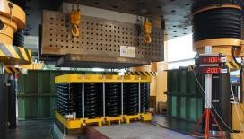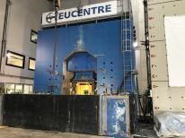

Figure 3. General view of the high capacity 3D spring unit (left) and 3D viscoelastic damper (right) for 3D BCS seismic isolation system under individual natural scale testing.

SIS equipped with elastic spring units and separately installed viscodampers has the name of the Base Control System (BCS) and over the course of decades has been used for vibration control, seismic protection and damping of operational vibration of powerful turbine decks and nuclear components, Figure 4. The new field of BCS application for base isolation of big structures has many advantages separately providing the structure with necessary natural frequencies and damping, thus tuning the system to the optimal parameters defined by analysis.

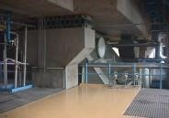

Figure 4. Base isolation of the turbine deck of powerful NPP turbogenerator (left) and BCAC and seismic isolation of NPP’s spent fuel pool with deadweight over 5800 tons.

The feasibility and efficiency of BCS have been confirmed by its behavior under real earthquake with PGA 0.12g when two similar buildings in Mendoza University, Argentina, one with BCS and the other without BCS (rigid based), were subjected to the seismic motion [8]. The views of the buildings tested by earthquake and the location of spring units and VD dampers are shown in Figure 5.

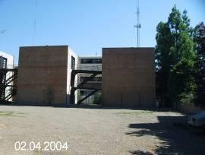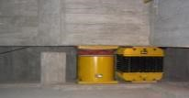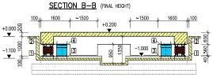

Figure 5. Isolated by BCS and non-isolated rigid based buildings (left) and location of spring units and viscodampers in the space between sub structure and super structure of the BCS isolated building (right).

The buildings were equiped with acceleration sensors and gauges to perform strain and stress comparative measurements in the structures. Figure 6 shows the time histories of accelerations at the top of these two buildings subjected to the earthquake 5.7 magnitude.

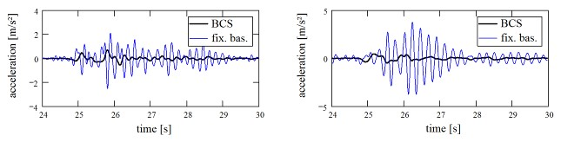

Figure 6. Accelerations at the top of two buildings, BCS isolated and non-isolated, subjected to the earthquake in the X (left) and Y (right) directions.

The measurement performed for the isolated (I) and non-isolated (NI) buildings have shown that the distortions in spring elements and viscodampers are very small (around 3.0 mm). At the same time it was observed that there is a constant acceleration distribution along the isolated building height.
Comparative acceleration measurements at the roofs of “NI” and “I” buildings and observation of the buildings state after earthquake have shown the following relative parameters:
- Acceleration along X, Y and Z axes: Xni/i = 0.25/0.05g Yni/i = 0.4/0.06g Zni/i = 0.06/0.07g. Roof 3D acceleration reduction achieved is more than 75%. In the vertical direction an essential amplification of accelerations was not observed in spite of non-optimal parameters of the elastic spring units in vertical direction.
- No structural damage was observed in both buildings.
- Comparative behavior of the structures: Axial force reduction: > 60%. Shear force reduction: > 75%. Bend Moment reduction: > 90%. Story Drift reduction: > 80%.
Thus, the BCS has demonstrated its outstanding isolation capability with very limited relative displacements of super and substructures under real earthquake conditions.
In general for the successful implementation of SIS, three important tasks should be resolved:
Verification (validation) of methods for modeling and analyzing buildings with SIS;
Carrying out a full complex of structural deterministic seismic analysis of the building and structures with SIS including a big airplane crash problem and other extreme loads;
Full scale testing and assessment of SIS fragilities and failure modes for performing a probabilistic safety analysis.

6. DETERMINISTIC ANALYSIS OF THE REACTOR BUILDING WITH THE OPTIONAL SIS

The deterministic structural analysis has been performed on a set of generated time histories fit well enough to the design uniform hazard response spectrum (UHRS) obtained by probabilistic hazard assessment approach for some real NPP site. Figure 6 shows the in-structure seismic response spectra (reactor supports ISRS elevation) for horizontal and vertical seismic excitation having intensity of a safe shutdown earthquake (SSE) with PGA 0.4g. The figure shows a direct comparison of the ISRS for isolated reactor building and with rigidly supported reactor building having hard soil properties with two levels of system’s damping 20% and 40% and two different factors of Goal function.
It is obvious that the efficiency of seismic isolation in horizontal direction is very high. For the vertical direction factor of isolation is also essential but little bit less than for horizontal one. This phenomenon could be evaluated as a unique result achieved by application of the optimal isolation parameters. It is well-known that all widespread isolation systems have essential coupling effects and provide serious amplification in the vertical direction under real 3D seismic excitation conditions [3]. Considering that a majority of components, equipment, distributions systems and piping have natural frequency above 2.0 Hz it should be concluded that the proposed optimal SIS has extremely high efficiency in the range 2.0 to 50 Hz in horizontal direction and definite efficiency in the vertical direction. On average, the optimal SIS provides the efficiency factor not less than 3 even in non-resonance zones and much higher at resonances.
Due to a high damping in optimal SIS a maximum seismic displacements are limited to 50 mm in horizontal direction and to 15 mm only in the vertical direction. These values are much lower than allowable displacement in the known powerful spring units and viscoelastic dampers and give a chance not to use special compensators for distribution systems crossing isolated and non-isolated structures. This conclusion is correct also for beyond design basis earthquake (BDBE) conditions.
Also in the frame of deterministic approach the structural analysis has been performed for the optimally isolated reactor building subjected to another BDB event as crash of a big commercial airplane (BCAC), namely Boeing 747-400 with a mass exceeding 390 tons. Figure 7 shows the corresponding loading diagram of impact and the time history of the maximal deformation of the optimal SIS isolation elements in the horizontal and vertical directions.

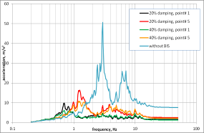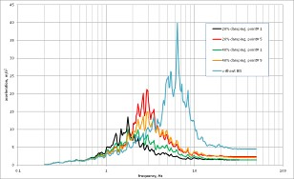

Figure 7. In-Structure Response Spectra for horizontal (left) and vertical (right) directions with
different range of SIS system’s damping (20-40%) and Isolation Goal Function factors.

It could be concluded that vertical displacements under BCAC impact are close to SSE conditions while horizontal displacements in the spring and dampers devices are much lower than under SSE.

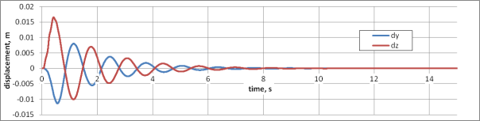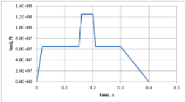

Figure 8. Horizontal (dy) and vertical (dz) deformations of the SIS elements due to the BCAC and corresponding Riera loading diagram.

7. PROBALISTIC SEISMIC SAFETY ASSESSMNT OF NPP WITH THE OPTIMAL SIS

It is known that in the frame of probabilistic safety and risk analyses in nuclear power the earthquakes of much higher intensity with much lower frequency of occurrence should be considered. Such BDB impacts could lead to a failure of the SIS devices. A SIS failure is determined as the loss of its dead weight bearing capacity and incapability to return reactor building to the initial neutral position.
The idea of the ”Defense in Depth” in its application to the SIS contains the requirement that available clearances in the 3D dampers should be less than elastic limits in spring units. Thus when gaps in the dampers are becoming close enough then an elastic-plastic behavior in the damper’s structure occurs as in the non-bearing element providing additional dissipation to the system. This mode exists up to the all dampers failure by its own failure mode. Only after that the spring units as the bearing elements shall be determined on its elastic-plastic behavior and failure. Fragility analysis of the SIS was based on dynamic analysis using Monte-Carlo simulations. Calculated parameters for the SIS: Am₁ = 2.0g and β_{c1} = 0.32.
To assess an effectiveness and safety of the RB installed on the SIS a simplified SPSA of the system «SIS-RB» was carried out. A failure logic model was based on the scheme shown in Figure 9.

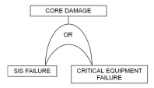

Figure 9. Failure logic model.

It was assumed that the accident with core damage (CD) occurs either in the event of the SIS failure, or in the event of the critical systems failure leading directly to CD and located in the RB. Then

𝑃_{𝑓} = 𝑃₁ + 𝑃₂ (4)

Where P₁ and P₂ are the frequencies (probabilities) of failure of the SIS and the critical equipment. It was also assumed that these are small values and failures are independent. Figure 10 shows the mean hazard curve and the composite fragility curve characterizing a seismic resistance of the SIS.

[1] 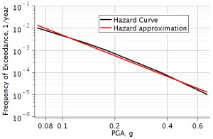 | [2] 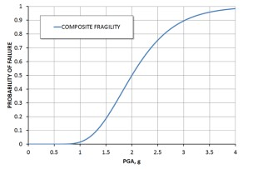

Figure 10. Typical hazard curve (left) and the composite fragility curve of the SIS.

Here is a widely used approximation for hazard curve $(a) K_{1}a^{-K_{h}}$ . A typical range of variation for K_{h} is 1.7 - 4.1 [9]. If the SSE [g] level corresponds to a frequency of 10⁻⁴ [1/year], then for the average parameter K_{h} = 2.9 we obtain K₁ = 1∙ 10⁻⁴ ∙ SSE^{2.9} [1/year]. Convolution with an approximated hazard curve [9]:

$P_{f}=$ (5)

Case 1: RB without seismic isolation :
In this case the design capacity of the unit expressed in HCLPF should not be less than SSE for the site:
HCLPF ≥ SSE. On the assumption that seismic capacity of the unit is completely determined and identical to the seismic capacity of the critical equipment, lognormal fragility model has a deviation β_{с2} = 0.6, $Am_{2}=HCLPF∙e^{2.326β_{c2}}=4.0∙HCLPF$, we have CDF P_{f} ≤ P_{f}* = 8·10⁻⁶ [1/year], which is acceptable for most Regulators.
Case 2: RB on seismic isolation:
The seismic response of the RB is decreased by the use of SIS, at various frequencies an efficiency is different. However, for the sake of simplicity and the possibility of further analysis it is assumed that the average efficiency of the SIS is 3:

$\frac{S_{a}}{{\hat{S}}_{a}} 3≡n$ (6)

Here S_{a} and ${\hat{S}}_{a}$ are spectral accelerations on the RB’s foundation before and after installation on a SIS. Then the probability of failure of the entire system "SIS-RB" can be expressed by the following formula:

$P_{f}(HCLPF,SSE)=P_{1}+P_{2}=K_{1}Am_{1}^{-K_{h}}e^{\frac{1}{2}{(K_{h}β_{ci})}^{2}}+n^{-K_{h}}K_{1}Am_{2}^{-K_{h}}e^{\frac{1}{2}{(K_{h}β_{ci})}^{2}}$ (7)

Again, the SIS parameters are as follows: Am₁ = 2.0g and β_{c1} = 0.32; for the unit itself: β_{с2} = 0.6, $Am_{2}=HCLPF∙e^{2.326β_{c2}}=4.0∙HCLPF$.

The condition of equal safety in terms of CDF of units installed on the SIS and without SIS

$P_{f}(HCLPF,SSE)≤P_{f}^{*}$ (8)

Forms the corresponding design domains (see Figure 11):

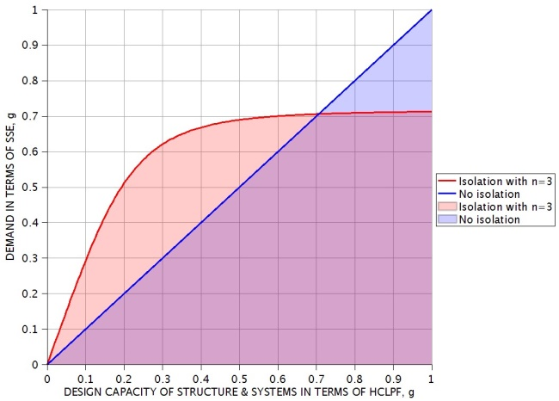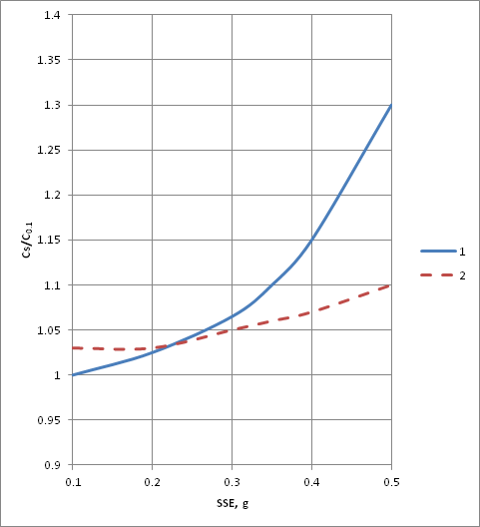

Figure 11. Acceptable design domains (left) and cost comparison for non-isolated and isolated structures (right)

Analysing the figures we can come to the following conclusions:
- Having a design capacity up to 0.2g we can select a site with seismicity up to 0.5g and more in compliance with the safety requirements, provided that the safety related buildings are installed on the SIS BCS;
- The construction of NPP without SIS in areas of SSE 0.4g-0.6g is associated with a large investments in seismic safety measures for equipment and structures, therefore the use of SIS for units with a standard seismic design of PGA 0.2g-0.25g should be beneficial;
- The intersection point of the curves is very characteristic. When considering the design of the unit with HCLPF exceeding this value, the safety of the system «SIS-RB» will be determined by the seismic behaviour of the SIS itself. This point provides the limits of the reasonableness of the SIS application.

8. NATURAL SCALE SIS INVERSE SEISMIC ISOLATION TEST FACILITY (SIST)

Beside individual SIS components testing required for validation of the BCS and/or other SIS elements and In order to perform testing of real structures with SIS a special inverse test rig (SIST) was developed and erected in Saint Petersburg, Russia for testing natural scale isolators with capacities from 1000 to 7500 kN and different types of dampers. SIS components at SIST could be subjected to a full dead load and seismic displacements corresponding to big earthquakes motions.

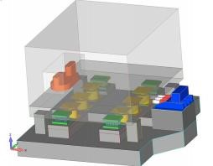a | 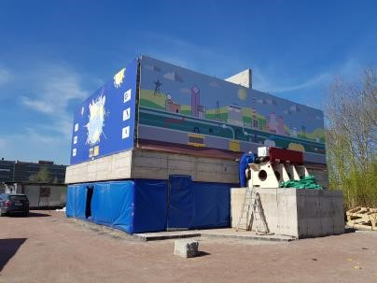  b
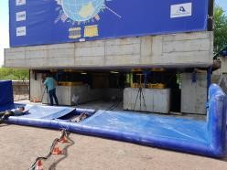c | 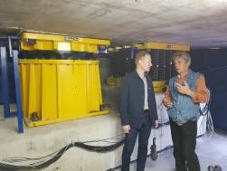d

Figure 12. Inverse test rig SIST

a) SIST design with fast release pushing system in blue color; mechanical shaker in red; isolators in green; dampers in yellow b) SIST general View; c) 3D BCS spring units; d) 3D BCS Viscodamper.

Inverse approach means that the substructure is not shaking but the superstructure is shaking at its natural frequencies providing SIS elements with a full scope of loads and deformations with amplitudes equal to full gravity, design basis (DBE) and beyond design earthquake (BDBE) conditions. SIST consists of a superstructure with variable mass form 1000 t to 3000 t, massive foundation with known soil parameters for investigating of soil-structure interactions, pushimg quazidynamic system with fast release system 1100 kN capacity and +/- 150 mm displacements, testing SIS elements (4 isolators and variable number of dampers) and mechanical vibration machine. First three natural frequencies and modes of the system using BCS elements are shown in Figure 13.

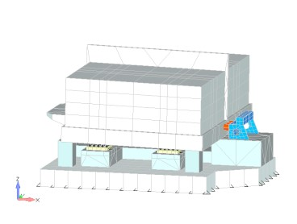f1=0.65Hz | 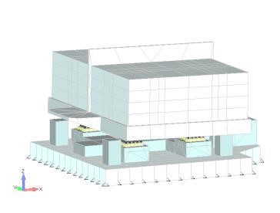f1=0.65 Hz
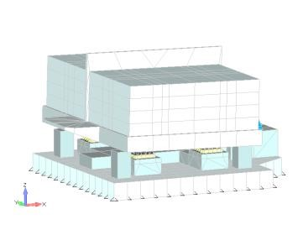f2=2.06 Hz | 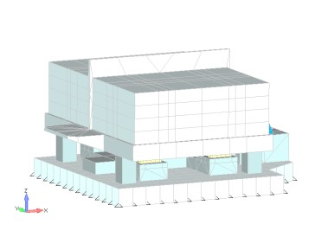f3=2.48 Hz

Figure 13. Natural frequencies and modes of SIST using 3D BCS isolation system.

SIST goals:
- Natural scale testing of a high capacity 3D seismic isolation under full dead load and displacement conditions.
- Reproduction of building structure behavior by shaking at natural frequencies of isolated system (rocking, horizontal and vertical modes and its combination);
- • Definition of a real non-linear SIS behavior and system damping.
- Confirmation and validation of analysis procedures and results.
- Investigation of SIS Soil Structure Interaction with known and definite soil characteristics.
SIST features:
- SIST uses initial displacement of the system provided by the hydraulic pushing system with its fast release to initiate free oscillation of the system in different modes of vibration.
- Variable Mass of building model: 1 000 to 3 000 tons.
- SIST uses four (4) isolators of different types loaded within a range of 250 to 750 ton gravity load each and different types of dampers.
- Additional dynamic excitation to the SIST provided by a powerful mechanical vibrator in a frequency range of 2.0 to 20.0 Hz.
First tests at SIST were performed in December 2017 and have shown its functionality and operability. It was shown that 3D BCS isolation approach using coil spring isolation elements and 3D viscodampers provides to the superstructure previously defined optimal parameters with any necessary system’s damping in the range of 10% to the critical values around 100% system damping and even more. Figure 13 shows that under similar conditions with the same initial parameters the behavior of the system without dampers is radically different from the case with the use of viscodampers and thus real conditions arise for the selection and application of optimal damping parameters for each particular structure and isolation system.

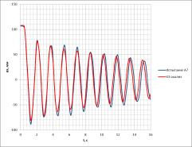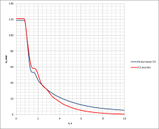

Figure 14. Behavior of the SIST with BCS subjected to a full seismic displacement corresponding to a big earthquake motion (fast release mode). System without dampers (left) and with dampers (right).

At the SIST it is possible to test any types of seismic isolators, snubbers and dampers subjected to a full dead load capacity and real seismic displacements by shaking the superstructure at its natural frequencies and modes of vibration.

9. CONCLUSIONS

- The proposed optimization approach in the definition of basic characteristics of Seismic Isolation Systems has shown new possibilities for essential increasing in 3D base isolation efficiency including the vertical direction and a possibility for a dramatic dropping of relative displacements of the sub- and super-structures of the isolated building.
- Both deterministic structural analysis and probabilistic safety assessment have shown that the SIS approach based on using of the coil spring isolation devices and 3D dampers having optimal or close to optimal parameters is feasible and highly efficient. This SIS could be implemented for any building structures in high seismicity areas and sites having the SSE PGA over 0.3g and up to 0.7g.
- It was confirmed high efficiency of the BCS seismic isolation system by individual natural scale testing of the BCS elements springs and dampers and by real structural tests at the unique SIST test facility.

10. REFERENCES

Ochi Y., Kashiwazaki A., and Kostarev V. (1990). Application of high viscous damper on piping system and isolation floor system, Proceedings of the 9th European Conference on Earthquake Engineering, Moscow.
Vasilyev P., (2013). Methods for calculation of the reactor building with seismic isolation system under dynamic loads, Transactions, SMiRT-22, San Francisco, USA.
Furukawa S., Sasaki T., Sato E., Okazaki T., Keri L., and Ryan K. (2012). Comparison of Vertical Dynamic Response Characteristics of Two Base-isolated Buildings based on Full-scale Shaking Table Test, Proceedings of 15WCEE, Lisbon, Portugal.
Whittaker D. (2016). Seismic Isolation - A structural engineer's comparison of lead-rubber versus curved-surface-slider type isolation bearings, NZSEE Conference.Characteristics of Two Baseisolated Buildings based on Full-scale Shaking Table Test, Proceedings of 15WCEE, Lisbon, Portugal.
Sollogoub P., Editor in Chief, International Atomic Energy Agency (IAEA) (2017). Technical Report. Seismic Isolation Systems for Nuclear Installations, Viena, Austria.
Stevenson J. (1981). NUREG/CR-1508. Evaluation of the cost effects on Nuclear Power Plant construction resulting from the increase in seismic design level, U.S. Nuclear Regulatory Commission.
Stevenson J. (2003). Historical development of the seismic requirements for construction of Nuclear Power Plants in the U.S. and worldwide and their current impact on cost and safety, Transactions of the 17thSMiRT Conference, 17-22 August, Prague, Czech Republic.
Stuardi J., Nawrotzki P. and Suárez L. (2008). Comparative seismic performance of a base control system based on measured and calculated responses, Proceedings of 14WCEE, Beijing, China.
Kennedy Robert P. (1999). Overview of Methods for Seismic PRA and Margin Analysis Including Recent Innovations, Proceedings of the OECD/NEA Workshop on Seismic Risk, Tokyo.

Director, CKTI-Vibroseism, Saint-Petersburg, Russia (victor.kostarev@gmail.com, vkostarev@cvs.spb.su)
CEO, GERB Vibration Control Systems, Berlin/Essen, Germany (peter.nawrotzki@gerb.de)
Principal, CKTI-Vibroseism, Saint-Petersburg, Russia (pvasilyev@cvs.spb.su)
Leading Engineer, CKTI-Vibroseism, Saint-Petersburg, Russia (mvayndrakh@cvs.spb.su)

