**switched resistance oil damper**

**Depending oN deformation**

**As A MEASURE AGAINST very large earthquakes**

**DOI 10.37153/2686-7974-2019-16-646-657**

Sachie KOTSUKI[1], Yoshihisa KITAMURA[2], Kazuhiko ISODA[3], Akira FUKUKITA[4]

**ABSTRACT**

The Nankai trough and the Sagami trough are expected to be the source of very large future earthquakes. The ground motions expected to result from such earthquakes will cause severe deformation of seismically isolated buildings. A response displacement of over 1.0 m also expected to occur at the isolation layer if the long-period pulse observed in the 2016 Kumamoto earthquake were to strike a seismically isolated building. If deformation at the isolation layer exceeds the assumed clearance, the building will collide with the retaining wall and the superstructure will be subject to excessive forces. One measure to suppress such extremely large displacements at the isolation layer is to increase the number of dampers. However, that addition of dampers impairs the isolation effect in the case of small and medium earthquakes, which occur more frequently. One solution to this problem is to design a damper with a resistance force that changes. The authors develop an oil damper with a damping coefficient that switches passively depending on deformation. This paper describes the basic characteristics of the damper and presents the results of performance tests using a full-scale prototype. The utility of the damper in a seismically isolated building is demonstrated through the results of dynamic response analyses.

*Keywords: Seismic Isolation; Very Large Earthquake; Oil Damper; Switching Resistance Force; Response Analysis*

**1. INTRODUCTION**

Seismic isolation systems are designed to increase the natural period of a structure by installation of isolators in an isolation layer to decrease the structure’s response to earthquake motions with many short-period components. In addition to the long natural period, a concentrated arrangement of damping devices in the isolation layer efficiently absorbs the input seismic energy. By greatly reducing the earthquake response of a building, a seismic isolation system not only prevents structural damage but also reduces the tendency of building contents to fall or fly around, as well as reducing damage to nonstructural members. This makes seismic isolation an effective approach to achieving good earthquake resistance performance as needed to maintain building function in times of disaster and allow business or life to continue even after an earthquake.

However, recent predictions of long-period earthquake motion arising in subduction-zones such as the Nankai Trough and the Sagami Trough, as well as experience of near-fault long-period pulse-like earthquake motion as observed in the 2016 Kumamoto earthquake, have indicated that the response displacement of the isolation layer in a seismic isolation system may become excessive. A seismic isolation system reduces the earthquake response of the superstructure by slowing the motion in the isolation layer, so a clearance corresponding to the response displacement must be allowed. However, with large enough seismic motion, the response displacement may exceed the seismic isolation clearance assumed in ordinary design. When this happens, the building can collide with the retaining wall and be damaged. (See the black line in Figure 1.) The response displacement of a seismically isolated building can be reduced increasing the number of dampers in the isolation layer. However, with too many dampers in place to cope with very large earthquakes, the isolation layer will not displace sufficiently during small and medium earthquakes, which occur relatively more frequently, and the seismic isolation effect is impaired. That is, the earthquake response of the superstructure is insufficiently reduced in small and medium earthquakes. (See the blue line in Figure 1.) As a solution to this problem, an oil damper whose performance switches according to the response displacement has been developed. The damping force is small when the response displacement is small, as in the case of a medium or small earthquake. When the response displacement increases under a very large earthquake, the damper switches to a large damping force, suppressing further displacement of the isolation layer. (See the red line in Figure 1.) Several switched performance oil dampers have ever been developed for the purpose of responding to different levels of earthquakes. For example, passive-switching oil damper has been developed to realize the short stroke seismic isolated system and enables the seismic isolation system with the clearance of 300 mm which is almost half of the typical one (M. Ryota et al. 2017). A connecting mechanism which defines the operation range of the standard oil damper has also been presented (Y. Hibako 2018). The switched resistance oil damper demonstrated in this paper prevents excessive displacement of the isolation layer at the time of a very large earthquake without loss of seismic isolation performance in the case of medium and small earthquakes. Switching of the damping force in this new damper occurs entirely passively depending on the displacement andno manual resetting operation is required, so there is no complication in operation.

Response Displacement of Isolation Layer

Clearance

Small Earthquake

Medium Earthquake

Very Large

Earthquake

**Increasing Damper Count**

OVER 1.0 m !

**Switched Resistance**

**Force Damper**

**Ordinary Design**

Response Acceleration of Superstructure

Figure 1. Concept of switched resistance force damper

**2. Damper with Switched resistance force depending on displacement**

***2.1 Structure of the Oil Damper***

A conventional oil damper expands and contracts according to the relative displacement of its two end fixings. When the relative motion between the piston rod and the chamber is compression, the pressure in the compression side pressure chamber rises. The hydraulic oil forces open the damping valves on the compression side and oil flows out to the extension side pressure chamber and the tank. The hydraulic resistance arising as oil moves through the damping valve is the resistance force corresponding to the velocity of the piston.

In the developed oil damper, there is a change in damping coefficient at an arbitrary displacement (the switching displacement). Below the switching displacement, the damping coefficient is low. It switches to high at a certain threshold as displacement increases. Figure 2 shows the structure of the switched resistance force damper. A switching rod passes through an additional hole in the piston. The middle section of the rod has an axial groove, the length of which determines the damping switching points. Figure 3 illustrates how the switched resistance force damper operates. In Figure 3 (a), the piston is moving from the neutral position up to the switching displacement (determined by the end of the groove); the groove allows hydraulic fluid to flow through the additional hole as well as the damping valve, reducing hydraulic resistance. This is the low damping state. As shown in Figure 3 (b), when displacement of the oil damper increases further and the piston moves past the switching displacement point, the additional hole is fully blocked (in the absence of a groove) and the only flow of hydraulic fluid is through the damping valve. The hydraulic resistance is therefore higher. This is the high damping state. That is, the performance of the developed damper switches according to the positional relationship between the groove along the switching rod and the piston. This makes the switching mechanism completely passive. Further, the damping coefficient is always switched in accordance with the current displacement. As the piston moves from beyond the switching displacement to less than the switching displacement, the hydraulic fluid again begins flowing through the groove and the damping coefficient returns to the low state. This switching mechanism is completely enclosed inside the damper, so in appearance the damper has the same shape and size as a conventional one.



Piston

Piston rod

Tank

Extension side damping valve

Compression side damping valve

Extension side pressure chamber

Compression side pressure chamber

Switching rod

Switching displacement

Additional hole

Figure 2. Structure of switched resistance force damper



Compress

Compress

Hydraulic oil flow through

both damping valve and additional hole

Hydraulic oil flow through

only damping valve

(a) Low damping state (b) High damping state

Figure 3. Working principle of switched resistance force damper

***2.2 Damper Characteristics***

The switched resistance force oil damper is based on a damper with a bilinear characteristic where the relief loaddepends on the velocity. Such a damper suppresses the rise of load once the damper force reaches the relief load and the secondary damping coefficient comes into play. The red line in Figure 4 represents the force-velocity relationship for this normal type of bilinear type oil damper. A low damping characteristic, shown by the blue dashed line in Figure 4, is added to this general bilinear damper characteristics. Even in the low damping state, when the force exceeds the relief force, the secondary damping coefficient is operational. As a result, the developed damper actually has four damping coefficients, *C*1*H*, *C*2*H*, *C*1*L* and *C*2*L*. Switching between the low damping state and the high damping state depends on displacement (as previously explained), so the developed damper has variable performance whose characteristic is represented by the red line or blue dashed line in Figure 4 according to the current displacement. Figure 5 compares conceptual diagrams of the force-displacement relationship between a standard oil damper and the new switched resistance force oil damper. Both are a force-displacement relationship with the initial damping coefficient up to the relief force. While the relationship is elliptical for the standard oil damper, as shown in Figure 5 (a), that for the new switched force damper consists of two superimposed ellipses joined at the switching displacement,as shown in Figure 5 (b). The new damper provides a small damping force when the displacement is below the switching displacement and a large damping force when the displacement is greater, as shown in Figure 5 (b).

Force

Velocity

Force

*C*1*L*

*C*1*H*

*C*2*H*

*C*2*L*

*FrH*

*FrL*

*C*1*H*, *C*1*L* : Initial damping coefficient in high or low state

*C*2*H*, *C*2*L* : Second damping coefficient in high or low state

*FrH*, *FrL* : Relief force in high or low state

Figure 4. Force-velocity relationship of

switched resistance force damper

Figure 5. Force-displacement relationship of switched resistance force damper and standard damper

1. Standard damper

(b) Switched resistance force damper

Force

Disp.

Disp.

Switching

displacement

**3. performance test**

***3.1 Prototype***

Figure 6 shows the appearance of the new damper. As already noted, since all the switching mechanisms are within the device, its physical appearance is the same as the standard oil damper. Table 1 shows the characteristics of the prototype. The damper stroke is ±800 mm, the switching displacement is ±200 mm, and the maximum resistance is about 900 kN. Figure 7 shows the design characteristics of the prototype. Here, the red line represents the high-damping characteristics and the blue solid line the low-damping state. As indicated by the blue solid line in Figure 7, the initial damping coefficient in the low-damping state is different on the extension and compression sides. This difference arises because the damper has a single piston rod, so the pressurized area is different on the compression and extension sides, while the groove in the switching rod has the same area on both sides. The initial damping coefficients on the extension side (*ext.C*1*L*) and the compression side (*com.C*1*L*) in the low-damping state are expressed by two approximate expressions, Equation (1) and (2).

*ext.C*1*L* = 1100*V* 2 + 2048*V* + 79.8 (1)

*com.C*1*L* = 500*V* 2 + 522*V* + 879.5 (2)

where *V* (m/s) is velocity. The blue dashed line in Figure 7 shows the average of the extension and compression side characteristics. The initial average damping coefficient (*ave.C*1*L*) is expressed by Equation (3).

*ave.C1L* = 800*V*2 + 1288*V* + 479.1 (3)

In the earthquake response analysis described in Section 4, the average characteristic is used. This is reasonable because, given how dampers are actually installed in a building, any displacement of the isolation layer in an arbitrary direction results in half of the dampers extending and others compressing.

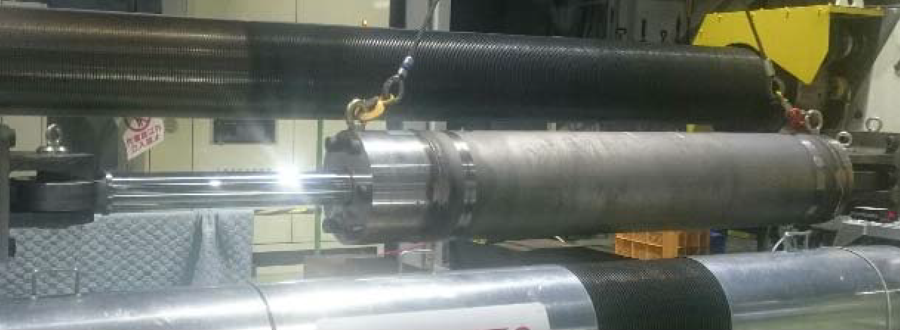

Figure 6. Appearance of the prototype

Table 1. Characteristics of the prototype

|  |  |  |
| --- | --- | --- |
|  | High damping | Low damping |
| Stroke [mm] | 1600 (±800) | |
| Limit velocity [m/s] | 1.5 | |
| Switching displacement [mm] | ±200 | |
| Maximum force [kN] | 920 | 905 |
| Relief force [kN] | *FrH* = 720 | *FrL* = 800 |
| Relief velocity [m/s] | 0.32 | 0.825 |
| Initial damping coefficient [kN/(m/s)] | *C*1*H*= 2250 | Equation (1) and (2) |
| Secondary damping coefficient [kN/(m/s)] | *C*2*H* = 169.5 | *C*2*L* = 155.0 |

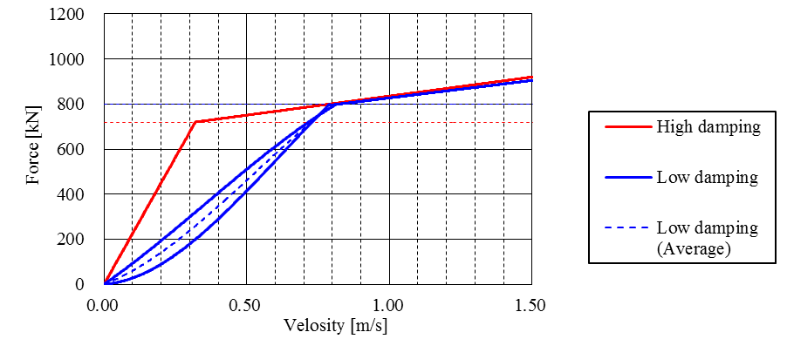

*C*1*H*H21c

*C*2*H*

*C*2*L*

*ext.C*2*L*

*com.C*2*L*

*FrH*

*FrL*

0.32

0.825

Figure 7. Design characteristics of the prototype

***3.2 Loading Program***

The prototype of the switched resistance force oil damper was used in tests to confirm its characteristics in the low and high damping states, as well as switching performance. Table 2 shows the loading program. To confirm its characteristics in the low damping state, a displacement of zero (the neutral position) was taken as the initial position and sinusoidal loadings with a period of 1.0 second and five different amplitudes, all below the 200 mm switching displacement, were applied. To test the high damping state, the same loading program was applied with the piston displaced by 400 mm from the neutral position. In the test to confirm switching performance, sinusoidal waves and random waves of amplitude 480 mm (that is, exceeding the switching displacement of 200 mm) were applied with a displacement of zero as the initial position.

Table 2. Loading cases

|  |  |  |  |  |  |  |
| --- | --- | --- | --- | --- | --- | --- |
| Case | Type | Input  wave | Amplitude  [mm] | Initial disp.  [mm] | Period  [s] | Velocity  [m/s] |
| 1 | Low damping | Sine | 60 | 0 | 1.0 | 0.37 |
| 2 | 80 | 0.50 |
| 3 | 107 | 0.67 |
| 4 | 140 | 0.88 |
| 5 | 160 | 1.00 |
| 6 | High damping | Sine | 60 | +400 | 1.0 | 0.37 |
| 7 | 80 | 0.50 |
| 8 | 107 | 0.67 |
| 9 | 140 | 0.88 |
| 10 | 160 | 1.00 |
| 11 | Switching | Sine | 480 | 0 | 14.3 | 0.21 |
| 12 | 7.2 | 0.42 |
| 13 | 3 | 1.00 |
| 14 | Random | - | - |

***3.2 Test Results***

Figure 8 shows the force-deformation relations obtained from the tests of damper characteristics in the low damping state (Cases 1-5 in Table 2) and the high damping state (Cases 6-10 in Table 2). In the low damping experimental cases 1, 2 and 3 in Table 2, the maximum velocity does not reach the relief velocity (0.825 m/s), so the damper operates only in the region of initial damping coefficient. In cases 4 and 5, relief occurs at the maximum velocity and the damping force does not rise much higher than the relief force. In the high damping state, the relief velocity (0.32 m/s) is exceeded in all five cases (6 to 10 in Table 2), the second damping coefficient comes into play, and the damping force does not increase greatly. The shape of the hysteresis loop is close to a rectangle. Figure 9 shows the relationship between maximum velocity and force at the maximum velocity in for both the low and high damping states in the characteristics test along with the design force-velocity relation. The low damping state is shown in blue and the high damping state in red. The experimental results of are in good agreement with the design characteristics for both low and high damping. This confirms that the prototype has the expected performance.

Figure 10 shows the force-deformation relationships obtained in the switching performance confirmation tests, with Figure 10 (a) showing the results for sinusoidal loading (cases 11-13 in Table 2) and Figure 10 (b) the results for random loading (case 14). Figure 10 (a) clearly shows that damping switches to a high coefficient and the damping force increases sharply at the switching displacement of 200 mm. When the loading period is short, as in case 13, the velocity at the switching displacement is high. Since the resistance forces in the high and low damping states at a particular velocity come close when the velocity is over 0.32 m/s (the relief velocity of the high damping state), the rapid rise in load at the switching displacement is relatively small. For the random loading case, the results are compared with calculation in Figure 10 (b). There is almost no time lag in switching performance as compared with the calculated results. This means that it is not necessary to consider the switching time delay in the time history response analysis.

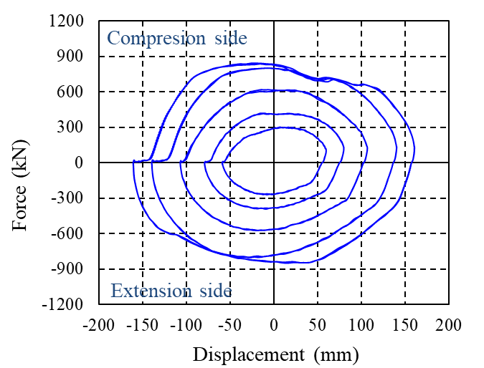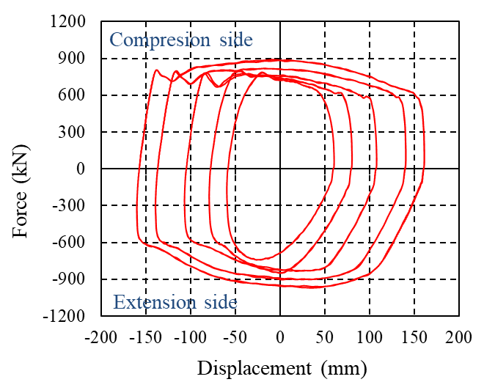

(a) Low damping state (b) High damping state

Figure 8. Force-deformation relation from results of characteristics testing

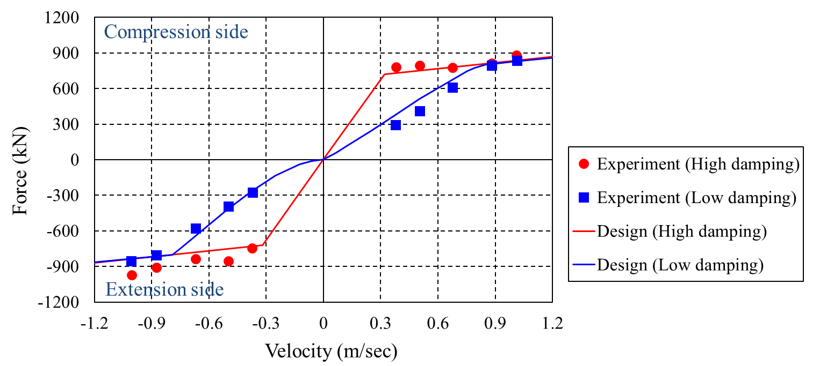

Figure 9. Force-velocity relation for experimental results and design characteristic

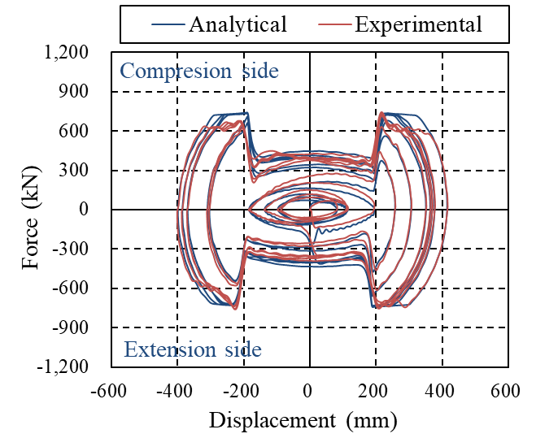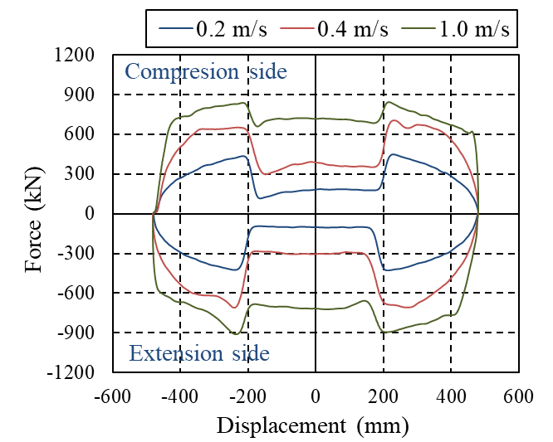

(a) Sinusoidal loading (b) Random loading

Figure 10. Force-deformation relation from results of damping switching performance test

**4. Response analysis of seismic isolated building**

***4.1 Building Model***

In order to verify the effect of the developed switched resistance oil damper, a time history response analysis of a seismically isolated building model is carried out. Figure 11 shows the building model, which is an equivalent shear model consisting of seven masses based on a real six-story pillar-head isolated building. There is an isolation layer comprising of six lead-rubber bearings (LRBs). The properties of the LRBs are indicated in Table 3. Oil dampers are added to the isolation layer of the model on the assumption that the building will undergo seismic strengthening in preparation for a future very large earthquake. In one case, six ordinary oil dampers (OD) are added, and in the other, six switched resistance oil dampers (SOD) are added, and the responses of both are compared. Table 4 shows the specifications of the ODs. These are oil dampers with bilinear characteristics with maximum load of 1000 kN. The characteristics of the switched resistance oil dampers are the same as those of the prototype shown in Section 3. The specifications are given in Table 1. For the switchedresistance oil damper, the damping coefficient in the low damping state is modeledusing Equation (3) as the average of the extension side and compression side characteristics.

6 LRBs

or

6 LRBs + 6 Oil dampers (ODs)

or

6 LRBs + 6 Switched damping

oil dampers (SODs)

Weight (kN)

1192

16740

10508

10409

10540

12167

1820

**∑63376**

Figure 11. Building model

[Isolation layer]

|  |  |  |  |  |
| --- | --- | --- | --- | --- |
| Type | Diameter of rubber  [mm] | Diameter of lead plug  [mm] | Rubber thickness  [mm] | number |
| LRB100 | 1000 | 220 | 201 | 3 |
| LRB110 | 1100 | 240 | 200 | 3 |

Table 3. Properties of LRBs installed in isolation layer

Table 4. Properties of ODs installed in isolation layer

|  |  |
| --- | --- |
| Initial damping coefficient  [kN s/m] | 2500 |
| Second damping coefficient  [kN s/m] | 169 |
| Releaf Load  [kN] | 800 |
| Maximum Load  [kN] | 1000 |

Shear modulus of rubber : *Gr*=0.39N/mm2

***4.2 Input Wave***

In this analysis, we use the observed waveform of the Kumamoto earthquake on April 16, 2016 as an example of a very large earthquake that needs to be protected against. The EW component of the observed waveform is used, as obtained at the Japan Meteorological Agency observation point “Mashiki-cho Miyazono”. In addition, we also apply earthquake ground motion standardized to velocities of 0.25 m/s and 0.50 m/s, as used in normal seismic design. The El Centro 0.25 m/s waveform is a level 1 earthquake motion assuming a return period of about 50 years and the El Centro 0.50 m/s waveform is a level 2 earthquake motion assuming a return period of about 500 years. Table 5 gives an overview of the input earthquake ground motions. Figure 12 shows the time history of acceleration of the input waveforms and Figure 13 shows the response spectrum with a damping coefficient of 20%. From Figures 12 and 13, it is clear that the observed Kumamoto earthquake waveform is much larger than the ordinary design earthquake motion, causing a large response displacement in the isolation layer.

Table 5. List of input waveforms

|  |  |  |  |
| --- | --- | --- | --- |
| Level | Name | Maximum Acceleration  [m/s2] | Duration  [s] |
| Very large | 2016 JMA Mashiki-cho Miyazono EW | 8.25 | 50 |
| Level 2 | 1940 El Centro NS L2 | 5.11 | 40 |
| Level 1 | 1940 El Centro NS L1 | 2.55 | 40 |

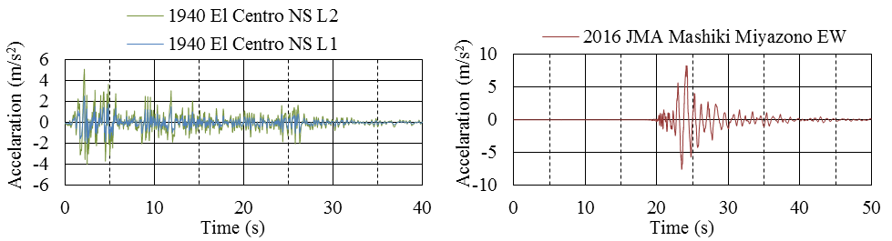

Figure 12. Time history of acceleration of input waveform

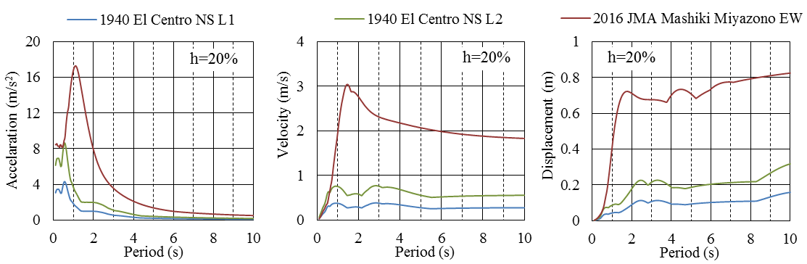

(a) Response acceleration (b) Response velocity (c) Response displacement

Figure 13. Response spectrum to input wave with damping coefficient of 20%

***4.3 Results of analysis***

Figure 14 shows distributions of peak response value obtained from the results of time history response analysis. For each input earthquake motion, the peak response values of acceleration, displacement, and story drift angle are shown. Three cases are compared in these plots of peak response values: the original design without oil dampers (6 LRBs only), the case with six ordinary bilinear oil dampers (6 LRBs + 6 ODs), and the case with six of the developed switched resistance oil dampers (6 LRBs + 6 SODs). Figure 14 (a) represents the 2016 Kumamoto earthquake JMA Mashiki Miyazono EW waveform case and the response displacement of the seismic isolation layer in the 6-LRB model is 923 mm. This exceeds the typical clearance allowed for a seismically isolated building, which is generally 600-800 mm. In the other two cases, 6 LRBs + 6 ODs and 6 LRBs + 6 SODs, the response displacement of the isolation layer is less than 600 mm; that is, it is successfully suppressed to within the clearance typically allowed in a seismically isolated building. Further, for this input case involving a very large earthquake, the ordinary oil dampers and the switched resistance oil dampers have equivalent effect at suppressing displacement. On the other hand, comparing responses to the level 1 and level 2 earthquake motions, which are shown in Figures 14 (b) and (c), although the response displacement of the model with 6 LRBs + 6 ODs model is greatly reduced, the response values of the superstructure (such as acceleration and story drift angle) are higher that with the 6-LRB model. This contrasts with the model incorporating the new dampers, where the response acceleration and story drift angle are slightly greater than with the 6-LRB model for the 1940 El Centro NS L2 input case, but much less so than for the model with 6 LRBs + 6 ODs. With the 1940 El Centro NS L1 input, the superstructure response of the model with the new dampers is almost equivalent to that of the original 6-LRB model.

Figure 15 compares the hysteresis loops of the ordinary oil dampers (OD) and the switched resistance oil dampers (SOD) obtained by response analysis. In the case of the 2016 JMA Mashiki Miyazono EW input shown in Figure 15 (c), the hysteresis loops are almost the same size since both types of damper reached the relief load. This shows that OD and SOD exhibit nearly equal damping performance in the case of a very large earthquake. When the design level earthquake motions are input, as shown in Figures 15 (a) and (b), the maximum load of the SOD is smaller than that of the OD. This means the SOD does not generate an excessive damping force when subject to the design level earthquake, restricting the response of the superstructure.

Through controlled switching of the damping force, the switched resistance oil damper is able to restrain displacement in the case of very large earthquakes while avoiding excessive superstructure response caused by excessive damping in the case of design level earthquakes. These analysis results therefore suggest that a switched resistance oil damper is one effective countermeasure against very large earthquakes.

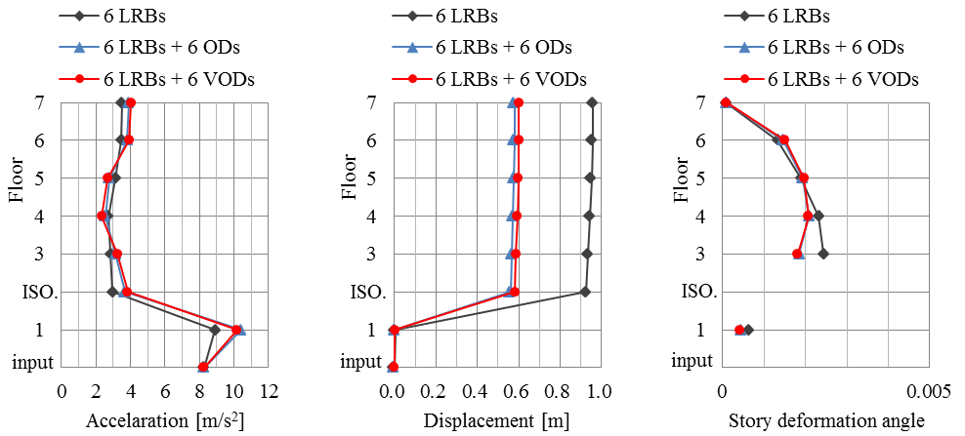

(a) 2016 JMA Mashiki Miyazono EW

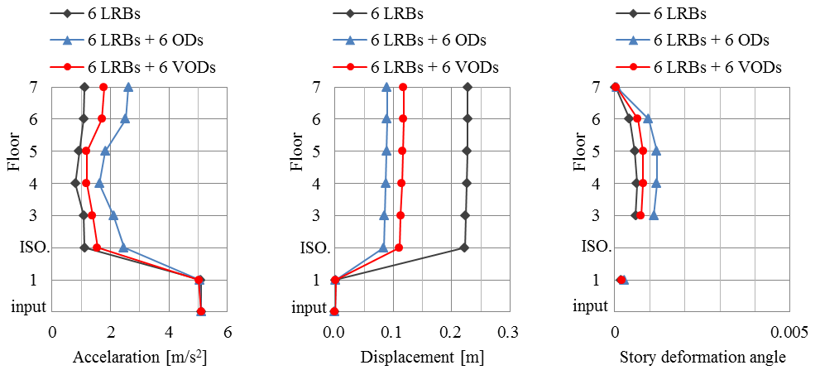

(b) 1940 El Centro NS L2

(c) 1940 El Centro NS L1

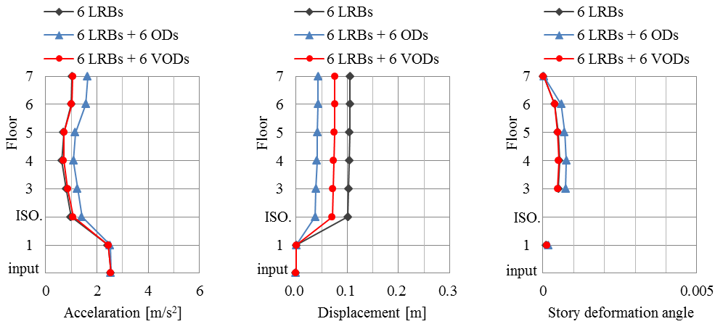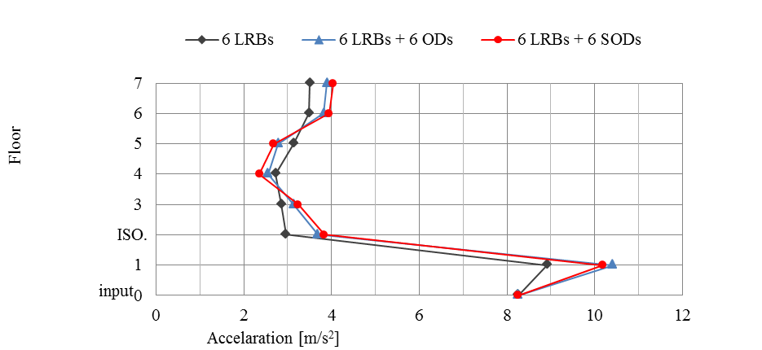

Figure 14. Peak response values

(a) 1940 El Centro NS L1

(b) 1940 El Centro NS L2

(c) 2016 JMA Mashiki

Miyazono EW

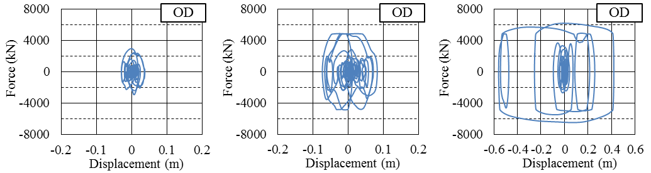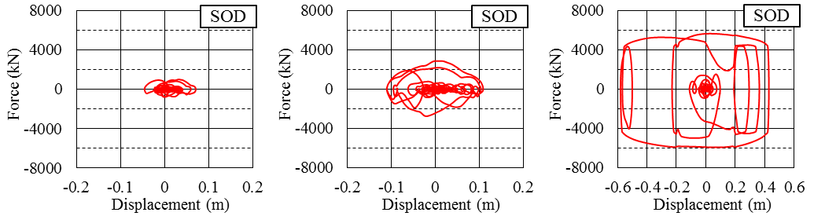

Figure 15. Oil damper hysteresis obtained in response analysis (total for six dampers)

**5. Conclusions**

If the earthquake ground motion during a very large earthquake exceeds the design level, there is a possibility that the response displacement of a seismically isolated structure may exceed the allowed clearance. This can result in the building itself colliding with the retaining wall surrounding the isolation structure and damage to the seismic isolation devices. Such an excessive response displacement can be suppressed by increasing the number of dampers in the isolation layer. However, if sufficient dampers are installed to suppress the response to a very large earthquake, there will be excessive damping in the case of medium and small earthquakes, resulting in impaired isolation performance and amplification of the superstructure response during relatively more frequent medium and small earthquakes. To solve this problem, the authors have developed an oil damper whose performance switches according to the response displacement of the seismic isolation layer. This damper exhibits a small damping force within range of small response displacements caused by small and medium earthquakes, but when a very large earthquake imposes a large response displacement the damping force increases to suppress the displacement of the superstructure.

This paper describes the mechanism of the new oil damper, including the completely passive switching system. Loading experiments using a full-scale prototype are presented, confirming that the damping force switches as expected. Further, the results of seismic response analysis are presented, demonstrating the advantage of the developed damper as a measure against very large earthquakes. The analytical results show that the new switched resistance oil damper is able to sufficiently suppress superstructure displacement in the case of very large earthquakes without compromising seismic isolation performance in the case of design level earthquakes. This switched resistance oil damper is therefore one effective countermeasure against possible future very large earthquakes.

**6. Acknowledgments**

The switched resistance oil damper described in this paper was jointly developed with Kayaba System Machinery Co., Ltd. We are grateful to everyone involved in its development.

**7. References**

M. Ryota, N. Ichiro, N. Aiko, K. Yuichi, M. Taro, DEVELOPMENT AND APPLICATION OF SHORT STROKE SEISMIC ISOLATED SYSTEM WITH PASSIVE-SWITCHING OIL DAMPER, *Proceedings of 16th World Conference on Earthquake*, 9-13 January 2017, Santiago, Chile.: Paper No. 3699.

Yoshifumi Hibako, Base-isolated building with new-type oil damper for long-period and huge ground motion, *Proceedings of The 7th World Conference on Structural Control and Monitoring*, 22-25 July 2018, Qingdao, China.: 525-534.

1. Senior Research Engineer, Institute of Technology, Shimizu Corporation, Tokyo,Japan, sachie.yamamoto@shimz.co.jp
2. Manager, Design Division, Shimizu Corporation, Tokyo, Japan, kitamura@shimz.co.jp
3. Chief Research Engineer, Institute of Technology, Shimizu Corporation, Tokyo, Japan, isoda@shimz.co.jp
4. General Manager, Institute of Technology, Shimizu Corporation, Tokyo, Japan, fukukita@shimz.co.jp