ENERGY DISSIPATION AND SEISMIC RESPONSE EVALUATION OF SEMI-RIGID FRAMES AT VARIOUS PERFORMANCE LEVELS

DOI 10.37153/2686-7974-2019-16-694-704

Vijay SHARMA, Sourabh VERN, Mahendra Kumar SHRIMALI,
Shiv Dayal BHARTI, Tushar Kanti DATTA

ABSTRACT

During the famous 1994 Northridge earthquake and 1995 Kobe earthquakes, the beam-column rigid connected steel moment-resisting frames were severely affected, especially at joints. As a consequence, the concept of semi-rigid (SR) frames for seismic energy dissipation attracted the attention of many researchers. This paper primarily focuses on the performance-based seismic behavior of SR frames under earthquakes. Herein, the seismic performance of SR steel moment frames is investigated at various performance levels through the nonlinear pushover analysis (POA) and the nonlinear time history analysis (NTHA) under a variety of far-field and near-field earthquakes. The SR connections are modeled as multi-linear plastic link element with a kinematic hysteresis behavior in the standard software SAP2000. POA is performed to identify the performance levels at different locations, elastic to the near collapse level. For the numerical study, a 5-story steel moment frame with rigid and SR connections are designed for the Indian standard provisions to assess the seismic performances. Further, the responses obtained from the POA are compared with the benchmark NTHA. The response quantities of interest are considered as the energy dissipation in SR connections, the peak top-floor displacement, the maximum base shear, the maximum inter-story drift and the SRSS of maximum plastic hinge rotations. From the study, it is concluded that predictions from POA are quite reliable up to the elastic and elastic-plastic performance levels. Further, the energy dissipations at the SR connections are found to be significant in NTHA showing the improved inelastic behavior of the SR frames as compared to the rigid frames.

Keywords: Seismic Performance; Semi-rigid; Far-field, Near-field earthquakes

1. INTRODUCTION

The conventional rigid connected steel structures are generally preferred in the high seismic zones due to cost-effectiveness with high ductility and faster construction practice. In conventional rigid connected structures, the seismic energy is dissipated in the form of plastic hinges, preferred in beams earlier to columns. During the 1994 Northridge and 1995 Kobe earthquakes, the rigidly connected steel moment frames (MR) were significantly damaged at the beam-column joints. These seismic events diverted the attention of researchers to the behavior of beam-column joints in semi-rigid connections in relation to the dissipation of the seismic energy in the joints.
The seismic behavior of the rigid and the semi-rigid (SR) connected beam-column joints were investigated under dynamic loading analytically and experimentally during the last thirty years or so (Awkar et al. 1999, Elnashai et al. 1994, Nader et al. 1991). These studies revealed the efficacy of the SR connections over rigid connections with less base shear and high seismic energy dissipations in theconnections and the material. The behavior of SR connections was studied experimentally and analytically from the last 50 years or so, andan inclusive state-of-art review paper was presented by Díaz et al. (2011) considering the growth of the SR connection in the last 19th century. The various standards also considered the SR connections and described their behavior that depended on their moment-rotation relationship (ANSI/AISC 2016, Eurocode (2005), IS-800 2007). Sekulovic et al. (2008) investigated the seismic behavior of SR frames at different PGA levels and examined the seismic energy dissipation in the connections and plastic hinges. Feizi et al. (2015) and Bayat et al. (2017) investigated the performance of structures under earthquakes by incorporating hybrid frames (combination of the rigid and the semi-rigid connections) and suggested the optimum locations and different patterns for different heights of buildings. The standard and accurate nonlinear time-history analysis (NTHA) is generally used for these studies, but NTHA was never the first choice for the designers due to the complexity of the analysis. Thus, simplified nonlinear-static procedures (NSP) such as the capacity spectrum method (Freeman 1978) and the N2 method (Fajfar 1999), which utilized the demand response spectrum of earthquakes to predict the inelastic capacity of structures, became popular. This led towards the performance-based seismic design (PBSD) and analysis of structures. These NSP procedures focussed on the displacement based design approach. Kunnath et al. (2004) and Kalkan et al. (2007) investigated the efficacy of NSP procedures with their limitations and compared with NTHA responses under near-field and far-field ground motions. The PBSD approach examined the performance of the structure in the form of performance points (PPs) at the inelastic state. Most of the performance-based studies compared the seismic performances at the yield level or the collapse level under far-field earthquakes. Practically no studies were reported on the PBSD of the semi-rigid jointed frames and verified their performances under near and far field earthquakes.
This paper investigates the energy dissipation and performance of a mid-rise 5-story steel moment-resisting frame at three PGA levels corresponding to the performance points, obtained at the elastic, elastic-plastic and plastic states in fully rigid and SR frames. Further, the comparison between the responses obtained from NTHA and NSP (pushover analysis using capacity spectrum approach) results were carried out at different performance states in order toexemplify the energy dissipation characteristics of the SR frames. The demand response spectrums for three different varieties of earthquakes, typified by far-field, near-field with directivity and fling step effects were chosen for the evaluation of performance points. The comparison is carried out for a wide range of response parameters, namely, the top-roof displacement, the maximum story drift, the maximum base shear, total number of plastic hinges, the SRSS of maximum hinge rotations and the energy dissipation in plastic hinges.The standard nonlinear SAP2000 software is used for NTHA and POA (SAP2000 2017).

2. THEORY

In order to assess the behavior of the rigid and the SR frames at three PGA levels corresponding to three performance points, three different types of earthquakes, namely, far-field (FF), near field field with the directivity effect (NFD), and near-field with the fling step effect (NFF) are considered. The design demand response spectrum is obtained through 10-point percentile filter smoothening of response spectrums of the earthquakes. The three different design demand response spectrums from FF, NFD,and NFF ground motions are superimposed on the capacity curve of the structures to obtain the performance points. The following section explains the implementation of different portions of the analysis in SAP2000.

2.1 Implementation of the Semi-rigid Connection in SAP2000

Semi-rigidity in beam-column connections is categorized by three parameters, namely, stiffness, strength,and ductility of adjoining members. The SR connections defined in SAP2000 are based on AISC 341-16 standards for a special moment resisting (SMR) frames under seismic excitations. The ratio of the yield moment (M_{yc}) capacity to plastic moment capacity of connections (M_{pc}) in the generic model is chosen as 2/3. The flexural strength or ultimate moment capacity of connections at the column ends should be minimum 80% of the connecting beam plastic moment capacity (M_{pb}) to satisfy the story drift limit (minimum 0.04 rad) of connection as per AISC 341-16. The degree of semi-rigidity in connections are explained by two dimensionless parameters (α and β) and the connection ductility. For SR connections, the ductility of connections should not be less than θ_{u} ≥ 0.04rad (Chan et al. 2000). The parameters are taken as follows:

$α={R_{ki}}/{\left(\frac{EI_{beam}}{L_{beam}}\right)}$……..(1) and $β=\frac{M_{pc}}{M_{pb}}$ ……… (2)

Where R_{ki}= Initial Connection Stiffness; EI_{beam}/L_{beam} = Connected Beam Stiffness

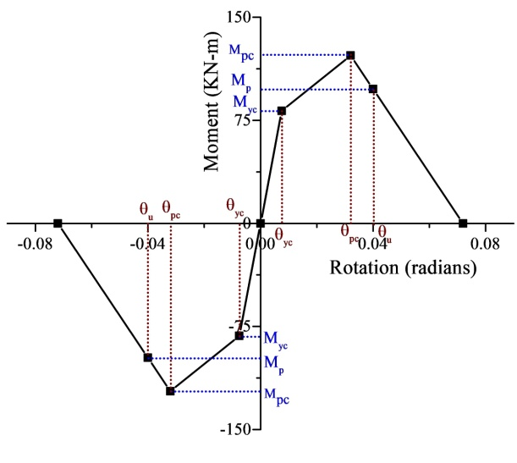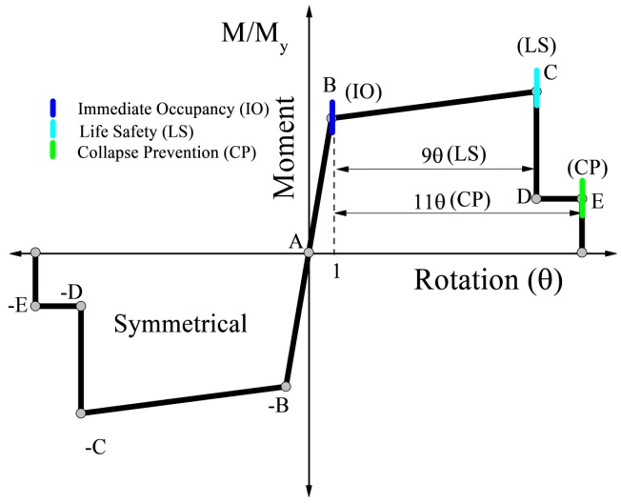
(a) (b)

Figure 1. (a) Typical Moment-Rotation Curve for Semi-Rigid Connection (b) Hysteresis Curve for Default Plastic Hinges as per ASCE-41-13

In SAP2000, the SR connections modeled as two jointed zero length multi-linear plastic link element (MLP) with rotational nonlinearity in the R3 direction. The material nonlinearity in the structureis modeled like a concentrated default flexural plastic hinge as per ASCE 41-13,and geometric nonlinearity is incorporating through P-Δ consideration. The kinematic hysteresis behavior of MLP link for energy dissipation in cyclic loadingis shown in Figure 1(a) and Figure 1(b) explained the hysteresis behavior of default plastic hinges.

2.2 Analysis

2.2.1 Nonlinear Static Procedure- Pushover Analysis (POA)

The nonlinear static pushover analysis of fully rigid connected (FRC) and semi-rigid (SR) connected frames are carried out at 4% of the total height of monitored displacement till the collapse level. The first mode shape lateral load is selected for the lateral push. Further, the performance points are obtained from three 5 % damped demand response spectrums for FF, NFD and NFF type earthquakes based on ATC-40 capacity spectrum method (CSM) ATC-40 (1996). The performance points are obtained at three PGA levels corresponding to three performance states, namely, 0.3g (Elastic), 0.5g (Elastic-Plastic) and 0.7g (Plastic).The performance point evaluations are based on the CSM method explained in ATC-40,procedure B.

2.2.2. Nonlinear Time History Analysis (NTHA)

The benchmark NTHA using Hilber-Hughes-Taylor time integration approach with default parameters (gamma=0.5 and beta=0.25) are selected for an analytical simulation purpose. The 5% proportional Rayleigh damping for first and second vibration modes are considered. The second order P-Δ effect is also considered in the analysis. In all, 27 NTHA simulations are executed for the analysis of the frames.

3. NUMERICAL STUDY

A 5-story mid-rise steel building is considered for the numerical study. The 5-story building has three bays of 5m each in both directions, and each floor has the same height of 3.2m. The building consists of special moment resisting frame (SMRF) with rigid beam-column connections. For the dead load, 150mm thick concrete slab with floor finish and 225mm thick partition walls are considered. The effective uniformly distributed loads on beams are 20KN/m as a floor dead load, 15KN/m as roof dead load and the 4KN/m of live load. The SMRF frame is designed as per Indian standard provisions IS-800 (2007). Thus, section selection followed the strong column-weak beam (SCWB) design standards and shown in Table 1. As per IS provisions, the ratio of plastic moment capacity of the column to the sum of the plastic moment of the connected beam should be higher than or equal to 1.2 for SCWB design.
The rigid SMRF frames are designed for the high seismic zone (zone V with zone factor 0.36) with medium soil condition as per the Indian standard seismic design code IS 1893 Part1(2016). Three different types of ground motions are considered with the three scaled PGA levels corresponding to three different performance states, namely, 0.3g for elastic, 0.5g for elastic-plastic and 0.7g for the plastic state. The ground motions considered are (i) Far-field earthquakes (FF), San Fernando-1971 (PGA 0.21g and magnitude 6.6 M_{w}); (ii) Near-field with directivity (NFD) pulses, Erzincan-1992 (PGA 0.5g and 6.7 M_{w}), and (iii) Near-field with fling step (NFF), Chi-Chi TCU072-EW-1999 (PGA 0.46g and 7.6 Mw) selected for the seismic performance evaluation.

Table 1. Detailing Of 5-Story Steel Moment Resisting Frame

Storey/  Floor | Beam Section | Column Section | Storey Height | Bay Width | Steel f_{y} (N/mm²) | Modulus of Elasticity E  ( N/mm²) | Poisson ratio
1st | ISMB 300 | ISHB 450 | 3.2 m | 5 m | 250 | 2.10E+05 | 0.3
2nd | ISMB 300 | ISHB 400 | 3.2 m | 5 m | 250 | 2.10E+05 | 0.3
3rd- 5th | ISMB 300 | ISHB 350 | 3.2 m | 5 m | 250 | 2.10E+05 | 0.3

Further, a typical internal SMRF is selected for the numerical study. Two types of beam-column connection are used, namely, fully rigid (FRC) and semi-rigid (SR) connections for seismic performance evaluation. The semi-rigidity in the beam-column connections is defined by the two dimensionless parameters, i.e., stiffness (α) and strength (β) parameters. The semi-rigid frames are designated as ‘SR-1_5S’ with parameters (α=10 and β=1.5) and ‘SR-2_5S’ with parameters (α=22 and β=1.5), and the results are compared to the FRC frame. The two-dimensional POA and NTHA are executed for the frames in SAP2000. The material nonlinearity in all framesis modeled as concentrated plasticity in the form of default plastic hinges as per ASCE-41-13 at the beam and column ends.

3.1 Capacity Curve (Nonlinear Static Pushover Curve)

The capacity curves for the 5-Story FRC and SR connected frames are obtained from POA as shown in Figure 2(a).The capacity curve estimates the behavior of the structure in the inelastic range. Figure 2(a) shows that there is a considerable reduction in the maximum base shear in SR frames as compared to the FRC frames. The maximum base shear in the elastic zone (typically a linear zone in the capacity curve) is substantially less in the SR frame as compared to the FRC frame as expected. However, the elastic-plastic (curved zone) and plastic (almost flat zone) portions which depict the inelastic excursion of frames, the SR frame undergoes large deformations before the collapse as compared to the FRC frame.

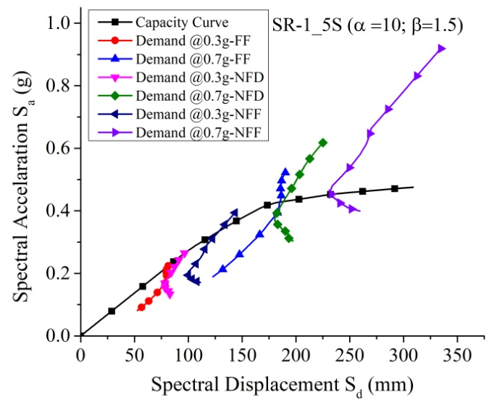
- (b)
Figure 2. (a) Capacity Curve of 5-Story FRC and SR Frame (b) Performance Points for SR-1_5S Frame at 0.3g and 0.7g PGA level for different types of earthquakes

3.2 The Performance Point

The performance of the frames at three performance points (PP) corresponding to three demand response spectrums having different PGA levels is investigated. The PPs are the intersections of the capacity curves with the design demand response spectrums, both reduced to the ADRS format. Three sets of PPs at three performance levels are evaluated. It is clearly seen from Figure 2(b) that NFF type of ground motion imposes a maximum displacement demand and the FF type of ground motion induces a minimum displacement demand for the frames. Thus, the seismic performance of the frames under the near-field ground motions should be closely examined.

4. RESULTS AND DISCUSSIONS

Performances of the semi-rigid (SR) and fully rigid (FRC) 5-story frames are evaluated at three different PGA levels, corresponding to the three different performance states, elastic, elastic-plastic and plastic under near-field and far-field ground motions. The response quantities of interest are the top roof displacement (TRD), the maximum Base Shear (BS_{max}), the maximum story drift (SD_{max}), the total number of plastic hinges (PH_{total}), the SRSS of maximum plastic hinge rotations (HR_{SRSS}) and the energy dissipation in the FRC and SR frames in the form of damping and link hysteretic energy. Further, the responses are compared for different types of ground motions.

4.1 Responses corresponding to performance points from Pushover CSM approach

The responses at different performance points are evaluated from POA using the CSM approach from three different types of ground motions, typified by FF, NFD, and NFF. Table 2 shows the maximum base shear (BS_{max}) and the top roof displacement (TRD) obtained at the PGA of 0.3g, 0.5g, and 0.7g for FRC and the two SR frames (SR-1_5S and SR-2_5S). It is observed that the base shear values are increased with an increase in PGA level for all types of frames. At the performance point corresponding to the elastic state (PGA 0.3g), the maximum base shear values in FRC frames are increased by 46% and 80% as compared to SR frames in the NFD and NFF earthquakes respectively. For the elastic-plastic state (0.5g PGA) and the plastic state (0.7g) also the FRC frame provides considerably higher base shear as compared to the SR frames. Thus, SR frames prove to be more beneficial in respect of base shear.
Table 2 also shows the top roof displacement in FRC and SR frames. It is seen from the table that the top floor displacement increases with the increase in the PGA and the degree of semi-rigidity (the less value of alpha shows more degree of semi-rigidity). However, the increase in the top floor displacement in the SR frames due to semi-rigidity is less for the near field earthquake as compared to the far field earthquake. Thus, the performance of the SR frames is relatively better in the near field earthquakes
Table 2. Responses Corresponding To Different Performance Points At Different PGA Level

Frame ID | PGA (g) | Base Shear BS_{max}(KN) |  |  | Top Roof Displacement (mm)
 |  | FF | NFD | NFF | FF | NFD | NFF
FRC_5S | 0.3 | 286.08 | 417.73 | 509.96 | 80.31 | 118.66 | 156.90
 | 0.5 | 449.54 | 554.36 | 610.30 | 130.04 | 179.08 | 228.03
 | 0.7 | 554.24 | 606.34 | 629.56 | 179.01 | 221.20 | 277.43
SR-1_5S (α=10; β=1.5) | 0.3 | 281.91 | 332.39 | 420.41 | 108.74 | 128.33 | 170.85
 | 0.5 | 431.73 | 462.32 | 543.63 | 176.60 | 192.82 | 249.56
 | 0.7 | 540.53 | 543.94 | 585.41 | 245.64 | 249.95 | 308.47
SR-2_5S  (α=22; β=1.5) | 0.3 | 281.57 | 359.58 | 448.80 | 92.81 | 122.52 | 165.41
 | 0.5 | 418.63 | 479.11 | 551.97 | 150.41 | 181.15 | 231.47
 | 0.7 | 539.44 | 554.92 | 591.35 | 219.23 | 234.85 | 289.32

4.2 Comparison of responses between POA and NTHA at different performance points

The responses obtained by POA and NTHA at different performance points are compared response wise in the following sections.

4.2.1 Comparison of maximum base-shear between POA and NTHA

The percentage differences in maximum base shear in 5-Story FRC and SR frames calculated from POA and NTHA at the three PGA levels are compared for the three types of ground motions. Table 3 shows the percentage difference as [BS_{max}(NTHA)- BS_{max}(POA)/ BS_{max}(NTHA)]. From the table, it is seen that the difference decreases with the increase in PGA for the FF earthquakes. For the NFD and the NFF earthquakes, a reverse trend is observed. Further, the difference is less for the near field earthquakes as compared to the far field earthquakes.

Table 3. Percentage Difference in Responses (Base Shear and Top-roof Displacement) obtained from NTHA and POA at different performance level PGA

Frame ID | PGA (g) | % Difference in Base Shear |  |  | % Difference in Top-Roof Displacement
 |  | FF | NFD | NFF | FF | NFD | NFF
FRC_5S | 0.3 | 37.27 | 15.66 | 16.67 | 35.21 | 7.34 | 16.68
 | 0.5 | 34.89 | 21.27 | 21.49 | 29.49 | 13.65 | 5.69
 | 0.7 | 30.58 | 25.26 | 26.70 | 21.11 | 25.71 | 4.04
SR-2_5S  (α=22; β=1.5) | 0.3 | 34.84 | 16.39 | 0.56 | 26.03 | 8.05 | 2.65
 | 0.5 | 26.73 | 20.72 | 2.54 | 17.03 | 21.15 | -1.94
 | 0.7 | 23.82 | 19.06 | 9.96 | 7.42 | 28.88 | -7.22
SR-1_5S  (α=10; β=1.5) | 0.3 | 39.46 | 13.77 | -23.87 | 36.42 | 10.38 | -1.77
 | 0.5 | 33.48 | 16.07 | 1.75 | 25.33 | 20.78 | -7.24
 | 0.7 | 29.94 | 15.10 | 16.47 | 19.25 | 28.52 | 5.31

The similar trend is observed for the difference (defined in a similar way as above) in the top floor displacement. Note that in the case of NFF, the difference becomes negative from positive as the PGA value is increased for SR frames.

4.2.2 Comparison of maximum story drifts (SD_{max}) between POA and NLTHA

Figure 3 compares the maximum story drifts obtained by POA and NTHA. It is seen from Figure 3 that the maximum story drifts are more for the near field earthquakes as compared to the far field earthquakes. Further, the maximum story drifts increase with the increase in the PGA value and are more for the SR frames. The differences between the maximum story drifts obtained by POA and NTHA for different cases remain nearly the same for both types of frames. The difference is found to be the maximum for the NFD earthquake.

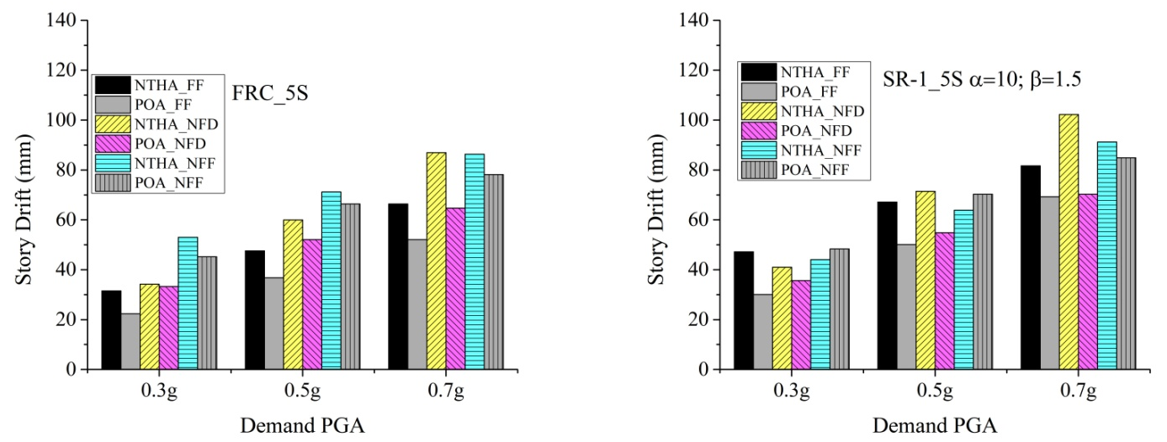
- (b)

Figure 3. Comparison Of Maximum Story Drift Responses In (A) FRC And (B) SR-1 Frame For Different Types Of Earthquakes

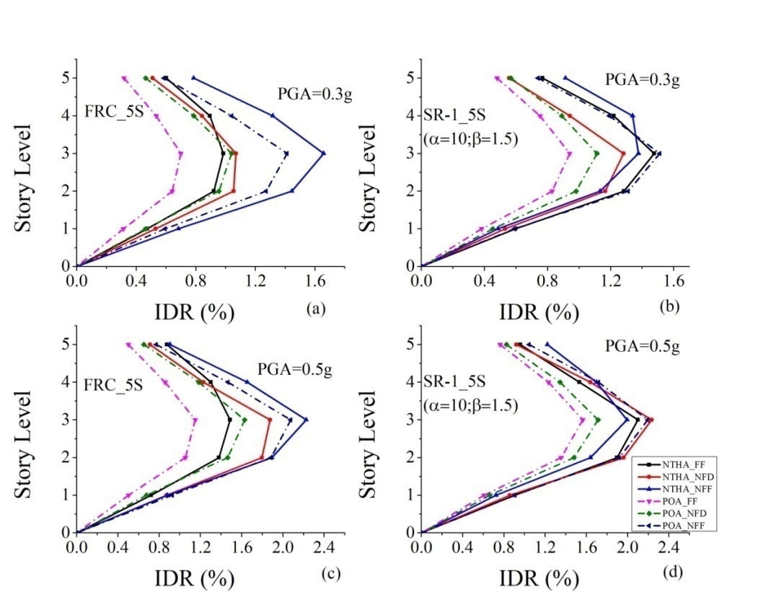

Figure 4. Variation Of Maximum Inter-story Drift Ratio (IDR %) Along The Height At 0.3g PGA (a) FRC_5S (b) SR-1_5S ; And At 0.5g PGA (c) FRC_5S (d) SR-1_5S

Figure 4 shows the variations of the maximum inter-story drift ratio along the height of the frame as obtained by NTHA and POA. It is seen from Figure 4 that the maximum inter-story drift peaks nearly at the third story for all cases. Further, the pattern of the variation remains the same for all cases for both types of the frame.

4.2.3 Comparison of inelastic effects (total plastic hinge formation and SRSS of hinge rotations) between POA and NTHA

Table 4 shows the formation of plastic hinges in the FRC and the SR frames at a PGA level of 0.7g. The table distinguishes the formation of hinges in three performance levels (IO, LS, and CP) defined as per ASCE-41-13. It is observed from the table that the maximum numbers of plastic hinges are formed in FRC frames in both NTHA and POA as expected; NTHA provides more number of plastic hinges. The numbers of total hinges are more in the NFD and the NFF earthquakes as compared to the FF earthquake. Further, the number of hinges in the B-IO range is much more than that in the IO-LS range. As it would be expected, the number of hinges is far less for the SR frames because of more energy dissipation.
The SRSS of maximum plastic hinge rotations shown in Table.5 provides additional information regarding the inelasticity in the frames. The SRSS values increase with the increase in the PGA level. Further, SRSS of plastic hinge rotations in the SR frames is much less as compared to the FRC frames indicating that the SR frames undergo less inelastic excursion

Table 4. Comparison of Total Plastic hinges formed in frames at 0.7g PGA Level in NTHA and POA

Frame ID | Earthquake Type | Total Number Of Plastic Hinges |  |  |  |  |  | Total Hinges
 |  | B-IO |  | IO-LS |  | LS-CP
 |  | NTHA | POA | NTHA | POA | NTHA | POA | NTHA | POA
FRC_5S | FF | 15 | 9 | 13 | 3 | 0 | 0 | 28 | 12
 | NFD | 11 | 13 | 18 | 9 | 0 | 0 | 29 | 22
 | NFF | 13 | 9 | 22 | 16 | 0 | 0 | 35 | 25
SR-2_5S  (α=22; β=1.5) | FF | 0 | 3 | 0 | 0 | 0 | 0 | 0 | 3
 | NFD | 15 | 1 | 5 | 3 | 0 | 0 | 20 | 4
 | NFF | 18 | 1 | 0 | 4 | 0 | 0 | 18 | 5
SR-1_5S  (α=10; β=1.5) | FF | 3 | 1 | 4 | 3 | 0 | 0 | 7 | 4
 | NFD | 13 | 1 | 6 | 3 | 0 | 0 | 19 | 4
 | NFF | 14 | 0 | 4 | 4 | 0 | 0 | 18 | 4

Table 5. Comparison of SRSS of Maximum Plastic hinge Rotations (in radians)

Frame ID | Earthquake Type | 0.7g |  | 0.5g |  | 0.3g
 |  | NTHA | POA | NTHA | POA | NTHA | POA
FRC-5S | FF | 0.03891 | 0.01960 | 0.02128 | 0.00477 | 0.00122 | 0.00000
 | NFD | 0.05667 | 0.03291 | 0.02708 | 0.01960 | 0.00333 | 0.00198
 | NFF | 0.05882 | 0.05187 | 0.04330 | 0.03492 | 0.01986 | 0.01249
SR-2_5S (α=22; β=1.5) | FF | 0.00405 | 0.00037 | 0.00000 | 0.00000 | 0.00000 | 0.00000
 | NFD | 0.00925 | 0.00161 | 0.00102 | 0.00000 | 0.00000 | 0.00000
 | NFF | 0.00357 | 0.00959 | 0.00028 | 0.00130 | 0.00014 | 0.00000
SR-1_5S (α=10; β=1.5) | FF | 0.00601 | 0.00195 | 0.00168 | 0.00000 | 0.00000 | 0.00000
 | NFD | 0.00649 | 0.00249 | 0.00060 | 0.00000 | 0.00000 | 0.00000
 | NFF | 0.00534 | 0.01082 | 0.00000 | 0.00249 | 0.00000 | 0.00000

4.3 Energy dissipation in rigid and semi-rigid frames in NTHA

Figure 5 shows typical plots of the energy dissipation with time for the PGA level of 0.7g PGA for the San Fernando (FF) and the Erzincan (NFD) ground motion. It is observed from Figure 5 that modal damping energy decreases significantly in the SR frame as compared to the FRC frame. Thus, the total plastic hinges and the SRSS of hinge rotations are considerably reduced in the SR frames. The link hysteretic energy dissipation (energy in SR connections) is noticeable in the SR frames. This is another reason for the reduction in the inelastic excursion in the form of plastic hinges in the SR frames. Note that energy in the frame is stored in different forms such as modal damping energy, kinetic energy, potential energy, hysteretic energy, and link energy. Out of them, energyis especially dissipated in modal damping and link hysteretic effect for the SR frames as seen in Tables 5 and 6.

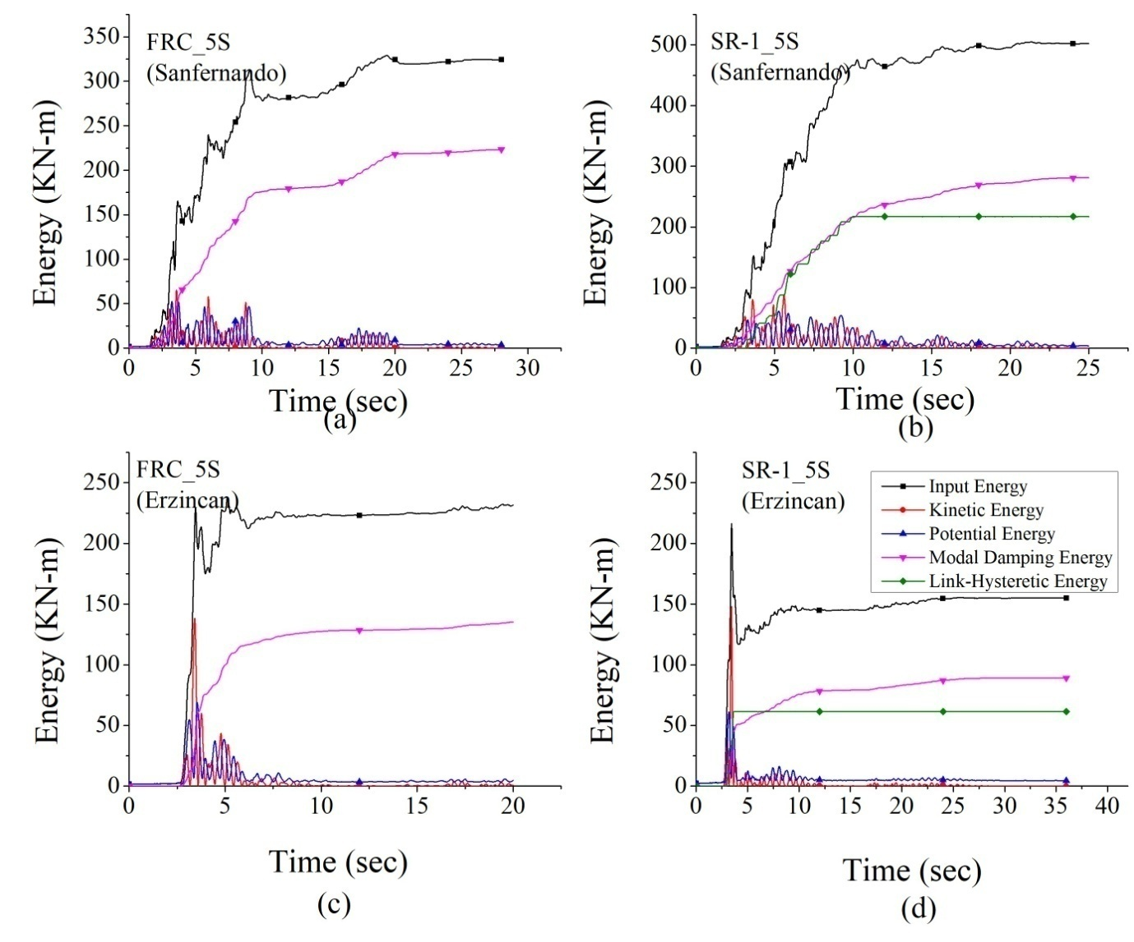

Figure 5. Comparison Of Energy Dissipation In FRC And SR-1 Frames At 0.7g PGA For San Fernando(FF) Earthquake (A-B); And Erzincan (NFD) Earthquake (C-D)

Table 5. Comparison of various forms of %difference in energy dissipation at 0.7g PGA in FRC and SR frames

Frame-ID | Input Energy |  |  | Kinetic Energy |  |  | Potential Energy
 | FF | NFD | NFF | FF | NFD | NFF | FF | NFD | NFF
FRC and SR-2 | -26.79 | 11.07 | 8.97 | -13.36 | 9.40 | 9.46 | 9.51 | 3.21 | 25.99
FRC and SR-1 | -53.56 | 7.21 | 7.87 | -35.23 | 1.89 | -0.43 | -16.49 | -7.50 | 15.58
SR-2 and SR-1 | -21.11 | -4.34 | -1.21 | -19.30 | -8.29 | -10.93 | -28.73 | -11.07 | -14.06

Table 6. Comparison of various forms of %difference in energy dissipation at 0.7g PGA in FRC and SR frames.

Frame-ID | Modal Damping Energy |  |  | Link Hysteretic Energy
 | FF | NFD | NFF | FF | NFD | NFF
FRC and SR-1 | -9.00 | 17.00 | 16.23 | -73.21 | 1.71 | -2.56
FRC and SR-2 | -26.43 | 3.00 | 8.66 | -123.62 | 20.47 | 7.12
SR-1 and SR-2 | -15.99 | 18.75 | -9.04 | -29.10 | 19.08 | 9.44

5. CONCLUSIONS

The behavior of a 5-story semi-rigid jointed frame is investigated at three performance points obtained from the pushover analysis under three different types of the earthquake, namely, the far field and the near field (with directivity and the fling step effects). The three identified performance points cover the elastic, the elastic-plastic and the plastic states of the frame. A number of response parameters are considered to investigate the inelastic behavior and the energy dissipation characteristics of the frame. The responses of the frame obtained from the pushover analysis are compared with those of the nonlinear time history analysis. A corresponding rigid jointed frame is analyzed to typify the behavior of the semi-rigid jointed frame. The results of the numerical study lead to the following conclusions.
- The maximum base shear is considerably reduced in the semi-rigid frames as compared to the fully rigid frames at the elastic performance point. The base shear values are more under the near-field earthquakes, especially for the NFF. A similar trend is observed at other performance points.
- The maximum top floor displacement increases with the increase in the degree of semi-rigidity; the displacements are more for the near field earthquakes.
- The percentage differences in the maximum base shear and the maximum top floor displacement between the NTHA and the POA are maximum under the far-field earthquake; they decrease with the increase in the PGA levels.
- The maximum inter-story drift ratio along the height of the frame occurs in the third story, irrespective of the type of earthquake. The difference in the maximum inter-story drifts obtained from the POA and the NTHA decreases with the degree of semi-rigidity.
- The plastic hinges are not formed at a PGA level of 0.3g corresponding to the elastic state in the SR frames. In general, the number of plastic hinges is less in the semi-rigid frames as compared to the rigid frames; the number of hinges is more for the near field earthquakes.
- The difference in the SRSS of maximum plastic hinge rotations between the POA and the NTHA is maximum for the far-field earthquakes.
- The energy dissipation in the rigid frame is mainly in the form of plastic hinges (modal damping energy), whereas the energy dissipation in the semi-rigid frame is due to both plastic hinge formation and the link hysteresis (in connection); the link hysteretic energy increases with the increase in the degree of semi-rigidity.

6. References

ANSI/AISC 360-16 (2016) Specification for Structural Steel Buildings American Institute of Steel Construction Inc.
ATC-40 (1996). -Seismic evaluation and retrofit of concrete buildings." Rep. No. SSC 96-01: Applied Technology Council Redwood City, California.
Awkar, J. and E. Lui (1999). Seismic analysis and response of multistory semirigid frames. Engineering Structures 21(5): 425-441.
Bayat, M. and S. M. Zahrai (2017). Seismic performance of mid-rise steel frames with semi-rigid connections having different moment capacity. Steel and Composite Structures 25(1): 1-17.
Chan, S.-L. and P.-T. Chui (2000). Non-linear static and cyclic analysis of steel frames with semi-rigid connections, Elsevier.
Díaz, C., P. Martí, M. Victoria and O. M. Querin (2011). Review on the modelling of joint behaviour in steel frames. Journal of constructional steel research 67(5): 741-758.
Elnashai, A. and A. Elghazouli (1994). Seismic behaviour of semi-rigid steel frames. Journal of Constructional Steel Research 29(1-3): 149-174.
Eurocode (2005). "Eurocode 3: Design of Steel Structures (Part 1-8: Design of Joints) European Committee for Standardization, B-1050 Brussels.
Fajfar, P. (1999). Capacity spectrum method based on inelastic demand spectra. Earthquake Engineering & Structural Dynamics 28(9): 979-993.
Feizi, M. G., A. Mojtahedi and V. Nourani (2015). Effect of semi-rigid connections in improvement of seismic performance of steel moment-resisting frames. Steel and Composite Structures 19(2): 467-484.
Freeman, S. A. (1978). Prediction of response of concrete buildings to severe earthquake motion. Special Publication 55: 589-606.
IS-800 (2007): General Construction in Steel-Code of Practice 3rd Revision Bureau of Indian Standards, New Delhi.
IS 1893 (2016) Criteria for earthquake resistant design of structures. Part 1 General Provisions and Buildings (Sixth Revision) Bureau of Indian Standards, New Delhi.
Kalkan, E. and S. K. Kunnath (2007). Assessment of current nonlinear static procedures for seismic evaluation of buildings. Engineering Structures 29(3): 305-316.
Kunnath, S. K. and E. Kalkan (2004). Evaluation of seismic deformation demands using nonlinear procedures in multistory steel and concrete moment frames. ISET Journal of Earthquake Technology 41(1): 159-181.
Nader, M. and A. Astaneh (1991). Dynamic behavior of flexible, semirigid and rigid steel frames. Journal of Constructional Steel Research 18(3): 179-192.
SAP2000 (2017). SAP 2000 v19: Integrated software for structural analysis and design. Computers and Structures, Inc., Berkeley, California.
Sekulovic, M. and M. Nefovska-Danilovic (2008). Contribution to transient analysis of inelastic steel frames with semi-rigid connections. Engineering Structures 30(4): 976-989.

Research Scholar, Malaviya National Institute Of Technology, Jaipur, INDIA, vrsgec2011@gmail.com
Research Scholar, National Center for Disaster Mitigation and Management, Malaviya National Institute Of Technology, Jaipur, INDIA, sourabh.vern@gmail.com
Professor, National Center for Disaster Mitigation and Management, Malaviya National Institute Of Technology, Jaipur, INDIA, shrimalimk@gmail.com
Professor, National Center for Disaster Mitigation and Management, Malaviya National Institute Of Technology, Jaipur, INDIA, sdbharti@gmail.com
Adjunct Professor, National Center for Disaster Mitigation and Management, Malaviya National Institute Of Technology, Jaipur, INDIA, tushar_k_datta@yahoo.com

