SEISMIC EVALUATION OF A REINFORCED CONCRETE SCHOOL BUILDING RETROFITTED WITH STEEL BRACING SYSTEM

DOI 10.37153/2686-7974-2019-16-822-837

Marina-Dimitra VOUDRISLI

ABSTRACT

An accurate seismic design is based on a combination of linear seismic analysis, followed by a non-linear analysis procedure. A common tool for the estimation of earthquake demands at multiple performance levels is pushover analysis. This paper aims to evaluate the inelastic behaviour of an existing reinforced concrete school building constructed in 1973 in the city of Kavala, Greece. It examines the subjection of a monotonic load which increases iteratively, through an ultimate condition, and then investigates the need of implementation of retrofitting techniques. The assessment of the building is based on the National Interventions Code (KANEPE - EC8 compatible, 2013), and performance levels, namely Immediate Occupancy (IO), Life Safety (LS) and Collapse Prevention (CP), are specified in compliance with ATC-40. According to six different analyses, including both triangular and uniform distribution of horizontal forces, it is concluded that structure can´t reach the target level of safety, as defined by importance levels criteria that ensure continued functionality of the building. More specifically, the results indicate that target displacement in X direction is 1,9 cm and plastic hinges occur in a great number of columns. For the variety of structures, several retrofitting techniques can be considered. In this study, the utilization of diagonal bracing arrangements in order to increase the seismic capacity is examined. The nonlinear pushover analysis confirms that target displacement is reduced by 73% if the recommended steel bracing system is used. The main conclusion that can be drawn is that, the examined method could provide an efficient approach for strengthening of existing RC buildings.

Keywords: seismic assessment, pushover analysis, performance-based design, collapse mechanism, strengthening techniques

1. Introduction

The differences in seismic response between new and existing RC structures during earthquakes brought forward the need to quantify their performance characteristics, with particular emphasis in existing buildings, since they exhibit higher vulnerability to earthquake excitation and suffer most of the damage. The seismic response of existing buildings is characterized by substantial uncertainty. During past earthquakes in Greece many deficiencies were reported, such as low concrete strength, weak column - strong beam behaviour, short column behaviour, inadequate splice lengths, poor confinement of end regions of columns and beams and improper hooks of the stirrups, leading to weaker than desired performance (Antonopoulos & Anagnostopoulos, 2012). A large number of residential buildings in Greece dates back to the 60s, 70s and 80s, and thus, the assessment of their expected structural behaviour under currently expected levels of earthquake motion is of great social and economic significance. These buildings were designed following allowable stress procedures using relatively low base shear coefficients, on the basis of simplified structural analysis models (particularly the earlier ones). Provision for capacity design and critical region detailing were not intentionally incorporated.
The quality of structural materials used in these structures, the detailing practices at the time of construction (for instance improper anchorage of top and bottom steel in the beams, inadequate splicing in columns, use of smooth reinforcement and small diameter largely spaced hoops) and past seismic loading history as well as possible occupancy changes, present significant causes of uncertainty in their expected seismic behaviour. Hence, reliable seismic assessment of existing buildings is highly important. Several simple nonlinear static procedures have been developed, such as Capacity Spectrum Method (CSM), Displacement Coefficient Method (DCM) and N2 Method, which is also employed in Eurocode 8, and later improved procedures were developed by various researchers (Repapis, 2016). These procedures were compared with nonlinear dynamic analyses in order to validate their accuracy. The results from nonlinear dynamic analyses are generally considered more accurate, however, this type of analysis is time-consuming. Furthermore, nonlinear static procedures offer simplicity with reasonable accuracy. Nevertheless, different nonlinear procedures often provide substantially different estimates of target displacement for the same ground motion and structure.
Quantification of structural seismic performance based on collapse capacity under extreme events provides a rational and powerful framework for evaluating existing buildings. The term “performance,” as it is related to exposure to natural hazards, usually refers to a building’s condition after a disaster, more specifically it signifies a level of damage expected or a load that can be resisted. Structural performance is currently determined by applying nonlinear static procedures defined in most earthquake design codes and standards, such as ATC-40 (1996), FEMA273 (1997), FEMA356 (2000) and TERDC (2007). Recent studies are concentrated on establishing seismic capacity-demand index relationships, and as an alternative to capacity-demand index relationships, there is a tendency among the researchers to use nonlinear dynamic time-history procedures as a part of a performance-based design approach (Farrow & Kurama, 2003). Goel and Chopra (2004) developed a modal pushover analysis procedure, where the target displacement is determined from nonlinear dynamic analysis of an equivalent single-degree-of-freedom (SDOF) inelastic system and its peak deformation. Although the inelastic time history analyses (ITHA) are becoming more cost effective, the static monotonic nonlinear analyses (push-over type) provide sufficient insight in the expected behaviour for design purposes.

1.1 Objectives and scope of research

Systematic seismic assessment of reinforced concrete buildings designed to various versions of earlier design codes is imperative in countries with a high seismicity such as Greece, since recent strong earthquakes have underscored their vulnerability. The large number of substandard, lightly reinforced existing buildings renders the massive use of detailed seismic analyses a very demanding work-intensive task.
The objective of this paper is the seismic performance evaluation of an existing RC school building, which is located in the city of Kavala, in Greece. This 2-storey building was built during 1978-1980 and it was designed by following the provisions of the first Greek seismic code introduced in 1959 (Greek Royal Decree of 1959). Pushover analysis is conducted in order to assess its seismic performance. A simplified nonlinear static method is used for the estimation of the target displacement and then, after the strengthening of the building initial results are compared with those derived from nonlinear analysis of the strengthened structure.
Building codes define the minimum design requirements to ensure the safety of occupants during specific design events. Recent natural disasters have prompted recognition that significant damage can occur even when buildings are compliant with the building code. Many critical facilities, including school buildings, are closed after natural disasters, even if damage is relatively minor, suggesting that satisfying the minimum code criteria may not be sufficient to ensure continued functionality. Communities also depend on school buildings to provide reliable shelter and critical services. In order to meet that need, school buildings should be designed and constructed according to criteria that result in continued and uninterrupted functionality.
Given their particularly sensitive role in the society, schools are given high priority when earthquake strengthening programmes are discussed, nevertheless, due to economic constraints, a very small fraction of the existing school building stock has actually been upgraded in the frame of pre-earthquake strengthening programmes world-wide. Until recently, the most extensive efforts in implementing school strengthening programmes were made in Japan, some interesting examples of such applications are given by Japan Ministry of Education (Chrysostomou et al., 2015).

2. SEISMIC HAZARD IN GREECE

Greece has by far the highest seismic hazard in Europe and one of the highest in the world. Thus, potentially destructive shallow earthquakes (M_{w} 5.5 and larger) occur, on the average, as often as one about every 2 months (Lekidis & Dimitriu, 2002). Fortunately, the majority of these earthquakes occur in sparsely populated areas or under the sea, which considerably reduces their destructive capability. Nonetheless, populated areas are affected by damaging to destructive earthquakes quite often. The tectonic regime in the wider area is determined primarily by the convergence, at a rate of about 1 cm/yr, between the Eurasian and African lithospheric plates and by the counter clock-wise rotation, at about 2.5 cm/yr, of the Anatolian plate relative to Eurasia (Lekidis & Dimitriu, 2002). The Arabian plate seems to affect the tectonic situation in the area of Greece only indirectly.

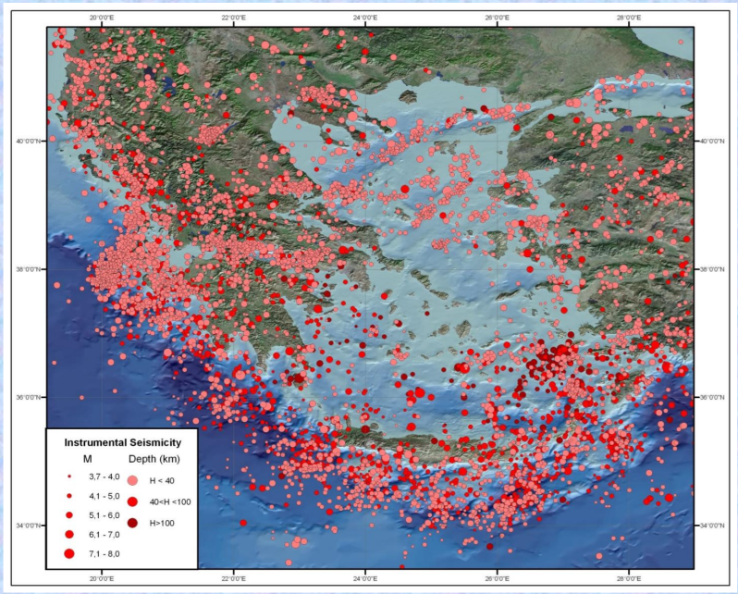

Figure 1. Seismicity in Greece 1900-2006 (Pelli, 2014)

3. BUILDING CODES AND STANDARDS

An overview of the main provisions of the Greek seismic codes is presented as follows:
- 1959 Code: It is based on allowable-stress design. Constant distribution of seismic loads along the height of the structure had been considered without overall seismic design. Stress-strain calculation for columns in the building was done for each storey independently. Ductile frames were absent, there were no ductile provisions and nodes were designed without stirrups.
- 1984 Code: 1984 Code is based on allowable-stress design. This design incorporated ductile frames and concrete shear walls together. Triangular distribution of seismic loads along the height of the building according to the first vibration mode of a regular shear building was considered. Another characteristic was the greater detail in the design of joints with increased ductility provisions comparing to the previous seismic code. Stiffness of beams and column played a dominant role of capacity design.
- 1995 Code: It is based on ultimate-strength design. It constitutes the modern seismic code which employs dynamic structural analysis with use of response spectra. However, after the destructive 1999 M5.9 Athens earthquake, seismic design in Greece follows the EAK-2003 provisions, an updated code which has matured further, more rigorous with respect to the previous one introduced in 1995. Despite the use of EAK-2003, it has been globally manifested for numerous cases of devastating earthquakes that generic provisions are grossly misleading, with ground motion parameters and macroseismic effects found far higher than predicted (Wyss & Rosset, 2013).
The building analysed in the present study is an RC structure with no plan irregularity. As mentioned above, it is designed following allowable stress procedures of the 1959 seismic design code, using grade B225 (equivalent to C16) concrete and ribbed S400 reinforcement.
Seismic design according to the Greek Royal Decree of 1959 was based on a three-zone classification system, with the seismic base shear coefficient in the three zones on hard soil being equal to 4%, 6% or 8% of the structural weight, which was calculated as the sum of unfactored dead plus live loads. Only simplified design models were used for analysis, with a special check for perimeter columns and beams, while interior beams were usually designed for gravity loads only. Neither critical region reinforcement for confinement nor any capacity design provisions were used in design. Buildings of this period were typically characterized by dense and regular column spacing with relatively short bay sizes (3.0 to 4.0 m) and no use of any shear walls. The perimeter frames were infilled with double leaf unreinforced masonry walls 25 cm thick, with regular location of openings. Furthermore, voids in the infill layout might have been encountered at the ground when the use of the building had changed from residential to commercial during its service life.
Buildings of the 80s were designed according to MOD84, Interim Modifications of the Royal Decree of 1959, that introduced modifications to the method of analysis and the lateral load distribution from uniform to inverted triangular and introduced ductile detailing provisions, such as the use of multiple closed stirrups with reduced tie spacing at the end member critical regions and a pseudo joint capacity design. Seismic base shear coefficient remained the same. The column spacing was usually regular, but the bay sizes were increased between 5.0 up to 7.0 m. An open first storey pilotis system, in which the use of infill walls is completely avoided, was also fairly common, following a growing need for commercial development or parking space in residential areas. Shear walls (primarily an elevator core and/or walls along the perimeter) were typically used.

4. PUSHOVER ANALYSIS

Pushover analysis constitutes a static, nonlinear procedure in which the magnitude of the structural loading is incrementally increased in accordance with a certain predefined pattern. Static pushover analysis is an attempt by the structural engineering profession to evaluate the real strength of the structure and it promises to be a useful and effective tool for performance-based design. The ATC-40 and FEMA-356 documents have developed modelling parameters, acceptance criteria and procedures of pushover analysis. These documents also describe the actions followed to determine the yielding of frame members during the analysis. Two actions which are used to govern the inelastic behaviour of members during the pushover analysis are deformation-controlled (ductile action) and force-controlled (brittle action).
Basically, a pushover analysis is a series of incremental static analysis carried out to develop a capacity curve for the building. Based on the capacity curve, a target displacement which is an estimate of the displacement that the design earthquake will produce on the building is determined. The extent of damage experienced by the structure at this target displacement is considered representative of the damage experienced by the building when subjected to design level ground shaking. Many methods were presented to apply the nonlinear static pushover (NSP) to structures. These methods can be listed as follows:
- Capacity Spectrum Method (CSM) (ATC)
- Displacement Coefficient Method (DCM) (FEMA-356)
- Modal Pushover Analysis (MPA)
Pushover analysis has been developed by many researchers with minor variation in computation procedure. Since the behaviour of reinforced concrete structures may be highly inelastic under seismic loads, the global inelastic performance of RC structures will be dominated by plastic yielding effects and consequently the accuracy of the analysis will be influenced by the ability of the analytical models to capture these effects. In general, analytical models for the pushover analysis of frame structures may be divided into two main types: 1) distributed plasticity (plastic zone) and 2) concentrated plasticity (plastic hinge). In the proposed investigation, the plastic hinge approach is going to be examined.
The capacity of a structure can be defined as the maximum force, Q_{max}(u), and the associated deformation, u_{max}, which a structure might exhibit during a series of seismic events with continuously growing intensity. Such analysis is a simple and efficient technique to study the strength-deformation capacity of a building under expected inertial force distributions. Therefore, solution of the equation of motion is carried out at each load increment, similarly with the step-by-step analysis, but the number of analysis steps are considerably less than the ones involved in an inelastic time-history analysis.
The sequence of component yielding, and the history of deformations and shear forces in the structure can be traced, as the lateral loads are monotonically increased. Along the response curve, critical stages in the response can be identified, such as first cracking or yielding in structural elements. Furthermore, strength and service limit states, such as the failure of an element, and the formation of a collapse mechanism can be marked.
The strength-deformation capacity curve determined from a pushover analysis of a multi degree of freedom (MDOF) structure depends on the lateral force distribution used to load it (Figure 2).

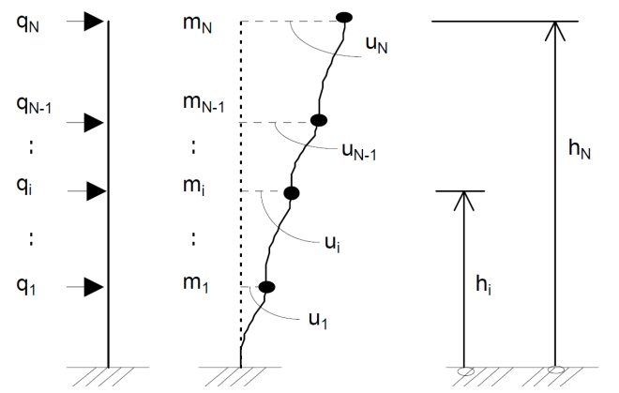

Figure 2. Lateral force distribution in Pushover Analysis (Reinhorn, 1997)

The main advantages that are attributed to Pushover Analysis are presented below:
- It allows the evaluation of the overall structural behaviour and performance characteristics.
- It enables the investigation of the sequential formation of plastic hinges in the individual structural elements constituting the entire structure.
- When a structure would be strengthened through a rehabilitation process, it allows the selectively reinforcement of the required members maximizing the cost efficiency.
- The pushover analysis provides an accurate estimate of global and local inelastic deformation demands for structures that vibrate primarily in the fundamental mode.
On the other hand, it also presents specific weaknesses which are analysed as follows:
- Deformation estimates obtained from a pushover analysis may be grossly inaccurate for structures where higher mode effects are significant.
- In most cases it is necessary to perform the analysis with displacement rather than force control, since the target displacement may be associated with very small positive or even a negative lateral stiffness because of the development of mechanisms and P-delta effects.
- Pushover analysis implicitly assurances that damage is a function only of the lateral deformation of the structure, neglecting duration effects, number of stress reversals and cumulative energy dissipation demand.
- The procedure does not consider the progressive changes in modal properties that take place in a structure as it experiences cyclic non-linear yielding during earthquake.
- Most critical is the concern that the pushover analysis may detect only the first local mechanism that will form during an earthquake and may not expose other weakness that will be generated when the structure´s dynamic characteristics change after formation of the first local mechanism.

5. MODELLING AND ANALYSIS OF THE BUILDING

The building was modeled and analyzed using SAP2000 software. The finite element analysis software SAP2000 is utilized to create 3D models and to analyse general structures varying from bridges and stadiums to industrial plants and offshore structures. It is an integrated program that allows model creation, modification, execution of analysis, design optimization, and results review from within a single interface. This software is also able to predict the geometric nonlinear behaviour of the space frames under static or dynamic loadings, considering both geometric nonlinearity and material inelasticity. It accepts static loads (either forces or displacement) as well as dynamic (accelerations) action and can perform eigen values, nonlinear static pushover and nonlinear dynamic analyses. SAP2000 is objecting based, meaning that the models are created with members that represent physical reality. Results for analysis and design are reported for the overall object, providing information that is both easier to interpret and consistent with physical nature.
The examined building, which constitutes an existing structure in the city of Kavala, is modelled as a series of load resisting elements. It is a two-story reinforced concrete frame structure including a basement. The floor area is equal to 34.29×22.2 m for all levels except of the level corresponding to the ceiling level of the first floor which is equal to 29.05×22.2 m. The overall height of the structure is 6.8 m, with all story heights equal to 3.4 m.

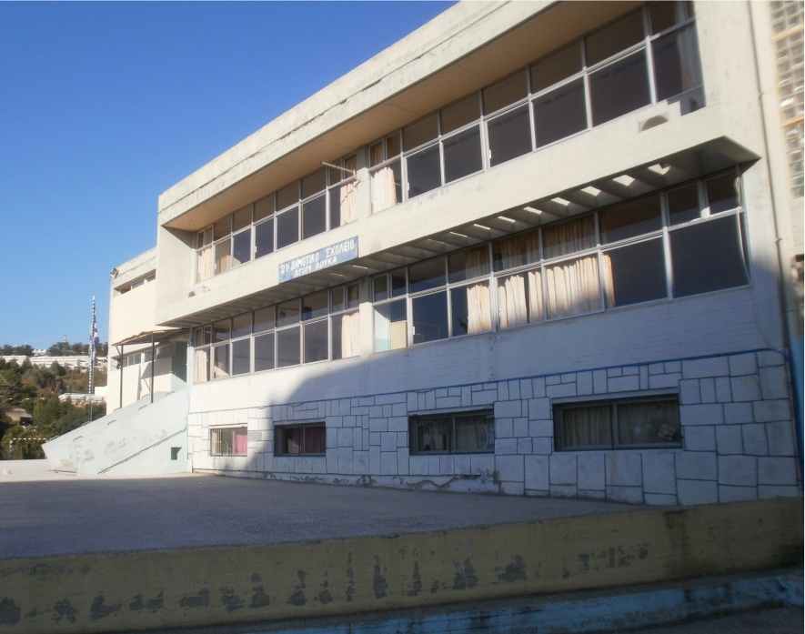

Figure 3. 2-Storey RC school building, Kavala, Greece

The lateral loads that have been applied on the building are based on Εurocodes. The study is performed for seismic zone Ι and terrain category B in compliance with Eurocode 8. The examined structure consists of web plates, and beam elements are modelled as rectangular cross sections with a width equals to effective flange width b_{eff} in compliance with Eurocode 2. The frames are assumed to be firmly fixed at the bottom and the soil–structure interaction is neglected.

Table 1. Structure´s characteristics

Structure | Data
Number of stories | 2
Storey height  Type of building use  Importance factor  Seismic zone  Peak Ground Acceleration | 3.4 m  School building  1.2  I  0.16g

Table 2. Material properties

Material Property | Data
Grade of concrete  Weight per Unit Volume | C16/20 (B225)  25 kN/m³
Modulus of Elasticity, E_{c}  Poisson’s Ratio, concrete  Grade of steel  Modulus of Elasticity, E_{s}  Poisson’s Ratio, steel | 29 GPa  0.2  S400 (STIII)  200 GPa  0.3

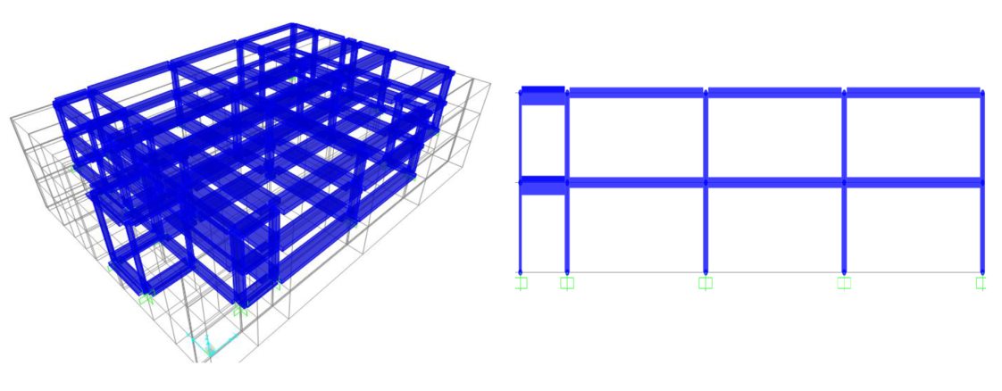

Figure 4. Model of 2-storey building without basemet created in SAP2000

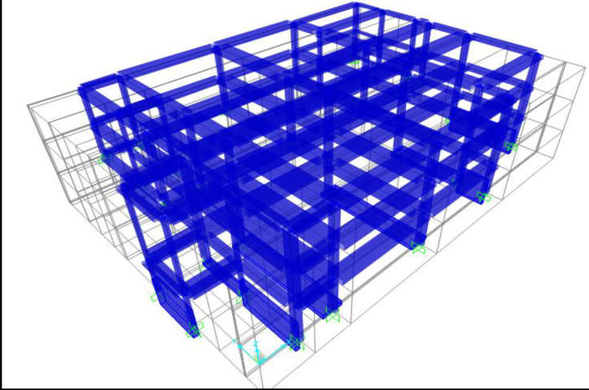

Figure 5. Model of 2-storey building with basemet created in SAP2000

6. RESULTS

In the present study, non-linear response of an existing RC school building using SAP2000 under monotonic loading has been carried out. The objective of this study is to evaluate the seismic behaviour of the structure and subsequently to identify whether a strengthening method should be implemented. The seismic base shear (V_{0,x}) is calculated to be equal to1940.81 kN and is estimated through the design provisions in Eurocode 8. The fundamental periods derived by eigenvalue analysis are 0.479 sec and 0.499 sec corresponding to the models without and with basement respectively. The pushover analysis´ results are derived based on the simplified model without the incorporation of the basement. The base shear V_{max} is attained by the structure under uniform and triangular lateral load profile.

Table 3. Modal properties of the structure

Frame system | Period (s) |  | Effective modal mass  (fraction of the  total mass)
 | 1st 2nd 3rd 4th |  | 1st 2nd 3rd 4th
Model with basement | 0.499 0.297 0.255 0.17 | 0.729 0.402 0.299 0.09
Model without basement | 0.479 0.285 0.2445 0.166 | 0.897 0.515 0.365 0.103

After running the pushover analyses, the Base Force-Displacement curves in x, y and -y directions are defined as shown in the following figures.

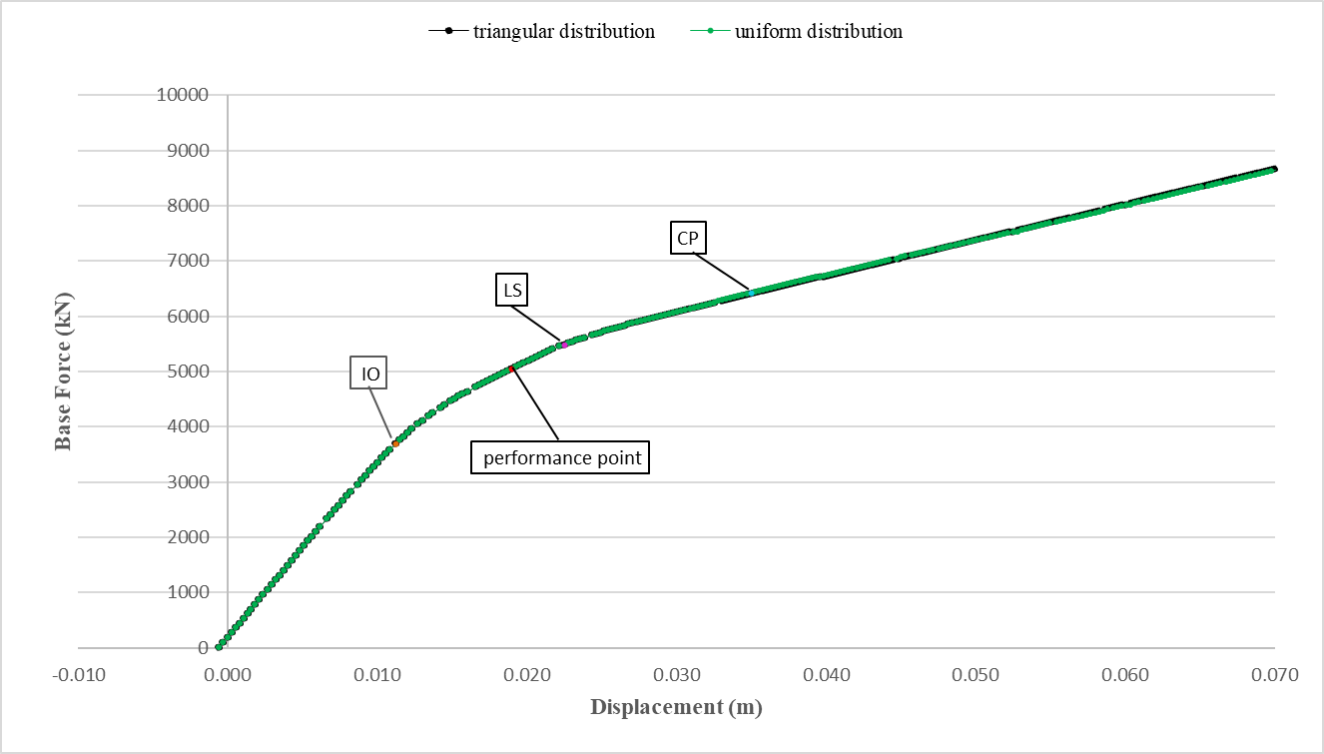

Figure 6. Base force-displacement diagram, X-direction

The performance point corresponding to the Χ-direction is defined for a base force equals to 5044.579 kN and a displacement of 1.9 cm.

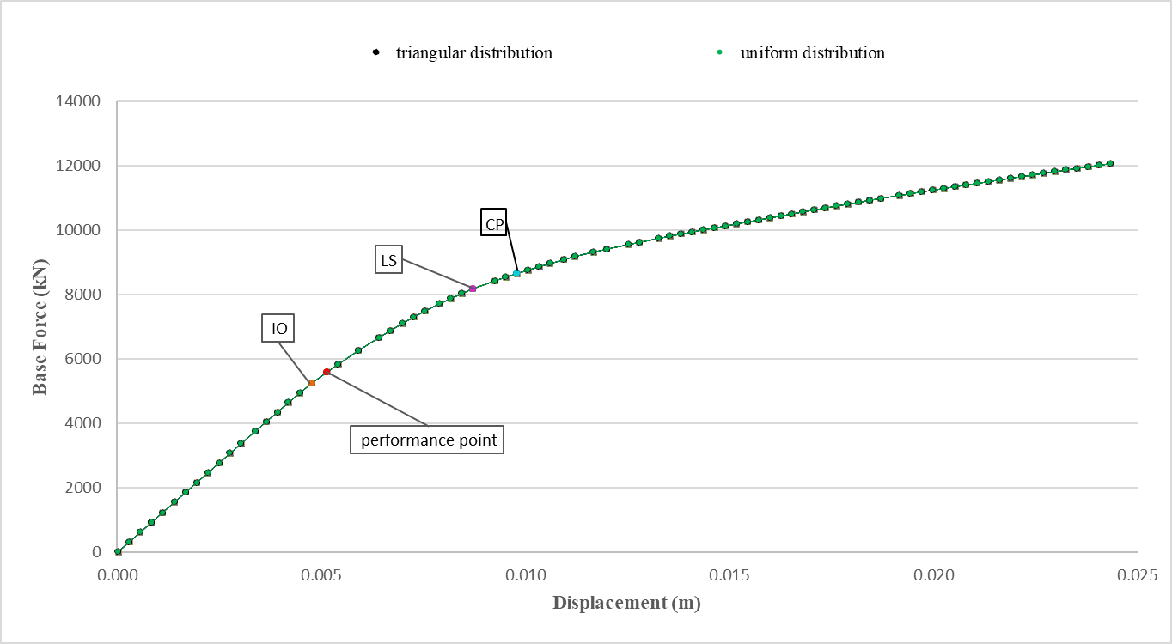

Figure 7. Base force-displacement diagram, Y-direction

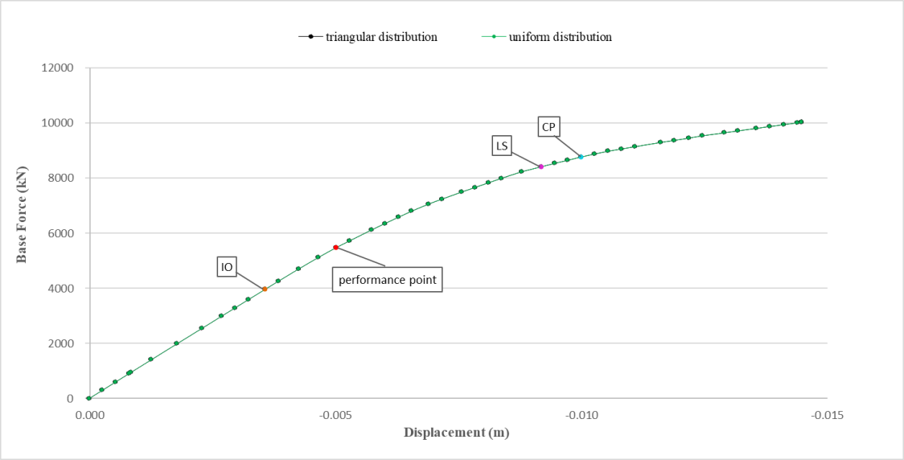

Figure 8. Base force-displacement diagram, -Y-direction

6.1 Plastic Hinges Mechanism

After Pushover analysis, hinges formation is calculated, as presented in figure 9. The yielding occurs mainly in columns in X-Direction and corresponds to the Immediate Occupancy (IO) performance level. In Y-Direction, the yielding occurs only in a limited number of columns due to the higher stiffness of the structure in this direction (K_{y}>K_{x}).

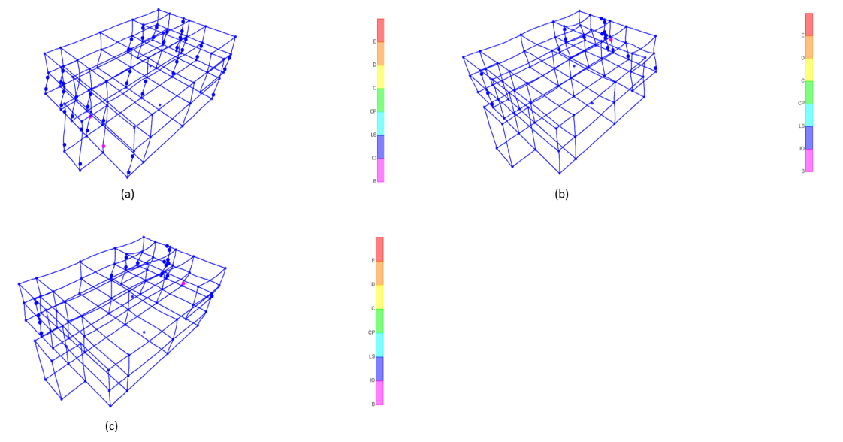

Figure 9. Deformation in X (a), Y (b), -Y (c) - direction respectively (corresponding to the performance point), SAP2000

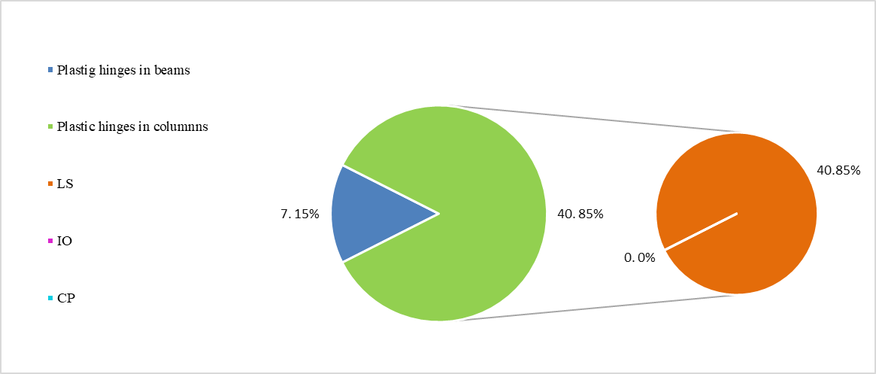

Figure 10. Hinges pattern in X-direction

Buildings that meet the Immediate Occupancy (IO) building performance level are expected to sustain minimal damage to their structural elements and only minor damage to their non-structural components. While it is safe to reoccupy a building, which is designed for this performance level immediately following a major earthquake, non-structural systems may not function due to power outage or damage to fragile equipment. Consequently, although immediate occupancy is possible, some clean-up and repair and restoration of utility services may be necessary before the building can function in a normal mode. The risk of casualties at this target performance level is very low.
Immediate Occupancy Building Performance Level should be at minimum the design goal for all school buildings. However, because even the smallest disruption of non-structural systems may be too detrimental for continued operation of a school that is designated as a shelter, owners and designers should consider an even higher level of protection for critical functions associated with this use. Therefore, it can be concluded that the margin safety against collapse is not high enough and there are no sufficient strength and displacement reserves, and thus, the security margin has to be enhanced in X direction. Within this framework, a retrofitting strategy is examined in order to enhance the overall performance of the structure.

6.2 Seismic Retrofitting

Bracing is a very effective global upgrading strategy to enhance the global stiffness and strength of steel and composite frames. It can increase the energy absorption of structures and/or decrease the demand imposed by earthquake loads. Structures with augmented energy dissipation may safely resist forces and deformations caused by strong ground motions. Generally, global modifications to the structural system are conceived such that the design demands, often denoted by target displacement, on the existing structural and non-structural components, are less than their capacities. Lower demands may reduce the risk of brittle failures in the structure and/or avoid the interruption of its functionality. The attainment of global structural ductility is achieved within the design capacity by forcing inelasticity to occur within dissipative zones and ensuring that all other members and connections behave linearly.
Several configurations of braced frames may be used for seismic rehabilitation of existing steel, composite steel–concrete and reinforced concrete building structures. The most frequently used systems include concentrically-braced frames (CBFs), eccentrically-braced frames (EBFs) and the knee-brace frames (KBFs). Common configurations for CBFs encompass V and inverted-V bracings, K, X as well as diagonal bracings.

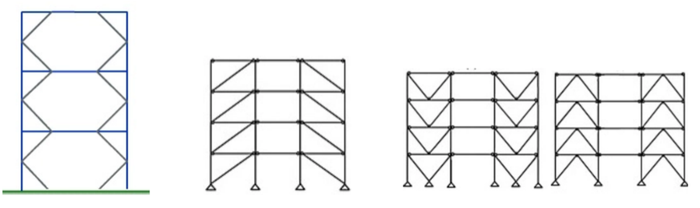

Figure 11. Different types of bracing systems (Designing Buildings Wiki, 2019)

However, bracing may be inefficient if the braces are not adequately capacity-designed. Braces can be also aesthetically unpleasant where they change the original architectural features of the building. In addition, braces transmit very high actions to connections and foundations, and thus, they should frequently be strengthened.
In this study, in order to improve the seismic performance of the existing building, inverted V-bracing system is proposed, and the analysis is carried out for the existing building with the incorporation of the inverted V-bracing system. Inverted V-bracing (also known as chevron bracing) corresponds to two members meeting at a centre point on the upper horizontal member. This system can significantly reduce the buckling capacity of the compression brace so that it is less than the tension yield capacity of the tension brace. The analysis´ results are demonstrated in the following figures and charts.

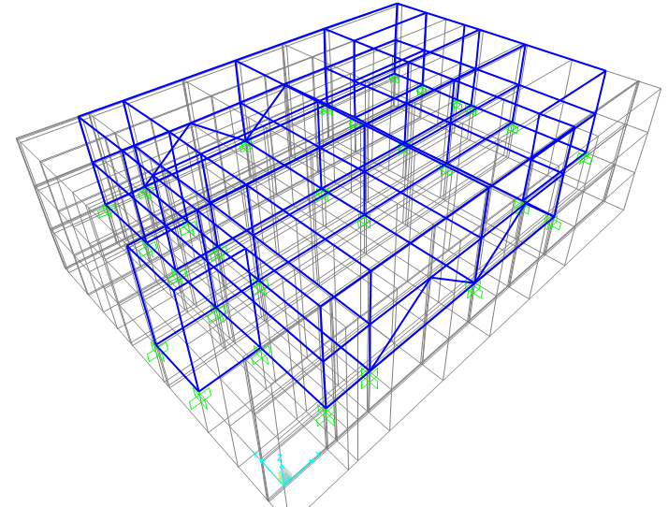

Figure 12. Inverted-V braced building, SAP2000

Table 4. Inverted-V braced structure, cross section´s characteristics

Cross-section HE180A Data
Outside height (h) | 171 mm
Flange width (b)  Flange thickness (t_{f})  Web thickness (t_{w})  Area (A) | 180 mm  9.5 mm  6 mm  45.25 cm²

The fundamental period derived by eigenvalue analysis is now equal to 0.356 sec; hence, lower than the obtained period corresponding to the non-braced building which is equal to 0.479 sec. This difference can be easily explained considering the increased stiffness of the braced structure.

Table 5. Modal properties of the inverted-V braced structure

Frame system | Period (s) |  | Effective modal mass  (fraction of the  total mass)
 | 1st 2nd 3rd 4th |  | 1st 2nd 3rd 4th
Model without basement | 0.356 0.268 0.22 0.12 | 0.74 0.774 0.10 0.25

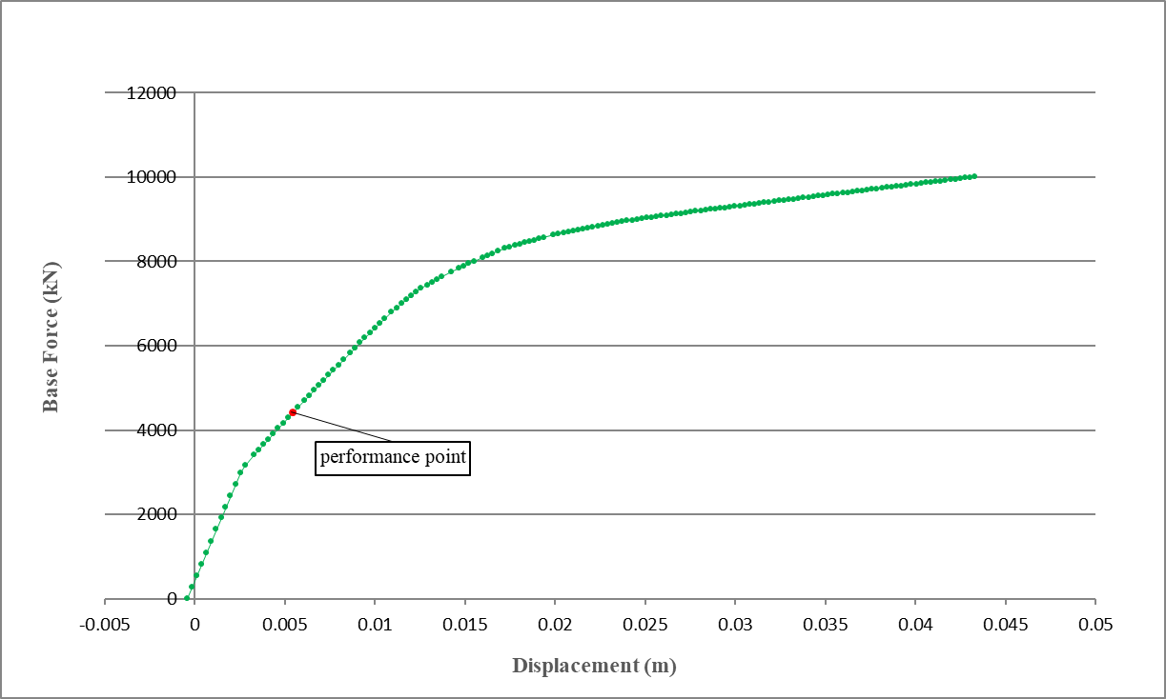

Figure 13. Base force-displacement diagram, X-direction, braced building

The performance point corresponding to the Χ-direction is now defined for a base force equals to 4412.713 kN and a displacement of 0.5 cm, leading to a target displacement which is reduced by 73% if the recommended steel bracing system is used.

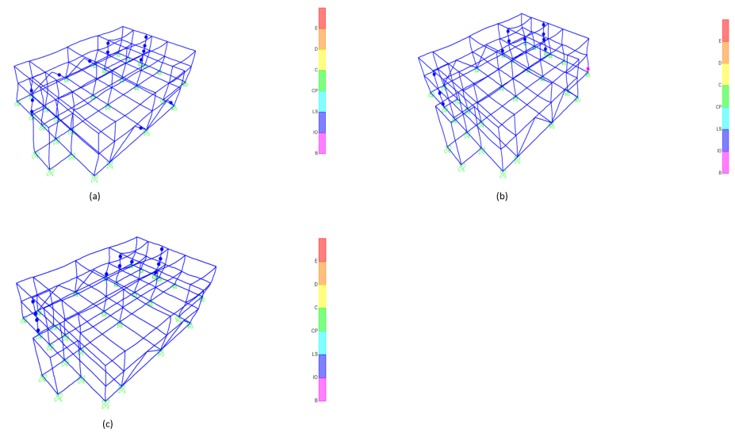

Figure 14. Deformation in X (a), Y (b), -Y (c) - direction (corresponding to the performance point), inverted-V braced building, SAP2000

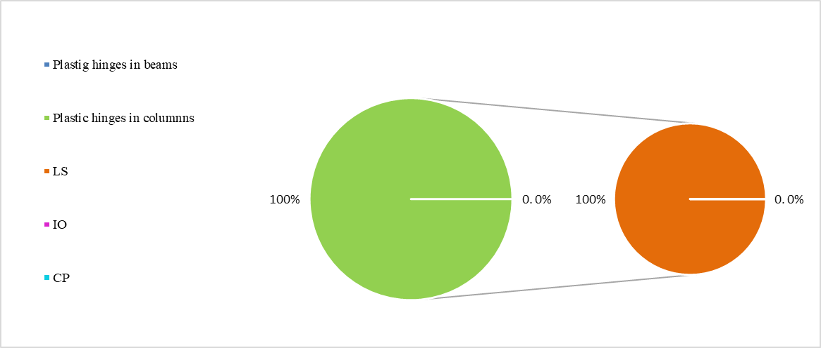

Figure 15. Hinges pattern in X-direction, inverted-V braced Building

As depicted in the previous figures (Figures 14, 15), the yielding occurs solely in columns, corresponding to the Immediate Occupancy (IO) performance level and the plastic hinge formation is 67.5 % lower in comparison to the initial hinge formation of the non-braced structure.

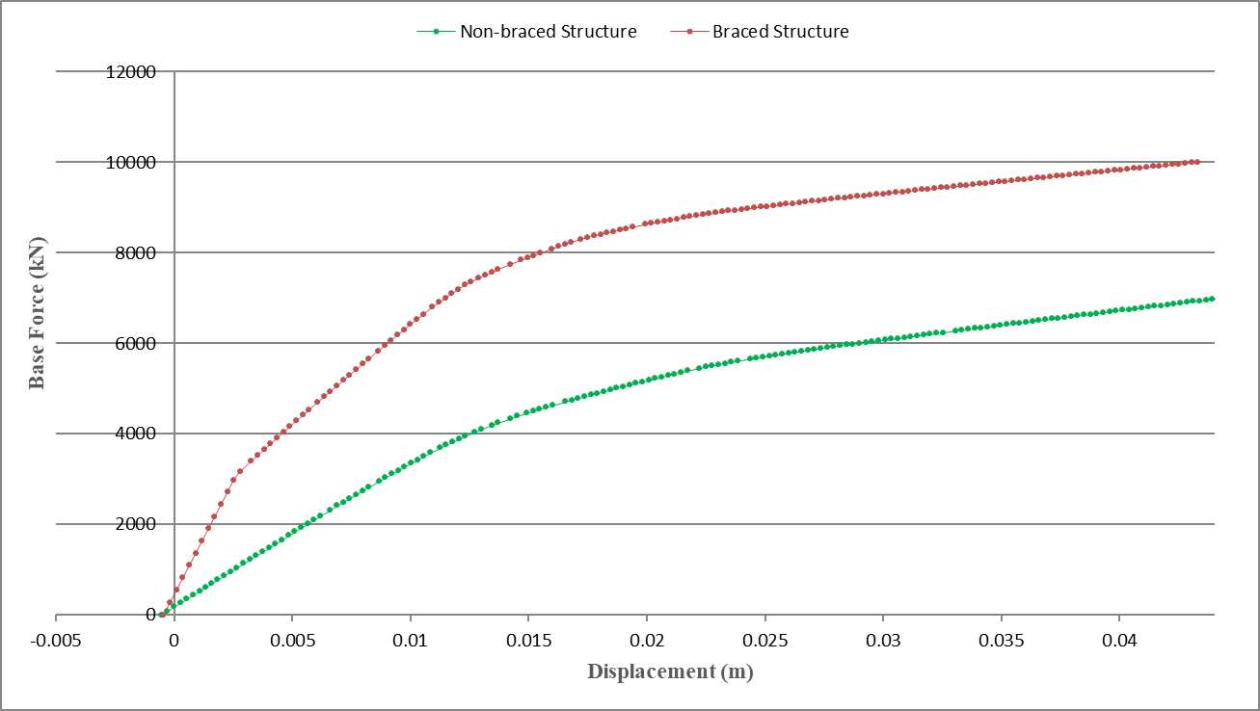

Figure 16. Comparison of displacement between non-braced building and building with bracing system
in X-direction

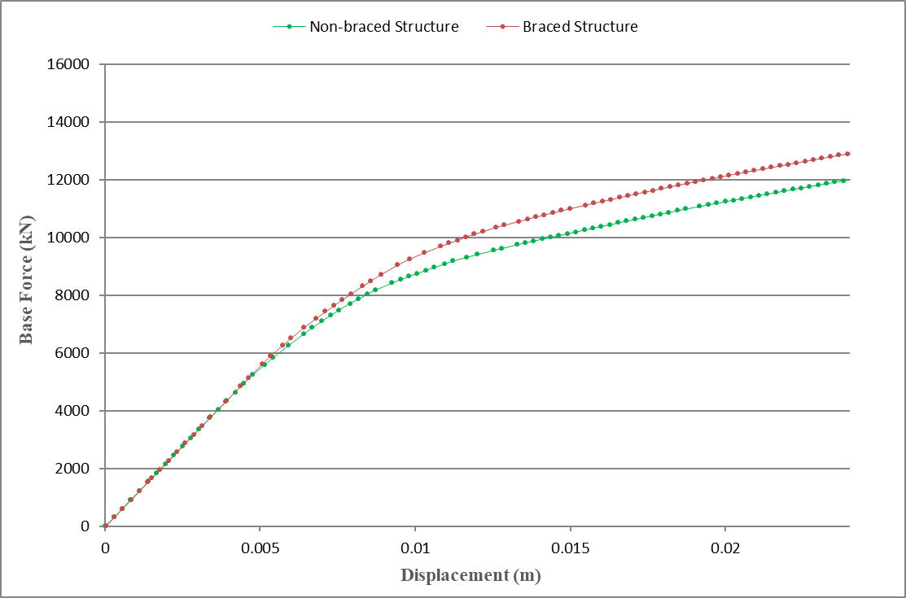

Figure 17. Comparison of displacement between non-braced building and building with bracing system
in Y-direction

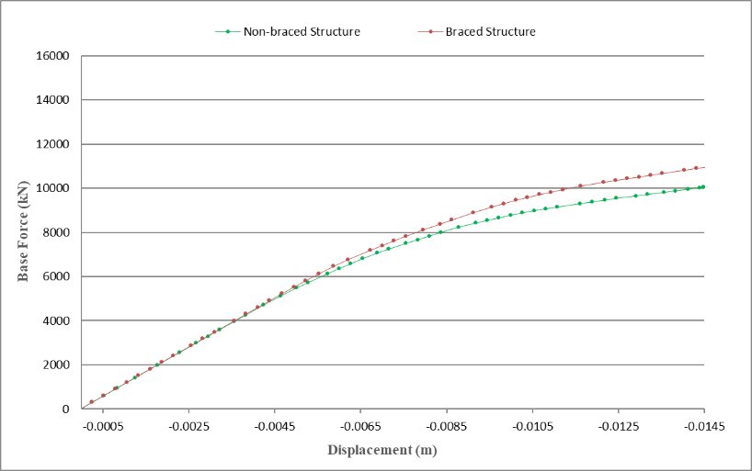

Figure 18. Comparison of displacement between non-braced building and building with bracing system
in -Y-direction

As Figure 19 indicates, the normalized-relative-displacement in floor levels corresponding to the braced structure has been computed to be significantly reduced in comparison to the initial, non-braced structure.

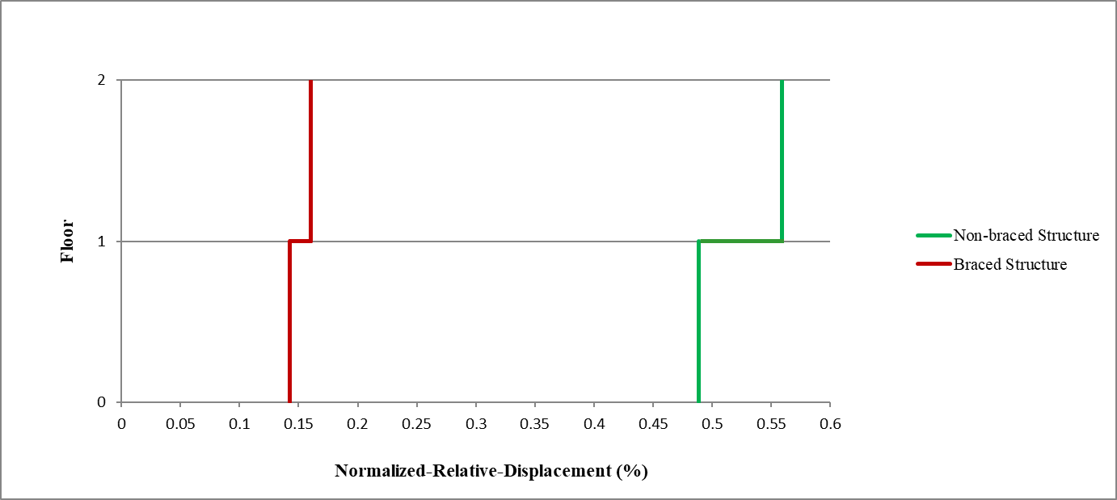

Figure 19. Normalized-Relative-Displacement for non-braced building and building with bracing system
in X-direction

7. CONCLUSION

The assessment of the seismic behaviour of the existing RC school buildings which is presented in this study is based on static non-linear analysis. The initial static pushover analysis indicates that the building presents deficiencies. More specifically, the structure exhibits inadequate seismic performance considering the increased importance that school buildings present. With the introduction of the bracing system, the structure performs an improved behaviour considering that it possesses higher deformability and strength, and lower relative displacements comparing to the non-braced structure.
More specifically, based on analyses´ results, it can be concluded that:
1. The initial behaviour of even properly detailed reinforced concrete frame building can be characterized as adequate as indicated by the intersection of the demand and capacity curves and the distribution of hinges in the beams and the columns. Most of the hinges developed in columns and fewer in beams.
2. The relative floor displacement corresponding to non- braced building frame is much higher as compared to inverted-V braced building frame.
3. The results obtained in terms of demand, capacity and plastic hinges give an insight into the real behaviour of structures.
4. Other bracing system, for instance eccentric bracing should be potentially examined in the future. In eccentric bracing, the braces are offset from the columns or they do not intersect at the floor beams. Eccentric bracing systems comprise both axial loading members and bending loading members. They are also heavily used in earthquake zones due to the high ductility they provide.
5. It is recommended that the inherent deficiencies in the detailing of the beam-column joints should be thoroughly considered after providing similar bracing systems.
6. Decisions regarding the seismic rehabilitation of existing buildings require both engineering and economic studies as well as consideration of social priorities.

8. Acknowledgments

The present study was conducted in the Section of Structural Engineering, at Civil Engineering Department, Democritus University of Thrace in 2012. Special thanks are attributed to my supervisor Assistant Professor Lazaros Vasiliadis, as well as to the Research Assistant at Democritus University, Ioannis Kavvadias.

9. References

Ahmed, S. Y. (2012) Seismic Evaluation of Reinforced Concrete Frames Using Pushover Analysis. Al-Rafidain Engineering, (21): 28-45.
Antonopoulos, T. A., Anagnostopoulos, S.A. (2012) Seismic evaluation and upgrading of RC buildings with weak open ground stories. Earthquakes and Structures, (3): 611-628.
Armijo, R., Meyer, B., Hubert, A., Barka, A. (1999) Historical Westwards propagation of the North Anatolian Fault into the Northern Aegean: timing and kinematics. Geology, 27 (3): 267-270.
ASCE (2007) Seismic Rehabilitation of Existing Buildings, ASCE 41-06, Structural Engineering Institute, Reston, VA.
Chandrasekaram, S., Serino, G., Gupta, V. (2008) Performance evaluation and damage assessment of buildings subjected to seismic loading. WIT Transactions on the Built Environment, ISSN 1743-3509. (98): 313-322.
Chopra, A.K., Goel, R.K., (2004) A modal pushover analysis procedure to estimate seismic demands for unsymmetric-plan buildings. Earthquake Engineering & Structural Dynamics, 33 (8): 903-927
Chrysostomou, C. Z., Kyriakides, N., Papanikolaou, V. K., Kappos, A. J., Dimitrakopoulos, E. G., Giouvanidis, A. I. (2015) Vulnerability Assessment and Feasibility Analysis of Seismic Strengthening of School Building. Bulletin of Earthquake Engineering, 13 (12): 3809-3840.
Comartin, C. D. (1996) ATC-40 Seismic Analysis and Retrofit of Concrete Buildings, Applied Technology Council, Redwood City, CA, USA.
Designing Buildings Wiki (2019) Braced frame structures. Available at: https://www.designingbuildings.co.uk/wiki/Braced_frame_structures
Earthquake Planning and Protection Organization (2013) Code of interventions (KANEPE - EC8 compatible).
EN 1990:2002+A1 (2005) Eurocode - Basis of structural design, European Committee for Standardization, Management Centre: rue de Stassart, 36, B-1050 Brussels.
EN 1991-4 (2006) Eurocode 1 - Actions on structures - Part 4: Silos and tanks, European Committee for Standardization, Management Centre: rue de Stassart, 36, B-1050 Brussels.
EN 1992-1-2 (2004) Eurocode 2: Design of concrete structures - Part 1-2: General rules - Structural fire design, European Committee for Standardization, Management Centre: rue de Stassart, 36, B-1050 Brussels.
EN 1998-1 (2004) Eurocode 8: Design of structures for earthquake resistance - Part 1: General rules, seismic actions and rules for buildings, European Committee for Standardization, Management Centre: rue de Stassart, 36, B-1050 Brussels.
Farrow, K.T., Kurama, Y.C. (2003) SDOF demand index relationships for performance-based seismic design. Earthquake Spectra, 19 (4): 799-838.
Favvata, M.J., Naoum, M.C., Karayannis, C.G. (2012) Seismic Evaluation of infilled RC Structures with Nonlinear Static Analysis Procedures. Proceedings of the 15th World on Earthquake Engineering, 24-28 September 2012, Lisbon, Portugal.
FEMA 273 (1997) NEHRP Guidelines for the Seismic Rehabilitation of Buildings. Federal Emergency Management Agency, Washington, DC, U.S.A.
FEMA 356 (2000) Prestandard and Commentary for the Seismic Rehabilitation of Buildings. Federal Emergency Management Agency, Washington, DC, U.S.A.
FEMA P-424 (2010) Design Guide for Improving School Safety in Earthquakes, Floods, and High Winds. Risk Management Series, U.S.A.
FEMA-440 (2005) Improvement of Nonlinear static seismic analysis procedures. Federal Emergency Management Agency, Washington, DC, U.S.A.
Goel, R.K., Chopra, A.K. (2004) Evaluation of modal and FEMA pushover analyses: SAC buildings. Earthquake Spectra, 20 (1): 225-254.
Kassaras, I., Sotirhos, J. (2015) Short Notes on the Seismic Vulnerability of Greece under Austerity. Austin Journal of Earth Science, 2 (1): 01-04.
Khan, S. I., Modani P. O. (2013) Seismic Evaluation and Retrofitting of RC Building by Using Energy Dissipating Devices. International Journal of Engineering Research and Applications (IJERA), ISSN: 2248-9622. (3): 1504-1514.
Kouskouna, V., Makropoulos, K. (2014) Historical earthquake investigations in Greece. Annals of Geophysics, (47): 723-731.
Lekidis, V., Dimitriu, P. (2002) Seismic Risk in Greece: What recent earthquakes have taught us. Structural Eng. /Earthquake Eng., JSCE, (19): 99-111.
Leslie, R. (2012) The Pushover Analysis, explained in its Simplicity. Kerala PWD, Trivandrum.
Pardalopoulos, S. J., Thermou, G. E., Pantazopoulou, S. J. (2010) Evaluation of Failure Modes of R.C. Buildings. Proceedings of the 9th U.S. National and 10th Canadian Conference on Earthquake Engineering, 25-29 July 2010, Toronto, Ontario, Canada.
Pelli, L. (2014) Antiseismic Policy of Greece. Proceedings of the ECCE International Conference on Seismic Design & Rehabilitation of Buildings, 29-30 May 2014, Tbilissi, Georgia.
Prasad, V., Nivin, P. (2014) Effectiveness of Inclusion of Steel Bracing in Existing RC Framed Structure. International Journal of Research in Engineering & Technology, ISSN(E): 2321-8843, ISSN(P): 2347-4599. (2): 81-88.
Repapis, C. (2016) Seismic Performance Evaluation of Existing RC Buildings Without Seismic Details. Comparison of Nonlinear Static Methods and IDA. The Open Construction and Building Technology Journal, (10): 158-179.
Reinhorn, A.M. (1997) Inelastic Analysis Techniques in Seismic Evaluations. Proceedings of the International Workshop on Seismic Design Methodologies for the Next Generation of Codes, 24-27 June 1997, Bled, Slovenia.
SAP2000. Integrated software for structural analysis and design, Computers and Structures Inc. Berkeley, CA, USA.
Sarnoa, L. Di, Elnashaib, A.S. (2008) Bracing systems for seismic retrofitting of steel frames. Journal of Constructional Steel Research, (65): 452–465.
Technical Chamber of Greece (2004) Strengthening of Structure under Seismic Loads, Athens, Greece.
TEDRC (2007) Turkish Earthquake Resistant Design Code. Ministry of Public works & Settlement, Ankara, Turkey.
Tugsal, Ü., Taskin, B., Kara, F.I. (2008) Comparison of Performance Evaluation Concept for RC Buildings considering Turkish Earthquake Code and Proposed Empirical Relation. Proceedings of the 14th World Conference on Earthquake Engineering, 12-17 October 2008, Beijing, China.
Wyss, M., Rosset, P. (2013) Mapping seismic risk: the current crisis. Natural Hazards, (68): 49–52.

Graduate Civil Engineer, Department of Civil Engineering, Democritus University of Thrace, Xanthi, Greece, Current Master´s Student at Swiss Federal Institute of Technology [ETH] Zürich, m.voudrisli@gmail.com

