Finite Element Analysis of Rubber Bearing Compressed by Steel Column with Smaller Cross-sectional Area

DOI 10.37153/2686-7974-2019-16-782-789

Mineo TAKAYAMA, Keiko MORITA

ABSTRACT

Generally, laminated rubber bearings used for seismic isolation are installed between a reinforced concrete foundation and a superstructure. Such bearings must support the weight of the building and be capable of undergoing a large amount of horizontal deformation during an earthquake. Generally, the foundation or superstructure which the laminated rubber bearing is installed is larger than the size of the laminated rubber bearing. Therefore, the entire surface of the laminated rubber bearing is compressed. Recently, the application range of seismic isolation structures has been expanded, and the application to steel structure has been increasing. In that case of steel frame structure, the size of the steel column is smaller than that of the laminated rubber bearing. As a result, there may be cases where the entire surface of the laminated rubber is not compressed. In such a case, it is verified using finite element analysis whether or not the performance of the laminated rubber is affected.

Keywords: Seismic Isolation; Rubber Bearing; Steel, Column; Finite Element Method

1. INTRODUCTION

Laminated rubber bearings are often installed between the superstructure and reinforced concrete foundations of seismically isolated buildings. Such bearings must support the weight of the building and be capable of undergoing a large amount of horizontal deformation during an earthquake. Normally, these bearings are smaller than the reinforced concrete columns above them, so that the rubber bearing is subjected to a uniform compressive deformation. Therefore, during performance testing of laminated rubber bearing, the entire cross section of the specimen is compressed.
However, as seismic isolation becomes more widespread in Japan, it is becoming more and more common for applying to steel frame structure. In that case, the size of the steel column may be smaller than the cross-sectional size of the laminated rubber bearing, and in some cases, a hollow cross-section column may be used like a square steel pipe.
When compressed with a column smaller than the cross-sectional size of the laminated rubber bearing, the compressive deformation of the laminated rubber bearing becomes non-uniform and there is a concern about the influence on the shear deformation capability of the laminated rubber bearing.
Therefore, the present study focused on the impact of such non-uniform compressive deformation on the performance of laminated rubber bearings using a finite element analysis.

2. SIMPLE ANALYSIS MODEL

2.1 Analysis Model and Loading

Figure 1 shows the model analyzed in this study. It consisted of natural rubber bearing, 900mm in diameter, with a shear modulus of 0.4 N/mm². Each rubber sheet was 6.6 mm thick, and the laminated rubber bearing contained a total of 25 layers. The interlayer steel plates were 4.5 mm thick with a primary shape factor S₁=33 and a secondary shape factor S₂=5.1. The flange plate bottom of the laminated rubber bearing was firmly fixed in place, while the base plate (BPL) was placed on the flange plate on the top of the laminated rubber bearing. BPL was bolted to the flange plate (friction was not considered). The elements for vertical jointing were spring elements with a stiffness corresponding to that in the axial direction of M30 bolts. Three thicknesses of the BPL were considered: 32, 50 and 100 mm. The steel components were all modeled as elastic bodies.
Table 1 shows the names of the models, the BPL thickness and the combination of loads. The analysis assumed a constant compressive load (the vertical pressure: 15 MPa, 30 MPa) on a laminated rubber bearing with a shear strain of 400%.
Figure 2 shows the loading method. Initially, solid cross-section columns 600 mm square (F600 model) and 300 mm square (F300 model) were constructed. In order to model the load due to the solid cross-section columns, the vertical displacements of all the nodes on the upper surface of the BPL inside a column were constrained to be equal. When the entire surface of the laminated rubber bearing was loaded (F_ALL model), the all nodes on the top face of BPL were constrained to have the same vertical displacement.

Table 1. Overview of analytical cases

Model | Column Width  (mm) | Base plate thickness  (mm) | Vertical Pressure  (MPa)
F_ALL | － | 32 | 15, 30
F600 | 600 | 32 | 15, 30
 |  | 50 | 15, 30
 |  | 100 | 15
F300 | 300 | 32 | 15, 30
 |  | 50 | 15, 30
 |  | 100 | 15

Base Plate (BPL)
(F300)
(F600)

45

Figure 1. Finite element analysis model

X (direction of applied force)
Diameter of Rubber Bearing 900mm
Figure 2. Loading surface of steel column

Rubber: 6.8 mm × 26 layers = 176.8 mm. Steel plates: 4.5 mm × 25 layers
Base plate
Flange plate
Bolt Joint of base plate and flange plate

2.2 Analysis Results using Simple Model

Figure 3 shows the dependence of the horizontal load on the horizontal displacement. The number following the model name is the BPL thickness. When the vertical pressure was 15 MPa, some influence from the BPL thickness was found for the F300 model, but the other models showed the same results as the F_ALL model. High compressive forces when the vertical pressure was 30 MPa had quite a large effect on the characteristics of the restoring force for the F300 model. It is possible that the deformation performance was insufficient for this model. For the F600 model, no influence on the restoring force was seen for vertical pressures of either 15 or 30 MPa.
Figures 4 – 6 present the vertical deformation of the nodes at the interface between the uppermost layer of the rubber sheet and the flange plate (the red dotted line in Figure 1). These figures show the distribution of the vertical deformation in the direction of the applied force (the X direction) under a vertical pressure of 15 MPa at 100% shear strain intervals. Although the vertical deformation increases with shear strain, it can be seen that for the F_ALL model, the laminated rubber bearing maintains a constant vertical deformation distribution, regardless of the magnitude of the shear strain. The vertical deformation for the F300 model is high in the area of contact with the steel column (just under the loading surface). The vertical deformation approaches that for the F_ALL model when the BPL thickness is increased to 100 mm, but exceeds that for the F_ALL model when the shear strain is 400%.
The F600 model shows the same pattern, but with a more uniform vertical deformation than for the F300 model, and little dependence on BPL thickness. The 900 mm-diameter laminated rubber bearing beneath the 300 mm square column exhibited highly non-uniform vertical deformation. The column strongly affected the deformation of the laminated rubber bearing. Thus, this analysis predicted that a square column size of about 600 mm can suppress local vertical deformation.

(a) F300 model (15 MPa) (b) F600 model (15 MPa)

(c) F300 model (30 MPa) (d) F600 model (30 MPa)

Figure 3. Horizontal load vs. horizontal displacement

Figure 4. Vertical deformation (F_ALL, BPL-32)

(a) F300, BPL-32mm (a) F600, BPL-32mm
(b) F300, BPL-50mm (b) F600, BPL-50mm
(c) F300, BPL-100mm (c) F600, BPL-100mm

Figure 5. Vertical deformation Figure 6. Vertical deformation
(F300, 15 MPa) (F600, 15 MPa)

3. Analysis OF Model with Steel Column

3.1 Analysis Model

Figure 7 presents the analysis model in this study. The laminated rubber bearing model was the same as that described in Section 2.1. The dimensions of the hollow cross-section column were 600 mm square (wall thickness 32 mm, 50 cm tall, SH600-32 model). The same steel column was used in another model including 19 mm thick ribs (SH600-32 rib model). Shell elements were used for the modelling of the steel columns and ribs. The steel components were all modeled as elastic bodies. The BPLs were all 32 mm in thickness. For comparison, the vertical deformation of the nodes in the BPL at the locations of the hollow cross-section column was also constrained (NF600 model). In this analysis, the BPL thicknesses were 32, 50 and 100 mm.

600mm
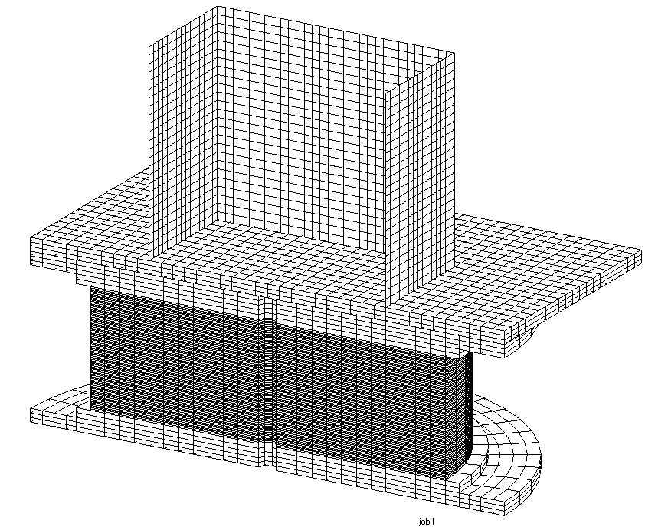SH600-32 model
900mm
500mm
(a) Steel column model
(no ribs)

600mm
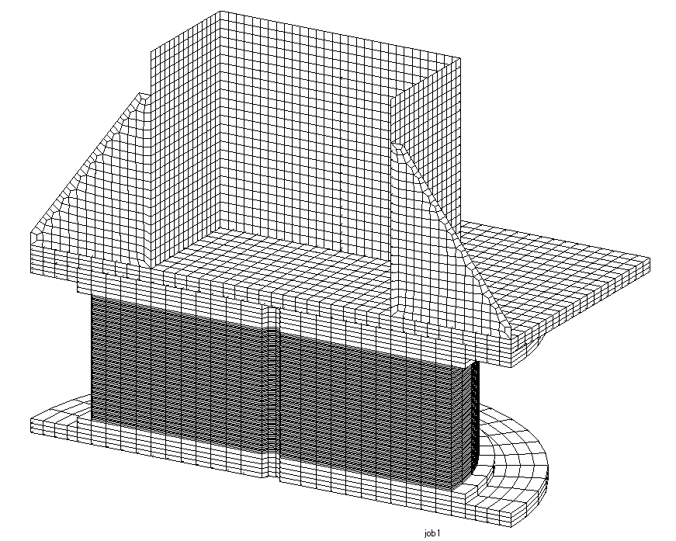SH600-32 ribbed model
900mm
500mm
(b) Steel column model
(with ribs)

Figure 7. Analysis model including steel column

3.2 Analytical Results using Steel Column Model

Figure 8 shows the dependence of the horizontal load on the horizontal displacement. The hollow cross-section column models, exhibited nearly the same restoring force as the F_ALL model with a compressive load on the entire surface. However, for the steel column with ribs, the analysis could only be carried out up to a shear strain of 335%.

(a) NF600 model (15 MPa） (b) NF600 model (30 MPa） (c) Models for steel columns with
and without ribs
Figure 8. Horizontal load vs. horizontal displacement

Figure 9 shows the distribution of the vertical deformation for the NF600 model. Since this column had a hollow cross section, the vertical deformation in the center of the laminated rubber bearing was small while that at the contact region with the column was large. However, the difference decreased when the shear strain reached 400%. This may be due to changes in the structure transmitting the compressive axial force. The reduced non-uniformity of the vertical deformation with increasing BPL thickness was similar to that for the solid cross-section column.
Figure 10 presents the vertical deformation for (a) plain steel columns, (b) steel columns with ribs, and (c) both cases. There are no large differences, but it can be seen that the model with ribs has more uniform vertical deformation at the outer portions of the laminated rubber bearing than the models without ribs (gray lines). Also, comparing these results to those in Figure 9, the vertical deformation of the steel column model is slightly tilted. This is thought to be due to bending or other effects from the steel column itself (length 50 cm).
Figure 11 shows contour diagrams for the equivalent stress levels in the steel column models with and without ribs for a shear strain of 300%. It can be seen that high stress levels occur in the columns and ribs, from which the force is applied to the laminated rubber bearing. High stress levels occur in the BPL and the flange plate just beneath the column, and it seems likely that plasticity occurs locally. An appropriate wall thickness must be selected in order to avoid plasticity in the BPL and other components.

(a) BPL-32mm (a) Model including steel column
(b) BPL-50mm (b) Ribbed steel column model
(c) BPL-100 mm (c) Comparison of steel column
and ribbed column

Figure 9. Vertical deformation Figure 10. Vertical deformation
(NF600, 15 MPa) (Steel column model)

Let us turn to some observations on stable deformation under compressive forces applied by a column which is smaller than the laminated rubber bearing. Figure 11 shows that nearly all the compressive axial force is transmitted by the edge on one side of the column. This suggests that all of the compressive axial force from the column (at the loading surface) is applied along the left edge, as shown in Figure 12, and the deformation is stable if the edge length does not exceed the diameter of the laminated rubber bearing. Based on this hypothesis, the following equation can be derived as a condition for preventing the edge length of the loading surface from exceeding the laminated rubber diameter.

(1)

where is the laminated rubber diameter, is the shear deformation, and is the width of the steel column.

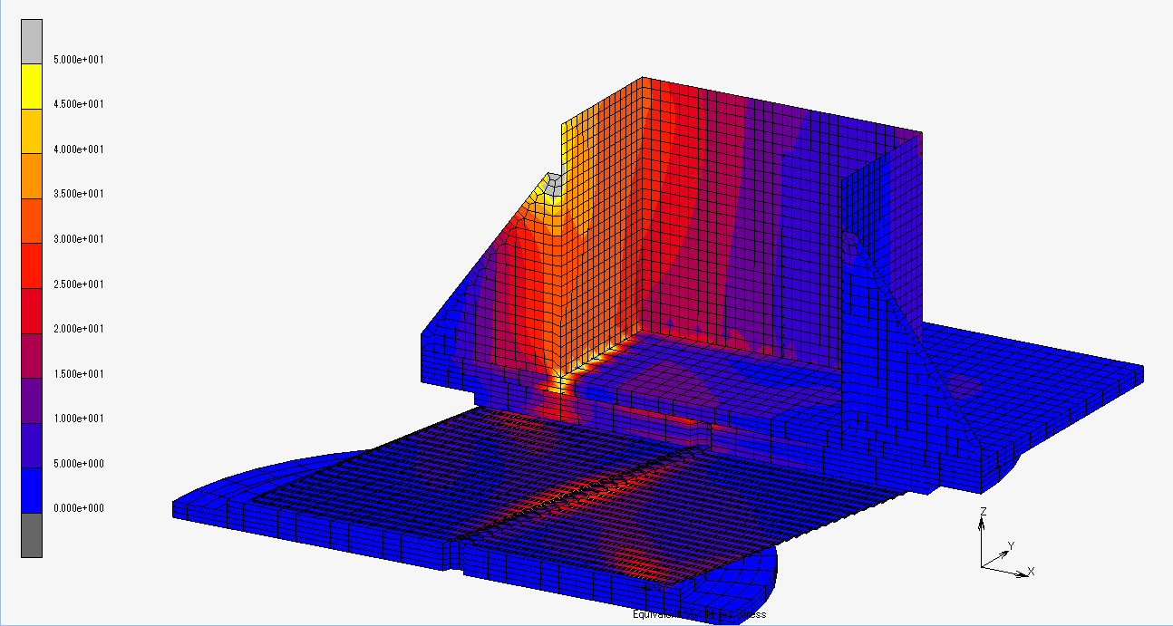
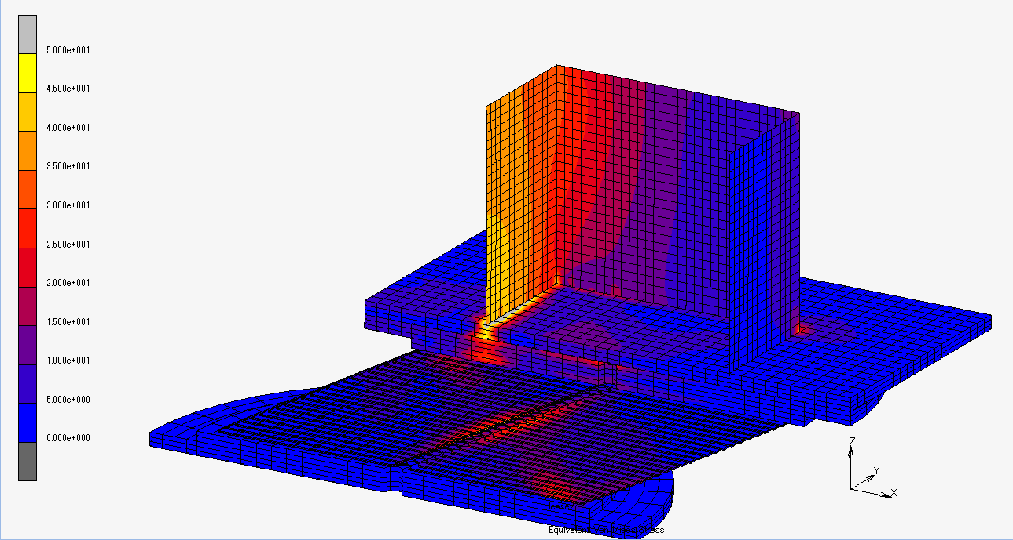
(a) Steel column model (b) Ribbed column model

Figure 11. Equivalent stress level contour diagram for 300% shear strain

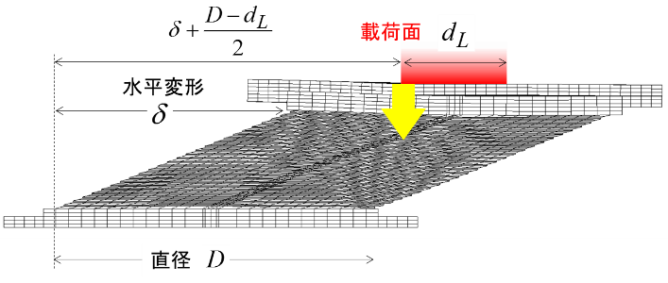
Loading Surface
Vertical Load

Diameter D
Shear Deformation

Figure 12. Stable deformation vs. size of steel column (loading surface)

The diameter of the laminated rubber bearing and the shear deformation can be calculated as follows:

, (2)

where is the secondary shape factor, is the total laminated rubber thickness, and is the shear strain.
Substituting Equation (2) into Equation (1), we obtain

(3)

If we substitute the shape of the laminated rubber () and the maximum shear strain () employed in this analysis into this equation, we obtain the following equation for stable deformation:

(4)

If we substitute the laminated rubber diameter D=900 mm into this equation, we find that the necessary width for the loading surface (of the column) is at least 540 mm. This predicts that employing a steel column at least 540 mm in width will allow stable deformation up to 400% shear strain. This is consistent with the fact that the loading-deformation relationship was stable for a column size of 600 mm in this analysis.

4. Conclusions

This paper presented a finite element analysis of compressive forces acting on a laminated rubber bearing through a steel column. Using a simple analysis, the dimensions of a solid cross-section square column was varied. This analysis demonstrated that if a flange plate attached to the steel column has sufficient thickness (approximately 100 mm), the plate has no significant effect on the shear deformation of the laminated rubber baring, and reduces the non-uniformity of the compressive deformation. An analysis of a column with a hollow cross section showed no particular influence on shear deformation, although some non-uniformity of the compressive deformation remained. However, it seems advisable to attach a rib to the hollow part or fill the cross section with concrete, in order to obtain uniform compressive deformation of the laminated rubber bearing. A simple equation was derived to predict stable deformation of the laminated rubber bearing. This equation indicates that stable deformation will be achieved if the size (width) of the steel column is at least 0.6 times the diameter of the laminated rubber bearing.

Professor, Faculty of Engineering, Fukuoka University, Fukuoka, JAPAN, mineot@fukuoka-u.ac.jp
Assistant Professor, Faculty of Engineering, Fukuoka University, Fukuoka, JAPAN, keikomt@fukuoka-u.ac.jp

