**ON SOME ISSUES OF TAKING ACCOUNT OF THE INTERACTION OF SEISMICALLY ISOLATING PILE FOUNDATIONS WITH FOUNDATION SOIL UNDER SEISMIC EFFECTS**

**DOI 10.37153/2686-7974-2019-16-919-927**

Yerzhanov S.[1]

**ABSTRACT**

Operation of dynamic system consisting of buildings with rigid structural scheme (large-panel, stone, etc.) on pile foundations with a high grillage pin-connected with piles and various damping (seismically isolating) elements affecting the value of calculated loads on supporting structures under seismic effects has been studied.

At the same time, the structural components of seismic isolation in practical execution can be quite simple and technologically accessible for construction companies.

The peculiarities of installation of pile foundations consist in the selection of the free length of piles and the ways to connect piles with a grillage (rigid, hinged), which allows for systems with sufficient ductility, on the one hand, as well as the use of elastic-plastic interaction of the soils surrounding the piles at the joint horizontal work, on the other hand.

Optimal combinations of the characteristics of pile foundations, foundation soils and parameters of damping (seismically isolating) elements of the system that minimize seismic loads on the supra-foundation parts of the building structure were set up for certain types of seismic effects, the characteristics of which are determined and may be dependent on regional (local) seismological conditions, the area of earthquake occurrence.

In the studies, accelerations of known real earthquakes recorded in various earthquake-prone regions of the world were taken as seismic effects. Particularly valuable are the instrumental data of the engineering seismometric service of the city of Almaty, through the use of which practical recommendations were given based on the study results for the application of seismic isolation design in earthquake engineering of the city of Almaty.

*Keywords: seismic isolation, accelerograms, piles*

**1. INTRODUCTION**

One of the effective systems of active seismic protection with increased dissipative properties is reduction of the inertia loading over foundation part of building by means of dry friction dampers, located between the elements of building. General principles of such systems are expounded in the works of Mikhailov G.M. (1974) and Pavlyk V.S. (1971). There are a lot of theoretical and experimental works dedicated to development and research of concrete types of dampers of dry friction for buildings of the different structural systems, such as works of Kazina G.A. and Kilimnik L.Sh. (1974), Aubakirov A.T. and Yerzhanov S.Ye. (1977), Yaremenko V.G. (1984), Aubakirov A.T. (1990).

Special attention should be given to constructions of pile foundations with a high grillage and increased dissipative properties for building with a rigid structural scheme, offered by Zhunusov T.Zh. and Aubakirov A.T. in KazPromstroyNIIproject, Almaty. The idea of the structural decision is based on the usage of the dampers of dry friction, located between the grillage of pile foundation and base of the building as an active dissipator of vibration energy.

Application of pile foundations is mainly stipulated by unfavorable for construction soil conditions of construction sites. The resistance of pile foundations to seismic effects, their high carrying capacity during earthquakes, as well as the positive impact of the piles on the dynamic characteristics of the structures is indisputable. Therefore, pile foundations are appropriate engineering solution for foundation f the building. Application of pile foundations in conditions of weak soils in seismic regions is very effective. Especially, the radical success can be achieved with full piles cutting of weak, highly compressible base layers and supporting their edges into the bearing soil layer of seismicity category Ӏ. With respect to pile foundations with piles submerged in the soil category II, then first of all it should be decided whether the piles are driven piles and what are their bearing capacity.

Studies of various issues related to the use of piles for seismic construction were intensively carried out by specialists of the former Soviet Union (Barkan DD, Zhunusov T.Zh., Ilyichev VA, Napetvaridze Sh.G., Savinov TA, Fedorov V. A., Aubakirov A.T., Golubtsova M.N., Grib S.I., Kipiani D.G., Kulchitsky G.B., Mongolov Yu.V., Obodovsky A.A., Pyshkin B. A., Samkov B.I., Stavnitser L.R., Kharitonov V.A. and others), which made it possible to obtain valuable data on the behavior of pile foundations during seismic effects.

At the same time, it should be noted that the influence of the design features of pile foundations on the reduction of seismic loads in the over foundation part of the building has not been adequately studied yet.

The constructive provision of seismic protection of buildings using pile foundations lies on the fact that the building foundation with a rigid structural scheme (stone, large-panel, large-block, brick, etc.) on pile foundations is located not on the ground surface, but at a certain height from it and is connected with piles using a structural unit that removes bending moments and allows rotation of the pile cap with respect to the grillage. Such constructions, in principle, implement the idea of a “flexible” ground floor, although it differs significantly from it.

The difference is that: firstly, the dissipative properties of pile foundations of the structures proposed above are higher than in buildings with a “flexible” first floor or on strip foundations, which is achieved due to the additional energy dissipation on the contact surfaces of the piles with the ground (in F-2 scenarios - dissipative properties are further enhanced due to the corresponding constructive solution, figures 1 and 2); secondly, in the buildings with a “flexible” ground floor, stress is concentrated in the areas of rigid pinching of the top of the struts in the girders, and the bottom of the struts - in the foundations, which leads to the early plastic deformations in these nodes and the system turns into an instantaneous some excess of the design loads.

In the F-1 pile foundations, the bending moments are practically removed from the upper zone, and the lower part of the pile is resiliently embedded in the ground, resulting in a more uniform stress distribution over the greater pile length and greater deformability of pile foundations compared to the same free length of pillars and piles.

In the seismic protection foundation which we consider, a dry friction damper is made in “parallel” and any movement of the over foundation part of the building relative to the base brings it into working condition. To compare the obtained results, the “analogs” systems were also considered – a building on a strip foundation and a building on a seismoprotective pile foundation without a dry friction damper.

It is necessary to note the work of Belash TA (1996), devoted to the optimization of energy absorption in buildings and structures on seismic insulating foundations.

In general, seismic isolation systems with elements of dry friction are a dynamically developing area with great prospects.

The damping of seismic insulating pile foundations of buildings with a rigid structural scheme is physically based on the fact that part of the seismic energy transmitted by the foundation will be spent on overcoming the dry friction forces in the damper, going down.

It should be noted a review of all seismic insulating structural systems used in the Republic of Kazakhstan to date, Yerzhanov S.Ye., Lapin V.A. (2015).

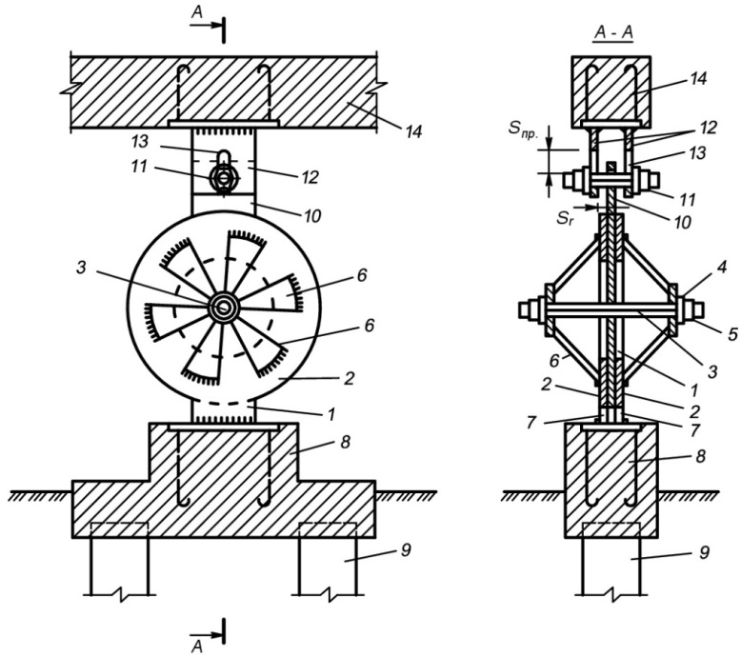

Figure 1. Special element of dry friction (SEDF) of Aubakirov A.T.

*Dry friction discs:1-internal movable and 2-external fixed, 3-axle coupling bolt, 4-washer, 5-nut, 6-pressure struts of fixed discs, 7-anchor lugs of non-movable discs, 8-rostrum SEDF, 9- pile for installation SEDF, 10-protrusion of the movable disk, 11 (12) - axial bolt, providing a hinged connection grillage of the pile foundation of the building with stationary disks SEDF and allowing horizontal sliding of the protrusion of the movable disk without play, 12 (13) kerchiefs rigidly attached to the bottom face of the grillage of the pile foundation of the building, 13 (14) – oblong holes in kerchiefs, which ensure unimpeded vertical movement of the bolt without backlash in the horizontal direction, 14 is a high grillage of a pile foundation of a building.*

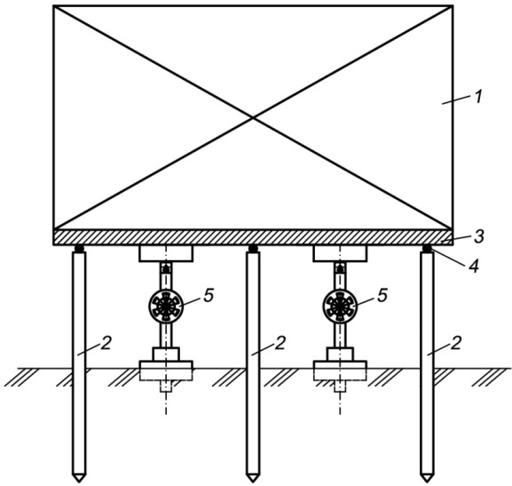

Figure 2. Buildings on pile foundations with high position of the grillages, with their hinged connection with the piles and with the SEDF.

*1 - buildings with a rigid structural scheme, 2 - piles, 3 - grillage,*

*4 - hinges between piles and grillage, 5 - SEDF*

**2. REsULTS**

Let’s evaluate the reduction of seismic load on the bearing elements of the building. Assume that a building on a seismic insulating pile foundation with a dry friction damper is designed for a design seismic load  (Figure 3).

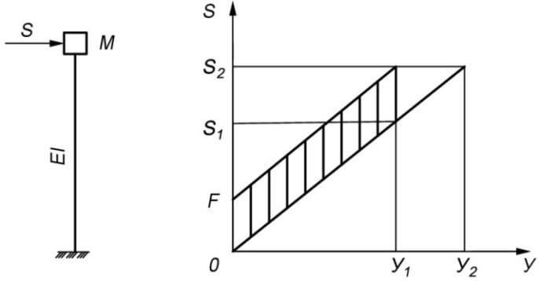

Figure 3. Reduction of seismic load on the bearing elements of the building on the SPF with DDF.

When a load  is applied, the corresponding system without a dry friction damper is displaced by the value of. The potential energy of an elastically deformed system is equal to

, (1)

where  is the elastic displacement of the mass M from the load application ;

 - stiffness coefficient of the console (,  - number of piles,  - bending stiffness of the pile and  - conditional free length).

In order to cause displacement in a system with a dry friction damper, the magnitude of which is equal , it is necessary to apply a load whose magnitude , which shall be greater than .

In this case, a work is performed in the damper by the force of dry friction, which is quantitatively equal to the value of the part of the energy expended to overcome dry friction, i.e.

 (2)

The total energy reported by the seismic load to the system is equal to the sum of the potential (1) and the energy dissipated by the damper (2), i.e.

 (3)

Thus, in order for a system with a dry friction damper to cause the same movement as in the corresponding system without a damper, it is necessary to expend additional energy.

We turn to the assessment of the load. If a load is applied to the system without a DST (dry friction damper), then the elastic displacement of the mass M is equal to .

The potential energy in this case

 (4)

Comparing (4) with (3), we obtain

,

where

 (5)

From (5) it can be seen that the use of a dry friction damper with a magnitude of friction force F leads to an increase in the carrying capacity by a factor of . In this case, the piles work for the design load , and a part of the load that exceeds the calculated value is perceived by the dry friction damper.

It is of interest to perform an assessment of the effectiveness of systems with dry friction, taking into account local features of the Almaty region.

The equation of the dynamics of a single-mass elastic system, taking into account the forces of dry friction, has the form:

 (6)

where - is the relative displacement of the system; - decrement of vibrations, taken in further calculations on the basis of a series of experimental works equal to 0.5; - period of own oscillations of the system;  - base acceleration represented in the form of digital accelerograms of real earthquakes; m - dry friction force, constant in absolute value and changing direction depending on the sign of the speed of oscillations ;  - coefficient of dry friction; см/c2 - acceleration of free fall.

The dry friction element is adopted here without inertia.

It is proposed to use the well-known approximation of the hyperbolic tangent function of Sigal F. R. (1983) to describe the forces of dry friction. Then equation (6) takes the form

 (7)

where  - is the coefficient selected depending on the problem to be solved. When properly selected, the stops are replaced by a very “slow motion”, which greatly simplifies the numerical solution of the problem, since there is no need to record and analyze the conditions for stopping the motion. Numerical experiments show that the more , the closer  to . For the case of harmonic motion of the base, we compared the exact and approximate solutions. The results indicate a slight difference between exact and approximate solutions. It is established that the coefficient should be chosen from the condition .

The most noticeable seismic event of the 90s of the last century for the region of Almaty is the Baisorun earthquake on November 12, 1990.

The earthquake occurred in the Northern Tien Shan within the highly active seismic and very dangerous for the city of Almaty Kungei Zaili zone. The vast territory, including Alma-Ata, Taldy-Kurgan and Dzhambul regions of Kazakhstan, as well as the Issyk-Kul region of the Kyrgyz Republic, was covered by shocks. The earthquake manifested itself with the greatest force in the village of Kuturgan, located 20 km east of the epicenter. In Alma-Ata, an earthquake manifested itself with an intensity of 5-6 points. Magnitude of earthquakes: M = 6.3. Focal depth: H = 15-20 km.

The maximum force at the epicenter is 8 points.

There is a two-component recording of the earthquake recorded by Kurmenty station at a distance of 35 km from the earthquake source (Figures 4–5). Digital step 0,008 sec.

This record can be used to develop a seismic model for the Almaty region.

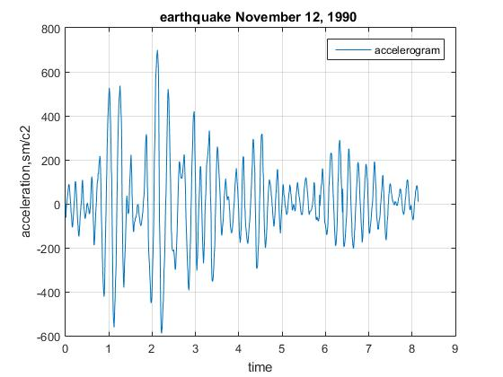

Figure 4. Accelerogram of the Baisorun earthquake on November 12, 1990

(component N-S)

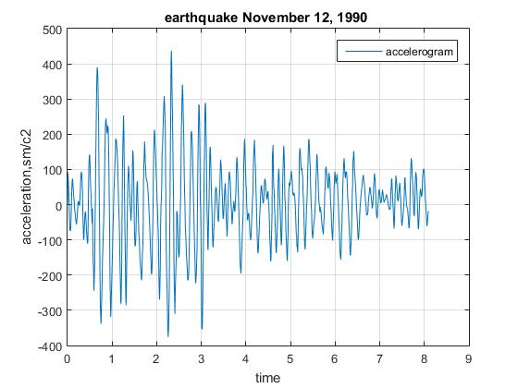

Figure 5. Accelerogram of the Baisorun earthquake on November 12, 1990

(component E-W)

Table 1 shows some parameters of instrumental recordings - accelerograms. A quick analysis of table 1 shows that accelerograms are well centered. Instrumental recordings are of high frequency. The predominant periods and carrier frequencies are determined by spectral density using the SCM MATLAB Signal Processing Toolbox. With a total duration of exposure over 8 seconds, the effective duration (duration of oscillations with an amplitude of more than half of the maximum) is 2.5 seconds, i.e. approximately 30% of the total duration. Thus, there is the impact of the pulse type.

The ratio of the maximum values of the component accelerations is 1.6. This ratio is very different from the results of the statistical analysis of strong European earthquakes. It was found that with a probability of 0.5, the maximum horizontal accelerations differ by less than 40%. Perhaps the differences are due to some regional effects. Interesting, the ratio of the sweeps is about the same - 1.59.

Table 1. Accelerogram Parameters

|  |  |  |
| --- | --- | --- |
| **Parameters** | **Component**  **1 (N-S)** | **Component**  **2(E-W)** |
| A maximum of accelerogram, cm/of c2 | 699,2 | 436,92 |
| A minimum of accelerogram, cm/of c2 | -589,85 | -375,53 |
| Dispersion, см2/с4 | 69,64 | 72,05 |
| Root-mean-square, cm/of c2 | 8,34 | 8,49 |
| Scope, cm/of c2 | 1289,05 | 812, 450 |
| Mean value, cm/of c2 | 4,193 | 6,098 |
| Median value, cm/of c2 | 1,600 | 9,845 |
| A maximum of spectral closeness | 42,20; 36,58 | 39,69 |
| Frequency,1/с | 3,66; 4,76 | 4,88 |
| Period, c | 0,27; 0,21 | 0,20 |
| Duration of vibrations with amplitude of greater half of maximum (effective duration), с | 2,52 | 2,50 |

Figures 6 and 7 show the spectral curves β, obtained by solving equation (8) for different values of the dry friction coefficient f. The value of the logarithmic coefficient δ = 0,314 (5% of the critical value). The calculations were performed using the MATLAB computer math system.

Note that the values of the dry friction coefficient f equal to 0.05-0.1 correspond to the parameters of fluoroplast-4. Due to the low coefficient of sliding friction when the inertial loads exceed the threshold, the building begins to slip relative to the foundation. From this point on, the seismic loads on the building do not increase. All the energy of the seismic impact is spent on the movement of the supra-foundation structures of the building.

When seismic effects are typical for the Almaty region, the effect of reducing seismic forces can be very significant - up to 2 times.

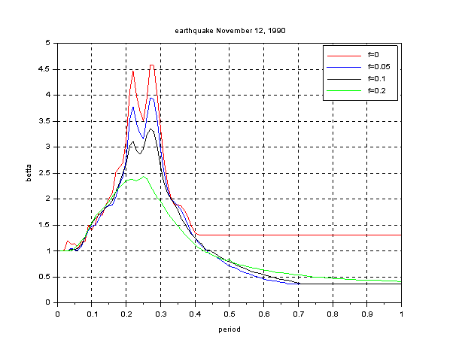

Figure 6. Spectral curves β for different values of the friction coefficient f (component N-S)

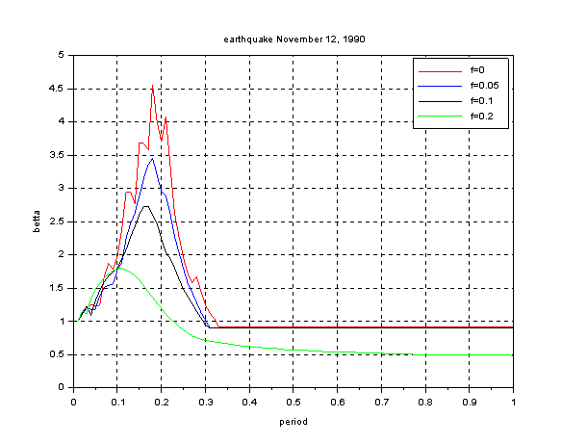

Figure 7. Spectral curves β for different values of the friction coefficient f (component E-W)

**3. Acknowledgments**

1. Kazakhstani scientists proposed constructive solutions for seismic insulating pile foundations, including dry-friction seismic insulation systems, which have found application in Almaty.
2. With the expected earthquakes taking into account local features of the seismic impact, there is a twofold decrease in seismic loads. Reduction of both inertial seismic loads and internal forces is provided at the level of the floors of each building.
3. In the city of Almaty, the use of seismic insulating pile systems with elements of dry friction is recommended in areas of seismicity of 10 points, composed of weak soils of category III according to seismic properties.
4. The use of seismic insulating pile foundations on construction sites near tectonic faults is recommended. There are over 300 hectares of such sites near tectonic faults on the territory of Almaty. Construction of low-rise rigid buildings (up to 4-5 floors) in such areas will contribute to improving the efficiency of earthquake-resistant construction in Almaty and its surroundings.
5. Mass application of seismic insulating pile foundations with dry friction elements at sites of the city of Shymkent is recommended. The territory of the city has a 7-point background seismicity and a population of over 1 million people. The use of such foundations will make it possible to reliably reduce the seismic load by 1 point and, therefore, use standard series for the construction of residential buildings for non-seismic areas.

**4. REFERENCES**

Mikhailov G.M. (1974) The use of the resiliently-friction systems is earthquake resisting building. // − Earthquake resisting building. М. of :TsINIS of Gosstroi of the USSR, producing 3: 36-38.

Pavlyk V.S. (1971) Principle of planning of earthquake resisting building with enhanceable dissipative properties. In book: Materials to the All-union conference on planning and building of earthquake resisting building and building. Basic directions of research on earthquake resisting building.− М.: TsINIS of Gosstroi of the USSR : 210-218.

Kazina G.A., Kilimnik L.Sh. (1974) Constructions of earthquake resisting building are in foreign building (review).− М.: TsINIS of Gosstroi of the USSR : 60.

Aubakirov A.T. (1990) The Seismic isolation pile foundations. Dissertation on the competition of graduate degree of doctor of engineering sciences. Almaty: 424.

Aubakirov A.T., Yerzhanov S.Ye. (1977) Features of reaction of building and building with the resilient terminators of vibrations on seismic influece./ In book: Researches of сейсмостойкости of building and constructions.− Alma-Ata: Kazakhstan: 70-87.

Belash T.A. (1996) Optimization of parameters of energyabsorption in building on seismic isolation foundations. Dissertation on the competition of graduate degree of doctor of engineering sciences : 458.

Yaremenko V.G. (1984) Earthquake resisting of building with facilities of seismic isolation and dry friction. Dissertation on the competition of graduate degree of candidate of engineering sciences : 212 p

Yerzhanov S.Ye., Lapin V.A.(2017) The systems of the seismic isolation are in Republic of Kazakhstan and developed countries of the world. / In book: Researches of earthquake resisting of building and constructions.− producing 25 (35). Almaty: Kazakhstan: 156-192.

Sigal F.R. (1983) Research of the construction damping in steel frameworks with connections on high-strength screw-bolts. it is Dissertation on the competition of graduate degree of candidate of engineering sciences. Tashkent: 174.

1. Ph.D. in Engineering Sciences, KazNIISA JSC, Almaty, abai_ata@mail.ru