**COMPARISON OF MODELING APPROACHES FOR HIGH DAMPING RUBBER BEARINGS**

**DOI 10.37153/2686-7974-2019-16-902-909**

Ahmet YAKUT[1], Ugurhan AKYUZ[2], Eser CABUK[3], Nobuo MUROTA[4], Shigenobu SUZUKI[5]

**ABSTRACT**

Two approaches were employed to model the High Damping Rubber isolators used in buildings. The first approach is the commonly used multi linear plastic link (MLP) force deformation relationship employed in SAP2000. The second alternative is the use of high damping rubber isolator link (HDRB) developed by Bridgestone. A 9-story seismically isolated reinforced concrete building was employed where high damping rubber bearings were used as isolators. In order to investigate the influence of force-deformation models on the response, isolators were modeled using the two-models that are described in SAP2000. The building was analyzed under a set of 7 earthquake records scaled to a target spectrum obtained from seismic hazard analysis. Base shear force transferred to the superstructure, floor accelerations as well as the isolator displacements that are obtained from nonlinear time history analyses of the building were compared for the two modeling approaches. It has been observed that floor accelerations obtained from HDRB model are significantly less than the ones obtained from MLP. The base shear and isolator displacements obtained from the HDR model are in general close to the ones determined from MLP model, the difference being approximately 5-30 percent. This shows that there is a significant influence of isolator modeling on the response.

*Keywords: High Damping Rubber isolators, Multi Linear Model, High Damping Model, Seismic Isolation*

**1. INTRODUCTION**

In Turkey, seismic isolation applications are recently becoming common among important buildings, bridges, data centers and so on. Friction pendulum systems, lead core rubber bearings and rubber bearings are the most commonly used ones in seismic isolation applications. Therefore, professionals are familiar with the theory and practices of such devices, but have limited experience about high damping rubber bearings(HDRB). Modeling of these bearings is quite important as the main nonlinearity concentrates in these units. Different modeling approaches are suggested for high damping rubber bearings. The study presented here is carried out to investigate two different modeling of high damping rubber bearings through analysis of a 9 story isolated reinforced concrete building. The comparisons are made in terms of floor accelerations, isolator displacements and base shear forces.

***1.1 Properties of the building and the site***

One of the blocks of a real hospital building located in Isparta, Turkey that was designed as seismically isolated was employed for this study. The hospital has a bed capacity of 775 which has been in service since 2017. The structural system of the building is composed of reinforced concrete shear wall and frame elements. The fixed base period of the building has been calculated as 1.57 seconds in x-direction. A total of 118 high damping isolators were used at the level above the basement floor as shown in Figures 1 and 2 where the isolation level plan and the model of the building are given, respectively. The circles shown in the plan indicate the location of isolators.

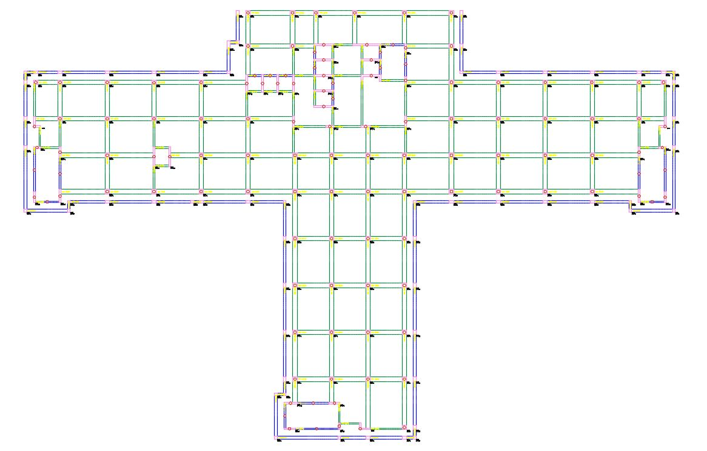

Figure 1. Plan of the Building at Isolation Level (circles show isolator locations)

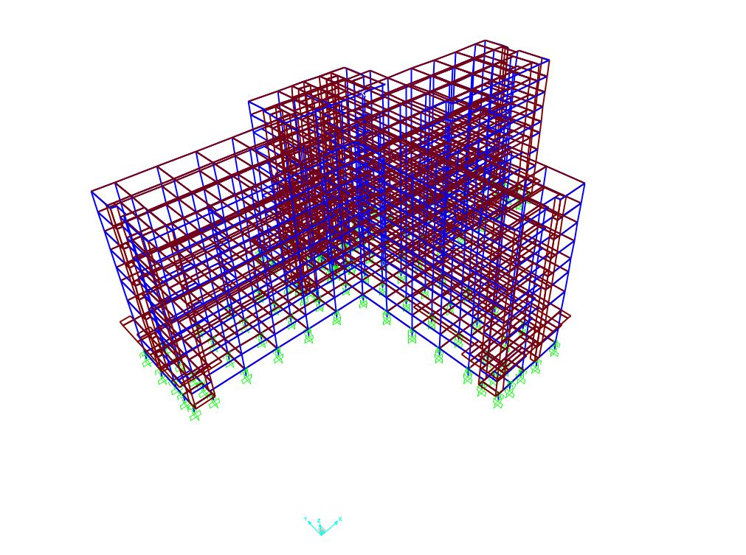

Figure 2. Three dimensional model of the building

Site specific seismic hazard analysis was conducted to determine the target spectra for Design Basis Earthquake (DBE) and Maximum Considered Earthquake (MCE) ground motion levels. Among the faults that influence the significant seismicity in Isparta, Fethiye-Burdur fault that is at a distance of approximately 25 km to the site was found to produce the largest contribution to seismic hazard. It is worth noting that an earthquake with a magnitude of 6.9 occurred in Burdur in 1914. The target spectra for DBE and MCE earthquake levels are shown in Figure 3.



Figure 3. Target and Mean response spectra for the Site

Seven real ground motion records were selected from ground motion database of Pacific Earthquake Engineering Research (PEER) that are scaled to match the target spectra. The list of selected ground motion records for DBE and MCE are given in Table 1. The comparisons of average scaled spectra and the target spectra are shown in Figure 3.

Table 1. Ground motion records used in the analysis.

|  |  |  |  |  |  |  |  |  |  |
| --- | --- | --- | --- | --- | --- | --- | --- | --- | --- |
| **Record ID** | **Earthquake Name** | **Year** | **Station Name** | **Magnitude** | **Mechanism** | **Rjb (km)** | **Vs30 (m/sec)** | **Scale Factors** | |
| **DBE** | **MCE** |
| 777 | "Loma Prieta" | 1989 | "Hollister City Hall" | 6.93 | Reverse Oblique | 27.33 | 198.77 | 0.96 | 2.28 |
| 821 | "Erzican_ Turkey" | 1992 | "Erzincan" | 6.69 | strike slip | 0.0 | 352.05 | 0.92 | 1.33 |
| 1116 | "Kobe_ Japan" | 1995 | "Shin-Osaka" | 6.9 | strike slip | 19.14 | 256.0 | 1.97 | 4.63 |
| 1158 | "Kocaeli_ Turkey" | 1999 | "Duzce" | 7.51 | strike slip | 13.6 | 281.86 | 1.15 | 1.87 |
| 1165 | "Kocaeli_ Turkey" | 1999 | "Izmit" | 7.51 | strike slip | 3.62 | 811.0 | 1.97 | 3.12 |
| 1605 | "Duzce_ Turkey" | 1999 | "Duzce" | 7.14 | strike slip | 0.0 | 281.86 | 0.85 | 1.21 |
| 1787 | "Hector Mine" | 1999 | "Hector" | 7.13 | strike slip | 10.35 | 726.0 | 1.69 | 4.40 |

***1.2 Seismic Isolation Design***

High damping rubber bearings were used in the isolation of the Building. The total of 118 isolators were grouped into five types based on their vertical load capacity. Each type of isolator has basically different diameter. The high damping rubber compound used for isolator is common in all types. The displacement capacity of the isolators for DBE and MCE were determined as 20 cm and 50 cm, respectively, which corresponds to the approximate shear strain of 100% and 250%. Table 2 lists the general properties of isolators used in this building.

Table 2. Properties of HDR bearings.

|  |  |  |  |  |  |
| --- | --- | --- | --- | --- | --- |
| Property | Type1 | Type2 | Type3 | Type4 | Type5 |
| Outer diameter (mm) | 800 | 1000 | 1200 | 1400 | 1500 |
| Inner diameter (mm) | 20 | 25 | 55 | 65 | 65 |
| Effective plane area (mm2) | 502300 | 784900 | 1128600 | 1536100 | 1763800 |
| Thickness of one rubber layer (mm) | 5.4 | 6.7 | 8 | 9.5 | 100 |
| Total rubber thickness (mm) | 200 | 201 | 200 | 200 | 200 |
| First shape factor | 36.1 | 36.4 | 35.8 | 35.1 | 35.9 |
| Second shape factor | 4 | 4.98 | 6 | 7.02 | 7.5 |
| Thickness of reinforcing steel plate (mm) | 4.4 | 4.4 | 4.4 | 5.8 | 5.8 |
| Rubber compound | Bridgestone specification: X0.6R | | | | |
| Nominal shear moduls (MPa) | 0.62 @ 100 % shear strain | | | | |
| Nominal equiv.damp. ratio (%) | 24% @ 100% shear strain | | | | |
| Total height (mm) | 422.2 | 400.6 | 385.6 | 405.5 | 410.2 |
| Total weight (kN) | 11.9 | 17.3 | 23.3 | 33.9 | 39.7 |
| Nominal long term column load (kN) | 6050 | 11800 | 16900 | 23000 | 26500 |

**2. Modeling and analysıs**

***2.1 Employed isolator models***

Two models are used for the high damping rubber bearings used in this study. In the multi linear plastic (MLP) model(SAP2000, 2018), the nonlinear force-deformation relationship is given by a multi-linear curve that has different loading and unloading behavior dissipating energy according to various hysteretic models. In this study, kinematic hysteretic model is used. The force deformation relation in this model is shown in Figure 4a.

The second model employed is the high damping rubber isolator model proposed, hereafter HDRB model, by Masaki et. al. (2017). The model has been specifically developed for HDRB and is for uniaxial or biaxial shear deformation of rubber isolators. The compressive characteristic which is independent of shear is modeled elastically. The force deformation relationship for HDRB is shown in Figure 4b. It is important to note that the shear properties of HDRB are based on the third cycle of sinusoidal loading at a shear strain of 100 %. Details of both models are given in SAP2000. The model properties for the isolators used in the building that are calculated at 244 percent shear strain are summarized in Tables 3 and 4. Where u represents the ratio of characteristic strength (*Q*d1) to maximum shear force (*Q*1=*K*eq\**X*1). *K*1 is the initial stiffness and *K*2 is post yield stiffness. *H*eq shows the equivalent damping ratio.

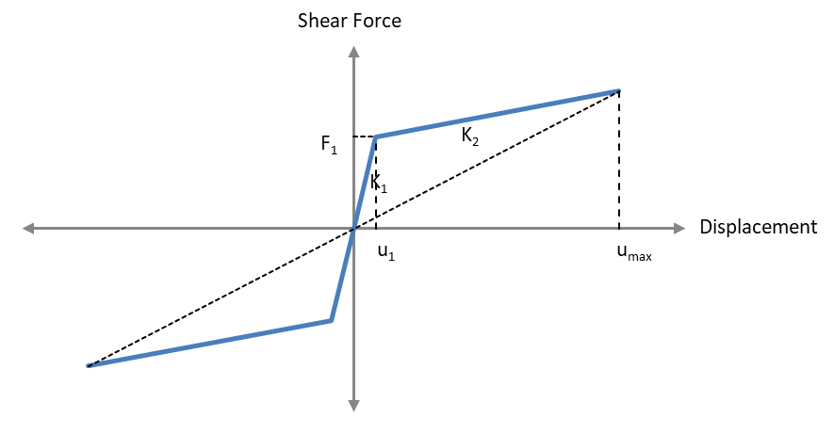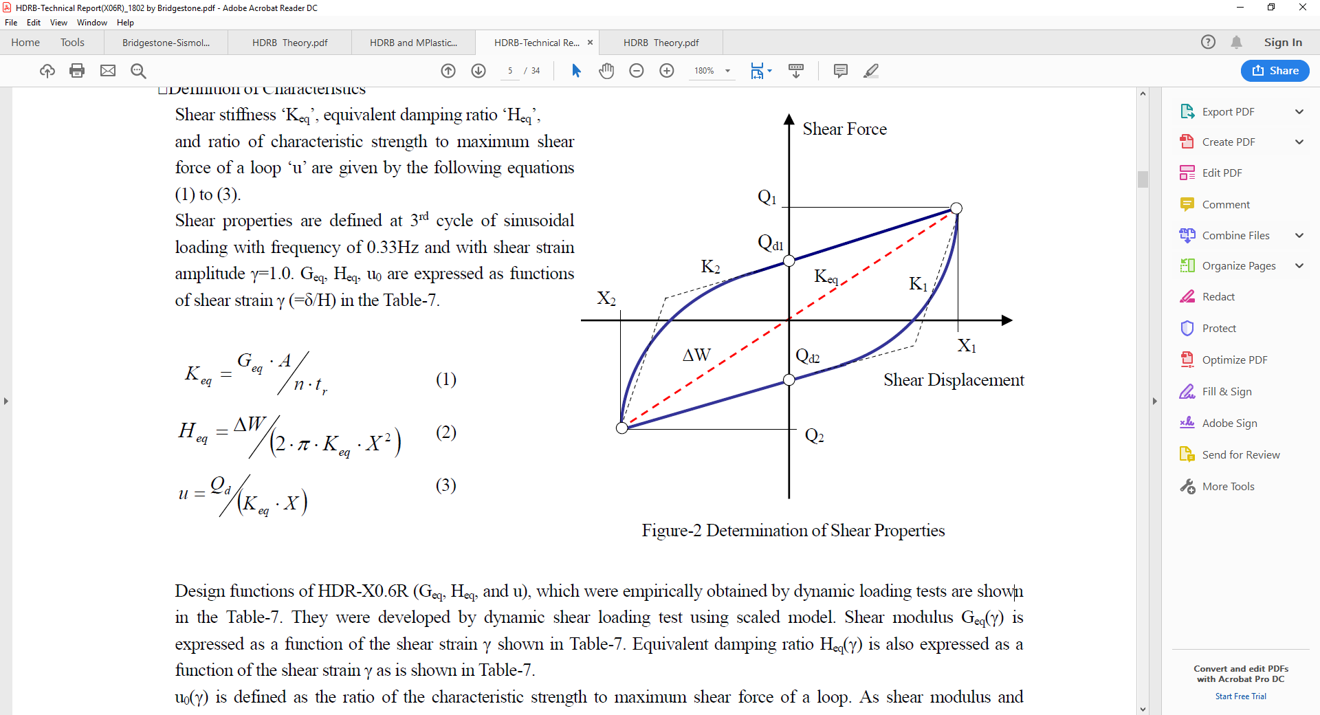

Figure 4. Force deformation relationship for Isolator: a)MLP model, b)HDRB model

Table 3. Model properties of HDR bearings.

|  |  |  |  |  |  |
| --- | --- | --- | --- | --- | --- |
| Property | Type1 | Type2 | Type3 | Type4 | Type5 |
| A (mm2) | 502300 | 784900 | 1128600 | 1536100 | 1763800 |
| H (mm) | 200 | 201 | 200 | 200 | 200 |
| Geq | 0.466 | 0.466 | 0.466 | 0.466 | 0.466 |
| Keq | 1170.21 | 1819.48 | 2629.29 | 3578.64 | 4109.12 |
| Heq | 0.200 | 0.200 | 0.200 | 0.200 | 0.200 |
| Dtm (mm) | 488 | 490.44 | 488 | 488 | 488 |
| u | 0.34 | 0.34 | 0.34 | 0.34 | 0.34 |
| Keq | 1170.21 | 1819.48 | 2629.29 | 3578.64 | 4109.12 |
| K1 (kN/m) | 7781.71 | 12099.30 | 17484.46 | 23797.52 | 27325.08 |
| K2 | 778.17 | 1209.93 | 1748.45 | 2379.75 | 2732.51 |
| Qd (kN) | 191.31 | 298.95 | 429.85 | 585.06 | 671.78 |
| F1 | 212.57 | 332.16 | 477.62 | 650.07 | 746.43 |

Table 4. Force displacement relation parameters of MLP model.

|  |  |  |  |  |
| --- | --- | --- | --- | --- |
|  | u1 (m) | F1 (kN) | umax (m) | Fmax (kN) |
| Type 1 | 0.027 | 212.6 | 0.49 | 571.1 |
| Type 2 | 0.027 | 332.2 | 0.49 | 892.4 |
| Type 3 | 0.027 | 477.6 | 0.49 | 1283.1 |
| Type 4 | 0.027 | 650.1 | 0.49 | 1746.4 |
| Type 5 | 0.027 | 746.4 | 0.49 | 2005.3 |

***2.2 Building model***

The isolated building is modeled in SAP2000 using both isolator models employed. The superstructure is modeled elastically using frame elements for beams and columns, and shell elements for shear walls. Rigid floor diaphragm is used for all floors. For the isolators, nonlinear properties are determined (Table 3 and 4) and assigned consisted with both model properties described in SAP2000 and given in Figure 4. The dynamic properties of the building that are calculated at the shear strain of 244 percent are summarized in Table 5, where properties of both fixed base and isolated structure are given. In first five modes, approximately 80 percent modal mass participation is attained for fixed base structure.

**3. COMPARISONS and ınterpretatıon**

The average of maximum floor acceleration results obtained for DBE and MCE earthquake sets are shown in Figure 5. The results are given at all floors at and above the isolation level (0th floor indicates the isolation level). It is seen that the results obtained from both models show significant differences. The average floor accelerations obtained from HDRB model are smaller than the MLP ones for both DBE and MCE earthquake sets. As expected DBE values are between 50-70 percent of MCE values. More variation along the floors is observed for MCE. The difference between the two models seems to be significant at all floors. The MLP results for MCE are 10-50 percent larger than HDRB results, whereas this difference is larger for DBE earthquake set. Floor accelerations were also calculated using response spectrum analysis under target spectrum and the results are presented in Figure 6. In general, the response spectrum analysis results are closer to the ones obtained using HDRB model.

Table 5. Modal Properties of the Building.

|  |  |  |  |  |  |  |
| --- | --- | --- | --- | --- | --- | --- |
|  | Fixed Base | | | Isolated | | |
|  |  | Mass participation ratios | |  | Mass participation ratios | |
|  | Period (s) | Mx | My | Period (s) | Mx | My |
| Mode 1 | 1.57 | 3.5E-01 | 1.9E-01 | 2.88 | 5.9E-01 | 1.3E-03 |
| Mode 2 | 1.54 | 1.2E-01 | 5.5E-01 | 2.85 | 1.5E-04 | 9.7E-01 |
| Mode 3 | 1.39 | 2.5E-01 | 4.3E-05 | 2.75 | 3.9E-01 | 4.2E-03 |
| Mode 4 | 0.45 | 1.7E-02 | 4.8E-02 | 0.75 | 5.3E-03 | 1.1E-02 |
| Mode 5 | 0.45 | 3.2E-02 | 2.8E-02 | 0.73 | 7.8E-03 | 7.2E-03 |
| Mode 6 | 0.40 | 3.0E-02 | 7.8E-05 | 0.69 | 3.8E-03 | 1.5E-05 |
| Mode 7 | 0.29 | 5.1E-05 | 2.2E-05 | 0.38 | 1.7E-04 | 6.2E-04 |
| Mode 8 | 0.27 | 9.9E-07 | 5.9E-04 | 0.37 | 3.9E-04 | 2.6E-04 |
| Mode 9 | 0.25 | 8.3E-03 | 3.0E-02 | 0.33 | 1.8E-04 | 2.1E-06 |
| Mode 10 | 0.25 | 3.5E-03 | 7.0E-03 | 0.30 | 2.1E-07 | 6.8E-08 |



Figure 5. Average floor accelerations



Figure 6. Comparison of floor accelerations with response spectrum results

Maximum isolator displacements and base shear coefficients are compared in Figure 7. Isolator displacements are in general between 20-50 cm for MCE and 5 to 25 cm for DBE earthquakes. The results indicate no clear trend; in certain earthquakes, displacements in HDRB model are larger than the MLP ones, in some other cases it is the other way around. The average isolator displacements obtained from MLP are close to the ones obtained from HDRB model for MCE earthquake level. The MLP displacements for DBE case are in the average around 70 percent of HDRB ones. The base shear coefficients change nearly between 5 to 20 percent for DBE and 15 to 35 percent for MCE earthquake sets. Although the trend is similar to the displacement as expected, MLP and HDRB results for base shear coefficients are very close.

**4. Conclusions**

An analytical study on seismically isolated RC hospital building with high damping rubber bearings using two different types of numerical models were conducted in order to investigate the influence of these models on floor accelerations, isolator displacements and base shear force. One model is based on commonly used multi linear plastic behavior (MLP) and the other model is a specific one developed for HDRB isolators. Nonlinear time history analyses and response spectrum analyses were carried out under seven pairs of ground motion sets applied in two principal directions of the building. The results obtained from nonlinear time history analyses employing these were compared. It was observed that the two modeling approaches lead to significant differences in floor accelerations, HDRB accelerations being smaller than the MLP ones. The difference in isolator displacements were less significant but still crucial for DBE earthquake level. The base shear coefficients obtained from two models were found to be close. This study indicates that modeling of HDRB isolators is quite important.



Figure 7. Isolator displacements and Base shear coefficients

**5. References**

N. Masaki, T. Mori, N. Murota, K. Kasai, 2017, “Validation of Hysteresis Model of Deformation-History Integral Type for High Damp-ing Rubber Bearings,” Paper 4583, Proceedings of the 16th World Conference on Earthquake Engineering, Santiago, Chile.

Computers and Structures Inc. (2018). CSI Analysis Reference Manual for SAP2000. Berkeley, California, USA

ASCE (2010). Minimum Design Loads for Buildings and Other Structures (ASCE 7- 10).

TEC (2007). Ministry of Public Works and Settlement Government of Republic of Turkey. Regulations for Buildings to be Built in Earthquake Areas. 2007.

TEC (2018). Turkish Building Earthquake Code. Ministry of Interior. Presidency of Disaster and Emergency Management. 2019.

1. Professor, Middle East Technical University, Ankara, Turkey, [ayakut@metu.edu.tr](mailto:emailaddress1@canterbury.ac.nz)
2. Professor, Middle East Technical University, Ankara, Turkey
3. Graduate Student, Department of Civil Engineering, METU, Ankara , Turkey, [eser.cabuk@metu.edu.tr](mailto:emailaddress@canterbury.ac.nz)
4. Bridgestone Corporation, Seismic Isolation and Vibration Control Products Development Department, Yokohama, Japan, [nobuo.murota@bridgestone.com](mailto:emailaddress@canterbury.ac.nz)
5. Bridgestone Corporation, Seismic Isolation and Vibration Control Products Development Department, Yokohama, Japan