THE MW 7.4 PALU EARTHQUAKE OF SEPTEMBER 28, 2018

DOI 10.37153/2686-7974-2019-16-891-901

Sugeng WIJANTO, I Wayan SENGARA, Erwin LIM and Takim ANDRIONO

ABSTRACT

A moment magnitude (M_{w}) 7.4 earthquake has rocked Central Sulawesi, Indonesia on September 28, 2018. The earthquake triggered, not only, a devastating tsunami but also a lateral soil movement due to liquefaction, destroying a tremendous number of houses and causing thousands of fatalities in several large neighborhoods. This paper aims to provide detailed discussion regarding the characteristics of the earthquake’s strike-slip type ground movement and to help provide recommendations based on lessons learned in this earthquake.

Keywords: Earthquake; Tsunami; Liquefaction; Strike-slip

1. INTRODUCTION

On September 28, 2018, at 18:02 local time (10:02 UTC), a major 7.4-magnitude earthquake with a depth of 11 km on the Palu-Koro fault line rocked Donggala district, Central Sulawesi, Indonesia. This major tremor was preceded by a series of small-to-moderate sized earthquakes over the hours leading up to this event; the USGS located 4 other earthquakes of M 4.9 and larger in the epicentral region, beginning with a M 6.1 earthquake three hours earlier and just to the south of the M 7.4 event. There has also been an active aftershock sequence, with 40 events of M 4.4 and larger in the first five days following this earthquake. The largest aftershock in this timeframe was M 5.8, about 12 minutes after the major earthquake (USGS, 2018). It has caused tremendous casualties. At least 4340 people have been confirmed dead and around 172,635 people displaced by the disaster (Government of Central Sulawesi, 2019). This devastating M 7.4 earthquake was one of the largest among 11,577 quakes with various magnitudes and source of depths, which hit Indonesia in 2018 as recorded by the Indonesian Meteorology, Climatology, and Geophysical Agency (BMKG, 2019).
This large tremor occurred as a result of strike-slip faulting at shallow depths within the interior of the Molucca Sea microplate, part of the broader Sunda tectonic plate. The USGS reports the focal mechanism solutions for the earthquake indicate rupture occurred on either a left-lateral north-south striking fault, or along a rightlateral east-west striking fault. In spite of occurring along a strike-slip fault, meaning the motion was horizontal, this quake was suspected to trigger a submarine landslide, and therefore it may have provided the energy that fueled a series of destructive tsunamis, which destroyed the coastline with destructive flows of mud and soil. As the coastal areas took heavy damage because of the tsunami, the quake also generated three large inland flows of mud that caused severe damage in densely populated areas. Intense shaking from the earthquake have triggered liquefaction and lateral spreading (landslides) processes in which saturated sand and silt takes liquefy during the earthquake. Maps showing the Sulawesi Island, the tectonic faults of Sulawesi Island, and the locations affected by landslides and liquefaction are shown in Figures 1.a, b, and c, respectively.
While commonly plotted as points on maps, earthquakes of this size are more appropriately described as slip over a larger fault area. Strike-slip events of the size of the September 28, 2018 earthquake are typically about 120x20 km in size (length x width); modeling of this earthquake implies dimensions of ~150x30 km, predominantly south of the hypocenter. Geodetic evidence (Pixel tracking and InSAR images) clearly show rupture (including surface rupture through the city of Palu) over a length of ~150 km.
Historically, this region has hosted several large earthquakes, with fifteen events of M 6.5 and larger within 250 km of the September 28th earthquake over the preceding century. The largest of these was a M 7.9 earthquake in January 1996, about 100 km to the north of the September 28, 2018 event. The 1996 earthquake – a shallow thrust faulting earthquake was likely to have occurred on the regional subduction zone system at depth beneath the shallow crust - resulted in approximately 10 fatalities, over 60 injuries, and significant building damage in the local region (USGS, 2018).

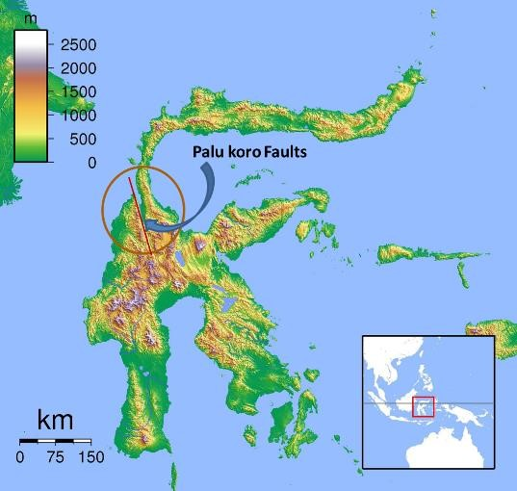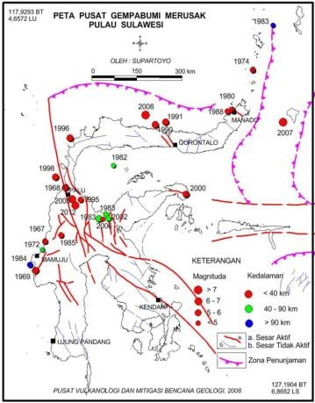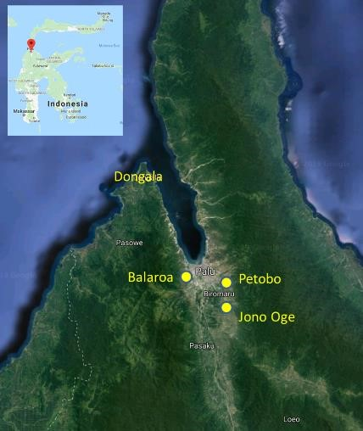

(a) (b) (c)

Figure 1. (a) Maps of Sulawesi Island, (b) Tectonic faults of Sulawesi Island (Supartoyo, 2014) and
(c) Location of landslides and liquefactions

2.2. GEOTECHNICAL ASPECTS AND LANDSLIDES

2.1 Post Earthquake Site Survey and Soil Properties

Eastern of Indonesia is characterized by complex tectonics in which motions of numerous small microplates are accommodating large-scale convergence between the Australia, Sunda, Pacific, and the Philippine Sea plates. At the location of the September 28th earthquake, the Sunda plate moves south with respect to the Molucca Sea plate at a velocity of about 30 mm/year. This earthquake was followed by a tsunami and liquefaction in some areas.
A number of documentations on the Petobo, Balaroa, and Jono Oge areas showed the phenomenon of flow liquefaction and causing heavy damage. Some buildings, roads, and slopes moved with very large deformations and caused the road and bridge collapsed (Figure 2).
To find out the behavior of the soil, several soil samples at the liquefied sites were tested. The test results showed that the soil at the location of Balaroa and Petobo were potentially liquefiable to most liquefiable with percentages of gravel 0 – 19%, of sand 65 – 85%, and of fines content 12 – 16% (Figure 3). The value of Specific Gravity varies between about 2.50 – 2.66.

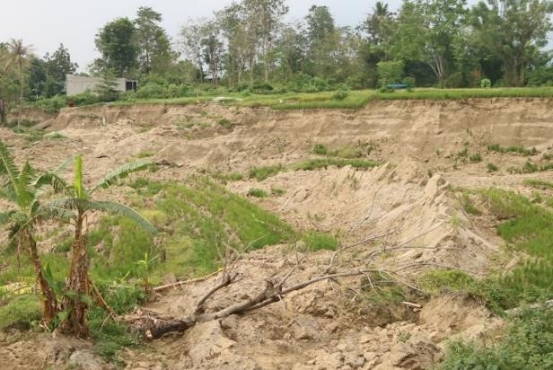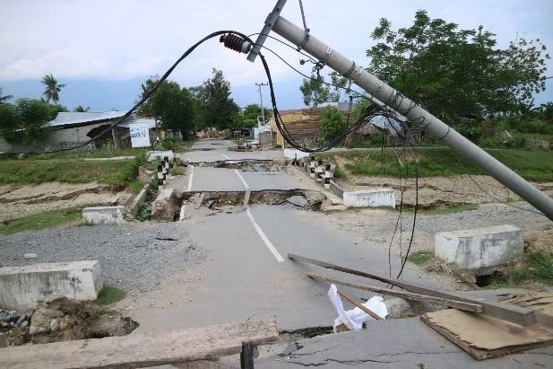
(a) Occurrence of Landslide in Petobo Site (b) Documentation of Landslide in Balaroa
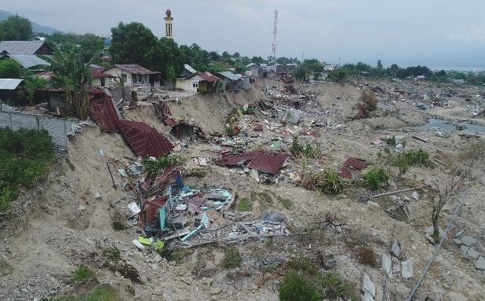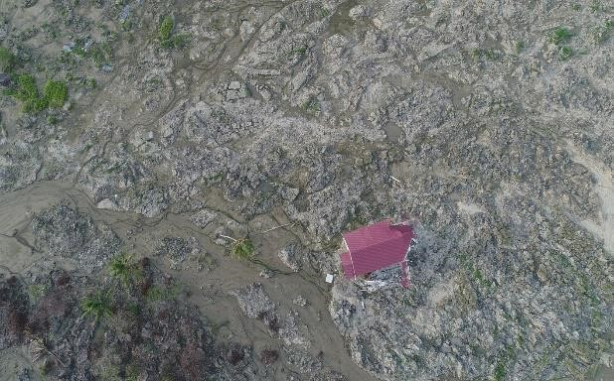
(c) Documentation of Road Damages in Balaroa (d) Occurrence of Flow Liquefaction in Jono Oge

Figure 2. Post-Earthquake Site Survey

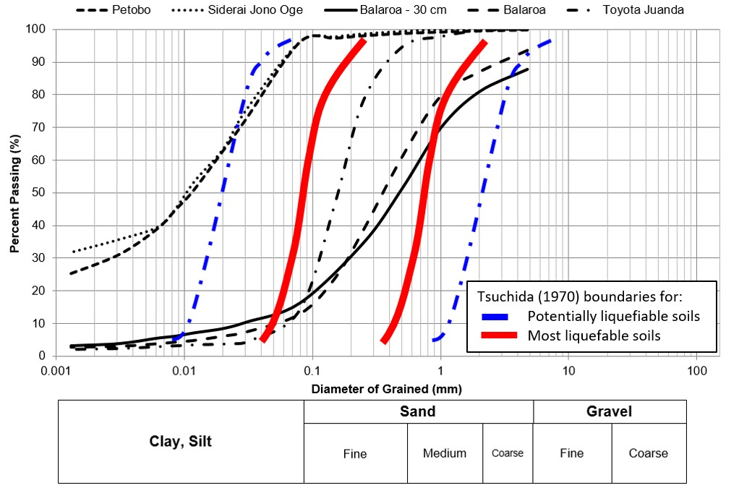

Figure 3. Grain size distribution of soil samples in liquefied area

2.2 Characteristic of Palu Earthquake Ground Motion and Liquefaction

Based on earthquake recording data received from the PCI-PALU (BMKG – JICA) station which is located at 0.91ºS and 119.84ºE (80 km to the south of the epicenter), the occurred PGAs were 0.277g in the east-west direction, 0.201g in the north-south direction, and 0.33g in the up-down direction (vertical direction) as shown in Figure 4.
Comparison between ground motions acceleration response spectra generated by Palu earthquake and design spectra of Palu City in accordance with Indonesian Building Code SNI 1726 – 2002 and SNI 1726 – 2012 is shown in Figure 5. The design spectra for Palu City based on the SNI 1726 – 2012 indicate relatively much higher spectral acceleration compared to that of ground motion acceleration spectra of Palu Earthquake in every periods except at 2 – 3s. However, the design spectra of Palu City based on the SNI 1726 – 2002 indicate slightly lower value compared to that of the ground motions spectra of Palu earthquake, particularly in periods of 0.1 – 0.2s and 2 – 3s. The highest value of ground motion spectral acceleration of Palu Earthquake was identified in the vertical direction component in low period which is about of 1.2g.

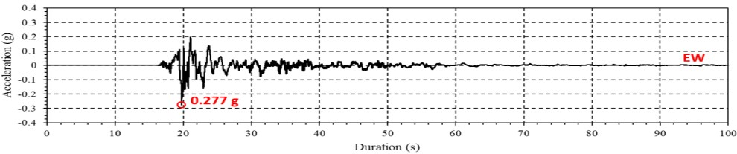
- E-W Direction
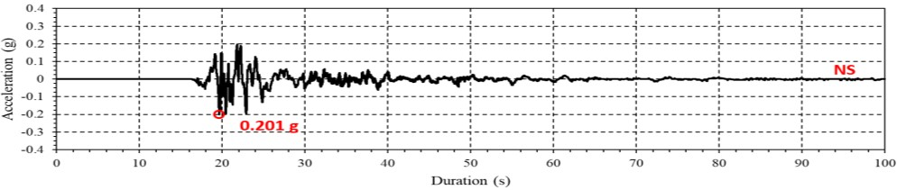
- N-S Direction
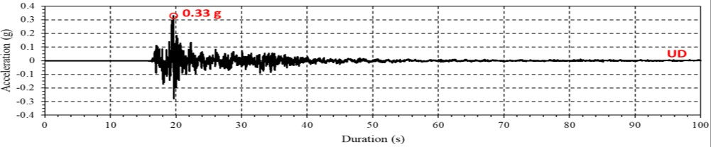
- U-D Direction

Figure 4. Ground motions of Palu earthquake

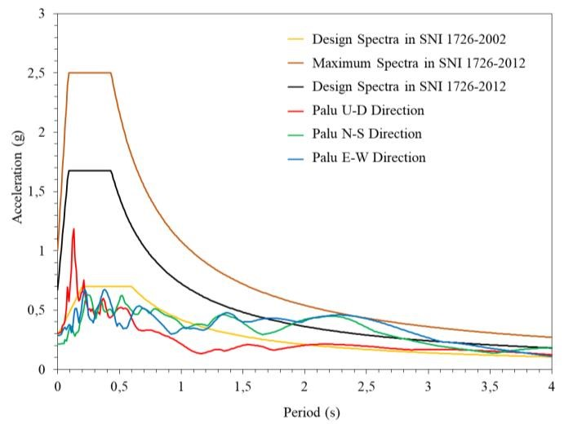

Figure 5. Comparison between acceleration response spectra of Palu earthquake and design spectra of Palu city for site soil class D, in accordance with Indonesian seismic building codes SNI 1726

To evaluate the liquefaction occurrence during Palu earthquake, back calculation of the safety factor of the liquefaction has been evaluated herein using a simplified procedure, which developed by Idriss and Boulanger (2008). The geotechnical information of such soil properties were assumed based on the field observation data. The magnitude of the earthquake load was used based on the largest PGA of all earthquake loads directions. In general, the result showed the safety factor (SF) of all sand layers was less than 1, as listed in Table 1.

Table1. Calculation of liquefaction potential using Idriss and Boulanger procedure (2008)

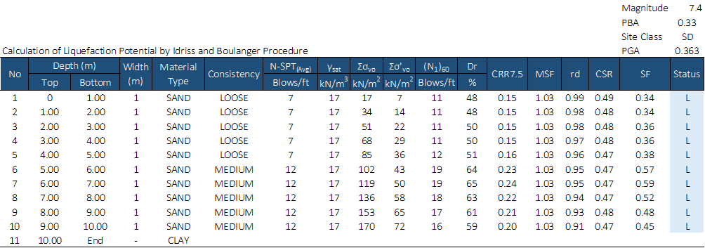

3. SEISMIC DESIGN AND BUILDING BEHAVIOR

The Indonesian earthquake design code was firstly published in 1970 and applied for engineered building only. The corresponding peak ground acceleration (PGA) is about 0.025g, 0.05g and 0.10g applied in three earthquake zones. This seismic code was then updated in 1987 and the region was divided into six earthquake zones with the highest Peak Ground Acceleration coefficient of 0.13g. Further in 2002, the seismic code was again revised by considering ground motion with a return period of 500 years or the probability of exceedance of 10% in a period of 50 years. The mean peak base acceleration for each zone starting from Seismic Zones 1 to 6 were respectively as follows: 0.03 g, 0.10 g, 0.15 g, 0.20 g, 0.25 g and 0.30 g (Wangsadinata, 2002).
Since 2002, the seismic code has been twice updated, i.e in 2012 and 2017. The peak based acceleration for Palu area was increased from 0.25g (in SNI 03-1726-2002) to 1.2g and 1.7g based on seismic-map 2012 and seismic map 2017, respectively. Most multi storey buildings in Palu and its surroundings were mainly designed based on the seismic code of 2002 or earlier with much smaller seismic inertia loads and less strict requirements for the building configurations and structural detailing. The failures of quite significant number of multi storey buildings in Palu area most likely were caused due to these reasons.
The level of understanding of engineers in Palu (and it is also believed in other local regions) depends mainly on what they have learned while they studied at the university. There is little effort among practitioners to update their knowledge and competence with the latest codes, standards and design methods. The exception is for those who are practicing in Jakarta and perhaps some other big cities in Java. The need for continuing professional development is actually mandatory to be fulfilled through the professional association.

3.1 Residential Housing

According to Indonesian government reports, the latest data of residential housing damages from four district areas, such as Palu, Sigi, Dongala and Parigi Moutong are as follows: minor damages 40,085 houses, moderate damages 26,122 houses, severe damages 29,711 houses and losses due to liquefaction 3,673 houses. Most of the housing is unreinforced masonry, although there are a significant number of timber houses with masonry skirt walls, and a growing number of confined masonry houses. Bricks common to rural areas are hand-molded, fired in outdoor kilns. Their quality and strength can vary considerably, depending on the type of clay used, duration of firing, and placement in the kiln.
During the reconnaissance, many severely damaged and collapsed residential housing in city of Palu were due to poor design and inadequate detailing as shown in Figure 6. Some housings were observed to have failed due to soft story effect, insufficient amount of longitudinal and tranverse reinforcement bars, poor anchorage between column longitudinal bars to foundation, and poor detailing of beam-column joint. In rural areas, where most houses were categorized into unreinforced masonry (URM), the failure observed was mainly due to insufficient integrity among vertical tie, horizontal tie, and brick wall. Similar failures have been observed in many URM structures at different locations in Indonesia during the past reconnaissance surveys (Boen, T. 2016)

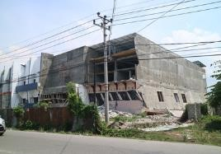
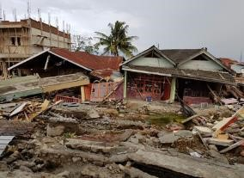
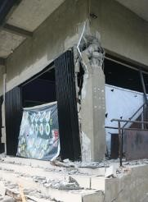
(c) column failure due to insufficient confinement
(
a) soft storey failure

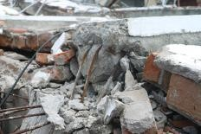
(b) collapsed of URM buildings (d) Insufficient vertical tie rebar

Figure 6. Failure of Residential Housing

3.2 Commercial Buildings

Mal “Tatura” and Hotel “Roa-Roa”, are two of many severely damaged or collapsed commercial buildings as shown in Figures 7 and 8, respectively. From the taken photographs, it is obvious that soft story effect and disintegrity of main structural elements were dominant. It was a common practice that commercial buildings eliminate the use of interior partition walls to freely allow for more spacious areas to be gained. However, the ignorance of the relative stiffness between stories and poor design caused soft story effect leading to partial collapsed as in Mal “Tatura”. In plane diagonal shear cracks and out of plane collapsed of brick wall were also commonly found in the damaged buildings. In addition, it is also obvious from the photos that the confinement requirement for columns were not met, resulting in buckling of main longitudinal bars.
The aforementioned damages could actually be avoided if the design and construction follow carefully the current prevailing building code as in the case of the Palu Grand Mall (Figure 9). This four storey building (the Palu Grand Mall) was designed based on the current standard and it performed well during the major earthquake and was able to withstand the tsunami.

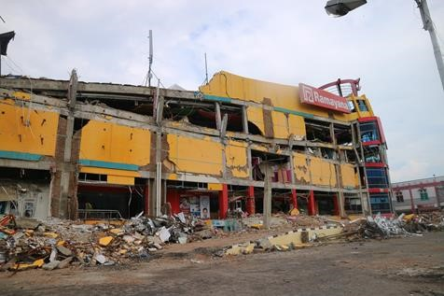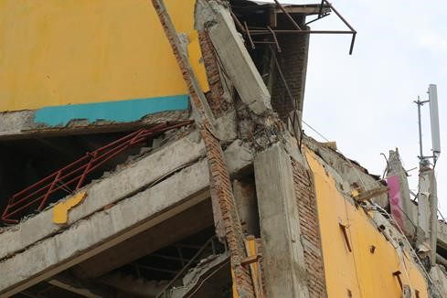

(a) partial collapse due to soft storey effect (b) insufficient beam-column joint confinement, poor
infill brick wall to RC-column connections
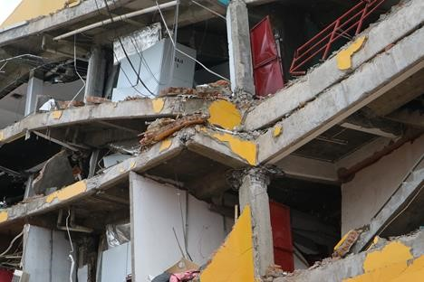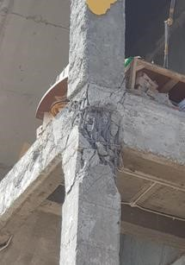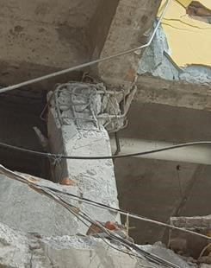

(c) insufficient column confinement, out-of-plane (d) insufficient beam- (e) insufficient column
failure of brick wall column confinement confinement

Figure 7. Mal “Tatura” built before 2012 and severe damage at beam column joint

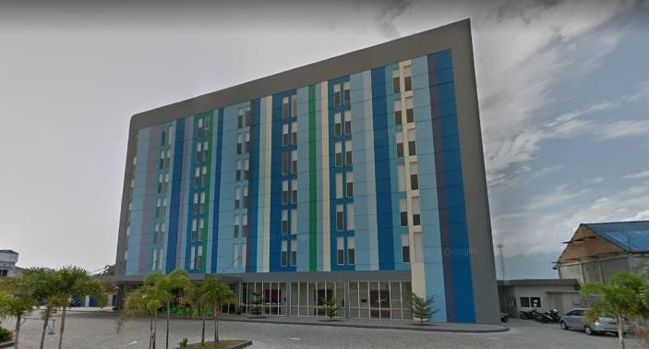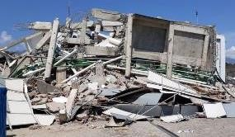
(a) Before earthquake (b) After Earthquake

Figure 8. Hotel “Roa-Roa” built in 2012 and totally collapsed

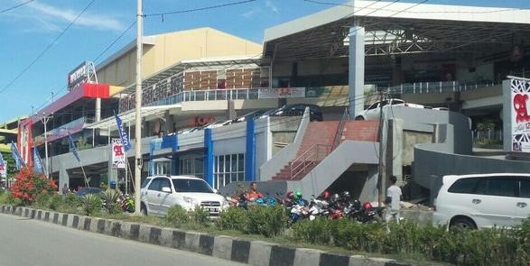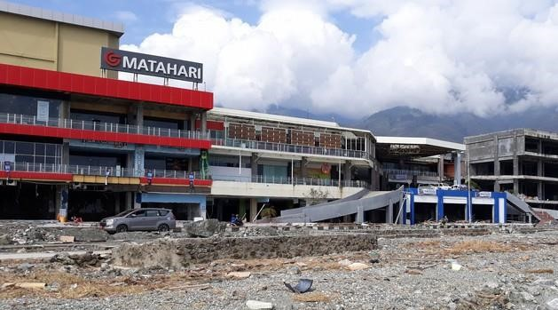

(a) Before Earthquake (b) After Earthquake

Figure 9. Palu Grand Mall (Madutujuh, 2019)

3.3 Performance of Airport, and Industrial Facilities

Many observed industrial facilities, such as car show rooms and warehouses which were constructed using structural steel elements did not experience severe damage. However, in most of those buildings, cracks were obsered on the brick wall and sometimes out-of-plane collapse of brick wall occured as shown in Figure 10.a. Detailed observation showed that no ties were present to hold the out-of-plane deformation of those brick walls as in the Figure 10.b and insufficient reinforcement in the vertical tie element (Figure 10.c). In some cases, failure of non-structural components were also observed, such as the anchorage failure of air conditioner seating as depicted in Figure 10.a.

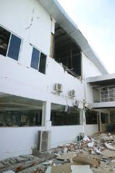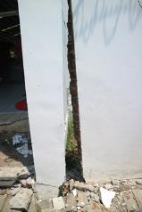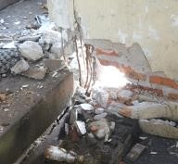

(a) out of plane failure of (b) insufficient integrity (c) insufficient reinforcement in vertical tie
infilled brick wall between infilled brick wall confining brick wall
and RC-column

Figure 10. Damage at Industrial warehouse

The damage of the terminal building of Palu Airport was observed to be mainly non-structural. Some partition brick walls, stairs, and suspended ceiling were among affected non-structural elements as shown in Figure 11.

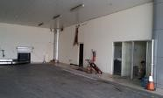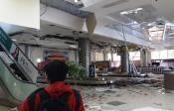

(a) damage of partition brick wall (b) damage of suspended ceiling (c) damage of stair-case

Figure 11. Damage of Non-structural Elements at Palu Airport Terminal Building

4. EMERGENCY RESPONSE AND COORDINATION

The government response to the earthquake tested the extensive planning that had been done in Indonesia since the 2004 Sumatran earthquake and tsunami. There was a substantial evidence that the disaster preparedness planning and training for tsunamis had a positive effect in Padang (2009). The earthquake further taught new lessons for disaster planning and response, some of which are critical to protecting lives, property, and continuity of operations, as demonstrated at the Palu Samaritan Hospital. Cracks at walls of this hospital were grouted after less than a month since the earthquake stroke as shown in Figure 12.

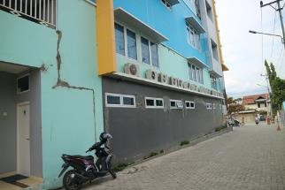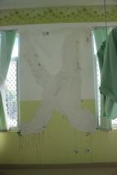

(a) grouted cracks at wall (b) grouted shear cracks

Figure 12. Palu Samaritan Hospital

However, it was also observed that owners of some private buildings, especially those for residential and commercial usage, did not receive proper technical advice from local authorities in retrofitting their property. For instance, Figure 13 shows a three storey building with a reinforced concrete frame with infilled brick wall system. The first floor is used for commercial, while the second and third floor were used for storage. After the earthquake, severe column damages were observed at the first floor and the owner decided to retrofit his house using steel column as depicted in Figure 13. Unfortunately, the steel column was pin-connected at both ends to the beam and grade beam, resulting in zero contribution to total lateral strength.

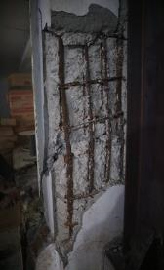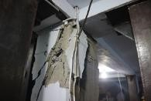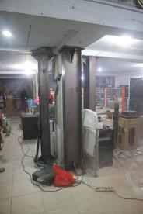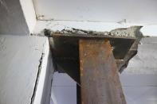

(
b) shear failure at a column

(a) column failure (c) pin connection of retrofit steel (d) incorrect column retrofit with column pin connections at both ends

Figure 13. Issues in un-advised retrofit

Meanwhile the local and national government has established some actions to recover the impact of this Central Sulawesi disaster as well as to learn from it, among others (AHA Centre, 2018):
- Right after the disaster, the Governor of Central Sulawesi announced an initial 14 days of emergency response period from 28 September till 11 October 2018 and received assistance from various countries.
- The National Search and Rescue Agency organized joint research and rescue efforts divided in several operational areas.
- Meteorology, Climatology, and Geophysical Agency dispatched immediately a team to conduct microseismic, macroseismic, microzonation, and post-tsunami surveys.
- Various humanitarian relief actions were carryout right away by government and other supporting agents.

5. FINAL REMARKS

Important lessons learned from this Central Sulawesi seismic calamities and some recommendations, which can be given, are as follows:
1. The design spectra of Palu City based on building code SNI 1726 – 2012 have greater value than acceleration response spectra of Palu Earthquake in every natural period. However, the design spectra of Palu City based on building code SNI 1726 – 2002 have lower value than response spectra of Palu earthquake in natural periode 0.1 – 0.2s and 2 – 3s.
2. In 2017, the Indonesian government issued a new seismic code with a much higher Spectral Acceleration (1.2 – 1.5g) compared to the previous codes, especially codes prior to 2012. In spite of the availability of this new Spectral Accelerations, Palu and its surrounding areas need more detailed seismic map to accommodate their various geological and geotechnical conditions.
3. Observations on structural failures for reinforced concrete buildings showed insufficient column and joint confinement, inadequate development length of longitudinal reinforcement leading to lack of structural integrity, and soft story effects. Meanwhile, for non structural elements, the main issues are on the proper confinement for infilled brick wall against diagonal shear crack and out-of-plane failures.
4. The national and local authorities need to provide continuous training on how to properly design and construct new buildings, as well as retrofit existing buildings in compliance with the most current seismic code and other buiding standards.
5. Searching for the most appropriate seismic isolation systems for protecting dwellings (by also considering local wisdom) and other buildings in Indonesia, especially for those located in high seismic areas.

6. ACKNOWLEDGMENTS

The authors of this paper express appreciation to the reconnaissance teams, especially the AARGI team, for their valuable contributions in carrying out site observations and preparing reports on this shocking event.

7. REFERENCES

AHA Centre (2018) Situation Update No. 3, M 7.4 Earthquake & Tsunami Sulawesi, Indonesia.
Badan Standardisasi Nasional (2002) Earthquake Resilience Planning for Building Structures (SNI 1726-2002), Jakarta: BSN.
Badan Standardisasi Nasional (2012), Earthquake Resilience Planning for Building and Non-Building Structures (SNI 1726-2012), Jakarta: BSN.
BMKG (2018) Review of Land Shock Due to the September 28, 2018 Donggala Earthquake. The Indonesian Meteorology, Climatology, and Geophysical Agency (BMKG).
BMKG (2019) Indonesia hit by 11,577 earthquakes in 2018, in Antara News, https://en.antaranews.com/news/121785/indonesia-hit-by-11577-earthquakes-in-2018
Boen, T. (2016) Learning from Structural Failure due to Earthquake: Non-Engineered Building in Indonesia, Gajah Mada University Press., June 2016.
Government of Central Sulawesi (2019) Finalization Report on Earthquake, Tsunami and Liquidation Disaster Data and Information in Central Sulawesi on January 18, 2019, Seminar on Rehabilitation and Mitigation Post 28 September 2018 Palu Donggala Earthquake, January 25, 2019, Bandung.
Idriss, I.M. and Boulanger, R.W. (2008) Soil Liquefaction during Earthquakes Earthquake Engineering Research Institute, USA.
Irsyam, M. et al. (2017) Source and Seismic Hazard Maps of Indonesia Year 2017, Puslitbang Perumahan dan Permukiman, September 2017.
Madutujuh, N. (2019) Sistem Struktur dan Pondasi Bangunan Tahan Gempa, Retakan tanah, Liquifaksi, Aliran Tanah dan Gelombang Tsunami untuk daerah Palu, Seminar on Rehabilitation and Mitigation Post 28 September 2018 Palu Donggala Earthquake, January 25, 2019, Bandung
Supartoyo (2014) Tectonic class of Palu Koro Fault, Central Sulawesi, Jurnal Lingkungan dan Bencana Geologi 5, pg 111-128.
USGS (2018) M7.5 – 70 km N of Palu, Indonesia, 2018-09-28 10:02:45 (UTC), https://earthquake.usgs.gov/earthquakes/eventpage
Wangsadinata, W. (2002) Seismic Resistant Design Standard for Building Structures SNI–1726–2002, Indonesian National Standardization Agency, Ministry of Public Work, 2002.

Principal of PT. Gistama Intisemesta, Structural Consulting Firm – Jakarta, Indonesia, s.wijanto1@gistama.com Senior Lecturer at Trisakti University – Jakarta and Member of AARGI - Indonesia
Professor at Institut Teknologi Bandung – Indonesia, wayansengara1208@gmail.com Chairman of AARGI (Association of Indonesian Earthquake Engineers) - Indonesia
Lecturer at Institut Teknologi Bandung and Member of AARGI – Indonesia,
Director of PT. Gistama Intisemesta, Structural Consulting Firm and Senior Lecturer at UKRIDA - Jakarta.

