Controllability Analysis of Eccentricity Influence on Seismic Behaviors of Curved Bridges

DOI 10.37153/2686-7974-2019-16-872-880

Yumei WANG, Ping TAN

ABSTRACT

Controllability is a measure for the influence of input on a system’s output. This paper attempted to use this concept to examine the how eccentricity influence the seismic behaviors of curved bridges under earthquakes. Rigid-body deck system of four-span curved bridges were used as research objects. First, the rigid-body motion of equations that can reflect the radius-tangential coupling of curved bridge were established and controllability indices such as grammian and Hankel singular values (HSV) were introduced. Then, eccentricity cases from bridge radius, bearing arrangement, and input directions, were schemed and weighted for parametric studies. Controllability indices were then calculated and examined by the change of earthquake input directions for all eccentricity cases and the sensitivity of the bridge motion to these factors. It showed that, the adverse effects from small radius could be strengthened or counteracted by bearing arrangements, i.e., seismic performance of curved bridges could be improved by adjusting the offsets of the center of rotation from the center of mass; and external eccentricity (input directions) has great impact on the bridge seismic behaviors, and there exists a few most unfavorable directions. Analyzing the controllability of the irregular bridges could make the bridge performance more predictable, and balanced design helps to reduce the sensitivity to earthquake excitations.

Keywords: curved bridge；controllability；eccentricity；coupling effects；seismic responses

1. INTRODUCTION

Seismic behaviors of curved bridges have been a subject of interest to many researchers. However, the seismic design of special bridges with irregular or unconventional geometrical configurations is still a challenging problem, and current seismic codes only provide general provisions [AASHTO, 2011; Caltrans, 2013; JTG/T B02-01-2008]. This may be due to the fact that analytical and experimental studies on the irregular bridges are still inadequate.
Unseating of the deck from abutments was one of the typical superstructure failures of irregularly shaped bridges (Maleki. 2002; Dimitrakopoulos, 2011, Ijima et al. 2001; Wieser et al. 2012) during earthquakes. Though superstructure damages exist in box beams, more damages still occurred in substructures. This is because that, superstructure is relatively more rigid than the substructure, and in conventional design, it is such detailed that substructure is where nonlinearity is expected to occur during earthquakes [Amirihormozaki et al, 2015, Wang et al, 2015]. In fact, the rigidity of the deck plays a critical role in the seismic performance of curved bridges, especially for pounding [Amjadian and Agrawal, 2016]. With rigid deck, the bridge is susceptible to global damage during many earthquakes (Kawashima et al. 2011). Unlike straight bridges, curved bridges are quite susceptible to damages from structural dynamics [Williams and Godden, 1979].
So studies based on proper analytical model are effective means to study curved bridges. Tseng and Penzien (1975a, b) have used mathematical models to investigate nonlinear seismic behavior of long curved multi-span reinforced concrete (RC) bridges that collapsed during the 1971 San Fernando earthquake. Ijima et al. (2001) developed analytical and experimental models to investigate the prevention of collapse of the decks of skew and curved bridges due to seismic pounding. Amjadian and Agrawal (2016) proposed an analytical model based on rigid-deck assumption and investigated the parameters affecting the seismic response quantities of curved bridges, especially pounding parameters. Their conclusion is that, the number of spans and the radius affected response quantities of these bridges more than other parameters; Studies of Ijima et al. (2001) show that, high stiffness of rubber bearings, and a small distance between stiffness and mass centers was effective in reducing the displacement of the deck due to seismic pounding.
Controllability and observability are structural properties of a dynamic system that carry useful information for structural testing and control. They indicate how well the states can be “reached” by inputs and how well the states can be “recovered” from outputs, respectively. Wang (2006) had used it for the allocation of the bearings of an isolated building. This paper would discuss the use of controllability to see how well the coupling effects could be “reached” by different earthquakes and different eccentricities, in the purpose of finding a proper bearing placement to counteract the adverse effects from geometry curvature eccentricity on the curved bridges’ seismic performance.

2. Analytical Model of Curved Bridges

2.1 Rigid-body equations of motion of curved bridges

This paper would use the analytical model proposed by Amjadian and Agrawal (2016) for the analytical study, which is briefly introduced in this section: Figure 1 is the schematic of the plane arc bridge, where B is the deck width, $f_{sri}$ and $f_{si}$ are normal and tangential bearing recovery forces, respectively, $f_{t}$ and $f_{n}$ are friction and contact pounding forces, respectively, ${}_{g}$ is the gap between the deck and abutment, $β$ is the azimuth angle.

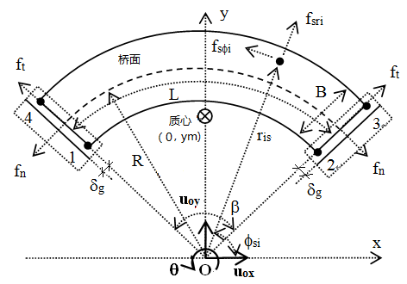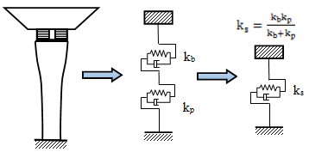

Figure 1. Schematic of the arc bridge, and equivalent recovery force

Taking the deck as the research object, point O as the origin point, axes of symmetries as the x- and y- axes, and assuming the deck is rigid, the 3 degrees of freedom (DOF) equations of motion of the bridge with repect to (w.r.t) point O ($U_{o}\left(t\right)={\left\{u_{ox},u_{oy},{}_{o}\right\}}^{T}$) can be written as:

$M{\ddot{U}}_{o}\left(t\right)+C{\dot{U}}_{o}\left(t\right)+KU_{o}\left(t\right)+H_{s}\left(t\right)+F_{p}\left(t\right)=-{MR}_{g}{\ddot{U}}_{g}(t)$ (1)

where,

$M=\left[\begin{matrix}M & 0 & -My_{m} \\ 0 & M & 0 \\ -My_{m} & 0 & I_{o}\end{matrix}\right]$, $K=\left[\begin{matrix}K_{XX} & K_{XY} & -K_{}r_{s}\sin_{s} \\ K_{XY} & K_{YY} & {K_{}r}_{s}\cos_{s} \\ -K_{}r_{s}\sin_{s} & {K_{}r}_{s}\cos_{s} & K_{}+{r_{s}^{2}K}_{}\end{matrix}\right]$,

and

$K_{}=\sum_{i}{[{}_{si}k_{si}\left(r_{si}^{2}-r_{s}^{2}\right)+k_{si}]}$, $K_{}=\sum_{i}{[{}_{si}k_{si}]}$, $K_{XX}=\sum_{i}{[{{}_{sri}k_{sri}\cos^{2}{}_{s}+}_{si}k_{si}\sin^{2}{}_{s}]}$

$K_{YY}=\sum_{i}{[{{}_{sri}k_{sri}{\sin^{2}}_{s}+}_{si}k_{si}{\cos^{2}}_{s}]}$ , $K_{XY}=\sum_{i}{[{(_{sri}k_{sri}-}_{si}k_{si})sin{}_{si}cos{}_{si}]}$ (2)

where, $k_{sri}$, $k_{si}$ are stiffnesses from decking supports, and were solved from the series pier-bearing system as in the Figure 1. ${}_{sri}$ , ${}_{si}$ are post-yield stiffness ratios,$r_{si}$ and ${}_{si}$（anti-clockwise）are polar ($r-$) coordinates for the ith pier, is the damping ratio, $C$ is the 2nd-order Rayleigh damping matrix, $y_{m}$ is the y-coordinate of COM, and$r_{s}$ and ${}_{s}$ are polar coordinates of the COS. In this paper, $=0.02.$ The subscripts $r$ and represent radial and tangential directions, respectively.

2.2 Recovery forces

The recovery force vector of the ith pier is $F_{si}={\left\{f_{sri},f_{si},{}_{si}\right\}}^{T}$. It is provided by bearings and supports in $r-$ coordinate system. It is the sum of non-hysteretic force and hysteretic force:

$F_{si}(t)=K_{si}U_{si}(t)+H_{si}(t)$ (3)

where, $H_{si}(t)={\left\{h_{sri},h_{si},0\right\}}^{T}$ is the hysteretic portion. When applied to Equation (1), $F_{si}$ is required to change into x-y coordinate system.
In this paper, ${}_{sri}=_{si}=1$ , i.e., $K{=K}_{o}$, and $H_{si}\left(t\right)=0$. Pounding force $F_{p}\left(t\right)$ is not considered, either.

2.3 State-space form equations

In order to establish the Matlab and Simulink model for simulation and calculations, Equation (1) can be changed as:

${\ddot{U}}_{o}\left(t\right)=-M^{-1}C{\dot{U}}_{o}\left(t\right)-M^{-1}KU_{o}\left(t\right)-R_{g}{\ddot{U}}_{g}\left(t\right)-{M^{-1}H}_{s}\left(t\right)-M^{-1}F_{p}\left(t\right)$ (4)

Define state vector $Z={\left\{\begin{matrix}U_{o} & {\dot{U}}_{o}\end{matrix}\right\}}^{T}$，the equation and outputs are written as:

$\dot{Z}=AZ+B{\ddot{U}}_{g}+EU$, $Y=C_{out}Z+D_{out}{\ddot{U}}_{g}+E_{out}U$ (5)

where ${\ddot{u}}_{g}={\left\{\begin{matrix}{\ddot{u}}_{gx} & {\ddot{u}}_{gy}\end{matrix}\right\}}^{T}$ is input vector, ${U=\{\begin{matrix}H_{s} & F_{p}\end{matrix}\}}^{T}$ is nonlinear recovery and pounding force vector and not considered herein. $Y$ is the output vector,$C_{out}$, $D_{out}$ and $E_{out}$ depend on the output type, and：

$A=\left[\begin{matrix}0 & I \\ -M^{-1}K & -M^{-1}C\end{matrix}\right]$，$E=\left[\begin{matrix}0 & 0 \\ -M^{-1} & -M^{-1}\end{matrix}\right]$，$B=\left[\begin{matrix}0 \\ -R_{g}\end{matrix}\right]$ , $R_{g}=\left[\begin{matrix}1⁡ & 0 \\ 0 & 1 \\ 0 & 0\end{matrix}\right]$ (6)

When bi-directional earthquakes input at angle $α_{g}$ w.r.t x-axis, term “1” in $R_{g}$ would change accordingly.

3. Controllability Measures

Controllability and observability indicate how well the states can be “reached” by inputs and how well the states can be “recovered” from outputs, respectively. Controllability, as a coupling between the inputs and the states, involves the system matrix A and the input matrix B. Observability, as a coupling between the states and outputs, involves the system matrix A and the output matrix C. Generally, controllability and observability properties are determined either by the rank of the controllability or observability matrices, or by the grammians, which is shown in Equations (8):

$W_{c}=\int_{0}{e^{-At}BB^{T}e^{-A^{T}t}dt}$, $W_{o}=\int_{0}{e^{-A^{T}t}C_{out}^{T}C_{out}e^{-At}dt}$ (7)

However, Grammians vary with coordinate systems. But the eigenvalues of the product of $W_{c}$ and $W_{o}$are invariant under linear transformations. These invariants are called Hankel singular values(HSV) of the system, denoted by $γ_{i}$, i.e.,

$γ_{i}=\sqrt{λ_{i}(W_{c}W_{o})}$ (8)

where $λ_{i}(.)$ denotes the eigenvalue.

4. Prototype of the study

The prototype of this study is an overpass curved bridge with span lengths of 46m, 74m, 74m, and 46m, and radius of 100m. It is made of steel box beam supported on single column piers. The mass of the bridge is 1.07×106 kg. On the top of the pier lay the rubber bearings. Figure 2 are the pictures of the bridge.

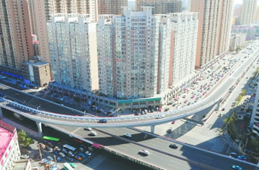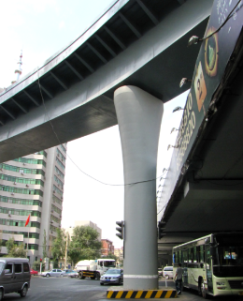

Figure 2. Pictures of the bridge

Table 1 shows the two types of bearings used in the analysis. LNR700 is regular rubber bearing, and LRB700-140 is high-damping lead rubber bearing.

Table 1. Bearings of the bridge model.

Parameters of bearings | LNR700 |  | LRB700-140
Vertical stiffness K_{v},(kN/mm) | 4800 | 4154
Equivalent horizontal stiffness K_{h},(kN/mm) | 1.922 | 2.843
Rubber thickness T_{r},(mm) | 240 | 24
Equivalent damping ratio % | 5 | 26.4
Post-yield stiffness ratio（α_{ri}, α_{φi}） | 1.0 | 0.114
Ultimate displacement % | 400% | 400%

5. Eccentricity cases for study

Eccentricity is inevitable for a curved shape because the center of mass (COM) does not coincide with the center of rotation (COR). This paper would examine 3 sources of eccentricities for curved bridges: geometry eccentricity (radius) with 3 radii of 90 m, 100m, 110m, respectively; physical (location of stiffness of rotation) eccentricity with 3 different restriction cases (bearing arrangement cases of symmetric, unsymmetric 1, unsymmetric 2, respectively) that results in different stiffness locations, and earthquake input directions w.r.t the x- direction. See Figure. 3

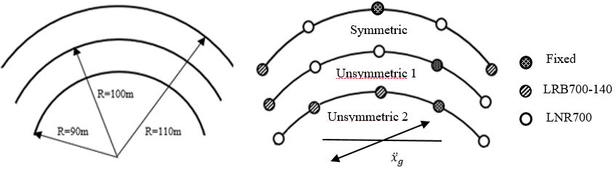

Figure 3. Eccentricity cases

With the equations of motion, the center of mass (COM) and the center of rigidity (COR) could be found, which is plotted in Figure 4:

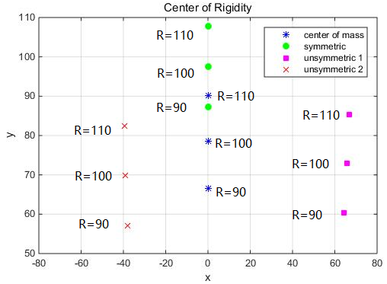

Figure 4. COM and COR locations for different radius and bearing arrangement

It can be seen that, the distance of COR from COM in x- direction is in the order of: unsymmetric 1> unsymmetric 2 > symmetric; the overall distance of COR from COM in y- direction is in the order of: symmetric > unsymmetric 2 > unsymmetric 1. So it can be predicted that, when ground motions input in y- direction, the largest rotation (moment) should occur in the unsymmetric 1 cases with R = 110m, while when ground motions input in x- direction, the largest rotation (moment) should occur in symmetric cases with R = 90m. The unsymmetric 1 cases are in between the two conditions and are more balanced but y- direction earthquakes would impact more on it. These phenomena agrees with the common sense.
Also notice that COR of symmetric cases are all above the COM, while the other 2 conditions are all below the COM.

6. results

First, mode shapes of the 3 (sym., unsym.1, unsym,2) cases were shown in Figure 5. It shows that, in case (a), mode 1 is symmetric w.r.t y-axis, mode 3 is anti-symmetric w.r.t y-axis, and mode 3 moves the most at the middle point (pt. #3) along the y-axis. In case (b), mode 1 & 3 are anti-symmetric about y-axis, while mode 2’s motion concentrates in the 3rd span. For case (c), mode 2 & 3 are anti-symmetric about y-axis, while mode 1’s motion concentrates in the 3rd span. So it does not loss generality to take the left end (pt. #1) as the example to examine the bridge’s responses, it only does not capture mode 2 of the case (a), mode 3 of case (b) a little weak. So the following Pt. #1 is used to show the calculations.
The controllability grammians of Pt. #1 were given Figure 6:

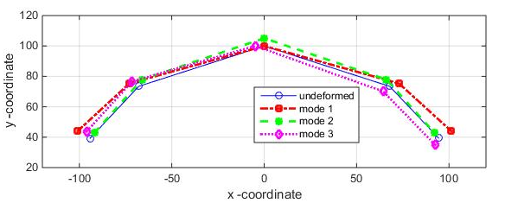
- Symmetric case
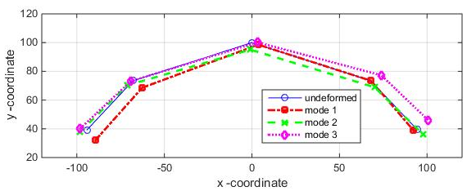
- Unsymmetric 1 case
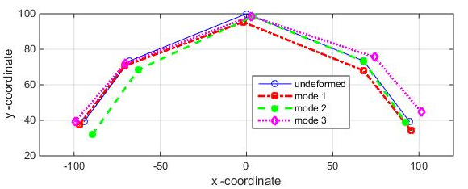
- Unsymmetric 2 case

Figure 5. Mode shapes

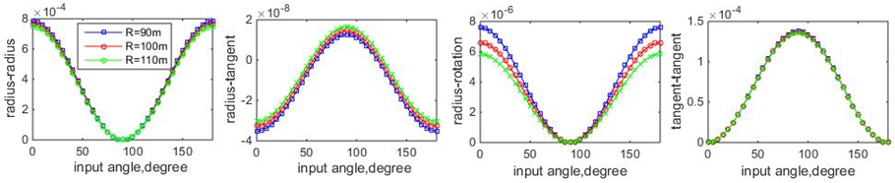
(a) Symmetric case
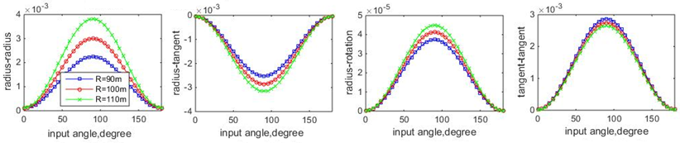
(b) Unsymmetric 1 case
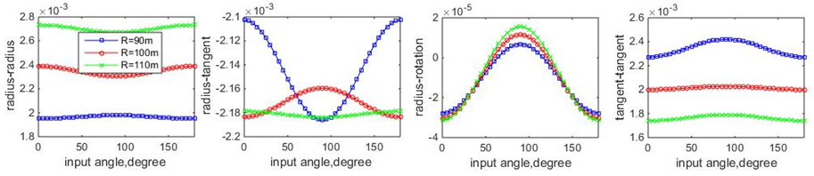
(c) Unsymmetric 2 case

Figure 6. Controllability grammians

It shows that, the controllability grammians change greatly with earthquake input directions, and 90 is a symbolic direction,when the diection is in y- direction.
For case (a), earthquakes impact on the radius-radius and radius-rotation coupling greater when input angle are small, when input angle are large, the controllability is weak because values are small. The dimension of radius overall does not make difference except ground motions are at small angles (near x-), when R=90 have relatively larger controllability. This agrees with the eccentricity analysis in the former section. So end beam-falling might occurs during x- direction earthquake for small radius bridge.
For case (b), controllability is large when input angle is near y- direction, for all responses and coupling, and larger radius are more controllable. In other word, y- direction inputs induce greater responses and coupling, especially for R =110. The fact also agrees with eccentricity analysis in the former section.
For case (c), controllability varies with radius greatly. Small radius of 90m responds greatly in tangent direction while large radius of 110m responds greatly in radius direction, and are not very sensitive with earthquake directions, but the radius-tangent coupling are relatively large for 60⁰ and 140⁰ earthquakes. This also confirms the eccentricity analyses in the former section in that this case is more balanced and stable.
To see how bridge motions in different directions couple, the ratios of Hankel Singular Values (HSV) of different motions were calculated and plotted in the Figure 7:

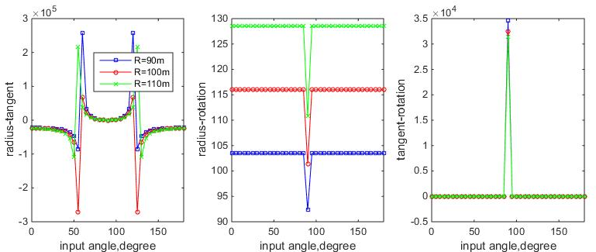
(a) Symmetric case
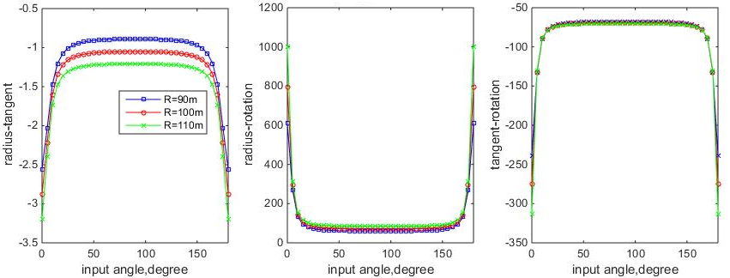
(b) Unsymmetric 1 case

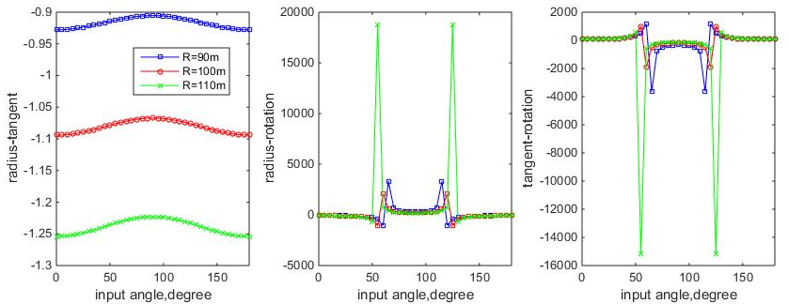
(c) Unsymmetric 2 case

Figure 7. Hankel singular value ratios

Figure 7 shows that, in case (a), the radius-tangent HSV ratios have an abrupt change (even change directions) when the earthquake input angles near #2 and #4 supports, indicating that at the two directions, the bridge’s motion may transfer from radius-direction-dominated to tangential-direction-dominated with small earthquake direction changes. At 90ºinput, #3 also change greatly. But it still is not sensitive to bridge radius, which is the same as in the other analyses.
HSV ratios of case (b) mostly remain the same values for all ground motion directions, except for very narrow range of x- direction earthquakes. This agrees with the previous analyses in that case (b) are sensitive to y- direction earthquakes because its COR deviates from COM a lot along x- direction.
For case (c), the 1st plot shows that it is sensitive to radius change; the 2nd and 3rd plots shows that around 60⁰ and 140⁰ ground motions, the rotation coupling effects are strong.
This paper only provides some primitive analysis using the controllability concepts. More work needs to be done to further examine and confirm the grammians on the seismic behavior analysis of curved bridges.

7. Conclusions

The paper introduced the concepts of controllability into the coupling effect analysis of curved bridges with different radius and bearing stiffness, to analyze the impact of eccentricity on the behaviors of curved bridges. Results show that, different radius and bearing placement would change the eccentricity of the curved bridges, and inevitably changes the potential seismic behaviors. Analysis showed that, controllability grammians and Hankel Singular Values grow large when bridge responses are large, and they could provide information on coupling effects, adverse earthquake direction, and so on. The analyses based on them reached similar conclusions to eccentricity and modal analyses and agree with the common sense. So they could be proper tool for curved bridge pre-design and analysis, because this analysis makes the seismic behaviors of bridges more predictable.

6. Acknowledgments

This work is acknowledged to National Natural Science Foundation of China (50578517)；Heilongjiang Provincial Natural Science Foundation (E2015071)； Innovative Team Project of Guangdong Provincial Education Department（2016KCXTD016）.

7. References

AASHTO (2011), AASHTO LRFD Bridge Design Specifications, American Association of State Highway and Transportation Officials, Interim Revisions. Washington, DC.
Amirihormozaki E., Pekcan G., and Itani A. (2015). Analytical Modeling of Horizontally Curved Steel Girder Highway Bridges for Seismic Analysis. Journal of Earthquake Engineering, 19:220–248. DOI：10.1080/13632469.2014.962667.
Amjadian M., Agrawal A. Rigid-body motion of horizontally curved bridges subjected to earthquake- induced pounding [J]. Journal of Bridge Engineering, 2016, 21(12): 1―20.
Caltrans (2013), Caltrans Seismic Design Criteria Version 1.7, California Department of Transportation Division of Engineering Services, April.
Dimitrakopoulos, E. G. (2011). Seismic response analysis of skew bridges with pounding deck–abutment joints. Engineering Structures, 33(3), 813–826.
Guidelines for seismic design of highway bridges (JTG/T B02-01-2008) [S], Beijing: China Communication Press, 2008. (in Chinese)
Ijima, K., Obiya, H., Aramaki, G., and Kawasaki, N. (2001). A study on preventing the fall of skew and curved bridge decks by using rubber bearings. Structural Engineering and Mechanics, 12(4), 347–362.
Maleki, S. (2002). Deck modeling for seismic analysis of skewed slab-girder bridges. Engineering Structures, 24(10), 1315–1326.
Tseng, W. S., and Penzien, J. (1975a). Seismic response of long multiple-span highway bridges. Earthquake Engineering and Structural Dynamics, 4(1), 25–48.
Tseng, W. S., and Penzien, J. (1975b). Seismic analysis of long multiple-span highway bridges. Earthquake Engineering and Structural Dynamics, 4(1), 1–24.
Wang Yumei, Guo Xun. Field modal test and seismic check of a curved overpass bridge[J]. Earthquake Engineering and Engineering Vibration, 2015, 35(2): 63―70. (in Chinese)
Wieser, J., Zaghi, A., Maragakis, M., and Buckle, I. (2012). A methodology for the experimental evaluation of seismic pounding at seat-type abutments of horizontally curved bridges. Structural Congress, 10.1061/9780784412367.055, 613–624.
Williams, D, Godden, W. (1979). Seismic response of long curved bridge structures: experimental model studies, Earthquake Engineering and Structural Dynamics, 7:107-128.
Wang, Y. (2006). “Control strategies for 3D smart base isolation systems Using modal and nodal approaches.”PhD Dissertation, Washington University in St. Louis.Zvezdov A.I., Smirnova L.N., Vedyakov I.I., Bubis A.A. (2017) Earthquake engineering of the Russian Federation as a priority direction of activity of JSC Research Center of Constructions. Earthquake engineering. Constructions safety, (6): 11-26.

Assoc. Professor, Guangdong Provincial Key Laboratory of Earthquake Engineering and Applied Technology, Guangzhou University, China; Earthquake Mitigation and Structural Safety, Ministry of Education, Guangzhou University, China; ymwang@gzhu,edu.cn
Professor, Guangdong Provincial Key Laboratory of Earthquake Engineering and Applied Technology, Guangzhou University, China; Earthquake Mitigation and Structural Safety, Ministry of Education, Guangzhou University, China. Ptan@gzhu.edu.cn

