**STUDY ON DAMPING EFFECT OF VARIABLE FRICTION DAMPER WITH BUTTERFLY HYSTERETIC CURVE**

**DOI 10.37153/2686-7974-2019-16-1098-1111**

LI Che**[1]**, XUE Yan-tao**[2]**, YAN Wei-ming**[3]**

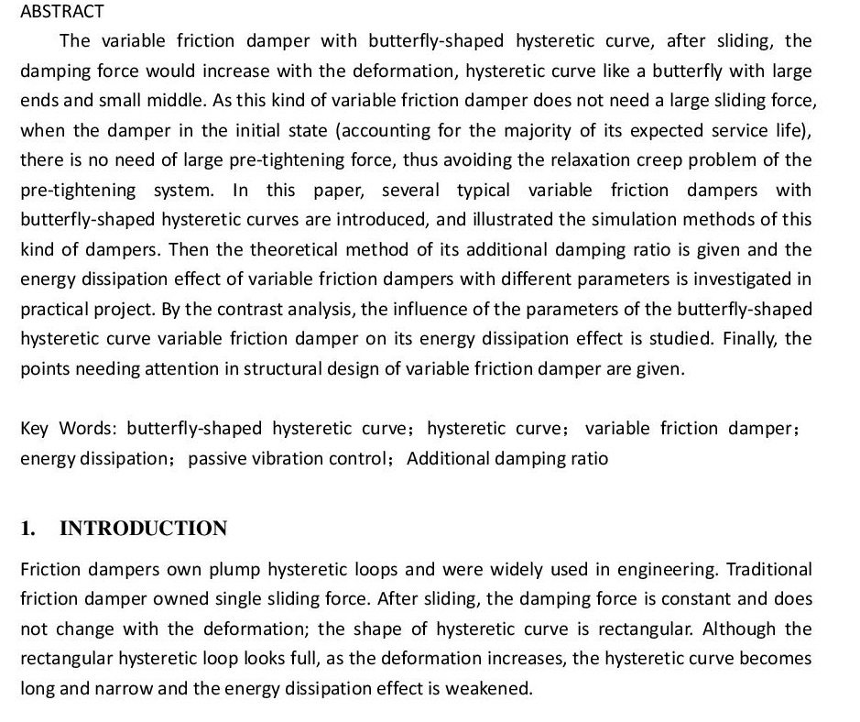

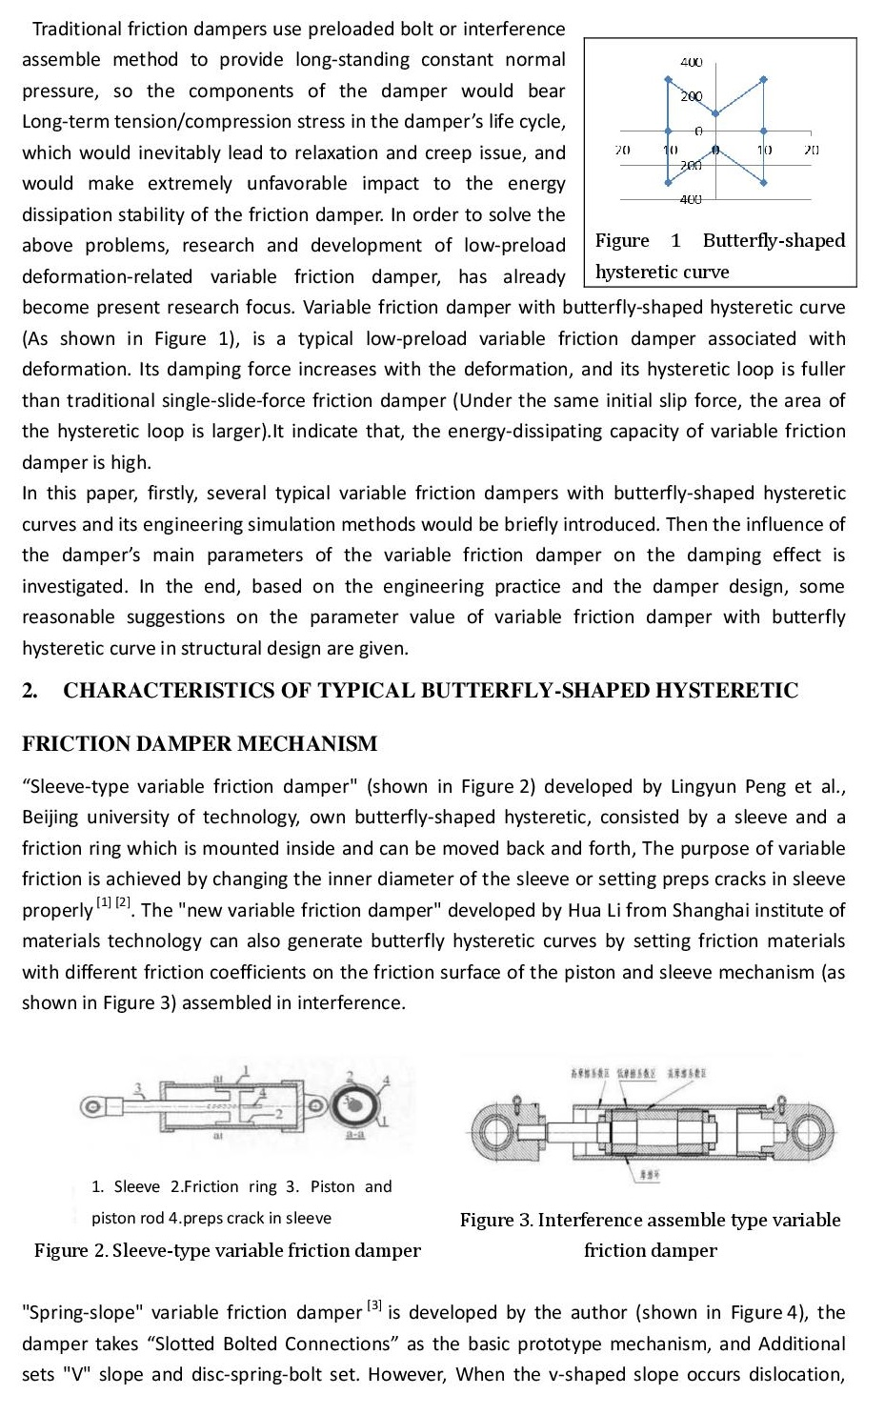

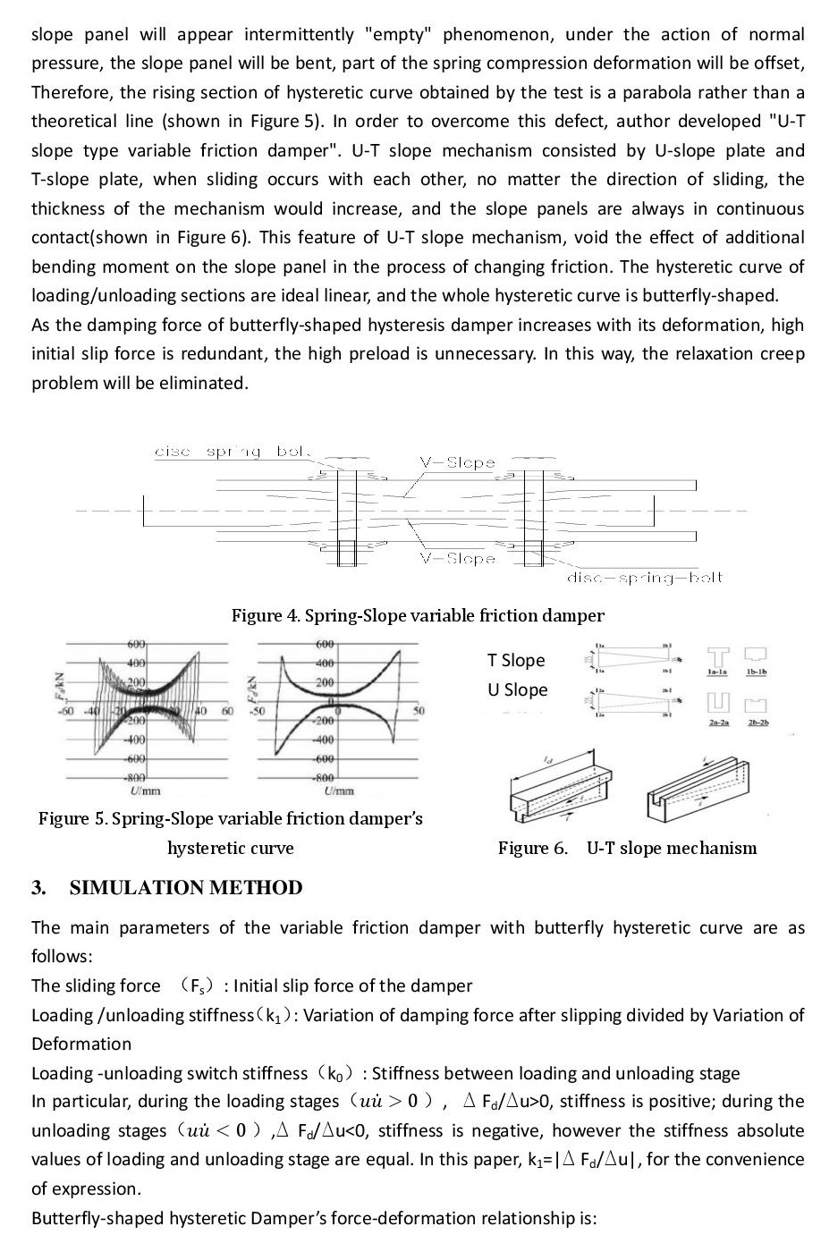

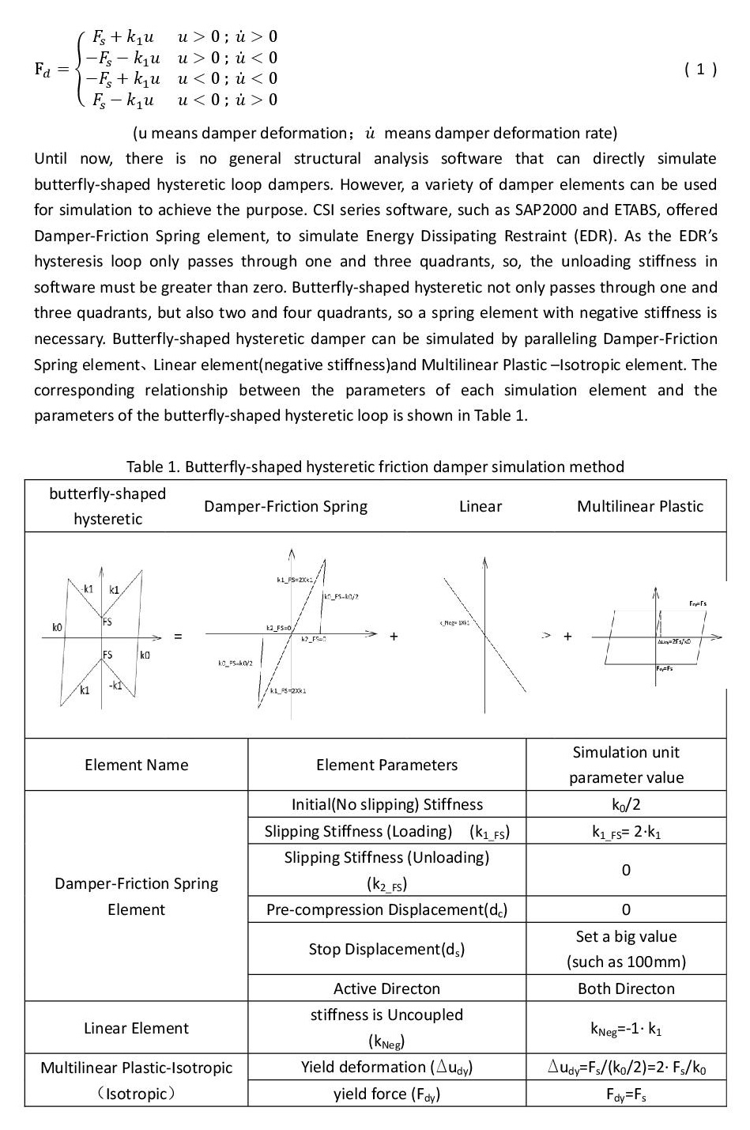

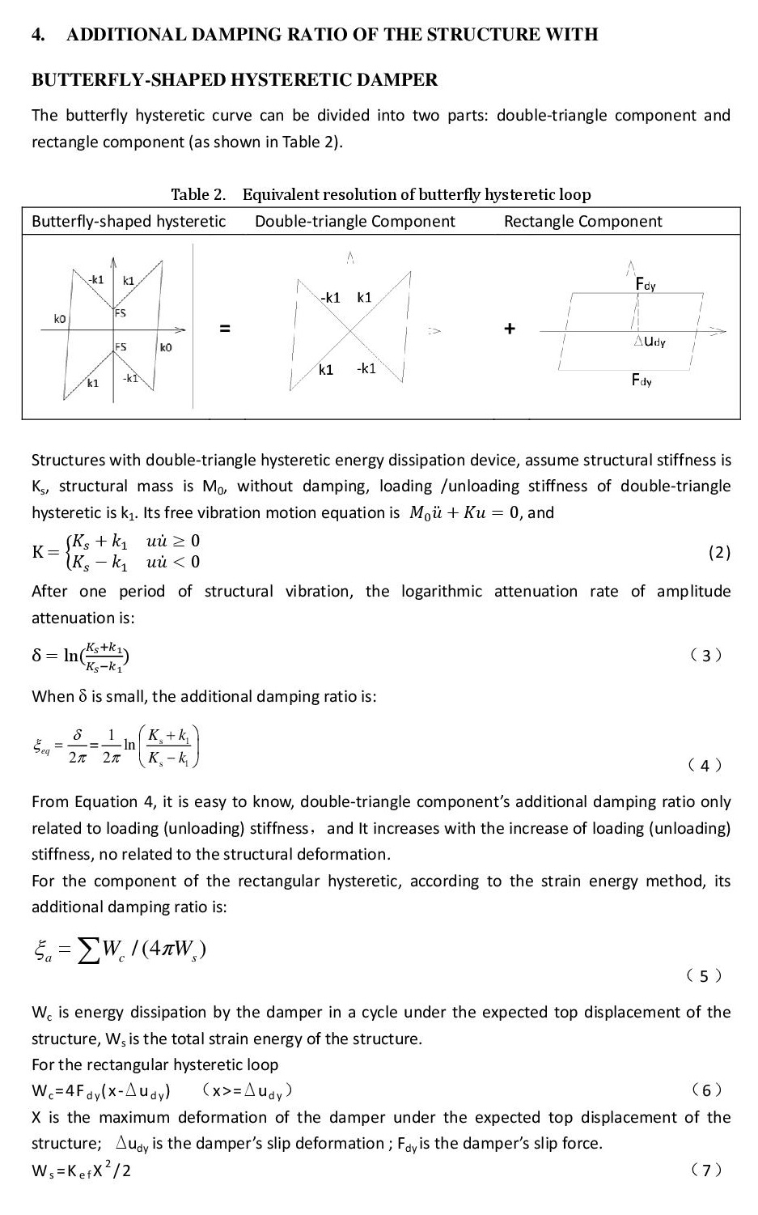

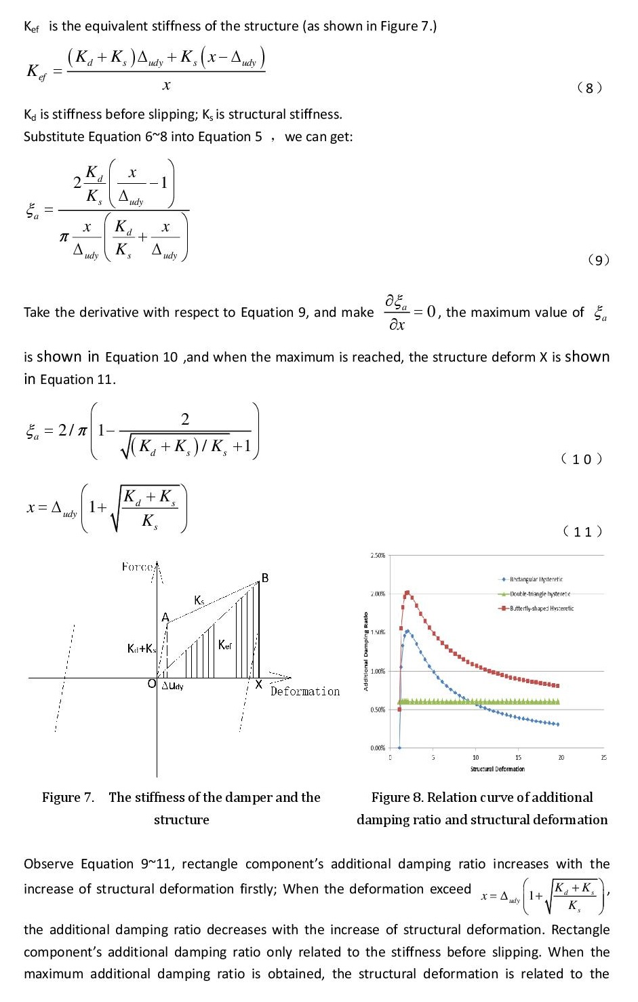

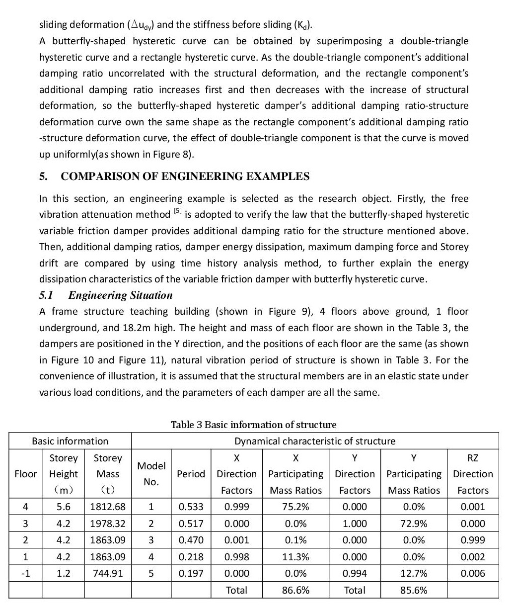

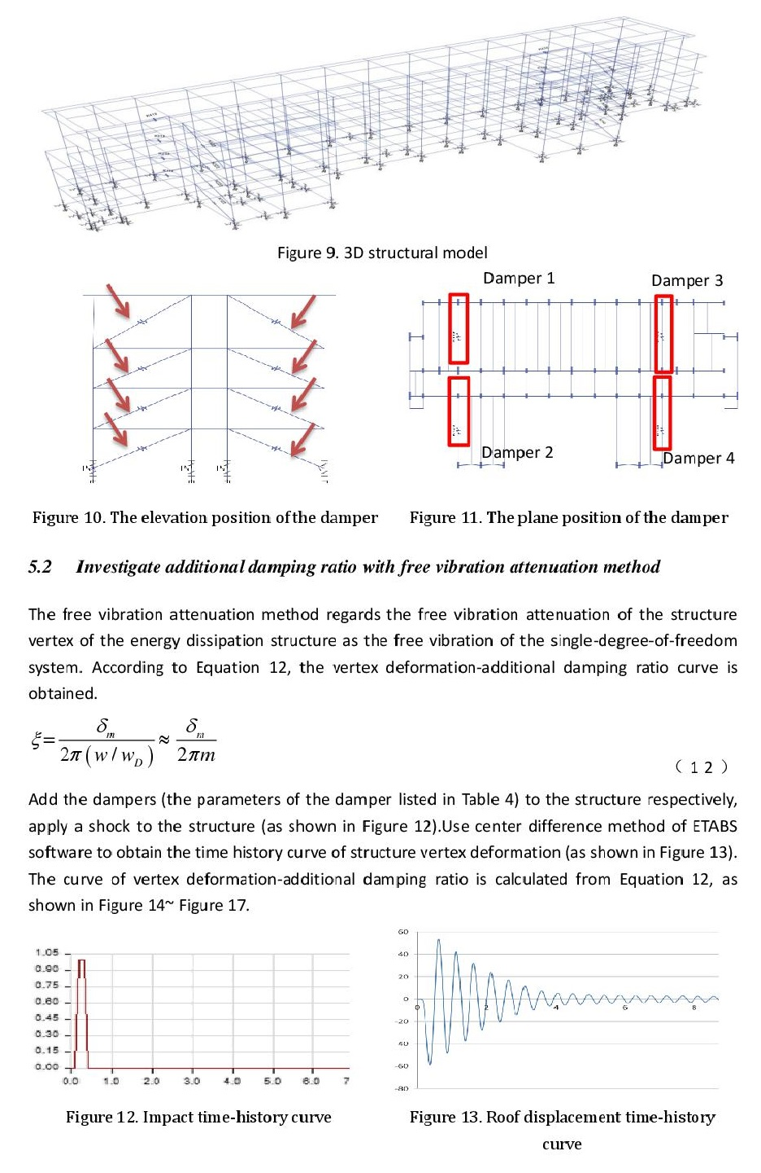

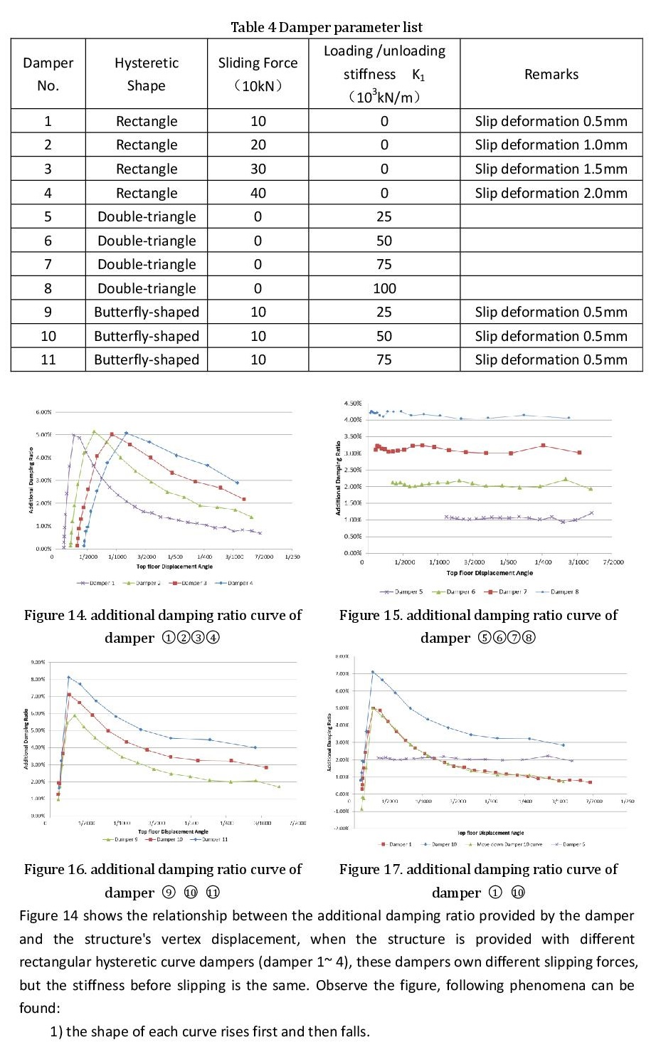

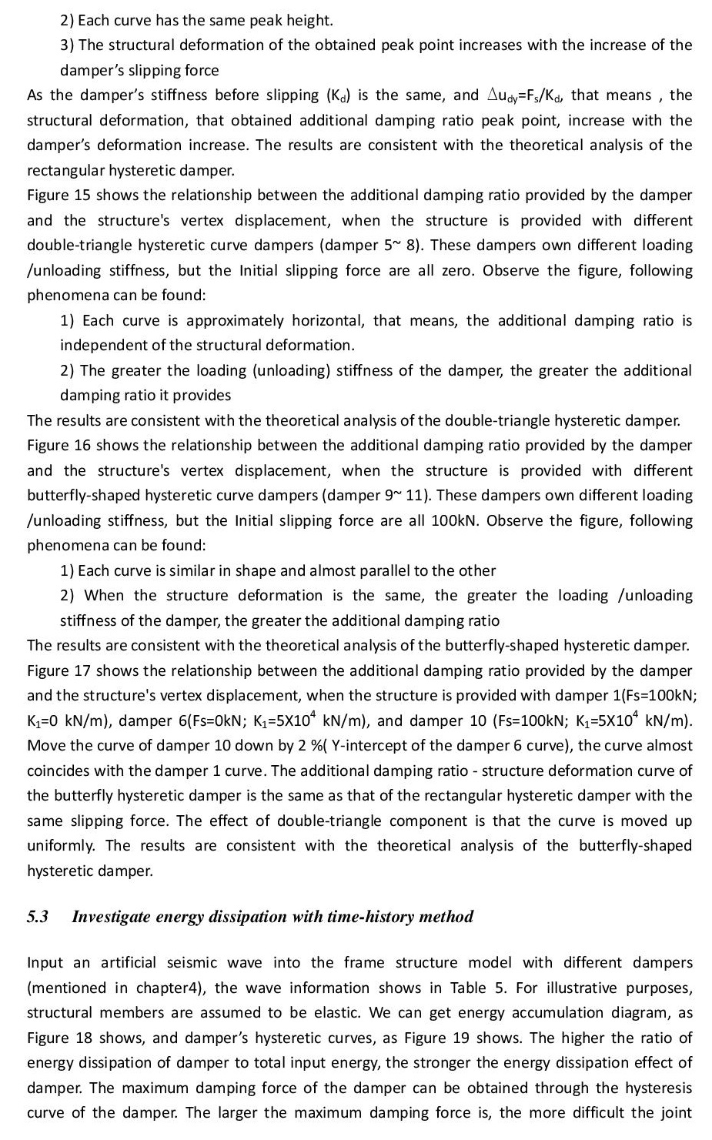

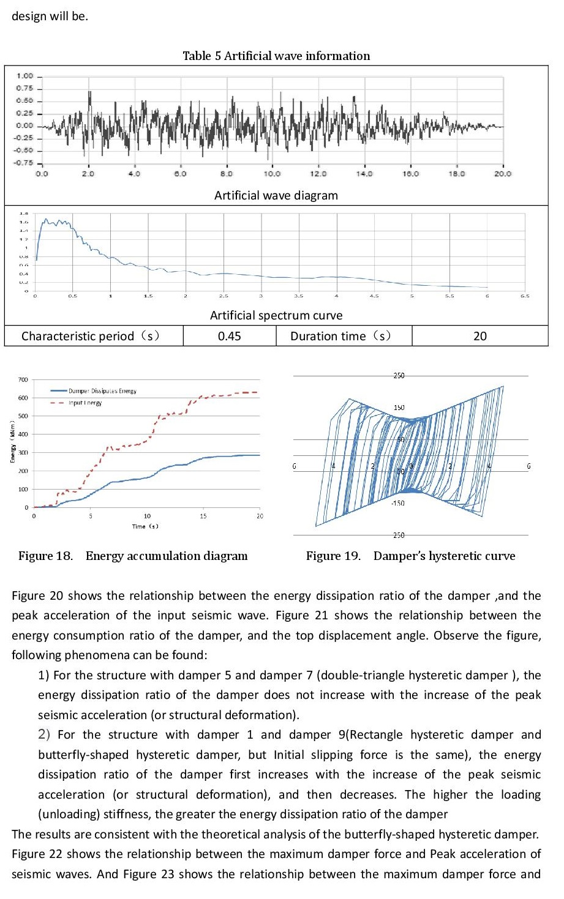

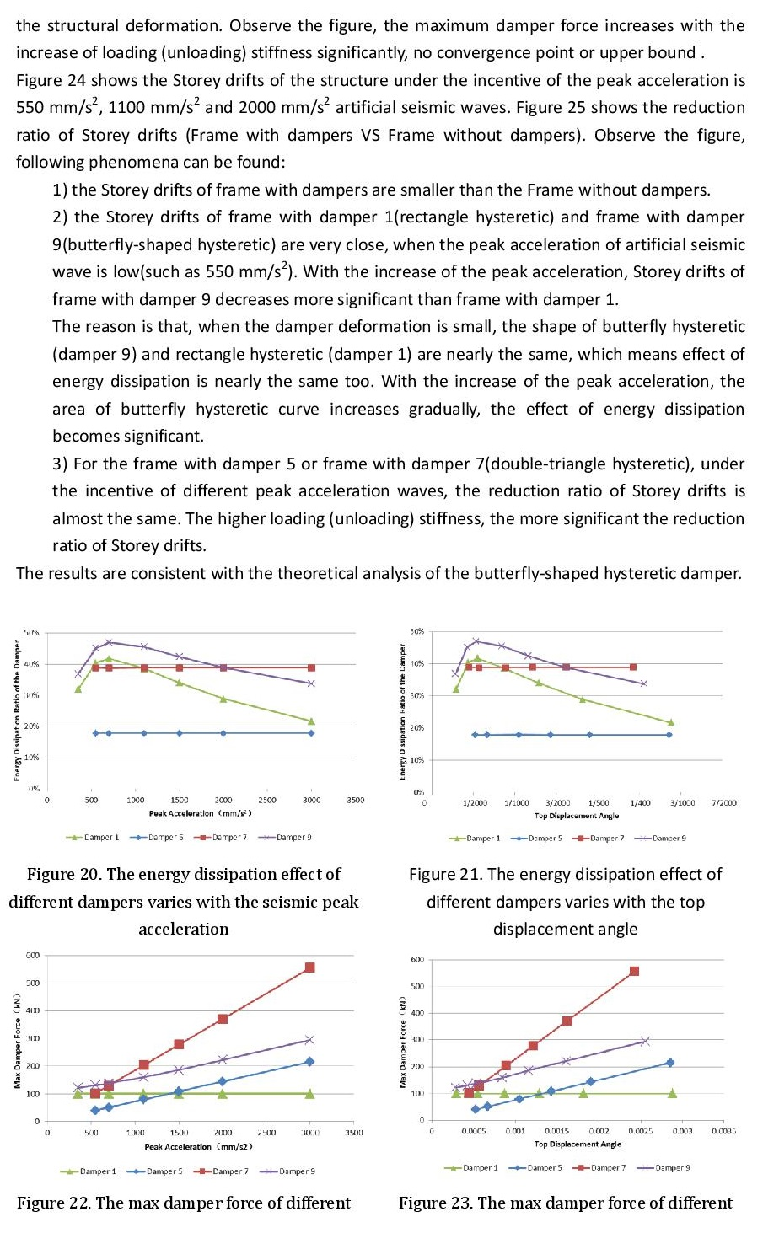

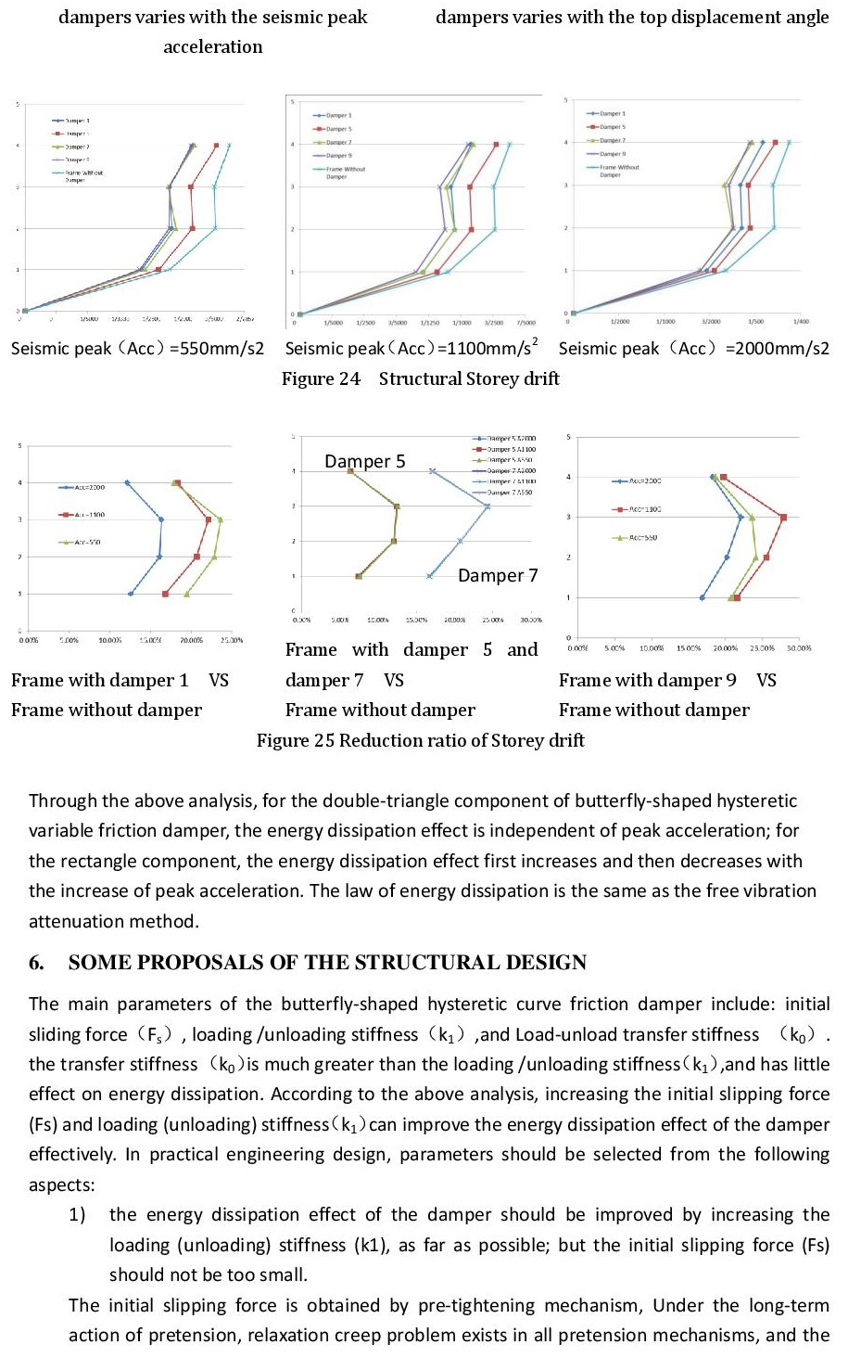

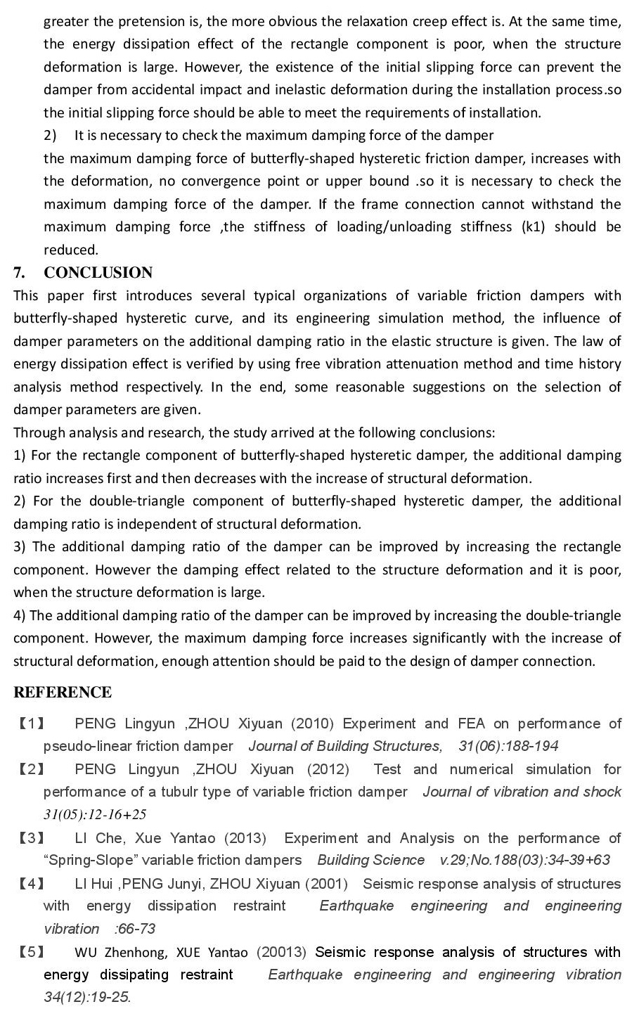

1. Beijing Laboratory of Earthquake Engineering and Structural Retrofit, Beijing University of Technology, Beijing, China, lichewin@163.com
2. China Academy of Building Research, Beijing, China, xueyantao@cabrtech.com
3. Beijing University of Technology, Beijing, China