Targeted Energy Transfer by a Double-Well Potential Nonlinear Energy Sink for Structural Seismic Control

DOI 10.37153/2686-7974-2019-16-1023-1040

Yangyang CHEN, Zhichao QIAN, Ping TAN, Xiangyun HUANG

ABSTRACT

A double-well potential nonlinear energy sink (NES) is presented to enhance passive targeted energy transfer from the primary structure to the attached NES under seismic excitation. A one-story moment-resistant frame is considered as a primary structure, which is attached with the present NES device. After deriving the governing equations of the system, numerical optimization is carried out to select the appropriate design of the device. Based on the numerical study results, shake table tests are carried out to verify the control effect. Good agreement between simulation and experiment is derived after the structural identification and calibration. The experimental results validate the numerical predictions that a significant fraction of energy introduced directly to the primary structure by seismic excitation, can be rapidly transferred to the present NES and be dissipated. The seismic performance of the present NES is compared with those of the linear tuned mass damper (TMD) and the cubic NES. The comparison shows that the attenuation observed under the present NES control is competitive and is totally more robust in respect to variation of the primary structural stiffness. This is found to be achieved by an immediate cascade of broadband internal resonance captures especially in low frequency domain, as the essential cause of high efficiency of the present NES system.

Keywords: Seismic response control; nonlinear energy sink; negative stiffness; sliding friction; transient internal resonance

1. INTRODUCTION

The last decades saw rapid development of passive vibration absorbers for engineering structures [1, 2]. Many absorbers were designed as linear or equivalent linear tuned mass damper (TMD) targeting predominant frequency of primary structure. Energy imparted on the primary structure can partly be transferred and dissipated through the TMD device. However, the controlling frequency bandwidth of traditional TMD system is narrow because of the fixed natural frequency of linear system. Once the frequency of the real-time structural response deviate from the theoretical design value, the TMD system will be inefficient as the linear resonance will fail to be thoroughly triggered, i.e., becomes detuned. Furthermore, structural damages or dynamical property variations, such as stiffness degradations under high-level earthquakes, can also lead to detuning of TMD.
Seismic control by fully passive absorber can be achieved using nonlinear energy sink (NES) [3]. A NES is a mass damper with nonlinear stiffness, which enables it to capture potential internal resonance with the primary structure attached to. Such internal resonance can only be triggered in nonlinear system at multiple resonance (wider bandwidth) frequencies. Thus, many researchers paid efforts to develop NESs with different nonlinear stiffness, to achieve high performance with stronger robustness of passive control. Some of them have already been investigated numerically and experimentally. For instance, McFarland et al. [4] realized the cubic NES (Type I NES) in lab by using transverse elastic wire which yields geometrically nonlinear restoring force. Nucera et al. [5, 6], Ahmadi et al. [7], Gendelman et al. [8], Li et al. [9] presented vibro-impact NESs, which can absorb the vibration energy of the primary structure by transient internal resonance captured at high frequencies. Luo et al. [10] completed the shaketable test on the large-scale structure model, for which cubic NES and vibro-impact NES were adopted for seismic control. They designed specially shaped polyurethane bumpers as stiffness elements to realize another kind of cubic NES. Wierschem et al. [11] proposed a two-degree-of freedom NES, for which they connected two cubic NES in series as one. Gendelman et al. [12] introduced a NES designed as a simple rotating eccentric mass, which can rotate with broadband frequency and resonate with multiple modes of the primary system. Wang et al. [13, 14, 15], Lu et al. [16] proposed the track NES, for which they shaped the track to determine the character of the nonlinear restoring force of the auxiliary moving mass.
The types of NES mentioned above have already been studied and their performance have also been experimentally verified. New concepts of NES have also been theoretically proposed. For example, Schmidt and Lamarque [17], Lamarque and Savadkoohi [18], proposed the NES involving non-smooth Saint-Venant terms. Al-Shudeifat [19] proposed a modification of the cubic NES configuration, to generate negative stiffness of the NES. He [20] also presented a magnet-based NES in which the asymmetric nonlinear magnetic repulsive force is generated by two pairs of aligned permanent.
An overview of the NES researches reported so far only the control performances of the cubic NES, the vibro-impact NES, the track NES, and their combination forms have been investigated with respect to seismic excitations. Under seismic excitations, the cubic NES provides lower efficiency with comparison to the vibro-impact NES [10]. The track NES was suggested to be combined with single-side impact surface to improve the seismic control performance [15]. However, structural collision generated by impacts is less popular for many real civil engineering structural designs, because they demand much higher structural requirement to resist full-scale collision effect at the installation location, even though they can scatter the energy in higher frequency domain.
In this paper we propose another type of NES that avoid impact but, can still achieve high performance for seismic control. Double-well potential property is considered in the present NES device, for which the control scheme is not to scatter the energy in higher frequency responses, but to capture cascade of internal resonance in broadband, especially in lower frequency domain. This enables the present NES to scatter the seismic energy by rapid long-stroke friction. Based on the numerical study, the testing device is also realized and a series of shake table tests are carried out to validate the predictions. The robustness of control performance is investigated with respect to variation of structural stiffness and peak ground acceleration (PGA). Comparison studies of the present NES, the TMD, and the cubic NES are studied.

2. Problem formulation

2.1 NES with negative stiffness and sliding friction

The cubic NES can be realized by geometrical nonlinear behavior of elastic elements, as shown in Figure 1(a). In the figure, the nonlinearity is realized by a moving mass hinged with transverse linear elastic elements when they are not compressed or elongated at their vertical position. Referring to the geometry, in the operational (horizontal) direction a restoring force F can be generated by a moving drift u in cubic nonlinearity, under truncated Taylor approximation. Previous experiments [3, 4] validated this NES performance by using piano wire as the elastic elements, which can only be stable in tension.
Once the transverse elastic elements are designed to be compressed as they are aligned in their vertical position, the layout becomes bi-stable geometry. In such case, the movable mass possesses two static equilibrium positions, i.e. u = ±u_{c}, at which both elastic elements are not stretched or compressed as shown in Figure 1(b). Consequently, a negative stiffness interval of the NES can be generated, with which performance improvement under impulse excitations had been verified theoretically [19]. However, such elastic element requires instability prevention due to its tension-compression multifunctional design. For instance, typical distortions of hinged springs in the negative stiffness interval is shown in Figure 2.

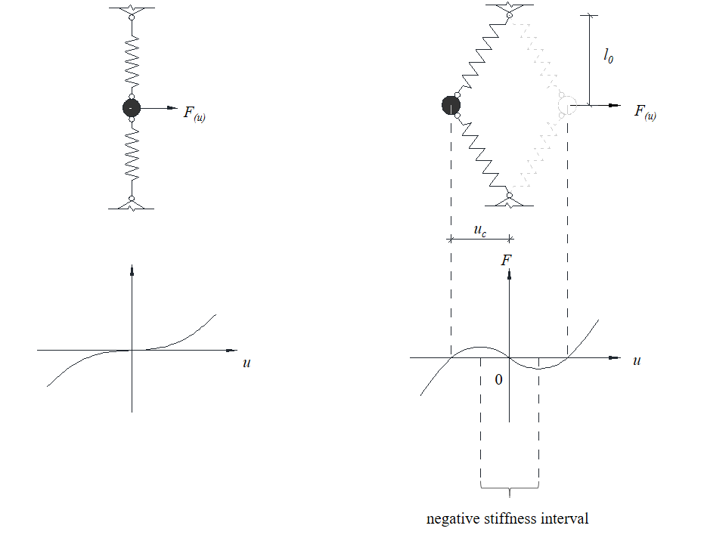
(a) Cubic NES | (b) NES including negative stiffness

Figure 1. Two typical types and restoring force diagrams of NES

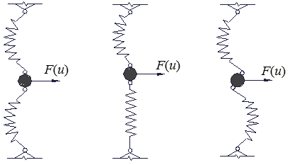

Figure 2. Some typical buckling forms of hinged springs in compression state

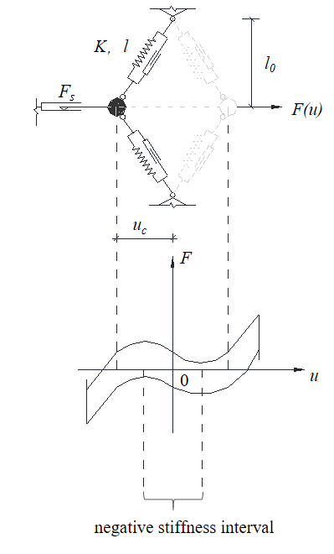

Figure 3. Conceptual layout of NES with negative stiffness and sliding friction

In this paper, considering feasible realization of the present NES device, we adopt elastic coil springs and added sliding tracks and guiders to prevent instable distortions of the device (Figure 3). In the present case, the friction force F_{s} of the slider has to be considered, as it is designed to support the entire weight of the NES mass. We utilized such sliding friction as damping of the present NES, to replace the widely used equivalent viscous damper in previous studies [3-20]. Moreover, we neglected frictions of the two guiders coupled to the springs, as they are non-bearing components with much smaller friction forces. Hence, the reaction force of the present NES is

, (1)

where k and l are the constant stiffness and relaxation length of the hinged spring, and

. (2)

The friction force f is expressed as
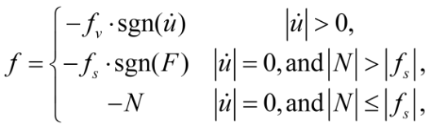 (3)

where N is the lateral resultant of external forces except of friction force, and sgn denotes the commonly used sign function. Here, f_{v} is the sliding friction force, f_{s} is the maximum static friction force beyond which sliding can happen. A typical hysteretic constitutive model Equation (1) governs is presented in Figure 3, from which the area enclosed by the hysteretic loop corresponds to the energy dissipated per cycle.

2.2 Governing Equations

A one-story moment-resistant frame in the laboratory of Earthquake Engineering Research & Test Centre at Guangzhou University serves as the primary structure of the study. Conceptual configuration of the primary frame combined with the present NES on its top is shown in Figure 4. A 2-DOF governing equations can be formulated for the combined system as

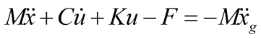, (4)

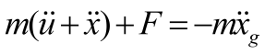, (5)

where M, K, C is equivalently the floor mass, the lateral stiffness, and the viscous damping coefficient which represents the structural damping effect of the primary frame. m is the mass of the present NES. x is the story drift of the primary DOF and u is the relative drift of the NES mass on it. is the acceleration of ground motion. For the present system, the friction forces can be expressed as

, (6)

, (7)

where μ_{v} and μ_{s} are the sliding and static friction factors, respectively.

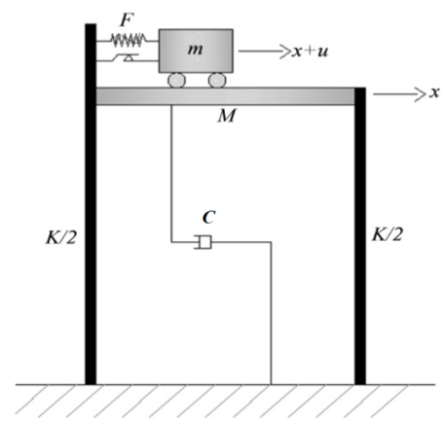

Figure 4. Conceptual layout of the primary structure with the present NES

3. Performance optimization

3.1 Primary structure identification

The primary structure consists of a steel moment resisting frame (MRF, Figure 5) with a 1000 mm ╳ 1000 mm ╳ 16 mm floor. The cross section of each column is 100 mm ╳ 12 mm, and the clear height of 2000 mm. The total weight of the primary structure including all connection accessories is 241.9 kg. To ensure high story drift capacity without yielding during our tests, the columns were designed with high yield strength of 690 MPa. The horizontal shake direction with weak bending stiffness of the columns was adopted as the operational direction of the test.

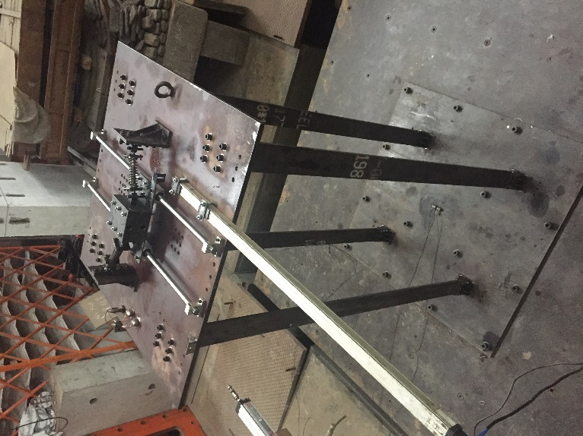

Figure 5. The test structure installed on the shake table
The equivalent mass, stiffness and damping ratio of the SDOF system representation of the MRF were estimated with fixed joint and boundary conditions. The estimated values were subsequently updated by trial-and-error procedures to match the natural vibration test. For realistic situation, structural damping can change along with different response levels and types of excitations. However, the structural damping of the present scaled MRF is very low compared to the NES friction, its deviation has very slight effect on performance of present controlling systems compared to the friction damping. Thus, the damping value was just simplified as a constant value identified under an impulsive acceleration excitation of 0.1g, which was generally at the same amplitude level in the following testing studies. The lumped mass, the stiffness, the natural frequency, and the modal damping ratio of the equivalent SDOF system is determined to be 189.4 kg, 26.2 N/mm, 1.87 Hz, and 0.35%, respectively.

3.2 Performance measure

Under seismic excitation, a traditional structure without any control scheme can only dissipate the seismic energy inputted by the inherent structural damping. To protect the primary structure, an efficient way is to reduce the seismic energy (Equation (8)) the primary structure is subjected to. Thus, the dissipated energy ratio E/E₀ is defined to measure the capacity of energy reduction by the present NES, where E and E₀ are the energy amount the primary structure withstands and dissipates by itself, with and without control, respectively. Here, T_{end} is the end time of a seismic response history. Lower value of E/E₀ results in a more efficient response reduction by the system.

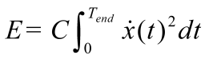. (8)

As many structural damages are story drift dependent, another critical aspect to protect the primary structure is to suppress the story drift level during the seismic response history. Thus, the drift ratios x_{rms}/x_{0,rms} and x_{max}/x_{0,max}, are also adopted to evaluate the control performance of the present NES for displacement response. Here x_{rms} and x_{0,rms} denote the root-mean-square (RMS) of historical story drift data of the primary frame, with and without NES control, respectively. Similarly, x_{max} and x_{0,max} respectively denote the peak value of story drift of the primary frame with and without NES control. Lower values of these ratios correspond to more-efficient reduction of control scheme.

3.3 Optimization procedure and results

To realize a present NES that can reduce the response of the primary structure to the lowest level, numerical optimization is performed before the detailed design of the present NES. Considering comprehensive control performance for both of energy and story drift responses, the minimization objective function is defined as the weighted performance measures E/E₀, x_{rms}/x_{0,rms} and x_{max}/x_{0,max}, i.e.

. (9)

Here each ratio is dimensionless value ranging from 0 to 1, and is multiplied by the weighting factors α, β, and γ, for which the values can be assigned according to the importance of each performance measure. In the following study, we adopt α = β = γ = 1.
For the parameter optimizations of NESs, previous studies [11-20] used impulsive ground motion to evaluate the vibration attenuation capacity of the NES system. Such simplification can avoid complexity and uncertainty of seismic excitations and the computational cost can be rapidly reduced. Thus, in this paper, we adopted an initial kinetic energy input for optimal parameter search of the NES. Considering the structural test on which the numerical model is based, the initial velocity value is given as 0.1 m/s.
The first step of the optimization procedure is to consider the NES parameters which can match up with the primary structure and the feasibility of the device manufacture. As normal manufacturing in workshop unavoidably introduce large error of sliding friction properties, we adopted a ready-made track slider product for the NES device, with its friction coefficients, μ_{v} and μ_{s} directly provided as reliable values. The movable mass m was 5% of the primary steel MRF so that the following control performance study of the TMD, the cubic NES, and the present NES can be fairly compared with the same auxiliary mass. The relaxation length of the spring, l, was also directly set up as 0.15 m by considering the installation space on the floor, so that the optimal oblique angle the springs slant at can be determined by the optimal length of l₀. Therefore, the spring stiffness k, and the length l₀ are considered as parameters to be numerically optimized in certain ranges.
The searching range of optimal value for k depends on reasonable design of the steel coil springs, which require multifunctional compressing-stretching deformation in elastic state as far as possible. Hence, with its relaxation length l = 0.15 m, k can possibly be chosen from 4.0 kN/m to 7.0 kN/m, in which numerical searching will performed with a step size 0.015 kN/m to determine the final value. On the other hand, as a too small value of l0 will lead to collisions of the coil springs with certain volume, the searching range of l0 was set up as from 0.07 m to 0.15 m, with numerical step size 0.0003 m for optimization search. Therefore, by numerical simulation of the present system expressed by Equations (4) and (5), exhausting trial in the searching ranges is conducted numerically for each combination of the stiffness k and the length l₀, to find out the values for minimum J. The fourth-order Runge-Kutta method is applied for the simulation. Consequently, the distribution of J, as well as the optimized values of k and l₀, were derived as shown in Figure 6. It can be seen from the figure that the control performance of the present NES is much more sensitive to l₀ than to k. This is preferable for our manufacturing as k is much more cumbersome to be accurately control than l₀. Finally, the designed values of the parameters for present NES device are summarized in Table 1.

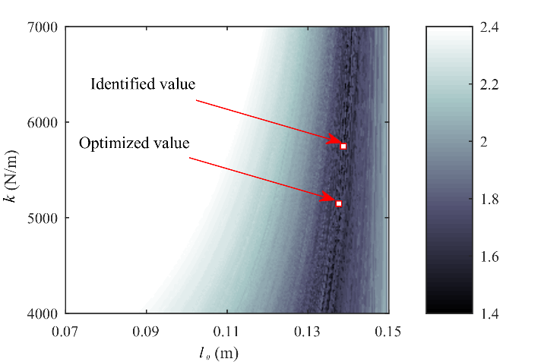

Figure 6. Value distribution of J with respect to k and l₀

Table 1. Design parameter values for the present NES

Parameter | k  (N/m) | l₀  (m) | l  (m) | m  (kg) | μ_{v} | μ_{s}
Theoretical design value | 5200 | 0.138 | 0.150 | 9.18 | 0.033 | 0.035

4. NES device realization and Experimental Investigation

The main purpose of the experimental work for the present NES is to calibrate and validate the present numerical model, based on which following analysis results and application potential of the present NES can be trusted. According to the designed parameters in Table 1, the device was physically manufactured for shake table tests. The physical realization of the NES system, the testing procedure, and the experimental verification of the device are discussed in this section.

4.1 Device design

The assembled physical device and schematic of the present NES are shown in Figure 5 and Figure 7, respectively. The device consists of a stack of steel plates as the NES mass, a pair of tube-sliders which support the movable mass, and a pair of coil springs providing restoring force. The total NES mass, including the sliders, is identical with the designed value. By means of linear bearings, the sliders are set on two straight parallel tubes grounded on the roof of the primary frame, providing reasonable friction in the operational direction. With the designed lengths of l and l₀, the two springs are fixed up at the optimized angle with respect to the moving direction of the mass. By means of hinged connections, each spring is linked to the movable mass at one end and, to a steel pedestal grounded on the roof of the primary frame, at the other end. To avoid eccentricity as the assembled NES mass slides, its mass centroid and the axes the springs lie in are in the same level. To prevent buckling of the hinged coil springs which afford compressing and stretching deformation elastically in turn, each spring is coupled with a low-friction driven sleeve.

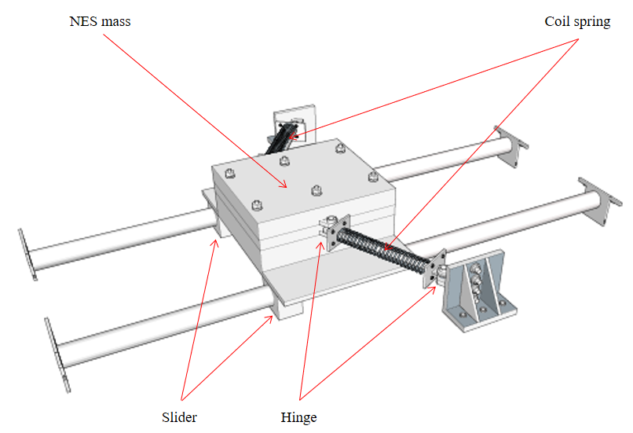

Figure 7. Schematic of the NES with negative stiffness and sliding friction

4.2 Testing overview

Experiments were conducted in the laboratory of Earthquake Engineering Research & Test Centre at the Guangzhou University, where a large-scale shake table manufactured by the MTS was used to excite the structure trough acceleration commands. The shake table possesses a 3 m ╳ 3 m platen and is capable of testing large specimens over broad displacement and frequency ranges in the presence of a payload in excess of 20 tons. Six Brüel & Kjær accelerometers were attached to the NES mass, the floor of primary frame, and the surface of shake table, respectively, to measure the acceleration and the displacement (using data integration) historical responses of the structure. Three Novotechnik telescopic-rod displacement sensors were added up to verify the displacement historical responses of the positions. All the data was synchronously collected by an FTS 12-channel acquisition system, with sampling frequency 256 Hz. The installation of test structure on the shake table is shown in Figure 4.
Three historic earthquake records were used to test the performance of the NES system: 1940 El Centro earthquake, 1976 Tangshan earthquake, and 1994 Northridge earthquake. The Tangshan and the Northridge records contain long-period ground motions which can result in drastic energy release to the primary structure. To insure reasonable large of responses which can be observed for comparison study but, the steel columns can keep in elastic and stable deformation limit, the PGA of the ground motions for shake table was modulated to 0.1g and 0.15g. After validation by the test results, more historic earthquake records were adopted for controlling performance study by numerical model.

4.3 Calibration and validation of the NES device

With the optimized values of k and l₀ summarized in Table 1 as the initial values, exhaustive trial-and-error numerical procedure was performed again after the tests, to calibrate the values of k and l₀, by minimizing the deviation between the historical displacement response by simulation and that by experiment. The deviation was defined as the RMS of the difference of historical displacement data of each time step, between the numerical result and the experimental result. Such numerical calibration was performed under each seismic wave collected on the shake table surface. Considering average value of calibration result under the three seismic waves, the calibrated parameters were finally selected as k = 5850 N/m and l₀ = 0.140 m. The calibrated value is also pointed out in Figure 6, from which it can be seen that the calibrated value still keep a nearly optimal result of J.
Figure 8 demonstrates the comparison of the story drift responses between experiment and the numerical simulation after calibration, subjected to PGA of 0.15 g. From the figure it can be seen that the results match up very well with some small discrepancies exist. These discrepancies may result from effects the simplified numerical model did not considered, including effect of the structure-table interaction or nonlinear friction properties, etc. Nevertheless, the overall accuracy of the comparison can validate the numerical model and the algorithm we used.

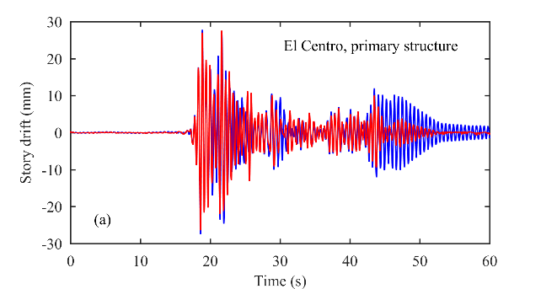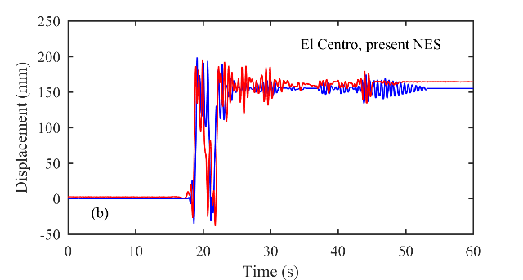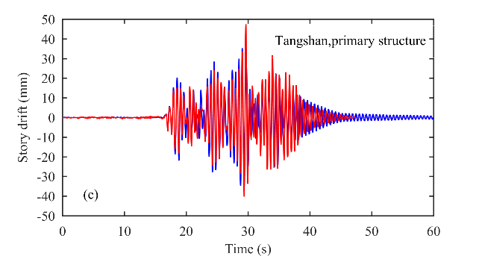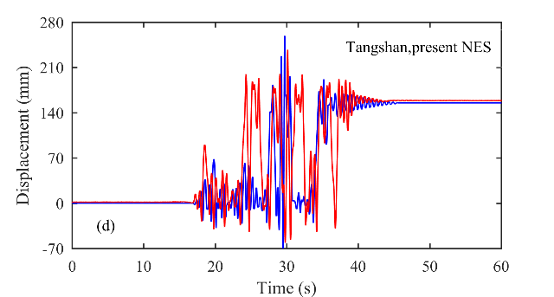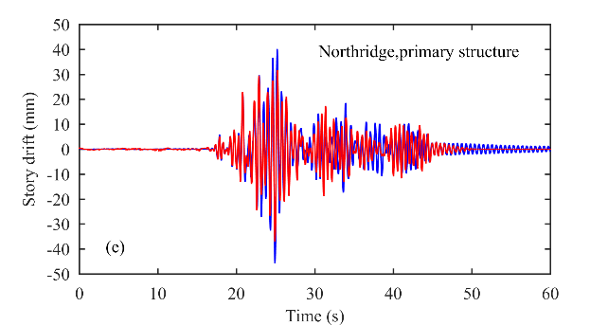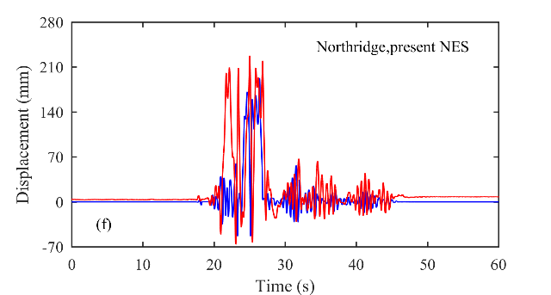
Experiment Simulation

Figure 8. Comparison of experimental and simulated displacement responses

4.4 Control performance

Tables 2-5 list the experimental results including the peak values and the RMSs of story drift, as well as the percentage reduction made by the present NES compared to the locked system. Although the characteristics of the seismic records, including the PGA and the frequency spectra, have effects on the performances of the structure, the overall performance of the present NES system is highly effective. The highest reduction percentages of story drift and the acceleration response can even reach 57.92% and 55.66% for peak values, and 76.76% and 84.68% for RMSs. The observed reduction of the story drift is important as it brings down the internal forces in the structure and thus protects the structure from damages under seismic waves.
Table 2. Maximum story drift of the primary structure

Seismic wave | PGA(g) | Story drift (mm) |  | Reduction amplitude (%)
 |  | Locked | Present NES control
El Centro | 0.1 | 30.74 | 18.90 | 38.52
El Centro | 0.15 | 45.85 | 27.54 | 39.93
Tangshan | 0.1 | 45.79 | 21.92 | 52.13
Tangshan | 0.15 | 63.94 | 47.43 | 25.82
Northridge | 0.1 | 59.52 | 29.16 | 51.01
Northridge | 0.15 | 88.09 | 37.06 | 57.92

Table 3. RMS of story drift of the primary structure

Seismic wave | PGA(g) | Story drift (mm) |  | Reduction amplitude (%)
 |  | Locked | Present NES control
El Centro | 0.1 | 10.36 | 2.64 | 74.49
El Centro | 0.15 | 15.13 | 4.46 | 70.53
Tangshan | 0.1 | 11.95 | 3.77 | 68.48
Tangshan | 0.15 | 16.77 | 7.80 | 53.49
Northridge | 0.1 | 17.37 | 4.93 | 71.59
Northridge | 0.15 | 24.92 | 5.79 | 76.76

Table 4. Maximum story acceleration of the primary structure

Seismic wave | PGA(g) | Story acceleration (cm/s²) |  | Reduction amplitude (%)
 |  | Locked | Present NES control
El Centro | 0.1 | 406.2 | 133.9 | 67.04
El Centro | 0.15 | 600.3 | 352.8 | 41.22
Tangshan | 0.1 | 582.1 | 296.1 | 49.14
Tangshan | 0.15 | 809.4 | 560 | 30.81
Northridge | 0.1 | 770.5 | 394 | 48.87
Northridge | 0.15 | 1155.1 | 512.1 | 55.66

Table 5. RMS of story acceleration of the primary structure

Seismic wave | PGA(g) | Story acceleration (cm/s²) |  | Reduction amplitude (%)
 |  | Locked | Present NES control
El Centro | 0.1 | 134.7 | 20.6 | 84.68
El Centro | 0.15 | 196.8 | 64.7 | 67.14
Tangshan | 0.1 | 155.8 | 55.5 | 64.40
Tangshan | 0.15 | 218.8 | 111.3 | 49.13
Northridge | 0.1 | 226.5 | 70.3 | 68.96
Northridge | 0.15 | 324.6 | 83.3 | 74.33

Figure 9 demonstrates the historical comparisons of story drift responses between the NES system and the locked system. It can be seen from the diagram curves that the present NES can rapidly suppress the seismic response in few seconds once drastic motions of the seismic waves arrive. Referring to the Figure 8, it can also be observed that these phenomena correspond to the NES mass sliding over the negative stiffness interval under the arrival of drastic seismic motions. In other words, once input energy reaches certain level, the moving NES mass can escape the attraction of one equilibrium and jump into the other. The negative stiffness interval drastically enhances such jumping with longer sliding strokes between the two static equilibriums. The intensive sliding thus rapidly dissipates the dynamical energy in shorter time by friction.

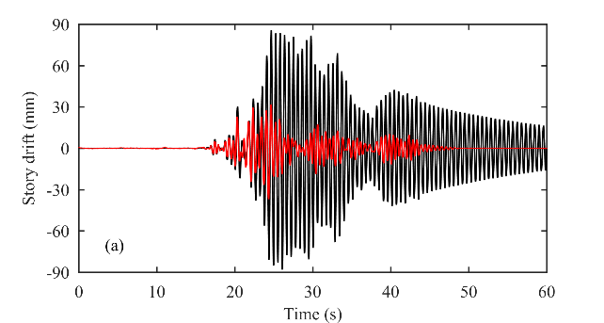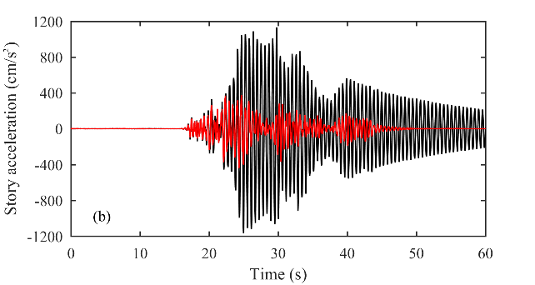
Present NES control ; Locked

Figure 9. Experimental response histories of the primary structure under Northridge wave

5. Comparison study and Robustness observation

Based on the numerical model validated by experiment, more performance comparison study is studied numerically between TMD, cubic NES, and the present NES. Totally 24 seismic waves listed in Table 6 are adopted for the numerical simulations. Particularly, as seismic excitations a structure may be subjected to in the real environment are unpredictable and the properties of structures can change over time due to accumulated damages, the comparison studies are also focused on robustness performances under structural or excitation variations. Moreover, transient internal resonance histories are also observed to interpret the essential targeted energy transfer processes of NES systems.

Table 6. Inputted seismic record for simulation

No. | Seismic wave | PGA (g)
 | El Centro, 1940, USA | 0.1
 | El Centro, 1940, USA | 0.2
 | El Centro, 1940, USA | 0.3
 | Taft, 1952, USA | 0.1
 | Taft, 1952, USA | 0.2
 | Taft, 1952, USA | 0.3
 | Emc_Fairview Ave, 1987, USA | 0.1
 | Emc_Fairview Ave, 1987, USA | 0.2
 | Emc_Fairview Ave, 1987, USA | 0.3
 | Cpc_Topanga Canyon, 1994, USA | 0.1
 | Cpc_Topanga Canyon, 1994, USA | 0.2
 | Cpc_Topanga Canyon, 1994, USA | 0.3
 | Lwd_Del Amo, 1994, USA | 0.1
 | Lwd_Del Amo, 1994, USA | 0.2
 | Lwd_Del Amo, 1994, USA | 0.3
 | Kobe, 1995, Japan | 0.1
 | Kobe, 1995, Japan | 0.2
 | Kobe, 1995, Japan | 0.3
 | Northridge, 1994, USA | 0.1
 | Northridge, 1994, USA | 0.2
 | Northridge, 1994, USA | 0.3
 | TangShan, 1976, China | 0.1
 | TangShan, 1976, China | 0.2
 | TangShan, 1976, China | 0.3

5.1 Comparison study under design condition

With the same primary structure and auxiliary mass, TMD system can be directly designed by tuning condition formulas provided in [1]. For cubic NES, similar numerical optimization procedure in Section 4.1 was performed to optimize the parameters. Consequently, the parameters determined for the systems are listed in Table 7, in which k denotes the stiffness of elastic element, c₁ denotes the coefficient of viscous damping the systems usually coupled with, and l denotes the relaxation length of the transverse spring of cubic NES.

Table 7. Design values of parameters of TMD and cubic NES

Parameter |  | m  (kg) | k  (N/m) | c₁  (N∙s/m) | l  (m)
Design value | TMD | 9.18 | 1231 | 24.24
 | Cubic NES |  | 69920.8 | 24.56 | 0.1

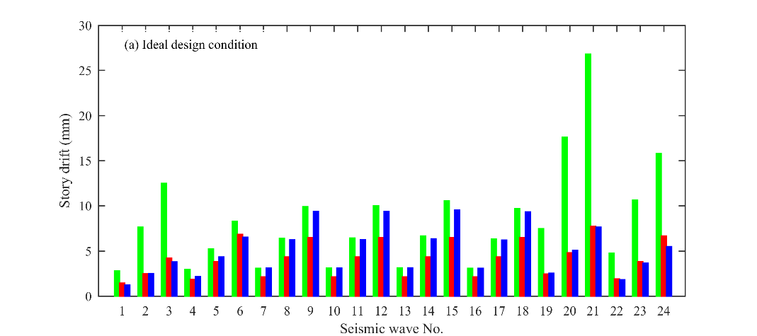
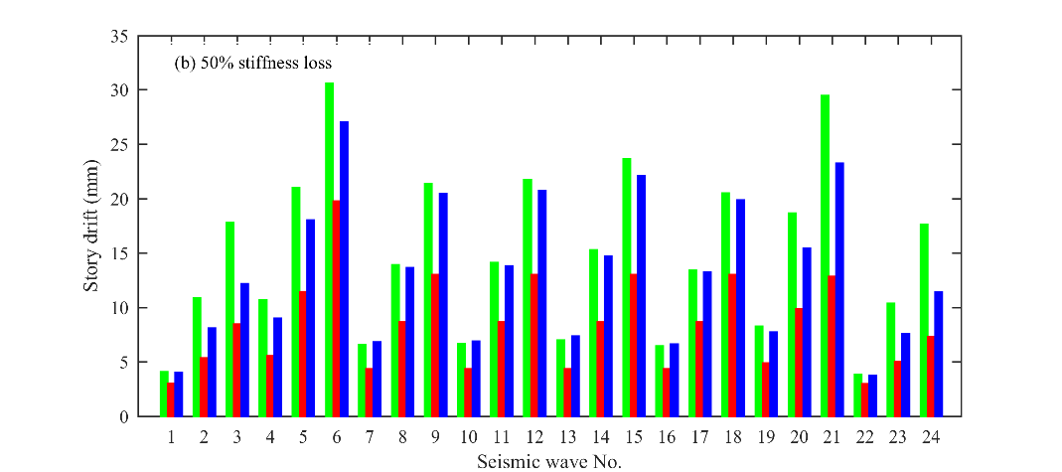
Cubic NES; Present NES; TMD

Figure10. RMS of story drift of the primary structure

Figure 10 shows the RMSs of story drift resulted in ideal design condition and in 50% stiffness loss of the primary structure, respectively. From Figure 10(a) it can be seen that, under the design conditions, the cubic NES system shows lower efficiency compared to the TMD and the NES systems in control performance. Comparisons have shown that in the most cases, the present NES gives the highest efficiency. In some cases, the story drifts of the primary structure with the cubic NES system even exceeds 2 times of those with TMD or present NES systems, for which it can be regarded that cubic NES is relatively not preferable for seismic control. The TMD shows good efficiency under in-tuned conditions, which verifies the viewpoint clarified in previous study [11]. Figure 11(a, b) demonstrate the response histories of the primary DOF under Northridge wave, for which the response with TMD systems and present NES systems are obviously suppressed faster than that with cubic NES system.

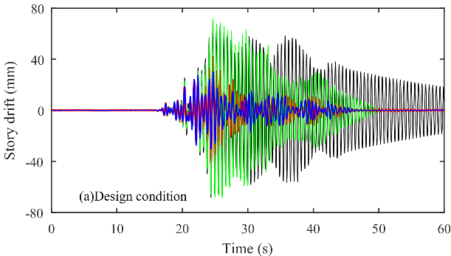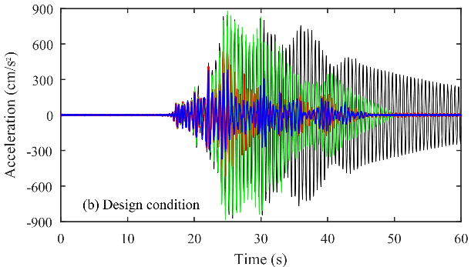
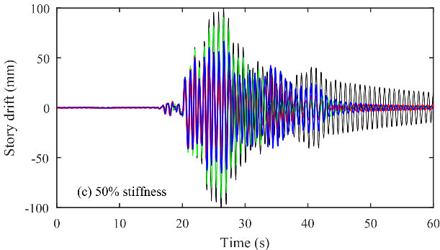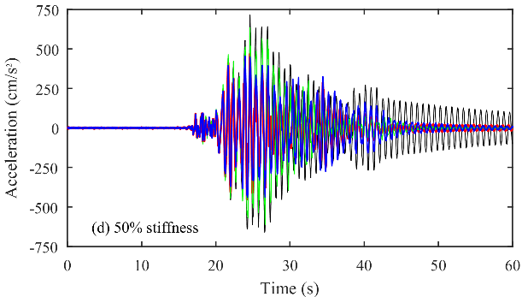
Cubic NES; Present NES; TMD; Without control

Figure 11. Numerical response histories of the primary structure under Northridge wave

5.2 Robustness observation

One typical issue a structure experiences under severe earthquakes is stiffness degradation, which can lead to very different behavior of controlling system during a response history from ideal in-tuned condition. Figure 10(b) presents the RMSs of story drift of the primary structure, with all the optimized parameter values unchanged but its stiffness lost in 50%. Compared with Figure 10(a), the performance maintenance of the present NES systems and the performance deterioration of the TMD system can be observed, while the cubic NES still gives relatively unsatisfactory behavior for seismic excitations. Figure 11(c, d) demonstrate the story drift histories of the primary DOF with 50% of stiffness degradation under Northridge wave. Comparison of Figure 11(a, b) and Figure 11(c, d) indicates that, the present NES system can keep efficient response reduction as the stiffness loss but, the TMD system and the cubic NES system lose efficiency in different levels.
Figure 12 demonstrates the response trends with respect to stiffness variation and excitation intensity variation, under the three seismic waves, respectively. Figure 12(a-c) indicate that, as the stiffness variates from 30% to 150% of the designed value, the present NES totally keeps the strongest robustness to suppress energy response of the primary DOF over the variation range. Similar behaviors are also derived in Figure 12(d-f), which display the robustness to story drift control. The figures underline the fact that the present NES system is preferable especially in stiffness variation of the primary DOF.
Figure 12(g-i) investigate the robustness with respect to seismic intensity variation. In the figures it can be seen that, as the PGA increases from 0.05g to 0.3g, the energy responses of the primary DOF increase. The cubic NES system is sensitively energy dependent as the figure shows. On the other hand, the linear TMD system maintains the energy response increasing linearly at lower level. By the present NES system, considerable improvement of NES with respect to seismic intensity variation can be observed, as the energy response of primary DOF is reduced to nearly level of that with TMD control.
To investigate the resonance process between the primary DOF and the auxiliary DOF for different controlling systems, Figure 14 demonstrates the wavelet transforms of the story drift histories under Northridge wave. The Figure displays the frequency distributions of the responses evaluated during the seismic excitation in gradient cloud graphs.
Figure 13(a) verifies the basic characteristic of linear SDOF system response without control, for which the dominant energy distributes at the natural frequency constantly during the whole seismic response history. The basic working mechanism of TMD system, which tunes such vibration response at the nearly identical frequency, can also be verified in Figures 13(b, c). It can be seen from the figures that, through the TMD tuning a large amount of vibration energy was rapidly absorbed and dissipated in about 10 seconds. Due to other frequency composition of the seismic wave, there is still energy distributed other than the natural frequency but is very weak.

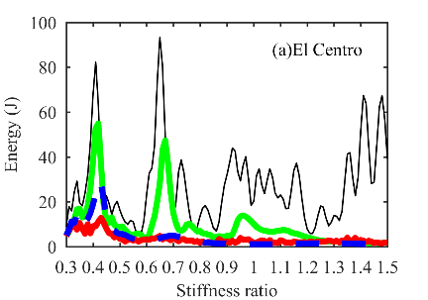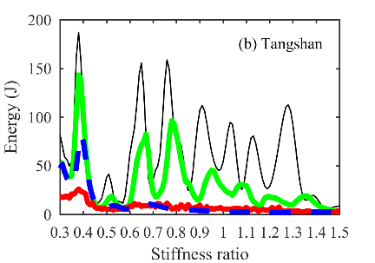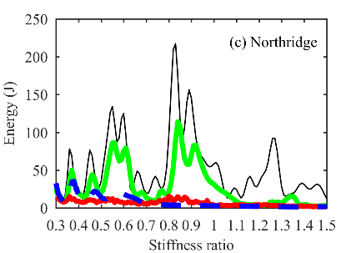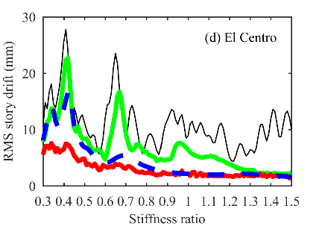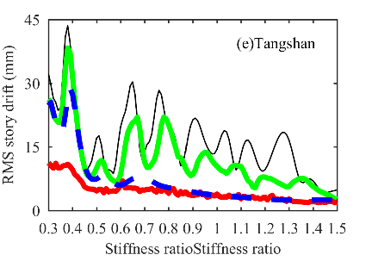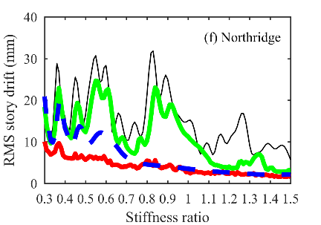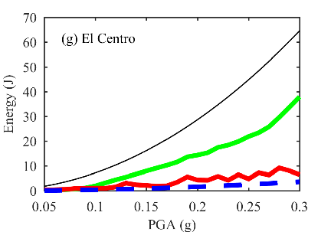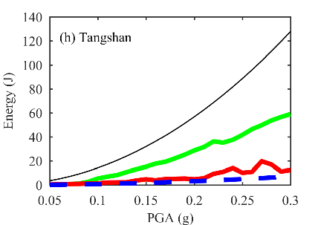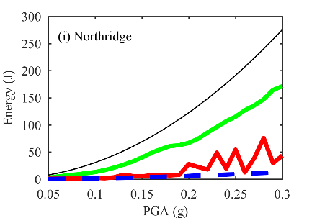
Cubic NES; Present NES; TMD; Without control

Figure 12. Response of the primary structure with respect to parameter variation

In contrast to the linear TMD system where the energy is only dissipated near the tuning frequency, wider energy distributions can be observed in the NES systems from Figures 13(d-g). This is especially true for the NES system where the nonlinear stiffness provides an effective mean of transferring vibration by transient internal resonance in wider frequency band, which can never be triggered by linear systems. However, from Figure 13(e) it can be seen that, such internal resonance capture by the cubic NES was yet too weak to achieve highly vibration reduction of the primary DOF. From Figure 13(g) we can see that, cascade of transient internal resonance was drastically captured by the present NES, which underlines the reason for much higher and faster response reduction by the present NES. Particularly, the present NES system enhances very strong sub-frequency internal resonance process in low frequency domain, which behaves as long-strokes of NES mass jumping over the negative stiffness interval.
Figure 14 shows the wavelet transforms in the case of 50% stiffness loss of the primary structure. From Figure 14(a) it can be seen the natural frequency deviates due to the stiffness loss. Due to detuning of TMD system, the active response of the primary DOF at the natural frequency continues in longer time, as shown in Figure 14(b, c). Furthermore, the loss of stiffness induces deterioration of cubic NES systems. This can be observed in Figure 15(d, e) that the transient internal resonance become weaker. However, Figure 15(f, g) shows that the present NES can still maintain cascade of internal resonance capture in broadband, which supports it to keep relatively good performance. Therefore, the underling mechanism of robustness of the present NES is that, the negative stiffness and frictions strongly induce cascade of transient internal resonance in wider frequency domain, which is very insensitive to natural frequency variation of the system.

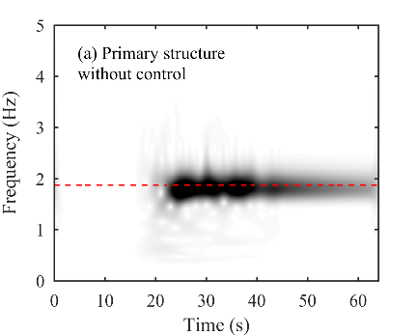
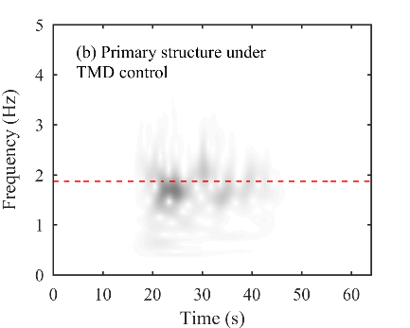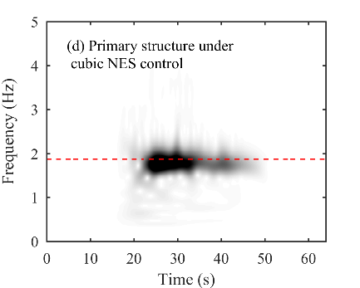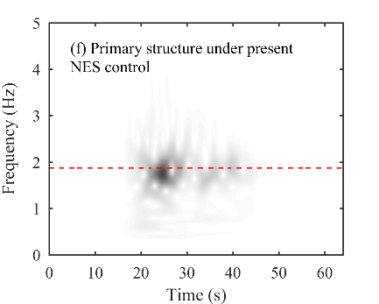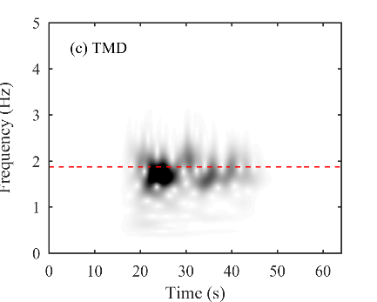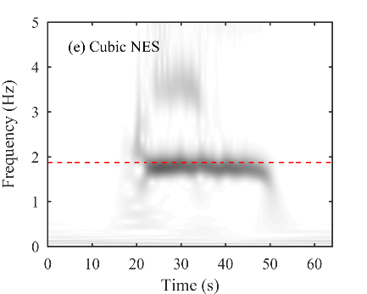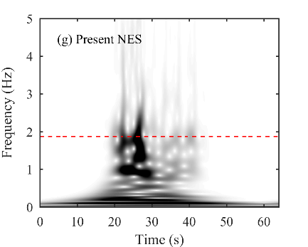
Natural frequency of the primary structure

Figure 13. Numerical wavelet transform of displacement response under Northridge wave, in ideal design condition.

6. Сonclusion

The present NES, realized by a sliding mass connected with geometrically bi-stable nonlinear springs, is found to be robustly and highly capable of protecting the primary structure during seismic excitations. The numerical model of the present NES system is carried out, as well as its parameters be optimal designed. The experimental results validate the numerical predictions that a significant fraction of seismic energy introduced directly to the primary frame by seismic excitation, can be rapidly transferred to the present NES and be dissipated. This achieves the amplitude reduction of response the primary has to withstand.
Comparison study of the present NES, the TMD, and the cubic NES shows that, the present NES overwhelms the others in overall behaviors including robustness performance for seismic control. In optimal condition, the present NES totally possesses highest efficiency control for response reduction of the primary structure in the most cases. Furthermore, in detuned condition of TMD, the present NES shows the strongest robustness to maintain the controlling performance with respect to stiffness variation of the primary structure. Compared to the cubic NES which shows low efficiency for seismic control, the present NES generally enhances the controlling capacity to large extent. It can also keep nearly strong robustness the in-tuned TMD system can provide, under PGA variations.
The negative stiffness interval between the two stable equilibriums can rapidly trigger long strokes with friction sliding of the present NES mass, which can induce highly absorbing and dissipating for seismic energy. The essential mechanism of this behavior corresponds to cascade of transient internal resonance between the present NES and the primary structure in wide frequency domain. The strong robustness of the present NES can be interpreted by the strong insensitivity of cascade of internal resonance to dominant frequency variation of the primary structure. Different from those impact-type NESs which scatter the seismic energy in high frequency domain by transient collisions, the present transient internal resonance is captured in broadband especially in low frequency domain, as the present sliding in negative stiffness interval is smooth with any impact avoided.

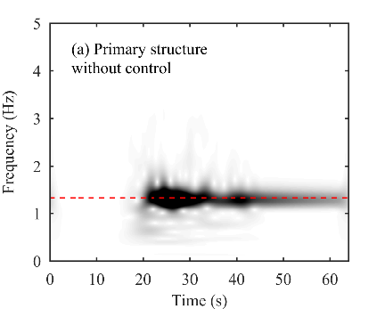
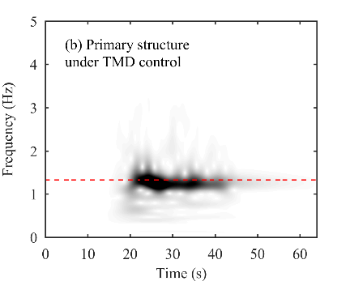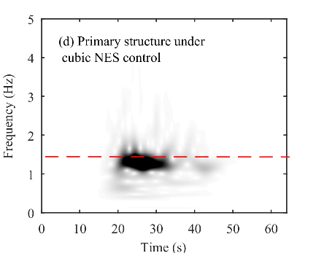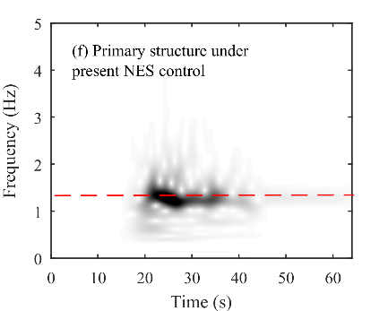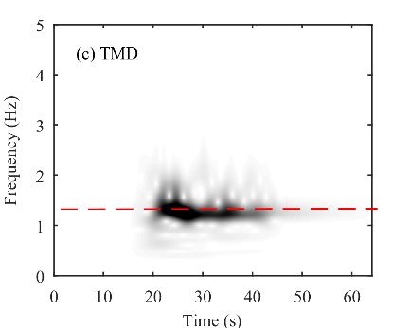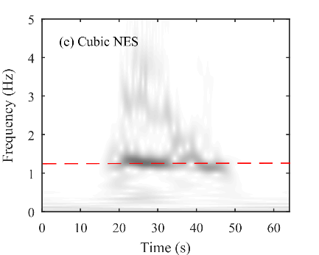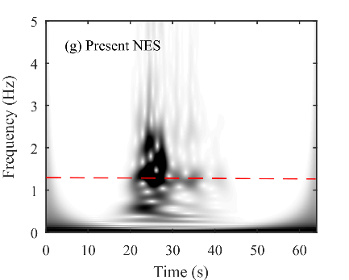
Natural frequency of the primary structure

Figure 14. Numerical wavelet transform of displacement response under Northridge wave excitation, with 50% stiffness loss of the primary structure.

7. ACKNOWLEDGEMENTS

The financial supports from the National Key R&D Program of China (2017YFC0703600), the National Natural Science Foundations of China (51578168), the Natural Science Foundation of Guangdong Province (2016A030313544), and the Pearl River Nova Program of Guangzhou (201610010159), are gratefully acknowledged.

8. REFERENCES

Rana R, Soong TT. Parametric study and simplified design of tuned mass dampers. Engineering Structures, 1998, 20(3):193-204.
Saaed TE, Nikolakopoulos G, Jonasson JE, Hedlund H. A state-of-the-art review of structural control systems. Journal of Vibration and Control, 2015, 21(5): 919-937.
Vakakis AF, Gendelman OV, Bergman LA, McFarland DM, Kerschen G, Lee YS. Nonlinear Targeted Energy Transfer in Mechanical and Structural Systems I & II. Springer, 2008.
Mcfarland DM, Bergman LA, Vakakis AF. Experimental study of non-linear energy pumping occurring at a single fast frequency. International Journal of Non-Linear Mechanics, 2005, 40(6): 891-899.
Nucera F, Lacono FL, Mcfarland DM, Bergman LA, Vakakis AF. Application of broadband nonlinear targeted energy transfers for seismic mitigation of a shear frame: Experimental results. Journal of Sound & Vibration, 2008, 313(1): 57-76.
Nucera F, Mcfarland DM, Bergman LA, Vakakis AF. Application of broadband nonlinear targeted energy transfers for seismic mitigation of a shear frame: Computational results. Journal of Sound & Vibration, 2010, 329(1): 2973-2994.
Ahmadi M, Attari NKA, Shahrouzi M. Structural seismic response mitigation using optimized vibro-impact nonlinear energy sinks. Journal of Earthquake Engineering, 2014, 19(2): 193-219.
Gendelman OV, Alloni A. Dynamics of forced system with vibro-impact energy sink. Journal of Sound & Vibration, 2015, 358: 301-314.
Li T, Seguy S, Berlioz A. On the dynamics around targeted energy transfer for vibro-impact nonlinear energy sink. Nonlinear Dynamics, 2016: 1-14.
Luo J, Wierschem NE, Hubbard SA, Fahnestock LA, Quinn DD, Mcfarland DM. Large-scale experimental evaluation and numerical simulation of a system of nonlinear energy sinks for seismic mitigation. Engineering Structures, 2014, 77: 34-48.
Wierschem NE, Luo J, Al-Shudeifat M, Hubbard S, Ott R, Fahnestock LA. Experimental testing and numerical simulation of a six-story structure incorporating two-degree-of-freedom nonlinear energy sink. ASCE Journal of Structural Engineering, 2014, 04014027: 1-10.
Gendelman OV, Sigalov G, Manevitch LI, Mane M, Vakakis AF, Bergman LA. Dynamics of an eccentric rotational nonlinear energy sink. ASME Journal of Applied Mechanics, 2012, 79(1): 1012.
Wang J, Wierschem NE, Spencer BF, Lu X. Track nonlinear energy sink for rapid response reduction in building structures. ASCE Journal of Engineering Mechanics, 2015, 141(1): 04014104.
Wang J, Wierschem N, Spencer BF, Lu X. Experimental study of track nonlinear energy sinks for dynamic response reduction. Engineering Structures, 2015, 94: 9-15.
Wang J, Wierschem N, Spencer BF, Lu X. Numerical and experimental study of the performance of a single-sided vibro-impact track nonlinear energy sink. Earthquake Engineering & Structural Dynamics, 2016, 45(4): 635-652.
Lu X, Liu Z, Lu Z. Optimization design and experimental verification of track nonlinear energy sink for vibration control under seismic excitation. Structural Control & Health Monitoring, 2017, DOI: 10.1002/stc.2033.
Schmidt F, Lamarque CH. Energy pumping for mechanical systems involving non-smooth Saint-Venant terms. International Journal of Non-Linear Mechanics, 2010, 45(9): 866–875.
Lamarque CH, Savadkoohi AT. Targeted energy transfer between a system with a set of saint-venant elements and a nonlinear energy sink. Continuum Mechanics and Thermodynamics, 2015, 27(4): 819-833.
Al-Shudeifat MA. Highly efficient nonlinear energy sink. Nonlinear Dynamics, 2014, 76(4): 1905-1920.
Al-Shudeifat MA. Asymmetric magnet-based nonlinear energy sink. ASME Journal of Computational & Nonlinear Dynamics, 2015, 10(1).

Associate Prof., Director Assistant, EERTC, Guangzhou University, Guangzhou, China, yychen@gzhu.edu.cn
Graduate Student, EERTC, Guangzhou University, Guangzhou, China, 1506957140@qq.com
Prof., Executive Director, EERTC, Guangzhou University, Guangzhou, China, ptan@gzhu.edu.cn
Prof., Deputy Director, EERTC, Guangzhou University, Guangzhou, China, eertchxy@gzhu.edu.cn

