INFLUENCE OF VEHICLE IMPACT LOAD ON ISOLATED BRIDGE

DOI 10.37153/2686-7974-2019-16-973-979

Bo-Han Lee, Fang-Yao Yeh, Chun-Chung Chen, Sheng-Yuan Shiao and Kuo-Chun Chang

ABSTRACT

In recent years, rapid urbanization, associated with large waves of urban population growth, has been imposing crucial demands on city transportation infrastructure. Therefore, an increasing number of elevated expressways, typically long-pier bridges, were erected in the city platform to ease urban transportation pressure. However, high traffic volume of such expressway bridges can cause significant vibration. To investigate the influence of the bridge-traffic-induced vibration, this study monitored the acceleration of an isolated bridge located for 24 hours in a row. The acceleration measurements were then analyzed using the fast Fourier transformation method and a system realization method, and the system parameters of both the bridge and building were thus calibrated. Furthermore, the bridge-deck-to-pier displacement and bridge deck acceleration were measured to explore how vehicle transportation affects the structural performance of the bridge deck and pier. The results may be used as a reference for future improving the bridge-traffic-caused vibration problem.

Keywords: Bridge Vibration; Signal Processing; System Identification

1. INTRODUCTION

Earthquake engineering research focuses on the seismic performance of structures, namely structural safety and life safety. With the intensification of urbanization, more and more urban roads and bridges have been developed, reshaping the landscape of large cities. However, the vibrations caused by bridge vehicles may to some extent exceed the comfort level of human beings, thus affecting citizens' daily life in the vicinity. Previous bridge vibration studies have focused on three areas: the impact of wind-induced bridge vibration on vehicle ride comfort, the characteristics of bridges under wind excitation, and the failure of expansion joints caused by vehicles (Wang, et al., 2014; Ding, et al., 2016). Through reference to reviewed research, this study aims to investigate the effects of vehicle-induced bridge vibration on nearby buildings.

2. Methodology

2.1 Root Mean Square (RMS) Acceleration

The study monitored the vibrations of the first, fourth and fifth layers of the target building over a continuous 24 hours. The obtained three-axis vibration measurements are shown in the direction of bridge traffic, vertical and vertical directions of traffic, respectively, in the X, Y, and Z directions. Analyze the readings of the servo speedometer and determine the floor acceleration using the following function according to ISO 2631-1 (1997).

(1)

where $a_{w}(t)$ is the acceleration measurement (m/s²),Ｔ is the measurement period (s), and $a_{w}$ is the root mean square (RMS) acceleration (m/s²).

2.2 Time-frequency Analyses

Time-frequency analyses are typically used to investigate the structure vibration responses. To execute the time-frequency transform of the floor acceleration signals, this study employed the discrete fast Fourier transform (FFT) algorithm (Function 2), which was derived from Cooley and Tukey’s FFT algorithm (1965).

${X\left(f\right)}_{k}=\sum_{k=0}^{n-1}{x_{k}}e^{\frac{-2πi}{n}jk}, j=0,1,⋯,n-1$${X\left(f\right)}_{k}=\sum_{k=0}^{n-1}{x_{k}}e^{\frac{-2πi}{n}jk}, j=0,1,⋯,n-1$ (2)

3. CASE STUDY

Regarding the investigated elevated expressway bridge (Figure 1), the local traffic management department reported the obvious building vibrations in the adjacent area and the discomfort caused by the local residents due to the bridge traffic. In this case, a specially designed obstacle is embedded in the ground (20 meters deep) between the pier and the adjacent building to reduce the impact of the bridge vibration caused by the vehicle on the adjacent building. In order to evaluate the effect of this vibration isolation implementation, the floor vibration of adjacent residential buildings was monitored and analyzed. The target RC frame building is five stories high with a basement above the roof and an additional lightweight sheet metal structure (Figure 2). The distance between the building and the bridge is approximately 25 meters.

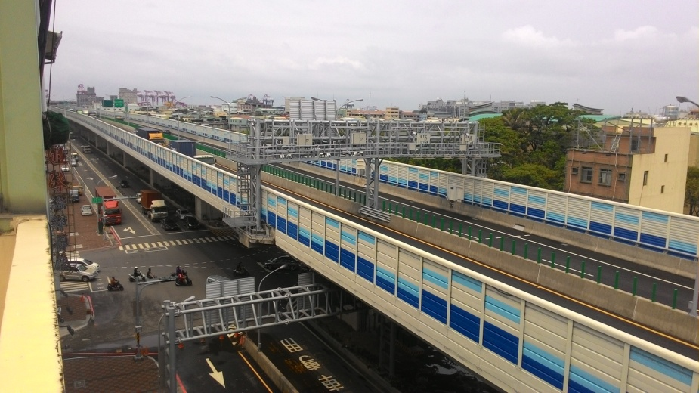

Figure 1. Target elevated expressway bridge

In this study, uniaxial servo velocity meters (VSE-15D, Tokyo Sokushin Co.,Ltd.) were deployed at six measurement spots (triaxial vibration measurements at each spot) in the target building (Figure 2). A portable ambient vibration monitoring system (SPC-51, Tokyo Sokushin Co.,Ltd.) was used to acquire the readings of these servo velocity meters before and after the vibration isolation implementation. The floor vibration was measured in accordance with the national standard for measuring ambient vibration level (NIEA P204.90C, 2005), and the sampling rate was 200 Hz.

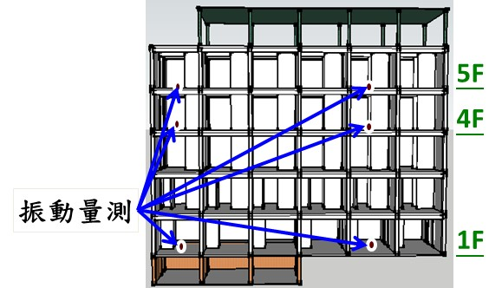
Measurement spots

Figure 2. Allocation of vibration measurement spots in the target building

4. vibration responses ANALYSIS

4.1 Target Building

The vibration responses of the target building are depicted in Figure 3. Before the vibration isolation implementation, the acceleration readings exhibited considerable vibration responses from 6:00 to 18:00, and the maximum RMS acceleration in the X, Y, and Z directions were 0.014, 0.013, and 0.015 m/s², respectively. Subsequently, the vibration isolation implementation substantially dimished the building vibration in all three directions: the maximum RMS acceleration in the X, Y, and Z directions were reduced to 0.008, 0.01, and 0.013 m/s², respectively. According to the discrete FFT analysis of the acceleration signal of the first floor, the peak vibration frequency in the X direction was 3.09 Hz (Figure 4), representing the dominant frequency of the building.
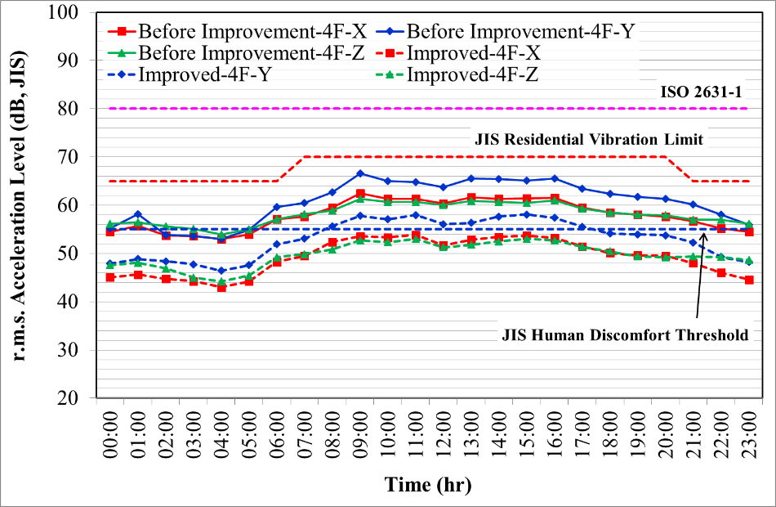

Figure 3. Floor vibration responses of the target building in a 24-hour period
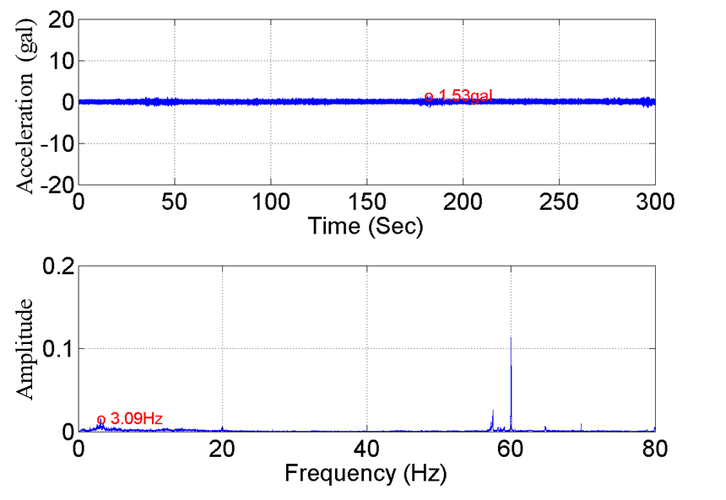
Figure 4. Discrete FFT analysis of the X-direction vibration responses of the first floor

Vehicle type (i.e., sedans, freight vehicles, and trailers) can somehow affect the bridge vibration and thus influence the adjacent buildings; therefore, to assess such effects, this study reckoned the average vehicle volume and trend in a 24-hour period (Table 1). Talbe 1 indicated that the daily rash hour of the bridge traffic is from 8:00 to 11:00 and from 14:00 to 17:00; and during these periods, semi trailers take a large percentage of the total vehicle volume, followed by freight vehicles. On the contrary, the sedan volume peaks at 7:00 and 17:00. According to Figure 5, the building vibration trend was consistent with the the total vehicle volume trend. Furthermore, intense floor vibration was significantly associated with trailers driving through the bridge.
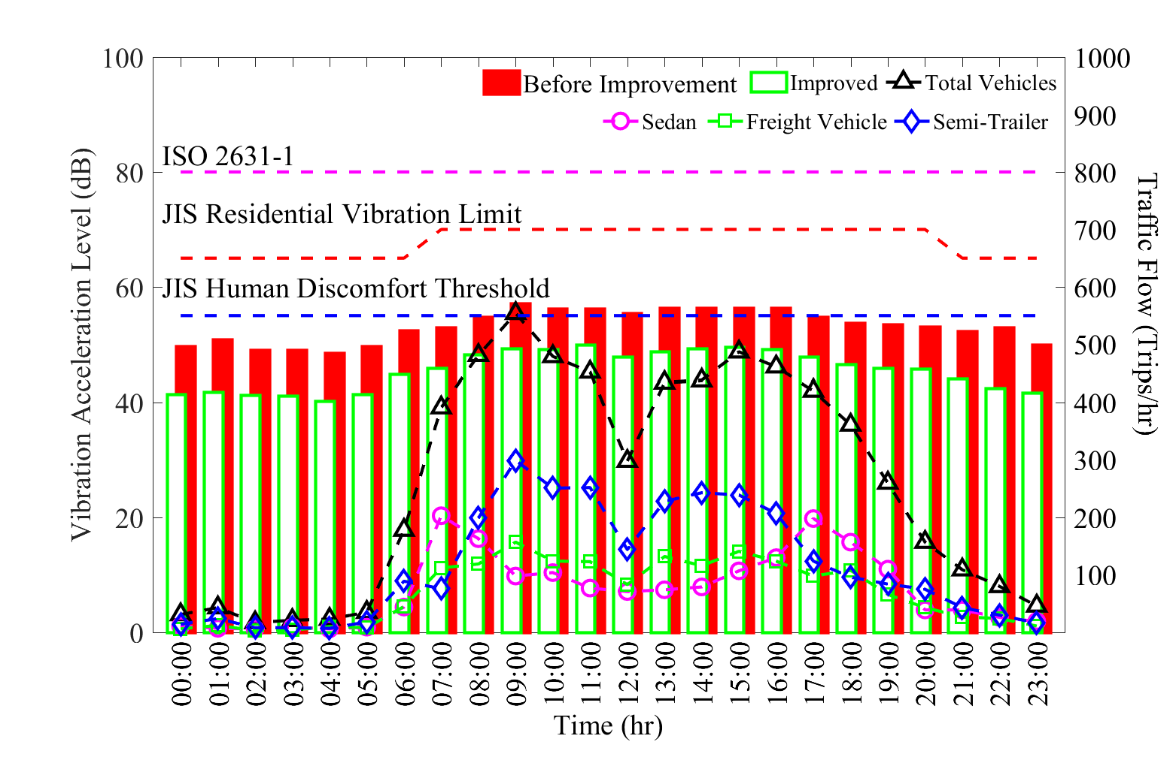

Figure 5. Building responses in respect to the bridge vehicle volume before and after the vibration isolation implementation

Table 1. Vehicle volume in 24 hours

Time | Vehicle Type |  |  | Total Vehicles
 | Sedan | Freight Vehicle | Trailer
00:00 | 11 | 6 | 14 | 31
01:00 | 7 | 12 | 24 | 43
02:00 | 6 | 3 | 8 | 17
03:00 | 9 | 4 | 8 | 21
04:00 | 6 | 10 | 7 | 23
05:00 | 9 | 8 | 18 | 35
06:00 | 44 | 45 | 89 | 178
07:00 | 203 | 112 | 76 | 391
08:00 | 163 | 119 | 199 | 481
09:00 | 98 | 157 | 299 | 554
10:00 | 104 | 124 | 251 | 479
11:00 | 77 | 123 | 252 | 452
12:00 | 71 | 83 | 144 | 298
13:00 | 74 | 132 | 228 | 434
14:00 | 79 | 116 | 243 | 438
15:00 | 107 | 141 | 239 | 487
16:00 | 130 | 124 | 207 | 461
17:00 | 198 | 98 | 124 | 420
18:00 | 157 | 108 | 96 | 361
19:00 | 110 | 66 | 84 | 260
20:00 | 39 | 43 | 75 | 157
21:00 | 39 | 27 | 43 | 109
22:00 | 26 | 24 | 30 | 80
23:00 | 19 | 11 | 16 | 46

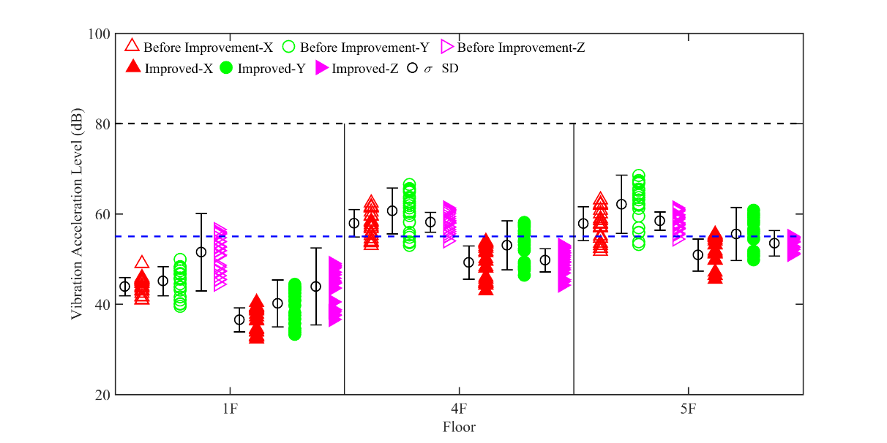

Figure 6. Comparison of the floor vibration responses before and after the vibration isolation implementation

Comparison of the floor vibration responses in all three directions before and after the vibration isolation implementation is presented in Figure 6. The comparison indicated that the vibration acceleration of all three measured floors were lowered by approximately 20% due to the improvement implementation. Moreover, after the implementation, the first floor vibration responses in all three directions did not exceed the human vibration comfort threshhold prescibed in the JIS standards (JIS Z8735, 1981; JIS C1510, 1995; JIS C1513, 2002). As to the fourth floor, despite the vibration in the Y direction, the acceleration in the other two directions was lower than the JIS threshold. The three direction acceleration of the fifth floor also decreased, and the X- and Z-direction acceleration approached the JIS threshold.

4.2 Bridge vibration

Observing the analysis results as shown in Table 2, the vibrations measurement in five different locations are set up in the vertical direction. Discussing the traffic flow in the rush hour, the vibration is generated at the center of the bridge and has gradually passed to the pier. The response of span center is approximate to 78 dB. The response of pier bottom is approximate to 59 dB and pier top is approximate to 58 dB, where the vibration of the top and bottom of the pier is similar to each other. The diaphragm is approximate to 71 dB and building base is approximate to 47 dB. The attenuation ratio is 9% of the diaphragm, 25% of the pier top, 24% of the pier bottom and 39% of the building base.
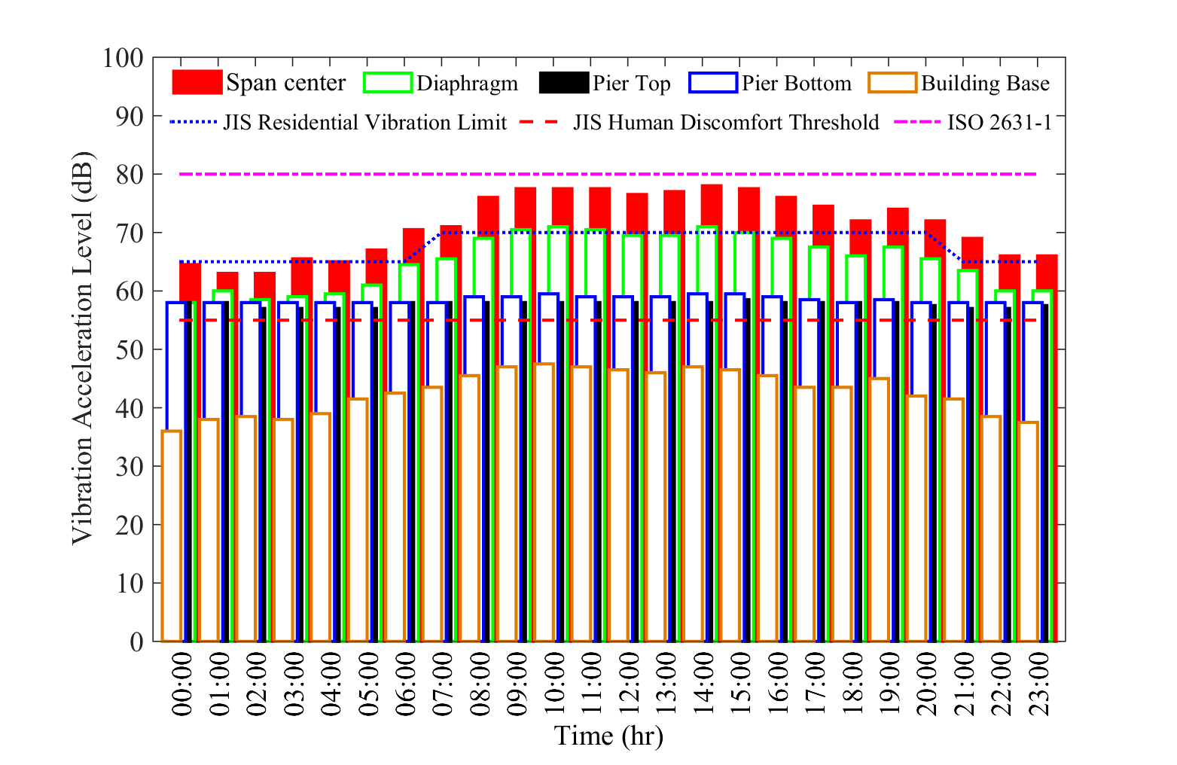

Figure 7. Bridge responses in respect to the bridge vehicle volume

5. Conclusions

The vibration analyses of the target residential building revealed that during the period from 6:00 to 21:00, the vibration of all three monitored floors (i.e., the first, fourth, and fifth floors) exhibited significant vibration responses. As to the first floor vibration, the vibration responses in the Z direction were larger than those in the other two directions with the maximum RMS acceleration was 0.021 m/s² and the ISO RMS acceleration was 86.3 dB. In contrast, for the fourth and fifth floors, the Y direction vibration had more intense responses than the other two directions, and the maximum RMS acceleration was 0.063 and 0.079 m/s², respectively, and the ISO RMS acceleration was 96.0 and 97.9 dB, respectively.
The FFT analyses suggested that the vibration frequency of the first floor in the Z direction (= 3.4 Hz) and the fifth floor in the Y direction (= 3.02 Hz) approximated the dominant frequency of the building.

6. Acknowledgments

I am very grateful for the cooperation of professor Kuo-Chun Chang and research fellow Fang-Yao Yeh who took part in this phase of this study. This research was supported by CECI, an engineering consultant, Inc., Taiwan.

7. References

Tao Wang, Wanshui Han, Fei Yang and Wen Kong, “Wind-vehicle-bridge coupled vibration analysis based on random traffic flow simulation”, Journal of Traffic and Transportation Engineering 1(4), pp 293-308, 2014.
Yong Ding, Wei Zhang and Francis T.K. Au, “Effect of dynamic impact at modular bridge expansion joints on bridge design”, Engineering Structures 127, pp 645-662, 2016.
ISO 2631-1, “Mechanical vibration and shock evaluation of human exposure to whole-body vibration, Part 1: General requirements”, International Organization for Standardization, Geneva, 1997.
JIS Z8735, “Methods of Measurement for Vibration Level”, Japanese Industrial Standard, Japan, 1981.
JIS C1510, “Vibration level meters”, Japanese Industrial Standard, Japan, 1995.
JIS C1513, “Octave-band and third-octave-band analysers for sounds and vibration”, Japanese Industrial Standard, Japan, 2002.
J. W. Cooley and J. W. Tukey, “An Algorithm for the Machine Calculation of Complex Fourier Series”, Mathematics of Computation 19(90), pp 297-301, 1965.
NIEA P204.90C, National standard for measuring ambient vibration level, Environmental Analysis Laboratory, Taiwan, 2005.

National Center for Research on Earthquake Engineering, Taipei, Taiwan, bhlee@narlabs.org.tw
National Center for Research on Earthquake Engineering, Taipei, Taiwan,
National Center for Research on Earthquake Engineering, Taipei, Taiwan,
National Center for Research on Earthquake Engineering, Taipei, Taiwan,
National Taiwan University, Taipei, Taiwan,

