NUMERICAL EVALUATION OF THE SEISMIC RESPONSE OF STEEL STORAGE RACK BEAM-TO-COLUMN CONNECTIONS BASED ON FINITE ELEMENT ANALYSIS

DOI 10.37153/2686-7974-2019-16-952-961

Zhi Jun LYU, Pei Cai ZHAO, Qian XIANG, Meng WU, Jun GU

ABSTRACT

This paper presents a finite element investigation on the structural behavior of Beam-to-column connections (BCC) of steel storage rack under cyclic loads. The finite element methodology was validated to be in agreement with the experimental results. Satisfactory consistency was observed between numerical and experimental results on the failure modes and backbone curves. As one of the most important assessment indexes, the energy dissipation capacity is used to evaluate the seismic response of different parameters in the bolted and riveted BCCs. The results obtained show that the energy dissipation capacity of combination bolted BCCs is above five times than that of only riveted BCCs. On the other hand, with respect to the riveted connections, the welding position of beam relative to beam end connector has the strong influence on the degradation of dynamic performance, followed by thickness of beam end connector, and clearance between the column and beam end connector has the weak influence. As such, this study serves as a fundamental step towards controlling and improving the seismic response for rack structures combined with the various framework design and fabricating process.

Keywords: Seismic Response; Energy Dissipation Capacity; Hysteretic Behavior; Bolted and Riveted Beam-to-Column Connections; Finite Element Methodology

1. INTRODUCTION

One of the most significant uses of cold formed steel members has been widely found in high-rise steel pallet racks (SPRs) for some decades (Claudio Bernuzzi et al. 2016). Rack systems are very similar to the framed steelworks traditionally used for civil and commercial buildings, despite many differences in member geometry and in connection systems. Within the SPRs, generally, beams have boxed cross-sections while columns are open thin-walled perforated to accept the tabs of beam-end-connectors, which joins beams and columns together without bolts or welds. In especial, the beam-to-column connections (BCCs) are the most critical part of the assembly which determines the stability of SPRs in the down-aisle direction (F.D. Markazi et al. 1997). So, the most recent design codes, such as that of the RMI (Rack Manufacturers Institute 2012), EN15512 (European Committee for Standardization 2009), and AS4084 (Standards Australia 2012), suggest individual experimental testing and define testing protocols to predict the moment–rotation (M–θ) behavior of any beam-to-column connections. Bernuzzi and Castiglioni (Bernuzzi Claudio et al. 2001) performed a series of 11 monotonic and 11 cyclic tests on two different types of beam-to-upright connections used in Europe. In paper (F. Gusella, M et al. 2017), where the importance of taking into account the cyclic behavior of connections to perform more reliable dynamic nonlinear analyses was underlined. The experimental results obtained from the monotonic tests indicated that the connections were characterized by significant ductile behavior. Lingfeng Yin and Gan Tang (Lingfeng Yin et al. 2016) analyzed a specific type of connector, in which tabs work in tension and compression. Their monotonic behavior and hysteretic response under cyclic loading were studied experimentally using a cantilever test method. Although more accurate results can be obtained by using experimental methods to study the performance of beam-column connections, experimental investigations are too expensive to apply in rack design on large scale. As an alternative method, finite element analysis tools have become so strong that they have been widely used in building structures. Elsayed Mashaly et al. (Elsayed Mashaly et al. 2011) presented a simple and accurate three-dimensional (3D) finite element model (FE) capable of predicting the actual behavior of beam-to-column joints in steel frames subjected to lateral loads. Effects of the number of tabs were investigated in (S.N.R. Shah. 2016) by means of numerical models, managing to capture the tearing of the column web produced by tabs. Even so, due to the heavy nonlinear of hysteretic characteristic itself, there are few reports about FE analysis on dynamic stability of beam-column joints in storage racking system.
In Fact, the failure of steel structures under earthquake is mainly due to the local buckling and fracture of members and connections, which leads to the decrease of bearing capacity and the failure of members (Liusi Dai et al. 2014). The increasing seismic demands from the high rise racking system make clear the need to provide a good deal of insight into the dynamic performance on the semi-grid connections. The results obtained from experimental testing are considered as the reference, the main objective of our work presented is to make an attempt to build a hysteretic model of BCCs with FE simulations. On the basis of these models, the dynamic performance degradation of the semi-grid connections with various parameters are assessed by the energy dissipation within the experimental process of cyclic loading. Finally, the comparison of dynamic performance between bolted connections and only riveted connections is made so as to take the economic and effective measures to improve the seismic response for rack structures furthermore.

2. CYCLIC BEHAVIOR BASED FINITE ELEMENT SIMULATION

2.1 Bi-directional cyclic loading experiment

2.1.1 Specimen Details

In SPRs, the main types of BCCs include weld, bolt and rivet connections. The weld connection is tightly connected, but it is not widely used nowadays because of their complicated fabrication technology. By contrast, the bolted and riveted connections are currently employed in the most SPRs in virtue of easy installation and disassembly. So, in this study, this kind of connections were utilized to study the difference on structural parameters which may affect the overall seismic performance of pallet racks. Its main components in the BCCs include columns, beam end connectors and beams, as shown in Figure 1.

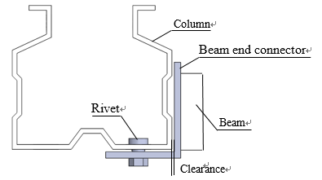

Figure 1. Details of the rivet connection

Here, two cyclic loading experiments were carried out in order to validate the accuracy of the results obtained by the finite element models established using FE software ANSYS Workbench. Considering the conventional structures of seismic design in real high rise SPRs, two kinds of riveted BCCs are selected for test and analysis. Among which, the columns are M100A and M120A, which are matched with the beams of B80 and B100 respectively. Both beam end connectors for these BCCs had three rivets. Detailed specimen parameters are listed in Table 1. All the test specimen including columns, beams and beam end connectors were manufactured from cold formed steel. The material properties of them are shown in Table 2.

Table 1. Detailed specimen parameters

 | Column | Column thickness(mm) | Beam | Number of rivets | Beam end connector thickness(mm)
Test 1 | M120 | 2.5 | B100 | 3 | 4
Test 2 | M100 | 2.5 | B80 | 3 | 4

Table 2. Material properties of specimens

Young’s modulus(E)  (Gpa) | Poisson’s ratio(μ) | Yield strength(fy)  (Mpa) | Ultimate strength(fu)  (Mpa)
210 | 0.3 | 235 | 390

2.1.2 Test setup and instrumentations

In our work, the cantilever test method was adopted to obtain the hysteresis curve of the BCCs. The test setup consists of a testing frame, a loading device, and displacement transducers, as illustrated in Figure 2. The column was fixed on the welding plate and the beam was connected to the column by the connector. In the test, the measuring plate used to reflect the rotation angle θ was installed on the beam, and two displacement transducers were installed on the plate for collecting the variation of deflection δ. The loading point had been applied at a distance of 400 mm from the surface of the upright. During the test, the loading device imposed a preload on the beam in advance, which is 10% of the expected failure load, then unloaded. The load was gradually increased till the connector failed. During the test, the data measured by the displacement transducers and pressure sensors were recorded by the data acquisition card and then M-θ curves were generated by processing the test data.

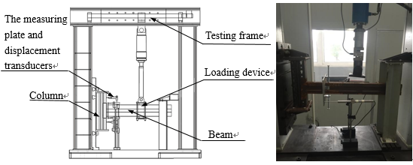

Figure 2. The test setup

2.1.3 Loading procedure

The cyclic loading procedure was based on variable amplitude load control mode. Before yielding, the load was increased by 1000N for each level and the load was repeated twice. After yielding, the load was still increased 1000N every step, but repeated once. The cyclic loading procedure is illustrated in Figure 3. When the force was downward, the direction was seen as positive, the angle θ was negative, the load was negative and vice versa. When the sample’s connector, welding spot or column holes appeared obvious damage, the test stopped.
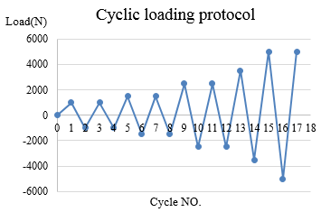

Figure 3. The cyclic loading procedure (Rack Manufacturers Institute 2012)

2.2 Finite Element Simulation

Because the test is relatively complicated and the cost is high, it is necessary to explore the method of finite element analysis to replace the cyclic loading test. According to enterprise drawings, three-dimensional CAD models including M120, M100 columns and B80, B100 beams are established. In order to ensure the accuracy of simulation, the details of web, flange openings, section reinforcements and fillets are retained. After three-dimensional models are established, the assembly is carried out according to the combination of physical test samples, and then a finite element model was built using the commercial FE software ANSYS Workbench. The analysis settings were consistent with the test setup. The analysis settings are as follows:
(1) Material Properties
Different combinations of beam, column and beam end connector assemblies were modeled. The material properties of all the three components listed in Table 2 were used for FE modeling (FEM).
(2) Connection Modeling and Surface Interaction
Contact nonlinearity was incorporated into the FE model by defining the interactions among column, beam end connectors, and rivets. The surface-to-surface interactions (front and side) between column and the beam end connector were defined through tangential frictionless behavior, as shown in Figure 4(a). Similarly, the surface-to-surface interactions between column and rivets were defined in two ways: (i) normal hard contact, as shown in Figure 4(b), and (ii) tangential frictionless contact, as shown in Figure 4(c). The former was defined to avoid the relative movement between the surfaces of the column and the rivet, whereas the latter was defined to restrain the sideways movement (normal to longitudinal axes) of the column.
(3) Loading and Boundary Conditions
Loading and boundary conditions were consistent with the test setup. In experimental setup, both column ends were clamped and the column moves only up and down as a rigid body. Therefore, similar boundary conditions were applied to end of beams and the column. Upper and lower column ends are pinned support. The concentrated force has been applied at a distance of 400 mm from the column's face. Similar loading procedure was adopted for FE analysis.

2.3 Simulation Results and its validations

2.3.1 Failure mode

Comparing experimental results with simulation results, failure modes of the FE model show close agreement with the experimental results. Under the cyclic load, holes were gradually deformed due to tension and compression of rivets and swinging of beams. After test, column holes appeared gap, rivets and the beam end connector appeared obvious deformation. A comparison of failure modes in both experimental and FE analysis was presented in Figure 5. Deformation of the above-mentioned components together resulted in failure of the beam-column connection.
Tangential front contact surfaces

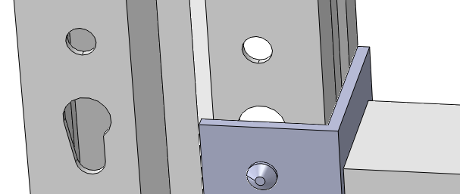
Tangential side contact surfaces

(a) Interactions between column and the beam end connector
Rivet surface
Column surface
Hard contact surfaces

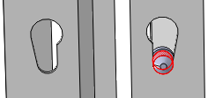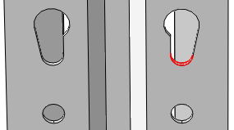

(b) Normal hard contact between column and rivet
Rivet surface
Column surface

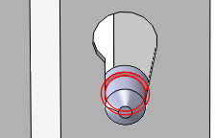
Tangential contact surfaces

(c) Tangential frictionless contact between column and rivet

Figure 4. Surface to surface interaction among components

2.3.2 Backbone curve

An analysis of the backbone curve of cyclic tests provides a means to compare with monotonic tests. For each connection, the backbone curve is derived from the cyclic moment-rotation curve by drawing a line between consecutive peak points of each primary cycle. The backbone curves from hysteretic moment-rotation responses are shown in Figure 6. By comparison, it can be found that experimental results are in close agreement with the backbone curves of simulation results. The main reason for the slight deviation is that the finite element model does not consider geometric imperfect and material nonlinear, which will cause backbone curves difference. However, from the point of view of engineering application, FE simulations have good agreements with actual experiments. Therefore, the seismic performance of BBCs can be studied and evaluated by finite element analysis instead of cyclic load test.

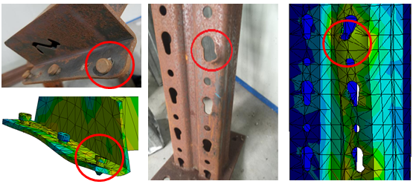
(a) Deformation of rivets and beam end connector (b) Gap of holes

Figure 5. Comparison of simulation and experimental deformation

(a) M100

(b) M120

Figure 6. Comparison of experimental and simulation backbone curves

2.4 Analysis and discussion of results

2.4.1 Types of beam-column connections

In order to evaluate the influence of different component parameters on the seismic performance of BCCs, four groups of BCCs models in Table 3 are built by finite element method. Each group includes a sample of riveted beam-column connection with M90B beam end connector thickness of 4 mm, clearance between beam end connector and column of 1 mm, and beam welded on the top. In order to facilitate subsequent data analysis, it is regarded as a standard part and marked in the Table 3.

Table 3. Groups and model parameters

 | ID | Thickness of beam end connector(mm) | Clearance (mm) | Beam position | Bolts
A | A-1(standard) | 4 | 1 | 32 (upper) | No
 | A-2 | 5 | 1 | 32 (upper) | No
 | A-3 | 6 | 1 | 32(upper) | No
B | B-1(standard) | 4 | 1 | 32(upper) | No
 | B-2 | 4 | 2 | 32(upper) | No
C | C-1(standard) | 4 | 1 | 32(upper) | No
 | C-2 | 4 | 1 | 48(middle) | No
 | C-3 | 4 | 1 | 64 (lower) | No
D | D-1(standard) | 4 | 1 | 32(upper) | No
 | D-2 | 4 | 1 | 32(upper) | Yes

2.4.2 The energy dissipation capacity

Hysteretic curve, also known as restoring force curve, is often used to describe the non-linear mapping relationship between load and deformation under cyclic loading. The relationship between load-displacement curve, i.e. hysteretic curve, can be obtained by low-frequency cyclic loading test. The hysteretic curves obtained from the analysis results of each group of models are shown in Figure 7. In order to study the effect of bolted beam-column connections on improving the seismic performance of connections, the low-frequency cyclic loading simulation analysis of bolted connections and riveted connections is carried out, and the hysteretic curves are shown in Figure 8. The area of hysteretic curve represents the total dissipated energy in the process of cyclic loading, i.e. hysteretic energy dissipation capacity (Lingfeng Yin et al. 2016), the calculation formula is as follows:

S = ∫f(x)dx (1)

Where f(x) is the curve equation, representing force and x represents displacement.
In this paper, the accumulated hysteretic energy consumption area is calculated by Origin 7.0 software. The maximum hysteresis loops of all hysteretic curves are extracted and compared. The results are shown in Table 4. The absolute difference rate is calculated by denominator of standard parts, and the difference is calculated by increasing or decreasing relative to the previous calculation.
Based on the analysis of energy dissipation data in Table 4, it can be concluded that group D (bolted connections) have an evident influence on hysteretic energy dissipation capacity. The hysteretic energy dissipation capacity of bolted connections is more than five times that of riveted connections.
For group A, the influence of thickness of beam end connector on hysteretic energy dissipation capacity is also studied. When the thickness of beam end connector increases from 4 mm to 5 mm, the hysteretic energy dissipation capacity of the connections increases by 4.05%. But when the thickness of beam end connector increases from 4 mm to 6 mm, the energy dissipation capacity of the connections increases to 1.67 times, with a large increase. With the increase of thickness of beam end connector, and the energy dissipation capacity of connections increases accordingly. Group B is to study the influence of the clearance between the column and beam end connector. When the clearance increases from 1 mm to 2 mm, the energy dissipation capacity increases by 49.43%. Group C is to study the influence of beam welding position on hysteretic energy dissipation capacity. When the beam is welded in the middle of beam end connector, the energy dissipation capacity is 220.89% higher than that when the beam is welded in the upper part; when the beam is welded in the lower part, its energy dissipation capacity is 109.09% higher than that when the beam is welded in the upper part. According to the analysis of Table 4, bolted connections have the more influence on improving the energy dissipation capacity of connections, followed by welding positions and the clearance between columns and beam end connector in turn.

(a) Standard (b) A-2

(c) A-3 (d) B-2

(e) C-2 (f) C-3

Figure 7. Hysteretic curves of finite element analysis of boltless beam-column connections

(e) Riveted connections (f) Bolted connections

Figure 8. Hysteretic curves of riveted and bolted connections

Table 4. Hysteretic energy dissipation capacity

Influence parameter | ID | Hysteretic energy dissipation capacity () | Absolute difference rate (%)
Thickness of beam end connector | A-1(standard) | 178704.42 | /
 | A-2 | 185944.03 | 4.05
 | A-3 | 478528.70 | 167.78
Clearance | B-1(standard) | 178704.43 | /
 | B-2 | 267041.36 | 49.43
Beam position | C-1(standard) | 178704.43 | /
 | C-2 | 573444.58 | 220.89
 | C-3 | 373654.17 | 109.09
Bolt | D-1(standard) | 178704.43 | /
 | D-2 | 1075088.61 | 501.60

3. SUMMARY AND CONCLUSION

The beam-column connections are critically important to the seismic performance of thin-walled steel storage rack. In view of practical application to the seismic performance evaluation of BCCs in SPR, a numerically FE model is presented to compute their bi-directional hysteretic behavior in a direct manner. The results of the FEMs were validated against the experimental results on hysteretic curves from low-frequency cyclic loading test. On the basis of the hysteretic model, the degradation performance of the different BCCs are evaluated by the indicator named energy dissipation capacity. The results obtained show that the bolted combination BCCs can evidently improve the dynamic performance of the semi-grid connections in comparison with only riveted BBCs. However, the bolted combination BCCs maybe give rise to the increase of the fabrication cost in SPRs. So the adjustment of welding position and the clearance between columns and beam end connectors is also reasonable alternative solution. The proposed hysteretic model and design recommendations on these connections can be further used in the modal response spectrum analysis (MRSA) to improve the seismic response for thin-walled steel storage pallet racks.

4. Acknowledgments

This paper has been funded by technology innovation program of Shanghai Municipal Science and Technology Commission (17DZ2283800), Minhang Science and Technology Foundation (2017mH205). The test specimens were kindly provided by JingXing Logistic Equipment Engineering (Shanghai) Co., Ltd.

5. References

EN15512. Steel static storage systems– Adjustable pallet racking systems–Principles for structural design. European Committee for Standardization 2009. Brussels, Belgium.
Claudio Bernuzzi, Marco Simoncelli. (2016) An advanced design procedure for the safe use of steel storage pallet racks in seismic zones. Thin-Walled Structures, 109: 73–87.
S.N.R. Shah, N.H. Ramli Sulong, R. Khan, M.Z. Jumaat, M. Shariati. (2016) Behavior of industrial steel rack connections. Mechanical Systems and Signal Processing, 70–71.
F. Gusella, M. Orlando, A. Vignoli. (2017) Effects of pinching in the hysteresis loop of rack connections. Proceedings of the XVII Convegno ANIDIS. 17-21.
F.D. Markazi, R.G. Beale, M.H.R. Godley. (1997) Experimental analysis of semi-rigid boltless connectors. Thin-Walled Structures, 28: 57–87.
Bernuzzi Claudio, Carlo A Castiglioni. (2001) Experimental analysis on the cyclic behavior of beam-to-column joints in steel storage pallet racks. Thin-Walled Structures, 39: 841-59.
Elsayed Mashaly, Mohamed El-Heweity, Hamdy Abou-Elfath, Mohamed Osman. (2011) Finite element analysis of beam-to-column joints in steel frames under cyclic loading. Alexandria Engineering Journal, 50: 91–104.
Lingfeng Yin, Gan Tang, Min Zhang, Bingjing Wang. (2016) Monotonic and cyclic response of speed-lock connections with bolts in storage racks. Engineering Structures, 116:40-55.
Liusi Zhao, Xianzhong Zhao. (2014) Review of seismic behavior of steel storage racks. Earthquake engineering and engineering dynamics, 34(S1):712-720.
Rack Manufacturers Institute (RMI). Specification for the design, testing and utilization of industrial steel storage rack. Material Handling Industry, MH16.1 2012. Charlotte, NC.
Standards Australia. Steel storage racking. AS4084, 2012. Sydney, Australia.

Associate professor, Donghua University, Shanghai, China, lvzj@dhu.edu.cn
College of Mechanical Engineering, Donghua University, Shanghai, China, 852692515@qq.com
College of Mechanical Engineering, Donghua University, Shanghai, China, xqsir@dhu.edu.cn
College of Mechanical Engineering, Donghua University, Shanghai, China, freemeng1@163.com
Shanghai Jingxing Storage Equipment Engineering Co., Ltd. Shanghai, China, sweetlv@163.com

