SEISMIC FRAGILITY ANALYSIS OF SPHERICAL STORAGE TANK WITH SIMPLIFIED FINITE ELEMENT MODEL

DOI 10.37153/2686-7974-2019-16-1083-1084

Chaulagain Nabin Raj, Sun Chang Ho, Kim Ick Hyun

Abstract

A three-dimensional simplified model is presented for conducting seismic fragility assessment of the spherical liquid storage tank. The proposed model consists of concentrated fluid mass assigned to the beam-column element through rigid links. Before conducting fragility analysis with the simplified model, its validation was done by comparing seismic analysis results through FSI (fluid-structure interaction) model. FSI model is characterized liquid element that can exhibit proper fluid-structure interaction and sloshing behavior. Seismic behavior of the simplified model and FSI model was studied at different filling state. Time history analysis was performed for 50% and 80% filling state to compare seismic base shear and overturning moment results for the simplified and FSI model. Once the seismic results were checked and validated, fragility analysis was carried out by the simplified model. A set of 18 different ground motions were selected from the historic earthquake database. Nonlinear time history analyses were performed to obtain strength of spherical storage system at different limit states. Finally, fragility curves were developed based on the maximum likelihood estimation approach with respect to defined strength limit states.

Keywords: spherical tank, seismic analysis, fluid-structure interaction, simplified model, fragility curve.

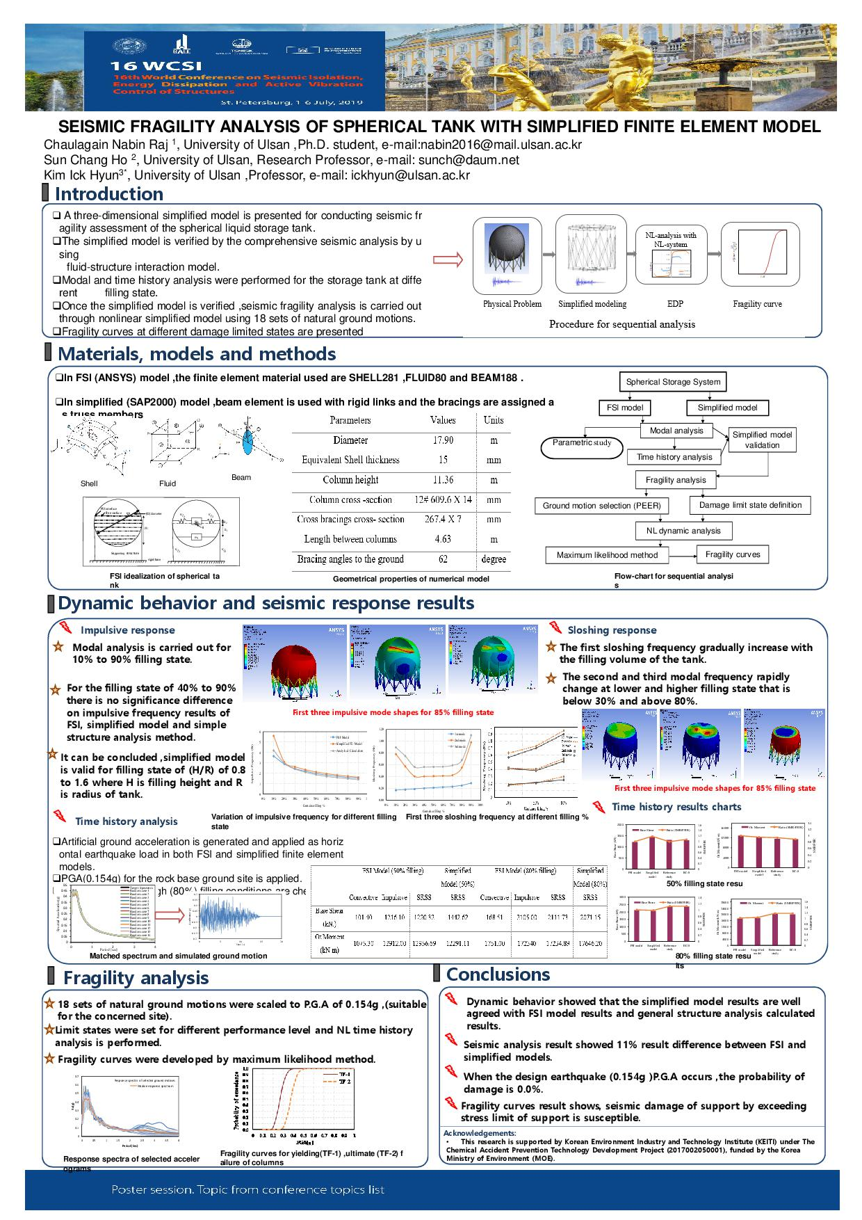

University of Ulsan, Ulsan, South Korea
University of Ulsan, Ulsan, South Korea
University of Ulsan, Ulsan, South Korea

