SEISMIC PERFORMANCE EVALUATION BY CAPACITY SPECTRUM

METHOD FOR BASE-ISOLATED FRAME

DOI 10.37153/2686-7974-2019-16-1075-1082

Mohit BHANDARI, R. N. SHARMA, S. D. BHARTI, Mahendra SHRIMALI, Tushar DATTA

ABSTRACT

The present study aims to investigate the efficacy of the capacity spectrum method (CSM) in the prediction of seismic demands as compared to the Nonlinear Time History Analysis (NTHA) for the base-isolated building frame at different performance points. In this line, a ten-story base-isolated building frame with lead rubber bearing (LRB) isolators is considered in the analysis. The corresponding fixed base frame is also analyzed as a reference for comparison purposes. Performance points are obtained corresponding to different PGA levels, namely, 0.1g, 0.2g, 0.3g, 0.4g, and 0.5g. The NTHA is performed by employing artificially generated time histories compatible to ATC-40 response spectrum and scaled to above mentioned PGA levels. The comparison between the responses predicted by the two analyses is made in terms of three response parameters, namely, the base shear, the maximum isolator displacement, and the maximum interstorey drift ratio. The results of the study reveal that the CSM is good in predicting the seismic demands in base-isolated building frames up to a specific performance point consistent with the low PGA level (0.2g). Beyond this level, the difference in response quantities between CSM and NTHA increases with increase in the PGA.

Keywords: Capacity spectrum method; Performance point; Nonlinear time history analysis; Lead rubber bearing; Base isolation

1. INTRODUCTION

The seismic performance of the fixed base building in the event of an earthquake is increased by providing different response control strategies. One of the successful and widely implemented technique is “Base Isolation”(Jangid and Datta, 1995; Kelly, 1986). In the base isolation, the building is decoupled from the foundation by inserting flexible devices known as a base isolator. Thus, the building is made more flexible resulting in an increase in its fundamental period of vibration which further reduces the acceleration demand from the earthquake. The base-isolated building moves like a rigid block under earthquake excitation as compared to the cantilever type movement in the fixed base building. Due to its effectiveness and no requirement of an external source of energy, base isolation is widely implemented in buildings and bridges, and has performed well under seismic excitations.
With the increase in the successful implementation and advancement in the research in the field of base isolation, it becomes essential to evaluate the performance of base-isolated buildings to estimate the effectiveness of this technique. There has been considerable research and development in the field of Performance-Based Seismic Design, for which different nonlinear static procedures have been developed for the performance evaluation of the buildings. The most popular methods are Capacity spectrum method, Displacement Coefficient Method, N2 method, Modal Pushover Analysis, and Adaptive Modal Combination procedure.
A large number of research studies have been performed to evaluate the performance of fixed base buildings (Erduran, 2008; Hasan et al., 2002; Kalkan and Kunnath, 2007; Kilar and Fajfar, 1997; Mahdi and Soltan, 2011). The same attempts to evaluate the seismic performance of base-isolated building are scanty. There are only a few studies which have been carried out using application of limited nonlinear static procedures in the case of base-isolated buildings. Doudoumis et al. (2006) compared the responses of a four-storey reinforced concrete building which is isolated with lead rubber bearings. The performance of the buildings is estimated by carrying out pushover analysis with uniform force lateral load pattern, and the seismic responses are compared with the exact predictions of NTHA. It was concluded that the responses estimated with uniform force load pattern hold good agreement with mean NTHA responses in terms of base shear and top displacement.
The N2 method has been put forward in various studies by Vojko Kilar and David Koren as an effective performance evaluation tool for seismic response prediction of base-isolated buildings. They have idealized the capacity of a four-storey building as a trilinear curve in which initial stiffness is depicted by the first yielding point (Kilar and Koren, 2010). N2 method was applied to estimate the seismic performance with the application of three lateral load patterns namely, pattern proportional to first mode shape, triangular patterns, ans pattern suggested by protective system committee (PSC) (SEAONC, 1986). The results were compared with the mean predictions of NTHA. It was concluded that the N2 method provided close estimates to the exact values of NTHA. The PSC pattern and first mode pattern provide good estimates. The same authors also prove the applicability of the N2 method by considering the torsional effects in the unsymmetrical base-isolated building (Kilar et al., 2011; Koren and Kilar, 2011) for various cases of asymmetry and torsional effect. Faal and Poursha (2017) investigated the effectiveness of three nonlinear static procedures namely, Modal Pushover Analysis (MPA), Extended N2 method and N2 method in order to estimate the inelastic demands of three and twelve storey steel frames base-isolated with LRB. The predictions of the abovementioned procedures were then compared to the those of NTHA values at three considered PGA values, namely,0.4g, 0.6g, and 0.8g. It was concluded that the extended N2 method provides the best estimates of inelastic effects and hinge rotations.
With reference to the available literature, it is observed that the studies have been conducted for a particular target displacement or at a specific performance point and for a specific nonlinear static procedure. With this motivation in view, the present study is attempting to investigate the effectiveness of the Capacity Spectrum Method in the seismic response prediction of a ten storey base-isolated and fixed base building frames at five performance points corresponding to specific PGA levels. The frame is isolated by lead rubber bearing. The effectiveness of the CSM is estimated by comparing its predictions with the exact values of mean NTHA.

2. MODELING AND DESIGN OF BUILDING FRAMES

For the analysis, a ten storey frame is considered to have three bays of 5 m each. The height of each storey is 3.2 m. For the sake of simplicity, the sizes of all beams and columns are kept uniform through out the building height; beam size is 450 mm × 650 mm; column size is 650 mm × 650 mm. The two-dimensional model of the frame is modeled in SAP2000 software. The configuration of the frame is shown in Figure 1(a). The beams and columns are modeled as line elements with specified properties given as input in the property data sheet of the software. The beam column joints is modelled by specifying the joint rigidity factor as 0.5 as recommended by the software in which the half joint length is rigid. The nonlinearity in the frame is modelled by defining the plastic hinges at both ends of the beams and columns at a relative distance of 0.1 and 0.9 of the total length. The default hinge properties are used to define all the parameters of hinges which are automatically calculated by the software as per the properties provided by the FEMA-356 (2000) specific to beams and columns. The default moment-rotation backbone curve for plastic hinges is shown in Figure 1(b). Three performance levels as per FEMA 356 has been considered, immediate occupancy, life safety, and collapse prevention as shown in Figure 1(b).
The building frame is designed for the fixed base condition as per Indian seismic code IS-1893 (2016) for the highest seismic zone having zone factor equal to 0.36 and medium type soil condition. The value of response reduction factor is taken as five corresponding to the special moment resisting frame as per the seismic code. The value of the dead load on all floor levels is 23 kN/m and the live load is 6.25 kN/m on typical floors. The design is carried out by considering full dead load plus 25% live load. The same frame which is designed for the fixed base condition is isolated with the lead rubber bearings. The strength of concrete is 40 MPa having an elastic modulus equal to 31620 MP, and the yield strength of reinforcing rebar is 415 MPa.

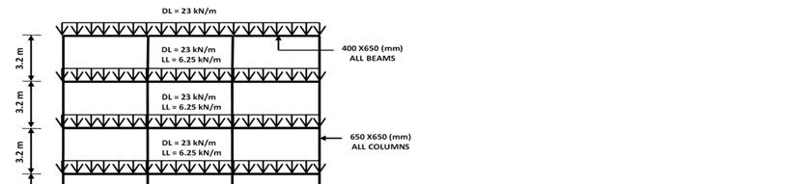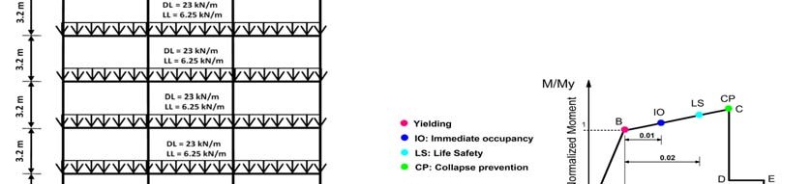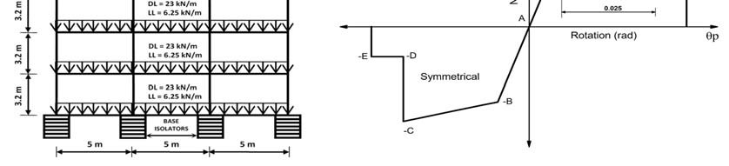
(a) (b)

Figure 1. Building details: (a) elevation view of the frame;
(b) default moment-rotation curve for plastic hinges as per FEMA 356.

The lead rubber bearing (LRB) isolator is selected to provide isolation to the frame. The force-displacement behavior of LRB is bilinear and is based on the modified Bouc-Wen model (Wen, 1976) as shown in Figure 2. The characteristic of the bilinear curve is described in the same figure. The design of the LRB is carried out by following the design guidelines and formulas given by Naeim and Kelly (1999) and Datta (2010) for the maximum column load. The fundamental vibration period of the fixed base and base-isolated building frames are 0.82 s and 3 s respectively.

Figure 2. The Idealized bilinear force-displacement curve of lead rubber bearing isolator

3. NUMERICAL STUDY

The performance of a ten storey fixed base and base-isolated building frame is evaluated by Capacity Spectrum Method (CSM) and Nonlinear Time History Analysis (NTHA). The CSM is used to obtain the performance points at five PGA levels, namely, 0.1g, 0.2g, 0.3g, 0.4g, and 0.5g. The capacity curve is obtained by performing pushover analysis in which lateral load pattern corresponding to the first mode shape is selected. This loading pattern is selected with the motivation that the first mode primarily governs the response of the building, especially for the case of base-isolated buildings and also it provides good estimates (Chopra and Goel, 2002; Kilar and Koren, 2010). The demand spectrum (as given in ATC-40) is intersected with the capacity curve to obtain the performance points at five above mentioned scaled PGA levels of the demand spectrum.
The NTHA is performed by employing three artificial time histories compatible with the ATC-40 demand spectrum. The NTHA is performed by using the Hibler Hughes integration scheme having a value of Beta = 0.25 and Gamma = 0.5. The Rayleigh damping is calculated corresponding to the first and the second modes of vibration. Two typical time histories (Artificial 1 and Artificial 2) are shown in Figure 3(a). The comparison of the response spectrum of the artificial time histories with that of ATC-40 is shown in Figure 3(b). The responses of the frames are then obtained by scaling the time histories at the above mentioned five PGA levels. Finally, the responses obtained by the CSM at a particular performance point are compared with those obtained from the mean NTHA values at the same PGA levels at which the performance points are obtained.

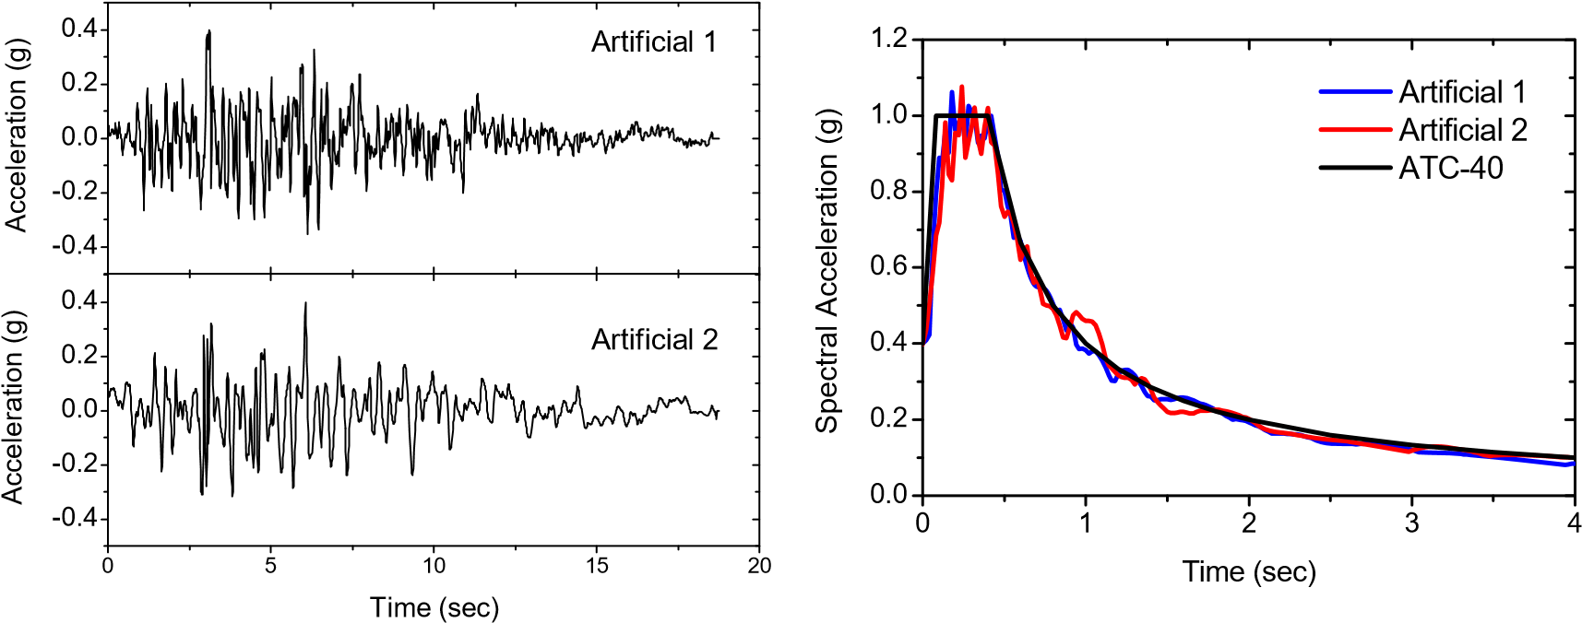
(a) (b)

Figure 3. Artificial time history data; (a) acceleration time histories;
(b) comparison of response spectrum (5% damping)

4. DISCUSSION OF RESULTS

The comparison of the capacity curves obtained for the two building frames is compared in Figure 4. It is observed from the figure that there is a significant difference between the initial slopes of the capacity curves for the two building frames. For the same displacement value, the value of the base shear is less in the case of the base-isolated frame. The flatness of the capacity curve of the fixed base frame is reached at a lower value of the base shear as compared to the base-isolated frame because the fixed base frame gets into the plastic state at the half displacement level as that of the base-isolated frame; the displacement capacity of the base isolated frame is higher. The performance points (PP) obtained for the two building frames are marked on the capacity curves as shown in Figure 4.
The comparison of maximum inter-storey drift (IDR) values for the two frames computed by both analysis methods are present in Table 1. In the same table, the percentage difference between the values is given with respect to the NTHA values. It is observed from the table that for the fixed base frame, the difference is less than 8% for a PGA level of 0.3g and after that, with a further increase in the PGA level, the difference increases. The same trend in the difference is observed in the case of the base-isolated frame only up to the PGA level of 0.2g. The large difference in the case of the base-isolated building is due to the fact that the vibration of the isolated building follows the rigid body motion in NTHA for which less IDR value is yielded; whereas, the lateral push to the isolated building is like that of a flexible building with flexible base yielding large IDR values. The height-wise variation of IDR values for the two building frames is shown in Figure 5.

Base shear (kN)

600
500
400
300
200
100
0
0
100
200
300
400
500
600
700
800
Storey
10
Fixed Based
Base-Isolated
Displacement (mm)
PP@0.1g
PP@0.2g
PP@0.3g
PP@0.4g
PP@0.5g

Figure 4. Comparison of capacity curves of 10-storey fixed base and base-isolated frames

Table 1. Comparison of maximum IDR values obtained by CSM and NTHA.

PGA level (g) | Inter-storey drift ratio (%)
 |  | Fixed Base |  |  |  | Base-Isolated
 | CSM | Mean NTHA | Percentage difference |  | CSM | Mean NTHA | Percentage difference
0.1 | 0.121 | 0.123 | 1 | 0.043 |  | 0.045 | 4
0.2 | 0.247 | 0.248 | 1 | 0.061 |  | 0.056 | 8
0.3 | 0.411 | 0.380 | 8 | 0.087 |  | 0.070 | 24
0.4 | 0.627 | 0.483 | 30 | 0.142 |  | 0.079 | 79
0.5 | 0.922 | 0.542 | 70 | 0.469 |  | 0.081 | 480

The difference in the base shear estimated by the two analyses for the fixed base and the base-isolated frame is shown in Table 2. It is observed from the table that the base shear predicted by the NTHA in case of the fixed base frame is more as compared to the CSM. The difference in the base shear increases with the increase in the PGA. Note that the increase in the difference is not significant as observed in the case of IDR. The reason for this large difference at the higher PGA level is due to the fact that after the performance point corresponding to the PGA = 0.3g, the capacity curve of the fixed base frame becomes almost flat as shown in Figure 4 resulting into the constant base shear. Whereas, the value of base shear goes on increasing with the increase in PGA level in case of NTHA and this trend is clearly observed in the table.
An opposite trend in the case of the base-isolated frame is observed in which the base shear estimated by the NTHA is less as compared to the CSM. This is due to the fact that the actual energy dissipation due to isolation is captured by the NTHA by the hysteresis effect. On the other hand, the CSM computes the energy dissipation through equivalent damping; CSM provides more base shear.

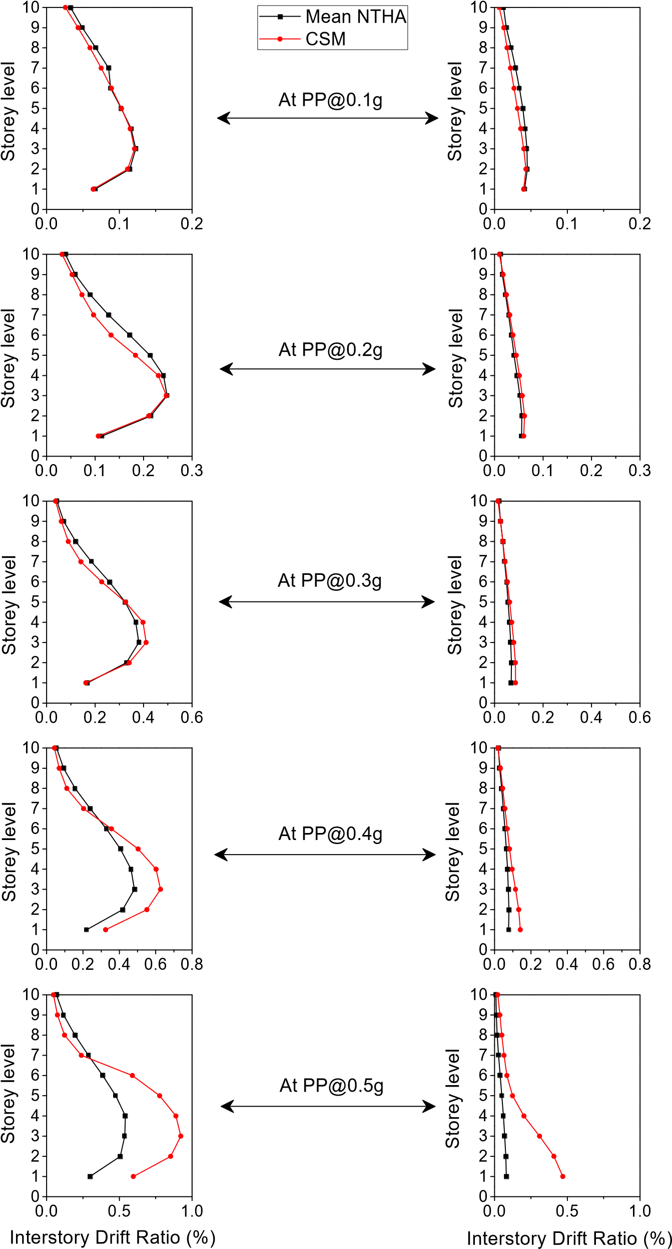
(a) Fixed Base frame (b) Base-isolated frame

Figure 5. Height wise comparison of IDR response determined by CSM and NTHA

Table 2. Comparison of base shear obtained by CSM and NTHA.

PGA level (g) | Base Shear (kN)
 |  | Fixed Base |  |  |  | Base-Isolated
 | CSM | Mean NTHA | Percentage difference |  | CSM | Mean NTHA | Percentage difference
0.1 | 522 | 546 | 4 | 237 |  | 218 | 9
0.2 | 626 | 828 | 24 | 336 |  | 308 | 9
0.3 | 680 | 1070 | 36 | 468 |  | 366 | 28
0.4 | 707 | 1267 | 44 | 613 |  | 404 | 52
0.5 | 707 | 1446 | 51 | 682 |  | 456 | 50

Table 3 presents the estimates of maximum isolator displacement predicted by the CSM and the NTHA. The CSM overestimates the isolator displacement in comparison to the NTHA and the difference yielded by the CSM is quite large even at the lowest PGA level (0.1g). The reason for the large difference is due to the fact that there is a large lateral push given in one direction to the isolated building in the process of generating a capacity curve, which provides a large value of isolator displacement.

Table 3. Comparison of maximum isolator displacement obtained by CSM and NTHA.

PGA level (g) | Isolator displacement (mm) |  |  | Percentage difference
 | CSM |  | Mean NTHA
0.1 | 24 | 18 |  | 33
0.2 | 43 | 37 |  | 16
0.3 | 68 | 56 |  | 21
0.4 | 95 | 69 |  | 38
0.5 | 126 | 81 |  | 56

5. CONCLUSIONS

A numerical investigation is carried out to check the efficacy of Capacity Spectrum Method (CSM) to predict the responses in comparison to the Nonlinear Time History Analysis (NTHA). The CSM (ATC-40) is carried out to obtain the performance points at five specified PGA levels, namely, 0.1g, 0.2g, 0.3g, 0.4g and 0.5g. The response at each performance point is then compared with the exact mean prediction of NTHA which is carried out by employing four artificial time histories compatible with ATC-40 response spectrum and scaled to the above-mentioned PGA levels. Finally, the comparison of both analyses is presented. The results arising from the present study for the specific problem analyzed are presented below:
The performance of the fixed base frame is increased by providing a base isolation.
- The maximum displacement depicted by the capacity curve of the base-isolated frame is large (550 mm) as compared to that of the fixed base frame (400 mm).
- For the specific base-isolated frame analyzed, the CSM provides good predictions of the base shear and the inter-storey drift with less differences (< 10%) in comparison to NTHA up to a performance point corresponding to the PGA of 0.2g.
- CSM overestimates the isolator displacement at all performance points.
- From the specific 10-storey frame analyzed, it is inferred from the results that the CSM should be cautiously used in the response prediction of base-isolated frames at higher PGA levels (> 0.3g).

6. ACKNOWLEDGMENTS

The funding of this study is provided by the Department of Science and Technology, the government of India, New Delhi, India.

7. REFERENCES

Chopra, A. K., & Goel, R. K. (2002). A modal pushover analysis procedure for estimating seismic demands for buildings. Earthquake engineering & structural dynamics, 31(3), 561-582.
Datta, T. K. (2010). Seismic analysis of structures: John Wiley & Sons.
Doudoumis, N. I., Kotanidis, C., & Doudoumis, I. N. (2006). A comparative study on static push-over and time-history analysis methods in base isolated buildings. Paper presented at the First European Conference on Earthquake Engineering and Seismology, Geneva, Switzerland, September, paper.
Erduran, E. (2008). Assessment of current nonlinear static procedures on the estimation of torsional effects in low-rise frame buildings. Engineering Structures, 30(9), 2548-2558.
Faal, H. N., & Poursha, M. (2017). Applicability of the N2, extended N2 and modal pushover analysis methods for the seismic evaluation of base-isolated building frames with lead rubber bearings (LRBs). Soil Dynamics and Earthquake Engineering, 98, 84-100.
FEMA-356. (2000). Prestandard and commentary for the seismic rehabilitation of buildings. Washington, DC: SAC Joint Venture for the Federal Emergency Management Agency.
Hasan, R., Xu, L., & Grierson, D. (2002). Push-over analysis for performance-based seismic design. Computers & structures, 80(31), 2483-2493.
IS-1893. (2016). (Part 1) Criteria for earthquake resistant design of structures. Bureau of Indian Standards, Manak Bhawan, New Delhi.
Jangid, R., & Datta, T. (1995). Seismic behaviour of base-isolated buildings: a state-of-the-art review. Proceedings of the Institution of Civil Engineers. Structures and buildings, 110(2), 186-203.
Kalkan, E., & Kunnath, S. K. (2007). Assessment of current nonlinear static procedures for seismic evaluation of buildings. Engineering Structures, 29(3), 305-316.
Kelly, J. M. (1986). Aseismic base isolation: review and bibliography. Soil Dynamics and Earthquake Engineering, 5(4), 202-216.
Kilar, V., & Fajfar, P. (1997). Simple push-over analysis of asymmetric buildings. Earthquake engineering & structural dynamics, 26(2), 233-249.
Kilar, V., & Koren, D. (2010). Simplified inelastic seismic analysis of base‐isolated structures using the N2 method. Earthquake engineering & structural dynamics, 39(9), 967-989.
Kilar, V., Petrovcic, S., Koren, D., & Šilih, S. (2011). Seismic analysis of an asymmetric fixed base and base-isolated high-rack steel structure. Engineering Structures, 33(12), 3471-3482.
Koren, D., & Kilar, V. (2011). The applicability of the N2 method to the estimation of torsional effects in asymmetric base‐isolated buildings. Earthquake engineering & structural dynamics, 40(8), 867-886.
Mahdi, T., & Soltan, G. V. (2011). Plan irregular RC frames: comparison of pushover with nonlinear dynamic analysis.
Naeim, F., & Kelly, J. M. (1999). Design of seismic isolated structures: from theory to practice: John Wiley & Sons.
SEAONC. (1986). Tentative Seismic Isolation Design Requirements: Structural Engineers Association Of Northern California. Seismology Committee. Base Isolation Subcommittee.
Wen, Y.-K. (1976). Method for random vibration of hysteretic systems. Journal of the engineering mechanics division, 102(2), 249-263.

Senior Research Fellow, National Centre for Disaster Mitigation and Management, Malaviya National Institute of Technology, Jaipur, India, man2301@yahoo.co.in
Associate Professor, Department of Architecture and Planning, Malaviya National Institute of Technology, Jaipur, India, rnsharma.arch@mnit.ac.in
Professor, Department of Civil Engineering, Malaviya National Institute of Technology, Jaipur, India, sdbhart@mnit.ac.in
Professor, Department of Civil Engineering, Malaviya National Institute of Technology, Jaipur, India, shrimalimk@gmail.com
Professor, Department of Civil Engineering, Malaviya National Institute of Technology, Jaipur, India, tushar_k_datta@yahoo.co.in

