SEISMIC PERFORMANCE OF FIXED BASE AND BASE-ISOLATED

BUILDING FRAME

DOI 10.37153/2686-7974-2019-16-1063-1174

Mohit BHANDARI, R. N. SHARMA, S.D BHARTI, Jaswant N. ARLEKAR, C. V. R. MURTY

ABSTRACT

The present study deals with the performance evaluation of a base-isolated building frame in contrast with a fixed base frame. For this purpose, the performance of two building frames is compared including (i) a seismically designed 6-storey reinforced concrete fixed base building frame; and (ii) an identical frame considered in the previous case, having the same configuration and loading conditions designed according to the proposed base-isolated building code (draft, 1893-2018 Part 6). The lead rubber bearing isolators are used as the base isolation system in the base isolated building frame. Two performance evaluation tools are used, namely (i) Capacity Spectrum Method (CSM), which is one of the established nonlinear static methods to estimate the seismic demands of buildings; and (ii) Nonlinear Time History Analysis (NTHA), which is the most exact method to evaluate the seismic performance of the buildings. The CSM is used to obtain the performance points consistent with the specified IS 1893-2016 response spectrum. The seismic demands are evaluated at three performance points corresponding to three assumed PGA levels, namely, 0.2g (design level), 0.4g (medium level), and 0.6g (high level). The NTHA is also performed with the simulated ground motions consistent with the IS 1893-2016 response spectrum. Finally, the effectiveness of using base isolation is evaluated at the three assumed PGA levels with respect to the fixed base frame. The study concludes that (i) the performance of the base-isolated frame is highly increased as compared to the fixed base frame at all considered PGA levels; (ii) in the case of the base-isolated frame, the reduction in the base shear is about 60%, and in inter-storey drift and top floor displacement is about 70% at all considered PGA levels.

Keywords: Base isolation; Lead rubber bearing; Performance points; Seismic demands; capacity spectrum method

1. INTRODUCTION

Base isolation is one of the most successful and practically implemented seismic control strategies which has been proven over the years to be effective against the damaging effect of earthquakes to the buildings (Deb, 2004; Kelly, 1986). The technique is to decouple the building from the foundation and to link them both with a flexible device called as a base isolator. The entire superstructure is mounted on the base isolators resulting in the shift in the fundamental frequency of the building. The base isolation enhances the performance of a building by (i) lengthening the fundamental period of the building which offers less earthquake force to be acted on the building; (ii) the fundamental mode is shifted to the sway mode in contrast to the cantilever mode as in the case of fixed base building; (iii) increases the damping of the system by providing energy dissipation in the isolators; and (iv) provides minimum rigidity against wind loads and minor seismic excitations.
It is important to evaluate the performance of the base isolated buildings against fixed-base buildings to get an estimate of the performance and effectiveness of providing a base isolation system. In recent years, with the development in the field of the performance-based seismic design, many nonlinear static procedures have been put forward by researchers to evaluate the seismic demands of the buildings imposed by the earthquakes (Krawinkler (1996); Krawinkler and Seneviratna (1998)). The most popular and established methods include the capacity spectrum method (CSM) documented in ATC-40 (1996), the coefficient method (CM) documented in FEMA-356 (2000), the modified CM and CSM documented in FEMA-440 (2005), the modal pushover method by Chopra and Goel (2002) , an adaptive modal combination procedure by Kalkan and Kunnath (2006) and the N2 method by Fajfar and Gaspersic (1996).
One such method, popularly known as a capacity spectrum method (CSM) was introduced by the research work of Freeman et al. (1975) in which a pilot study was performed to evaluate the seismic risk of the existing building at the Puget Naval Shipyard, Washington. The CSM is a simple graphical procedure in which capacity the curve of the building obtained by performing pushover analysis is intersected by the demand spectrum to obtain a performance point. The performance point gives the likely maximum displacement of the building to be imposed by the demand spectrum of a specific intensity. The method was latter document in ATC-40 (1996) in detail.
Regarding the fixed base buildings, a large number of investigations have been carried out to evaluate the seismic demands with different nonlinear static procedures (Kalkan and Kunnath (2007); Mwafy and Elnashai (2001); Tso and Moghadam (1998); Zou and Chan (2005)). The research studies pertaining to the performance evaluation of base-isolated buildings are scantly. Recently, few attempts have been made to evaluate the seismic demands of base-isolated buildings by nonlinear static procedures. Faal and Poursha (2017) performed a comparative study of evaluation of the performance of the base-isolated building by different nonlinear static procedures namely, the modal pushover analysis, the N2 method, and the extended N2 method. The mean response values of NTHA, obtained by different methods, were compared. It was found that the predictions estimated by the N2 method were better in terms of floor displacements, story drift, and rotation of plastic hinges. For the severely damaged state of the building, the extended N2 predictions were much closer to mean NTHA values. Kilar and Koren (2010) applied the N2 method to a four-storey RC base isolated building and compared the responses to those obtained by the NTHA. They idealized the capacity curve of the base-isolated building as a trilinear curve. The performance is evaluated by designing three different types of lead rubber bearings (LRB) isolators namely, hard, normal, and soft, which cater to three protection levels of the building. Three different load patterns were selected for performing pushover analysis namely, proportional to the shape of 1st mode, a triangular pattern, and pattern suggested by the protective system committee (PSC) SEAONC (1986). It was concluded that the N2 method provides close estimates of seismic demands when compared with mean predictions of NTHA by PSC load patterns.
Further, the demands obtained by using load pattern corresponding to 1st mode shape is reasonably good when the building is severely damaged. The same authors extended the applicability of the N2 method in further research works for the case of base-isolated buildings and investigated the effect of asymmetry and torsion (Kilar et al., 2011; Koren and Kilar, 2011). It was found the N2 method provides reasonable predictions of seismic demands with torsional and asymmetric conditions. Doudoumis et al. (2006) performed a comparative study in which the performance of a four-storey reinforced concrete (RC) base-isolated building was evaluated by pushover analysis (POA) and compared to the predictions of nonlinear time history analysis (NTHA). The uniform force distribution was selected as a lateral load pattern to perform POA. The NTHA was performed by employing three real ground motions, scaled to match twice of the elastic demand spectrum of Greek seismic code. It was concluded that the results obtained by the two analyses show a good agreement in terms of the maximum base shear evaluated, against top displacement and number of plastic hinges.
There are several investigations which have been carried out to evaluate the performance of base-isolated buildings using NTHA considering different cases. Alhan et al. (2016) investigated the influence of stiffening of high damping rubber bearing (HDRB) installed in the 6-storey frame under real and synthetically generated near-field earthquakes. Two different models were considered to represent the behavior of HDRB, one is smooth bi-linear hysteretic model ignoring the strain hardening of HDRB, and another one is hysteretic model including stiffening effect taking into account the strain hardening property of HDRB. The nonlinear time history analysis was carried out in the two cases to evaluate the response of the base-isolated building in terms of the base displacements, the floor accelerations, and the storey drifts. There was a significant effect of the stiffening model on the storey drift and the floor accelerations; the responses increase. It was suggested that the hysteretic model should be cautiously selected for the accurate representation of HDRB, especially in the case of earthquakes having a moment magnitude > 6.5 and near-field earthquakes. Tavakoli et al. (2014) compared the seismic response of the fixed base and the base-isolated buildings under near and far field earthquakes. The lead rubber isolator was used as a base isolation system. The responses were obtained by performing the nonlinear time history analysis of 2-D frames of 4, 8, and 12 stories each. The results obtained showed that the reduction in the base shear with implementing the base isolation is more in far-field earthquakes. The reduction of the absolute acceleration of the base is not much in base-isolated conditions for near-field earthquakes. Moreover, the maximum reduction is found in the middle floor levels for all buildings and is maximum for far-field earthquakes. The trend in the results also showed that by increasing the number of floors in the building, the effectiveness of the base isolation decreases especially in the case of near-field earthquakes. High inter-storey drift demands were imposed by the near-field earthquakes on the fixed base structures, especially in the middle storey levels. Cardone et al. (2013) performed a parametric study to evaluate the inelastic response of four reinforced concrete base-isolated buildings, each having 2, 4, 6 and 8 stories. Three different isolator bearings were considered, namely, lead rubber bearing (LRB), friction pendulum bearing (FPS), and high damping rubber bearing (HDRB). The nonlinear time history analysis was conducted by employing three artificial and 4 real Italian seismic records, compatible (on average) to EC8 response spectrum and scaled to two intensity levels, equal to 0.35g and 0.5g. The results of the analyses were compared with those of fixed base counterparts. It was found that with the fewer inelastic cycles experienced by the isolated structure, the peak response of the isolation system is marginally affected by the inelastic behavior of the superstructure. The ductility demand of the superstructure increases with an increase in the equivalent viscous damping of LRB and FPS. The work suggested that for allowing limited plastic deformations in the base-isolated structure, its collapse limit should be based upon the lateral capacity of the superstructure. Jangid (2007) studied the response of base-isolated multi-storey building, which was assumed as the N-storey flexible shear type structure, with lead rubber bearings (LRB) under near-fault ground motions. The bearing displacement and the top floor absolute accelerations were considered to measure the response of the base-isolated structure and plotted for different system parameters like the isolation period, the yield strength of LRB, and the superstructure flexibility. It was observed from the study that low values of the yield strength will produce significant bearing displacements. The author derived an optimum value of the bearing yield strength by minimizing the bearing displacement and the top floor absolute acceleration. The optimal value of the yield strength was found to be in the range of 10 % -15 % of the total weight of the structure which was obtained for different values of the isolation period (2, 2.5, and 3 sec) and the yield displacement (2.5 and 5 cm). The optimum value of the yield strength decreases with an increase in the isolation period. Moreover, the higher yield displacement increases the performance of LRB under near-fault excitations. Matsagar and Jangid (2004) investigated the influence of the isolator characteristics on the base-isolated building. Two different mathematical models modeled the isolation system, one with equivalent linear viscous damping behavior and the other one is the bilinear hysteretic behavior. The force-deformation loops of the two models were studied for different system parameters like the isolator yield displacement, the isolation period, and the system flexibility considering the top floor absolute acceleration and the bearing displacement as response parameters. It was observed that the top floor acceleration was underestimated and the equivalent linear model overestimated the bearing displacement. For the bilinear model, with an increase in the yield displacement, there is a significant decrease in the top floor acceleration and a marginal increase in the bearing displacement. There is a significant difference in the prediction of the superstructure acceleration predicted by the two isolation models and hence, should be cautiously used to capture the behavior of the isolator.
The preference of the base-isolated building designed over the conventional fixed base building design is motivated by three objectives (i) under the design level earthquake, the building is expected to remain in the elastic range; (ii) it performs better under extreme level earthquakes; and (iii) there is a significant reduction in the base shear as well as member forces leading to the economic structural design. In order to demonstrate the three above mentioned objectives, the comparison between the seismic behaviors of the fixed base building frame, and the same building frame with a base isolation system designed according to the prevailing codes is necessary. In the present study, such a comparison is made to investigate the seismic performance of the baseisolated building frame. The seismic performance of the two types of building frames, designed as per proposed Indian code (design of base-isolated buildings) is compared at three different performance points which are obtained by the CSM corresponding to three assumed PGA levels, namely, 0.2g (design level), 0.4g (medium level), and 0.6g (high level). The NTHA is also performed with simulated ground motion consistent with IS
1893-2016 response spectrum. Finally, the effectiveness of using base isolation is evaluated at the PGA levels with respect to the fixed base frame. A critical evaluation of the seismic demands for various cases is conducted by considering the inter-storey drift, the top floor displacement, the base shear, and the number of plastic hinges.

2. MODELING AND DESIGN OF FRAMES

For the present study, a six-storey reinforced concrete building frame, which represents a typical office building frame in the Jaipur city of India is selected for the seismic analysis as shown in Figure 1(a). The frame consists of four bays of equal length of 6 m each. The height of each storey is considered equal to 3.5 m. For the lower three storey’s, the size of the beam is 400 mm × 600 mm, and the column size is 500 mm × 500 mm. For the upper three storeys, the size of the beam is 400 mm × 500 mm, and the column size is 400 mm × 400 mm. The size of the base beam in the case of the base-isolated frame is 400 mm × 700 mm. By keeping the same configuration and loading conditions, two variants of the frame mentioned above are taken (i) a frame seismically designed for fixed base condition (Frame A), (ii) a frame designed as per proposed base-isolated building code, draft 1893-2018: part 6 (Frame B).

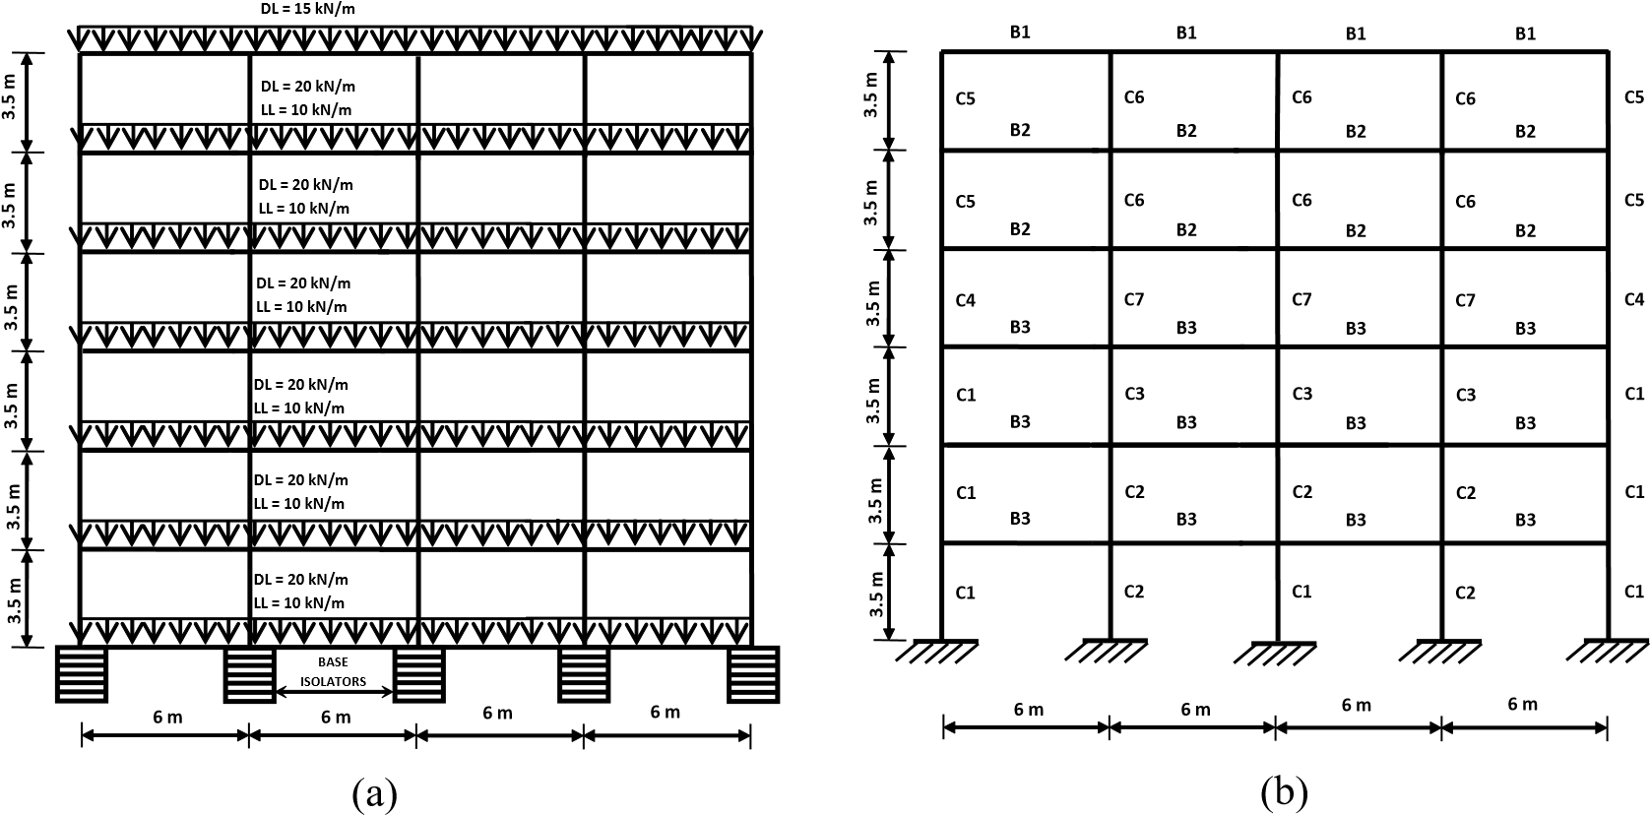
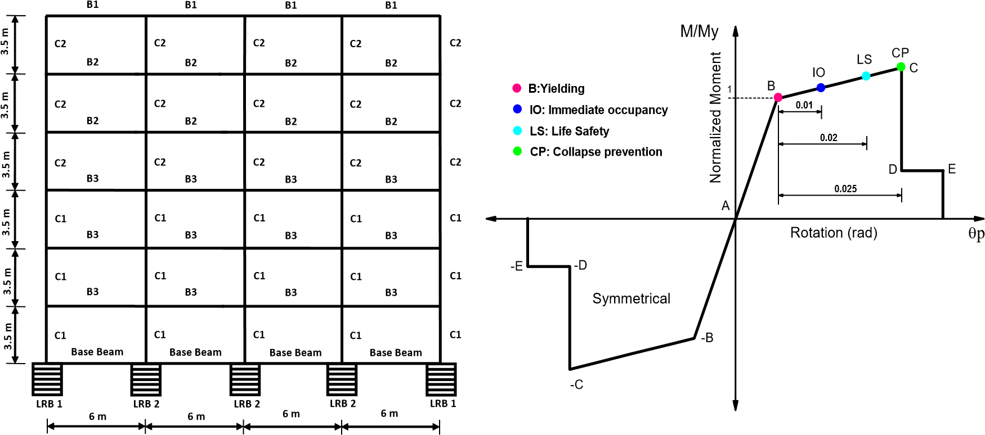
(c) (d)

Figure 1. Details of building frame; (a) elevation view; (b) beam-column layout of Frame A; (c) beam-column layout of Frame B; (d) simplified moment-rotation backbone curve adopted for plastic hinges.

A 2-dimensional model of building frame is modeled in the commercial software ETABS as shown in Figure 1(a). The beams and columns are modeled as line elements with the frame property. For modeling the beamcolumn joint, the rigidity factor is taken as 0.5 which means that half of the joint length would be rigid. To introduce the plasticity in the frame elements, plastic hinges are defined at the ends of each element. The beams are provided with the moment (M3) hinges and columns are provided with the P-M3 hinges which take into account the interaction of the axial load and the bending moment subjected on the column.
The user-defined plastic hinge properties are used to define the plastic hinges adopting the model of the moment-rotation as prescribed in FEMA 356 as shown in Figure 1(d). The moment-rotation relation is simplified to five points, namely A (origin), B (yield point), C (ultimate point), D (residual strength), and E (reduced strength). In the same figure, three performance levels, namely, IO (immediate occupancy), LS (life safety), and CP (collapse prevention) are marked. The moment-rotation relationship is obtained by performing moment-curvature analysis of beams and columns in the section designer facility provided in the SAP2000 software. The plastic hinge length is multiplied by the curvature ductility (the difference between ultimate curvature and yield curvature) to obtain the total plastic hinge rotation. The length of plastic hinge is taken as 0.5 H ( H is the depth of the section) from the face of the beam-column joint as recommended by Park and Paulay (1975), and ATC-40 (1996). The acceptance criteria adopted in the present study for the abovementioned performance levels is 10%, 60%, and 90% of the plastic rotation for IO, LS, and CP levels which is referred from the study of Inel and Ozmen (2006).
The dead load (DL) is assumed to be 20 kN/m on typical floors and 15 kN/m on the roof. The live load (LL) is assumed as 10 kN/m on typical floors. The grade of concrete used is M30 having a compressive strength equal to 30 MPa, the Poisson’s ratio equal to 0.2, and the elastic modulus equal to 27386 MPa. The Fe, 415grade steel, is used for reinforcing bars having a yield strength equal to 415 MPa and the ultimate strength equal to 534 MPa.
The beams and columns of the fixed base frame are designed as per Indian seismic code IS-1893 (2016) for the full value of DL plus 50% of LL by assuming the building to be located in the highest seismic zone (v) for which zone factor (Z) is equal to 0.36. The value of the response reduction factor, R, is considered to be 5 corresponding to the special moment resisting frame. The ductile design and detailing of the Frame A is carried out by following the provisions of the Indian code for ductile detailing, IS 13920:2016. The provision ensuring strong column-weak beam design philosophy for a moment resisting frame is strictly followed in which the design moment of resistance of columns should be 1.4 times of the design moment of resistance of beams meeting at a joint. Note that, by following this provision, the reinforcement requirement in the beams and columns to maintain the column to beam strength ratio = 1.4 comes out nearly the same for Frames A and B. In order to save the reinforcement, this strength ratio is not maintained in the design of Frame B.

Table 1. Reinforcement details of Frame A.

 | Frame  element | Breadth  (mm) | Depth  (mm) | Reinforcement |  | Spacing of lateral ties (mm)
 | Columns
 | C1 | 500 | 500 | 8 bars@ 20 mm dia. |  | 125
 | C2 | 500 | 500 | 10 bars@ 20 mm dia. |  | 125
 | C3 | 500 | 500 | 12 bars@ 20 mm dia. |  | 125
 | C4 | 400 | 400 | 12 bars@ 20 mm dia. |  | 100
 | C5 | 400 | 400 | 10 bars@ 20 mm dia. |  | 100
 | C6 | 400 | 400 | 16 bars@ 20 mm dia. |  | 100
 | C7 | 400 | 400 | 20bars @ 20 mm dia. |  | 100
 | Beams |  |  | Top | Bottom
 | B1 | 400 | 500 | 4 bars@ 16 mm dia. | 4 bars@ 16 mm dia. | 100
 | B2 | 400 | 500 | 5 bars@ 16 mm dia. | 3 bars@ 16 mm dia. | 100
 | B3 | 400 | 600 | 5 bars@ 16 mm dia. | 3 bars@ 16 mm dia. | 100

As per the draft IS 1893: 2018 (part 6), the design base shear force in the case of the base-isolated building is estimated corresponding to the fixed base building having a natural period equal to the isolated period of the base-isolated building. The response reduction factor, R in designing the base-isolated building, is considered to be 2 as per draft 1893:2018 (part 6). The beam-column layout for the two frames is shown in Figure 1(b) and 1(c). The frames are designed in ETABS, and the reinforcement details are provided in Tables 1 and 2 respectively.

Table 2. Reinforcement details of Frame B.

 | Frame  element | Breadth  (mm) | Depth  (mm) | Reinforcement |  | Spacing of lateral ties (mm)
 | Columns
 | C1 | 500 | 500 | 8 bars@20 mm dia. |  | 100
 | C2 | 400 | 400 | 6 bars@20 mm dia. |  | 100
 | Beams |  |  | Top | Bottom
 | B1 | 400 | 500 | 4 bars@ 16 mm dia. | 4 bars@ 16 mm dia. | 100
 | B2 | 400 | 500 | 5 bars@ 20 mm dia. | 4 bars@ 16 mm dia. | 100
 | B3 | 400 | 600 | 5 bars@ 20 mm dia. | 4 bars@ 16 mm dia. | 100
 | Base  Beam | 400 | 700 | 4 bars@ 20 mm dia. | 4 bars@ 20 mm dia. | 100

The lead rubber bearing (LRB) isolators are used as a base isolation system in the building frames. The forcedisplacement behavior of the LRB is bilinear and is based on the modified Bouc-Wen (Park et al., 1986; Wen, 1976) hysteretic model as shown in Figure 2. The design of important parameters, which governs the behavior of LRB is carried out by following the design guidelines provided by Naeim and Kelly (1999), and Datta (2010) for the design of LRB isolator. The designed properties of the LRB are presented in Table 3. The fundamental period of the fixed base frame (Frame A) is 0.81 seconds, and the base-isolated frame (Frame B) is 2.6 seconds.

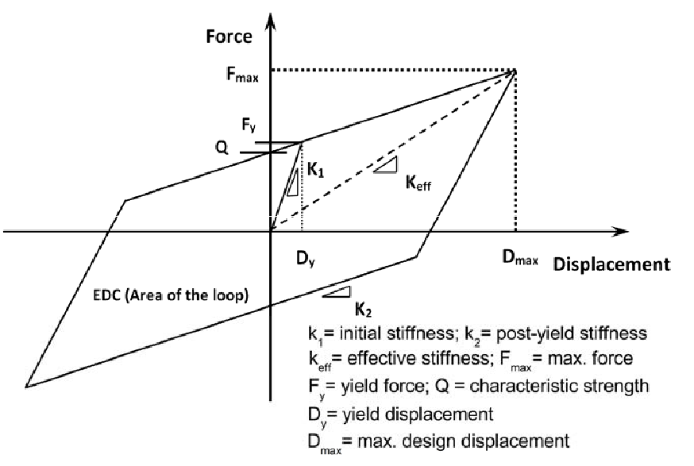

Figure 2. The Idealized bilinear force-displacement curve of lead rubber bearing isolator

Table 3. Characteristics of isolators designed for two building frames.

Isolator | Effective  stiffness,  Keff  (kN/m) | Elastic  stiffness, k1  (kN/m) | Post  yield  stiffness  ratio, γ | Effective  Damping  βeff | Yield  strength,  Fy (kN) |  | Design  disp.  Dmax  (mm)
LRB 1 | 445 | 3600 | 0.1 | 40 | 25 |  | 256
LRB 2 | 846 | 6851 | 0.1 | 31 | 48 |  | 256

3. NUMERICAL STUDY

The performance of the two versions (mentioned in the previous section, Frames A and B) of a six-storey frame is evaluated with the help of two methods of analysis (i) Capacity Spectrum Method (CSM), and (ii) Nonlinear Time History Analysis (NTHA). The CSM is used to obtain performance points of the two frames (Frames A and B) which are found consistent to the three assumed PGA levels, namely, 0.2g (design level), 0.4g (medium level), 0.6g (high level). The capacity curves of frames are obtained by carrying out the pushover analysis considering the lateral load pattern proportional to the 1st mode shape of the frame. The 1st mode shape pattern is motivated by the fact that the dynamic response of the building is primarily governed by the 1st mode, especially in the case of base-isolated buildings (Doudoumis et al. (2006); Kilar and Koren, 2010).
The NTHA is carried out using direct integration scheme using Hibler Hughes integration assuming values of Beta and Gamma to be 0.25 and 0.5 respectively. The damping of the building is calculated by Rayleigh damping model corresponding to the damping ratio of 5% for the first and second modes of the building frame. The NTHA is performed by employing three artificial time histories (Artificaila1-3) generated by SeismoArtif (2016) software compatible to IS 1893:2016 response spectrum. The comparison of response spectrum of three artificial time histories with the IS 1893:2016 response spectrum is shown in Figure 3.

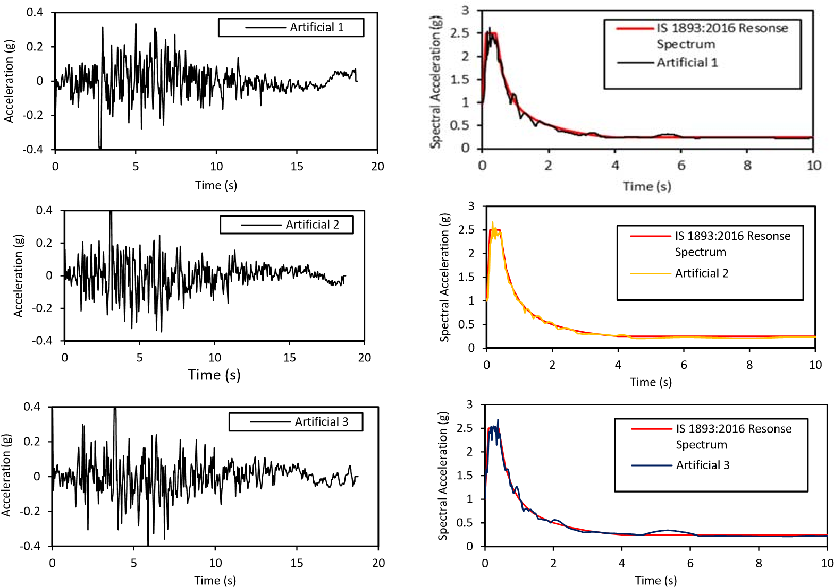
(a) (b)

Figure 3. Artificial time history data; (a) acceleration time histories; (b) comparison of IS response spectrum with response spectrum of artificial time histories

4. DISCUSSION OF RESULTS

The comparison of the capacity curves of the two building frames is shown in Figure 4. It is observed from the figure that there is a significant difference between the capacity curves of the fixed base frame (Frame A) and the base-isolated frame (Frame B). For the same level of displacement, the value of the base shear is less for frame B as compared to the frame A up to the displacement level of 300 mm. Beyond the displacement value of 75 mm, the capacity curve of the frame A becomes flat, showing that the frame A has gone into a highly nonlinear state. On the contrary, the capacity curve of the frame B remains almost linear and reaches to the final displacement value of 420 mm. This proves the high displacement capacity of the base-isolated frame and less base shear offered up to a specified displacement value as compared to the fixed base frame. Hence, the performance of the frame B is better as compared to the frame A.

Base shear (kN)

300
200
100
0
500
400
0
200
400
600
800
1000
1200
Top Displacement (mm)
Frame A
Frame B

Figure 4. Comparison of capacity curves obtained for different frames.

The comparison of base shear predicted for the frames A and B by two analyses methods is presented in Table 4. It is observed from the table that there is a significant reduction in the base shear, of the order of 59%, at a performance point corresponding to a PGA level of 0.2g as estimated by the CSM. As the PGA level increases, the reduction in the base shear decreases and after a specific PGA level (0.6g), the base shear in the baseisolated frame becomes more than that of the fixed base frame. This is due to the difference in the capacity curves of the two building frames as shown in Figure 4.

Table 4. Comparison of Base Shear values obtained by CSM and NTHA for two building frames.

Building Frame |  |  | Base Shear (kN)
 |  | CSM |  |  |  | Mean NTHA
 | 0.2 g | 0.4g | 0.6g |  | 0.2g | 0.4g | 0.6g
Frame A | 801 | 901 | 915 | 817 |  | 1187 | 1432
Frame B | 330 | 622 | 953 | 316 |  | 515 | 711
%age Difference | -59 | -31 | +4 | -61 |  | -56 | -50
sign indicates reduction; + sign indicates an increment

On the other hand, the base isolation has shown nearly a consistent performance in reducing the base shear maximum up to 61% at 0.2g and minimum up to 50% at 0.6g as predicted by the exact method, i.e., NTHA. As the CSM is an equivalent nonlinear static method and not an exact method, the predictions of the CSM are not reliable at all performance points. Hence, the predictions of the CSM should be compared with those of the more accurate NTHA method.
Table 5 presents the values of the maximum inter-storey drift ratio (MIDR) for the two building frames. It is observed from the table that the base isolation system is highly effective in reducing the MIDR to an average value of 70% at all PGA levels. The height-wise variation of IDR values for the two building frames obtained by the CSM and the NTHA is compared in Figure 5. The effectiveness of the base-isolation is observed from the figures which depict very less difference in the IDR values along the height of the frame B as compared to the frame A. In the case of the frame B, the MIDR is obtained in middle storey levels (between 3rd to 5th storey) by the NTHA and at bottom storey levels (between 1st to 3rd storey) by the CSM.

Table 5. Comparison of MIDR values obtained by CSM and NTHA for two building frames.

Building Frame |  | Maximum Inter-storey Drift Ratio (%)
 |  | CSM |  |  |  | Mean NTHA
 | 0.2 g | 0.4g | 0.6g |  | 0.2g | 0.4g | 0.6g
Frame A | 0.37 | 0.58 | 1.13 | 0.43 |  | 0.81 | 1.17
Frame B | 0.089 | 0.17 | 0.28 | 0.16 |  | 0.24 | 0.32
%age Difference | -76 | -71 | -75 | -64 |  | -70 | -72
sign indicates reduction

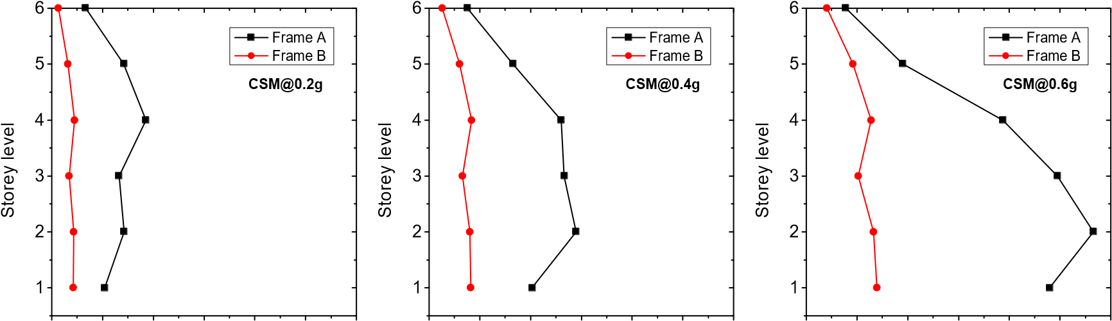
0.0 0.2 0.4 0.6 0.8 1.0 1.2 0.0 0.2 0.4 0.6 0.8 1.0 1.2 0.0 0.2 0.4 0.6 0.8 1.0 1.2

IDR (%) IDR (%) IDR (%)

(a) Height-wise variation of IDR estimated by CSM

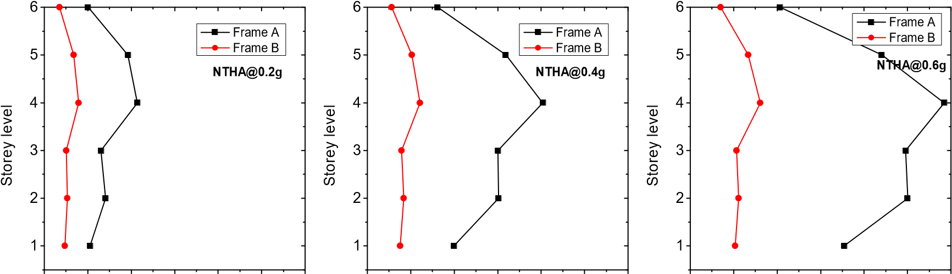
0.0 0.2 0.4 0.6 0.8 1.0 1.2 0.0 0.2 0.4 0.6 0.8 1.0 1.2 0.0 0.2 0.4 0.6 0.8 1.0 1.2

IDR (%) IDR (%) IDR (%)

(b) Height-wise variation of IDR estimated by NTHA

Figure 5. Height-wise variation of IDR values estimated by two analyses

The comparison of the top floor displacement for the two building frames is presented in Table 6. Note that in the case of the frame B (base-isolated frame), the relative top floor displacement is presented, which is relative with respect to the base storey level above the isolation system. It is observed from the table that there is a high percentage of reduction in the top floor displacement in the case of the frame B at all considered PGA levels, which shows the high effectiveness of the base isolation system. Note that there is very less (<10%) difference between the estimates predicted by the two analysis methods at a specified PGA level.

Table 6. Comparison of top floor displacement obtained by CSM and NTHA for two building frames.

Building Frame |  |  | Top Floor Displacement (mm)
 |  | CSM |  |  |  | Mean NTHA
 | 0.2 g | 0.4g | 0.6g |  | 0.2g | 0.4g | 0.6g
Frame A | 54 | 88 | 152 | 56 |  | 101 | 154
Frame B | 14 | 28 | 44 | 14 |  | 17 | 61
%age Difference | -74 | -68 | -71 | -75 |  | -83 | -61
sign indicates a reduction

The inelastic effect in both frames is estimated in terms of the number of plastic hinges formed in the building frames, which is compared in Table 7. It is observed from the table that there is the large number of plastic hinges formed in the case of frame A and it increases with the increase in the PGA level. On the contrary, the Frame B remains in the elastic state up to a PGA level of 0.4g and forms very fewer hinges at the PGA level of 0.8g. This comparison shows that the base isolation system is highly effective in reducing the inelastic effect in the fixed base frame even at high PGA level of 0.6g.

Table 7. Comparison of plastic hinges obtained by CSM and NTHA for two building frames.

 |  |  | Number of Plastic Hinges
Building Frame |  | CSM |  |  |  | Mean NTHA
 | 0.2 g | 0.4g | 0.6g |  | 0.2g | 0.4g | 0.6g
Frame A | 10 | 29 | 35 | 11 |  | 26 | 29
Frame B | 0 | 0 | 8 | 0 |  | 0 | 3

5. CONCLUSIONS

The performance of a base-isolated building frame, as designed by the proposed draft Indian code, IS 1893:2018 (part 6) (criteria for earthquake resistant design of the base-isolated buildings) is compared with that of its counterpart fixed base version. For this purpose, a 6-storey building frame is considered, which is base-isolated with lead rubber bearing isolators. The performance of the building frame is evaluated by two methods, one is a nonlinear static method which is the capacity spectrum method (CSM) and the other is the well-known exact method, the nonlinear time history analysis method (NTHA). The performance points are obtained by the CSM by considering IS 1893-2016 hazard spectrum at three assumed PGA levels of 0.2g, 0.4g, and 0.6g. The NTHA is performed by employing artificially generated time histories compatible to IS 1893:2016, response spectrum scaled to the above-mentioned PGA levels. Finally, the different demand measures obtained the two analysis methods are compared between the base-isolated and fixed base frames. The important conclusions obtained from the analysis of the specific building frames, considered in the study, are presented below:
- The performance of the base-isolated building frame is highly increased as compared to the fixed base frame at all considered PGA levels.
- There is a significant difference between the capacity curves of both building frames. The displacement capacity of the base-isolated frame is nearly twice as that of the fixed-base frame.
- On an average, for the case of the base-isolated frame, the reduction in base shear is about 60%, and in inter-storey drift and top floor displacement is about 70% at three considered PGA levels.
- The base-isolated frame remains in the elastic state up to a PGA level of 0.4g and gets into less inelastic state by exhibiting less number of plastic hinges as compared to the fixed base frame.

6. ACKNOWLEDGMENT

The funding of this study is provided by the Department of Science and Technology, the government of India, New Delhi, India.

7. REFERENCES

ATC-40. (1996). Seismic evaluation and retrofit of concrete buildings. Applied Technology Council, report ATC-40. Redwood City.
Chopra, A. K., & Goel, R. K. (2002). A modal pushover analysis procedure for estimating seismic demands for buildings. Earthquake engineering & structural dynamics, 31(3), 561-582.
Datta, T. K. (2010). Seismic analysis of structures: John Wiley & Sons.
Deb, S. K. (2004). Seismic base isolation-an overview. Current Science Bangalore, 87, 1426-1430.
Doudoumis, N. I., Kotanidis, C., & Doudoumis, I. N. (2006). A comparative study on static push-over and time-history analysis methods in base isolated buildings. Paper presented at the First European Conference on Earthquake Engineering and Seismology, Geneva, Switzerland, September, paper.
Faal, H. N., & Poursha, M. (2017). Applicability of the N2, extended N2 and modal pushover analysis methods for the seismic evaluation of base-isolated building frames with lead rubber bearings (LRBs). Soil Dynamics and Earthquake Engineering, 98, 84-100.
Fajfar, P., & Gaspersic, P. (1996). The N2 method for the seismic damage analysis of RC buildings. Earthquake engineering & structural dynamics, 25(1), 31-46.
FEMA-356. (2000). Prestandard and commentary for the seismic rehabilitation of buildings. Washington, DC: SAC Joint Venture for the Federal Emergency Management Agency.
FEMA-440. (2005). Improvement of nonlinear static seismic analysis procedures. Redwood City.
Freeman, S., Nicoletti, J., & Tyrell, J. (1975). Evaluations of existing buildings for seismic risk–A case study of Puget Sound Naval Shipyard, Bremerton, Washington. Paper presented at the Proceedings of the 1st US National Conference on Earthquake Engineering.
Inel, M., & Ozmen, H. B. (2006). Effects of plastic hinge properties in nonlinear analysis of reinforced concrete buildings. Engineering Structures, 28(11), 1494-1502.
IS-1893. (2016). (Part 1) Criteria for earthquake resistant design of structures. Bureau of Indian Standards, Manak Bhawan, New Delhi.
Kalkan, E., & Kunnath, S. K. (2006). Adaptive modal combination procedure for nonlinear static analysis of building structures. Journal of Structural Engineering, 132(11), 1721-1731.
Kalkan, E., & Kunnath, S. K. (2007). Assessment of current nonlinear static procedures for seismic evaluation of buildings. Engineering Structures, 29(3), 305-316.
Kelly, J. M. (1986). Aseismic base isolation: review and bibliography. Soil Dynamics and Earthquake Engineering, 5(4), 202-216.
Kilar, V., & Koren, D. (2010). Simplified inelastic seismic analysis of base‐isolated structures using the N2 method. Earthquake engineering & structural dynamics, 39(9), 967-989.
Kilar, V., Petrovcic, S., Koren, D., & Šilih, S. (2011). Seismic analysis of an asymmetric fixed base and base-isolated high-rack steel structure. Engineering Structures, 33(12), 3471-3482.
Koren, D., & Kilar, V. (2011). The applicability of the N2 method to the estimation of torsional effects in asymmetric base‐isolated buildings. Earthquake engineering & structural dynamics, 40(8), 867-886.
Krawinkler, H. (1996). Pushover analysis: why, how, when, and when not to use it. Paper presented at the Proceedings of the 65th Annual Convention of the Structural Engineers Association of California.
Krawinkler, H., & Seneviratna, G. (1998). Pros and cons of a pushover analysis of seismic performance evaluation. Engineering Structures, 20(4), 452-464.
Mwafy, A., & Elnashai, A. (2001). Static pushover versus dynamic collapse analysis of RC buildings. Engineering Structures, 23(5), 407-424.
Naeim, F., & Kelly, J. M. (1999). Design of seismic isolated structures: from theory to practice: John Wiley & Sons.
Park, R., & Paulay, T. (1975). Reinforced concrete structures: John Wiley & Sons.
Park, Y., Wen, Y., & Ang, A. (1986). Random vibration of hysteretic systems under bi‐directional ground motions. Earthquake engineering & structural dynamics, 14(4), 543-557.
SEAONC. (1986). Tentative Seismic Isolation Design Requirements: Structural Engineers Association Of Northern California. Seismology Committee. Base Isolation Subcommittee.
SeismoArtif. (2016). Computer program for generation of artificial earthquake accelerograms. Siesmosignal.
Tso, W., & Moghadam, A. (1998). Pushover procedure for seismic analysis of buildings. Progress in structural engineering and materials, 1(3), 337-344.
Wen, Y.-K. (1976). Method for random vibration of hysteretic systems. Journal of the engineering mechanics division, 102(2), 249-263.
Zou, X.-K., & Chan, C.-M. (2005). Optimal seismic performance-based design of reinforced concrete buildings using nonlinear pushover analysis. Engineering Structures, 27(8), 1289-1302.

Senior Research Fellow, National Centre for Disaster Mitigation and Management, Malaviya National Institute of Technology, Jaipur, India, man2301@yahoo.co.in
Associate Professor, Department of Architecture and Planning, Malaviya National Institute of Technology, Jaipur, India, rnsharma.arch@mnit.ac.in
Professor, Department of Civil Engineering, Malaviya National Institute of Technology, Jaipur, India, sdbharti@mnit.ac.in
Structural Engineer, R. S. Mandrekar & Associates, Mumbai, India, jaswant.arlekar@gmail.com
Professor, Department of Civil Engineering, Indian Institute of Technology, Madras, India, cvrm@iitm.ac.in

